- Internship Name : Data Analysis
- Task Name: Task 13: Exploring Relationship student Marks Data using Seborn
- Your Name : Shubhangi Naresh Khonde
- Internship Organization :
- Date:

1. Objective
To create heatmaps, boxplots and distribution plots using Seaborn and use them to explore the distribution of marks and the relationships between subjects in a student marksheet.

2. Dataset Description
The dataset is an Excel file (marksheet 1.xlsx) containing student marks. Columns used for analysis:
- Subjects: Java, SEPM, ADBMS, CHN, NS (numeric marks)
- Other columns in the file: Sr.no., Student Name, Total, Average, Result, Grade
- Number of students: 16
Tools used: Python 3.13, Pandas, Seaborn, Matplotlib, Jupyter Notebook (VS Code).

3. Implementation

Step 1: Import libraries, load and prepare the data
The libraries are imported, the Excel file is loaded, the header row is detected, empty rows/columns are removed and the subject marks are converted to numbers.

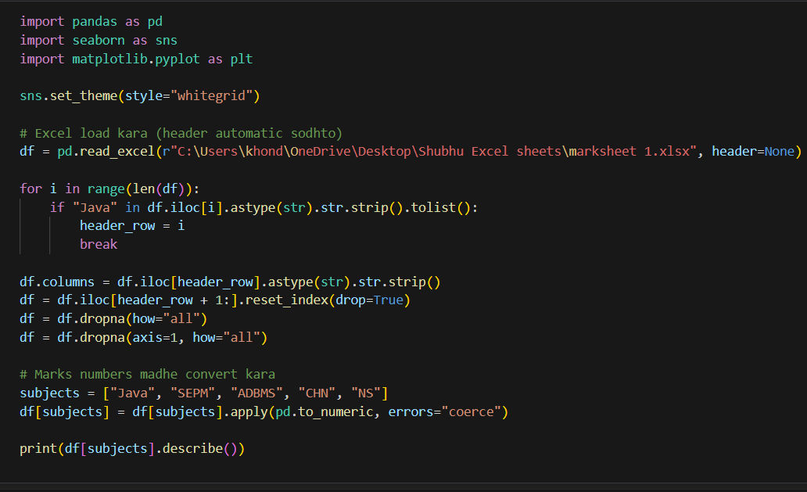

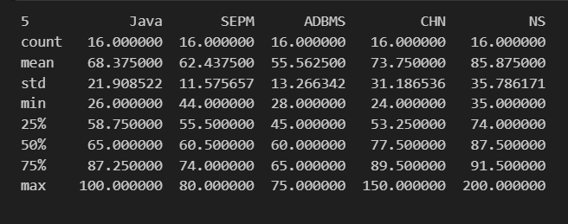

Step 2: Distribution Plot
A histogram with a KDE curve is drawn for each subject to see how the marks are spread.

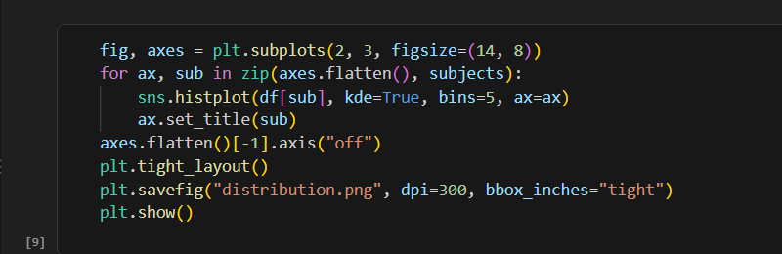

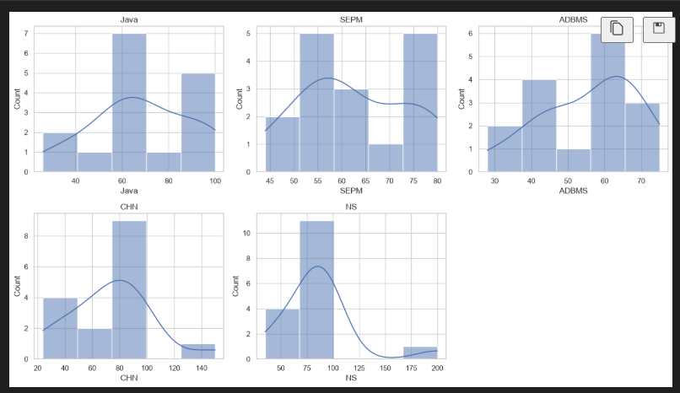

Observations:
- Java: most students (7) scored between 60 and 70 marks.
- SEPM: the marks form two groups, one around 55-60 and another around 75-80.
- ADBMS: most students scored between 60 and 65 marks.
- CHN and NS: most marks are high, but a few very large values (150 and 200) stretch the plot.

Step 3: Boxplot
A boxplot is drawn for all subjects to compare their medians, spread and outliers.

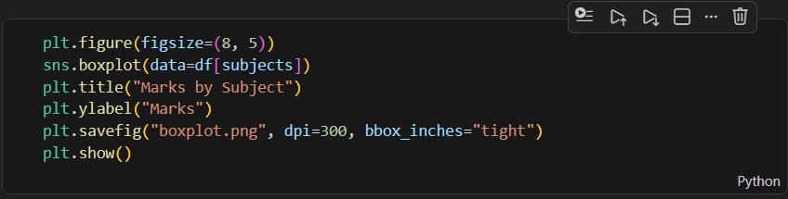
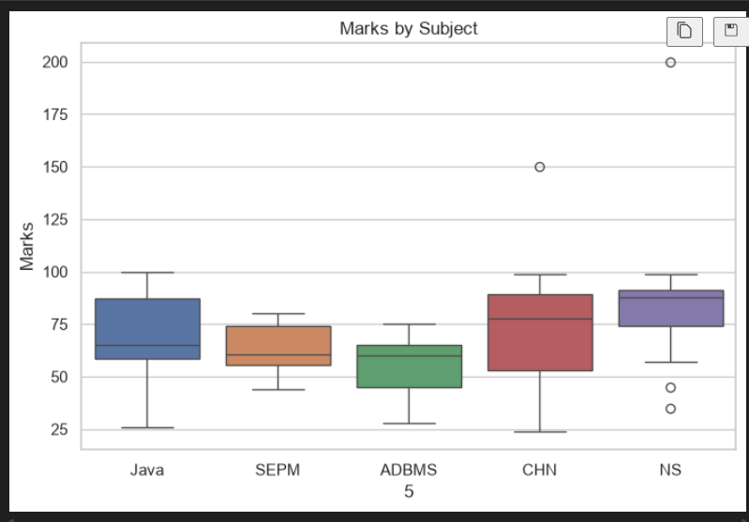
Observations:
- NS has the highest median (about 87) and ADBMS has the lowest (about 60).
- SEPM has the smallest spread, so its marks are close to each other.
- Java and CHN have a wide spread, so student performance varies a lot.
- Outliers: CHN has a value of 150 and NS has a value of 200 (and two low values around 35-45). Marks above 100 are likely data entry mistakes.

Step 4: Heatmap
A correlation heatmap shows how strongly the marks of one subject are related to the marks of another. Values near +1 mean a strong positive relationship, near 0 mean no relationship and near -1 mean a negative relationship.

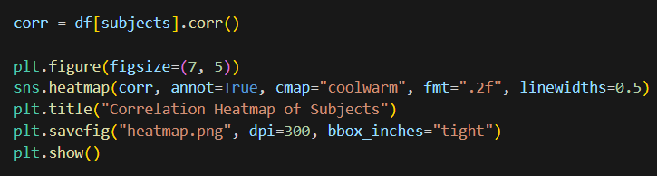

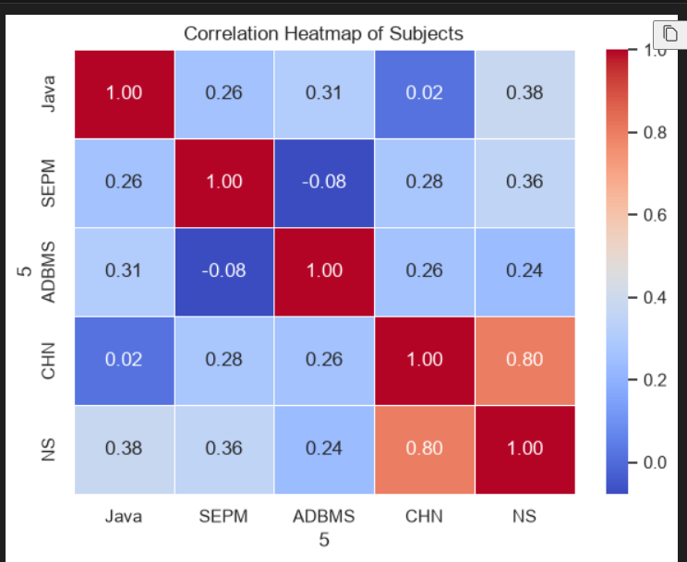

4. Conclusion
The distribution plots showed how marks are spread in each subject, the boxplot compared the subjects and highlighted outliers, and the heatmap showed which subjects are related. NS had the best performance and ADBMS the weakest, while SEPM marks were the most consistent. Values above 100 in CHN and NS should be checked and corrected in the source data. Seaborn made it easy to explore the data visually and find patterns that are hard to see in a plain table.

