**Power BI Assignment 2**

**1.Explain the advantages of Natural Queries in PowerBi with an example?**

- Advantages of Natural Queries in Power BI:

1. Ease of use: Natural language queries make it easier for users with limited technical skills to interact with the data in Power BI. 2. Accessibility: Natural quires provide a more inclusive and accessible experience for all users. People who may not be comfortable with writing complex queries or using traditional BI toll can still retrieve meaningful insights.

3. Faster insights: With natural language queries, users can quickly ontain answers to their questions without needing to write and validate complex SQL or DAX queries.

4. Explorataion and Discovery: Natural queries encourage exploration and discovery of data.

1. **Explain Web Front End(WFE) cluster from Power BI Service Architecture?**

* In the Power BI Service architecture, the web front end cluster plays a crucial role in handling user interactions and delivering the powerbi experience through the web browser. The WTF clusters is responsible for receiving requests from users, rendering and displaying reports , dashboards, and other visualizations, as well as handling user interactions such as filtering, sorting and drilling down into data.

1. **Explain Back End cluster from Power BI Service Architecture?**

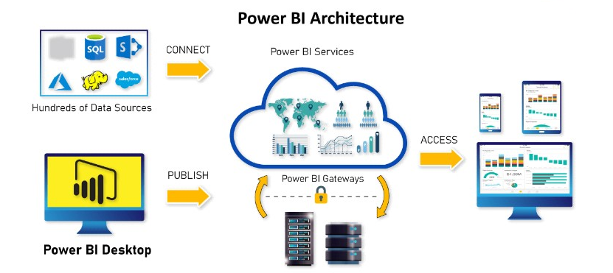

In the Power BI Service architecture, the Back End cluster is a critical component responsible for handling data processing, storage and management tasks. It serves as the backbone of the power bi infrastructure, supporting funcationalities such as data ingestion, data transformation , data modeling and data storage.

Key aspects and functions of the Back End cluster in Power BI Service architecture:

1.Data Ingestion: The Back End cluster is responsible for receiving and processing data from various sources, such as databases, files, APIs or data connectors. It handle the extraction transformation and loading process to bring the data into Power BI ecosystem.

2. Data Transformation and modeling : Once the data is ingested, the Back End cluster performs data transformation and modeling operations. This includes tasks like data cleansing ,data shaping, creating relationship between different data sources, and defining calculations are measures.

3.Query Processing : When users interect with reports and visualizations in the power bi service, the Back End cluster handles the execution of queries to retrieve and aggregate data based on the users request.

4. Data storage : The Back End cluster managers the storage of data within the Power BI Service. It includes both the metadata associated with data sets ,reports, dashboards and visualizations as well as the underlying data itself.

5. Security and Access Control: The Back end cluster enforces security measures to protect the data and ensure that it is accessed only by authorized users. It includes authentication mechanisms ,role based access controls and data encryption to safeguard the confidentiality and integrity of the data.

6. Administration and Monitoring: The Back End cluster provides administrative capabilities to manage the power bi environment . This includes tasks such as user management , performance monitoring ,capacity planning and system maintenance.

7. Integration and other services : The Back End cluster integrated with other services and components within the Power bi ecosystem, such as the web Front End cluster, data gateways, data connector and external services like Azure services.

1. **What ASP.NET component does in Power BI Service Architecture?**

-In the Power BI service architecture , ASP.NET is web application framework that is used to build and deploy the web based components of the Power BI service. ASP.NET provides a robust and scalable platform for developing the web applications that make up the Power BI Service ,including the user interface, interactive visualization and various backend funcations.

1. **Compare Microsoft Excel and PowerBi Desktop on the following features:**

**Data import**

**Data transformation**

**Modeling**

**Reporting**

**Server Deployment**

**Convert Models**

**Cost**

**-**

|  |  |  |
| --- | --- | --- |
| **Feature** | **Microsoft Excel** | **PowerBI** |
| **Data Import:** | -Excel allows users to import data from various sources as databases, text files and online services. Importing data into Excel involves selecting the data source, specifying connection settings, and importing the data into worksheets. | **-** Power BI Desktop offers a similar data import capability, allowing users to connect to a wide range of data sources, including databases, files, cloud services and online platforms. Power BI Desktop provides connectors and tools specifically designed for data integration and import into the Power BI environment. |
| **Data Transformation:** | -Excel provides basic data transformation capabilities, such as sorting ,filtring, and basic formulas. Users can also use Excel’s power query feature to perform more advanced data transformation, such as data cleansing, merging and reshaping. | - Power BI Desktop includes more robust and intuitive data transformation tool called power query editor. Power query editor offer advanced data transformation capabilities, allowing users to clean,shape,and combine data from multiple sources. |
| **Modeling :** | Excel supports basic data modeling by allowing users to define relationship between tables and create calculated columns and formulas. However excel modeling capabilities are more limited compared to Power BI Desktop | Power BI Desktop offers advanced data modeling capabilities . Analysts can create complex data models by defining relationships between tables ,creatinf calculate columns and measures and implementing more advanced modeling technique like hierarchical modeling and many to many relationships |
| **Reporting :** | Excel is widely used for creating tabular reports, charts and graphs. Users can create visually appealing reports using Excel’s formatting and charting options. Excel also supports the creation of pivot tables and pivot charts for data analysis | Power Bi Desktop is specially designed for creating interactive and visually compelling reports and dashboards. It provides a wide range of visualization options, custom formatting and interactive features such as drill-down, filtering and dynamic slicers. |
| **Server Deployment:** | -Excel files are typically shared through file sharing methods ,such as email or shared drivers. Collboration and real-time updates can be challenging with Excel files. | - power bi desktop reports and dashboard can be published to the power BI Service for centralized sharing and collaboration. Users can share reports with specific individual or groups ,set permissions and collaborate in real-time. |
| **Convert Models:** | -Excel models can not be directly converted to power bi models. However data from Excel can be imported into Power BI Desktop for modeling purpose. | Power BI Desktop models cannot be published to the Power BI Service,allowing users to access and interact with the reports and dashboards online. |
| **Cost:** | **-**Excel is included in the Microsoft office suite and is available through various licensing options, including one time purchases or subscription based office 365 plans. | **-**Power Bi is a free tool provided by Microsoft. However additional costs may be associated with using the Power BI Service for sharing and collaboration, depending on licensing and subscription plan. |

1. **List 20 data sources supported by Power Bi desktop.**

Data sources supported by Power Bi desktop:

1.Excel workbook(.xlsx)

2. CSV(Comma-separated values) files

3. SQL Server databases

4. Oracle database

5. MySQL database

6. PostgreSQL database

7. Sharepoint List

8. Azure SQL database

9. Azure Data Lake storage

10. Salesforce

11. Google Analytics

12. Dynamic 365

13. Sharepoint Online

14. web API

15. JSON

16. XML

17. Hadoop Distributed file system

18. Share point folder

19. OData feed

20. Microsoft Exchange