Detailed Flow Architecture: ACME HR System
This diagram maps out the detailed logical flow of the system architecture, preventing overlap and representing the request lifecycle just like a structured flowchart.
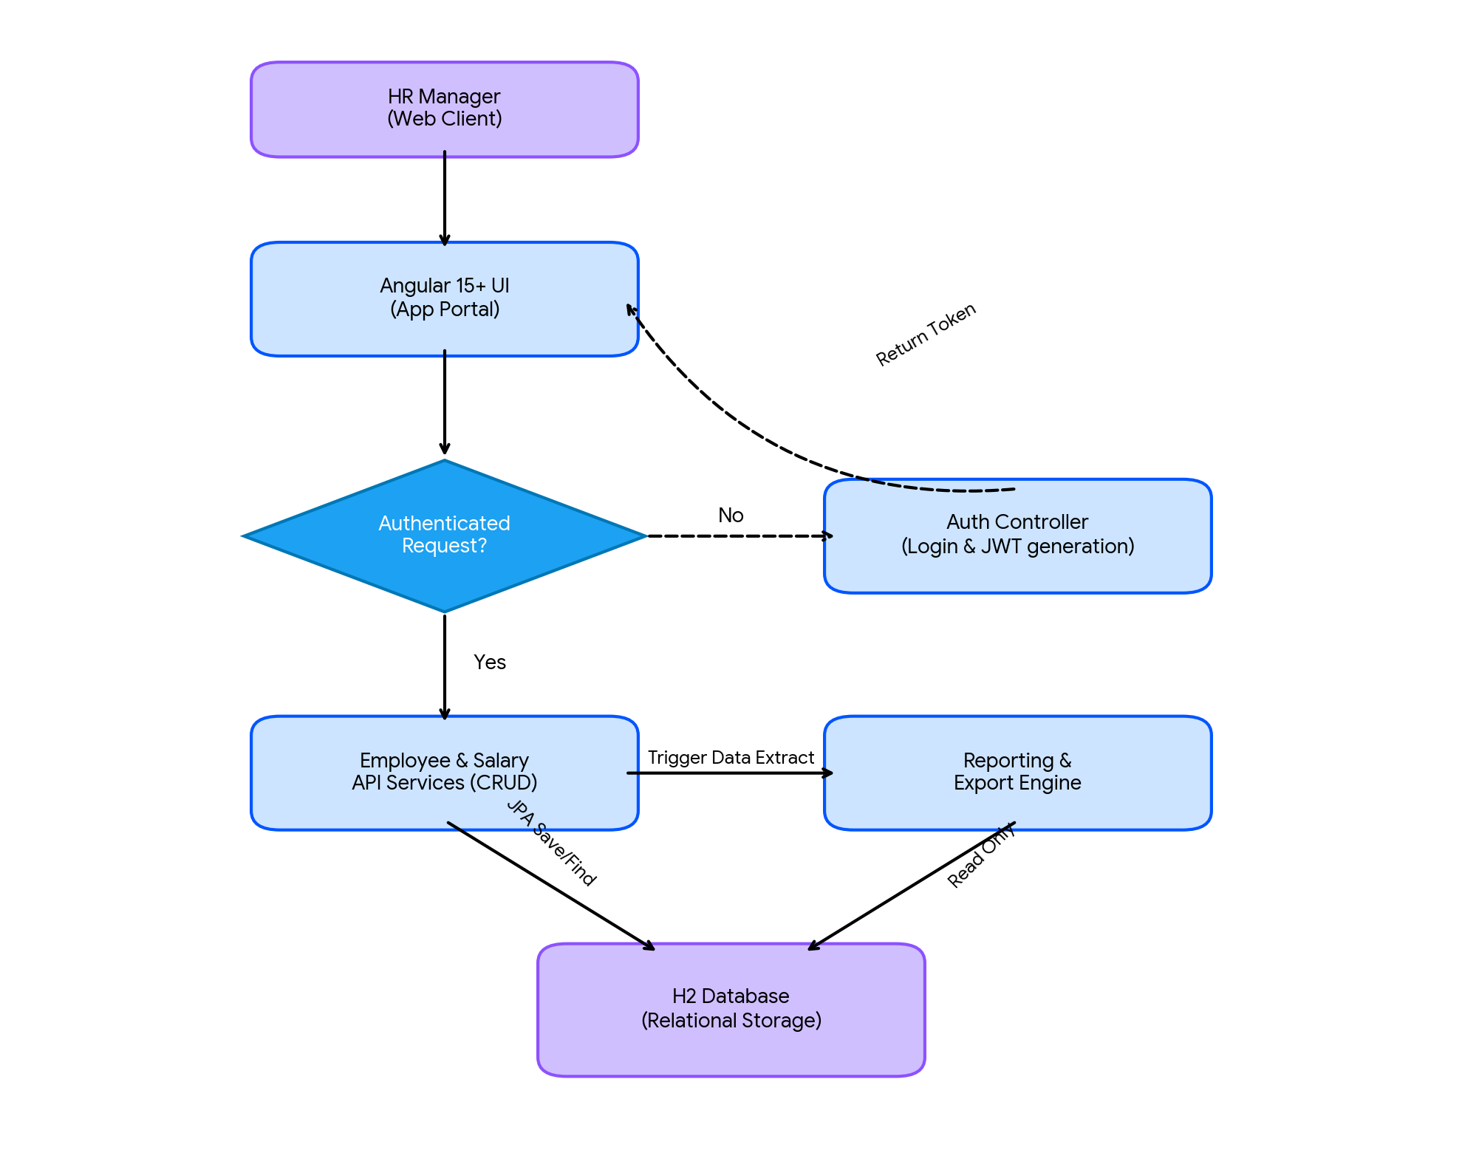

Architecture Flow Details
- 1. HR Manager (Web Client): The user accesses the application through their browser.
- 2. Angular 19+ UI: Manages user inputs, form submissions, and renders the data grid.
- 3. Authentication Check: The Spring Security Filter intercepts the API calls. If the request lacks a valid JWT token, it is routed via the dashed line to the Auth Controller.
- 4. Auth Controller: Authenticates the user credentials and returns a valid JWT to the frontend.
- 5. Employee & Salary API Services: Handles authorized CRUD operations for the employee directory and salary logic.
- 6. Reporting & Export Engine: A specialized controller used when the user requests data downloads (Excel/Word formats).
- 7. H2 Database: The ultimate data persistence layer accessed via JPA repositories.

