Shubhanjan Medhi
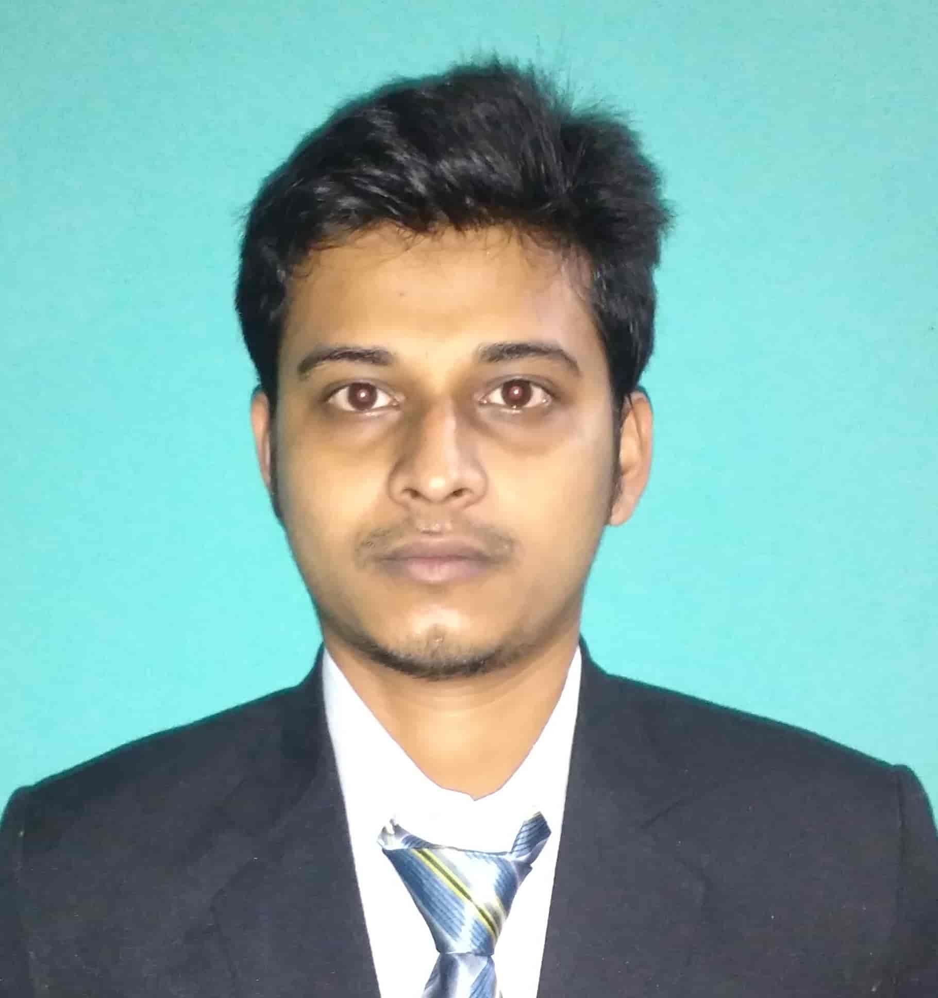
Email: s.medhi1@gmail.com
Contact No: 8638128782 / 8876193990
BTM 2nd Stage, Bengaluru, Karnataka, India
https://shubhanjanmedhi.github.io/
Career Objective

Recent graduate equipped with a Master in Computer Applications degree, eager to join a reputable organization to begin a fulfilling, lifelong career. Extensive knowledge of planning and design, developing user friendly applications. Additional knowledge of Android, React Native; expert in building logic for solving various problems.
Work Experience

- Internship at Skaplink Technologies Pvt. Ltd., Guwahati as a team member in developing a social networking site entitled “Skaplink” (6 months)
- Worked at Mirania Data Systems as Web Developer (7 months)
Academic Qualification

Course | College & Board/University | Year of Passing | Percentage
MCA | Assam Engineering College, (Gauhati University) | 2018 | 70.25%
BCA | Cotton College, (Gauhati University) | 2014 | 62.06%
HS | B.H. College, (AHSEC) | 2010 | 52.2%
HSLC | St. Mary’s High School, (SEBA) | 2008 | 55.3%

Academic Projects

- Title: Skaplink, a Social Networking and Skill Sharing Site
Description: A Social Networking site that allows registered users to create profiles, upload photos and video, send messages and keep in touch with friends, family and colleagues. Skaplink, is basically focused on Skill Sharing. Using this application one can share their skills or learn new skills from other users.

- Title: Online Loan Approval System
Description: Using the portal, users can apply for different kinds of loan and also check the approval status.
Computer Proficiency

- C, C++, Java, Android, React Native
Computer Proficiency

- HTML, PHP, JSP, JavaScript, Wordpress
- Diploma in Computer Hardware and Networking (DCHE)
Personal Strength

Confident, Quick Learner, Dedicated and Honest, Adaptive, Self-Learning
Extra Curriculum Activities

Team Leader in participating “Smart India Hackathon 2017” for submitting idea under the “Ministry of Civil Aviation”
Area of Interest

Playing Computer Games
Languages Known

Reading, Writing and Speaking: English, Hindi, Assamese
Personal Details

- Name: Shubhanjan Medhi
- Fathers name: Dilip Kr. Medhi
- Date of birth: 30/07/1991
- Gender: Male
- Marital status: Unmarried
- Nationality: Indian
- Hometown: Barpeta Road, Assam
- Phone: 8638128782 / 8876193990

Declaration

I hereby declare that the above information is true and correct as far as my knowledge and concern.
Place: Guwahati
Date: 02/06/2019 Shubhanjan Medhi

