Shubhanjan Medhi
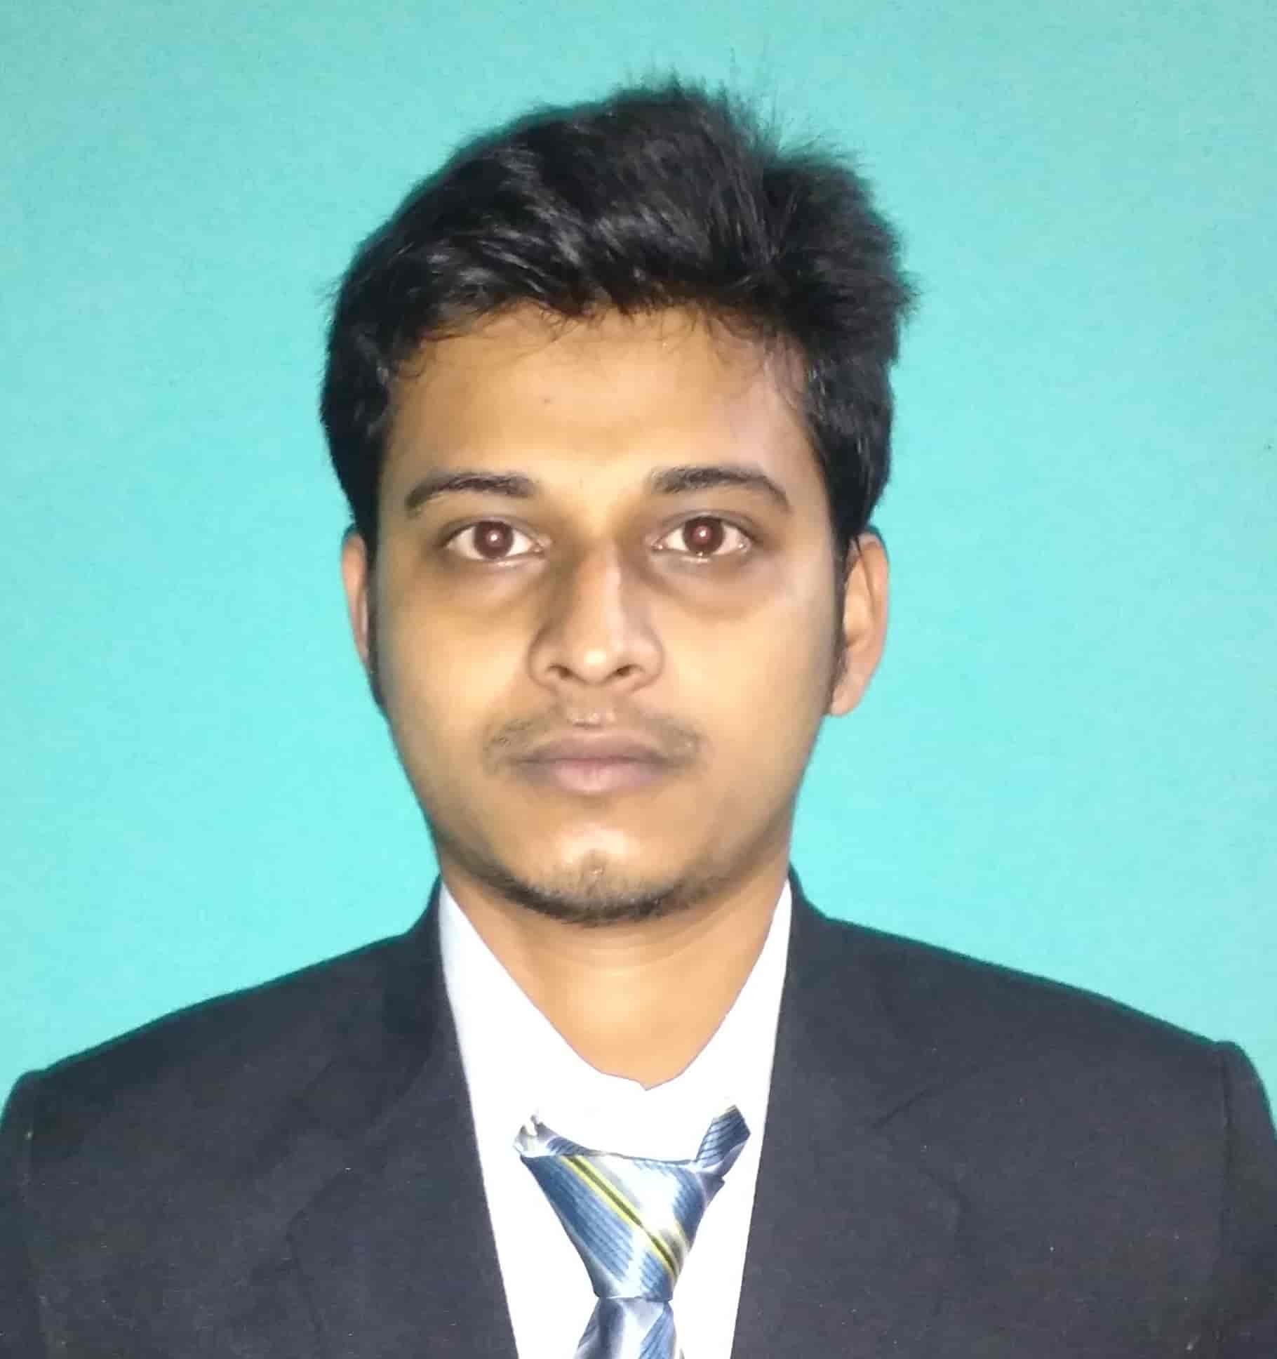
Email: s.medhi1@gmail.com
Contact No: 8638128782 / 8876193990
Simlaguri (Near Sat Sangha Mandir), Barpeta Road, Assam
Career Objective

Recent graduate equipped with a Master in Computer Applications degree with a concentration in Information Technology, eager to join a reputable organization to begin a fulfilling, lifelong career. Extensive knowledge of planning and design, developing user friendly applications. Additional knowledge of Android, Wordpress; expert in building logic for solving various problems.
Academic Qualification

Course | College & Board/University | Year of Passing | Percentage
MCA | Assam Engineering College, (Gauhati University) | 2018 | 70.25%
BCA | Cotton College, (Gauhati University) | 2014 | 62.06%
HS | B.H. College, (AHSEC) | 2010 | 52.2%
HSLC | St. Mary’s High School, (SEBA) | 2008 | 55.3%

Computer Proficiency

- C, C++, Java, Android, React Native
Computer Proficiency

- HTML, PHP, JSP, JavaScript, Angular 2, Node.js, Wordpress
- Diploma in Computer Hardware and Networking (DCHE)
Work Experience
- Completed a web project at Cotton College, Guwahati entitled “Online Loan Approval System” using PHP and MySQL
- Developed a Wi-Fi Controlled “Home Automation System” using LUA and ESP8266 Module
- Internship at Skaplink Technologies Pvt. Ltd., Guwahati as a team member in developing a social networking site entitled “Skaplink” (6 months)
- Worked at Mirania Data Systems as Web Developer (7 months)
Personal Strength

Confident, Quick Learner, Dedicated and Honest, Adaptive, Self-Learning
Extra Curriculum Activities

Team Leader in participating “Smart India Hackathon 2017” for submitting idea under the “Ministry of Civil Aviation”
Area of Interest

Playing Computer Games, Coding
Languages Known

Reading, Writing and Speaking: English, Hindi, Assamese
Personal Details

- Name: Shubhanjan Medhi
- Fathers name: Dilip Kr. Medhi
- Date of birth: 30/07/1991
- Gender: Male
- Marital status: Unmarried
- Nationality: Indian
- Phone: 8638128782 / 8876193990

Declaration

I hereby declare that the above information is true and correct as far as my knowledge and concern.
Place: Guwahati
Date: 08/05/2019 Shubhanjan Medhi

