Project Title:
Visual Analytics of Airline Data
Final Project Report


Lawrence Technological University
INT 7253
Visual Analytics

A Project Report By:
Shubhankan Shinde

Introduction:

Background:
Data-driven insights are essential for increasing operational effectiveness and raising passenger satisfaction in the quickly changing airline sector. In order to find trends and patterns that can guide strategic choices, this project uses visual analytics to examine extensive airline data.

Project Objective:
This project's main goal is to examine a number of airline operations metrics, such as market share, ticket prices, total travel time, and the number of stoppages. This study aims to give a thorough understanding of how these factors affect airline performance and passenger choices by utilizing Tableau, a top visual analytics tool.

Dataset Overview:
The dataset for this project includes records from several airlines that cover a variety of topics, including ticket price, departure airports, total travel time, and departure time. A thorough examination of various aspects of airline operations is made possible by the data's extensive nature.

Significance of the Study:
The goal of this analysis is to help airline stakeholders by identifying important operational metrics that can affect the formulation of policies and strategies. Passengers can use the study's findings to help them make well-informed travel choices by considering airline performance and service quality.

Report Structure:
The report will go into detail about the data exploration process, answer particular business questions, and go over the implications of the results after this introduction. This report's visualizations were painstakingly created to guarantee clarity and offer significant insights into the operational dynamics of the airline industry.

Explore the Data:

Tableau Techniques Utilized:
To thoroughly explore the airline data, several Tableau techniques were employed, including:
- Data Import and Cleansing: Data was first imported into Tableau, where initial data cleansing procedures were carried out to guarantee data integrity. These procedures included renaming the column names and altering the data types of different fields that were appropriate for that specific field.
- Data Segmentation and Filtering: separated data according to a number of criteria, including airline, departure airport, and date, using Tableau's filtering features. This made it possible to analyze particular data subsets with greater focus.

- Dynamic Parameters: Implemented Flight duration parameter which lets users select different values of travel time to compare the performance for that particular flight duration across different airlines.

Visualizations Created:
Each visualization crafted using Tableau served a distinct purpose and provided unique insights into the airline data:

- Top 10 Airlines by Travel Time - Bar chart ranking the airlines with the most cumulative travel hours, showcasing those with extensive operational hours.

- Top 10 Airlines with Most Stoppages - This bar chart ranks the top 10 airlines according to the total number of flight stoppages.

- Average Ticket Cost by Airline - A bar chart presenting the average cost of tickets for each airline, highlighting the range in pricing strategies.

- Ticket Cost and Stoppages Correlation - A bar chart analyzing the relationship between the ticket cost and the number of stoppages for flights.
- Departure Flight Frequency by Airport - Bar chart comparison of flight frequencies, showing how often flights depart from major airports.

- Distribution of Flight Ticket Prices - Histogram indicating the common price ranges of flight tickets, with a peak at the $500 mark.

- Total Stoppage Time Distribution - A tree map displaying the distribution of total stoppage time across different flights and airlines.

- Airlines Market Share Overview - Pie chart illustrating the market share of top airlines, with a segment size reflecting their market presence.

- Flight Departure Times by Airport - Stacked bar chart showing the distribution of flights' departure times across various airports.

- Air Traffic Frequency Heatmap - Heatmap visualizing the intensity of flight frequencies between arrival and departure airport pairs.

- Trend of Ticket Prices Over Time - Line graph showing the change in average ticket cost across different days, highlighting price dynamics.

- Airline Dominance at Departure Airports - Map pinpointing departure airports, with markers sized to represent the volume of flights from dominant airlines.

Types of Calculations Used
- Row-Level Calculation: Ticket Cost per Hour – evaluates cost efficiency.
- Aggregate Calculation: AVG Ticket Cost – used in airline pricing comparison.
- LOD (Level of Detail): FIXED [Airline] : AVG([Total Travel Time]) – ensures consistent metrics across filters.
- Table Calculation: Rank function – used in airline and airport rankings.

Questions:

Following are the five proposed business questions:

- Which airline has the most total travel time?

- Which airline has the highest average ticket cost?

- Which airline has the most stoppages?

- Which airport has the highest number of flight departures?

- Does the number of stoppages affect the total ticket cost?

- What is the most common price range for flight tickets?

- How is stoppage time distributed across different flights and airlines?

- How is the market share distributed among top airlines?

- What are the peak departure times at major airports?

- What patterns can be observed in air traffic frequency between different airports?

- How do ticket prices change over time?

- Which airline has the dominance at which departure airport?
Calculations:

Data Cleaning and Transformation:
In preparation for the analysis, several data cleaning and transformation steps were undertaken to ensure accuracy and usability of the dataset:
- Column Renaming: Renamed columns for enhanced clarity and interpretability.
- Data Type Conversion: The ticket price field was converted to a currency format to reflect financial values accurately.
- Field Splitting: Applied the split function to the fields indicating the 2nd and 3rd stoppage waiting times for further analysis.
- Field Removal: Unnecessary fields were removed to streamline the dataset and minimize confusion.
- Date and Time Formatting: Departure and arrival times were converted into a proper date and time format for temporal analysis.
- Geocoding Import: Integrated geocoding data to convert airport fields into geographical roles, enabling spatial analysis of routes and stoppages.

Calculated Fields:
- Explanation of where calculated fields were used:
Avg. Waiting Time per Stop was used in the dashboard's tooltip and stop-related bar charts to inform delay duration per stop.
- Total No. of Stoppages was applied in bar charts ranking airlines by stops.
- Total Waiting Time was used in the treemap visualization to assess delay intensity.
- Ticket Cost per Hour helped in evaluating price efficiency, reflected in comparative cost charts.
- Flight Count was used in heatmaps and airport-level departure charts.
- Flight Duration Parameter was implemented in the dashboard to allow interactive filtering based on travel time.

To derive additional insights from the dataset, the following calculated fields were created:
- Avg. Waiting Time per Stop: Calculated by dividing the total waiting time by the total number of stoppages, providing an average waiting period at each stop.
- Total No. of Stoppages: A count of all stoppages per flight was computed to assess the frequency and distribution of stops.
- Total Waiting Time: Summed the waiting times for all stoppages to measure the overall delay experienced by passengers.
- Ticket Cost per Hour: Assessed the cost-effectiveness of flights by relating the ticket price to the duration of the flight.
- Departure Date: Isolated the departure date from the datetime field to facilitate analysis by specific dates.
- Departure & Arrival Time Span: Categorized the time of day for flight departures and arrivals to study patterns in travel times.
- Flight Count: A count of flights was determined for frequency analysis by departure and arrival points.
- Flight Duration Parameter: To facilitate a more dynamic analysis and enable users to interact with the dashboard, a flight duration parameter was implemented. This parameter allows users to select different values of travel time, which in turn filters the dataset to compare the performance of various airlines within the chosen flight duration brackets.
Functionality: Users can adjust a slider from a set of predefined travel time ranges to refine the visualizations accordingly.
Impact: This interactivity enriches the user experience by providing tailored insights on how travel time affects airline performance.
Additional Measures:
Quick table calculations and other measures were applied for dynamic and comparative analysis, which were crucial for the development of interactive dashboards and insightful visualizations.

Visualizations:
Each business question listed corresponds directly to a unique Tableau visualization. No chart has been reused to answer more than one question. Screenshots of these charts are included in the final PowerPoint presentation and dashboard.

Q1: Which airline has the most total travel time?
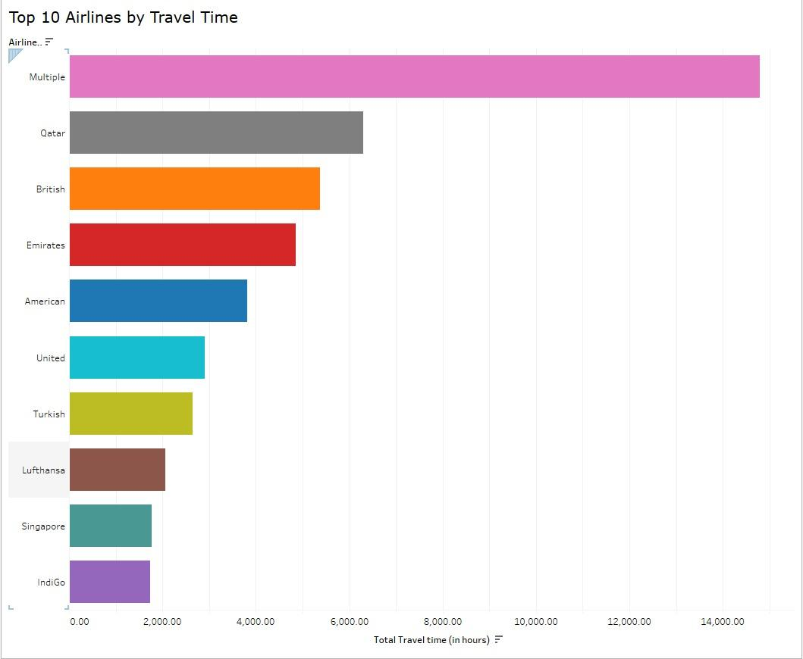
Answer: "Multiple" has the longest total travel time, far longer than any of the listed airlines, according to the bar chart. This might be a collection of different smaller airlines or code-share flights that together make up a sizable amount of travel time. Qatar Airways leads the single-brand airlines with what seems to be the second-highest total travel time, after "Multiple".
Insight: The top spot for "Multiple" in travel time points to the combined power of smaller alliances or carriers, which can provide passengers with flexibility and wide networks. The prominence of Qatar Airways suggests a robust global presence and perhaps a preference for longer routes or more frequent flights, which can improve service offerings and connectivity. The airline's strategic advantage in the market is bolstered by this substantial operational time, which suggests effective scheduling and resource allocation that serve a global audience.

Q2: Which airline has the most stoppages?
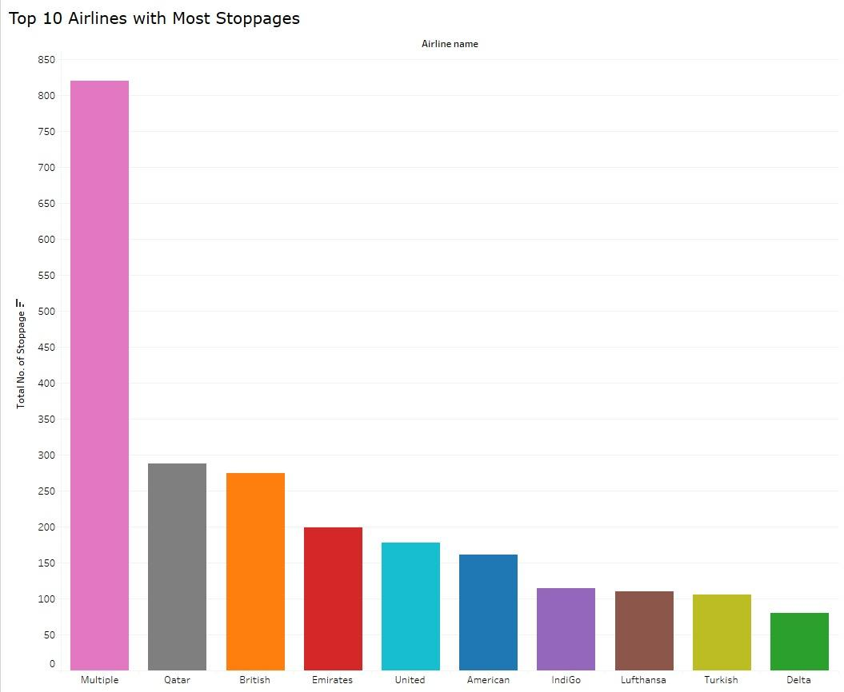

Answer: The "Multiple" airline is at the top of the list of airlines with the most stoppages, suggesting that this could be a group of airlines or flights. Among the top ten airlines, Qatar Airways has the second-highest number of stoppages.
Insight: The significant number of stoppages for "Multiple" airlines may be a result of a strategic decision to provide multi-stop flights or a varied set of routes requiring layovers. The high frequency of stoppages may indicate a strategic hub-and-spoke model for Qatar Airways, with Doha serving as the main hub. Although this strategy can improve connectivity, passengers may have to travel farther. In areas with high demand, the data could be used to enhance direct flight offerings and optimize route planning.

Q3: Which airline has the highest average ticket cost?

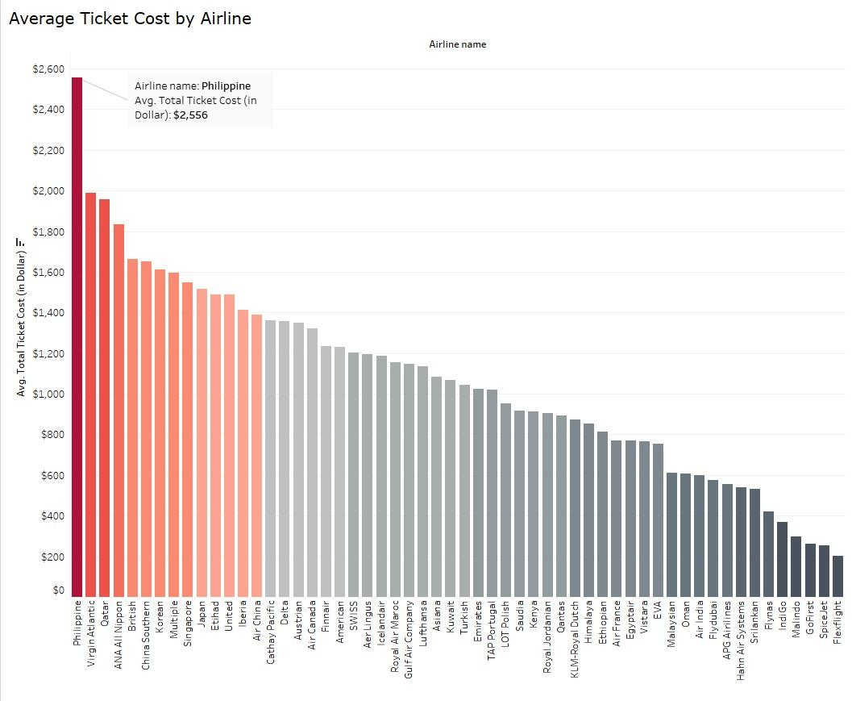

Answer: With an average ticket price of $2,556, Philippine Airlines has the highest average ticket cost compared to other airlines, as the bar chart shows. The average ticket prices by airline are shown in descending order in the chart, making it easy to compare prices across the sector.

Insight: Higher operating costs that are passed on to the customer, more opulent service offerings, or exclusive routes may all be associated with Philippine Airlines' premium pricing strategy. A wide variety of pricing strategies within the industry are also suggested by the visualization, which may represent various target markets, ranging from tourists on a tight budget to those looking for upscale travel experiences.

Q4: How does the number of stoppages affect ticket cost?


Answer: The bar chart indicates that one-stop flights are the most expensive overall, costing more than two- and three-stop flights. Unexpectedly, nonstop flights—which one might anticipate would fetch a higher price due to their convenience—have the lowest overall cost. It's also crucial to remember that nonstop flights have a significantly lower flight count than flights with stops, which could have an impact on the data's overall cost.
Insight: The comparatively higher expenses for flights with stoppages may suggest that these flights provide extra services or incur higher operating expenses that are transferred to passengers. Because nonstop flights are less expensive and there are fewer flights, this could indicate a competitive pricing strategy to fill seats or a possible skew in the data because of the smaller sample size. It might be necessary for airlines to carefully assess the demand for nonstop flights and determine whether pricing strategies can be modified without sacrificing load factors.

Q5: Which airport has the highest number of flight departures?

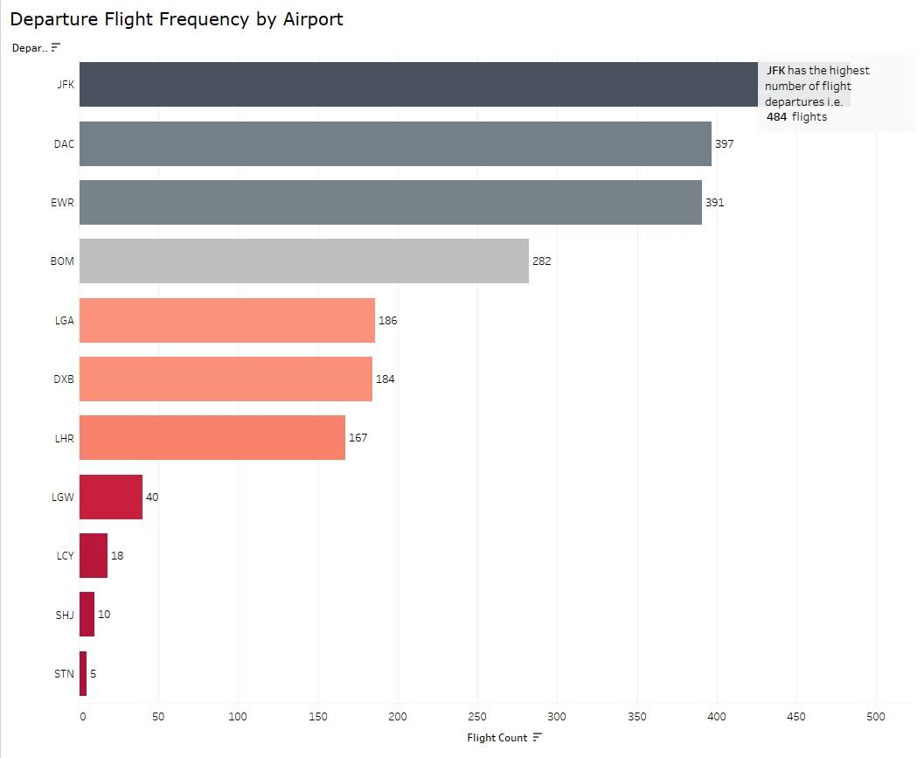

Answer: With 484 flights overall, JFK Airport has the most flight departures, according to the bar chart. When comparing the number of flights at major airports, JFK is clearly the most popular departure location.
Insight: The reason for JFK's dominant position is that it is a major international hub that provides a large number of destinations and is an important transit hub for both domestic and foreign travelers. In addition to offering passengers more options and flexibility, this high flight frequency may also pose operational difficulties like traffic and a higher chance of delays. To manage the high throughput while preserving service quality, airline schedules and airport management techniques must be carefully adjusted.

Q6: What is the most common price range for flight tickets?
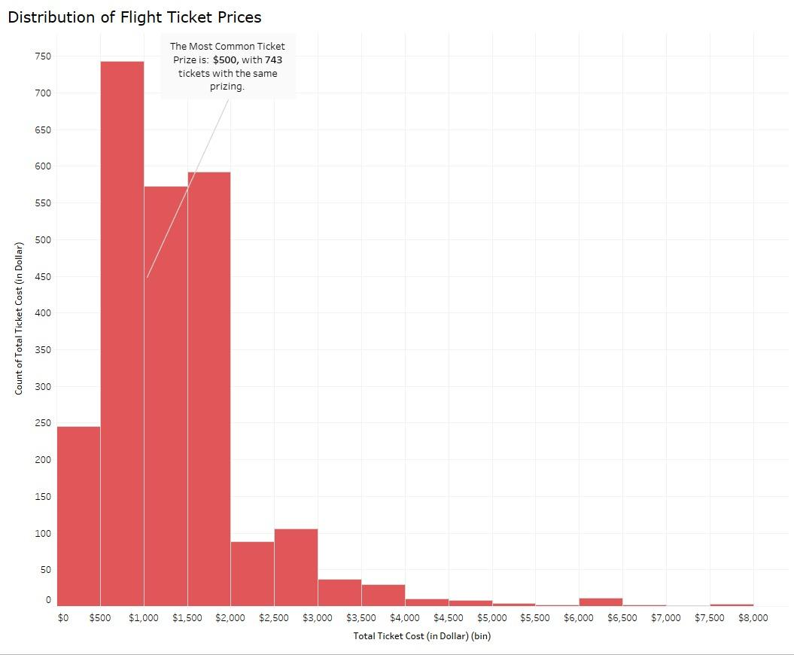

Answer: With 743 tickets sold at this price point, the histogram, which shows the distribution of flight ticket prices, makes it evident that the $500 price range is the most popular. As ticket prices rise, the distribution shows a sharp drop in frequency.
Insight: The high frequency of tickets priced at $500 indicates a sweet spot in the market where a sizable portion of travelers are prepared to pay for them. For airlines, this price range might offer the best mix of affordability and profitability. Airlines may choose to target this range when setting their flight prices in order to optimize sales volume, as such data can help guide pricing strategies. Additionally, it shows how elastic demand is across price points, with less demand for more expensive tickets.

Q7: How is stoppage time distributed across different flights and airlines?
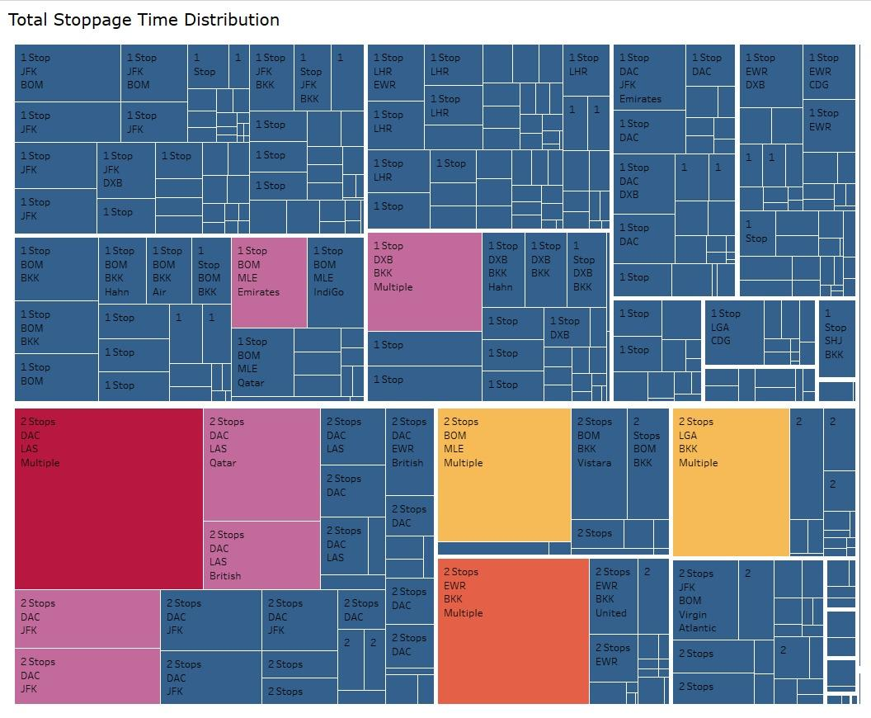

Answer: The distribution of total stoppage time across different flights and airlines is shown in the tree map. Longer wait times overall are represented by larger rectangles, making it simple to identify particular routes and airlines. Regardless of the airline, the route with stoppages at DAC (Dhaka) airport appears to accrue the longest wait times.

Insight: The routes and transit hubs where passengers might encounter prolonged stoppage times are highlighted in this visualization. For example, DAC's frequent stoppage points might indicate that better scheduling or infrastructure upgrades are required to reduce wait times. The longer stoppage times may need to be addressed by airlines using these hubs because they can impact passenger choice and satisfaction, particularly in competitive markets where customers have a variety of carrier options.
Q8: How is the market share distributed among top airlines?

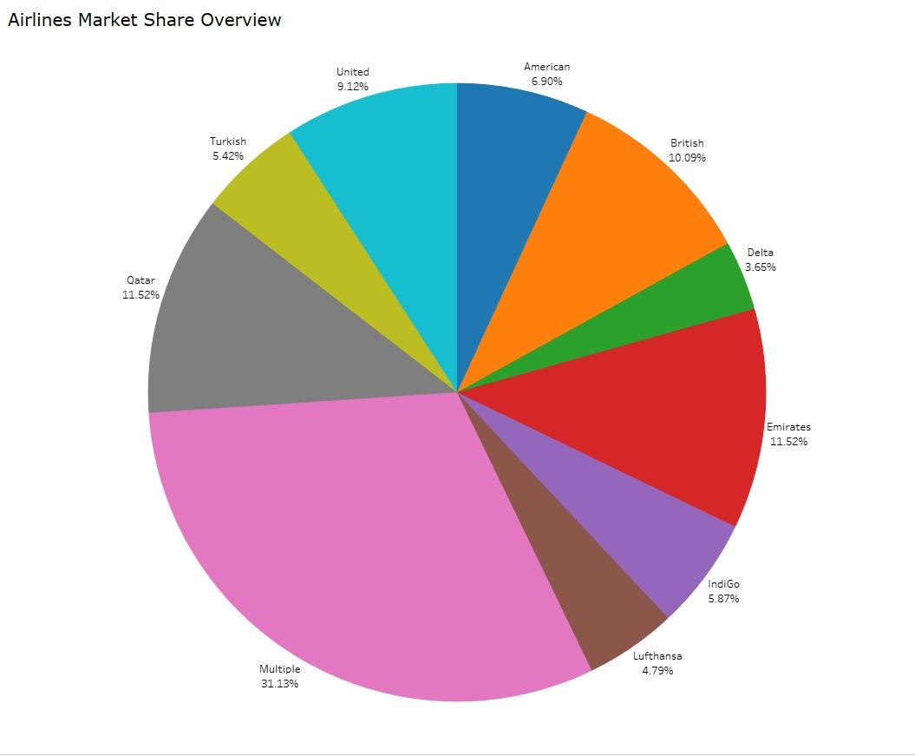

Answer: A visual representation of the market shares held by different airlines is provided by the pie chart. The largest segment falls under the "Multiple" category, which most likely consists of a group of smaller airlines or code-share flights. Emirates and Qatar Airways hold a substantial market share among individual carriers, with British Airways and United Airlines following closely behind.
Insight: Emirates and Qatar Airways' sizable market share can be attributed to their extensive route networks and strategic position as international transit hubs. Strong market positions are also shown by United and British Airways, most likely as a result of their extensive domestic and international operations. The lead in the "Multiple" segment may reflect the combined power of smaller or affiliated airlines that have a significant market share thanks to a variety of route options and aggressive pricing. For airlines to develop successful competitive strategies and for new entrants to spot possible market gaps, it is essential to comprehend these market dynamics.
Q9: What are the peak departure times at major airports?

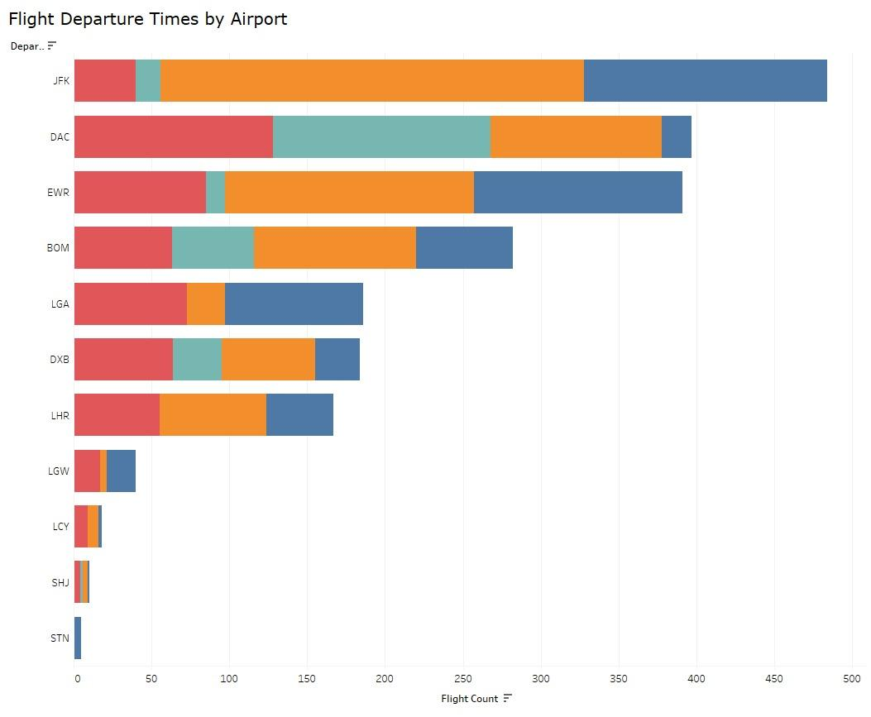

Answer: The distribution of flight departure times at different airports is shown in the stacked bar chart. It shows that the evening hours at JFK Airport have the most departures, as indicated by the orange segment, indicating a spike in flight activity during this time.
Insight: The increasing amount of evening flights from JFK may be due to a number of reasons, including the timing of long-haul flights that are best served by overnight flights or scheduling tactics that take into account the arrival schedules of foreign locations. According to the insight, JFK might be a crucial hub for evening departures, which could affect resource allocation and passenger flow. To properly handle the evening rush, airports with such a noticeable departure peak might think about the effects on passenger services and resource management.
Q10: What patterns can be observed in air traffic frequency between different airports?

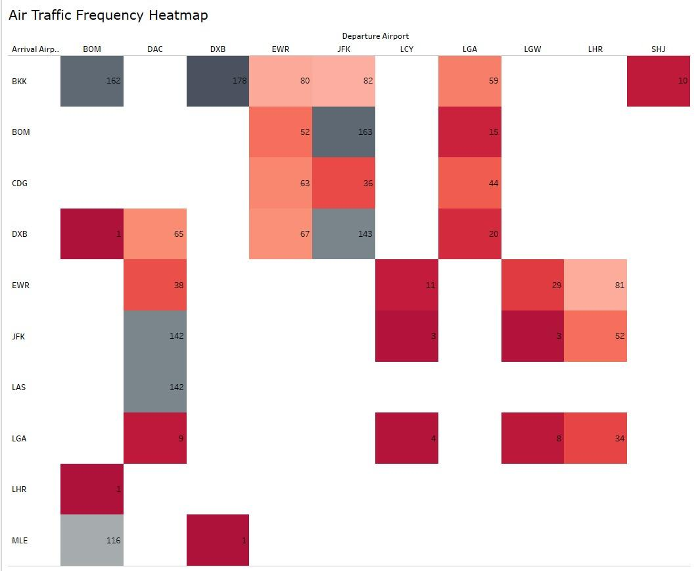

Answer: The intensity of flights between different arrival and departure airport pairs is illustrated visually in the heatmap. The route between DAC (Dhaka) and DXB (Dubai), which has the highest flight count of 178, has the most saturated color. The BOM (Mumbai) to DXB route is another extremely crowded one.

Insight: The DAC to DXB route's high traffic volume may be an indication of close cultural or economic ties that necessitate frequent travel between these locations. Similar to this, the BOM to DXB route is a significant transatlantic link that is frequently taken by both business and leisure travelers. These trends highlight how important key international hubs are to the world's air traffic. Airports must plan capacity and services appropriately, and airlines must optimize their networks by comprehending such traffic flows.

Q11: How do ticket prices change over time?

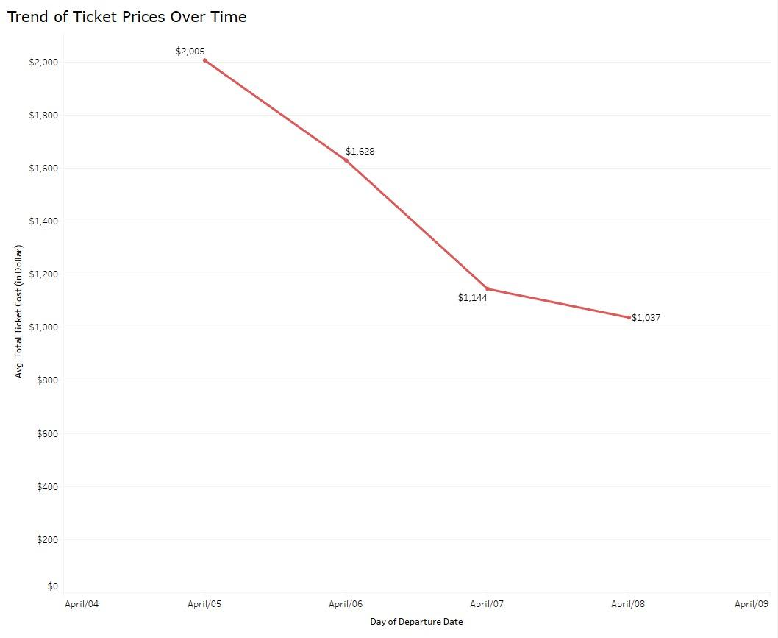

Answer:A downward trend in average ticket prices over a four-day period is depicted in the line graph. By the fourth day, the average price has dropped dramatically from $2,005 to $1,037. Between the first and second days, the decline is the most pronounced.
Insight: This downward trend may indicate that prices are being lowered as departure dates draw near, which may be a tactic to fill available seats. It might also suggest that buying tickets far in advance isn't always the way to save money that travelers might think. On the other hand, this pattern might be the result of a particular promotion or a change in demand brought on by a number of variables, like the conclusion of a holiday season. Such trends could be analyzed by airlines to improve their pricing strategies, possibly by better implementing early bird promotions or adapting to demand elasticity.

Q12: Which airline has the dominance at which departure airport?
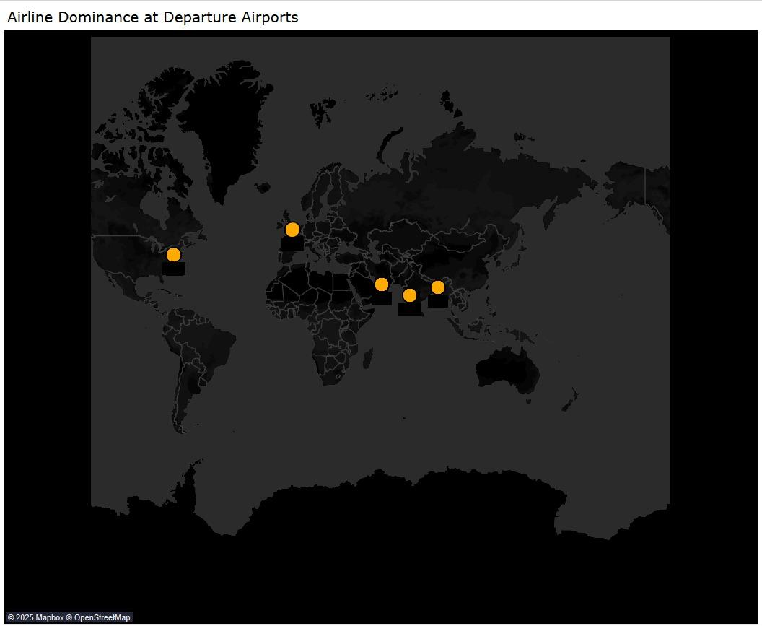

Answer: Air India dominates at BOM (Mumbai) airport, with a large number of flights to and from DXB (Dubai), according to the tooltip displayed when hovering over the departure airport markers. In a similar vein, the tooltip highlights IndiGo's supremacy at Sharjah Airport. According to this data, these Indian airlines operate flights on these particular routes quite frequently.
Insight: Air India and IndiGo's dominance at these international airports suggests that strategic routes are prioritized, perhaps in an effort to meet the high demand for travel between India and the hubs in the Middle East. These trends might be a result of increased regional mobility and economic ties. Such insights are essential for airport and airline operations in order to plan for future service expansions, optimize route capacity, and predict travel demands.

Dashboard Analysis:
Airline Performance Dashboard
The dashboard presents a multi-faceted view of airline performance metrics, including travel time, stoppages, ticket cost, market share, and airport dominance.
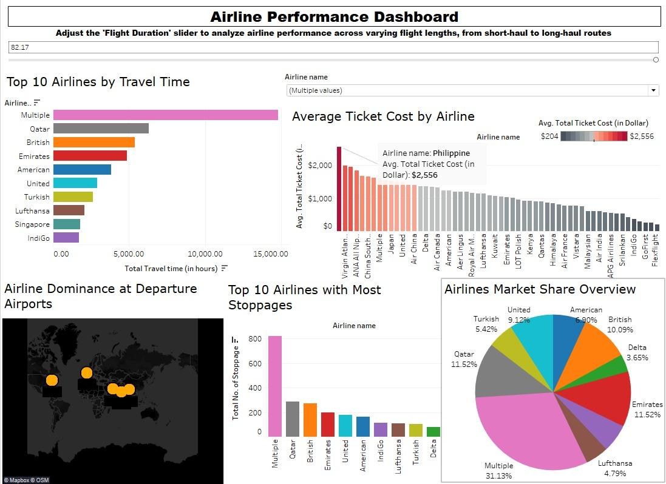

Insights:The data presented indicates that 'Multiple', possibly an amalgamation of smaller airlines or alliances, has a significant operational footprint in terms of travel time and stoppages. Competitive advantages through a variety of service offerings and strategic hub use are demonstrated by Philippine Airlines' premium pricing and the market presence of airlines such as Emirates and Qatar. Certain airlines' dominance at important departure airports suggests operational concentrations that might fit with business plans aimed at busy routes. These insights can help stakeholders make strategic decisions about pricing, market competition, capacity planning, and route optimization.

Conclusion:
Throughout the analysis of the airline dataset, we observed several key findings:
- The importance of cooperative strategies in today's airline industry is demonstrated by the fact that "multiple" airlines, which represent a coalition or codeshares, hold a significant share in both total travel time and stoppages.
- As the airline with the highest average ticket price, Philippine Airlines may be focusing on long-haul, less competitive routes or providing premium services.
- A strong correlation was found between the number of stoppages and ticket prices, with one-stop flights being the most expensive.
- The peak departure times at JFK airport were in the evening, which could have an impact on passenger flow and resource management.
- Air India and IndiGo displayed notable route dominance between BOM and DXB, and SHJ, respectively, indicating strong route specialization.

According to the data, airlines must constantly modify their plans to meet the needs of the market. In order to improve customer satisfaction and competitiveness, airlines with a high number of stoppages are advised to evaluate the possibility of direct flights. Optimizing resources to manage peak times efficiently is essential for airports, particularly those acting as major hubs like JFK. Furthermore, taking into account competitive pricing tactics for nonstop flights may help fill more seats and boost total earnings.

Airlines should, in conclusion, use data insights to improve operational effectiveness and customize their pricing and route plans. Airports must, however, make sure that their service quality and infrastructure can adapt to the changing needs of peak operating periods. By implementing these solutions, current issues could be resolved and the market's current dynamics could be leveraged.

