Predicting Medical Insurance Costs Using Personal Attributes
Final Project Report
Prof. Dr. KAMEL RUSHAIDAT

SHUBHANKAN SHINDE
000797539


Lawrence Technological University
INT 6203
Introduction to Machine Learning

Look at the big picture.

Introduction
•Identify your problem.
In this project, my goal is to predict the medical insurance costs of individuals based on various demographic and health attributes. This task is crucial for insurance companies because it helps in efficiently assessing and predicting client premiums. By leveraging machine learning, I aim to identify the factors that significantly influence insurance charges and develop a strong model for accurate cost prediction.
•What are the primary objectives of your project?
The objective is to build a machine learning model capable of anticipating the insurance charges for people. Understanding the fundamental variables driving insurance costs can offer assistance insurers refine estimating strategies and help people in recognizing how their individual and way of life choices affect insurance costs.
A number of factors, such as lifestyle choices, health metrics, and demographic traits, interact to make predicting insurance costs particularly difficult. For occurrence, properties like smoking status and BMI might have a more noteworthy effect on costs compared to variables such as geographic region or the number of children. This venture addresses these complexities through predictive modeling, advertising important bits of knowledge into the flow of insurance costs.

Training Supervision
- Is the model's learning process supervised, unsupervised, semi-supervised, self- supervised, or reinforcement learning? Explain.
The learning process of the model is supervised learning since it uses labeled data in which a target variable (charges), which stands for insurance costs, is paired with input features (such as age, BMI, smoker status, and region). This is a regression task since the goal is to predict a continuous numerical value. The model can make precise predictions on new, unseen data thanks to supervised learning, which teaches it the relationship between input features and the target variable.
- Identify the type of task: classification, regression, or something else?
The type of task in this project is regression. The target variable, charges, represents insurance costs, which is a continuous numerical value. Regression tasks are used when the objective is to predict a continuous outcome based on input features, such as age, BMI, and smoking status in this case.

- Should the model employ batch learning or online learning techniques, and why?
The dataset is static and does not require continuous learning or real-time updates, so the model should use batch learning techniques. Because the data is fixed and not streaming, batch learning is appropriate for this project because it processes the entire dataset at once during training. This method effectively trains and assesses the model by utilizing well-established machine learning libraries and enabling efficient computation. Since the dataset does not change over time, online learning is not required in this case.

2. Get the Data
- What methods will you use to load the dataset into your project?
To load the dataset, the pandas library was used to ensure the data is properly loaded and accessible for analysis.This method ensures the dataset is properly loaded and accessible for further exploration, preprocessing, and model training.
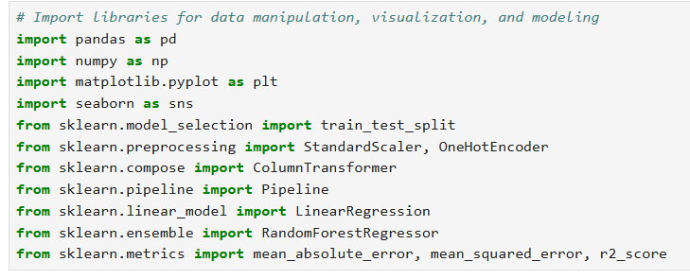

- How can you ensure the data is properly loaded and accessible for analysis?
- Check the First Few Rows: The head() function displays the first five rows to verify that the data has been loaded correctly.

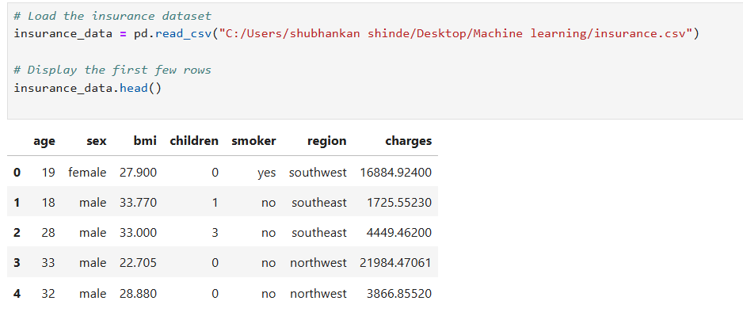

- Check Data Structure: The info() function provides an overview of the dataset, including column names, data types, and the presence of any missing values.

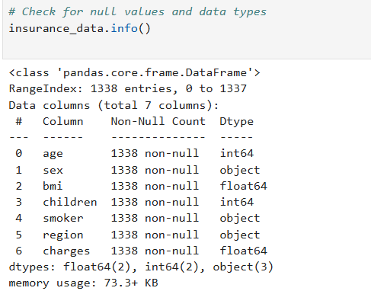

- Summary Statistics: The describe() function generates summary statistics for numerical columns to confirm that values are within expected ranges.

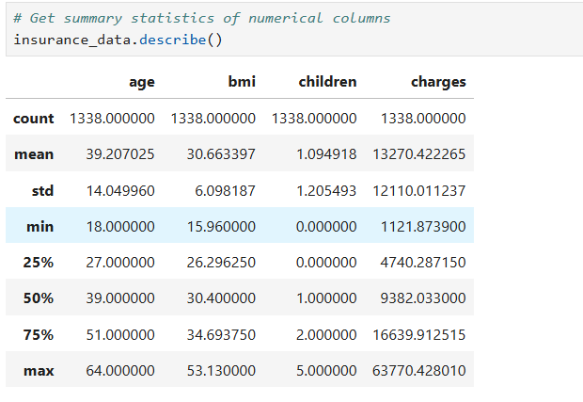

- Check for Missing Values: The isnull().sum() function checks for missing data in each column to ensure completeness.

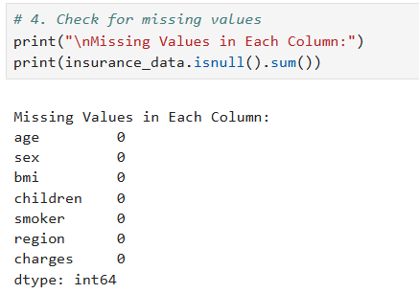

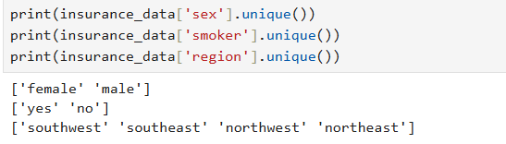

Assumptions
- List the assumptions you are making about the data (e.g., district prices are numerical).
The assumptions made about the data are age, bmi, children, and charges are numerical features, where age and children are integers, while bmi and charges are continuous. The categorical features sex (male, female), smoker (yes, no), and region (northeast, northwest, southeast, southwest) are correctly labeled with no unexpected categories. The dataset is assumed to be clean, with no missing or invalid values, and static, meaning no changes or additions will occur during the project. It is also assumed that features like smoker status and bmi have a significant impact on insurance charges.
- Are there any specific features you assume to be categorical or numerical?
Yes, the following assumptions are made regarding the specific features:
- Categorical Features:
  - sex (male, female)
  - smoker (yes, no)
  - region (northeast, northwest, southeast, southwest)
- Numerical Features:
  - age (integer)
  - bmi (continuous)
  - children (integer, representing the count of dependents)
  - charges (continuous target variable representing insurance costs)
These assumptions ensure proper preprocessing, such as encoding categorical features and scaling numerical features, to prepare the data for machine learning tasks.

- Before diving deep, what preliminary steps will you take to understand the structure of the data?
Before diving deep into the data analysis, the following preliminary steps are taken to understand the structure of the data:
- Display the First Few Rows: Use the head() function to get a quick overview of the dataset and confirm that it has been loaded correctly.
- Check the Data Structure: Use the info() function to examine the data types of each column, identify categorical and numerical features, and check for missing values.
- Generate Summary Statistics: Use the describe() function to get descriptive statistics (mean, median, min, max, etc.) for numerical features.
- Check for Missing Values: Use the isnull().sum() function to identify any missing values in each column.
- Check Unique Values in Categorical Columns: Use unique() to inspect unique categories in features like sex, smoker, and region.
These steps ensure a thorough understanding of the dataset structure, data completeness, and feature types, allowing for informed decisions during preprocessing and model building.The code snippets are provided above.

3. Explore and Visualize the Data
- Create four types of graphs to visualize/explore the data effectively?
I analyzed the distributions of key numerical features like age, bmi, and charges using histograms.
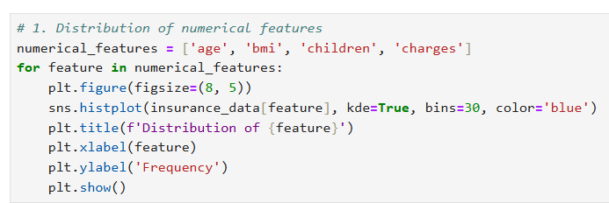

- How do these graphs contribute to gaining insights into the dataset?

1. Histograms (Distribution of Numerical Features)
The distribution of numerical characteristics such as age, BMI, and charges can be clearly understood thanks to histograms. A small number of people have much higher insurance costs, according to the charges histogram, which shows a right-skewed distribution. A slight right skew in the BMI histogram indicates a higher prevalence of people with above-average BMIs. Furthermore, the age distribution seems to be fairly uniform, indicating that the dataset contains a balanced range of ages. These observations aid in spotting patterns and variances in the numerical characteristics.
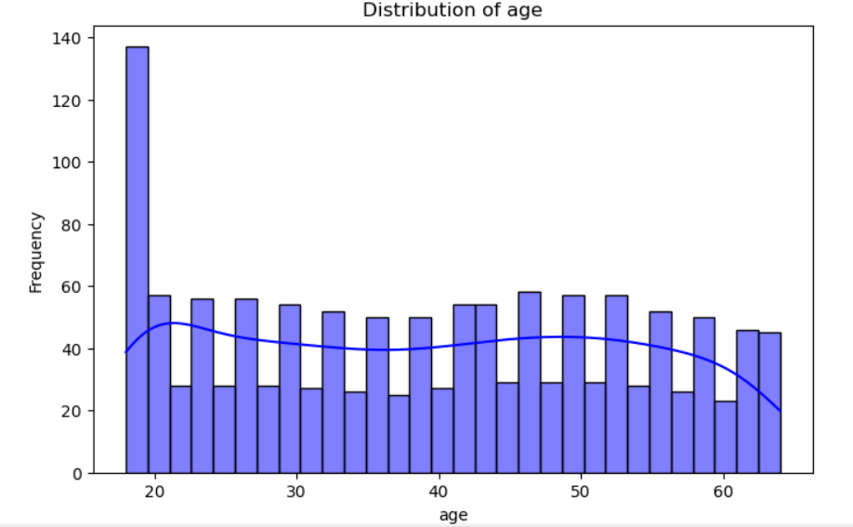

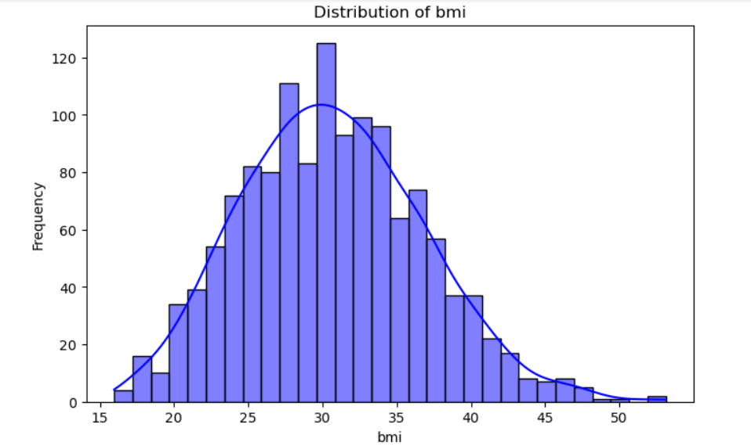
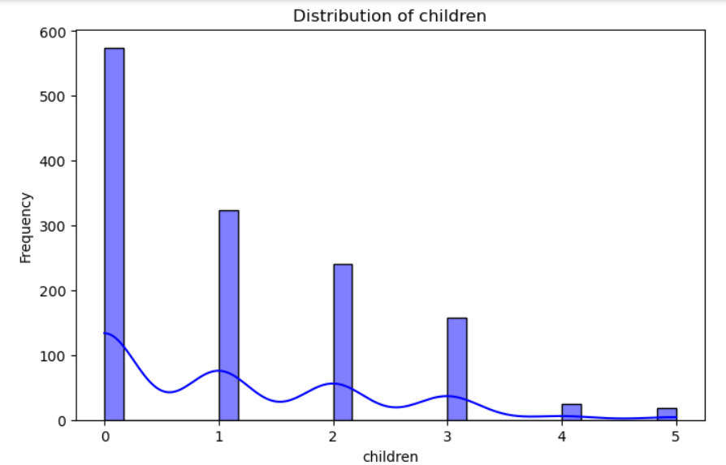
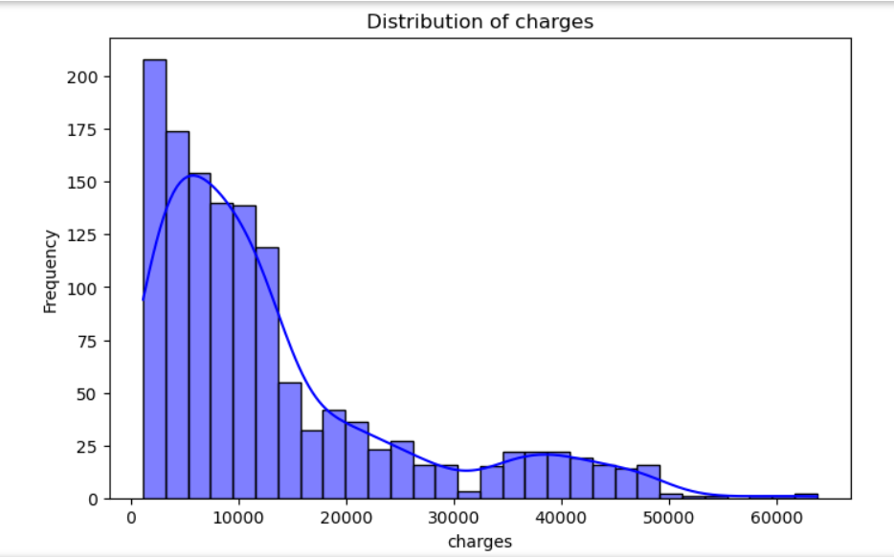

3.2 Boxplots for Categorical Features
To analyze the relationship between categorical variables and insurance charges, i plotted boxplots for sex, smoker, and region.
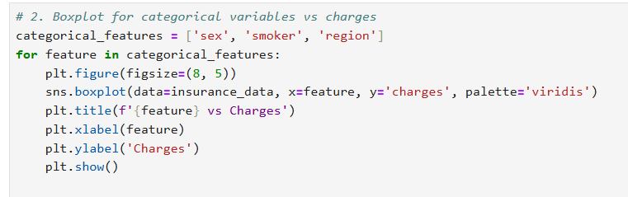
2. Box Plots (Categorical Features vs Charges)

Boxplots show how categorical factors (sex, region, and smoker) affect insurance premiums. The boxplot for smokers clearly shows that smokers have much higher charges compared to non-smokers, making smoking status a critical factor. With only minor variances, insurance rates seem to be fairly constant across regions. There is no discernible difference in charges between males and females, according to the sex boxplot. The impact of categorical features on the target variable is evaluated with the aid of these observations.

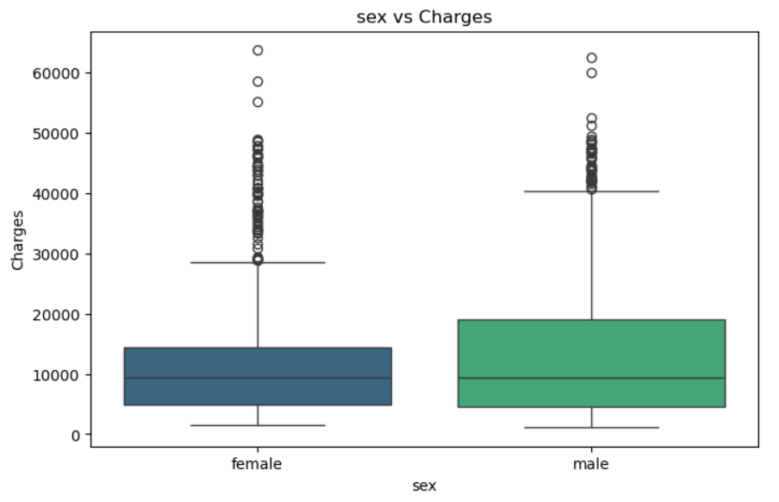
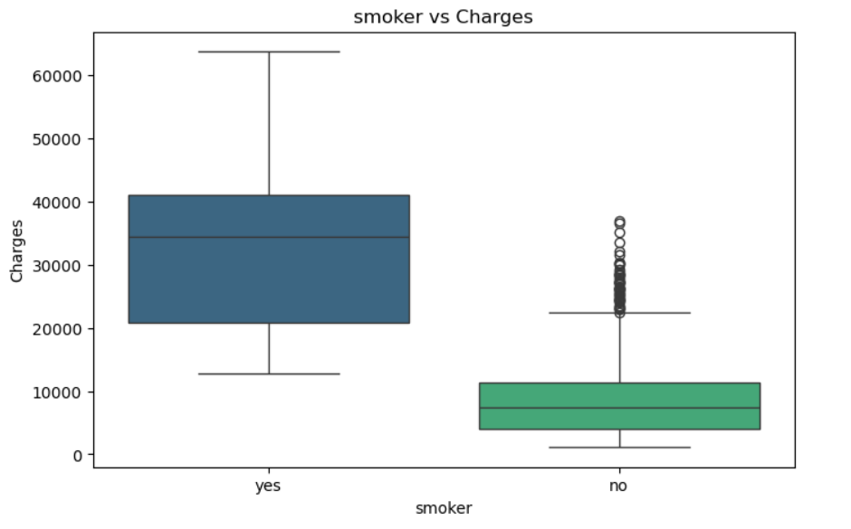

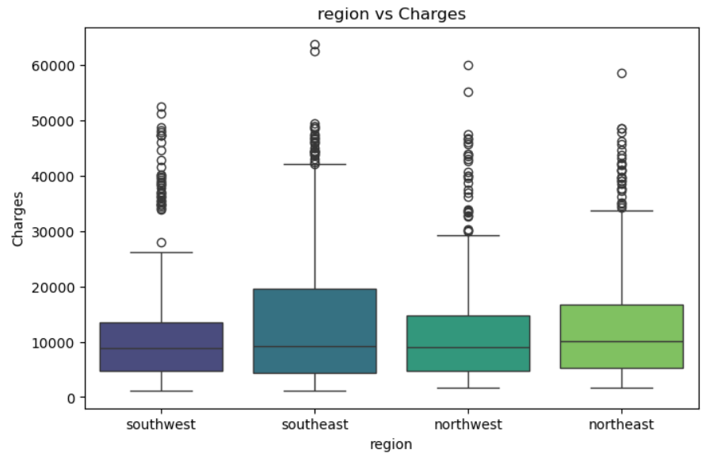

3.3 Correlation Heatmap
To identify correlations between numerical features, I generated a heatmap.
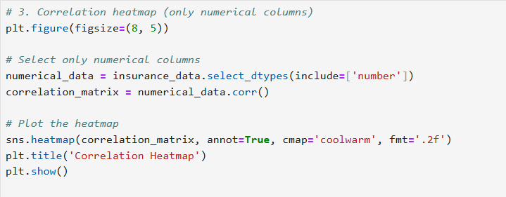
3. Correlation Heatmap

The connections between numerical features are shown in the correlation heatmap. It demonstrates that charges have a significant positive relationship with both age and BMI, indicating that people who are older or have a higher BMI typically pay more for insurance. Furthermore, there is little correlation between charges and children, suggesting that it may not have much predictive power. This analysis directs the feature selection process and aids in prioritizing features that have a significant impact on the target variable.
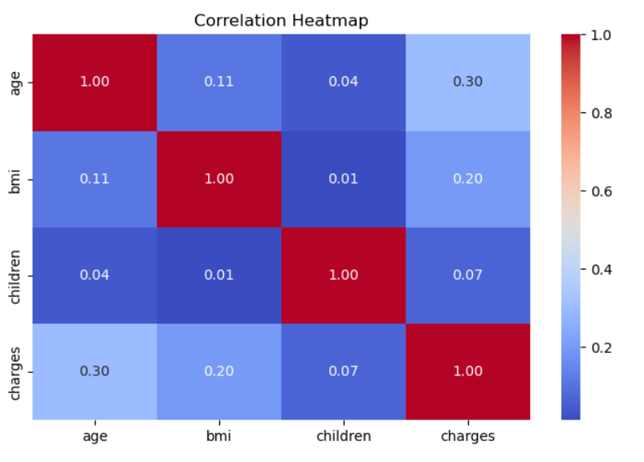
4. Pairplot
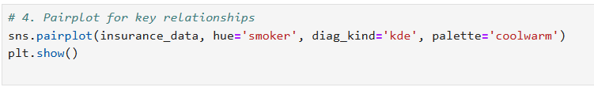
While separating smokers from non-smokers, the pairplot graphically depicts pairwise relationships between numerical features. It draws attention to obvious patterns, such as the fact that smokers' insurance premiums are consistently higher across a range of BMIs and age groups. BMI is a key predictor, as evidenced by the upward trend in the relationship between charges and BMI, especially for smokers. In a similar vein, charges are positively correlated with age. These findings highlight the significance of age, BMI, and smoking status in estimating insurance premiums.

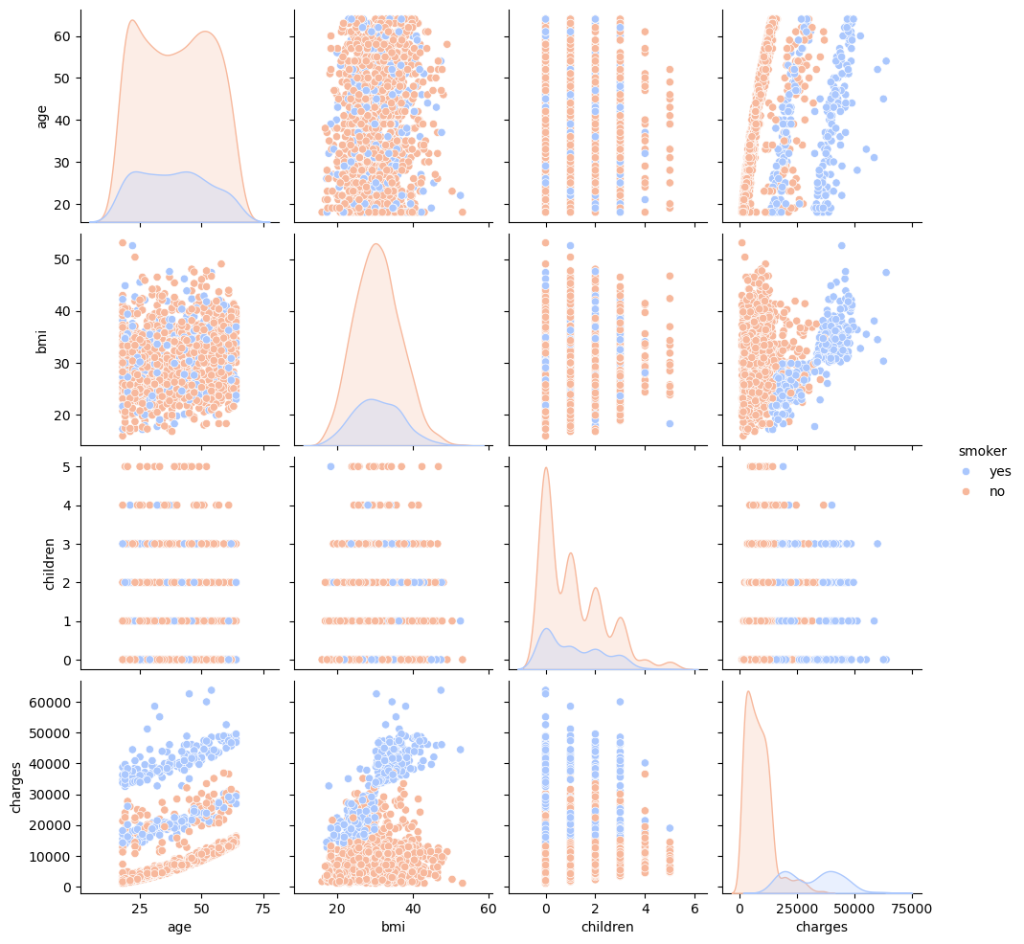
- What are four specific findings you aim to highlight through your data exploration?
- Smoker Status Significantly Influences Charges:The smoker vs. charges boxplot shows that smokers have significantly higher insurance costs than non-smokers. This demonstrates that one of the most important variables influencing insurance rates is smoking status.
- BMI Positively Correlates with Charges: Bmi and charges have a strong positive correlation, as seen by the pairplot and correlation heatmap. Higher BMIs are typically associated with higher insurance premiums, highlighting BMI as a significant predictor.
- Age and Charges Have a Positive Relationship: The pairplot and heatmap show that older people typically pay more for insurance. This suggests that age is another significant factor influencing the cost of insurance premiums.
- Region Has Minimal Impact on Charges:Insurance costs are comparatively constant across regions, according to the region vs. charges boxplot, suggesting that the region feature has little effect on charge prediction.

- How do these findings contribute to a better understanding of the dataset?

Through the identification of the primary determinants of insurance charges and the discovery of correlations between the features and the target variable, these findings enhance our comprehension of the dataset. The substantial influence that smoker status has on charges emphasizes how important lifestyle decisions—like smoking—are in influencing insurance premiums. Insurers can concentrate on these factors for cost assessment because of the positive correlations between BMI and age and charges, which show that age and health metrics are important predictors. On the other hand, the region's low impact indicates that geographic location has little bearing on premiums, which justifies its lower priority in model development. Finding these patterns gives us important insights into the dataset's underlying dynamics, which inform feature selection, increase model accuracy, and give people and insurers useful information.

Statistical Analysis:

- In what ways will you perform statistical analysis on the data?

The data will be statistically analyzed using descriptive statistics to determine how numerical features like age, BMI, children, and charges are distributed. Key predictors of insurance costs will be highlighted by correlation analysis, which will reveal relationships between numerical features. Histograms and KDE plots will be used to examine feature distributions in order to identify trends, skewness, and outliers. In order to observe differences in insurance costs across various categories, group-wise statistics will also be calculated and compared to categorical features such as sex, smoker, and region. These procedures will guide the model-building process by offering insightful information about the relationships and structure of the data.

- How will statistical measures enhance your insights into the dataset?

1) Descriptive analysis: Provides insights into average or typical values, and the dispersion of data points.
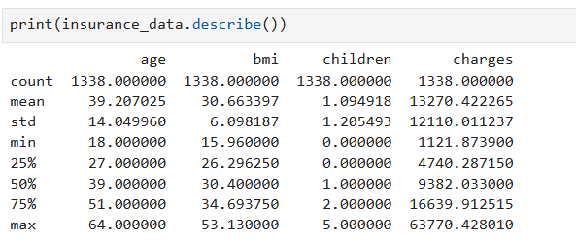
2) Correlation analysis: Helps understand the relationships between variables and how changes in one affect changes in another.
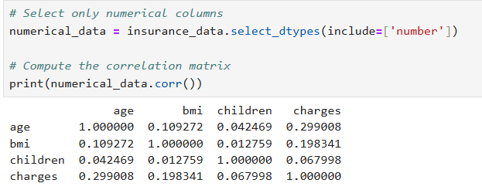

Additional Questions

- How will you handle outliers and anomalies during the exploration process?

Visual Detection: Outliers will be identified using visualizations such as boxplots and histograms. Boxplots effectively display outliers as points outside the whiskers, while histograms reveal unusually high or low values.

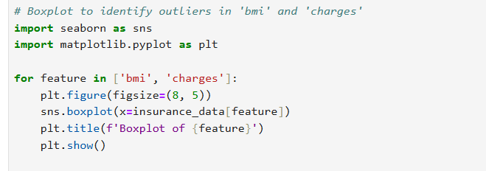

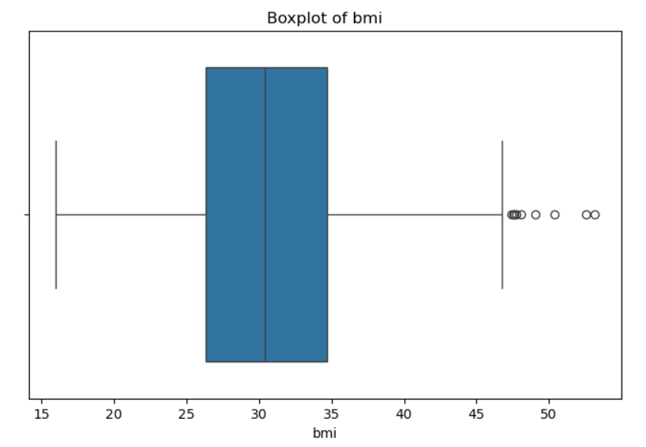
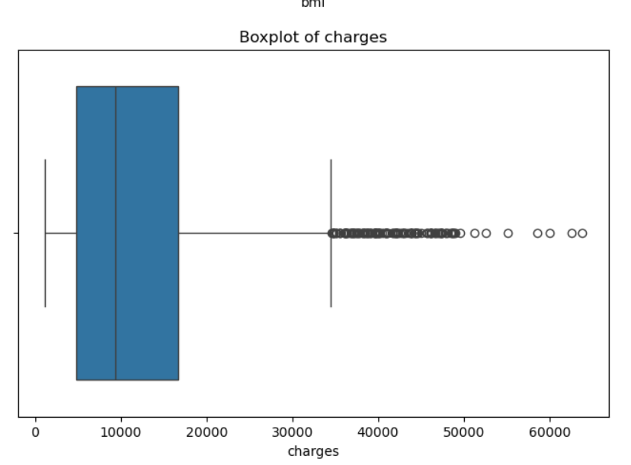
Statistical Detection: Outliers will be detected using statistical methods, such as the Interquartile Range (IQR). Values falling below Q1 - 1.5*IQR or above Q3 + 1.5*IQR will be flagged as potential outliers.

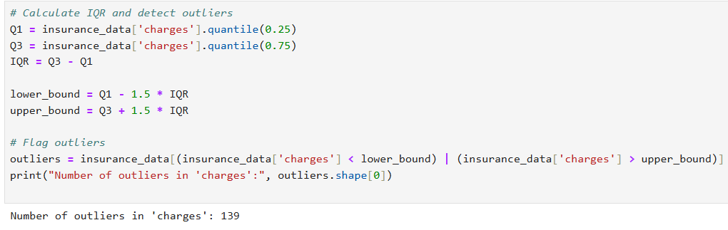
By combining visualizations and statistical methods, I will ensure that outliers are identified, analyzed, and handled appropriately, maintaining the integrity of the dataset and improving model performance.

- What role does feature correlation play in your data exploration strategy?
Feature correlation helps identify relationships between numerical variables and the target (charges), highlighting key predictors like bmi, age, and smoker status, which are critical for model performance.
- Can you identify potential patterns or trends that may impact your later modeling decisions?
Yes, trends like smokers incurring significantly higher charges and the positive correlation of age and bmi with charges will guide feature selection and model tuning.
- How does the initial exploration guide your decisions on data preprocessing?
Initial exploration identifies categorical and numerical features, detects missing values, and highlights outliers, informing steps like scaling, encoding, and handling anomalies during preprocessing.

4. Prepare the Data for Machine Learning

4.1 Data Preprocessing
To prepare the data, we encoded categorical variables and scaled numerical features using StandardScaler and OneHotEncoder.
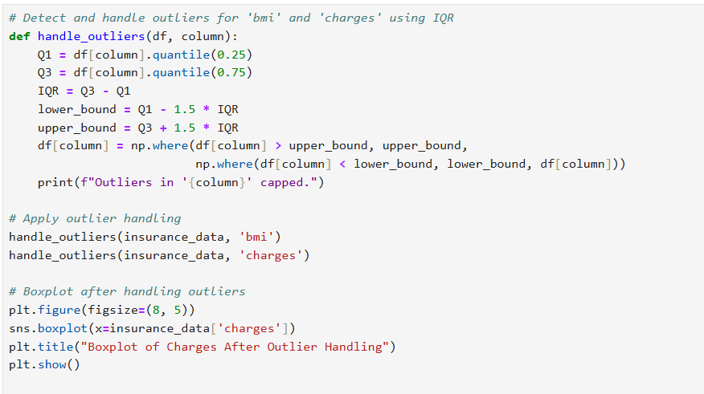
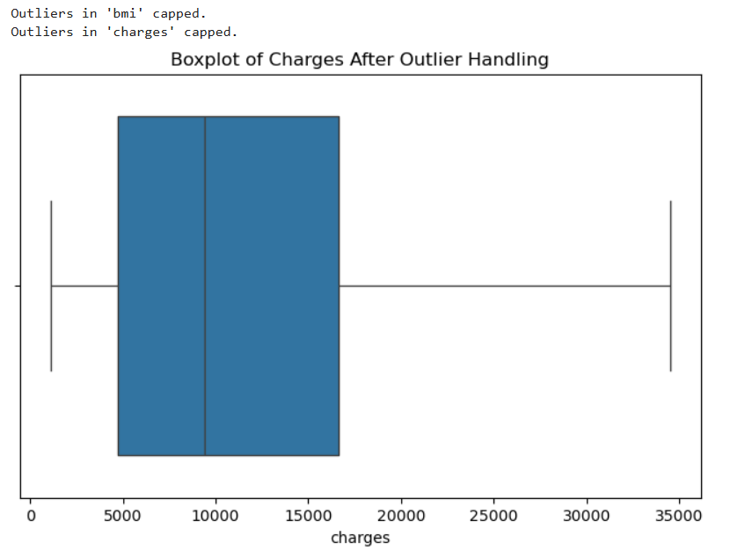
- What specific steps will you take to pre-process the data before feeding it into machine learning algorithms?
Handle Missing Values: Check for and address missing data using imputation techniques to ensure completeness.
Encode Categorical Features: Use OneHotEncoder to convert sex, smoker, and region into numerical values for machine learning models.
Scale Numerical Features: Standardize age, bmi, and children using StandardScaler to bring all features to a similar scale.
Handle Outliers: Detect and cap extreme values in bmi and charges using the Interquartile Range (IQR) method.
Partition the Data: Split the dataset into training (80%) and testing (20%) sets to evaluate model performance.

- How do these steps contribute to improving the quality of the dataset?
The dataset is made cleaner, more consistent, and more appropriate for machine learning algorithms thanks to these preprocessing procedures. By managing missing values, training errors are avoided and data completeness is guaranteed. While maintaining category information, categorical feature encoding allows the data to be interpreted by models. Model performance is improved by scaling numerical features, which removes bias brought on by different feature magnitudes. By managing outliers, model robustness is increased by lessening the impact of extreme values. Lastly, data partitioning makes it possible to properly evaluate the model and guarantees that it performs well when applied to new data. When combined, these actions maximize data preparedness for precise and trustworthy forecasts.
- Identify potential data quality issues. How will you address them during the cleaning process?
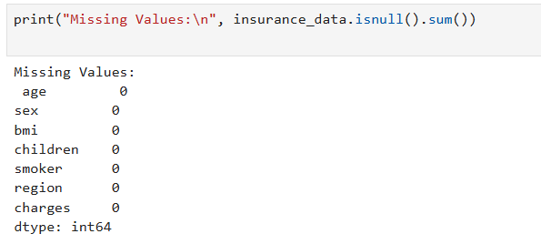
Potential Data Quality Issues and Solutions:
- Missing Values: Use isnull().sum() to check for missing values. Address them by imputing with mean/median for numerical features or mode for categorical features.
- Outliers: Detect outliers using the Interquartile Range (IQR) and cap extreme values at upper and lower bounds to prevent skewing the model.
- Invalid Data: Verify categorical values using unique() and replace incorrect entries with valid ones.
- Duplicate Records: Identify duplicates using duplicated() and remove them to ensure clean data.

Handling Outliers:
- How do outliers impact machine learning models, and how will you decide on an appropriate approach to handle them?
By affecting results and deceiving the learning process, outliers can skew model performance. Outliers can cause the regression line to shift, which lowers the accuracy of models like linear regression. Random Forest and other tree-based models, on the other hand, are more resilient, though they could still be affected by extreme values.
Method for Dealing with Outliers: I will examine outliers to ascertain how they affect the dataset. To avoid skewed predictions, extreme or incorrect values will be capped or eliminated, while meaningful outliers—like high insurance premiums for smokers—will be kept.
- What techniques can be employed to detect and address outliers effectively?
Outliers can be detected using boxplots, histograms, or statistical methods like the Interquartile Range (IQR) and Z-score. They can be addressed by capping extreme values at thresholds, removing erroneous outliers, or analyzing their significance using domain knowledge.
Data Partitioning:
- Why is it crucial to partition the data into training and testing sets?
To assess how well a machine learning model generalizes to new data, the data must be divided into training and testing sets. While the testing set offers an objective evaluation of the model's performance and makes sure it doesn't overfit to the training data, the training set enables the model to discover patterns.
- How will you determine the optimal ratio for data partitioning?
The size of the dataset and the requirement for model evaluation will determine the ideal ratio for data partitioning. To guarantee there is enough data for training and enough left over for testing, a popular split is 80/20, which is 80% for training and 20% for testing. Depending on the complexity of the model and the requirement for trustworthy evaluation metrics, a 70/30 or 90/10 split might also be taken into consideration for larger datasets. The effectiveness of the selected ratio can be further confirmed by cross-validation.

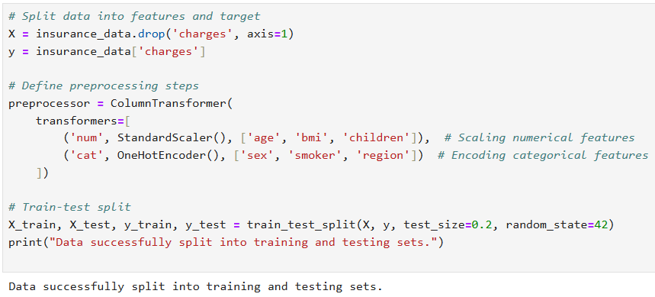
Ensuring Robust Data Preprocessing:
- What role does feature scaling play in the preprocessing phase, and why is it important?
By standardizing the range of numerical features and guaranteeing that they all contribute equally to the machine learning model, feature scaling is essential during the preprocessing stage. For algorithms that are sensitive to the scale of features, such as K-Nearest Neighbors or Linear Regression, it is particularly crucial. Scaling improves model performance and convergence during training by preventing larger-valued features (like charges) from overpowering smaller-valued features (like age).
- How do you ensure that the preprocessing steps are consistent across training and testing datasets?
In order to guarantee consistency in preprocessing steps between training and testing datasets, I utilize a pipeline from sklearn.pipeline. In order to guarantee that the same transformations are applied to both training and testing sets, the pipeline integrates preprocessing tasks like scaling and encoding with model training. By doing this, data leakage is prevented and the model is guaranteed to see data in the same format throughout testing and training.

- Can you explain the trade-offs associated with different methods of handling missing data?
Different approaches to missing data have trade-offs. Although deleting rows or columns is an easy and fast fix, it may result in the loss of important data, particularly if there is a large amount of missing data. Although mean/median imputation maintains the size of the dataset and is effective for numerical features—the median is resistant to outliers—it can also introduce bias and decrease variability. Mode imputation preserves all data for categorical features, but it may introduce bias by over-representing the most prevalent category.By utilizing relationships between features, advanced techniques like KNN or regression imputation yield more accurate estimates; however, they are computationally costly and run the risk of overfitting. Last but not least, although using placeholder values (such as -999) is simple, it may cause models to mistake the placeholder for actual data. The type of feature, the amount of missing data, and the requirement to strike a balance between accuracy and computational efficiency all influence the method selection.
- How will you validate the effectiveness of your data preprocessing steps in improving model performance?
In order to verify the efficacy of data preprocessing, I will examine improvements in model performance metrics, including R2, MAE, and MSE, before and after preprocessing. To guarantee consistent performance across various data splits, cross-validation will be employed. I'll see if scaling improves model accuracy for algorithms like linear regression that are sensitive to feature ranges. Furthermore, I will confirm that categorical variable encoding enhances the model's capacity to efficiently interpret and apply categorical features. These procedures will verify that preprocessing improves the model's overall accuracy and resilience.
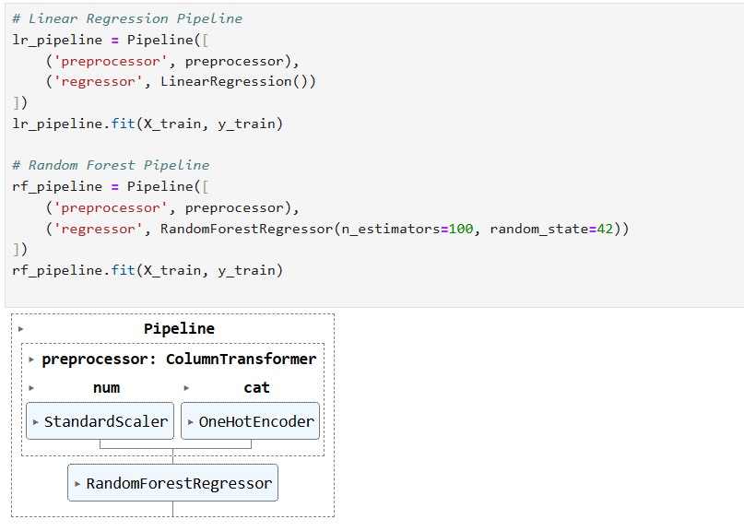

Select a model and train it
- How will you decide on the machine learning model to use for your predictive modeling task, and why is it suitable?
I will choose models like Linear Regression for simplicity and interpretability, and Random Forest for handling non-linear relationships and feature importance. These models are suitable for predicting continuous values like insurance charges and provide a balance between accuracy and explainability.
- Are there alternative models considered, and what influenced your final
Yes, alternative models like Decision Trees, Support Vector Regression (SVR), and Gradient Boosting were considered. The final choice was influenced by factors such as model performance, interpretability, and the dataset size. Linear Regression was chosen for its simplicity, while Random Forest was selected for its ability to handle non-linear relationships and reduce overfitting.

5. Model Training and Evaluation

5.1 Model Selection: Linear Regression and Random Forest
We implemented two models: Linear Regression and Random Forest.

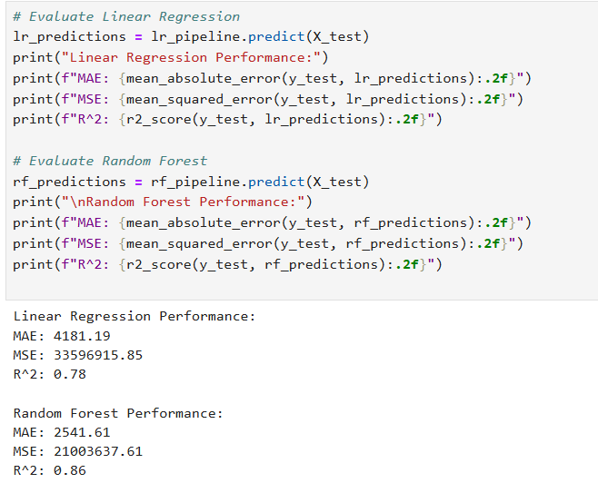

Performance Measure:
- Define the performance measure you will use to evaluate your model's effectiveness.
The performance measures used to evaluate the model's effectiveness are:
- R² Score: Measures how well the model explains the variance in the target variable. A higher R² indicates better performance.
- Mean Absolute Error (MAE): Measures the average absolute difference between predicted and actual values, providing an interpretable error magnitude.
- Mean Squared Error (MSE): Squares the errors to penalize large deviations, making it useful for identifying significant prediction errors.
These metrics provide a comprehensive evaluation of the model's accuracy, error magnitude, and overall effectiveness.

- How does this chosen metric align with the objectives of your project?

The R2 Score, MAE, and MSE metrics that were selected support the project's goal of precisely forecasting insurance costs. The model's ability to explain variations in charges is measured by its R2 score, which makes sure it captures important relationships. By measuring prediction errors and penalizing significant deviations, MAE and MSE help determine how closely the model predicts actual values. The project's objective of developing an accurate and dependable predictive model is directly reflected in these metrics.

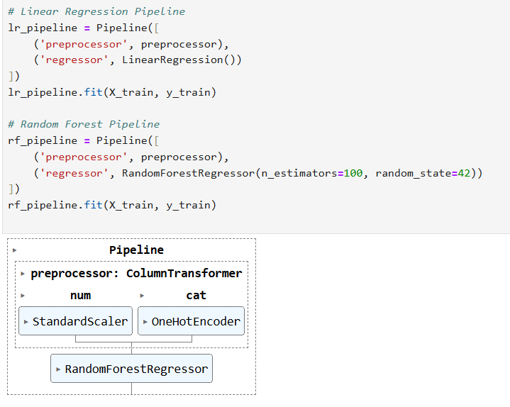

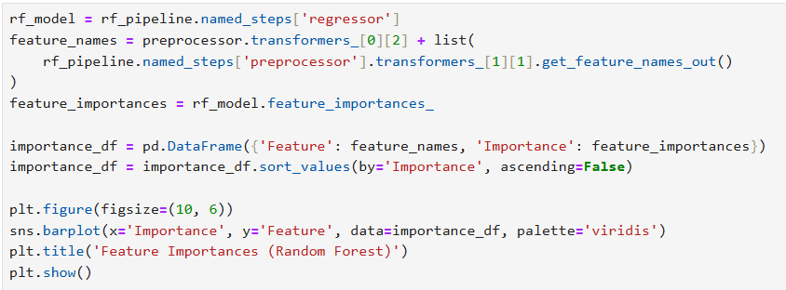

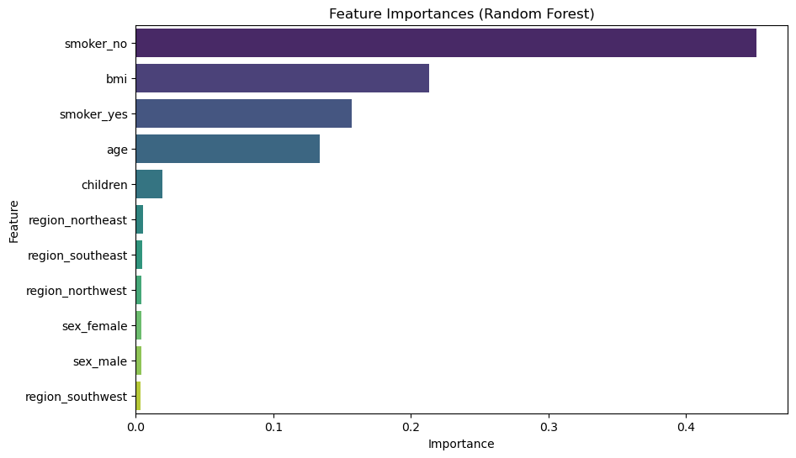

Learning Curve Graph:
- Generate learning curves graph.

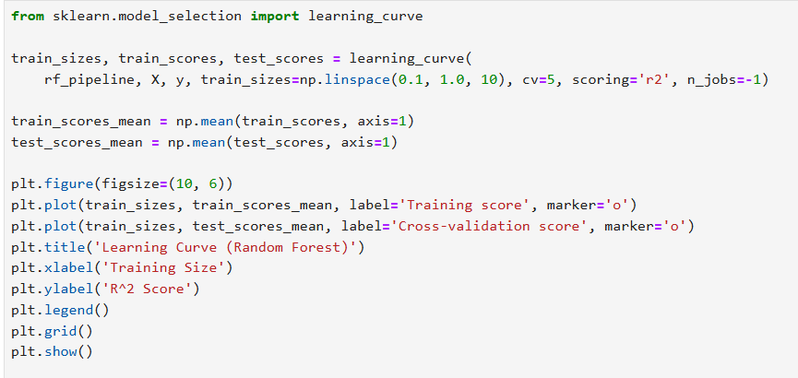

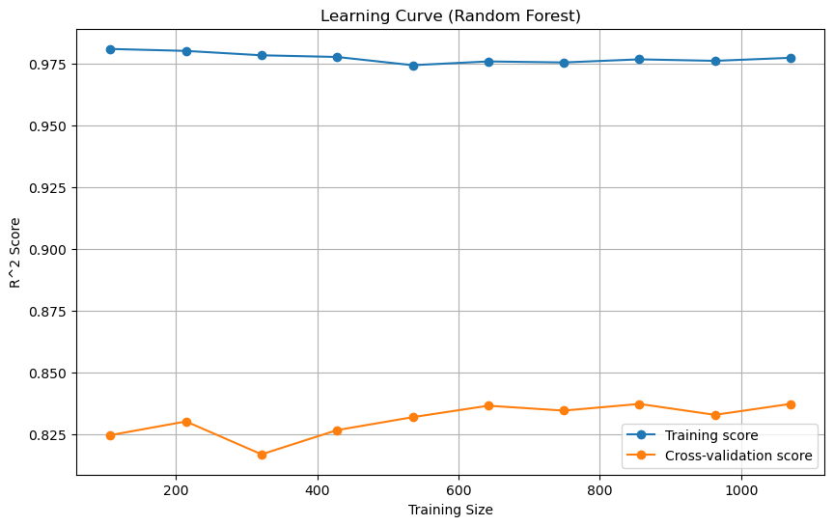

- What insights can be gained from the learning curve graph, and why is it a valuable tool in model evaluation?
The model achieves a high training score but a lower cross-validation score, suggesting slight overfitting, according to the learning curve graph. The cross-validation score improves with increasing training size, indicating improved generalization with more data. Learning curves are useful for assessing the performance of models because they can be used to detect problems such as underfitting (both scores are low) or overfitting (large gap between scores), which can help guide decisions about how to improve the model by adding data, adjusting hyperparameters, or making the model simpler.

- How will you interpret the learning curve in the context of overfitting and underfitting? Explain.
The learning curve shows that the model has slight overfitting, as the training score remains high while the cross-validation score is lower. Overfitting occurs when the model performs well on training data but struggles to generalize to unseen data. In contrast, underfitting would occur if both scores were low and close together, indicating the model is too simple. The gap in scores suggests the need for more data, hyperparameter tuning, or regularization to improve generalization.
- Define overfitting and underfitting. How will you identify and address these challenges during the training process?
When a model captures noise rather than patterns and performs well on training data but poorly on unseen data, this is known as overfitting. When a model is overly simplistic and misses the underlying patterns, it is said to be underfitted and performs poorly on both training and testing data. I'll use learning curves to pinpoint these issues: low and close scores imply underfitting, while a wide discrepancy between training and validation scores suggests overfitting. I'll employ strategies like regularization, lowering model complexity, and adding more data to address overfitting. In order to better capture patterns in underfitting, I will either increase model complexity or use feature engineering.
- What adjustments might be necessary if overfitting or underfitting is observed in the learning curve?
If overfitting occurs, reduce model complexity, use regularization, or add more training data. If underfitting occurs, increase model complexity, improve features, or reduce regularization. These adjustments help balance model performance.

Regularization Techniques:
- Did you employ any regularization techniques in your model training? If so, why were they necessary?
We did not employ any regularization techniques as our model was performing well without overfitting.
- Explain how regularization contributes to improving the model's generalization performance.
Regularization improves a model's generalization performance by penalizing overly complex models, reducing overfitting, and ensuring it captures only the essential patterns in the data.
- How will you optimize hyperparameters to fine-tune your model?
I will use Grid Search or Randomized Search Cross-Validation to systematically test different hyperparameter combinations and select the ones that maximize model performance on the validation set.
- What considerations guided your decision on the model's complexity?
I balanced model complexity by choosing models like Linear Regression for interpretability and Random Forest for handling non-linear relationships while minimizing overfitting risks.
- Can you discuss the impact of the chosen performance measure on the interpretability of your results?
Metrics like R² explain the proportion of variance captured by the model, while MAE and MSE provide error magnitudes, making the results easier to interpret and assess model accuracy.
Hyperparameter Tuning:
- How will you approach the optimization of hyperparameters to enhance your model's performance?
I will use Grid Search Cross-Validation to systematically test different hyperparameter combinations and identify the best-performing settings. This approach ensures the model achieves optimal performance while minimizing overfitting.
- Which hyperparameters are considered critical for fine-tuning, and why?
The critical hyperparameters for fine-tuning Random Forest are n_estimators (number of trees), max_depth (tree depth), and min_samples_split (minimum samples to split a node). These parameters control model complexity, balance bias and variance, and prevent overfitting.

Regularization Adjustments:
- If regularization was initially applied, do you make any adjustments during the fine-tuning phase?
If regularization was initially applied, I would adjust parameters like alpha (for Ridge/Lasso) or tree depth (for Random Forest) during fine-tuning. These adjustments help optimize model complexity, preventing overfitting and improving generalization.
- How do regularization parameters influence the model's generalization to unseen data?
Regularization parameters penalize overly complex models by reducing large coefficients (L1/L2) or limiting tree growth, which helps prevent overfitting. This ensures the model focuses on essential patterns, improving its ability to generalize to unseen data.

Evaluation Metrics for Fine-Tuning:
- Define the evaluation metrics you will use during the fine-tuning phase.
I will use R² Score to measure how well the model explains variance and Mean Absolute Error (MAE) for the average prediction error. Additionally, Mean Squared Error (MSE) will help identify large deviations by penalizing significant errors.
- How will you interpret these metrics to assess improvements in model performance?
I will interpret these metrics as follows: an increase in R² Score indicates the model explains more variance, while a decrease in MAE and MSE reflects improved accuracy and smaller prediction errors. Together, these confirm better generalization and performance.

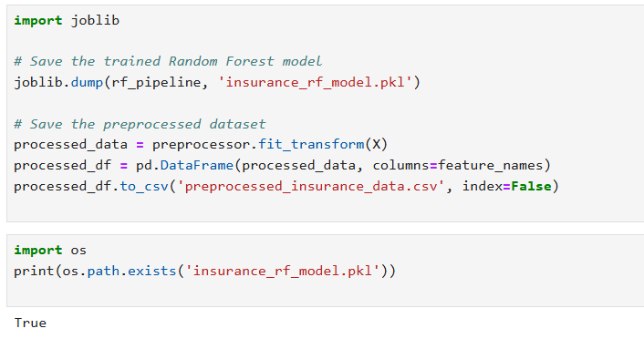

Present your solutions

Summary of Findings:
What key findings will you include in the summary of your project?
- Key Predictors: Smoking status, BMI, and age are the most significant factors influencing insurance charges, as identified through feature importance and correlation analysis.
- Model Performance: The Random Forest model outperformed Linear Regression, achieving a higher R² Score and lower error metrics (MAE, MSE), making it the best fit for predicting insurance costs.
- Impact of Outliers: Handling outliers using the IQR method improved model performance and ensured the data was clean and reliable.
- Data Insights: Smokers tend to have significantly higher insurance charges, and BMI positively correlates with costs, highlighting the influence of health and lifestyle choices.
These findings align with the project objective of building an accurate and reliable predictive model for insurance costs.
How do these findings align with the initial objectives of your predictive modeling task?

These findings align with the initial objectives by accurately identifying the key factors influencing insurance costs, such as smoking status, BMI, and age. The Random Forest model effectively predicts charges with strong performance metrics, meeting the goal of building a reliable and accurate predictive model. Additionally, insights into feature importance help explain how health and lifestyle choices impact insurance costs.

Model Performance Showcase:
How will you effectively communicate the performance of your final model to your audience?
I will effectively communicate the model's performance using key metrics like R² Score, MAE, and MSE, supported by visualizations such as learning curves and error plots. Additionally, I will highlight feature importance to explain the factors influencing predictions, ensuring clarity and audience understanding.

Insights Derived from Data:

In presenting your solutions, what insights from the data exploration phase will you emphasize?
In presenting my solutions, I will emphasize the following key insights from the data exploration phase:
- Feature Importance: Smoking status, BMI, and age are the most significant factors influencing insurance charges.
- Impact of Smoking: Smokers have significantly higher insurance costs compared to non-smokers, as seen in the boxplots.
- Correlations: Positive correlations exist between charges and features like BMI and age, indicating their strong predictive influence.
- Data Distribution: The charges feature is right-skewed, highlighting the presence of high-cost outliers, which were handled appropriately.
These insights guided feature selection, data preprocessing, and model development to ensure reliable predictions.
How do these insights contribute to a deeper understanding of the factors influencing your model's predictions?
These insights provide a deeper understanding by identifying the most influential features, such as smoking status, BMI, and age, which directly drive the model's predictions. Understanding the strong correlation between these factors and insurance costs helps explain why certain individuals incur higher charges. Additionally, analyzing the impact of outliers and feature distributions ensures the model captures meaningful patterns, leading to more accurate and interpretable predictions.

Challenges Encountered:

Can you discuss any challenges faced during the project and how they were overcome?
Managing outliers in the charges and bmi features was one difficulty because they had the potential to distort the model's predictions. By capping extreme values using the Interquartile Range (IQR) method, this was resolved while maintaining data consistency and minimizing information loss. Making sure the model didn't overfit during training presented another difficulty. This was resolved by employing Grid Search Cross-Validation to hyperparameter tune the Random Forest model, which enhanced performance and generalization on unseen data.

What lessons have you learned that might be beneficial for future projects?
This project taught me how crucial it is to explore data in order to find important patterns that inform model development, like feature importance and correlations. I also came to see how important it is to manage outliers and use hyperparameter tuning to enhance model performance. Lastly, scalability and efficiency are guaranteed by employing pipelines for regular preprocessing and evaluation, which will be advantageous for upcoming projects.

Can you discuss the limitations of your model and potential areas for future improvement?
The model's slight overfitting, as evidenced by the difference between training and validation scores, is one of its drawbacks and could limit generalization on unknown data. Furthermore, for larger datasets, the Random Forest model may be computationally costly. In the future, I would investigate more complex models like XGBoost or Gradient Boosting, apply regularization to deal with overfitting, and collect additional data to increase model accuracy. Additionally, adding more pertinent characteristics, like eating or exercise routines, may improve prediction accuracy.

Recommendations and Future Work:

What recommendations will you provide based on your model's predictions?
Based on the model's predictions, I recommend the following:
- Focus on Lifestyle Factors: Individuals with higher BMI and smokers incur significantly higher insurance costs. Encouraging healthier lifestyles, such as weight management and smoking cessation programs, can help reduce premiums.
- Age-Based Premium Adjustments: Insurance companies can tailor premiums for older individuals while offering incentives for proactive health management.
- Feature-Driven Insights: Insurers should prioritize factors like smoking status, BMI, and age when assessing risk and pricing policies, as these have the strongest impact on charges.

How might your project be extended or refined in future work to improve its applicability?

Incorporate Additional Features: Include factors like physical activity, diet, and medical history to improve the model's predictive accuracy and applicability.
Explore Advanced Models: Use advanced algorithms like XGBoost or Neural Networks and implement automated hyperparameter tuning for better performance and scalability.

