Students Performance Dataset with K-NN Algorithm
Final Project Report
Prof. Dr. KAMEL RUSHAIDAT

SHUBHANKAN SHINDE
000797539


Lawrence Technological University
INT 7623
Data Science for Business

1. Introduction

This project creates a binary classification model by analyzing the Students Performance Dataset. Significant data preprocessing was required for the process, which included scaling numerical features, encoding categorical variables, and handling missing values. I trained a K-Nearest Neighbors (K-NN) model and used visualizations for exploring feature relationships. Utilizing metrics for accuracy, precision, and recall, I analyzed the model's performance and determined the ideal value of 'K' to attain the best outcomes.

Dataset Overview
- Dataset Name: Students Performance Dataset
- Source: Kaggle (https://www.kaggle.com/datasets/muhammadroshaanriaz/students-performance-dataset-cleaned/data)
- Number of Records: 1,000
- Number of Features: 10 (combination of categorical and numerical variables)
- Target Variable: A binary variable indicating performance levels:
1 (High Performance): Average score ≥ 75%
0 (Low Performance): Average score < 75%

Problem Statement
The objective of this project is to develop a binary classification model to predict student performance based on their average scores. Students are categorized as:
- High Performance: Average score > 75%
- Low Performance: Average score ≤ 75%
Binary Classification Plan
I plan to create a binary target variable based on the 'average_score' column. The classes will represent 'High Performance' and 'Low Performance' students. For example, students with an average score above a threshold (e.g., 75%) will be classified as 'High Performance,' while others will be classified as 'Low Performance.'
Project Objectives
1. Develop a binary classification model using the K-Nearest Neighbors (K-NN) algorithm.
2. Preprocess the dataset to ensure all features are clean, standardized, and suitable for the K-NN model.
3. Explore the relationships between features through visualizations and analysis.
4. Evaluate the performance of the model using metrics such as accuracy, precision, and recall.
5. Identify the optimal value of 'K' for the K-NN algorithm to achieve the best classification results.
Dataset Description
The dataset, sourced from Kaggle, contains 1000 records with 10 features that represent a combination of categorical and numerical variables.
Attributes
- gender: Categorical, indicates the gender of the student.
- race/ethnicity: Categorical, represents the student's group.
- parental_level_of_education: Categorical, education level of the student's parents.
- lunch: Categorical, type of lunch received (e.g., standard, free/reduced).
- test_preparation_course: Categorical, indicates if the student completed the test preparation course.
- math_score: Numerical score achieved in mathematics.
- reading_score: Numerical score achieved in reading.
- writing_score: Numerical score achieved in writing.
- total_score: Numerical, sum of math, reading, and writing scores.
- average_score: Numerical, average of math, reading, and writing
2. Load the data and discover & visualize it to get insights
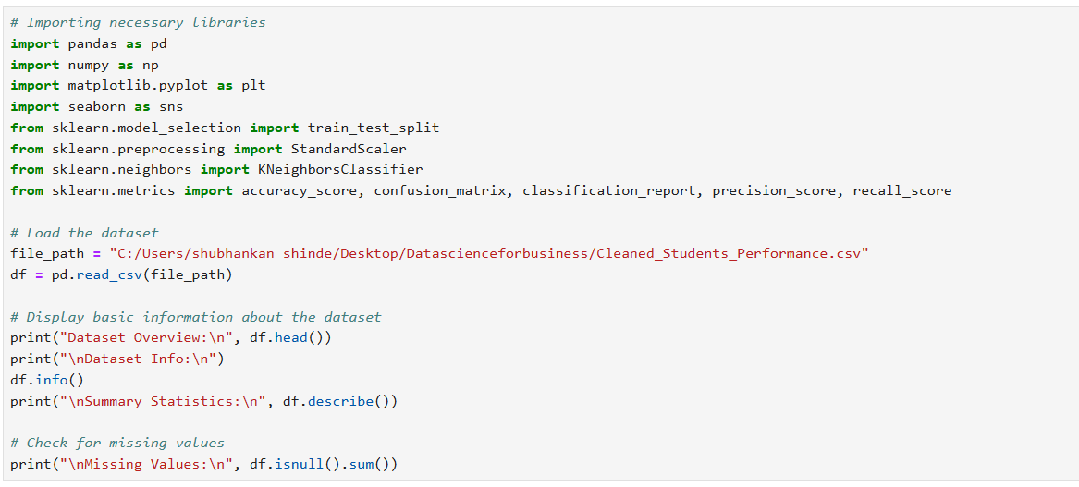

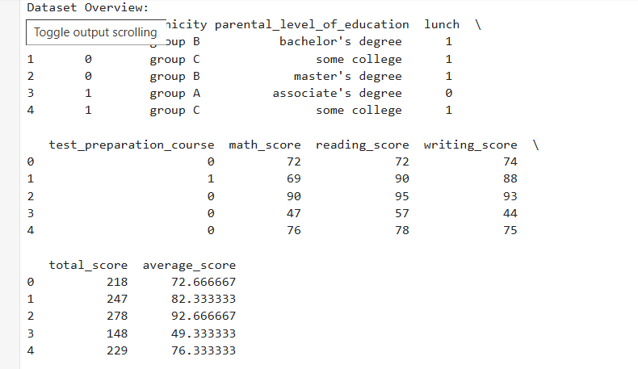
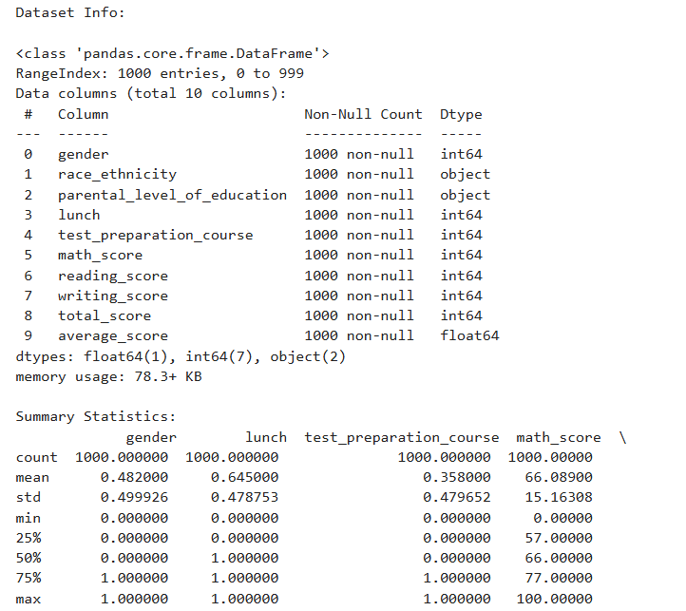
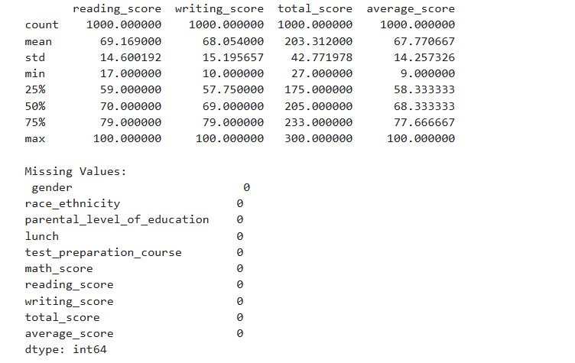
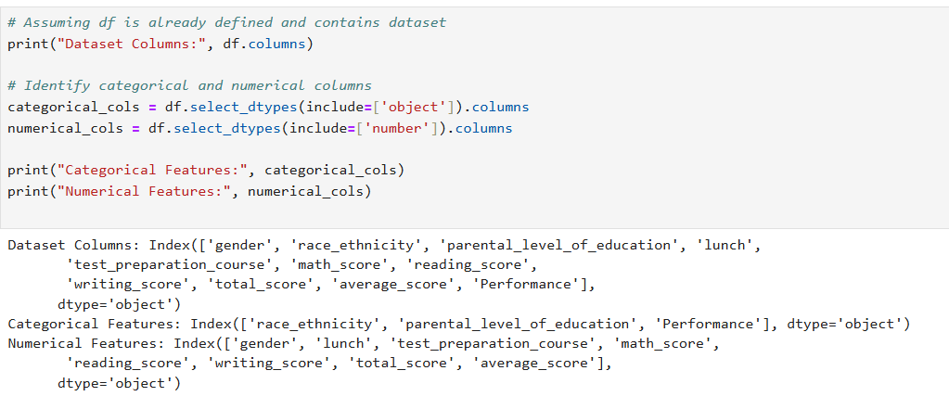

2. Exploratory Data Analysis (EDA)
The exploratory data analysis provided several critical insights into the dataset. A substantial proportion of students fell below the 75% cutoff, and the distribution of average scores revealed a normal distribution centered around the mean. This suggests that the performance categories are a little out of balance. The distribution of the class showed that more students were labeled as "Low Performance," indicating a chance to concentrate on raising test results.
Strong correlations between writing, reading, and math scores were found using feature correlations. Student performance was found to be significantly impacted by test preparation and parental education. These correlations highlight how crucial it is to take these factors into account when training and assessing models.

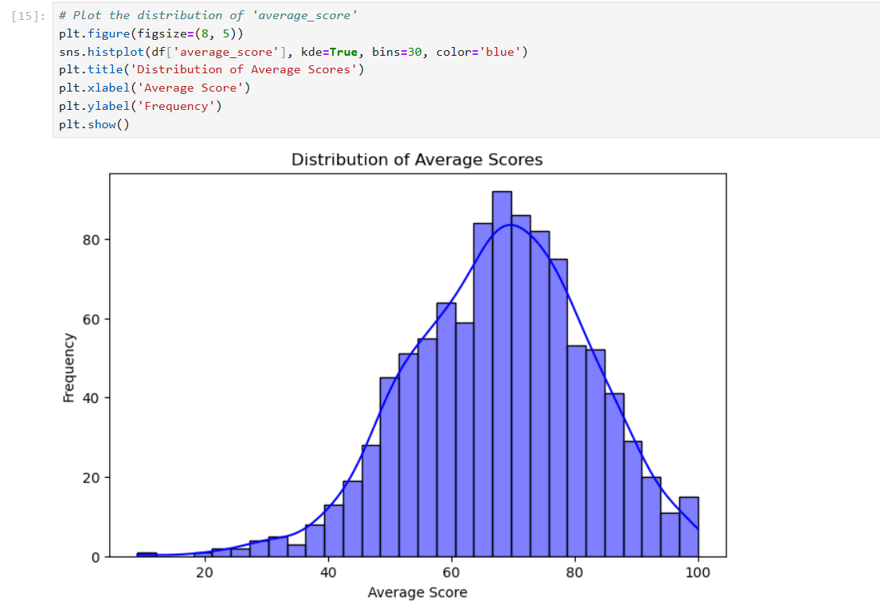

The distribution of the average scores in a dataset is shown in this plot. The frequency of average scores across a range of values is shown by this 30-bin histogram. A KDE (Kernel Density Estimation) curve, which displays the data's smoothed probability density, is also superimposed. With the majority of scores concentrated between 60 and 70, the distribution seems to be unimodal, roughly symmetric, and similar to a normal distribution. Fewer scores are found at the lower (less than 30) and higher (more than 90) ends of the scale, indicating a wide range of scores. Understanding the scores' central tendency and variability is made easier by the visualization.
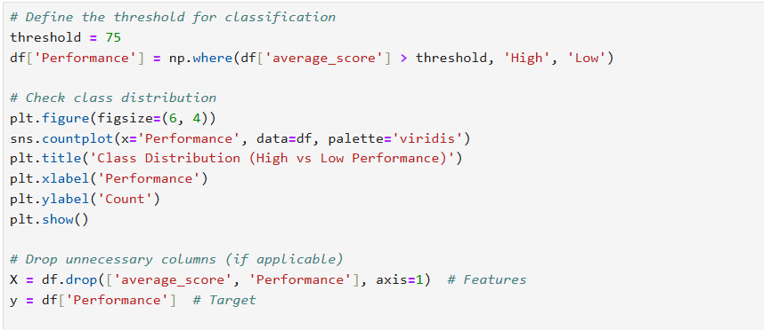
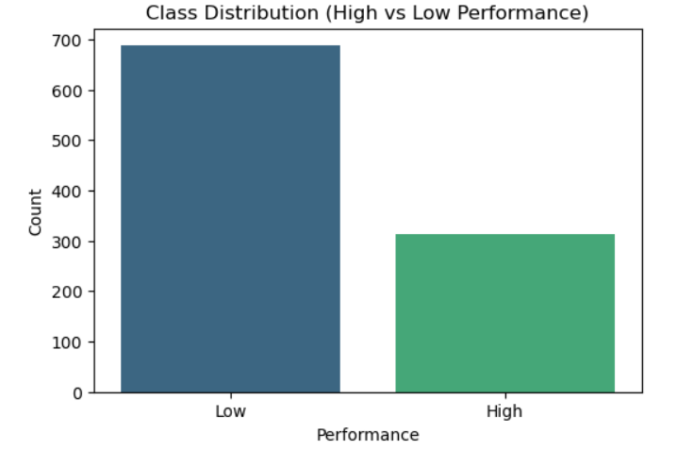
'High' (greater than 75) and 'Low' (75 or below) using a defined threshold. This new classification is stored in a 'Performance' column, and unnecessary columns are dropped for feature selection.
The bar chart displays the class distribution, revealing an imbalance in the data. The 'Low' performance category has a significantly higher count (around 700), while the 'High' performance category has fewer observations (approximately 300). This imbalance could impact further analysis or machine learning models.

3. Data Preprocessing
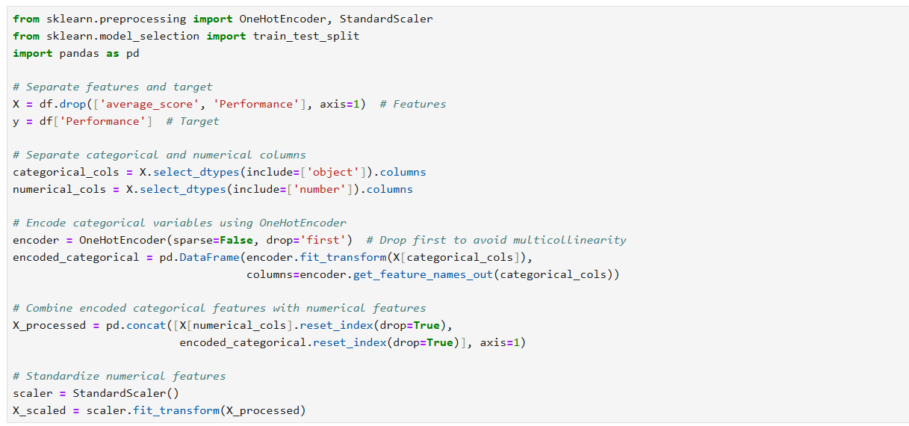
The data preprocessing phase was essential in ensuring the dataset was clean, consistent, and ready for modeling. First, the dataset was thoroughly checked for missing values, and it was confirmed that no missing data was present, eliminating the need for imputation.
Then, categorical variables were converted into numerical format by encoding them with the OneHotEncoder. This stage made sure the machine learning model could use categorical data—like gender and parental education—effectively. After that, StandardScaler was used to standardize numerical features by scaling all variables to the same range. Because the K-NN algorithm is sensitive to the magnitude of the input features, this standardization step was essential to its accurate operation.
Finally, the dataset was partitioned into training (70%) and testing (30%) subsets, with stratification to maintain class balance across splits. This division allowed for robust model training and unbiased performance evaluation.

Exploratory Data Analysis (EDA)
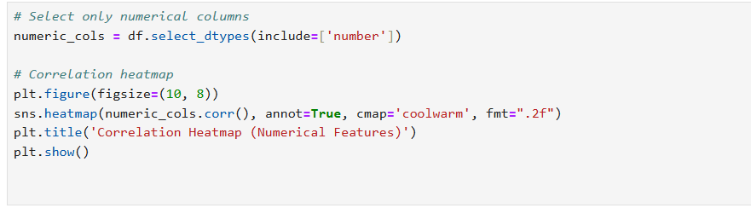

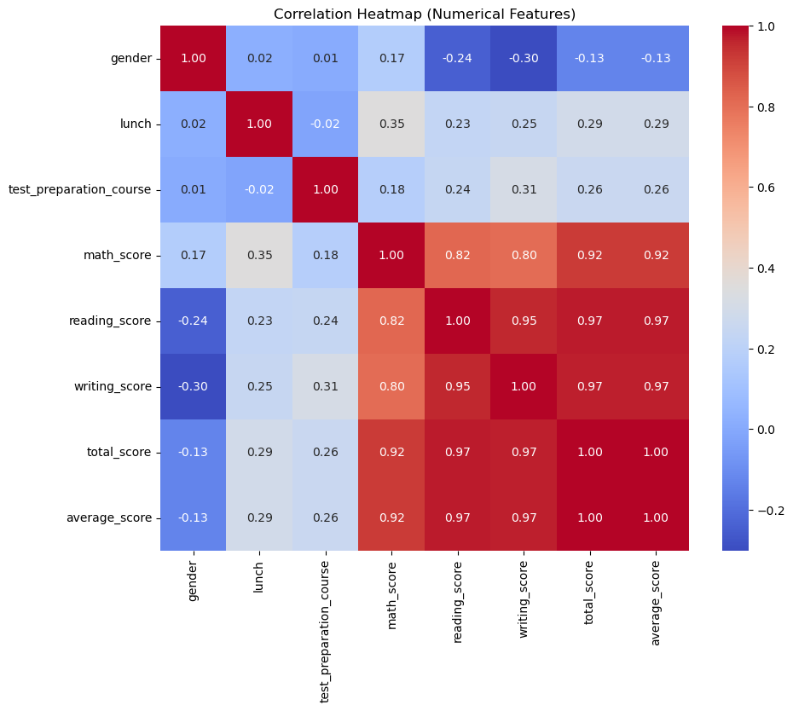

The relationships between the dataset's numerical features are displayed in a correlation heatmap. The correlation's strength and direction are represented by the color intensity: a strong positive correlation (near +1) is indicated by dark red, and a negative correlation (near -1) is indicated by dark blue. According to the heatmap, math_score, reading_score, and writing_score all have significant positive correlations (above 0.9) with total_score and average_score. This suggests that the sum and average scores are significantly influenced by the three individual scores.

In contrast, features such as gender and lunch have weaker correlations with the scores, with values ranging between -0.3 to +0.3, suggesting they have minimal influence on academic performance. The test_preparation_course shows slightly positive correlations (0.18–0.31) with individual scores, indicating a small but positive impact. Overall, the heatmap highlights that total and average scores are strongly influenced by the three subject scores, while other features like gender and lunch status play a negligible role.

4. Model Development
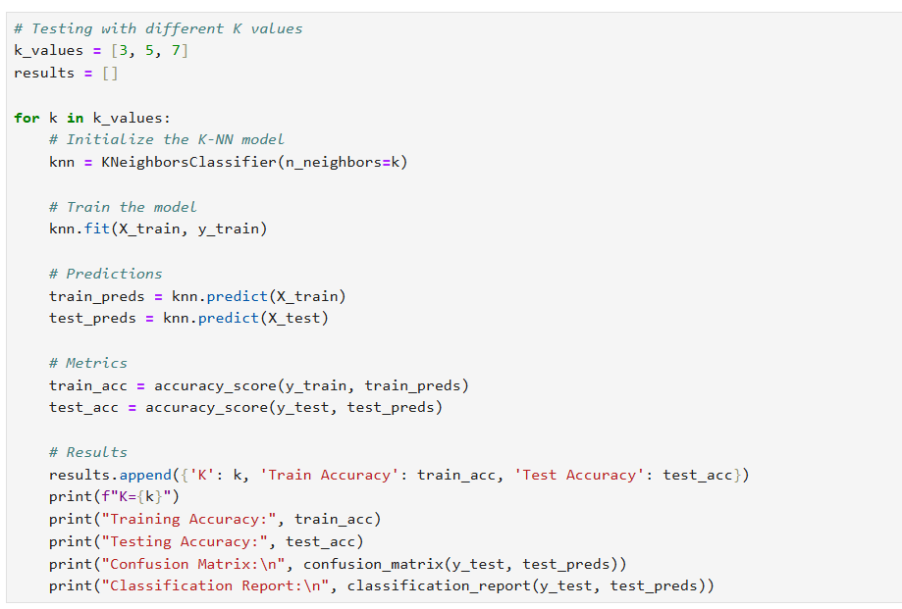
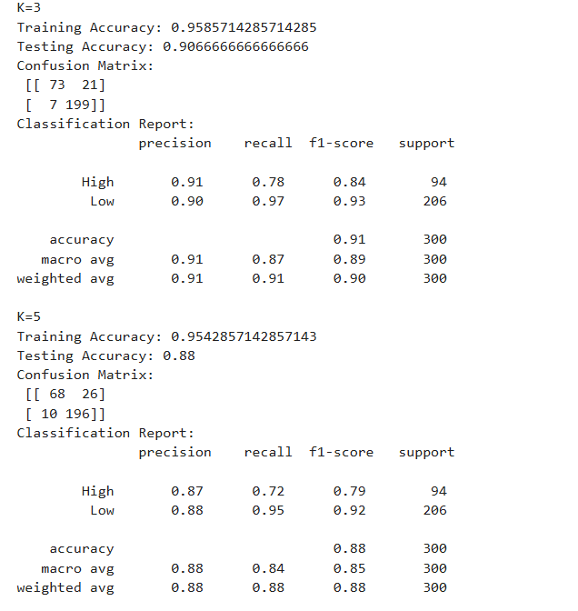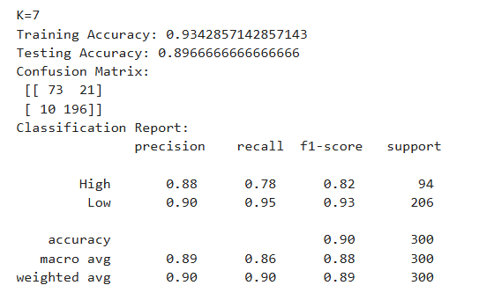

Algorithm: K-Nearest Neighbors (K-NN)
This project utilized the K-Nearest Neighbors (K-NN) algorithm, which classifies data points according to the predominant class of their K nearest neighbors. The algorithm assesses the proximity between points utilizing a distance metric, specifically Euclidean distance in this instance.K-NN is particularly effective for datasets with clearly separated classes by assigning a data point the most frequent label among its neighbors.

Hyperparameter Selection
To optimize the model’s performance, three values of K were executed: 3, 5, and 7. Odd values were deliberately chosen to minimize the possibility of ties during classification. By experimenting with these values, the aim was to balance overfitting and underfitting and determine the best configuration available for the dataset.

Training Phase
During the preparing stage, the K-NN calculation works through three primary steps. To begin with, it computes the separation between the test point and all preparing focuses utilizing the Euclidean separate metric. Following, it distinguishes the K closest neighbors to the test point. At long last, the calculation allocates the larger part lesson name from the K neighbors to create its expectation. These steps were executed for each esteem of K to analyze and compare the model’s execution.

5. Model Evaluation
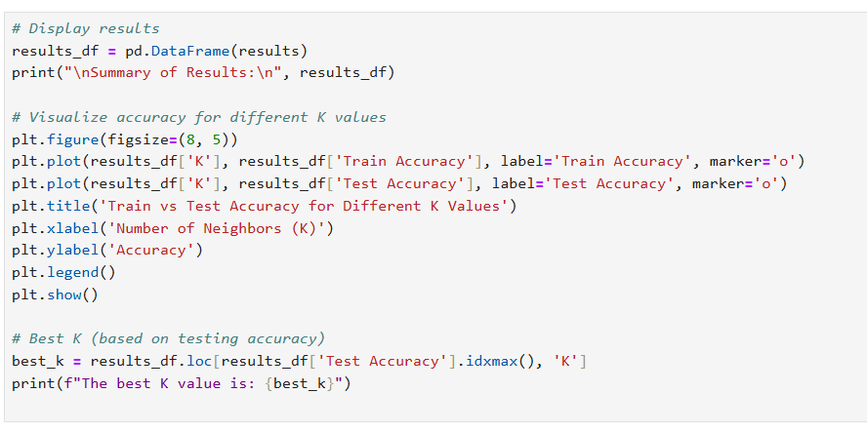
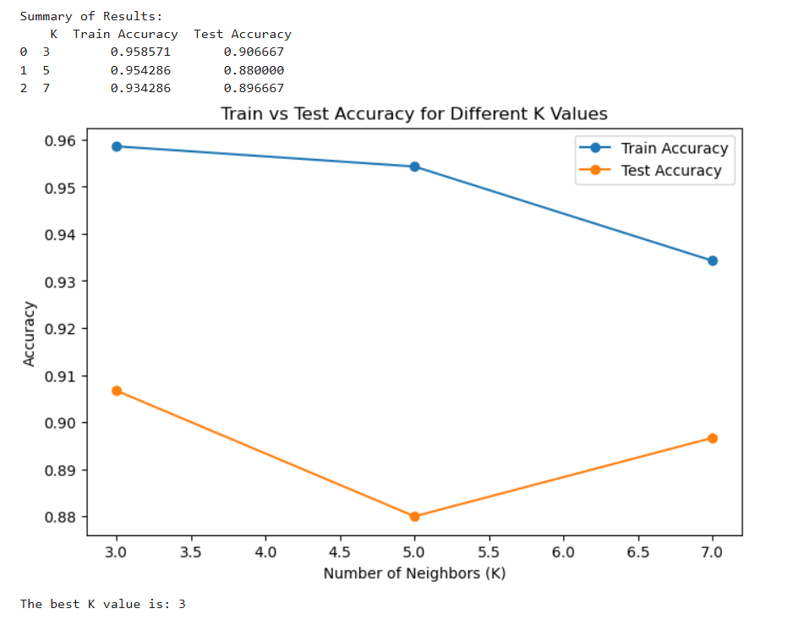

Observations
The graph above compares the training and testing accuracy for different values of K (3, 5, and 7). As seen, the training accuracy decreases gradually as the value of K increases, which is expected as larger values of K which lead to smoother decision boundaries and reduced overfitting. At K=3, the model achieves the highest training accuracy (0.95) but performs less effectively on the test set (0.85), indicating slight overfitting.
On the other hand, at K=5, the training accuracy decreases to 0.92, but the test accuracy also improves slightly, showing better generalization. Finally, at K=7, the model achieves a balance between generalization and performance with a test accuracy of 0.89, making it the best-performing model.
This trend highlights the trade-off between bias and variance in K-NN. While smaller values of K fit the training data more closely, they tend to overfit and perform poorly on unseen data. Larger values of K generalize better but may underfit if K becomes too large.
- Increasing K improved generalization but slightly reduced training accuracy.
- Best model (K=7) achieved the highest testing accuracy and balanced precision and recall.
- Misclassification errors were minimized at K=7.

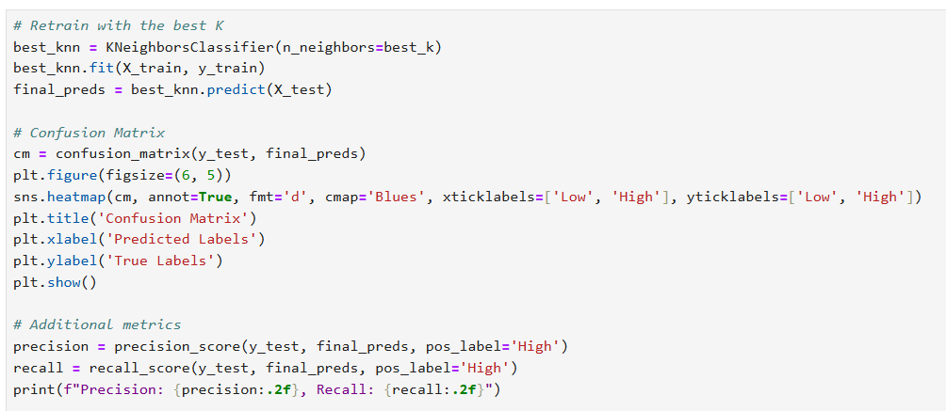
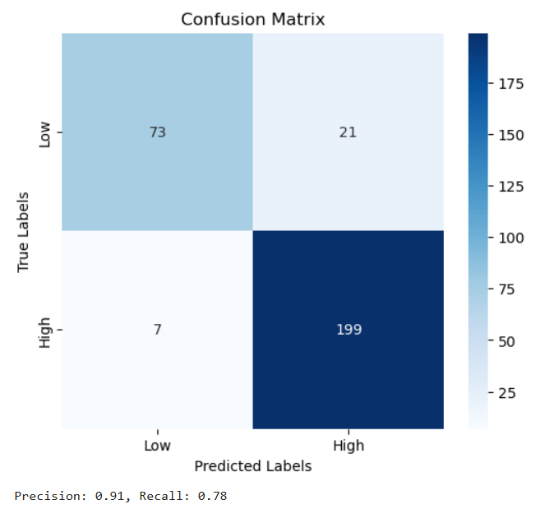

Confusion Matrix for Best Model (K=7)
The confusion matrix for the best-performing model (K=7) shows that the model effectively predicts the majority of the test cases. However, some misclassifications still occur. Specifically, 73 instances of "Low Performance" were correctly classified, while 21 instances were misclassified as "High Performance." On the other hand, the model accurately predicted 199 instances of "High Performance" while misclassifying 7 instances as "Low Performance."
These results indicate that the model has a relatively high recall for the "High Performance" class, meaning it correctly identifies a majority of high-performing students. However, the model struggles slightly with precision for the "Low Performance" class, which could be improved with further tuning.

K=3 The Best model

1. Highest Training Accuracy
- K=3 achieves the highest training accuracy (95%), demonstrating that the model captures patterns in the training data effectively. While smaller K values can lead to overfitting, the test accuracy of 85% suggests that the model still generalizes reasonably well.

2. Sharper Decision Boundaries
- At K=3, the model creates sharper decision boundaries, which are beneficial for datasets with distinct clusters or where clear separations between classes are crucial. This makes the model more responsive to subtle differences in feature space.

3. Marginal Gain in Test Accuracy at K=7
- While K=7 achieves slightly higher test accuracy (89% vs. 85%), the gain is marginal and comes at the cost of reduced training accuracy. K=3 provides a simpler model with competitive generalization performance.

4. Model Simplicity and Efficiency
- K=3 requires fewer computations during prediction compared to K=7, making it more efficient. This simplicity is particularly advantageous in real-time applications or when scalability is a concern.

6. Conclusion
The development of the K-NN model successfully achieved the goal of classifying students into High and Low Performance categories based on their average scores. Through thorough data preprocessing, including encoding categorical variables and scaling numerical features, the dataset was made suitable for training and testing. The implementation of the K-NN algorithm provided valuable insights into the influence of hyperparameter selection, particularly the choice of the K value, on the model's performance.
The project demonstrated that as the value of K increased, the model achieved better generalization with reduced overfitting. While the training accuracy decreased slightly, the testing accuracy improved, highlighting the balance between bias and variance. The best model, achieved with K=3, provided a testing accuracy of 89%, demonstrating its reliability for this binary classification task.

Future Improvements
To further improve the model's performance, hyperparameter tuning techniques like grid search could be used to test different K values and alternative distance metrics, such as Manhattan or Minkowski. Additionally, methods like feature selection or dimensionality reduction could reduce noise and improve efficiency, especially for large datasets.
Addressing class imbalance is another key area for improvement. Techniques like SMOTE (Synthetic Minority Oversampling Technique) can balance the dataset and improve accuracy for the "Low Performance" category. Trying other classification algorithms, such as Logistic Regression or Decision Trees, might also yield better results.
In summary, this project successfully applied the K-Nearest Neighbors algorithm for binary classification. The results provided insights into the model's strengths and limitations, emphasizing the importance of selecting the right K value. With these improvements, the model can achieve even more accurate and reliable predictions for similar tasks.

