## **MID-TERM EVALUATION REPORT**

## *SUBMITTED IN PARTIAL FULFILLMENT OF THE REQUIREMENT FOR THE*

## *AWARD OF THE DEGREE OF*

## BACHELOR OF ENGINEERING

## (INFORMATION TECHNOLOGY)

## 

## 

## **Supervisor: Shubhankar Rana (UE198098)**

## **Dr. Neelam Goyal QA Intern at INCEDO Inc.**

## 

## To

## Department of Information Technology

## University Institute of Engineering and Technology

## Panjab University, Chandigarh

## March 2023

## **Table of Contents**

|  |  |  |
| --- | --- | --- |
| **Sr. No.** | **Description** | **Page No.** |
| 1 | Summary | *3* |
| 2 | Introduction | *4* |
| 3 | About Company | *5* |
| 4 | Work (Internship Timeline) | *7* |
| 5 | Industry | *8* |
| 6 | Details of the Work (Programs & Results) | *10* |
| 7 | Review | *16* |
| 8 | References/Important Links | *NA* |
| 9 | Conclusion and Future Scope | *17* |
| 10 | EndNote | *19* |

## **Summary**

I am **Shubhankar Rana**, final year undergraduate student at University Institute of Engineering & Technology, Panjab University, Chandigarh. This is the mid-term report for my ongoing 8th Semester training undergoing in **Incedo Inc**. where I’m currently working in the **Gurugram Office** of the firm.

Currently all the interns of Incedo are called **Incedo Northstars** and all have been assigned in **Delivery function department** under the manager **Suchismita Pardhan**. We were assigned buddies during our **4 week Capstone Project**. **Ankit Jha** was assigned as the buddy for our team. We were given a task to develop a **Portfolio Management System (PMS) website.**

During my internship as a **Quality Assurance Intern at Incedo**, I gained valuable experience and skills in software testing and Quality Assurance. This allowed me to develop my technical skills and work collaboratively with team members. Through participation in the 4 week Capstone Project. I feel confident that the skills and knowledge I gained will benefit me in my future career as a Quality Analyst.

## **Introduction**

The purpose of this report is to provide a mid-semester evaluation of my internship as a Quality Analyst at Incedo Inc. as a Quality Analyst, my responsibilities include designing and executing test cases, analyzing test results, and collaborating with the development team to ensure that the software meets the desired quality standards. This report will provide a comprehensive overview of my progress and achievements during the first half of my internship, as well as the challenges and opportunities for growth that I have encountered.

The report will begin with a brief overview of the company and the role of Quality Analyst within the organization. This will be followed by a detailed description of my job responsibilities, including the tasks that I have performed and the tools and techniques that I have used to complete them.

In addition, the report will provide an analysis of the challenges and opportunities for growth that I have encountered during the first half of my internship. This will include a discussion of the key challenges that I have faced, such as learning new technologies and working with a large development team, as well as the opportunities for growth that I have identified, such as improving my communication skills and gaining a deeper understanding of the software development life cycle.

## **About**



Incedo Inc is a multinational technology solutions and services company that provides digital transformation services to clients in various industries. The company was founded in 2011 and has since grown to over 4,000 employees across offices in the United States, India, and Europe.

Incedo specializes in delivering data-driven solutions that help clients optimize their operations and improve business outcomes. The company's services include analytics and AI, digital engineering, product engineering, and advisory services. Incedo also has expertise in emerging technologies such as blockchain, cloud, and the Internet of Things (IoT).

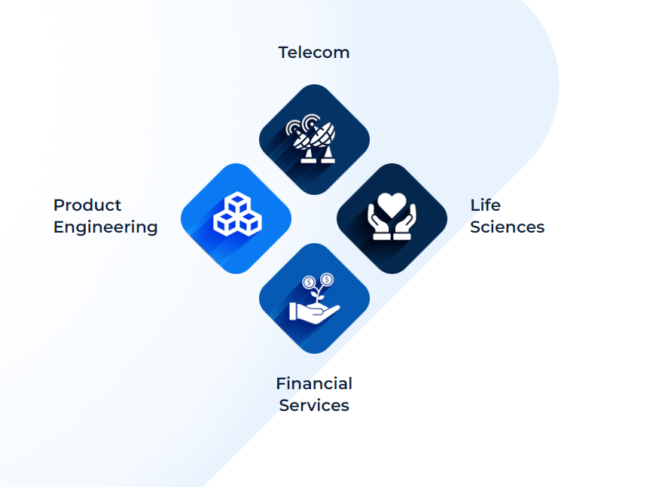 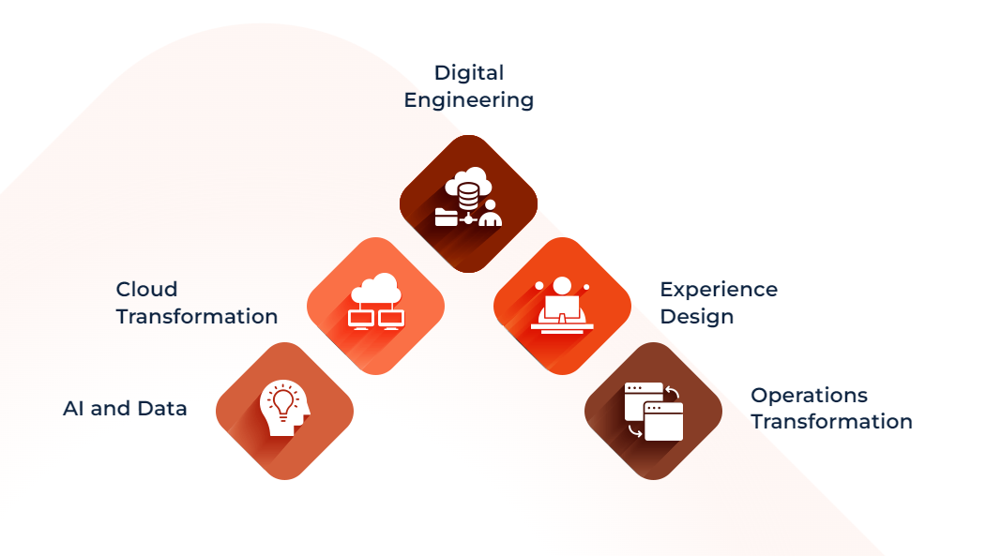

One of Incedo's unique strengths is its ability to work with clients across the entire product development lifecycle, from ideation to commercialization. The company's agile development methodology enables it to rapidly develop and iterate on solutions, ensuring that clients receive high-quality products that meet their needs.

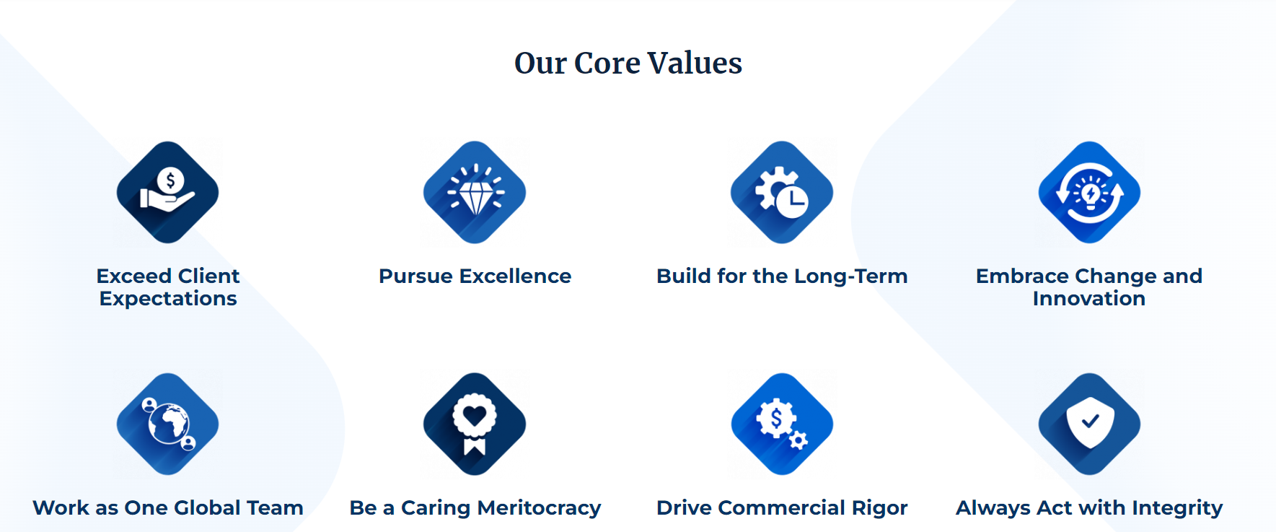

These values reflect Incedo's commitment to delivering high-quality solutions, fostering a culture of innovation and excellence, promoting ethical business practices and social responsibility, and valuing its employees as a key asset in achieving its mission.

**Why are we called Incedo NorthStars?**

From the term NorthStar we can conclude that it’s something about the stars. The Pole star is also called the NorthStar thereby it is said that all the other stars change their position in the night as the earth revolves in turn makes the navigation difficult in the night for sailors. But the pole star is the only star that remains stagnant, it helps in navigation as it always points towards North. Therefore we can conclude that:

Incedo always takes an employee lens for the company’s future i.e. do the current steps / directions of the company aligns with the future prospect of the organization and that is observed by hiring good amount of young talent to understand their vision**.**

## **Work (Internship Timeline)**

## **Industry**

Testing is the process of evaluating a software application or system to identify any defects, bugs, or errors that may impact its functionality or usability. Testing is an essential component of the software development life cycle (SDLC), and it helps to ensure that the software meets the desired quality standards and is ready for release.

There are various types of testing methodologies used in the software industry, including:

* Functional testing: This type of testing evaluates the software's functionality to ensure that it meets the specified requirements.
* Performance testing: Performance testing evaluates the software's performance under different load conditions, to ensure that it can handle the expected number of users and transactions.
* Security testing: Security testing evaluates the software's security features to ensure that it is protected against threats and vulnerabilities.
* Usability testing: Usability testing evaluates the software's ease of use and user interface, to ensure that it is user-friendly and intuitive.
* Regression testing: Regression testing is performed to ensure that changes made to the software do not impact its existing functionality or introduce new defects.

Testing can be performed manually or using automated testing tools. Automated testing tools use software to perform tests and report results, which can save time and reduce the risk of human error.

Testing is a critical function in the software development process, and it helps to ensure that the software meets the desired quality standards and is ready for release. As a Quality Analyst, your role is to ensure that the testing process is efficient, effective, and meets the desired quality standards.

**Details of the Work (Programs & Results)**

1. **Orientation (9-10 January)**

* We introduce them to the company's culture, values, and operations
* The orientation day typically includes the following activities
  + Welcome and introduction
  + Company overview
  + Policies and procedures
  + Culture and values
  + Benefits and perks
  + Team building activities
* Most important we were taught the values of our company
* We were allotted company assets for work

1. **Engineering Primer Training (1 week)**

* Prior to Engineering Primer we were provided with our role in the company as interns, mine being of Quality Analyst.
* This training was for all the employees joining Incedo. It was a mandate for all to complete this training before beginning their respective Tech- Stack trainings.
* Engineering Primer Training was organized by the company to build further depth around our role and responsibilities.
* The idea was to ensure that all of the new jonnies get more practical exposure through the Engineering Primer training as we started our journey with Incedo, the training was lead by ***Mr. Neeraj.***
* We had a pre-assessment and post-assessment after undergoing the Engineering Primer Training.

1. **Testing Training**

* The training was intensely focused to develop and improve our automation techniques using the Test Automation Techniques.
* In this training our instructor was ***Mr. Tarun*** under whose guidance we learned about Selenium with Java, Cypress, Apache JMeter, Selenium API and about all the testing methodologies.
* We had a pre-assessment and post-assessment after undergoing the Testing Training.

1. **Intermediate Coding Practices**

* Coding sessions were organized for all the NorthStars to provide them with the knowledge of different technical domains.Coding Practices helped us to gain hands on experience with the modern day technologies.
* The practices were organized frequently on the domains like SQL, Node.js, React.js, etc

1. **Intermediate Sessions**

* Sessions were organized as per the company calendar including Branding Sessions, Company Employee Meets, Learning & Development Sessions, Business Communication Session, etc.
* We have a CEO Townhall wherein we get useful insights about the company’s projects and about the company finances along with the upcoming company growth and expansion plans.
* These sessions make us feel more integrated with Incedo and help us to interact directly with more experienced employees in the company to understand their perspective well.

[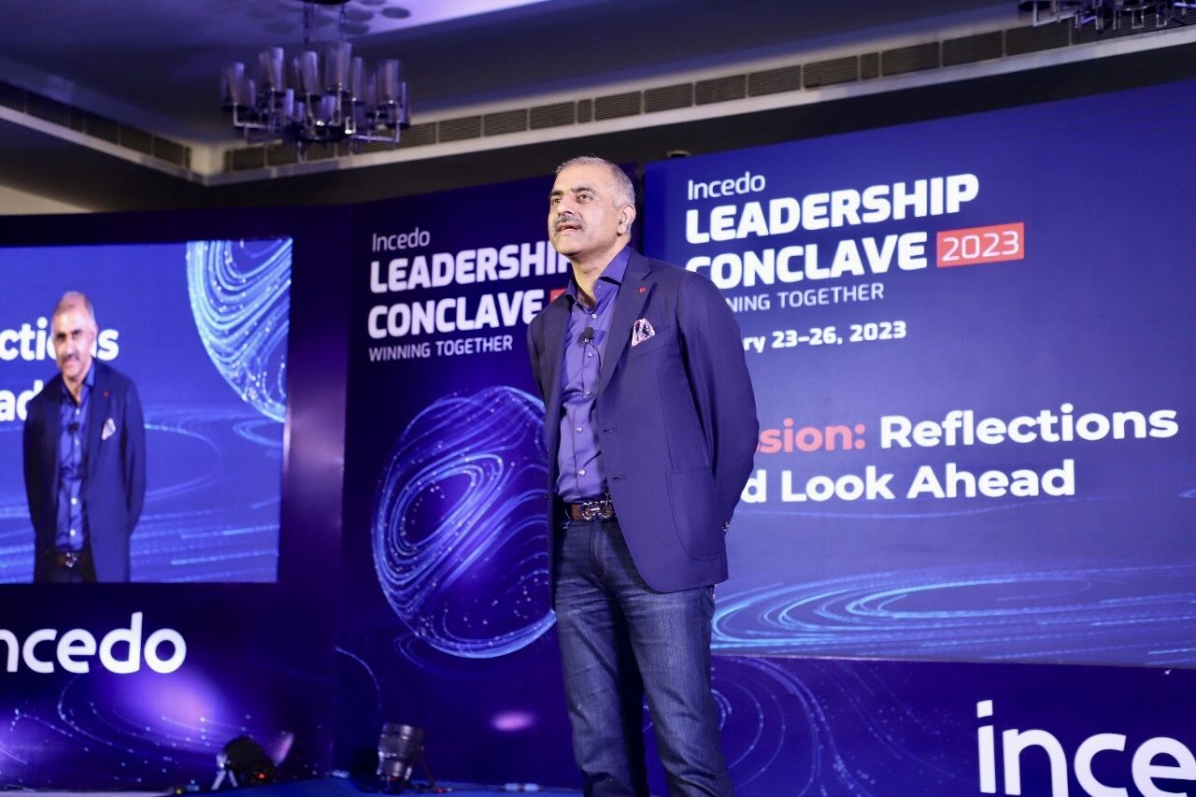](linkedin.com/posts/nitinseth_goodtogreat-scurve-winningtogether-activity-7024772143787712513-e4Ik/?originalSubdomain=me)

*Incedo CEO* ***Nitin Seth*** *in CEO Townhall Session organized at Incedo Inc, Gurugram office*

1. **4WCP – Four Week Capstone Project**

* Our problem statement for the 4WCP was to create a PMS Website for the client with specified requirements included in a SRS(Software Requirement Specification) document.
* Due to the work done while working with Incedo, the product developed belongs to the assets of the company and thus can’t be demonstrated outside its premises due to compliance issues.
* Here is the Phase wise approach of our team to solve the problem statement given to us:
* My roles as a QA tester in the project included the following:
  + Collaborating with the development team to understand project requirements and design test plans and test cases accordingly.
  + Executing and documenting manual test cases to identify defects and ensure a responsive website.
  + Analyzing test results and reporting defects to the development team.
  + Participating in the daily scrum meetings to provide testing status updates and discuss defects and test-related issues.
  + Conducting regression testing to ensure that changes did not have any unintended impacts on existing features.
  + Contributing to process by providing feedback and suggestions for improvement.
* We used the Iterative Incremental Model for the development of our PMS website as it prioritize delivering working software quickly and frequently, and emphasize collaboration between our team, buddy and mentor.
* We used this agile methodology as it helps us provide continuous feedback and adaptation for changes to be made throughout the development process over **Daily Standup Meetings** and **Daily Scrum Meetings** for intra team discussion.
* Below are some of the **Manual Testing Techniques** I used to test the PMS website created by our team:

1. **Working with Client**

* My BGV (Background Verification Check) is going on currently and after the verification is completed, I will be working with my team to serve the US client.

*(We can’t disclose the client as it doesn’t comply with the privacy policies of the company)*

* Under the guidance of my manager **Anuj Kogata** *(Wealth Management)* I will be allotted my mentor and buddy soon for working with the client*.*

## **Review Section**

## Overall, my role as a Quality Analyst was challenging and engaging, and provided me with an opportunity to develop my skills in testing and automation. I appreciated the level of autonomy and responsibility I was given, and felt that I was able to make a meaningful contribution to the 4WCP as I was the only tester in my team. The experience has also helped me to get a deeper understanding of the technologies used in the development Portfolio Management Website and the importance of quality assurance in ensuring that products meet customer requirements.

## Throughout my internship, I received support and guidance from my mentor and buddy Ankit Jha and our team, who were always available to answer questions and provide feedback as and when coordinated. I found these responsibilities to be challenging and rewarding, as they provided me with valuable hands-on experience in software testing and quality assurance. I also appreciated the opportunity to work closely with experienced professionals in the industry and to learn from their expertise and guidance.

## The positive work culture at Incedo also made my experience enjoyable and rewarding, and I appreciated the company's commitment to promoting diversity, equity, and inclusion. My internship at Incedo was a valuable learning experience, and I am grateful for the opportunity to have worked with such a talented and supportive team.

## **Future Scope**

## The global software testing market is a rapidly growing industry, driven by the increasing demand for software testing services across various industries. According to a report by Market Research Future, the global software testing market is expected to grow at a CAGR of 11.4% during the forecast period of 2023-2027.

## The future of software testing is constantly evolving with advancements in technology and changes in the way software is developed and deployed. Here are some potential areas of growth and opportunities for software testing in the future:

## Test Automation: With the increasing complexity of software applications, test automation is becoming more critical for efficient and effective testing.

## The future of software testing will see more use of automation tools and frameworks, including the use of artificial intelligence and machine learning to improve testing accuracy and efficiency.

## Agile and DevOps: Agile and DevOps methodologies are becoming increasingly popular for software development and testing. These methodologies focus on continuous integration, testing, and deployment, which can reduce the time to market for software products.

## The future of testing will see more adoption of these methodologies, which will require Quality Analysts to adapt their testing processes and tools accordingly.

## Cloud Testing: Cloud computing is becoming more prevalent in the software industry, with many companies moving their software applications to the cloud.

## The future of testing will see more emphasis on cloud testing, which involves testing software applications in a cloud environment. This will require Quality Analysts to develop new testing strategies and tools to ensure that software applications are compatible with various cloud platforms.

## Internet of Things (IoT) Testing: The Internet of Things is a rapidly growing industry, with millions of connected devices being deployed every year. The future of testing will see more emphasis on IoT testing, which involves testing the software applications that run on these devices.

## This will require Quality Analysts to develop new testing methodologies and tools to ensure that IoT devices are reliable, secure, and compatible with other devices and platforms.

## The future of testing is bright, with new technologies and methodologies constantly emerging. As a Quality Analyst, it is important to stay current with these trends and developments, and to adapt your testing strategies and tools accordingly.

## **Endnote**

## As my internship as a Quality Analyst comes to a close, I wanted to take a moment to reflect on my experience and express my gratitude for the opportunity to work with such a talented and supportive team.

## During my time in Incedo Inc. as a Quality Assurance intern, I had the opportunity to contribute to Fur Week Capstone Project. Through the training in different domains here, I gained a deeper understanding of the importance of Quality Assurance as well as other industry as a whole and its business perspective in ensuring the success of software projects. I also learned valuable technical skills and honed my problem-solving and critical thinking abilities.

## I am grateful for the guidance and support of my colleagues and supervisors, who provided me with valuable feedback and mentorship throughout my internship. I appreciate the time took to discuss my career goals and offer advice on how to achieve them.

## Looking ahead, I am excited to continue developing my skills and expertise as a Quality Analyst. I am confident that the experiences and knowledge I gained during my internship will serve me well in my future career.

## Sincerely,

## Shubhankar Rana