Identifying Cross-Selling Opportunities

Shubhankar Gupta

March 8, 2016

I have used a Market Basket Analysis in R for the required solution.

Reading the data into R.

product = read.table("ProductCategoryData.txt", header = T)  
user = read.table("UserProfileData.txt", sep = "\t", header = T)  
click = read.table("ClickStream.txt", sep = "\t", header=T)

## Warning in scan(file, what, nmax, sep, dec, quote, skip, nlines,  
## na.strings, : number of items read is not a multiple of the number of  
## columns

State/Region of Portugal have been recorded as numeric values. Therefore I have removed them for easier calculation. Also futher cleaning the data.

click = click[,-(8:16)]  
x = which(click$Region.State=="10")  
b = which(click$Region.State=="11")  
c = which(click$Region.State=="47")  
d = which(click$Region.State=="")  
click$Region.State = as.character(click$Region.State)  
click = click[-c(x,b,c,d),]  
click$Region.State = as.factor(click$Region.State)  
click$Country = as.character(click$Country)  
click$Country = as.factor(click$Country)  
click$City = as.character(click$City)  
click$City = as.factor(click$City)

We merge the data of product category and click stream by URL, to access the click on a particular product category.

a1 = merge(click, product, by= "URL")

Now we merge the data of a1 and user profile by USER ID, to access the user who is clicking for the product category.

a2 = merge(a1, user, by = "User.ID", all.x = T)

Market Basket Analysis is also called product association analysis.Association mining analysis mostly done based on an algorithm named "Apriori Algorithm".

library(arules)

## Loading required package: Matrix

##   
## Attaching package: 'arules'

## The following objects are masked from 'package:base':  
##   
## %in%, abbreviate, write

Now I converted the data frame into transaction class as per the requirements of **arules** package.

a3 = a2[,-3]  
data = a3[,(1:2)]  
r = unique(data)  
head(r)

## User.ID  
## 1 002Y4OT6-5QCS-48PD-CDLK-0TSRUM620CLY  
## 5 004906IP-LUPB-VM24-IO92-WE6X7FQL53N6  
## 6 005O4L5Z-JUEX-BAPR-62BV-WGYFGA88C2TK  
## 7 005O4L5Z-JUEX-BAPR-62BV-WGYFGA88C2TK  
## 8 006EGSY4-FKS5-MT33-7TCF-RNHZL3EPJOXH  
## 9 00BNYZVF-XUKN-DIUE-YSR1-RNYMDFSJVBGR  
## URL  
## 1 https://www.ideatory-store.com/SH51443900/VD30782423  
## 5 https://www.ideatory-store.com/SH51443900/VD50250356  
## 6 https://www.ideatory-store.com/SH51443900/VD05732995  
## 7 https://www.ideatory-store.com/SH51443900/VD50250356  
## 8 https://www.ideatory-store.com/SH51443900/VD30782423  
## 9 https://www.ideatory-store.com/SH51443900/VD90147750

spl = split(r$URL, r$User.ID)  
trans = as(spl, "transactions")  
df = data.frame(URL=levels(r$URL))  
df$URL =as.character(df$URL)  
level = merge(df,product, by="URL")

Using **support** for this transaction as 0.001 and **confidence** as 0.75 to get the association rules. As we will decrease confidence number of association rules will increase.

rules = apriori(trans, parameter = list(supp=0.001, conf=0.75))

## Apriori  
##   
## Parameter specification:  
## confidence minval smax arem aval originalSupport support minlen maxlen  
## 0.75 0.1 1 none FALSE TRUE 0.001 1 10  
## target ext  
## rules FALSE  
##   
## Algorithmic control:  
## filter tree heap memopt load sort verbose  
## 0.1 TRUE TRUE FALSE TRUE 2 TRUE  
##   
## Absolute minimum support count: 8   
##   
## set item appearances ...[0 item(s)] done [0.00s].  
## set transactions ...[28 item(s), 8237 transaction(s)] done [0.00s].  
## sorting and recoding items ... [18 item(s)] done [0.00s].  
## creating transaction tree ... done [0.00s].  
## checking subsets of size 1 2 3 4 5 done [0.00s].  
## writing ... [33 rule(s)] done [0.00s].  
## creating S4 object ... done [0.00s].

inspect(rules)

## lhs rhs support confidence lift   
## 1 {10,12} => {11} 0.001942455 0.8000000 25.640467  
## 2 {7,10} => {11} 0.001092631 0.7500000 24.037938  
## 3 {7,10} => {8} 0.001092631 0.7500000 6.355710  
## 4 {5,11} => {7} 0.002428068 0.7692308 1.763472  
## 5 {8,12} => {9} 0.009226660 0.7916667 12.637516  
## 6 {9,10,12} => {11} 0.001092631 0.8181818 26.223205  
## 7 {8,10,11} => {12} 0.001335438 0.7857143 20.161771  
## 8 {8,10,12} => {11} 0.001335438 0.7857143 25.182601  
## 9 {9,10,12} => {8} 0.001092631 0.8181818 6.933502  
## 10 {6,8,11} => {7} 0.001821051 0.7500000 1.719385  
## 11 {6,8,9} => {12} 0.001821051 0.7500000 19.245327  
## 12 {6,7,9} => {8} 0.001214034 0.7692308 6.518677  
## 13 {5,9,11} => {12} 0.001214034 0.7692308 19.738797  
## 14 {7,9,11} => {8} 0.002913682 0.8275862 7.013197  
## 15 {5,9,11} => {7} 0.001214034 0.7692308 1.763472  
## 16 {5,8,11} => {7} 0.001578245 1.0000000 2.292513  
## 17 {5,8,12} => {9} 0.001942455 0.8421053 13.442676  
## 18 {7,9,12} => {8} 0.005098944 0.7777778 6.591107  
## 19 {7,8,12} => {9} 0.005098944 0.8076923 12.893336  
## 20 {5,7,12} => {9} 0.002185262 0.8181818 13.060782  
## 21 {5,8,12} => {7} 0.002063858 0.8947368 2.051196  
## 22 {5,7,12} => {8} 0.002063858 0.7727273 6.548307  
## 23 {5,8,9} => {7} 0.003520699 0.7631579 1.749550  
## 24 {6,8,11,12} => {7} 0.001214034 0.7692308 1.763472  
## 25 {7,9,11,12} => {8} 0.002185262 0.8571429 7.263668  
## 26 {7,8,9,11} => {12} 0.002185262 0.7500000 19.245327  
## 27 {5,8,11,12} => {7} 0.001092631 1.0000000 2.292513  
## 28 {5,7,11,12} => {8} 0.001092631 0.9000000 7.626852  
## 29 {5,8,9,11} => {7} 0.001092631 1.0000000 2.292513  
## 30 {5,7,9,11} => {8} 0.001092631 0.9000000 7.626852  
## 31 {5,8,9,12} => {7} 0.001821051 0.9375000 2.149231  
## 32 {5,7,9,12} => {8} 0.001821051 0.8333333 7.061900  
## 33 {5,7,8,12} => {9} 0.001821051 0.8823529 14.085157

Where these numbers correspond to a product category.

level

## URL Category  
## 1 https://www.ideatory-store.com/ books  
## 2 https://www.ideatory-store.com/SH28141648/VD18727364 clothing  
## 3 https://www.ideatory-store.com/SH28141648/VD75236732 clothing  
## 4 https://www.ideatory-store.com/SH29978718/VD61428707 accessories  
## 5 https://www.ideatory-store.com/SH51443900/VD05732995 shoes  
## 6 https://www.ideatory-store.com/SH51443900/VD21190582 movies  
## 7 https://www.ideatory-store.com/SH51443900/VD30782423 clothing  
## 8 https://www.ideatory-store.com/SH51443900/VD50250356 handbags  
## 9 https://www.ideatory-store.com/SH51443900/VD61965752 home&garden  
## 10 https://www.ideatory-store.com/SH51443900/VD66504762 games  
## 11 https://www.ideatory-store.com/SH51443900/VD90147750 electronics  
## 12 https://www.ideatory-store.com/SH51443900/VD96818936 computers  
## 13 https://www.ideatory-store.com/SH71385357/VD84093603 automotive  
## 14 https://www.ideatory-store.com/SH71795094/VD85353798 handbags  
## 15 https://www.ideatory-store.com/SH78531697/VD10477648 handbags  
## 16 https://www.ideatory-store.com/SH78531697/VD99549384 handbags  
## 17 https://www.ideatory-store.com/SH79068897/VD33761081 tools  
## 18 https://www.ideatory-store.com/SH79068897/VD43931037 clothing  
## 19 https://www.ideatory-store.com/SH81099722/VD38327020 handbags  
## 20 https://www.ideatory-store.com/SH81099722/VD86857969 handbags  
## 21 https://www.ideatory-store.com/SH87807518/VD50647383 clothing  
## 22 https://www.ideatory-store.com/SH92865249/VD04293136 handbags  
## 23 https://www.ideatory-store.com/SH94844021/VD23829396 shoes  
## 24 https://www.ideatory-store.com/SH94844021/VD39965501 clothing  
## 25 https://www.ideatory-store.com/SH94844021/VD47053396 shoes  
## 26 https://www.ideatory-store.com/SH94844021/VD56960204 shoes  
## 27 https://www.ideatory-store.com/SH94844021/VD72293071 shoes  
## 28 https://www.ideatory-store.com/SH95413515/VD22615851 outdoors

Here are some Plots of the Rules we Obtained from the analysis.

library(arulesViz)

## Warning: package 'arulesViz' was built under R version 3.2.4

## Loading required package: grid

plot(rules)

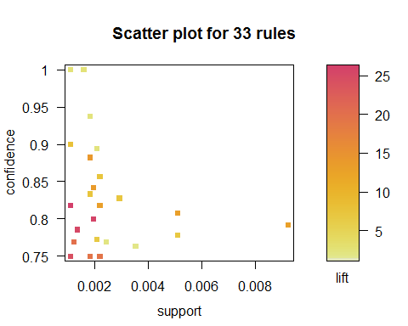

plot(rules, method="graph", control=list(type="items"))

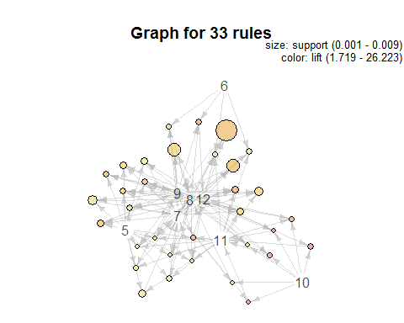

plot(rules, method="paracoord", control=list(reorder=TRUE))

