Vision Statement of the Department.
To be a preferred hub for nurturing computer engineering aspirants through innovative, ethical, value-based technical education, impactful research, and industry collaboration, to become successful professionals contributing for the betterment of society.
Mission Statement of the Department.
To nurture computer engineering professionals by offering Dynamic learning environment that encourages problem-solving using emerging technology, National Education Policy aligned evidence-based technical education, fostering ,innovation, research, and industry–institute collaboration & Holistic, ethical and sustainable development for lifelong success.

Session 2026-2027
Vision:Dream of where you want. | Mission: Means to achieve Vision
Program Educational Objectives of the program (PEO): (broad statements that describe the professional and career accomplishments)
PEO1 | Preparation | P: Preparation | Pep-CL abbreviation pronounce as Pep-si-lL easy to recall
PEO2 | Core Competence | E: Environment  (Learning Environment) | Pep-CL abbreviation pronounce as Pep-si-lL easy to recall
PEO3 | Breadth | P: Professionalism | Pep-CL abbreviation pronounce as Pep-si-lL easy to recall
PEO4 | Professionalism | C: Core Competence | Pep-CL abbreviation pronounce as Pep-si-lL easy to recall
PEO5 | Learning  Environment | L: Breadth (Learning in diverse areas) | Pep-CL abbreviation pronounce as Pep-si-lL easy to recall
Program Outcomes (PO): (statements that describe what a student should be able to do and know by the end of a program)
Keywords of POs:
Engineering knowledge,Problem analysis, Design/development of solutions,Conduct Investigations of Complex Problems, Engineering Tool Usage, The Engineer and The World,Ethics, Individual and Collaborative Team work,Communication, Project Management and Finance, Life-Long Learning
PSO Keywords: Cutting edge technologies, Research
“I am an engineer, and I know how to apply engineering knowledge to investigate, analyse and design solutions to complex problems using tools for entire world following all ethics in a collaborative way with proper management skills throughout my life.” to contribute to the development of cutting-edge technologies and Research.
Integrity: I will adhere to the Laboratory Code of Conduct and ethics in its entirety.

Name and Signature of Student and Date
(Signature and Date in Handwritten)
Vision Statement of the Department.
To be a preferred hub for nurturing computer engineering aspirants through innovative, ethical, value-based technical education, impactful research, and industry collaboration, to become successful professionals contributing for the betterment of society.
Mission Statement of the Department.
To nurture computer engineering professionals by offering Dynamic learning environment that encourages problem-solving using emerging technology, National Education Policy aligned evidence-based technical education, fostering ,innovation, research, and industry–institute collaboration & Holistic, ethical and sustainable development for lifelong success.
Session | 2024-25 (ODD) |  | Course Name | Web Technology Lab
Semester | 3 |  | Course Code | 23CT1301
Roll No | 75 |  | Name of Student | Shubhankar hardas
Practical Number
Course Outcome |  | - Understand various internet technologies.  - Design the web pages using HTML and CSS.  - Implement the XML technology to store the data.  - Develop the interactive web pages using JavaScript.
Aim |  | To design and develop a web-based shopping-cart interface in JavaScript using arrays of objects, and to implement item addition, deletion, and real-time total price computation using higher-order functions (map(), filter(), and reduce()).
Problem Definition |  | Design and implement an interactive shopping-cart application using JavaScript, HTML, and CSS. The system models catalog and cart items as arrays of objects, providing functionality to dynamically add items to the cart, remove specific entries, and compute the total price using JavaScript higher-order functions: map(), filter(), and reduce().
Theory  (100 words) |  | JavaScript treats functions as first-class citizens, enabling higher-order functions that accept callback functions as arguments to transform data without explicit loops.  - Arrays of Objects: Provide structured data storage, where each element represents an entity containing properties such as id, name, and price.  - map(): Creates a new array by applying a callback to every element, typically used to transform data into HTML string templates for rendering.  - filter(): Returns a subset array containing elements that pass a boolean predicate, ideal for removing an item matching a target identifier.  - reduce(): Aggregates array elements into a single value, such as summing item prices.
Procedure and Execution  (100 Words) |  | Step for Implementation:  1. Catalog Definition: Initialize an array of product objects containing id, name, and price.  2. Catalog Rendering: Use .map() on the product catalog to generate interactive UI buttons and cards with attached click handlers.  3. Add to Cart: Maintain a cart array; on clicking "Add to Cart", push the selected item into the cart array.  4. Remove from Cart: Implement item deletion by applying .filter() against unique item indices or IDs to exclude the selected entry.  5.Total Calculation: Compute the cumulative cost using .reduce((acc, curr) => acc + curr.price, 0).  6. DOM Update: Re-render the cart list and total summary after every add or remove event.
Code:
HTML:<!DOCTYPE html>
<html>
<head>
<meta charset="UTF-8">
<title>Shopping Cart</title>
<link rel="stylesheet" href="style.css">
</head>
<body>
<h1>Shopping Cart</h1>
<section id="product-list"></section>
<aside id="cart">
<h2>Your Cart</h2>
<ul id="cart-list"></ul>
<p>Total: <span id="total-price">0</span></p>
</aside>
<script src="javascript.js"></script>
</body>
</html>
JAVASRIPT: const products = [
{ id: 1, name: "Notebook", price: 40 },
{ id: 2, name: "Pen", price: 10 },
{ id: 3, name: "Bag", price: 500 },
{ id: 4, name: "Water Bottle", price: 150 }
];

let cart = [];

const productList = document.getElementById("product-list");
const cartList = document.getElementById("cart-list");
const totalPriceEl = document.getElementById("total-price");

function displayProducts() {
productList.innerHTML = products
.map((product) => `
<div class="product-card">
${product.name} - ₹${product.price}
<button onclick="addToCart(${product.id})">Add to Cart</button>
</div>
`)
.join("");
}

function addToCart(id) {
const item = products.find((p) => p.id === id);
cart.push(item);
displayCart();
}

function removeFromCart(id) {
cart = cart.filter((item) => item.id !== id);
displayCart();
}

function calculateTotal() {
return cart.reduce((sum, item) => sum + item.price, 0);
}

function displayCart() {
cartList.innerHTML = cart
.map((item) => `
<li>
${item.name} - ₹${item.price}
<button onclick="removeFromCart(${item.id})">Remove</button>
</li>
`)
.join("");
totalPriceEl.textContent = calculateTotal();
}

displayProducts();
css: body {
font-family: Arial, sans-serif;
display: flex;
gap: 30px;
}

.product-card {
border: 1px solid #ccc;
padding: 10px;
margin-bottom: 10px;
}

Vision Statement of the Department.
To be a preferred hub for nurturing computer engineering aspirants through innovative, ethical, value-based technical education, impactful research, and industry collaboration, to become successful professionals contributing for the betterment of society.
Mission Statement of the Department.
To nurture computer engineering professionals by offering Dynamic learning environment that encourages problem-solving using emerging technology, National Education Policy aligned evidence-based technical education, fostering ,innovation, research, and industry–institute collaboration & Holistic, ethical and sustainable development for lifelong success.
 | Output: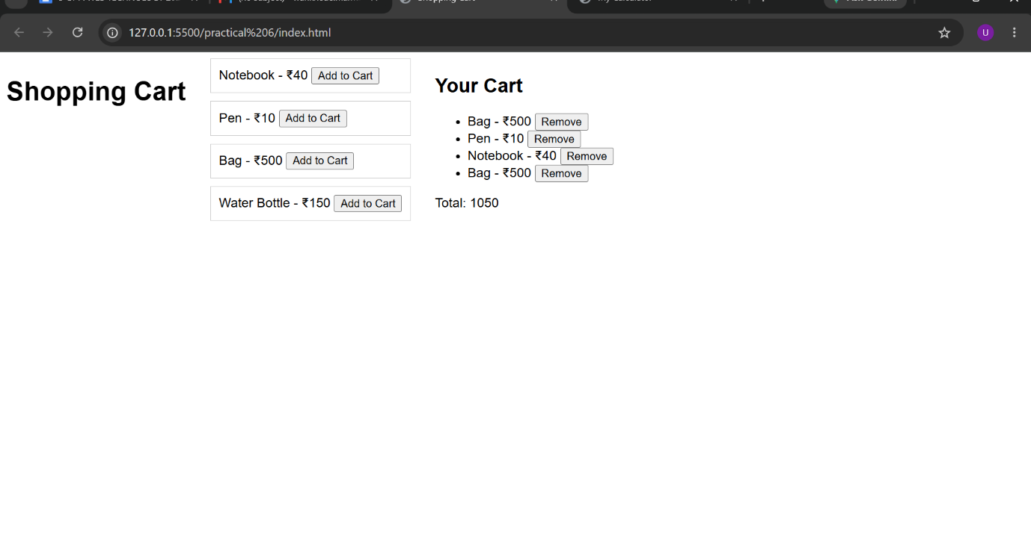
Output Analysis | The screenshot demonstrates the working state of the shopping-cart interface:  Product Catalog: Displays available inventory items—Notebook (₹40), Pen (₹10), Bag (₹500), and Water Bottle (₹150)—each paired with an "Add to Cart" action button.  Cart State: Contains four dynamically appended items: Bag (₹500), Pen (₹10), Notebook (₹40), and Bag (₹500), each equipped with an individual "Remove" button.  Arithmetic Verification: The cumulative total is evaluated via reduce():  $$\text{Total}=500+10+40+500=1050$$  The interface displays Total: 1050, confirming accurate aggregation and state synchronization.
Link of student Github profile where lab assignment has been uploaded | https://github.com/shubhankar2007501
Conclusion | The implementation demonstrates how functional programming principles in JavaScript produce clean, declarative, and maintainable state management. Leveraging map() for templating, filter() for state updates, and reduce() for cumulative computations eliminates boilerplate loop structures and simplifies DOM synchronization.
Plag Report (Similarity index < 12%)
Date | 30-09-2026

