**@Database Project- Doctor’s Appointment Booking System**

**How tos?**

(includes the website link, where and how to find the code for the map page.)

Re: Ramin Udash

Bishesh Shrestha

Shubhankar Bhattarai

Group 17

01.12.2022 // Assignment 11

1. **Website Link:** [**http://clabsql.clamv.jacobs-university.de/~rudash/**](http://clabsql.clamv.jacobs-university.de/~rudash/)

(Map can be found at the bottom of the home page. See screenshot below)

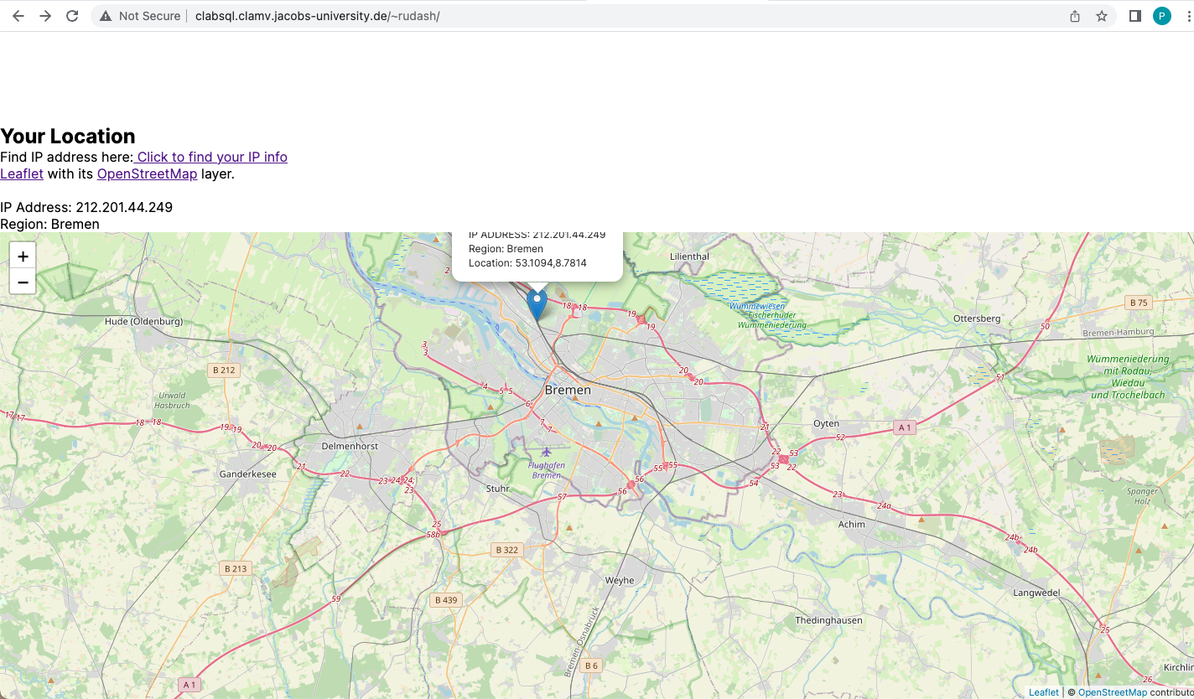

1. **Accessing assignment 11:**

Go to the home page i.e., index.html and scroll to thew bottom of the page.

* Username: group17admin
* Password: AboveInside

IP address and the region of the visitor of the website is displayed. Within the map, a marker is displayed that shows the IP, region and location coordinate.

This is the password for our database admin that we received recently. This should be entered in all individual data entry pages within Maintenance page. If incorrect or unauthorized combination is given, an error message will be given as necessary.

The other available user account with only read access for this group is:

* Username: group17
* Password: troopsstuck

Data cannot be entered into the tables using this combination of uname and pw. However, we use the second one within our php files for search pages as suggested in the assignment to use the one with read access only for search operations. The search files can be located within **/public_html/searchforms.**

We have created a user management table called usercredentials within our database which stores both of these. The entries were entered manually.