**CHAPTER 1**

**INTRODUCTION**

* 1. **INTRODUCTION :**

AgroZone is the farmer system where they can plan, monitor and analyse the activity of the farmers production system. It manages farmer operation with one system and organizes data in one place. It helps smart farmers become even smarter. This creates in partnership with growers and buyers. It inspire farmer to produce and buyers to consume fresh goods.

AgroZone System will make better connection among Farmers and Buyers ensure quality food. Standardize and increase efficiency of agro culture process.

* 1. **PROBLEM STATEMENT :**

Traditionally farmers used to travel and work hard to sell their product and even buyer has to reach a particular place to buy products from farmers . In some cases farmers fail to sell their products resulting in huge loses . Since the retail price is more than the wholesale prize , the buyers will have to pay more. Hence this application helps to solve these problems ,where farmers directly add products and price and buyer can buy it directly through this website .

**CHAPTER 2**

**LITERATURE WORK**

* 1. **Issues in Existing System**

In existing system Farmers used to travel to big cities to sell their products . This might cause them a huge amount of loss . Another problem for farmers is the difference between the price of wholesale and retail market . Looking at the buyer point of view ,some buyers has to travel and pay retailers more than the farmer. This might cause irregularity in prices .

* 1. **Proposed system**

It is focused on studying the existing system of agriculture in and to make sure that the peoples are getting quality fresh goods. This is also will produce:

* Less effort and less labour intensive, as the primary cost and focus primary on creating, managing, and running a secure quality food supply.
* Increasing number of buyers as individuals will find it easier and more convenient to buy goods.
* Easy management.

**CHAPTER 3**

**TOOLS USED**

**3.3. HTML :**

Hypertext Markup Language (HTML) is the standard markup languages for documents designed to be displayed in a web browser. It can be assisted by technologies such as Cascading sheets (CSS) and scripting languages such as JavaScripts .

Web browsers receive HTML documents from a web server or from local storage and render the documents into multimedia web pages. HTML describes the structure of a web page semantically and originally included cues for the appearance of the document.

HTML elements are the building blocks of HTML pages. With HTML constructs, images and other objects such as interactive forms may be embedded into the rendered page. HTML provides a means to create structured documents by denoting structural semantics for text such as headings, paragraphs, lists, links, quotes and other items.

* 1. **Skeleton CSS :**

Skeleton is a simple, responsive boilerplate to kickstart any responsive project.

Skeleton is lightweight and simple. It styles only raw HTML elements (with a few exceptions) and provides a responsive grid. Nothing more.

* Around 400 lines of CSS unminified and with comments
* It's a starting point, not a UI framework
* No compiling or installing just vanilla CSS

* 1. **Cascading Style Sheets** (**CSS**)**:**

Is a style sheet language used for describing the presentation of a document written in a markup language such as HTML. CSS is a cornerstone technology of the World Wide Web, alongside HTML and JavaScript.

CSS is designed to enable the separation of presentation and content, including layout, colors, and fonts. This separation can improve content accessibility, provide more flexibility and control in the specification of presentation characteristics, enable multiple web pages to share formatting by specifying the relevant CSS in a separate .css file which reduces complexity and repetition in the structural content as well as enabling the .css file to be cached to improve the page load speed between the pages that share the file and its formatting.

* 1. **PHP :**

**PHP** is a general-purpose scripting language especially suited to web development. It was originally created by Danish-Canadian programmer Rasmus Lerdorf in 1994.The PHP reference implementation is now produced by The PHP Group. PHP originally stood for *Personal Home Page*, but it now stands for the recursive initialism *PHP: Hypertext Preprocessor*.

PHP code is usually processed on a web server by a PHP interpreter implemented as a module, a daemon or as a Common Gateway Interface (CGI) executable. On a web server, the result of the interpreted and executed PHP code – which may be any type of data, such as generated HTML or binary image data – would form the whole or part of an HTTP response. Various web template systems, web content management systems, and web frameworks exist which can be employed to orchestrate or facilitate the generation of that response. Additionally, PHP can be used for many programming tasks outside of the web context, such as standalone graphical applicationsand robotic drone control.Arbitrary PHP code can also be interpreted and executed via command-line interface (CLI).

* 1. **XAMP :**

XAMPP is a free and open-source cross-platform web server solution stack package developed by Apache Friends, consisting mainly of the Apache HTTP Server, MariaDB database, and interpreters for scripts written in the PHP and Perl programming languages.  Since most actual web server deployments use the same components as XAMPP, it makes transitioning from a local test server to a live server possible.

XAMPP's ease of deployment means a WAMP or LAMP stack can be installed quickly and simply on an operating system by a developer, with the advantage that common add-in applications such as WordPress and Joomla! can also be installed with similar ease using Bitnami.Though it is a heavy app for most of the operating systems even when owing to its less size it takes a load on the processor speed.

* 1. **PhpStorm :**

PhpStorm is a commercial, cross-platform IDE (integrated development environment) for PHP built by the Czech Republic-based company JetBrains.

PhpStorm provides an editor for PHP, HTML and JavaScript with on-the-fly code analysis, error prevention and automated refactorings for PHP and JavaScript code. PhpStorm's code completion supports PHP 5.3, 5.4, 5.5, 5.6, 7.0, 7.1, 7.2, 7.3, 7.4 and 8.0 (modern and legacy projects), including generators, coroutines, the finally keyword, list in foreach, namespaces, closures, traits and short array syntax. It includes a full-fledged SQL editor with editable query results

**CHAPTER 4**

**DESIGN**

**ENTITY RELATIONSHIP DIAGRAM :** 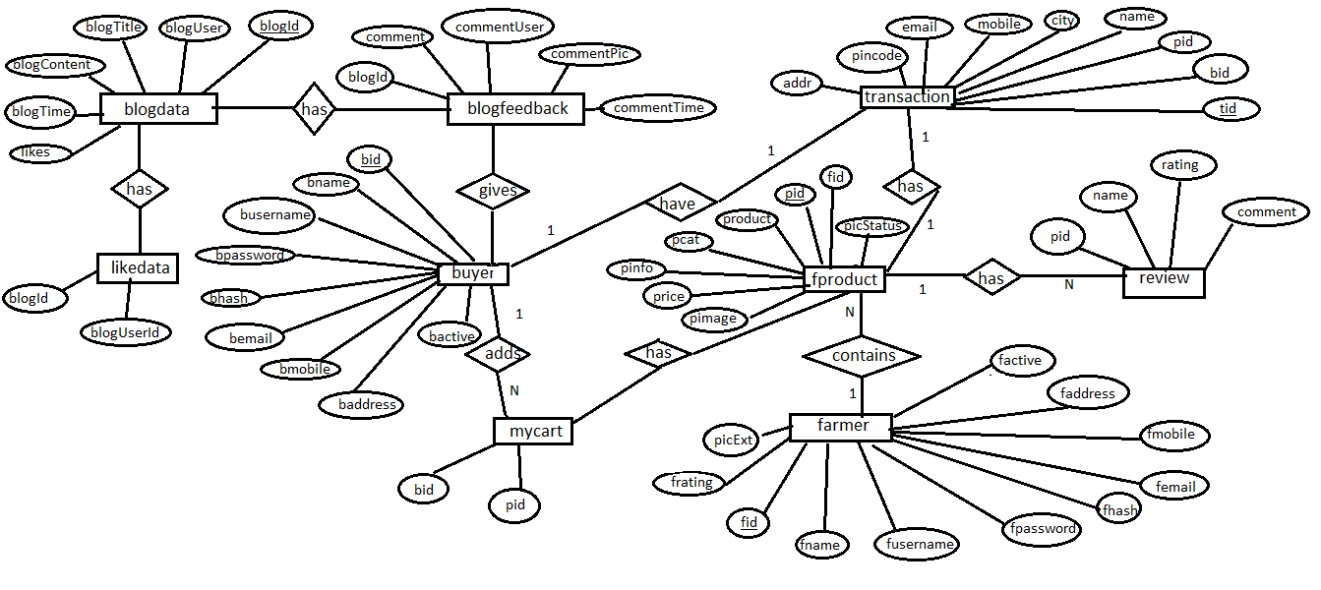

**Figure 1 :** E R Diagram.

An entityrelationshipdiagram (ERD) shows the relationships of entity sets stored in a database. These entities can have attributes that define its properties. By defining the entities, their attributes, and showing the relationships between them, an ERdiagram illustrates the logical structure of databases. In our ERD it is clearly shown above there are nine entities which are blogdata , farmer , buyer , fproduct , transaction , my cart , blog feedback , blog data, like data , review. And the attributes are shown respectively.

**SCHEMA DIAGRAM :**

blogdata

blogContent

blogTitle

likes

blogTime

blogUser

blogId

blogfeedback

commentTime

commentPic

commentUser

comment

blogId

blogid

buyer

bmobile

bemail

bhash

bpassword

busername

bname

bid

bactive

baddress

farmer

faddress

fmobile

femail

fhash

fpassword

fusername

fname

fid

picExt

frating

factive

fproduct

picStatus

pimage

price

pinfo

pcart

product

pid

fid

likedata

blogUser

blogId

mycart

pid

bid

review

comment

rating

name

pid

transaction

addr

pincode

email

mobile

city

name

pid

bid

tid

Relationalschema refers to the meta-data that describes the structure of data within a certain domain. It is the blueprint of a database that outlines the way its structure organizes data into tables. The term "schema" refers to the organization of data as a blueprint of how the database is constructed (divided into database tables in the case of relational databases). The formal definition of a database schema is a set of formulas (sentences) called integrity constraints imposed on a database.

**CHAPTER 5**

**IMPLEMENTATION**

* 1. **db.php :** This is the connection of database using php.

<?php

$serverName = "localhost";

$userName = "root";

$password = "";

$dbName = "agrozon";

$conn = mysqli_connect($serverName, $userName, $password, $dbName);

if (!$conn)

{

die("Connection failed: " . mysqli_connect_error());

}

?>

<!-- db connection -->

* 1. **Agrozon.sql:**

CREATE TABLE `blogdata` (

`blogId` int(10) NOT NULL,

`blogUser` varchar(256) NOT NULL,

`blogTitle` varchar(256) NOT NULL,

`blogContent` longtext NOT NULL,

`blogTime` timestamp NOT NULL DEFAULT current_timestamp(),

`likes` int(10) NOT NULL DEFAULT 0

)

CREATE TABLE `blogfeedback` (

`blogId` int(10) NOT NULL,

`comment` varchar(256) NOT NULL,

`commentUser` varchar(256) NOT NULL,

`commentPic` varchar(256) NOT NULL DEFAULT 'profile0.png',

`commentTime` timestamp NOT NULL DEFAULT current_timestamp()

)

CREATE TABLE `buyer` (

`bid` int(100) NOT NULL,

`bname` varchar(100) NOT NULL,

`busername` varchar(100) NOT NULL,

`bpassword` varchar(100) NOT NULL,

`bhash` varchar(100) NOT NULL,

`bemail` varchar(100) NOT NULL,

`bmobile` varchar(100) NOT NULL,

`baddress` text NOT NULL,

`bactive` int(100) NOT NULL DEFAULT 0

)

CREATE TABLE `farmer` (

`fid` int(255) NOT NULL,

`fname` varchar(255) NOT NULL,

`fusername` varchar(255) NOT NULL,

`fpassword` varchar(255) NOT NULL,

`fhash` varchar(255) NOT NULL,

`femail` varchar(255) NOT NULL,

`fmobile` varchar(255) NOT NULL,

`faddress` text NOT NULL,

`factive` int(255) NOT NULL DEFAULT 0,

`frating` int(11) NOT NULL DEFAULT 0,

`picExt` varchar(255) NOT NULL DEFAULT 'png',

`picStatus` int(10) NOT NULL DEFAULT 0

)

CREATE TABLE `fproduct` (

`fid` int(255) NOT NULL,

`pid` int(255) NOT NULL,

`product` varchar(255) NOT NULL,

`pcat` varchar(255) NOT NULL,

`pinfo` varchar(255) NOT NULL,

`price` float NOT NULL,

`pimage` varchar(255) NOT NULL DEFAULT 'blank.png',

`picStatus` int(10) NOT NULL DEFAULT 0

)

CREATE TABLE `likedata` (

`blogId` int(10) NOT NULL,

`blogUserId` int(10) NOT NULL

)

CREATE TABLE `mycart` (

`bid` int(10) NOT NULL,

`pid` int(10) NOT NULL

)

CREATE TABLE `review` (

`pid` int(10) NOT NULL,

`name` varchar(255) NOT NULL,

`rating` int(10) NOT NULL,

`comment` text NOT NULL

)

CREATE TABLE `transaction` (

`tid` int(10) NOT NULL,

`bid` int(10) NOT NULL,

`pid` int(10) NOT NULL,

`name` varchar(255) NOT NULL,

`city` varchar(255) NOT NULL,

`mobile` varchar(255) NOT NULL,

`email` varchar(255) NOT NULL,

`pincode` varchar(255) NOT NULL,

`addr` varchar(255) NOT NULL

)

* 1. **Index.php :**

<?php session_start(); ?>

<!DOCTYPE html>

<html lang="en">

<head>

<meta charset="UTF-8">

<title>AgroZon</title>

<meta http-equiv="content-type" content="text/html; charset=utf-8" />

<meta name="description" content="" />

<meta name="keywords" content="" />

<link href="bootstrap\css\bootstrap.min.css" rel="stylesheet">

<script src="https://ajax.googleapis.com/ajax/libs/jquery/1.12.4/jquery.min.js"></script>

<script src="bootstrap\js\bootstrap.min.js"></script>

<!--[if lte IE 8]><script src="css/ie/html5shiv.js"></script><![endif]-->

<link rel="stylesheet" href="login.css"/>

<script src="js/jquery.min.js"></script>

<script src="js/skel.min.js"></script>

<script src="js/skel-layers.min.js"></script>

<script src="js/init.js"></script>

<noscript>

<link rel="stylesheet" href="css/skel.css" />

<link rel="stylesheet" href="css/style.css" />

<link rel="stylesheet" href="css/style-xlarge.css" />

</noscript>

<link rel="stylesheet" href="indexfooter.css" />

<!--[if lte IE 8]><link rel="stylesheet" href="css/ie/v8.css" /><![endif]-->

</head>

<?php

require 'menu.php';

?>

**CHAPTER 6**

**RESULT AND DISCUSSION**

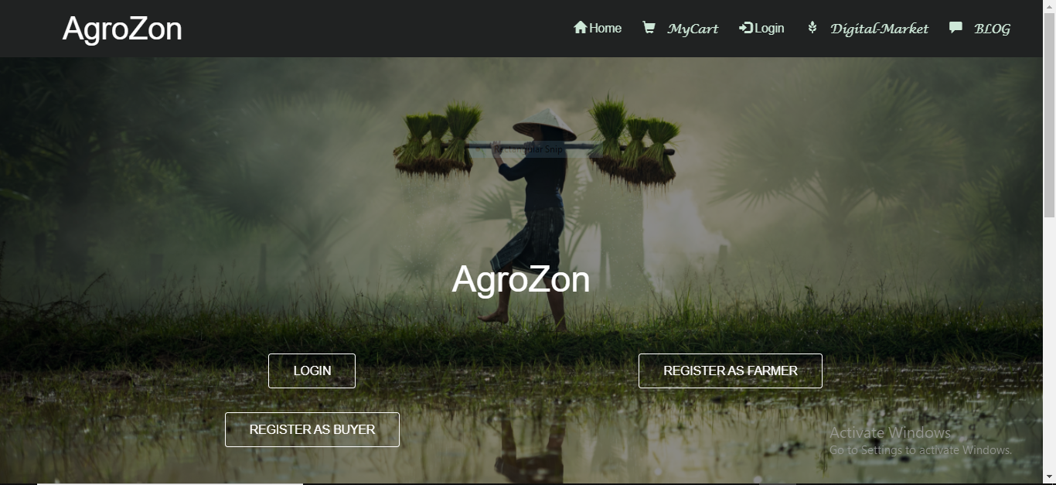

**Figure 3 :** home page of our web app

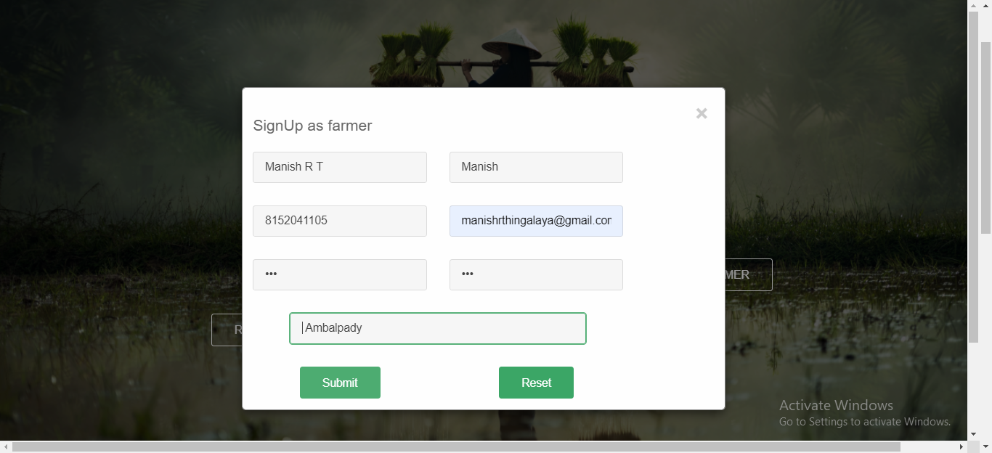

**Figure 4 :** This is the registration form for farmer

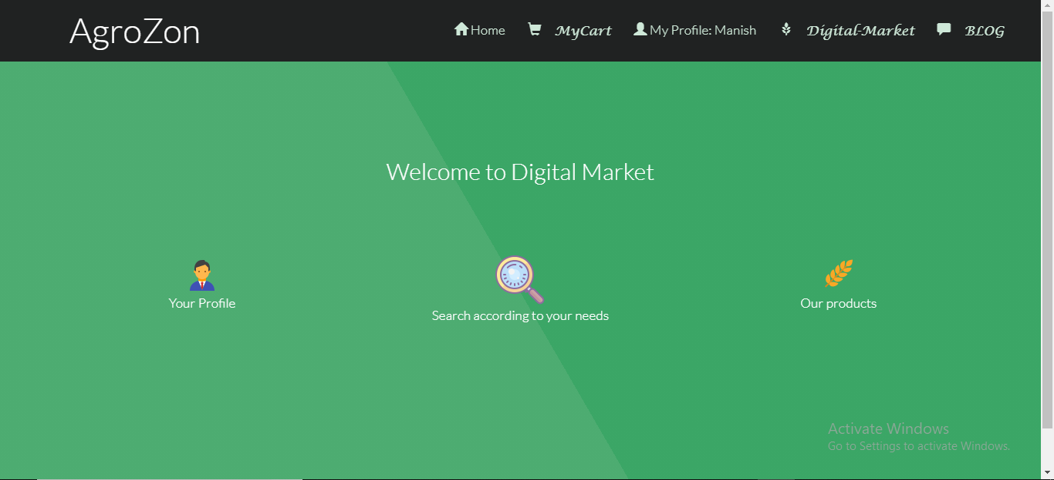

**Figure 5:** This snap is of a page when we press digital market.

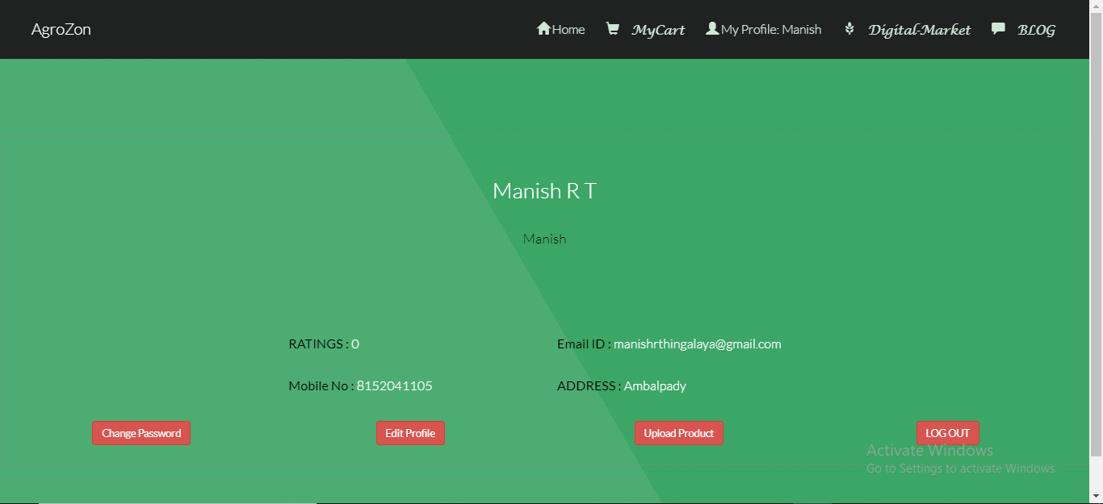

**Figure 6:** This snap is of a page when we press your profile .

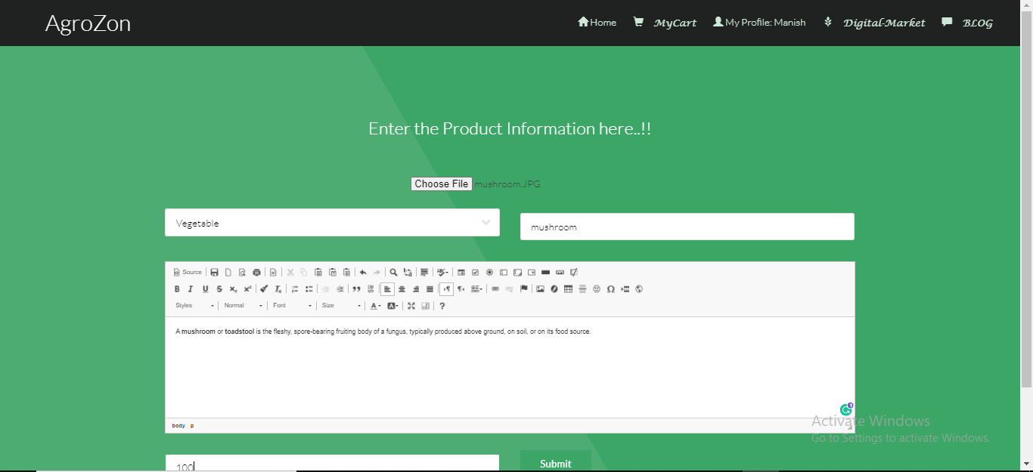

**Figure 7 :** Farmer can upload their product .

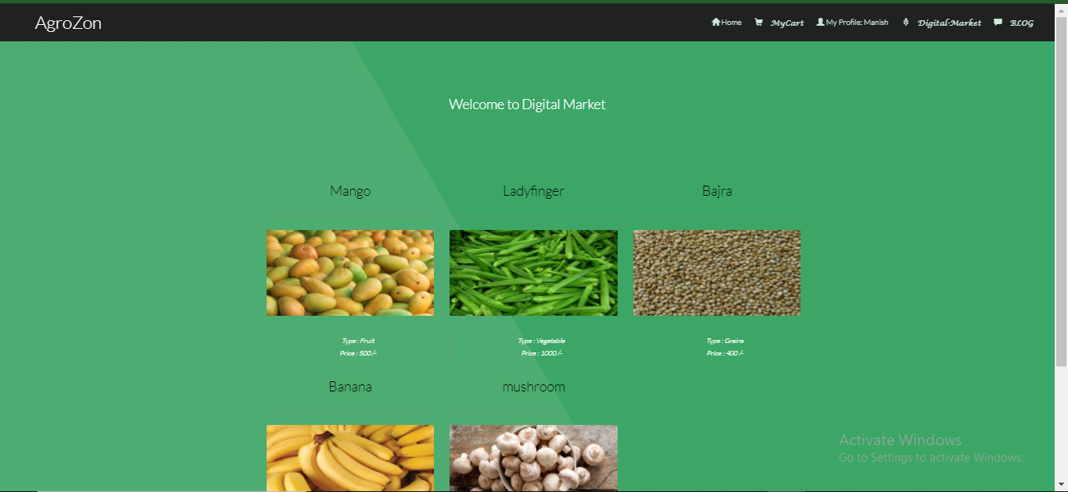

**Figure 8 :** View the product entered by farmer.

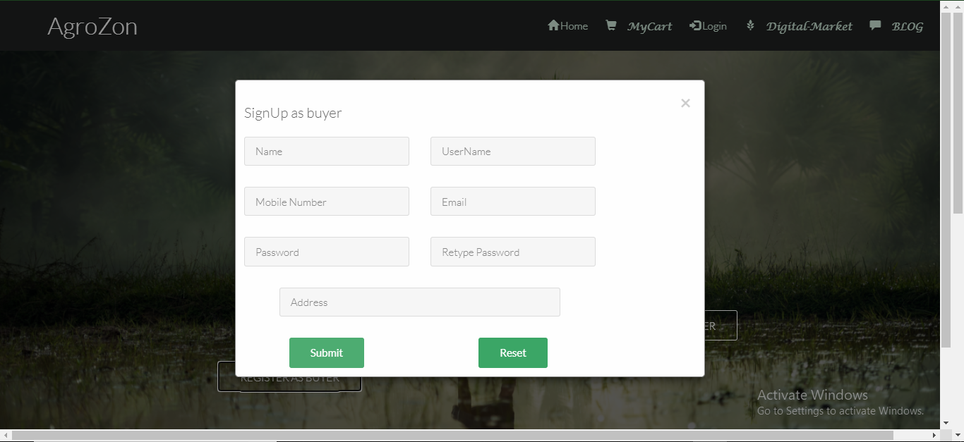

**Figure 9 :** A user can register as buyer too

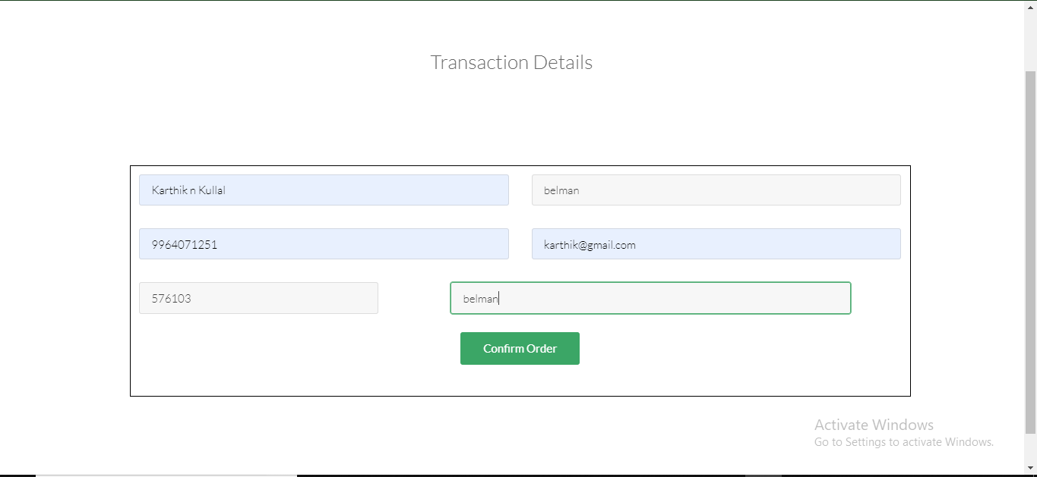

**Figure 10:** After buying the product the buyer has to put Transaction details.

**CHAPTER 7**

**CONCLUSION**

The farm management system helps the farmers to sell their product online hence reducing the work of farmer . This web application also help buyer to buy the farm products online and at the price mentioned by farmers . Hence can be affordable and easy to buy , which will also increases the number of buyers . This web application helps in solving all the problems faced by both buyer and seller . Agrozon is the error less web application making easy for farmer to go online and sell their products which can bring more buyer due its flexibility. Its connects the connection between farmers and buyer. Farmer can upload any products in this web application which reduces the work of farmer and buyer can buy the products with ease. Hence we conclude that this web application helps the society in digital way.