Name: Chandrakant Thakare
PRN : 22310303 Roll No. : 382014
Class : TY CSE AI (B)
Subject : IS (Practical Lab)

Assignment No: 3

Title: Implement RSA Algorithm

Objective: The key objectives of this assignment are:
- To study the concept of asymmetric (public-key) cryptography.
- To understand the RSA algorithm for encryption and decryption.
- To implement RSA for secure message communication.

Theory:

Introduction to Asymmetric Cryptography
Unlike symmetric key cryptography (AES, DES) where the same key is used for both encryption and decryption, asymmetric cryptography uses two keys:
- Public Key → Shared openly, used for encryption.
- Private Key → Kept secret, used for decryption.
This removes the problem of secure key distribution that exists in symmetric cryptography.

RSA Algorithm
The RSA algorithm, developed in 1977 by Ron Rivest, Adi Shamir, and Leonard Adleman, is one of the first public-key cryptosystems and remains widely used today.
- Type: Asymmetric (Public Key) Cryptosystem
- Key Sizes: 1024, 2048, 4096 bits commonly used
- Based On: Difficulty of factoring large prime numbers

RSA Key Generation Steps
- Choose two large prime numbers p and q.
- Compute modulus:
n = p×q
(This n is part of both public and private keys.)
- Compute Euler’s Totient Function:
ϕ(n)=(p−1)(q−1)
- Choose public exponent e:
  - Must be relatively prime to φ(n) (commonly e = 65537).
- Compute private exponent d:
  - d is the modular inverse of e modulo φ(n).
d×e ≡ 1 (mod ϕ(n))
Public Key = (e, n)
Private Key = (d, n)

RSA Encryption
To encrypt a message M (as a number < n):
C = M^e mod n
Where:
- M → plaintext (converted to number)
- C → ciphertext

RSA Decryption
To decrypt:
M = C^d mod n
Where:
- C → ciphertext
- M → original plaintext

Advantages of RSA
- Secure: Based on difficulty of factoring large numbers.
- Key Distribution: Public key can be freely shared.
- Digital Signatures: Provides authentication along with encryption.

Limitations of RSA
- Slow: Much slower than symmetric algorithms like AES.
- Key Size: Requires very large keys (2048/4096 bits) for strong security.
- Not used for bulk data: Instead, RSA is typically used to exchange a symmetric key, which is then used for fast encryption (hybrid cryptography).

Code:

def gcd(a, b):
while b != 0:
a, b = b, a % b
return a

def multiplicative_inverse(e, phi):

d, x1, x2, y1 = 0, 0, 1, 1
temp_phi = phi
while e > 0:
temp1, temp2 = divmod(temp_phi, e)
temp_phi, e = e, temp2
x, y = x2 - temp1 * x1, d - temp1 * y1
x2, x1, d, y1 = x1, x, y1, y
if temp_phi == 1:
return d + phi

def generate_keys(p, q):
n = p * q
phi = (p - 1) * (q - 1)

e = 3
while gcd(e, phi) != 1:
e += 2

d = multiplicative_inverse(e, phi)

return ((e, n), (d, n

def encrypt(pk, plaintext):
key, n = pk
cipher = [pow(ord(char), key, n) for char in plaintext]
return cipher

def decrypt(pk, ciphertext):
key, n = pk
plain = [chr(pow(char, key, n)) for char in ciphertext]
return ''.join(plain)

if __name__ == "__main__":
print("Simple RSA Demonstration")

p = 61
q = 53

public, private = generate_keys(p, q)

print("\nPublic Key:", public)
print("Private Key:", private)

message = input("\nEnter a message to encrypt: ")
encrypted_msg = encrypt(public, message)
print("Encrypted Message:", encrypted_msg)

decrypted_msg = decrypt(private, encrypted_msg)
print("Decrypted Message:", decrypted_msg)

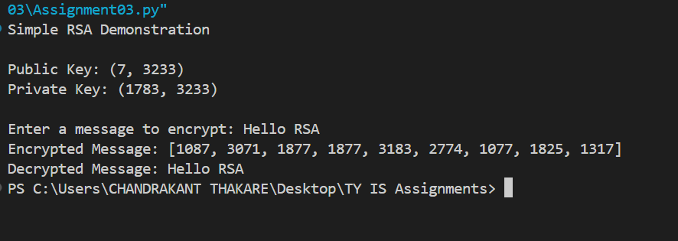
OUTPUT :

