Code coverage document can be found in axocover_report/index.htm – Gated as 90%

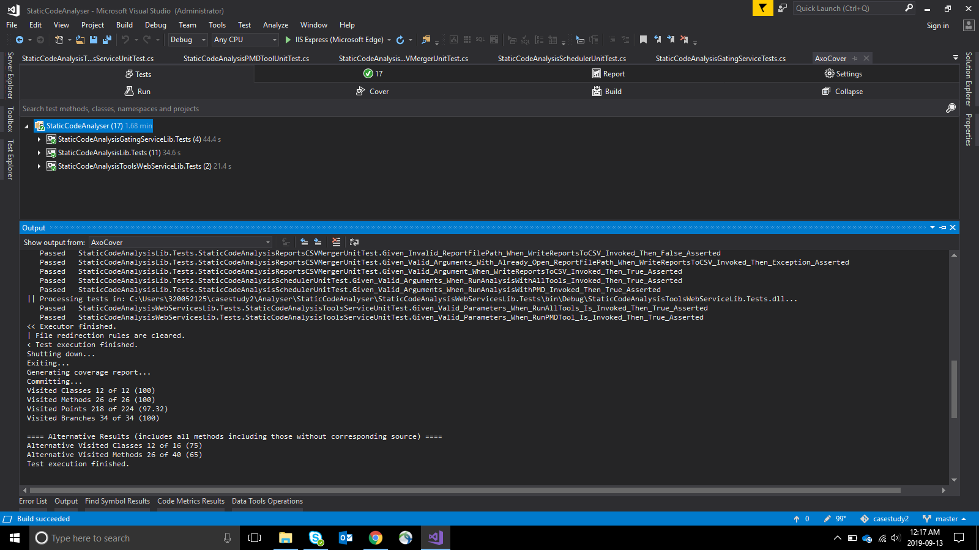

For code duplication run AutoBuild.bat to execute simian tool – Gated as 0

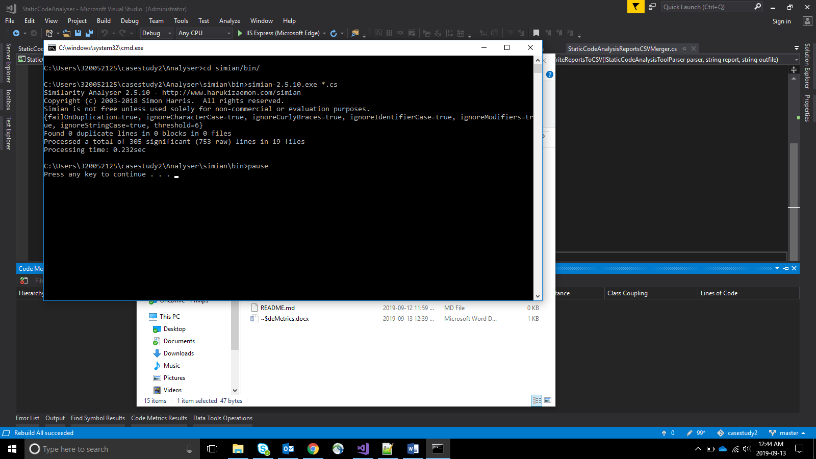

Cyclomatic Complexity report can be found in Documentation/CyclomaticComplexity.xlsx – Gated as 4