**Experiment-1**

**Aim** - a. Learn to install PostgreSql.

b. Compare different Databases such as PostgreSQL, Oracle, IBM DB2, MySql.

**a) Learn to install PostgreSql**

Following steps were to install PostgreSQL on Windows machine. Pick the version number of PostgreSQL you want and, as exactly as possible, the platform you want from a Enterprise DB

1. Download postgresql-16.1 for Windows PC running in 64 bit mode.
2. Run postgresql-16.1-1-windows-x64.exe as administrator and click next.

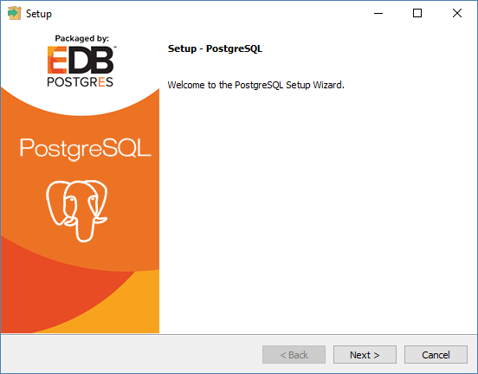

1. To install PostgreSQL. Select the location where you want to install it. By default it is installed within Program Files folder.

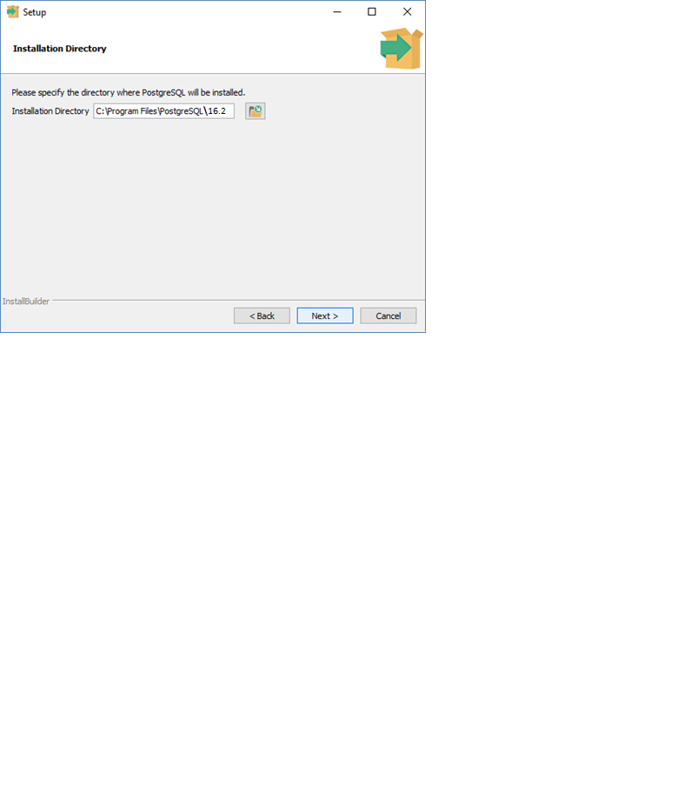

1. The next step of the installation process would be to select the directory where data would be stored, by default it is stored under "data" directory.

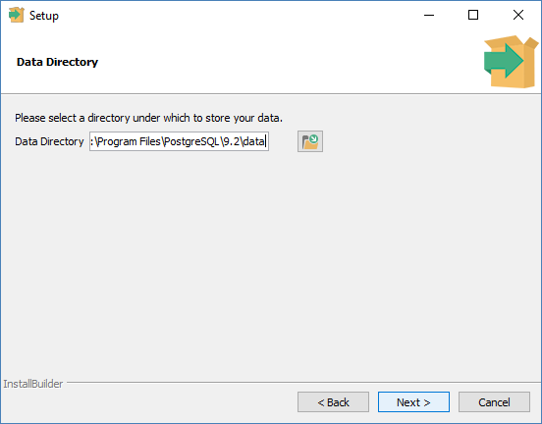

1. The next step, setup asks for password, so you can use your favorite password

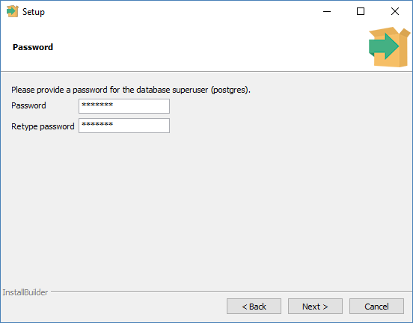

1. The next step, keep the port as default

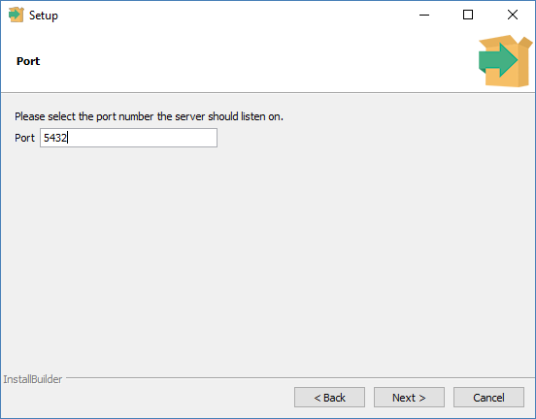

1. The next step, when asked for "Locale", "English, United States" has been selected.

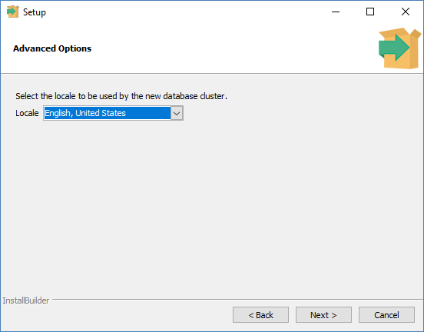

1. It takes a while to install PostgreSQL on your system. On completion of the installation process, you will get the following screen. Uncheck the checkbox and click on Finish button.

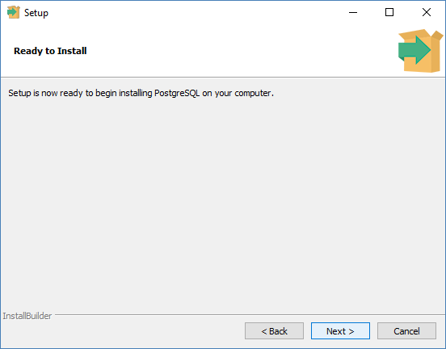

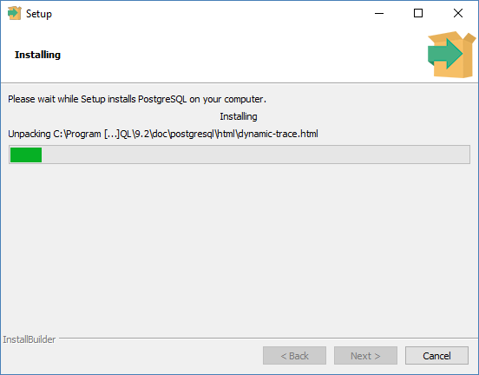

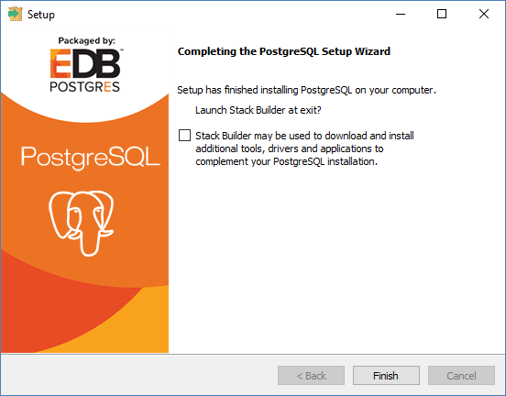

**b) Compare different Databases such as PostgreSQL, Oracle, IBM DB2, MySql.**

PostgreSQL, Oracle, IBM DB2, and MySQL are all popular relational database management systems (RDBMS), but they have some differences in terms of features, performance, licensing, and use cases. Below is a comparison of these databases:

**PostgreSQL:**

* Licensing: PostgreSQL is open-source and released under the PostgreSQL License, which is similar to the MIT License.
* Performance: Known for its extensibility, PostgreSQL supports various indexing methods and has good performance for read-heavy workloads. It has strong support for complex queries and advanced data types.
* Features: Supports advanced data types like JSON, hstore, and array. Has a rich set of features including support for stored procedures, triggers, and views.
* Community: Has a strong open-source community that contributes to its development and maintenance.

**Oracle:**

* Licensing: Oracle Database is a commercial product, and its licensing can be expensive. Oracle offers various editions with different feature sets and pricing.
* Performance: Oracle is known for its robustness and is often used in enterprise-level applications. It excels in handling complex transactions and high-concurrency environments.
* Features: Offers a wide range of features including advanced security options, data warehousing, and support for complex data types. Oracle also has a comprehensive set of management tools.
* Community: Oracle has a large user base and provides extensive documentation and support, but it's not an open-source community.

**IBM DB2:**

* Licensing: IBM DB2 is a commercial RDBMS, and its licensing model can vary based on the edition and deployment scenario.
* Performance: IBM DB2 is known for its performance and scalability. It is often used in large enterprises and supports various deployment options, including on-premises and cloud.
* Features: Offers features like robust security, data compression, and support for complex data types. It has a reputation for high availability and reliability.
* Community: IBM DB2 has a strong user community, and IBM provides support and documentation for its users.

**MySQL:**

* Licensing: MySQL is open-source and is dual-licensed under the GNU General Public License or a commercial license for proprietary use.
* Performance: MySQL is known for its speed and is often used in web applications. It is particularly well-suited for read-heavy workloads.
* Features: Supports a wide range of storage engines, including InnoDB and MyISAM. It has a simple configuration and is easy to set up.
* Community: MySQL has a large and active open-source community. It is widely used in web development, and there are many resources available for support.

**Experiment-2**

**Aim** - Write SQL queries on DDL (eg create, alter, drop, rename, truncate), DML (eg. Insert, update, delete etc.), DCL (eg. Grant, revoke etc.) and Built-in Functions (eg Sum, min, max, avg, count, lower, upper, trim, len etc.) in PostgreSQL.

**Code:**

1. **DDL – Data Definition Language**

**Create query** – create table students (name varchar(50), roll_number INT, branch varchar(50), marks INT);

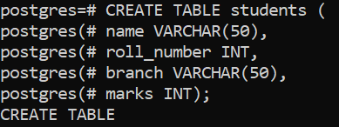

**Alter query** – alter table students add column age INT;

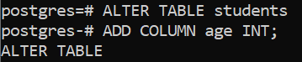

**Drop query** – drop table students;



1. **DML – Data Manipulation Language**

**Insert query** – INSERT INTO students (name, roll _ number, branch, marks) values

('John Doe', 101, 'CSE', 85), ('Jane Smith', 102, 'CSE', 78), ('Bob Johnson', 103, 'CSE', 90),

('Alex smith', 104, 'IT', 91), ( 'Taylor Ron', 105,'IT', 87), ('Aditya Goel', 106, 'CSE', 94),

('Stephen max', 107, 'ME', 89), ('Jayden Miller', 108, 'ME', 63);

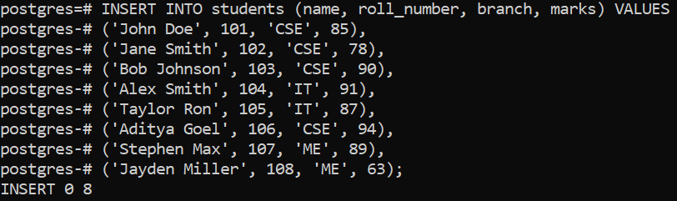

**Update query** – update students set marks = 98 where roll_number = 106;



**Delete query** – delete from students where roll_number = 108;



1. **DCL – Data Control Language**

**Create user -** CREATE USER username WITH PASSWORD 'password';

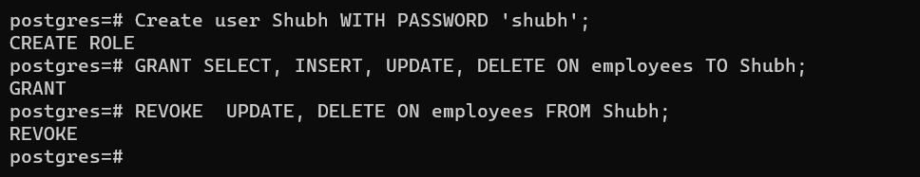

**Grant permission -** GRANT SELECT, INSERT, UPDATE ON table_name TO rolename;



**Revoke Permission -** REVOKE SELECT, INSERT, UPDATE ON tablename FROM role;



1. **Built in Functions**

**Sum** – select sum(marks) as total_marks from students;

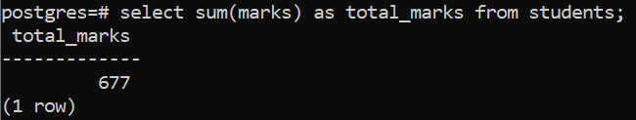

**Count** – select count(*) from students;

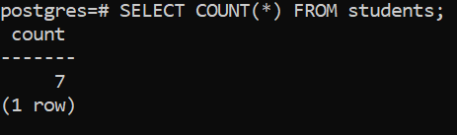

**Average** – select avg(marks) from students;

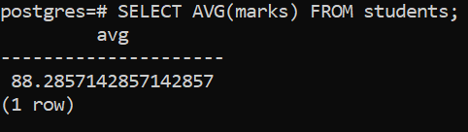

**Min Max** – select max(marks) as max_marks, min(marks) as min_marks from students;

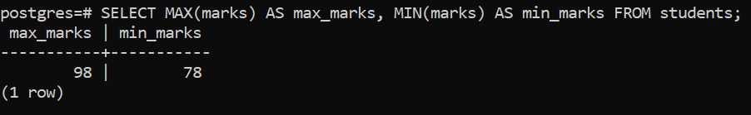

**Lower** – select name, lower(name) as lower_name from students;

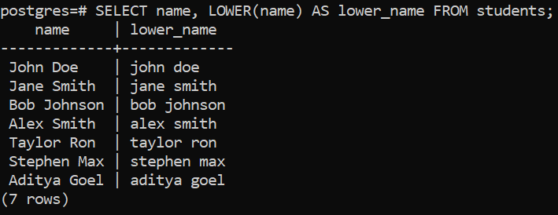

**Upper** – select name, upper(name) as upper_name from students;

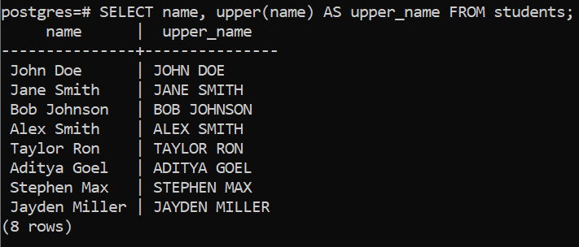

**Length** – select name, length(name) as name_length from students;

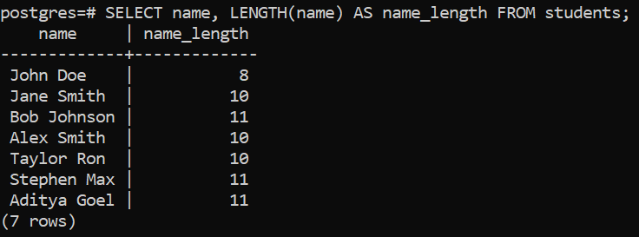

**Experiment-3**

**Aim** - Write SQL queries on Nested queries and Join.

Code:

1. **Nested Query 1 -** Select name, (select ( avg(marks) from students) as avg_marks from students;

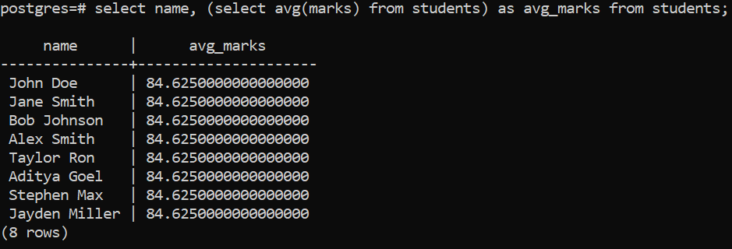

1. **Nested Query 2 -** Select name, branch, marks from students where marks > (select avg(marks) from students);

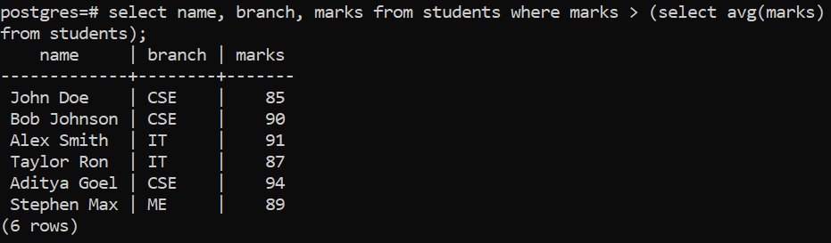

1. **Inner Join -** Select * from students inner join courses on students.branch = courses.course_name;

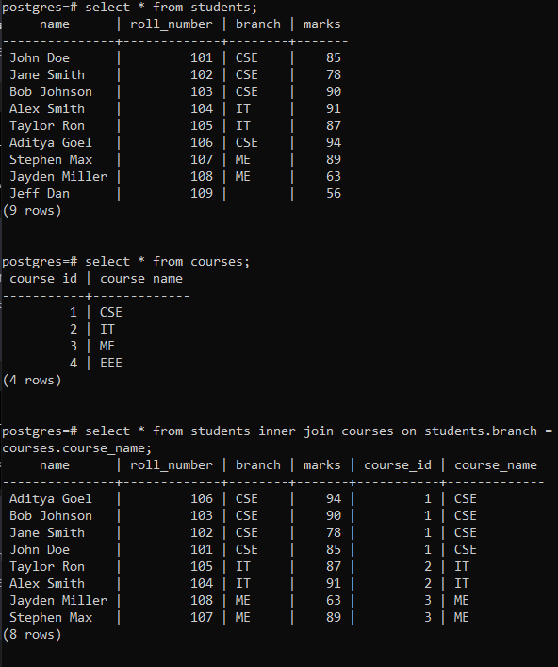

1. **Left Join**

Select * from students left join courses on students.branch = courses.course_name;

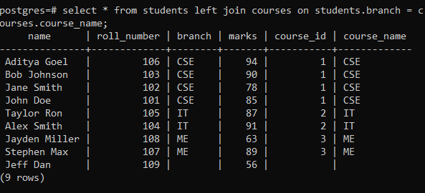

1. **Right Join**

Select * from students right join courses on students.branch = courses.course_name;

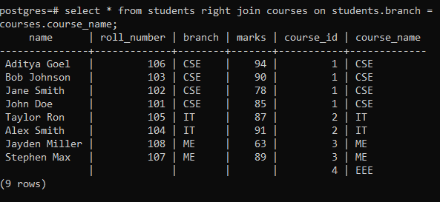

1. **Full Outer Join**

Select * from students full outer join courses on students.branch = courses.course_name;

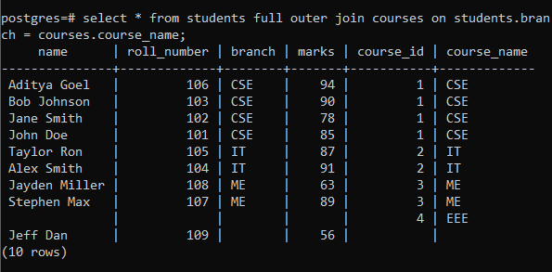

**Experiment-4**

**Aim** - a. Create an index

b. Drop index

c. Create view with condition

d. Drop the view

**Code:**

1. **Create index -** Create index idx_marks on students(marks);



1. **Drop index -** Drop index idx_marks;



1. **Create view -** Create view high_marks_students as select * from students where marks > 85;

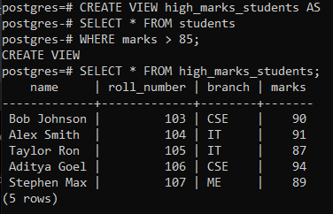

1. **Drop view -** Drop view high_marks_students;

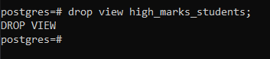

**Experiment-5**

**Aim** - a. Write a program for addition of two numbers

b. Write a program to check the given number is even or odd

c. Write a program to inverse a number

d. Write a program to calculate the average of n numbers

**Code**

1. **Addition of two numbers.**

CREATE OR REPLACE FUNCTION add_numbers(a INTEGER, b INTEGER)

RETURNS INTEGER AS $$

DECLARE

result INTEGER;

BEGIN

result := a + b;

RETURN result;

END;

$$ LANGUAGE plpgsql;

SELECT add_numbers(5, 7) AS sum_result;

1. **Check if number is even or odd**

CREATE OR REPLACE FUNCTION check_even_odd(num INTEGER)

RETURNS VARCHAR AS $$

DECLARE

result VARCHAR;

BEGIN

IF num % 2 = 0 THEN

result := 'Even';

ELSE

result := 'Odd';

END IF;

RETURN result;

END;

$$ LANGUAGE plpgsql;

SELECT check_even_odd(10) AS number_result;

1. **Inverse a number**

CREATE OR REPLACE FUNCTION reverse_digits(num INTEGER)

RETURNS INTEGER AS $$

DECLARE

reversed INTEGER := 0;

remainder INTEGER;

BEGIN

WHILE num > 0 LOOP

remainder := num % 10;

reversed := reversed * 10 + remainder;

num := num / 10;

END LOOP;

RETURN reversed;

END;

$$ LANGUAGE plpgsql;

SELECT reverse_digits(12345) AS reversed_result;

1. **Calculate average of n numbers**

CREATE OR REPLACE FUNCTION calculate_average(numbers INTEGER[])

RETURNS NUMERIC AS $$

DECLARE

total NUMERIC := 0;

count INTEGER := 0;

avg NUMERIC;

BEGIN

FOR i IN 1..array_length(numbers, 1) LOOP

total := total + numbers[i];

count := count + 1;

END LOOP;

IF count > 0 THEN

avg := total / count;

RETURN avg;

ELSE

RAISE EXCEPTION 'Array is empty.';

END IF;

END;

$$ LANGUAGE plpgsql;

SELECT calculate_average(ARRAY[5, 10, 15]) AS avg_result;

**Output**

1. **Sum of two numbers**

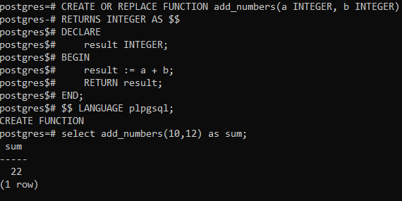

1. **Check number odd or even**

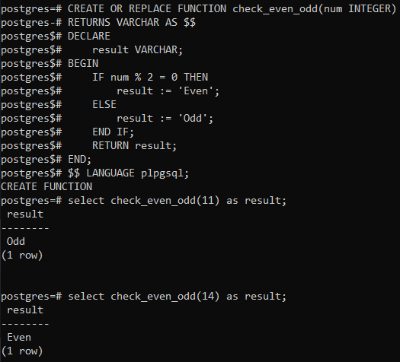

1. **Inverse a number**

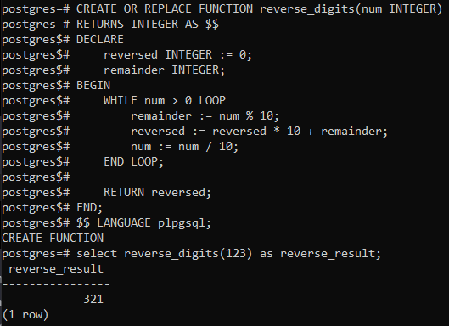

1. **Average of n numbers**

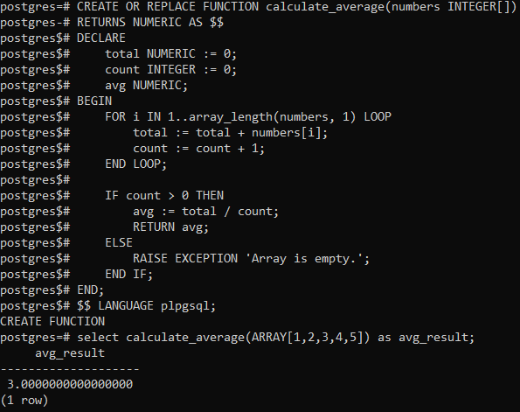

**Experiment-6**

**Aim** - Write the cursor to increase the salary by 50%

**Code** :-

DO $$

DECLARE

emp_record RECORD;

BEGIN

FOR emp_record IN SELECT id, salary FROM employees LOOP

UPDATE employees

SET salary = emp_record.salary*1.5 -- Increasing salary by 50%

WHERE id = emp_record.id;

END LOOP;

END $$;

select* from employees

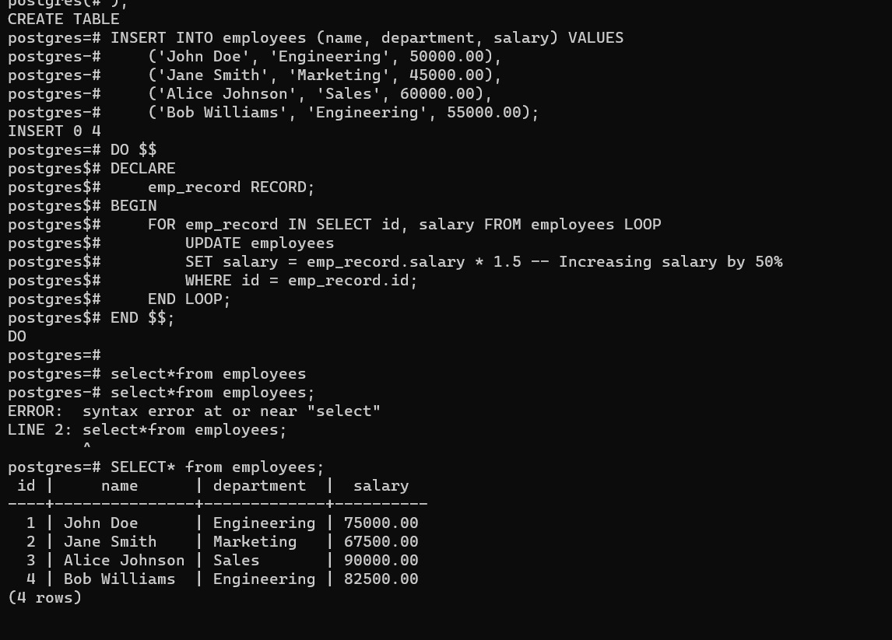

**Experiment-7**

**Aim** - Write a program to create exceptions according and raise these exceptions explicitly by using raise command.

**Code:**

CREATE OR REPLACE FUNCTION example_exception_handling()

RETURNS VOID AS $$

DECLARE

v_condition BOOLEAN := true; -- Change this condition to test different exceptions

BEGIN

-- Raise custom_exception_1

IF v_condition THEN

RAISE EXCEPTION 'Custom Exception 1 Raised';

END IF;

-- Raise custom_exception_2

IF NOT v_condition THEN

RAISE EXCEPTION 'Custom Exception 2 Raised';

END IF;

-- This block will not be executed if an exception is raised

RAISE NOTICE 'No exception raised. This line will be reached if no exception occurs.';

END;

$$ LANGUAGE plpgsql;

**Output**

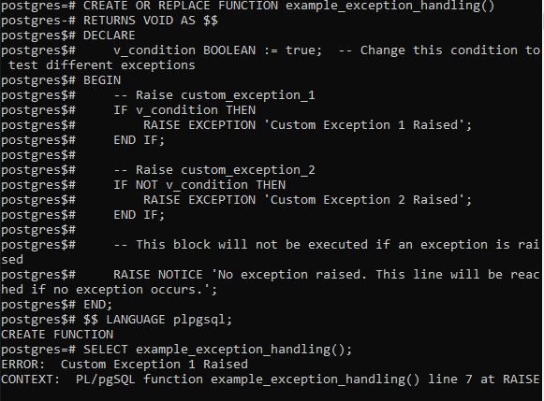

**Experiment-8**

**Aim** - a. Write the procedure to get the average marks of students for branch “CSE”.

b. Write a function that accepts department name and returns the total no. of classes of the department. Also write a function to call the function.

**Code :**

**8a) Procedure to get average marks of students :-**

CREATE OR REPLACE FUNCTION get_average_marks_cse()

RETURNS NUMERIC AS $$

DECLARE

avg_marks NUMERIC;

BEGIN

SELECT AVG(marks) INTO avg_marks

FROM students

WHERE branch = 'CSE';

RETURN avg_marks;

END;

$$ LANGUAGE plpgsql;

SELECT get_average_marks_cse();

**8b) Function to get number of classes of departments**

**Code 1)**

CREATE OR REPLACE FUNCTION get_total_classes_by_department(dept_name VARCHAR)

RETURNS INT AS $$

DECLARE

total_classes INT;

BEGIN

SELECT SUM(class_count) INTO total_classes

FROM classes

WHERE department = dept_name;

RETURN COALESCE(total_classes, 0);

END; $$ LANGUAGE plpgsql

**Code : 2)**

CREATE OR REPLACE FUNCTION call_get_total_classes()

RETURNS INT AS $$

DECLARE

dept_name VARCHAR := 'CSE'; -- Change this to the desired department

total_classes INT;

BEGIN

total_classes := get_total_classes_by_department(dept_name);

RETURN total_classes;

END;

$$ LANGUAGE plpgsql;

Call this function :-

SELECT call_get_total_classes();

**Output**

**8a) average marks of CSE**

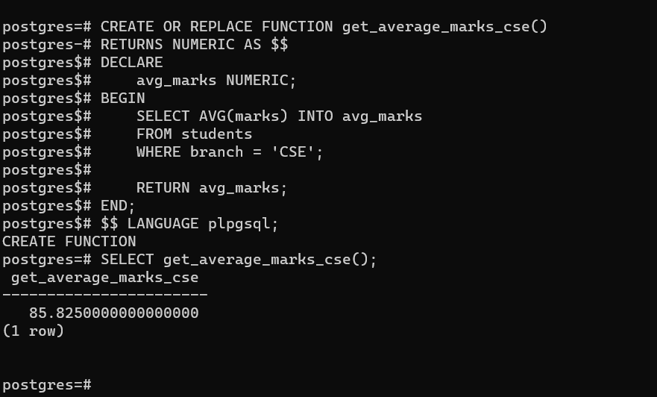

**8b) Get number number of classes of department**

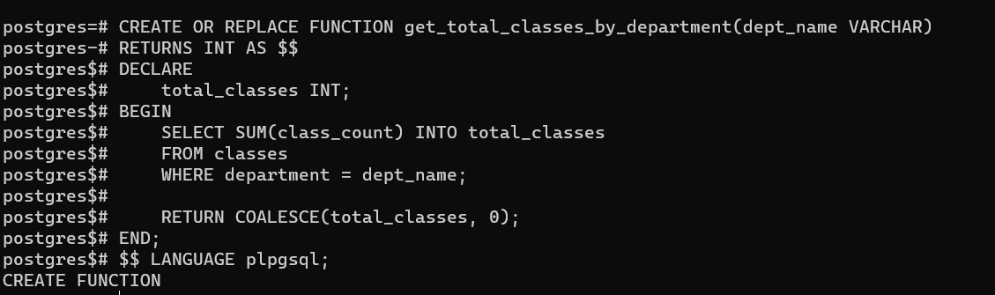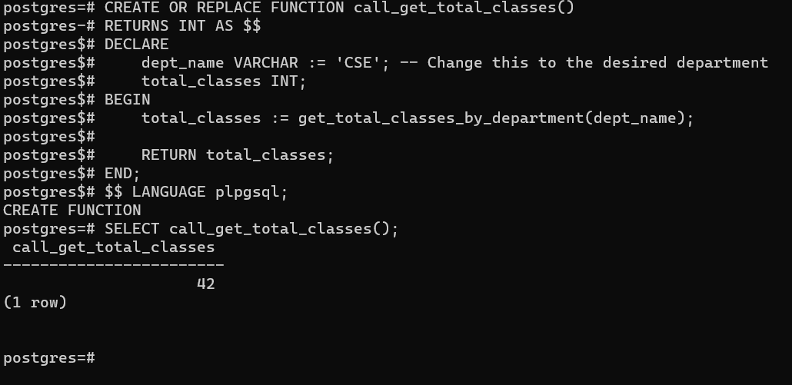

**Experiment-9**

**Aim** - a. Create a trigger on table after inserting a row into table.

b. Create a trigger on table after updating a row into table.

c. Write a row trigger to insert the existing values of the student table in to a new table when the marks of student are updated.

**Code :**

**9a) Trigger after inserting a row.**

CREATE OR REPLACE FUNCTION after_student_insert_trigger()

RETURNS TRIGGER AS $$

BEGIN

-- Perform an action after insertion (e.g., print a message)

RAISE NOTICE 'A new student has been inserted with ID: %', NEW.id;

RETURN NEW;

END;

$$ LANGUAGE plpgsql;

//Create the trigger to execute the function after insertion//

CREATE TRIGGER after_student_insert

AFTER INSERT ON students

FOR EACH ROW

EXECUTE FUNCTION after_student_insert_trigger();

**9b) Trigger after updaating a row.**

CREATE OR REPLACE FUNCTION after_student_update_trigger()

RETURNS TRIGGER AS $$

BEGIN

-- Perform an action after update (e.g., print a message)

RAISE NOTICE 'Student with ID % has been updated', NEW.id;

RETURN NEW;

END;

$$ LANGUAGE plpgsql;

-- Create the trigger to execute the function after update

CREATE TRIGGER after_student_update

AFTER UPDATE ON students

FOR EACH ROW

EXECUTE FUNCTION after_student_update_trigger()

UPDATE students SET marks = 95.0 WHERE id = 11;

**9c) trigger to insert the existing values of the student table in to a new table when the marks of student are updated.**

CREATE TABLE IF NOT EXISTS student_marks_history (

history_id SERIAL PRIMARY KEY,

student_id INT,

name VARCHAR(100),

branch VARCHAR(100),

old_marks NUMERIC(5, 2),

new_marks NUMERIC(5, 2),

change_timestamp TIMESTAMP DEFAULT CURRENT_TIMESTAMP

);

CREATE OR REPLACE FUNCTION on_student_marks_update_trigger()

RETURNS TRIGGER AS $$

BEGIN

IF NEW.marks <> OLD.marks THEN -- Check if the marks have actually changed

INSERT INTO student_marks_history (student_id, name, branch, old_marks, new_marks)

VALUES (NEW.id, NEW.name, NEW.branch, OLD.marks, NEW.marks);

END IF;

RETURN NEW;

END;

$$ LANGUAGE plpgsql;

CREATE TRIGGER student_marks_update

AFTER UPDATE OF marks ON students

FOR EACH ROW

EXECUTE FUNCTION on_student_marks_update_trigger();

**Output**

**9a) Trigger after inserting a row**

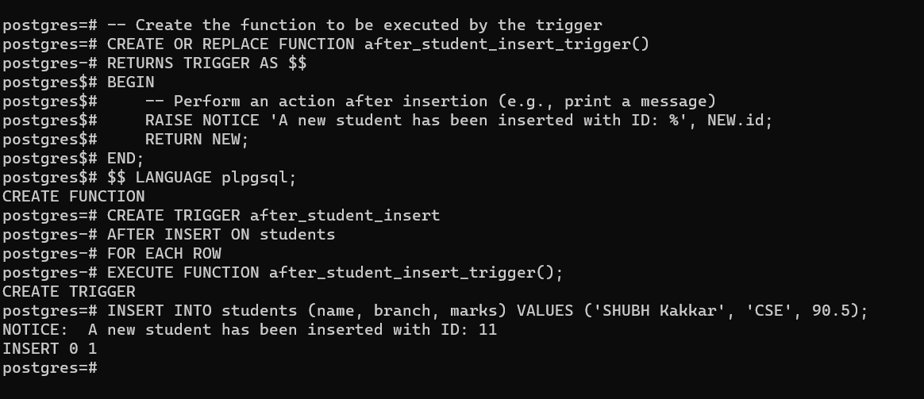

**9b) Trigger after updating a row**

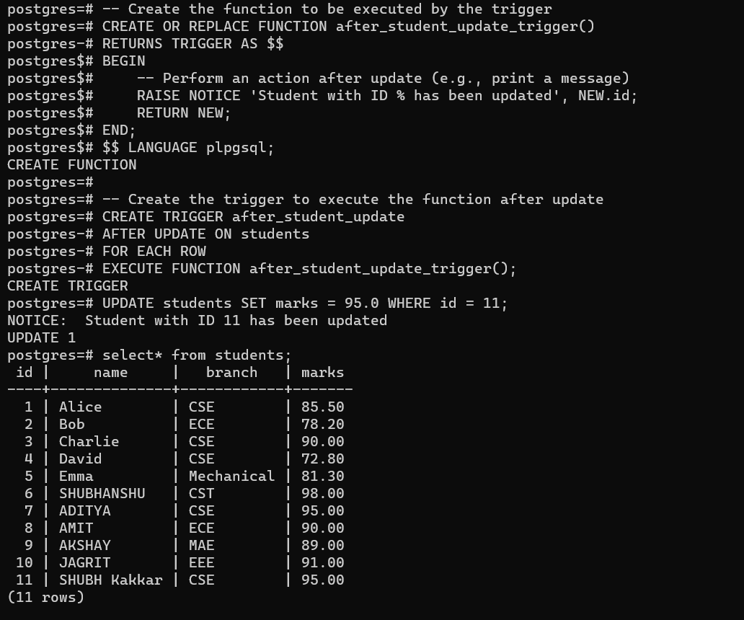

**9c) trigger to insert the existing values of the student table in to a new table when the marks of student are updated.**

