Academic Task Number: CA 2 Course Code: INT332
Course Title: DEVOPS VIRTUALIZATION AND CONFIGURATION MANAGEMENT
Date of submission: 28th March, 2024 Maximum Marks: 50
Academic Task Type: BYOD Practical
Question Number | Question Statement | Course Outcome | Bloom’s level | Marks per Question
Q1: | Show with one application how can we check the connectivity of one container from other container by creating a userdefined network | CO2 | L3:apply | 25
Q2: | You're working as a DevOps engineer for a software development company. Your team has developed a new microservice-based application using Node.js, and you're responsible for containerizing it using Dockerfile.  As part of the containerization process, describe how you would structure your Dockerfile to ensure efficient building and running of the Node.js application container. Consider factors such as dependencies, environment configuration, and best practices for optimizing image size and build time. | CO3 | L3: apply | 25

Shubhansu Kumar Singh

Roll: B60

RegNo: 12104991

SetB

Q1: Show with one application how can we check the connectivity of one container from other container by creating a userdefined network
Solution: Create a user defined network and create two container with the same network. After creating the containers ping one container from other and show the connectivity through ping results.
- Initial Status
- 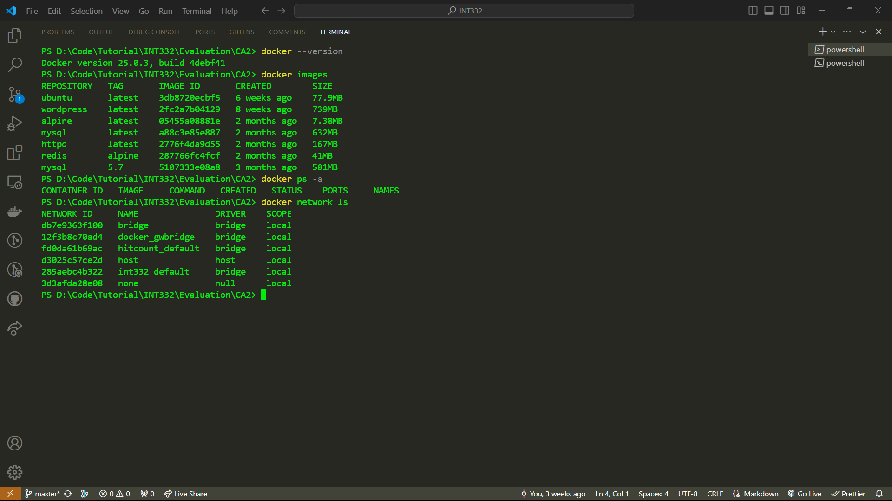
- Create a new network named network1

- 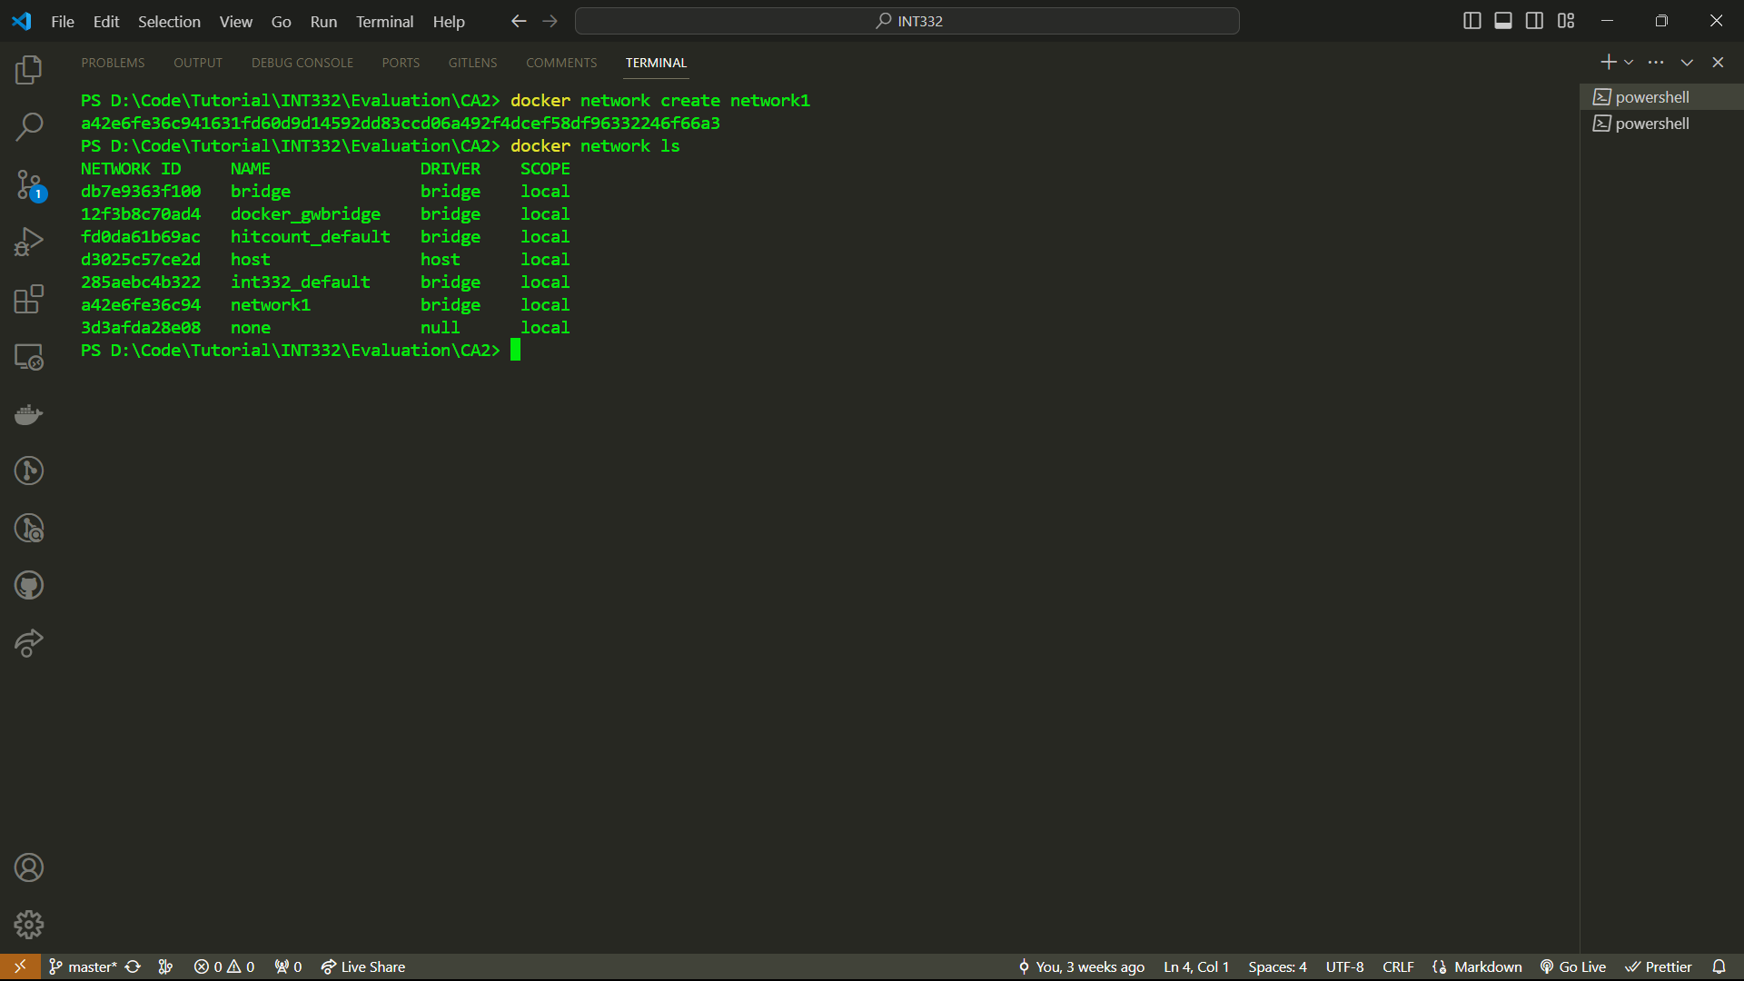
- Create two container linking network1
- 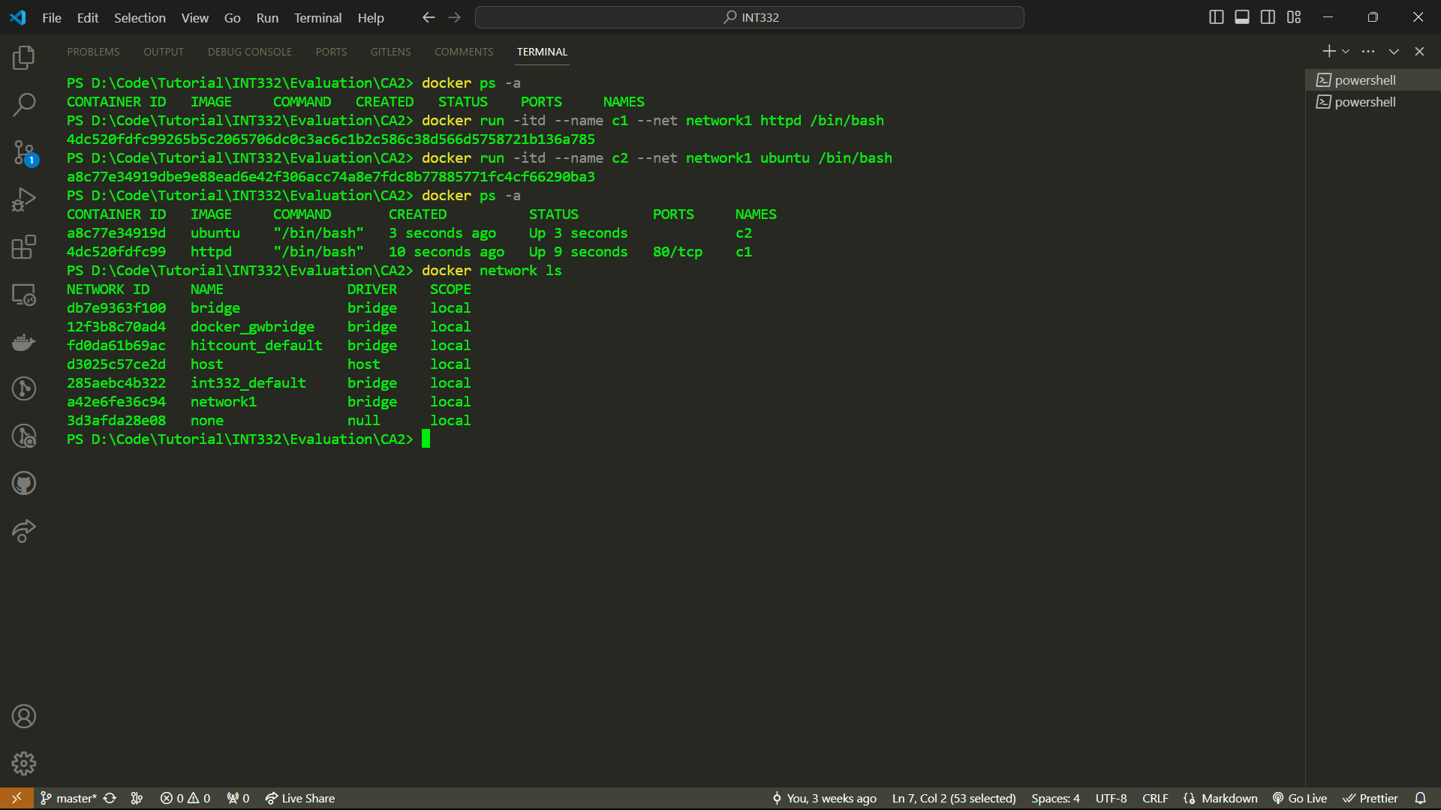
- Inspect the network
- 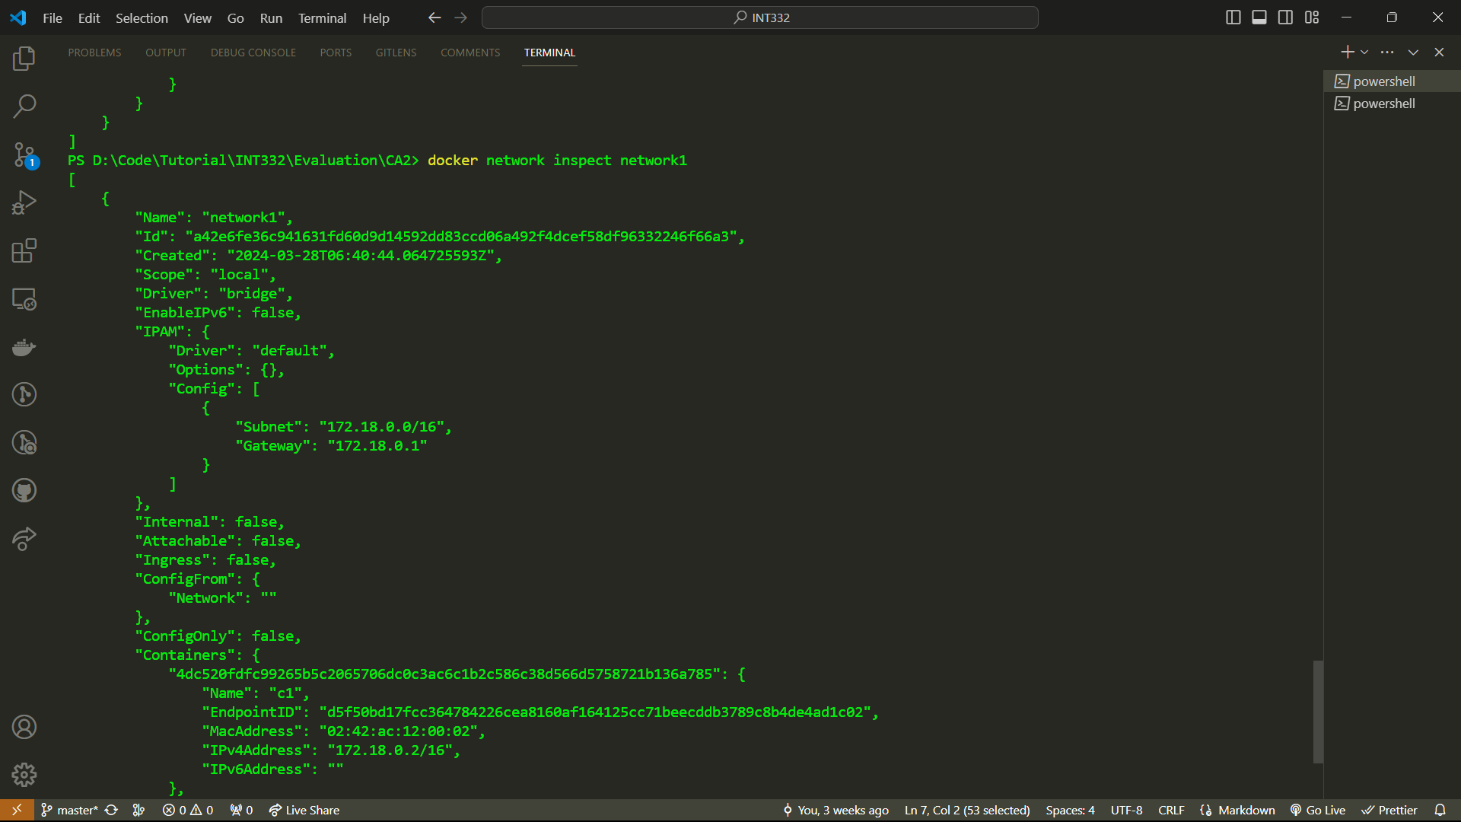
- Execute container 1 and install iputils-ping

- 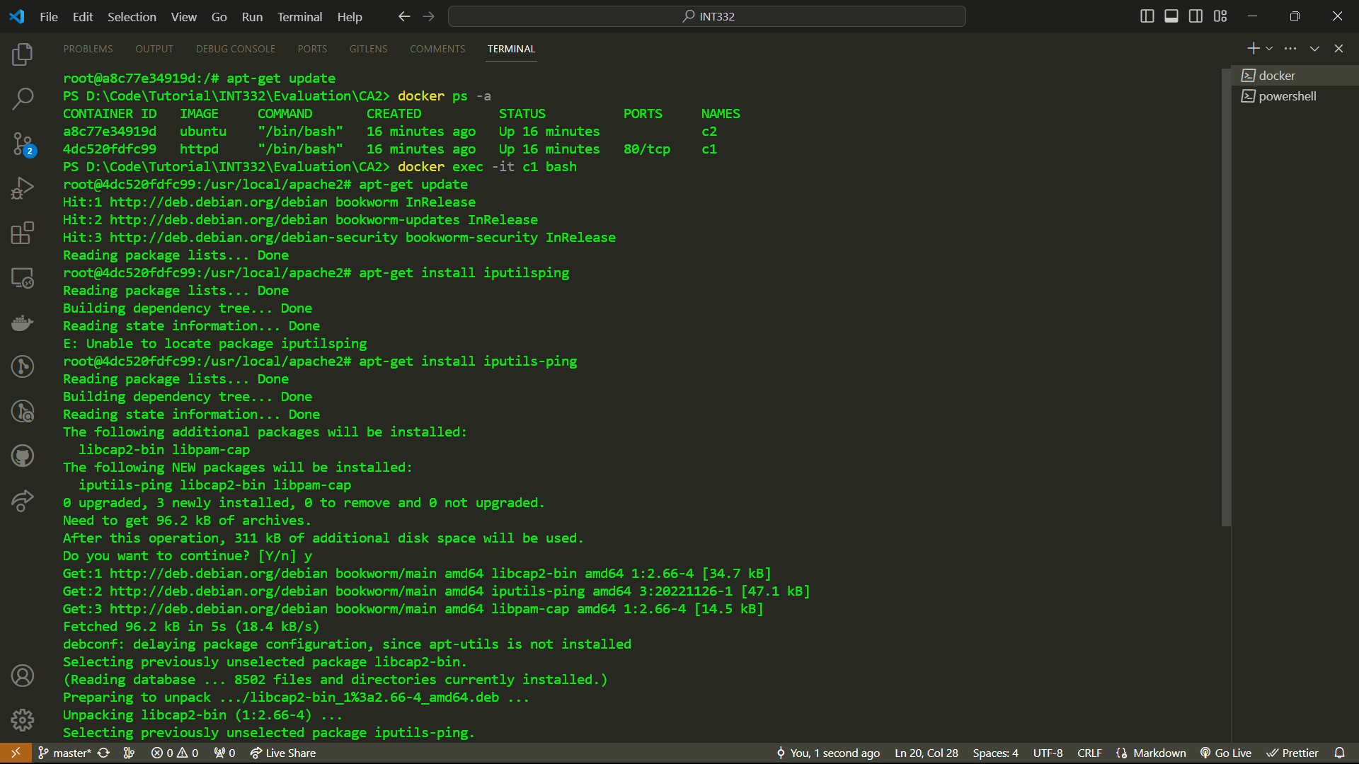
- After installation ping container c2 and check the response.

- 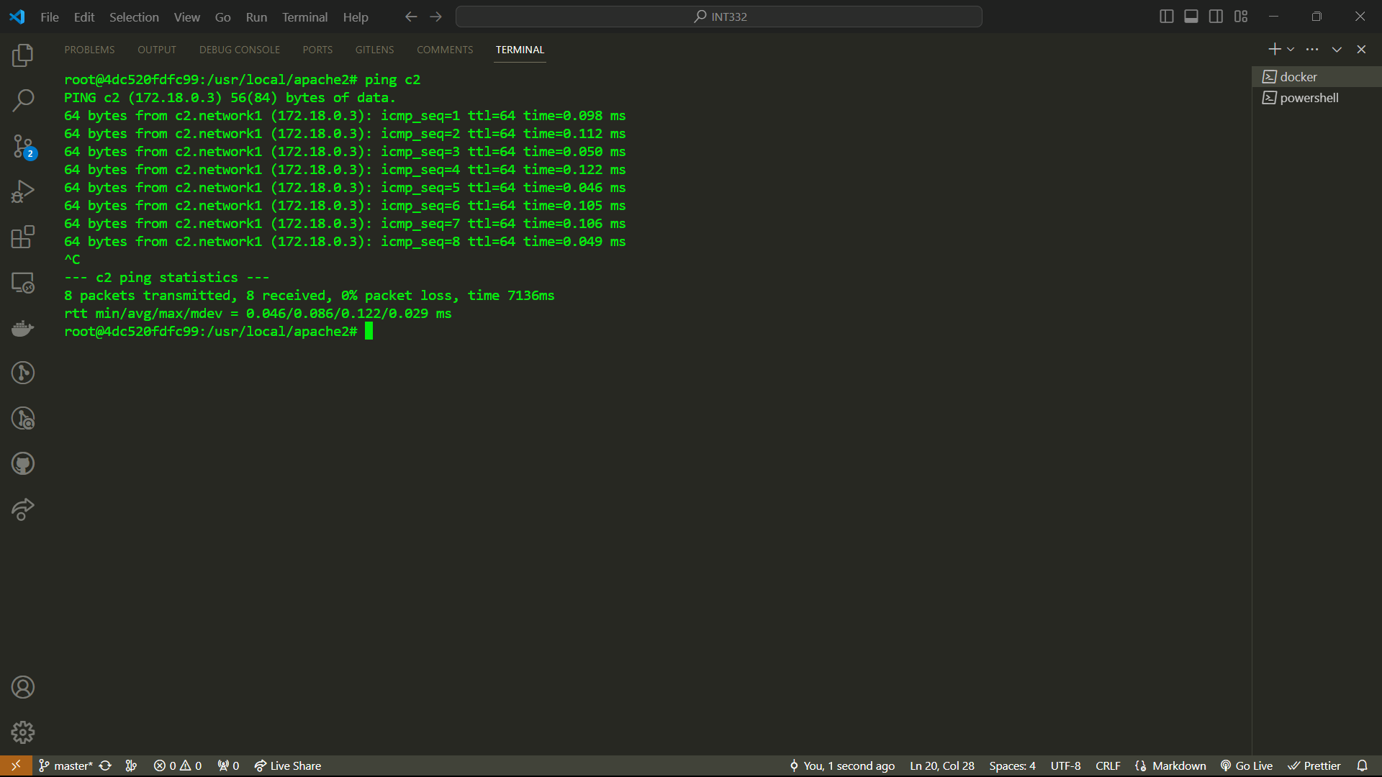
- Ping success 100%, since c1 and c2 are linked through network1.
- Now create a third container c3 without linking to network1.

- 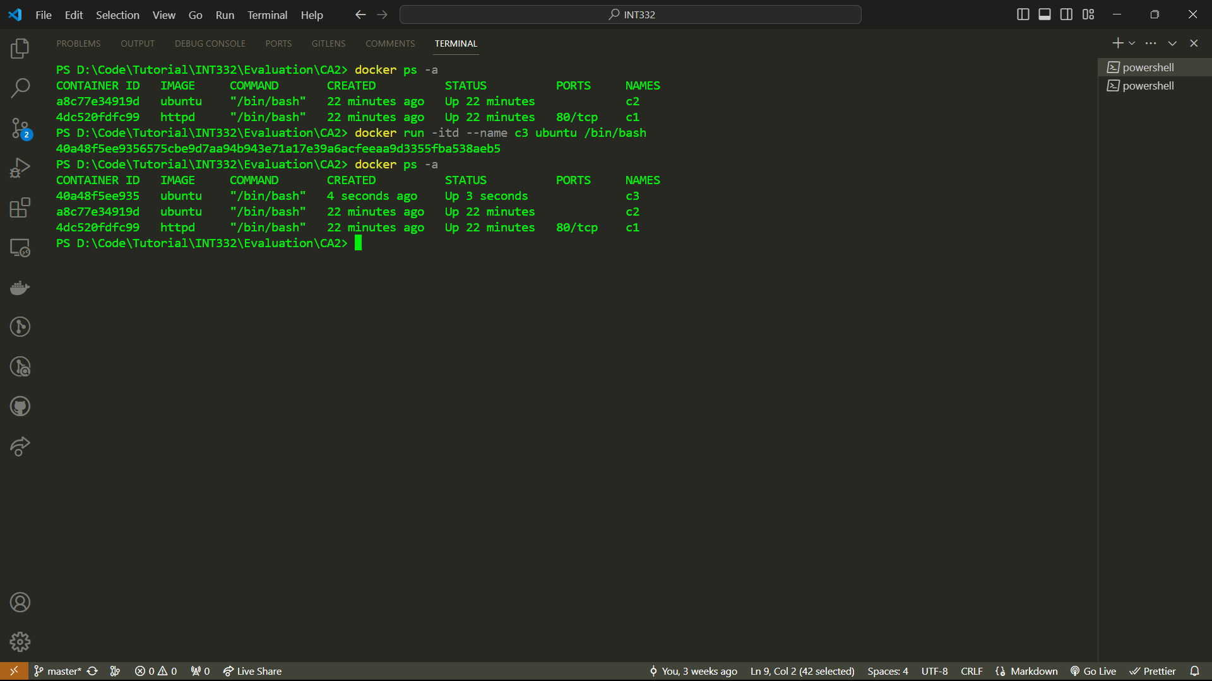
- Now try to ping c3 from c1
- 100 percent packet loss.
- 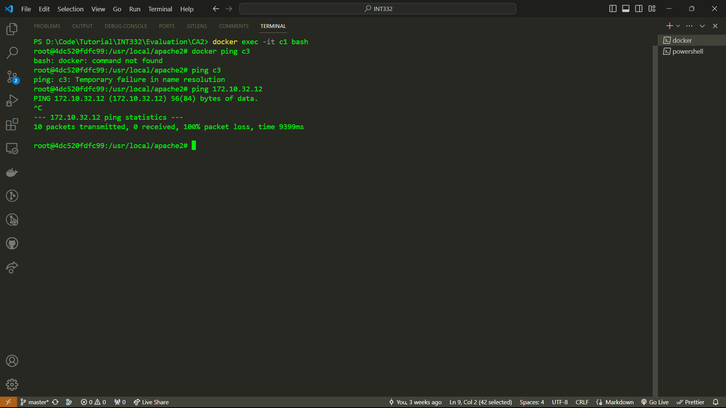

- Conclusion: Containers are connected if they are in the same network. By default if network is not specified, container is connected to the default network bridge.
Q2: You're working as a DevOps engineer for a software development company. Your team has developed a new microservice-based application using Node.js, and you're responsible for containerizing it using Dockerfile.
As part of the containerization process, describe how you would structure your Dockerfile to ensure efficient building and running of the Node.js application container. Consider factors such as dependencies, environment configuration, and best practices for optimizing image size and build time.

Solution:
- Create an application for containerization
- A simple application which displays the number of times a user hits the webpage

- 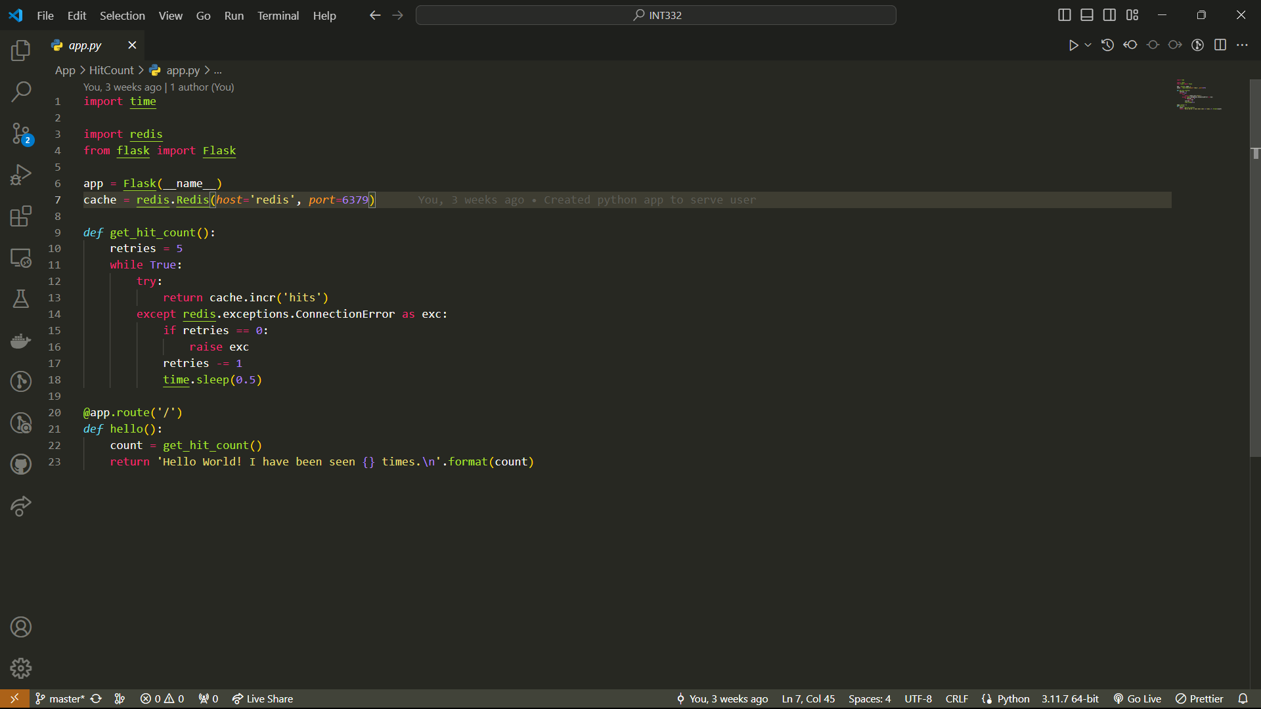
- Now this application has dependencies which is needed to be installed in the container. Add a requirement.txt file to list all the dependencies. In this case flask and reddis
- 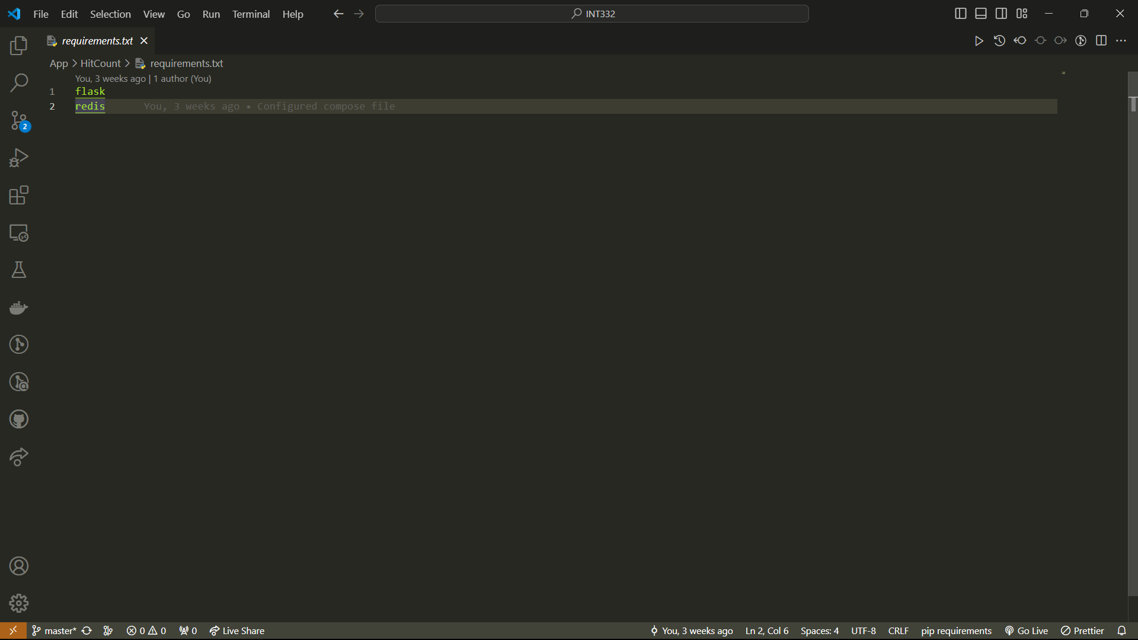
- Now to configure the execution create a dockerfile which will store all the env variables and run the commands inside the container, ports and working dir.
- 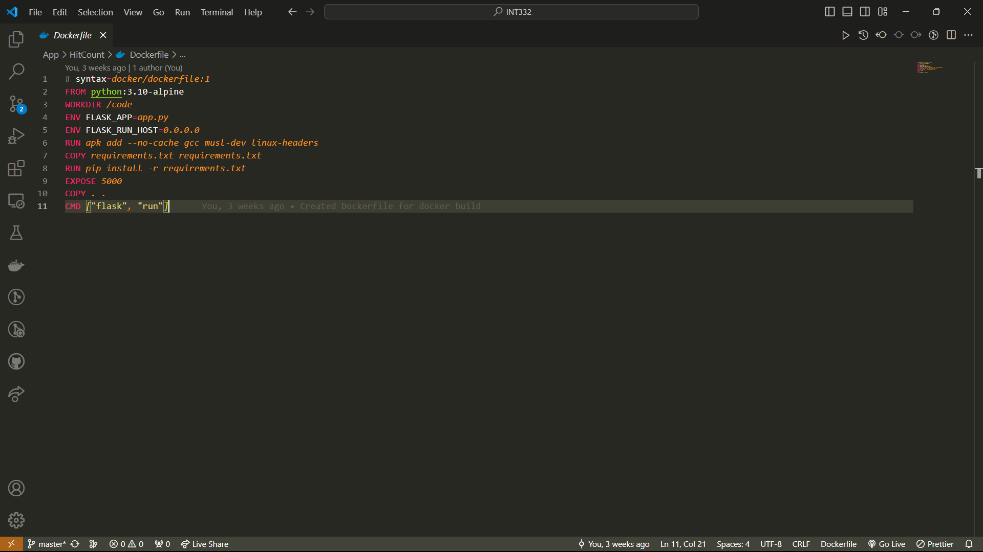
- Now create a docker compose file to create all the services required for the application. In this case redis and application.
- 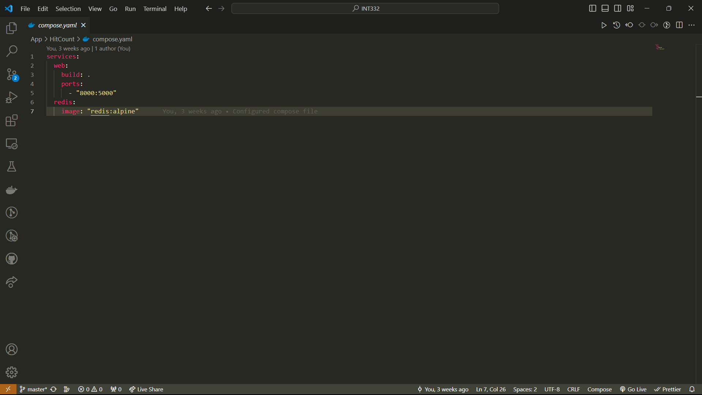
- Now execute the compose file using the command docker compose up
- First check the docker running status
- 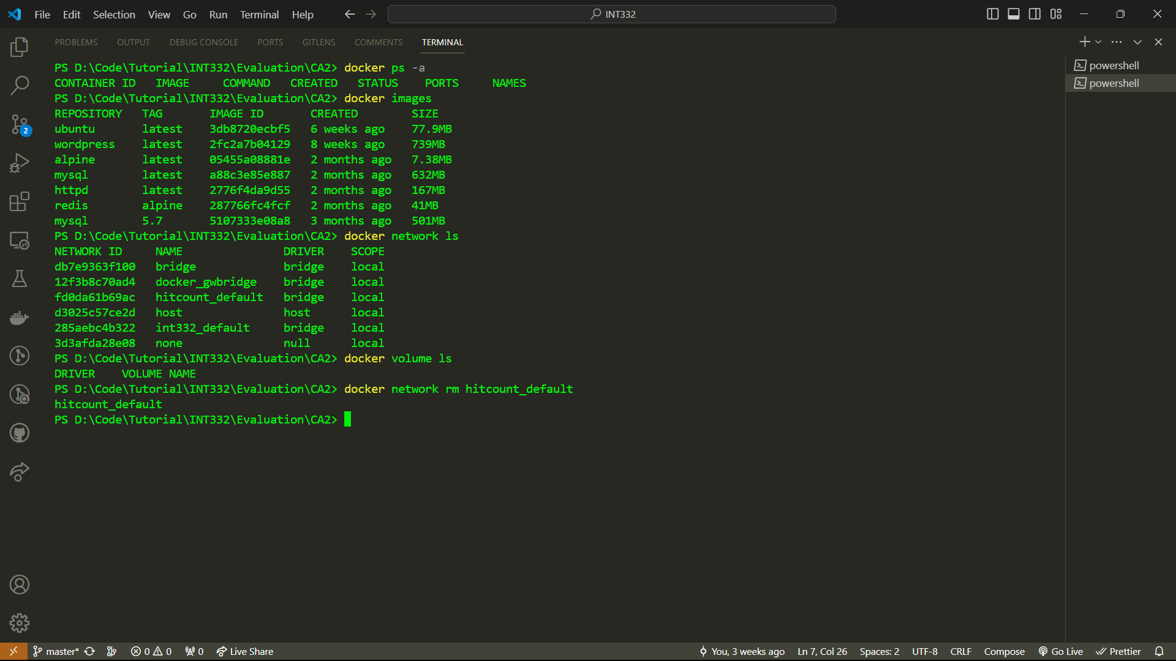
- Now run the command
- 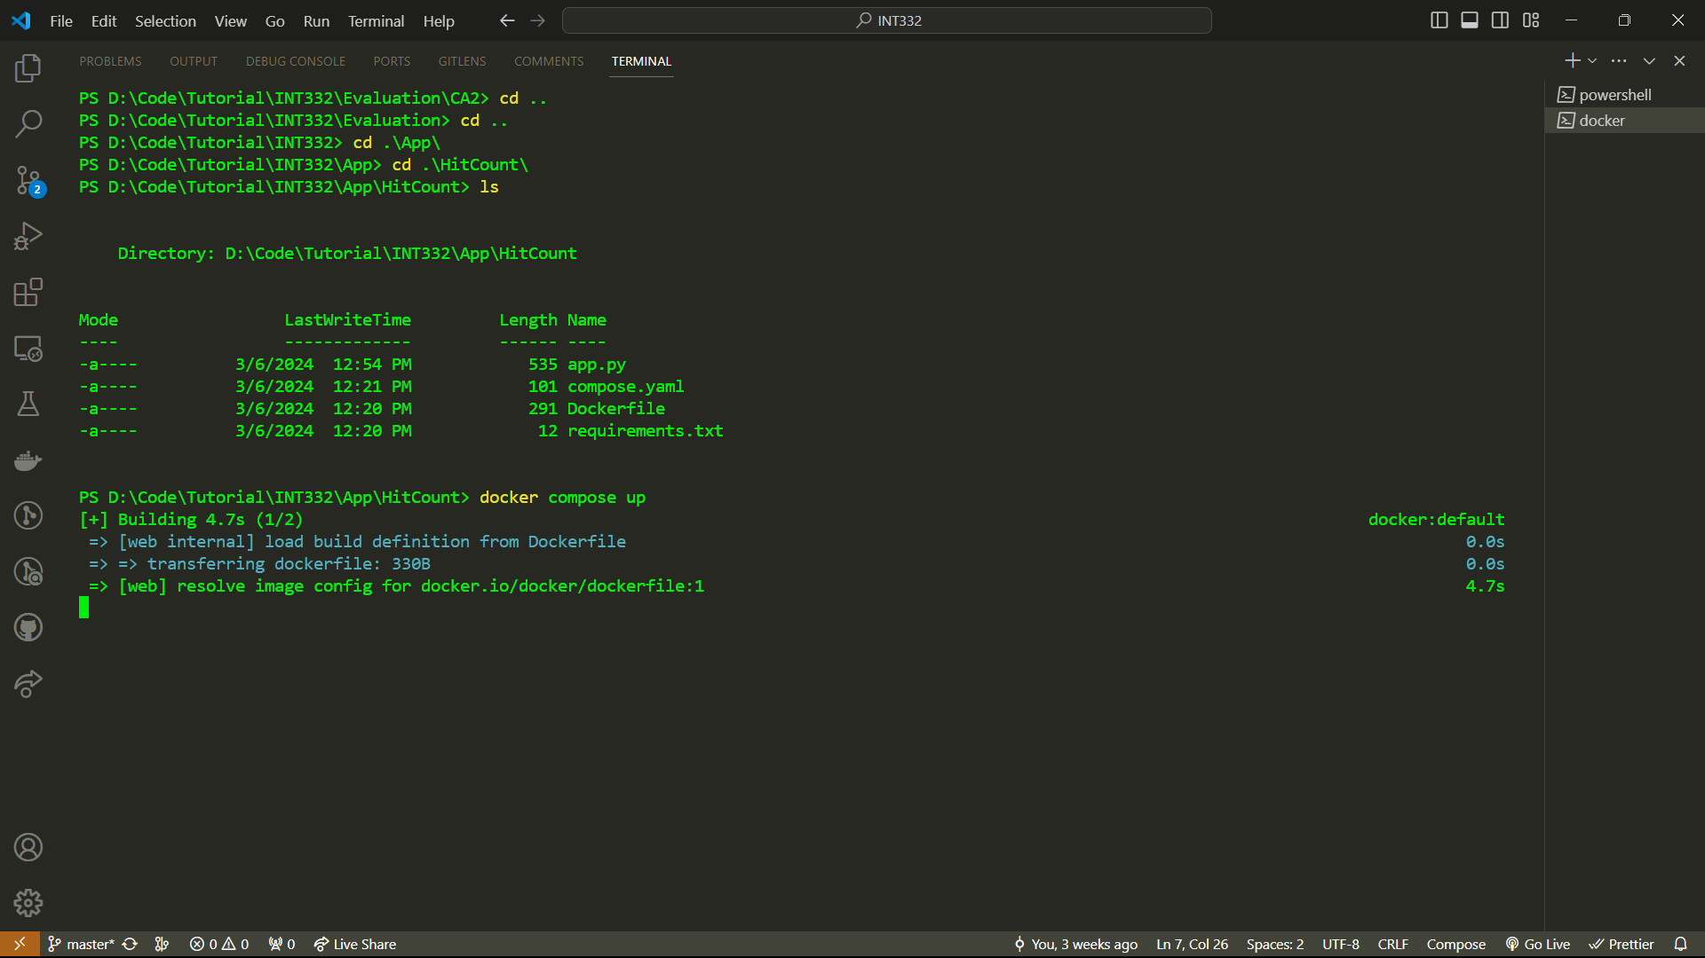
- 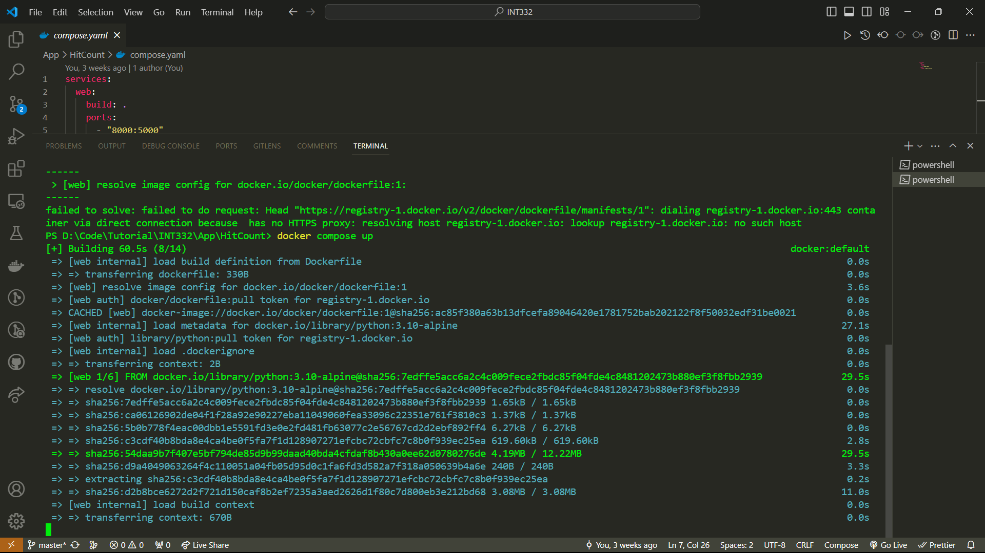
- 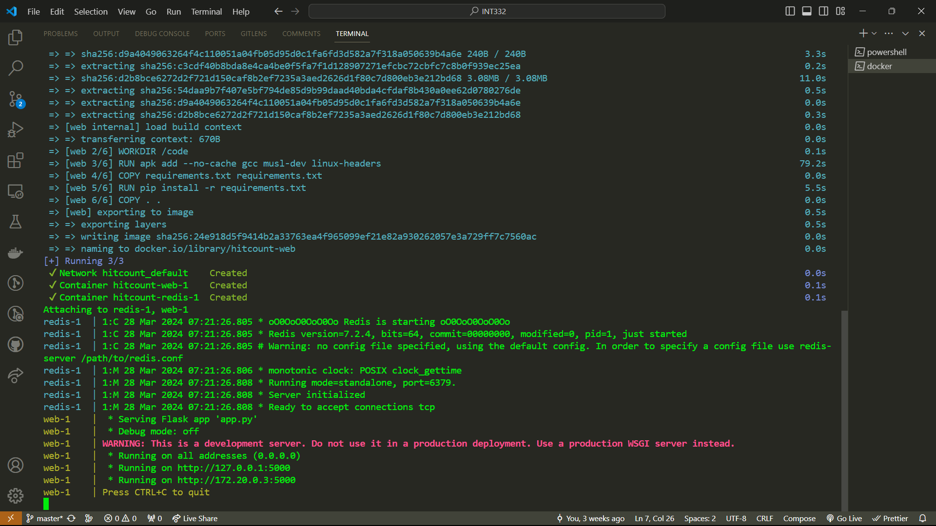
- The server is running on port 5000 and client on 8000.

