**After installing splunk in aws ec2 instance then run the following command

sudo /opt/splunk/bin/splunk restart

** Then after log on to browser http://<ip_add>:8000

Click on searching & reporting option

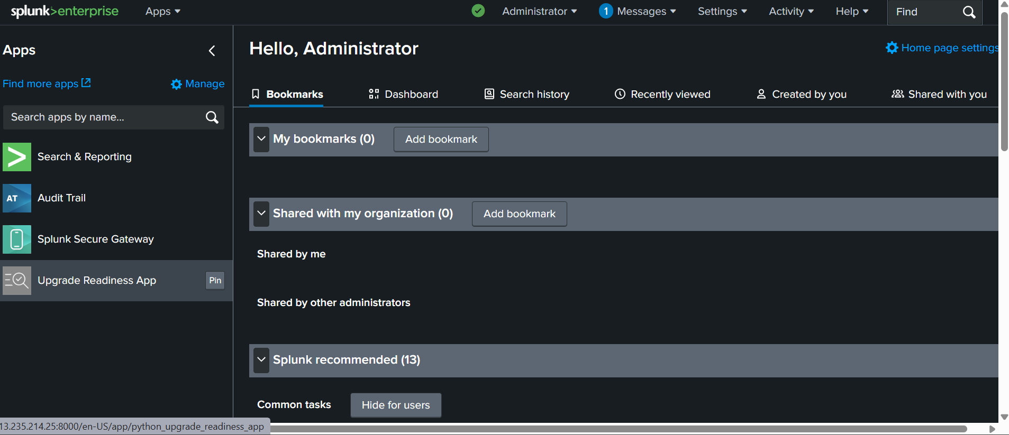

Run the following command in the search bar to create a dashboard .

Command🡪 index="_internal" | dedup 1000 sourcetype | stats count(date_hour) by sourcetype

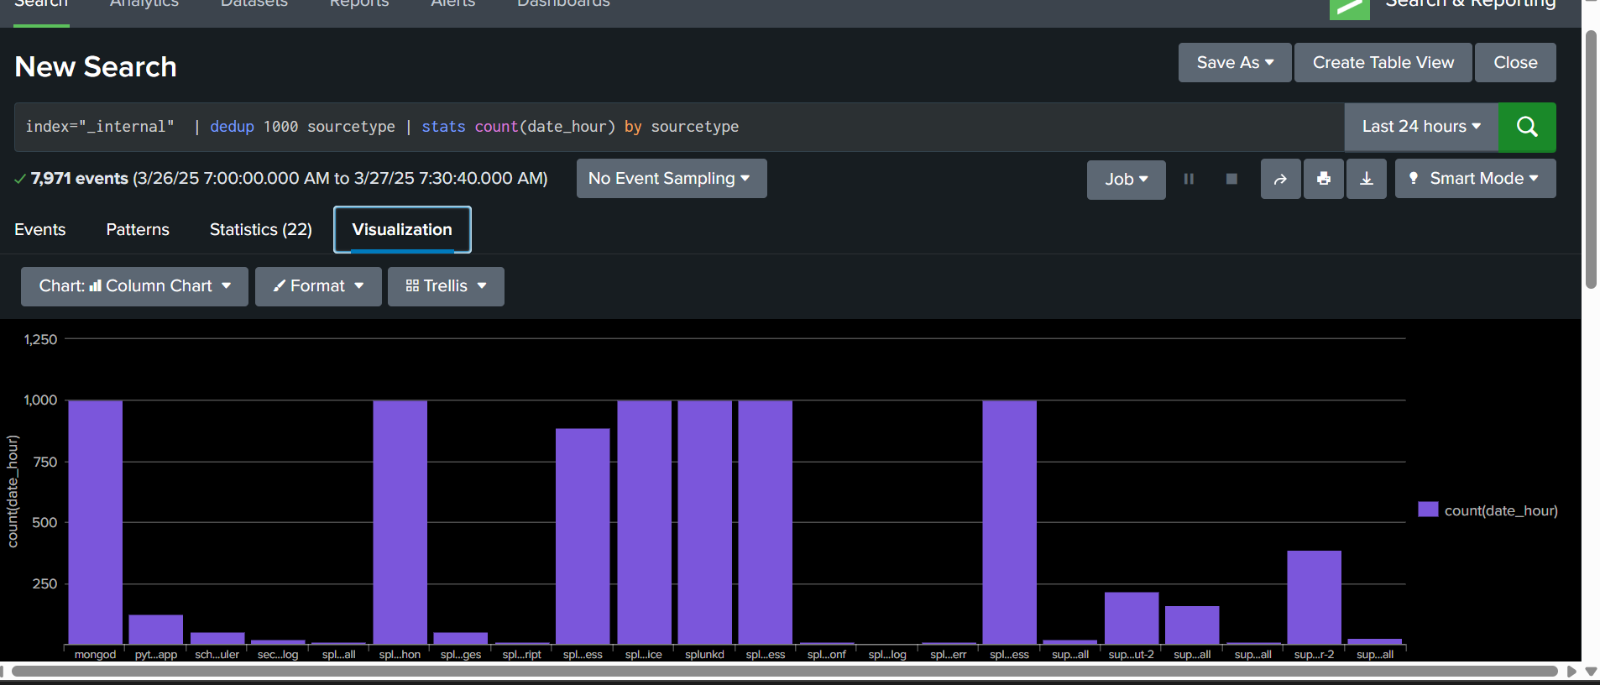

Click on visualization ,Save AS option then after click new dashboard---give name, click classic dashboard then save to dashboard

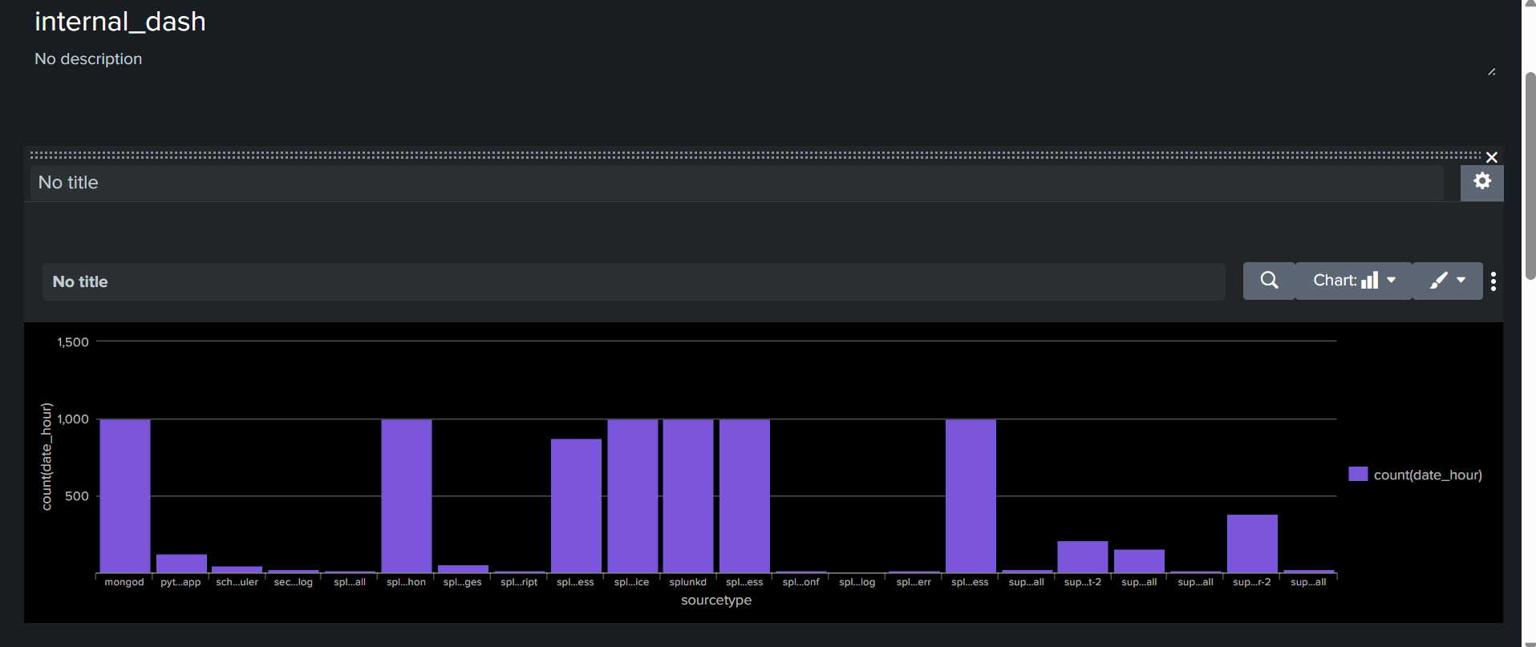

We can add the more panels in the dashboard

Click🡪 add panel option

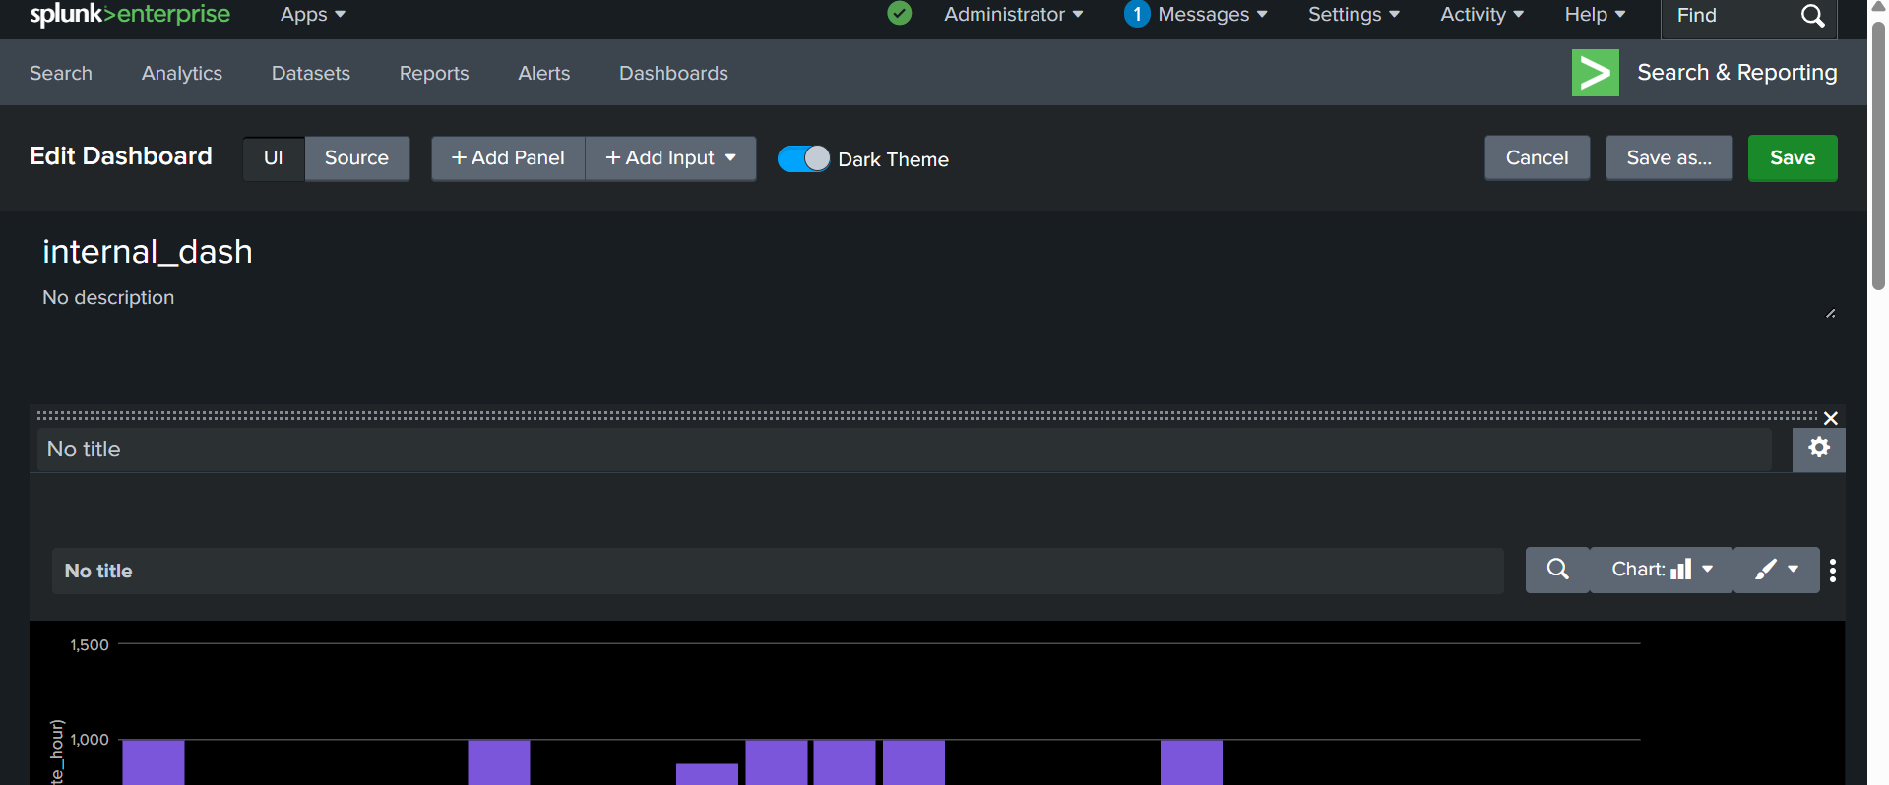

Click🡪 new 🡪 select chart🡪 search string run the following command 🡪add to dashboard

Command🡪 index="_internal" | dedup 1000 sourcetype | stats count(date_hour) by sourcetype

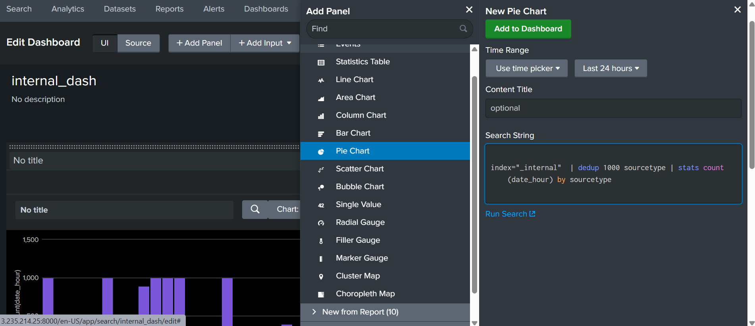

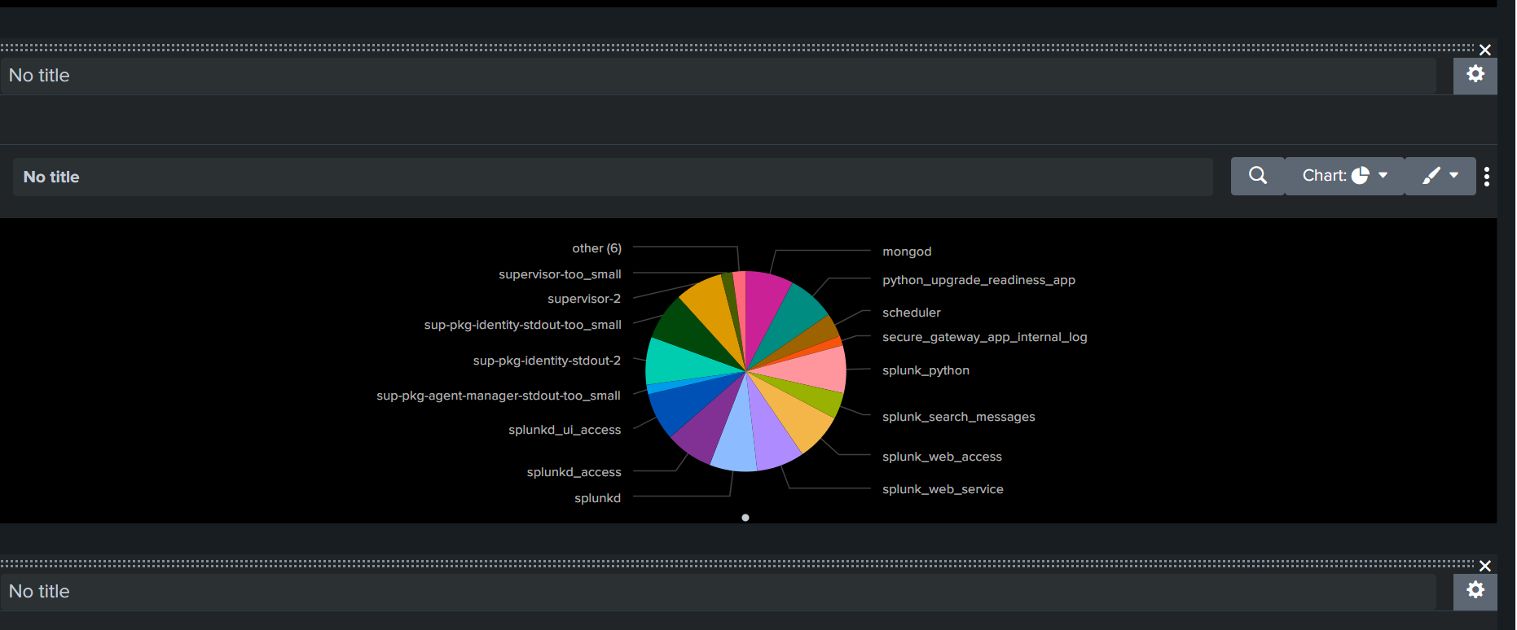

We can create reports and add to dashboard

Click🡪searching & reporting 🡪search bar run the following command

Command🡪 index="_internal" | dedup 1000 sourcetype | table _time "sourcetype" "date_hour"| rename date_hour as hours

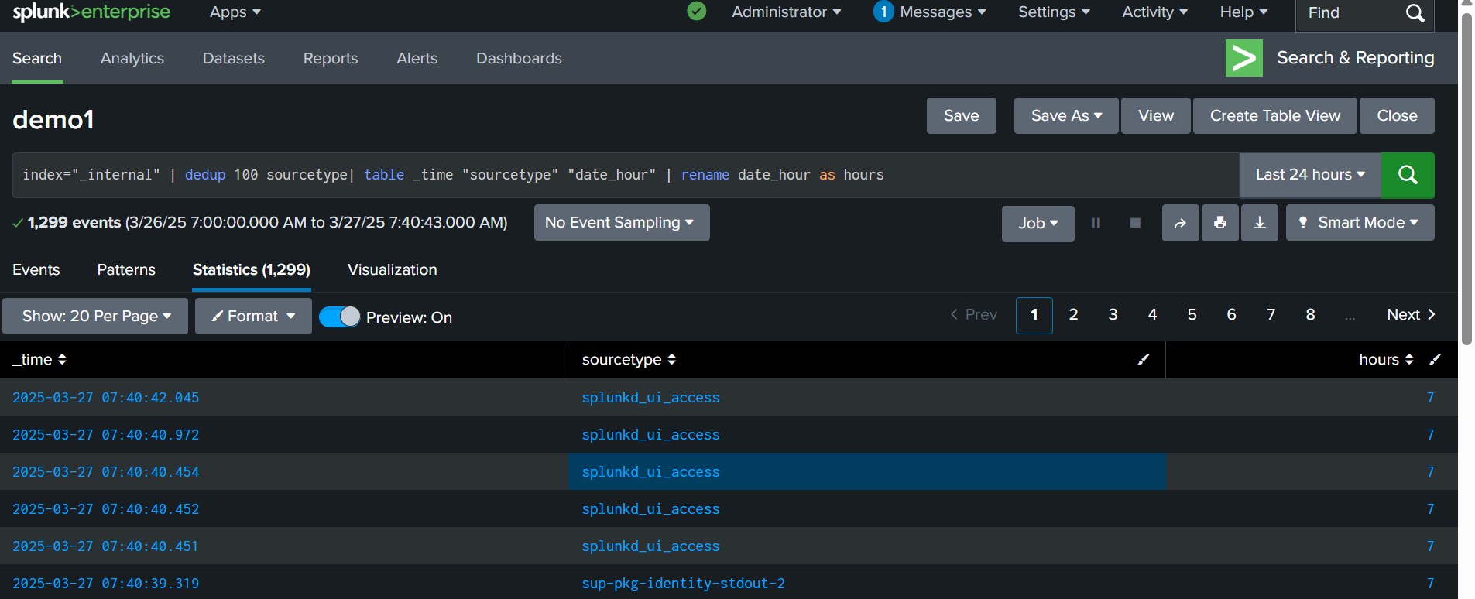

Click 🡪save AS 🡪report🡪 fill the details—name click save

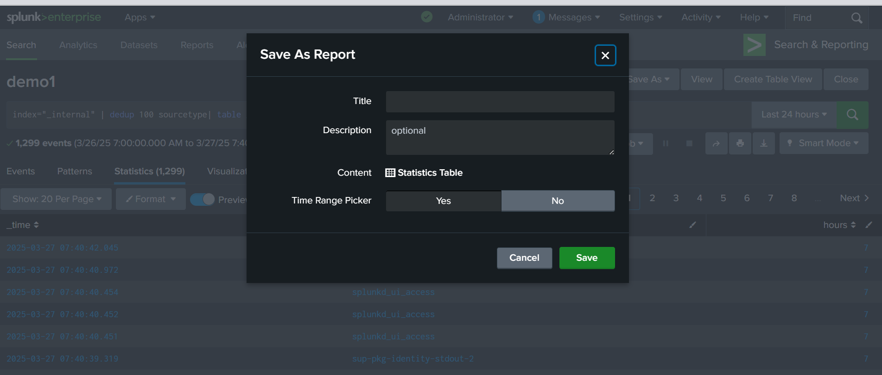

Go to report option which is displayed in the below picture you can the report which you have created

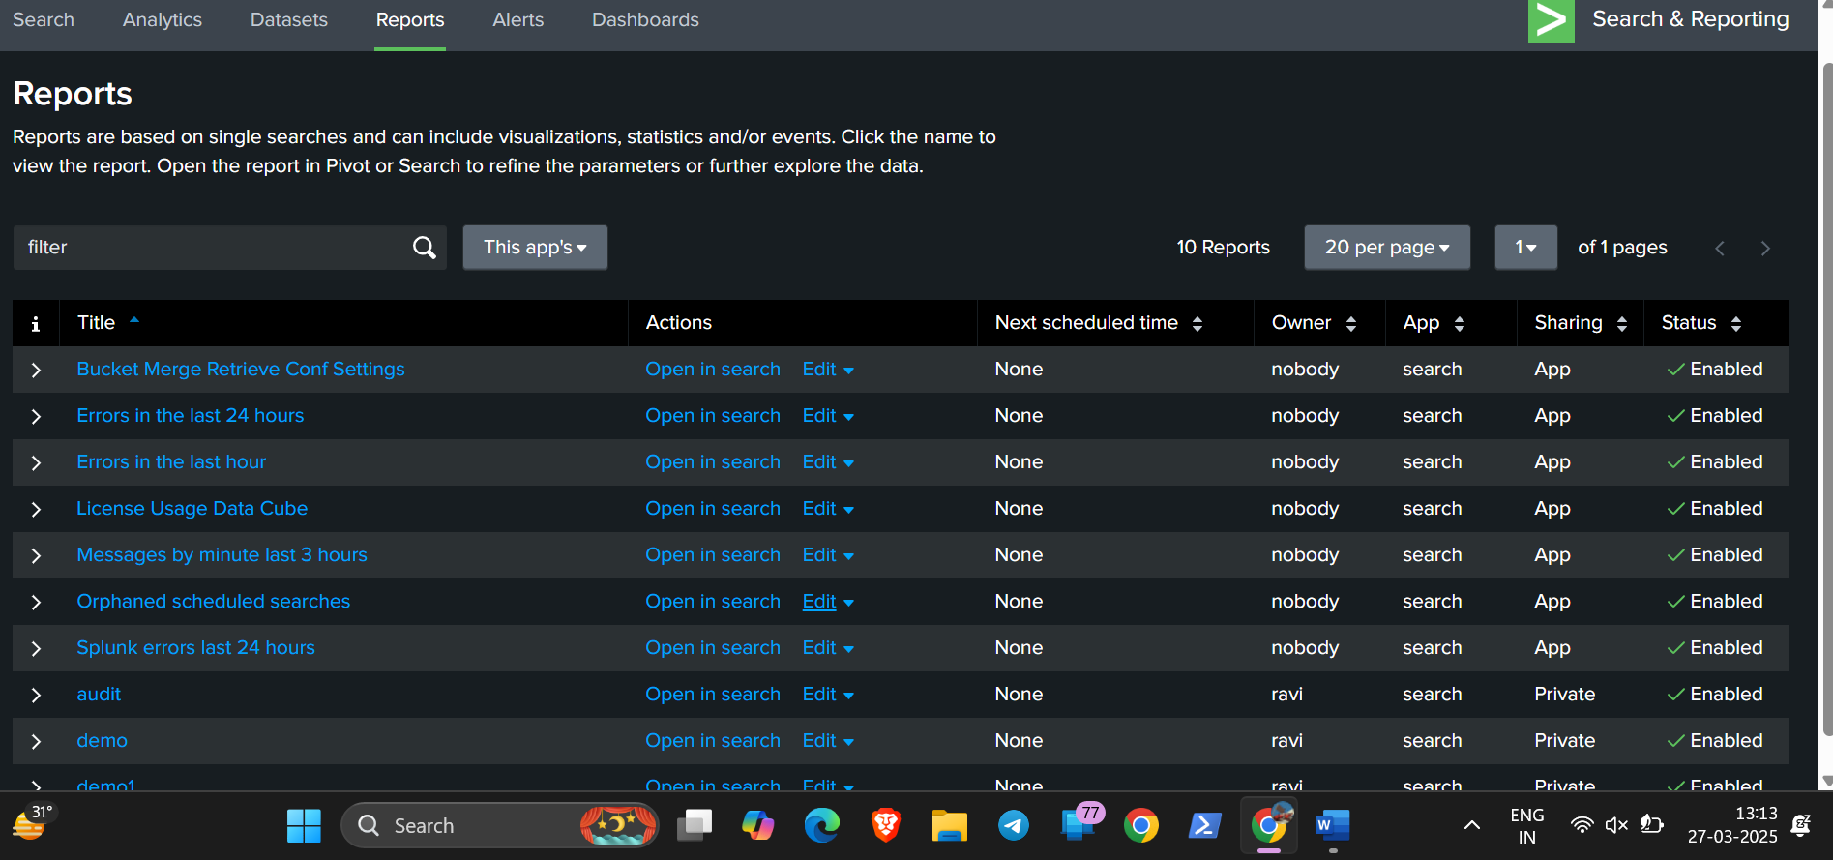

Click 🡪 open in search ----in the report you have created

Click🡪save As 🡪existing dashboard

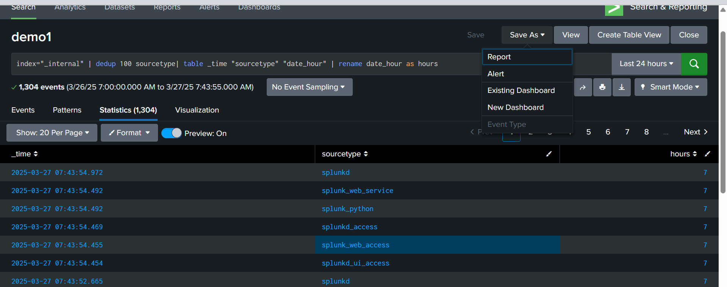

Click🡪 the dashboard which you have created before

Click🡪save to dashboard

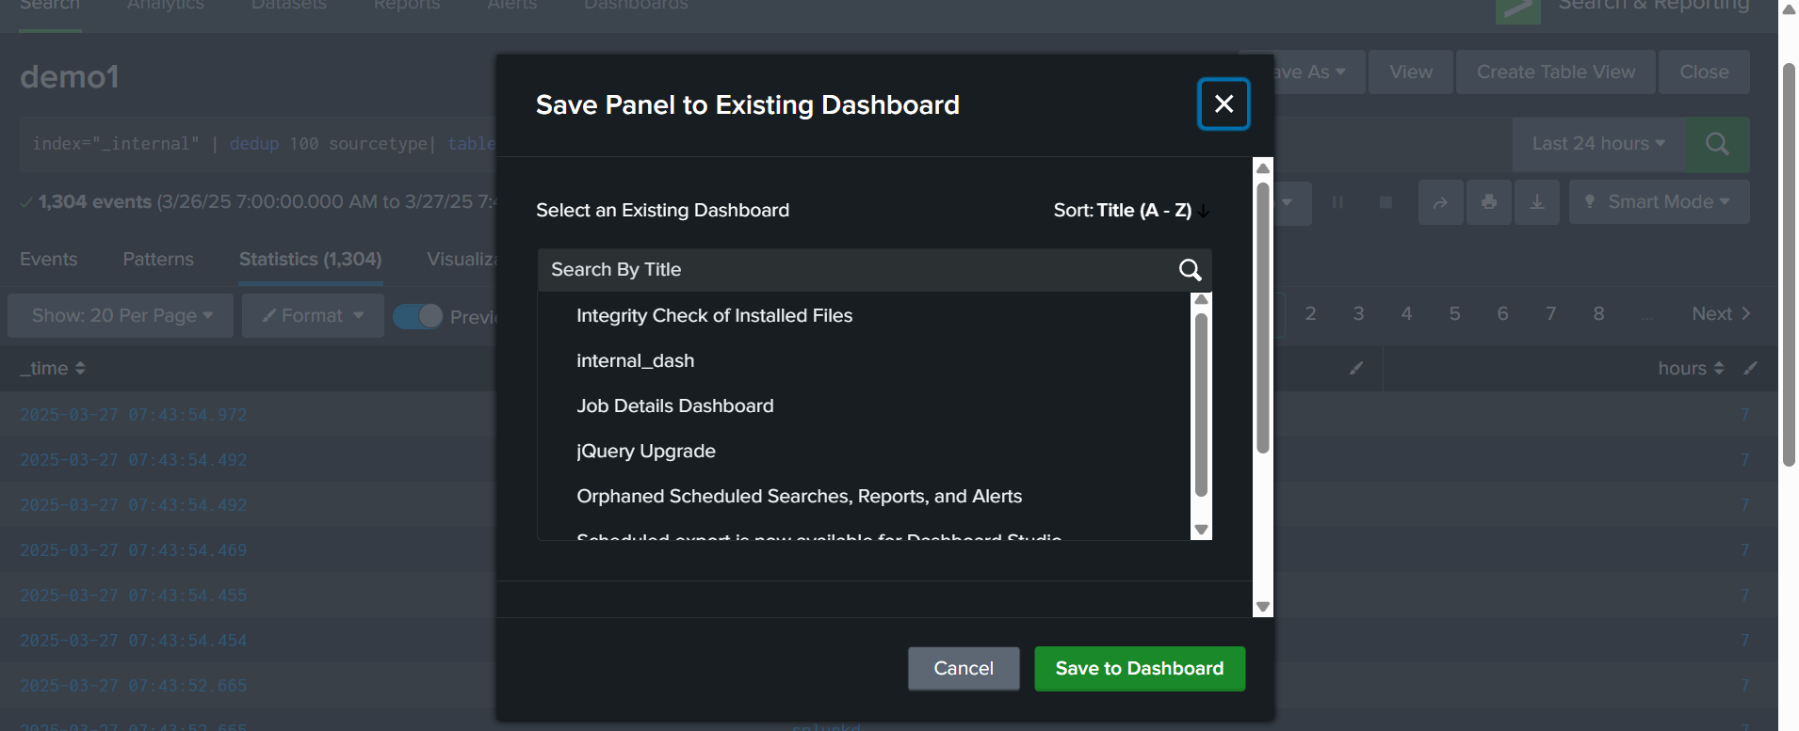

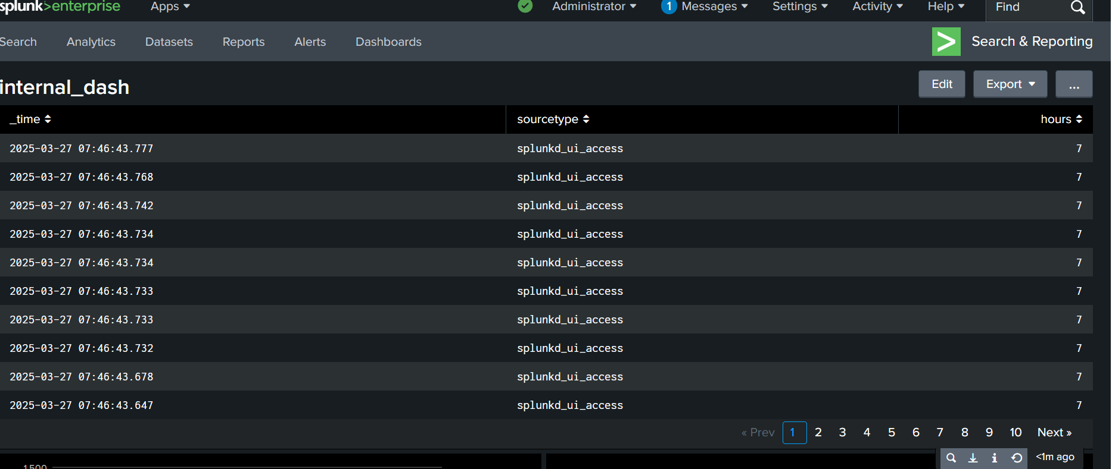

Click 🡪edit 🡪 chart in table

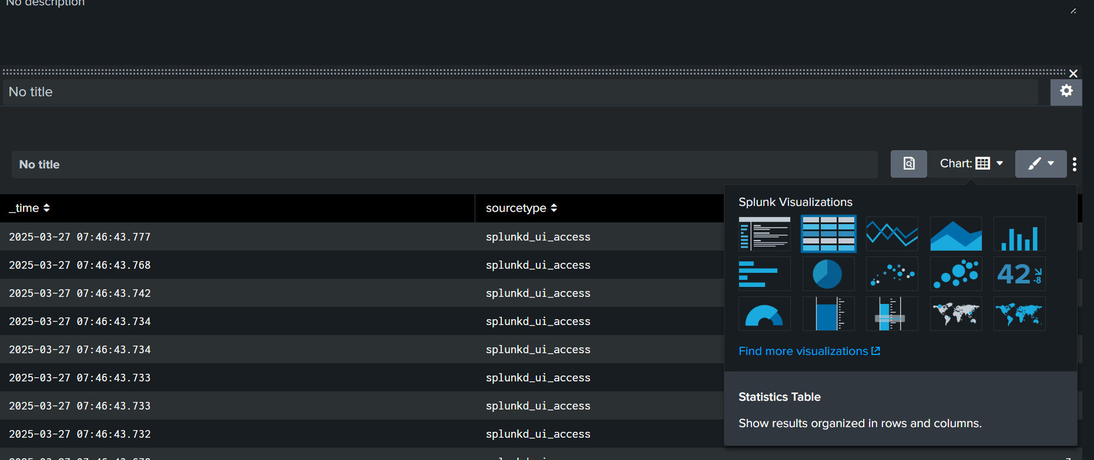

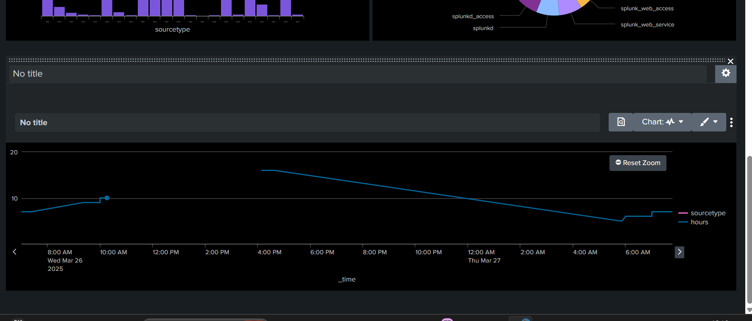

CLICK🡪 save

FINAL DASHBOARD:

