Report For UMS built using HTML and CSS.
AS A PROJECT WORK FOR COURSE
Internet Programming Laboratory (CSE 326)

NAM E : Harsh Vidit
REGISTRATION NUMBER : 12104689
PROGRAM : B-TECH (Computer Science and Engineering)
SEMESTER : SEMESTER Two
SCHOOL : SCHOOL OF COMPUTER SCIENCE AND ENGINEERING
NAME OF UNIVERSITY : LOVELY PROFESSIONAL UNIVERSITY
DATE OF SUBMISSION : April 15, 2022

Lovely Professional University
Jalandhar, Punjab, India


TABLE OF CONTENTS :
S.NO | CONTENTS | PAGE NO’S
1 | Abstract | 3
2 | Introduction:  2.1 What is UMS?  2.2 Why we use UMS? | 3-4
3 | UMS:  3.1 Dashboard  3.2 Assignment download  3.3 Assignment Upload  3.4 Practical Upload  3.5 Time table | 4 - 7
4 | Code : Github link | 7
5 | Sample Output of the program | 8
6 | Conclusion | 8-9

BUILDING UMS USING HTML and CSS.

- ABSTARCT :
What is a UMS? How does it help you to access all of the online services proposed by the university? How can you build your own UMS?
UMS (university management system) is an online platform which provides students the access to a wide range of services offered by the university. By the University it is used for administrative and communication purposes. Examples of services are - assignment download, assignment upload, RMS, fees status, placement drives, announcements and much more.
To access online services offered by University you must login into your UMS account using the credentials given by the University itself. After logging in a beautiful UI systems lists down all of the services available and the student can access any service/feature with just a click.
Building a UMS is a time consuming and hard-working job. One must be well known with the concepts of HTML, CSS and JavaScript (for frontend). It is very important to use appropriate tags and styling to make the website look good and interactive.

INTRODUCTION:

  - What is UMS?
University Management System or commonly abbreviated as UMS. It is a group of services arranged properly in a website to address the common problems faced by the students. It includes many services like, assignment download , assignment upload, RMS, fee status , fee submission, Next term registration , details of upcoming exams, platform to publish the result, information regarding placement drives and important announcement made by the University. All a student need to do is to login into his/her UMS account and then he/she can access all of the services listed above and many more.
It also helps the student to connect to the head authorities of the respective school in case any query arises.

  - Why we use UMS?
    - Time saving- student need not to wander here and there to get his/her queries addressed.
    - Free to use- provided by the university, it is completely free to use platform.
    - Platform for announcement- most announcement regarding events, classes, fee submission are done here.
- UI- user friendly interface hence feels good to use.

3.2 Assignment Download-
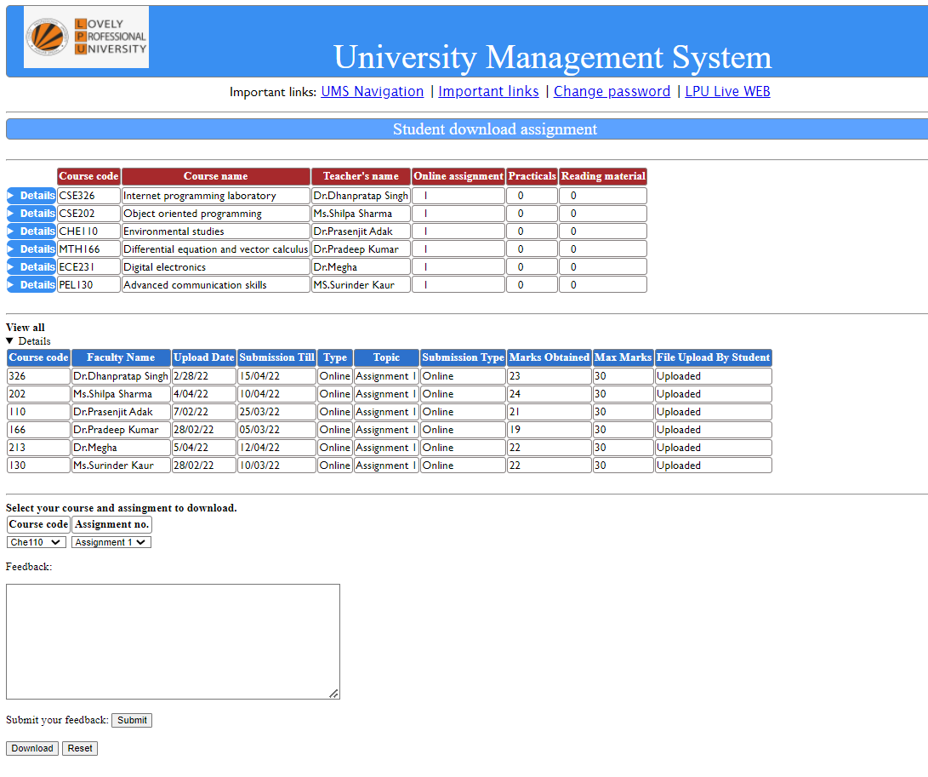
The picture above depicts the assignment download page linked in the UMS. Student can get to know to know about the pending assignment and, can download the material for the assignment. Course code, course name and teacher’s name are provided simultaneously so that there is no scope of any confusion. To download the material , two select options are provided, student need to pick course code and the assignment number to download , after selecting the material can be downloaded with just a single click on the download button given below. If the selection is done wrong for any reason, the student can reset the selection and can select again. Feedback is also provided for some extra convenience.

3.3 Assignment upload-
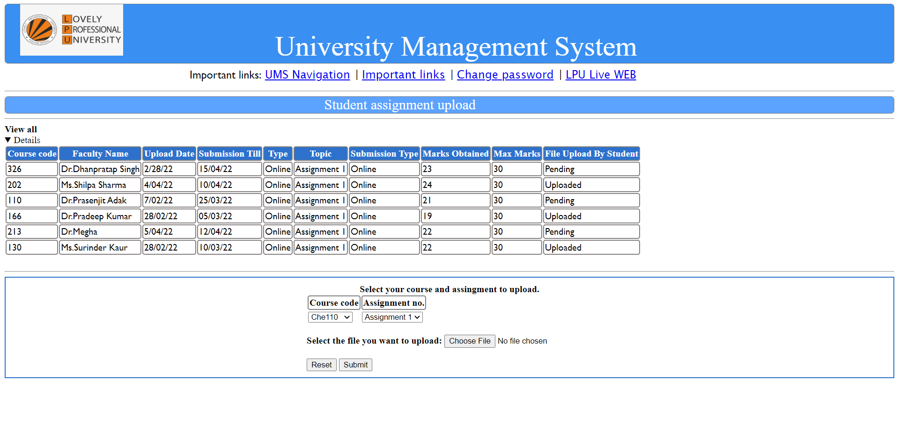
The picture above depicts the assignment upload page linked in the UMS. Student can upload the completed assignment through this page. Information regarding assignment is also provided in this page like, submission type, due date, upload update. Just like the assignment download page, course code, course name, teacher’s name etc. information is provided simultaneously to avoid any confusion. The appearance is kept simple, keeping in mind the thought that this is an educational site. A dedicated section is provided for uploading. Student must select proper course code and assignment number and then select the file from the pc to upload. After doing this much student need to click on the submit button to upload the assignment. In case any wrong file is selected, the student can simply click on the reset button and then reselect form respective folder/pc.

3.4 Practical upload-
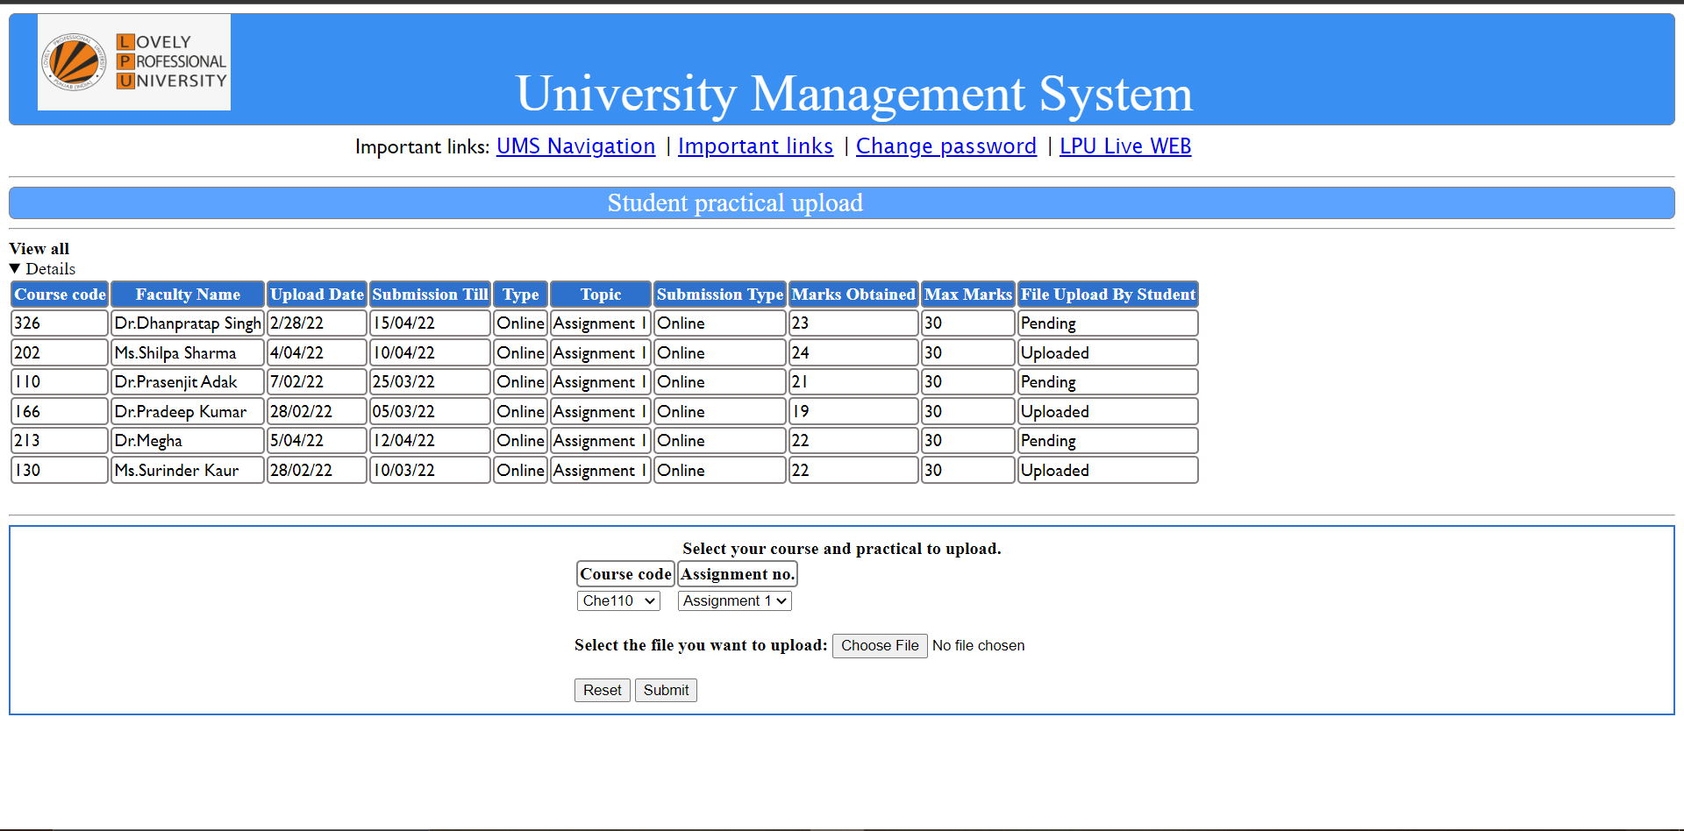
The picture above depicts the practical upload linked in the UMS. This page will help the student to upload his/her practical. It is very similar to assignment upload page because these pages provide same service hence creating a new page from scratch won’t do anything good. Basic information regarding course code, course name is provided for convenience. Separate upload space is given. File can be easily selected and if wrong file is selected, reset button is also given.

