**AI Lab Programs Output**

1. **Implement Tic-Tac-Toe game.**

Test case 01:

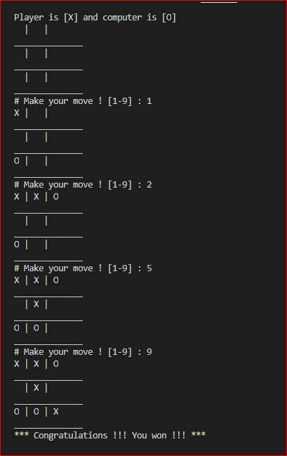

Test case 02:

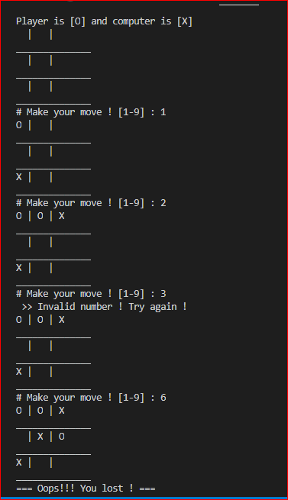

1. **Solve 8 puzzle problem.**

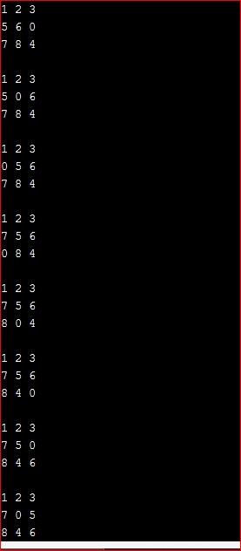 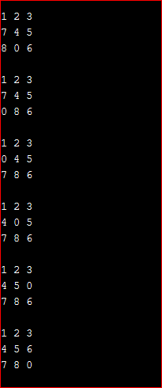

1. **Implement Iterative Deepening search.**

        

       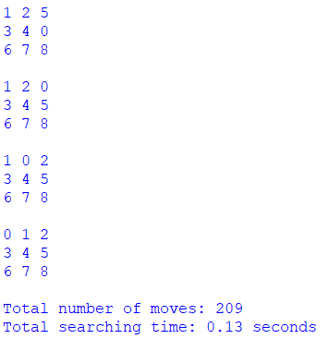

1. **Implement A* search algorithm.**

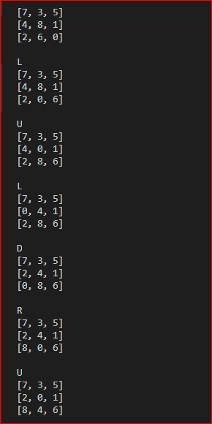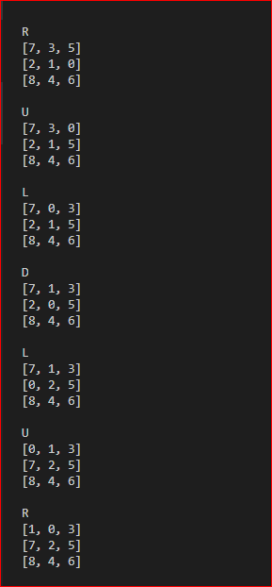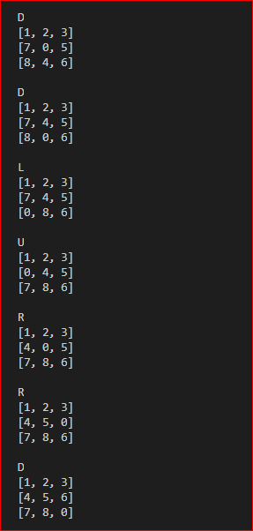

1. **Implement Vacuum cleaner agent.**

Test case 01:

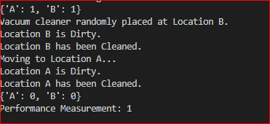

Test case 02:

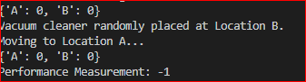

Test case 03:

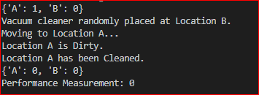

1. **Create a knowledge base using prepositional logic and show that the given query entails the knowledge base or not.**

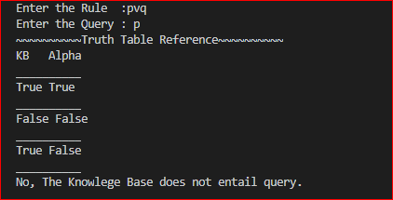

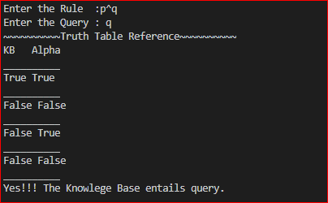

1. **Implement Unification in First order logic.**

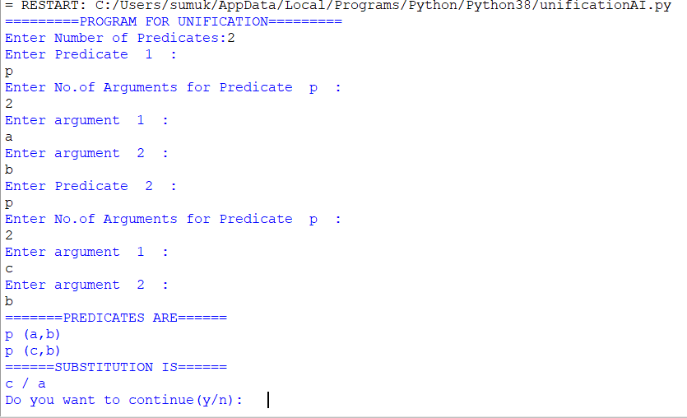

1. **Convert giver First order logic statement into Conjunctive Normal Form.**

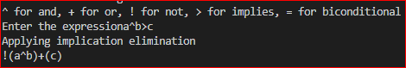

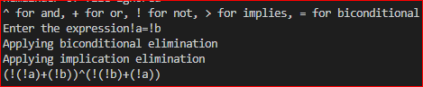

1. **Create a KB consisting of First order logic statements and prove the given query using forward reasoning.**

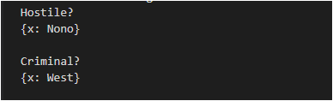

1. **Demonstrate decision tree learning for a given set of training examples and test data.**

