LAB level 3 PROJECT
EcoFoodSync: Polyglot Database System for Automated Perishable Food Rescue

DBMS Engine: MySQL 8.0 | Course: DBMS Experiential Learning – Level 3
Lab Task: ER Diagram & DDL Schema Implementation
Team : G14

SRN1: PES2UG24CS660 SRN2:PES2UG24CS676 SECTION

Lab Objective
To design a normalised relational schema, define logical entities, construct an Entity-Relationship (ER) Diagram using standard Chen notation, and implement database structures using Data Definition Language (DDL) commands in MySQL 8.0 with primary keys, foreign keys, constraints, and performance indexes.

System Architecture & Core Entities
The EcoFoodSync system coordinates perishable food rescue across 7 key relational entities:
  - FOOD_DONOR: Stores donor business profiles (Restaurants, Supermarkets, Caterers, Individuals).
  - FOOD_DONATION: Tracks surplus food batches, preparation/expiry timestamps, and condition types.
  - CHARITY_OR_NGO: Manages recipient organisations, contact details, operational areas, and food capacity.
  - ALLOCATION: Maps food donations to charities while enforcing allocation status and quantities.
  - VOLUNTEER: Stores driver information, real-time availability status, and current locations.
  - PICKUP_DELIVERY: Handles physical transportation and logistics logs from donor to recipient charity.
  - FOOD_REQUEST: Tracks specific food demand requests submitted by charities based on urgency level.

Entity-Relationship (ER) Diagram (Chen Notation)
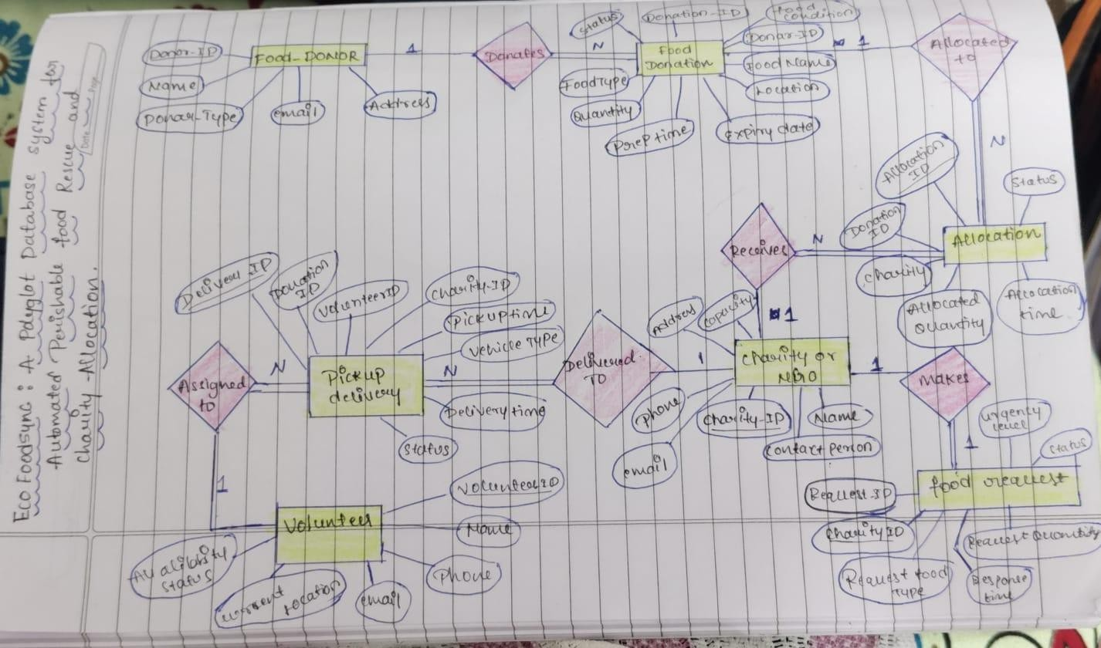

Cardinality & Relationship Summary
  - FOOD_DONOR (1) : DONATES : FOOD_DONATION (N) — One donor can generate multiple food donation listings.
  - FOOD_DONATION (1) : ALLOCATED TO : ALLOCATION (M) — One donation batch can be split into multiple allocations.
  - ALLOCATION (N) : RECEIVES ALLOCATION : CHARITY_OR_NGO (1) — One charity can receive multiple allocations.
  - CHARITY_OR_NGO (1) : MAKES REQUEST : FOOD_REQUEST (N) — One charity can issue multiple food requests.
  - VOLUNTEER (1) : ASSIGNED TO : PICKUP_DELIVERY (N) — One volunteer driver handles multiple delivery tasks.
  - FOOD_DONATION (1) : PICKED UP / DELIVERED : PICKUP_DELIVERY (N) — One donation batch links to logistics tasks.
  - PICKUP_DELIVERY (N) : DELIVERED TO : CHARITY_OR_NGO (1) — Multiple delivery actions arrive at a single target charity.

SCHEMA DIAGRAM

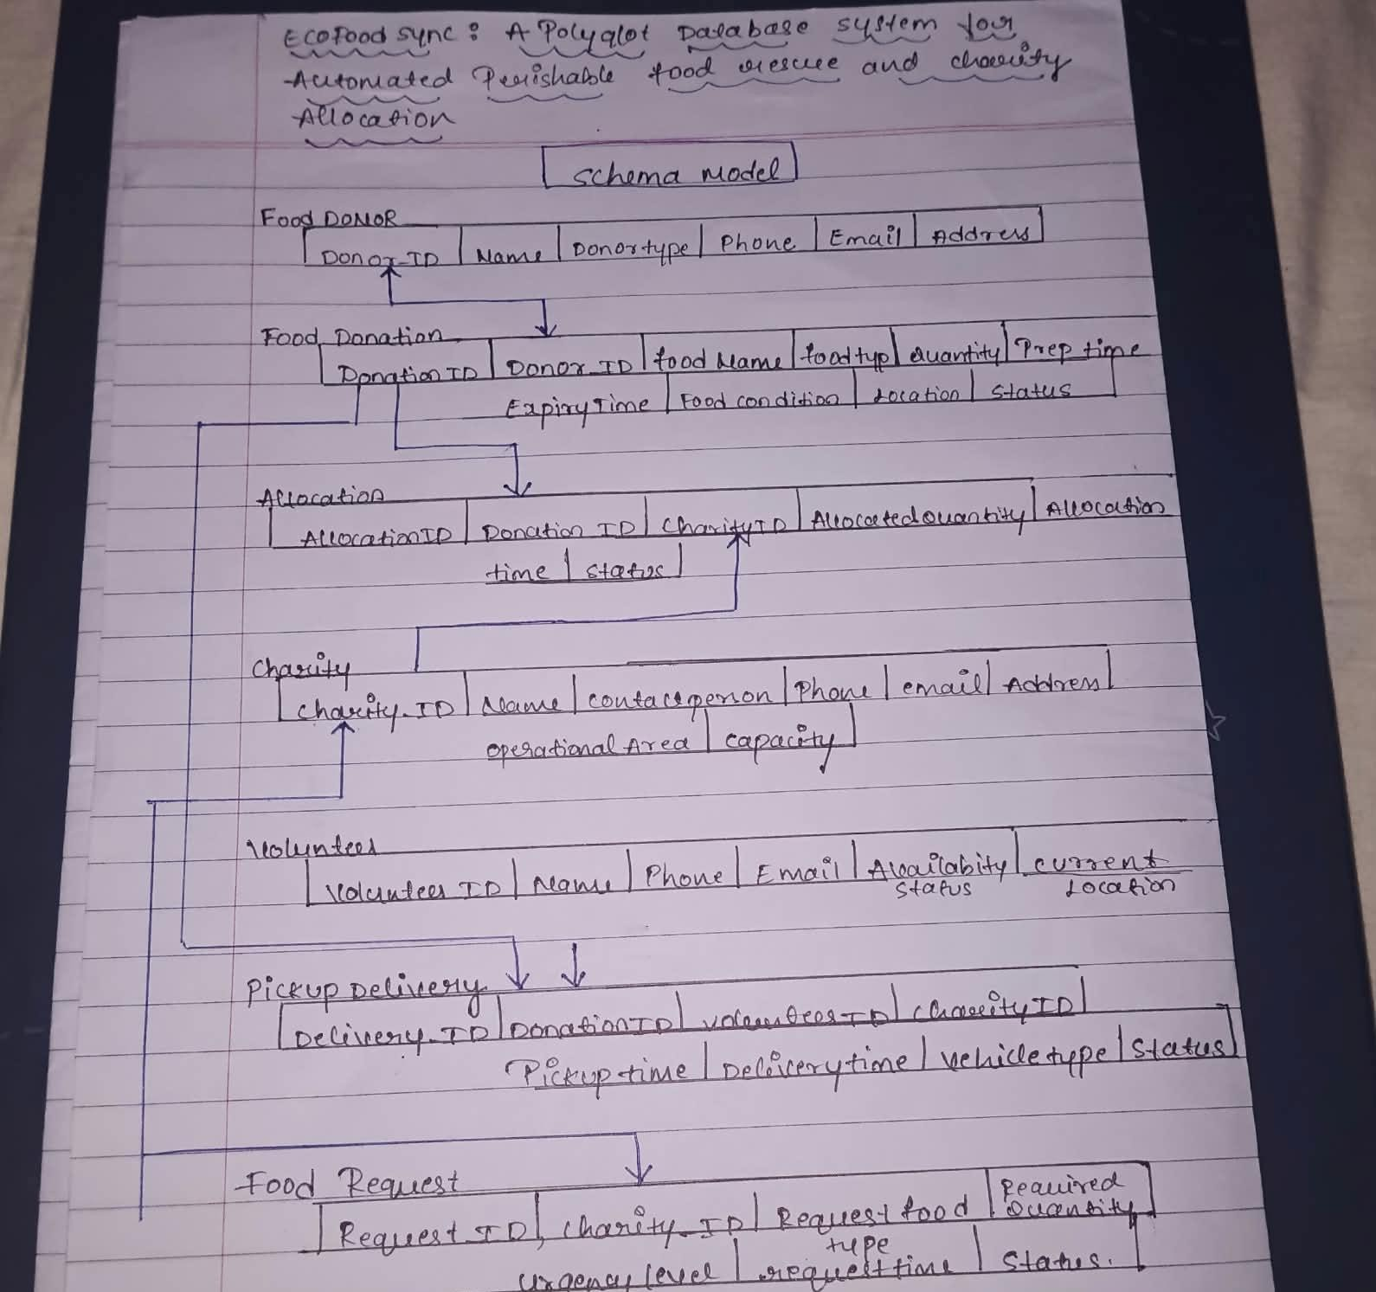

Data Dictionary

Table Name | Attribute Name | Data Type | Constraint | Description
food_donor | donor_id | CHAR(36) | PRIMARY KEY | UUID string generated via DEFAULT (UUID())
food_donor | name | VARCHAR(255) | NOT NULL | Legal name of donor entity
food_donor | donor_type | ENUM(...) | NOT NULL | Type (RESTAURANT, SUPERMARKET, etc.)
food_donor | email | VARCHAR(255) | UNIQUE, NOT NULL | Unique donor contact email

food_donation | donation_id | CHAR(36) | PRIMARY KEY | Unique food donation batch ID
food_donation | donor_id | CHAR(36) | FOREIGN KEY | FK referencing food_donor(donor_id)
food_donation | quantity | DECIMAL(10,2) | CHECK (>0) | Total quantity/weight in KG
food_donation | expiry_time | DATETIME | CHECK (>prep) | Timestamp before which food expires
allocation | allocation_id | CHAR(36) | PRIMARY KEY | Unique allocation claim ID
allocation | donation_id | CHAR(36) | FOREIGN KEY | FK referencing food_donation
allocation | charity_id | CHAR(36) | FOREIGN KEY | FK referencing charity_or_ngo
pickup_delivery | delivery_id | CHAR(36) | PRIMARY KEY | Unique logistics tracking ID
pickup_delivery | volunteer_id | CHAR(36) | FOREIGN KEY | FK referencing volunteer (NULL allowed)

MySQL 8.0 DDL Implementation Script Create :
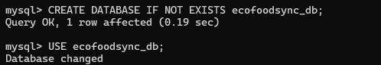
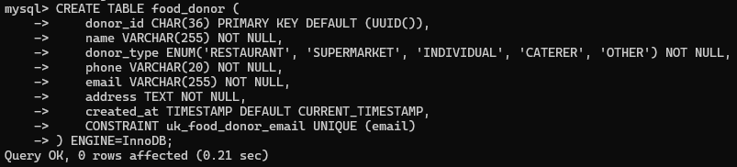
-- Database Creation

-- 1. FOOD_DONOR Table

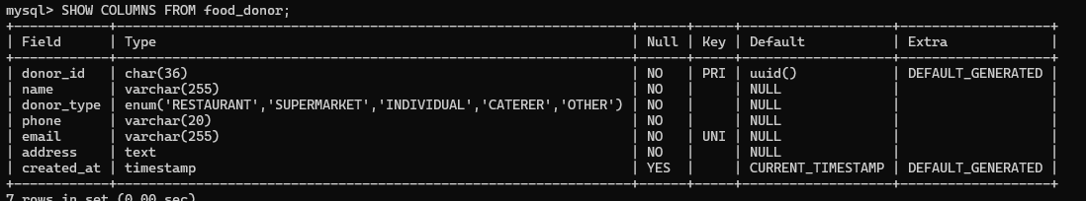
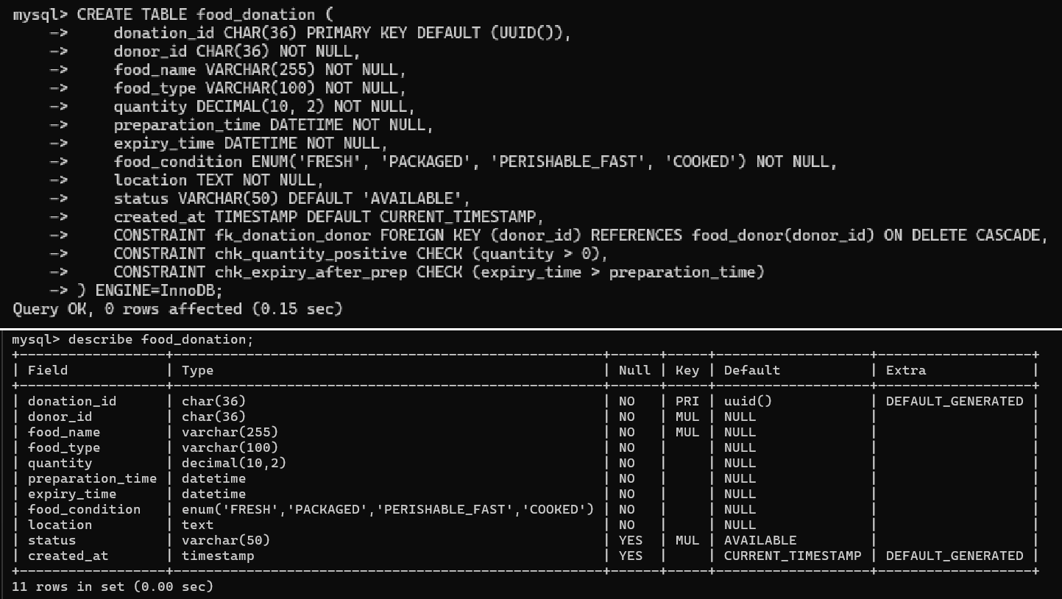
-- 2. FOOD_DONATION Table

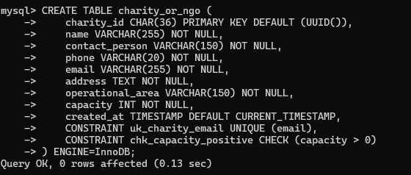
-- 3. CHARITY_OR_NGO Table

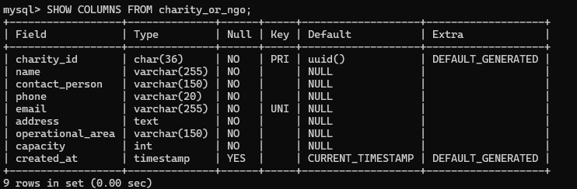

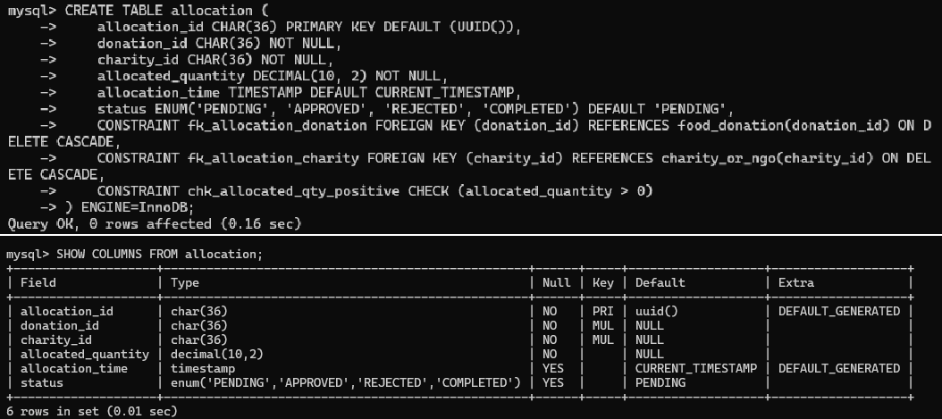
-- 4. ALLOCATION Table
-- 5. VOLUNTEER Table
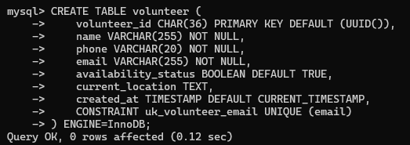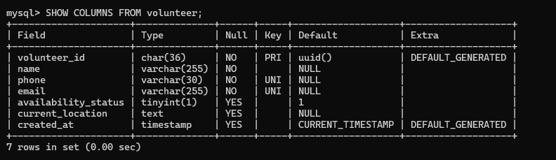

-- 6. PICKUP_DELIVERY Table

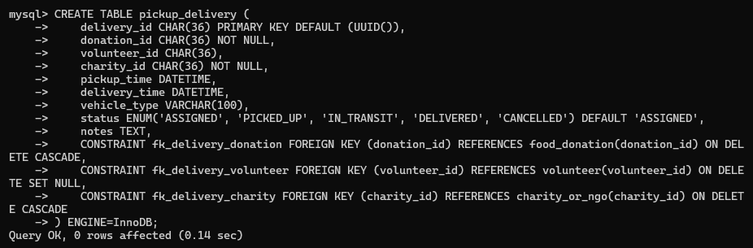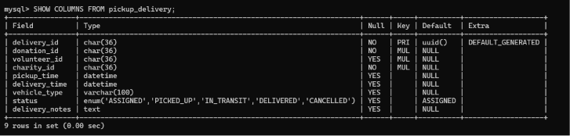

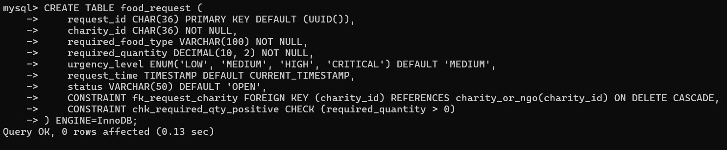
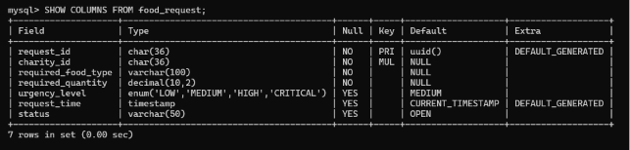
-- 7. FOOD_REQUEST Table

Indexing :

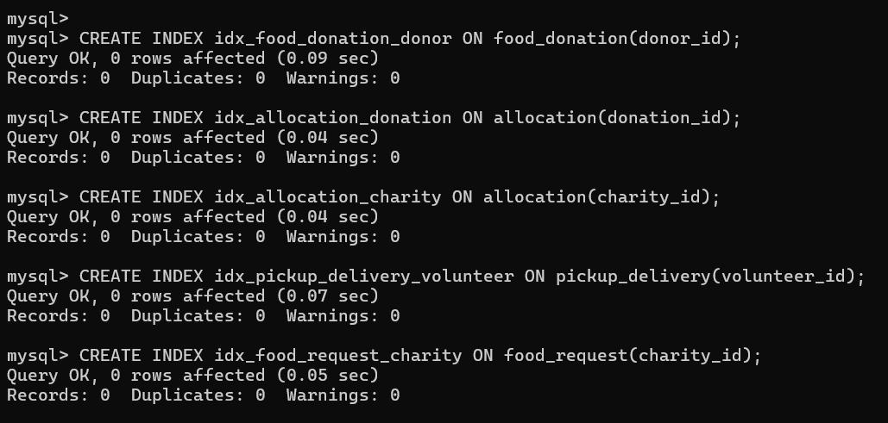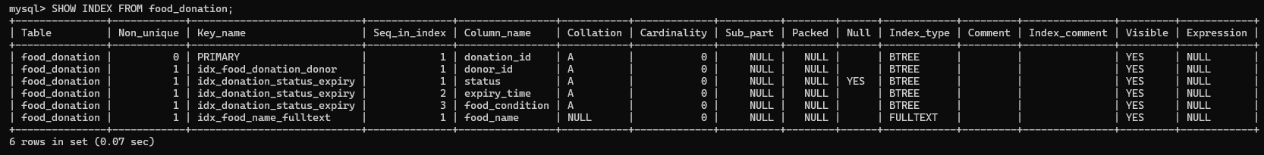

-- 1. ALTER OPERATIONS

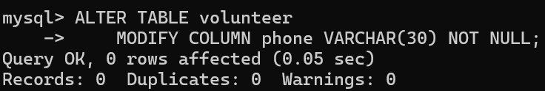
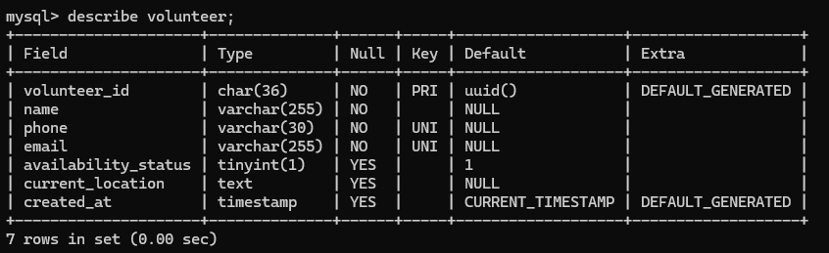
-- 1. Modify phone column in volunteer
-- 2. Rename notes column in pickup_delivery
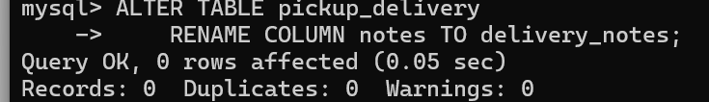

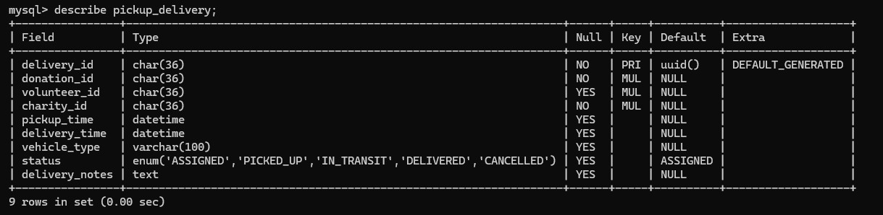

-- 3. DROP Operation (Demonstration)
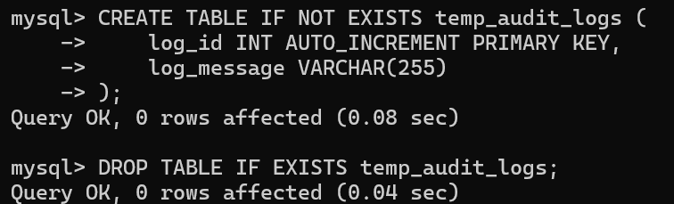

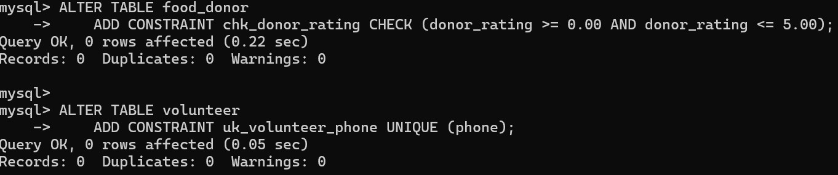
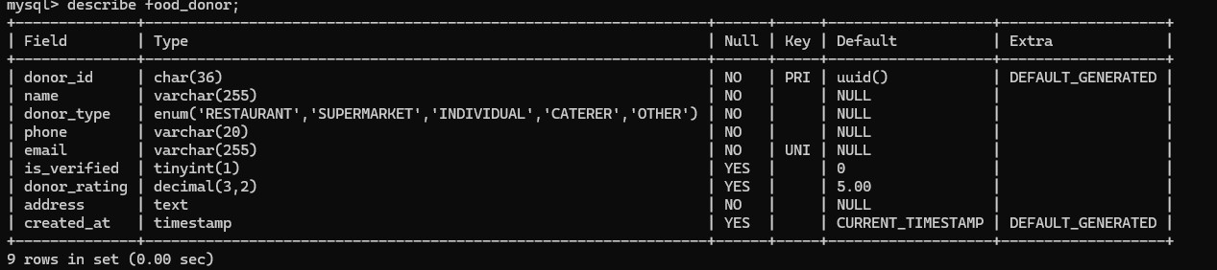
-- 4. Add Constraints

-- 5. Create Indexes

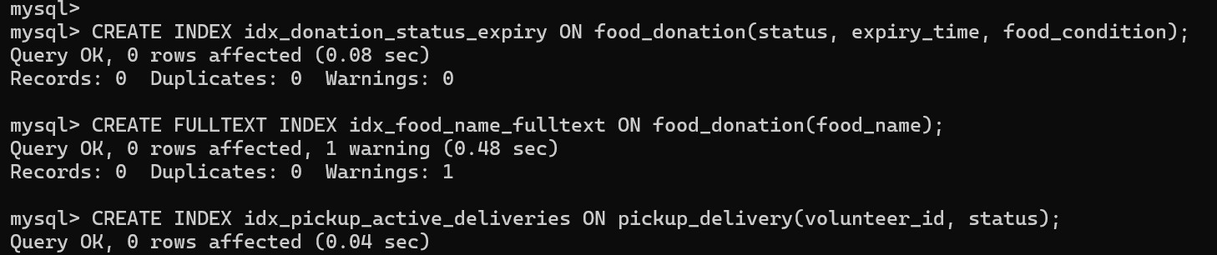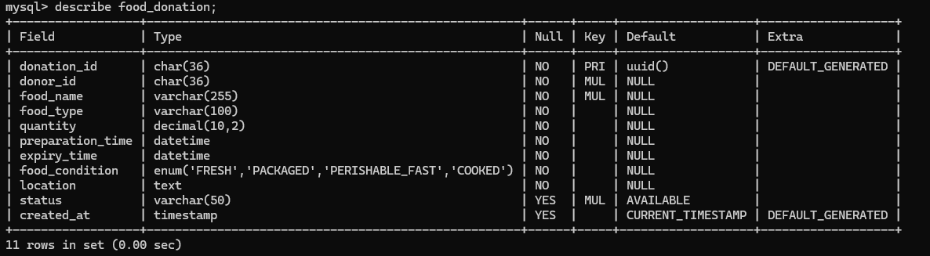
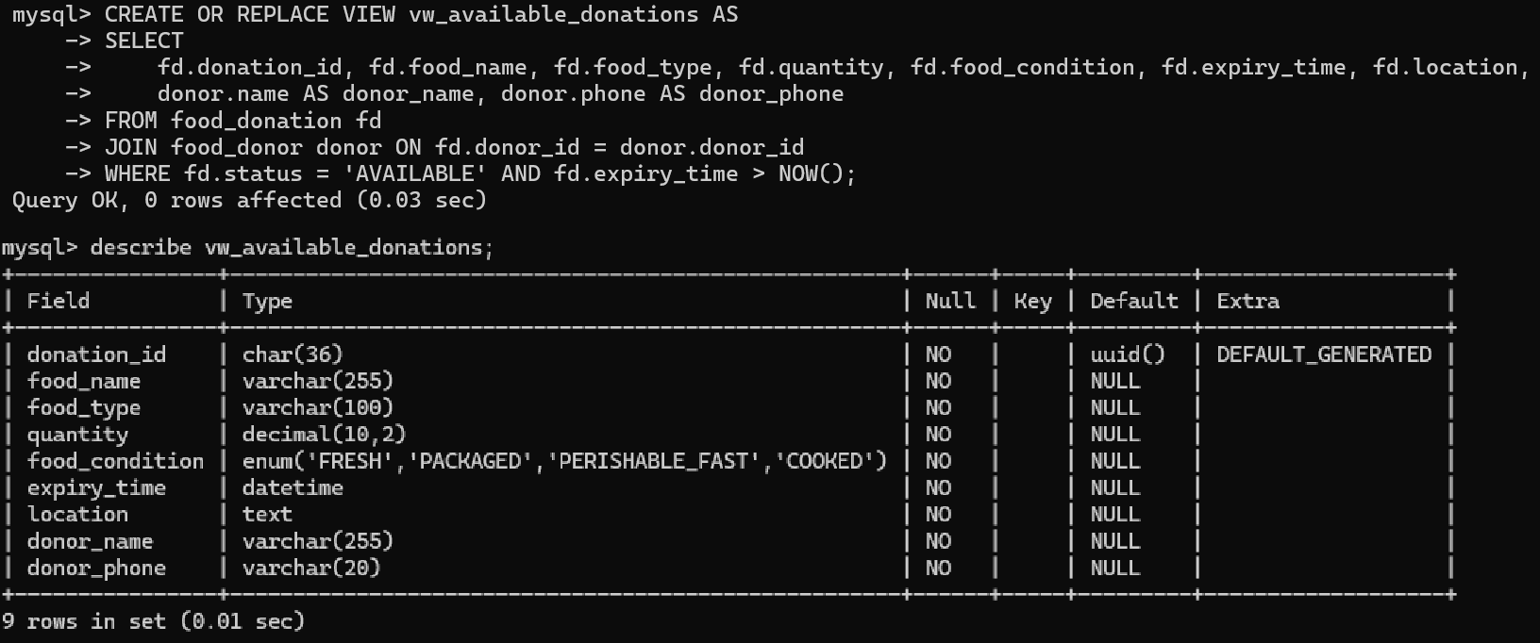
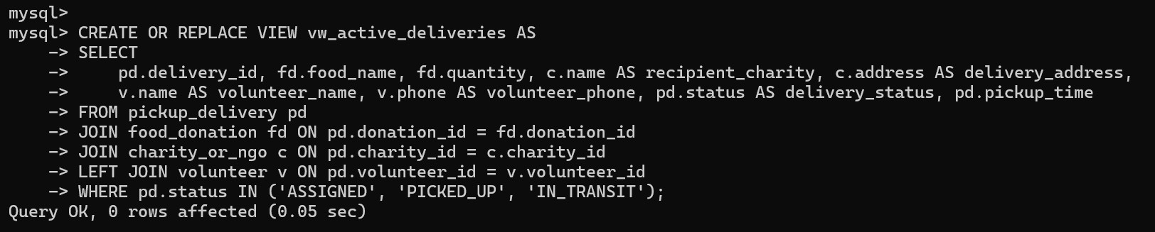
-- 6. Create Views

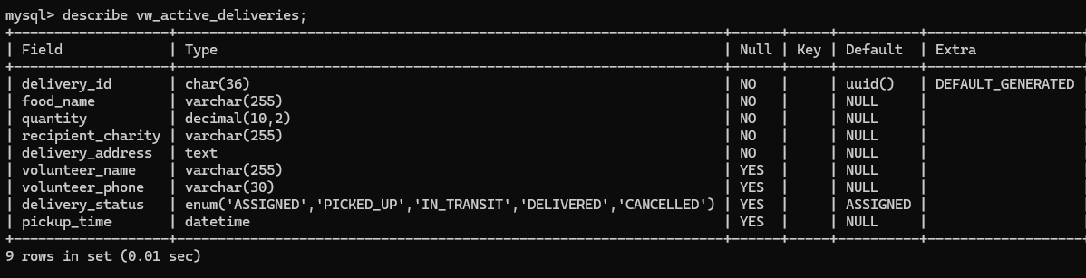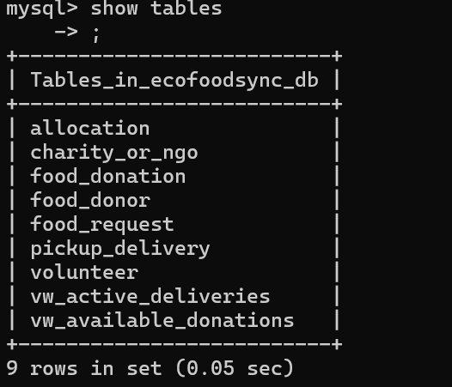
Tables after

DML IMPLEMENTATION

6.1 INSERT Operations
- Insert records into food_donor
- Insert records into charity_or_ngo
- Insert records into volunteer
- Insert records into food_donation
- Insert records into allocation
- Insert records into pickup_delivery
- Insert records into food_request

6.1.1 Insert data into food_donor
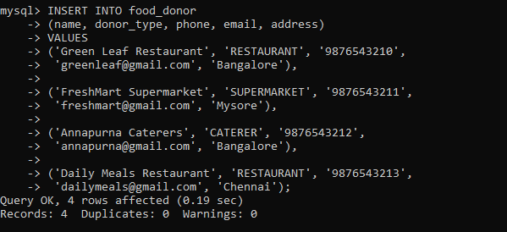

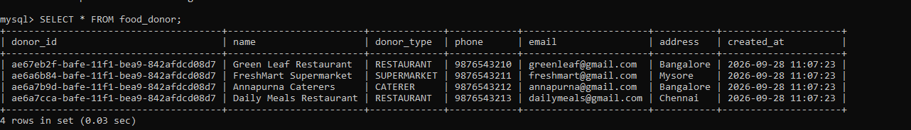

6.1.2 Insert data into charity_or_ngo

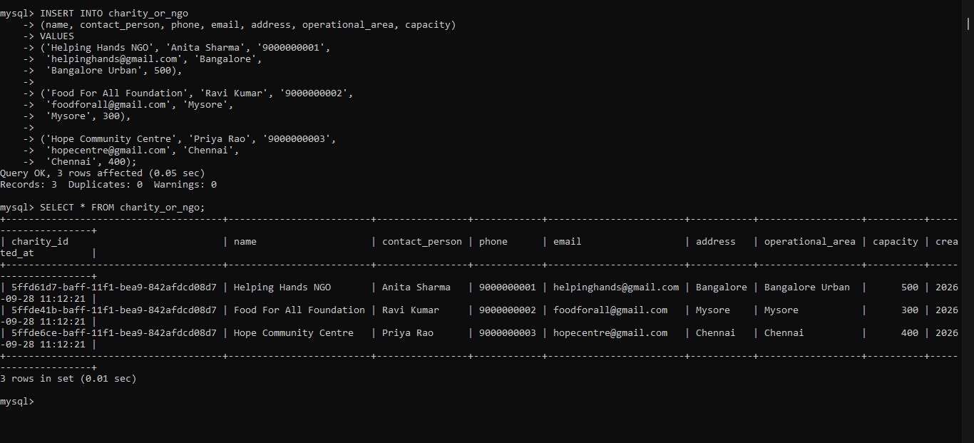

6.1.3 Insert data into volunteer

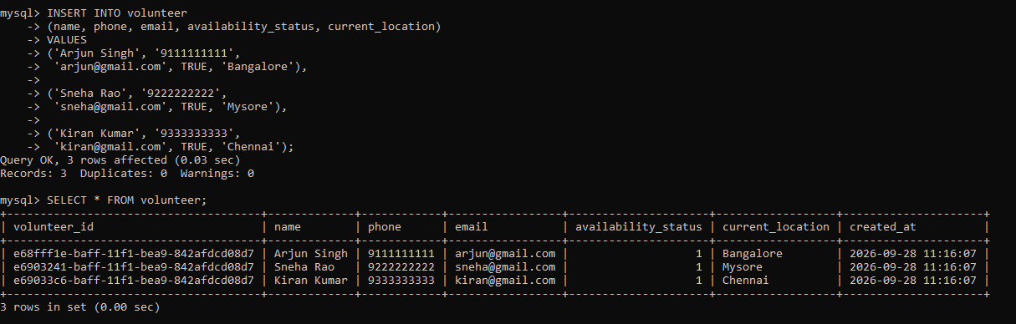

6.1.4 Insert data into food_donation

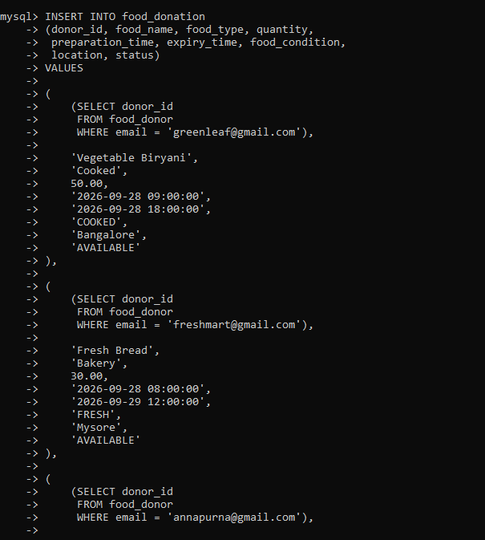

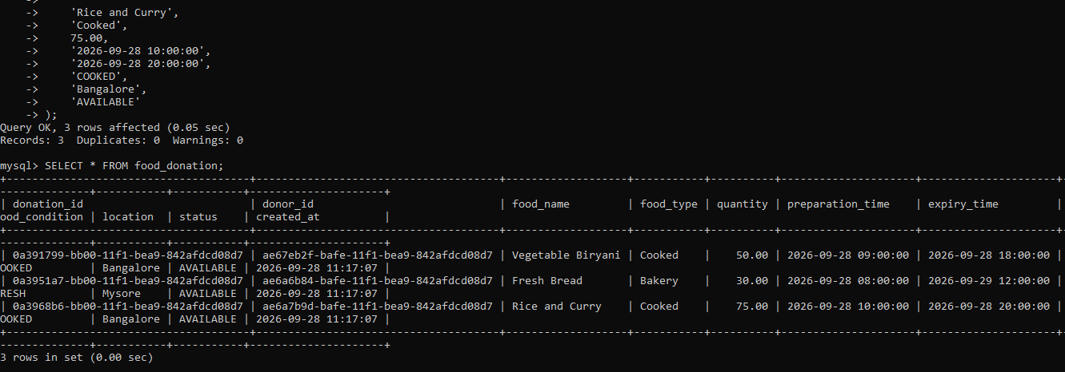

6.1.5 Insert data into allocation

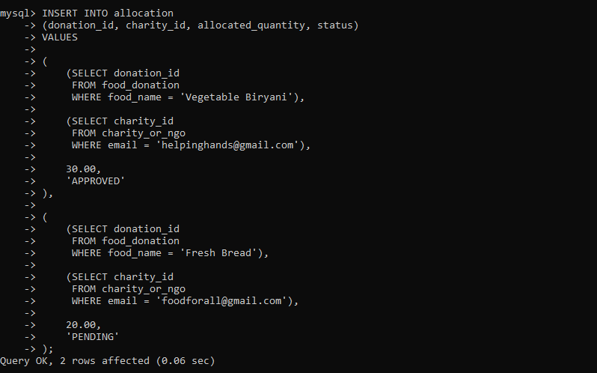

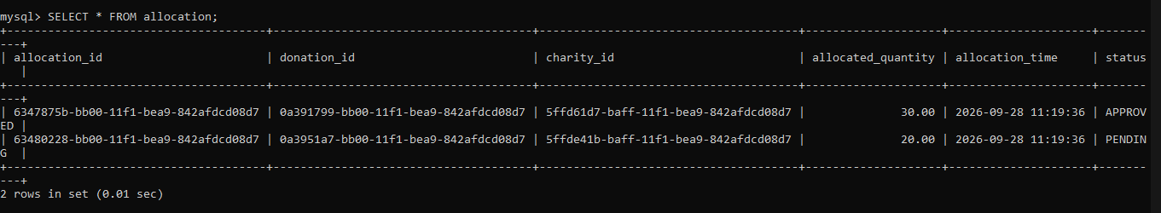

6.1.6 Insert data into pickup_delivery

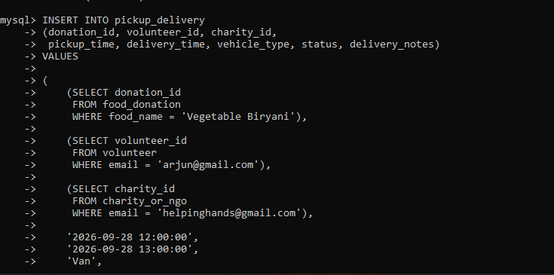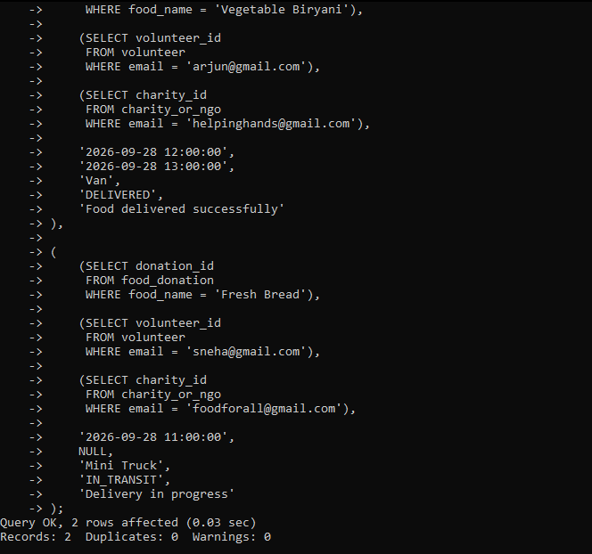

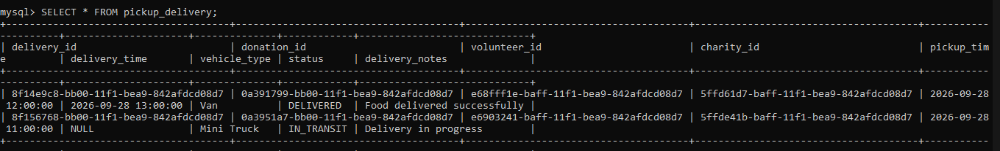

6.1.7 Insert data into food_request

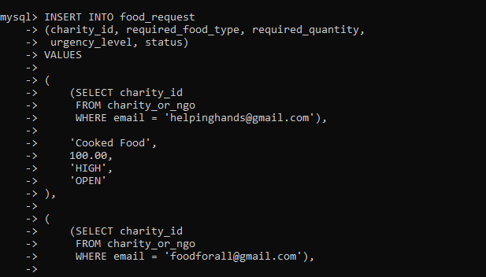
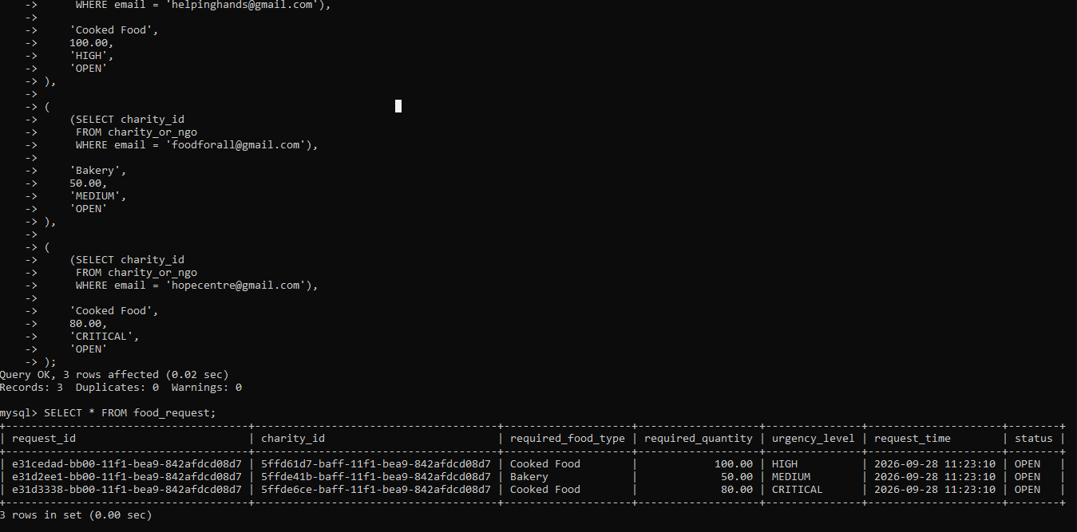

6.2 UPDATE Operations

6.2.1 Update Food Donation Status

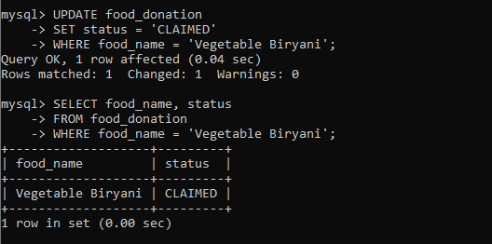

6.2.2 Update Volunteer Availability

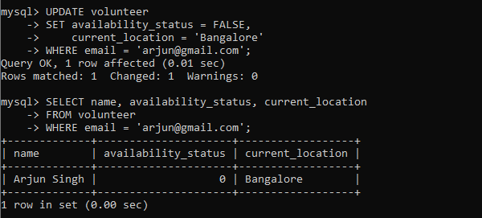

6.2.3 Update Charity Capacity

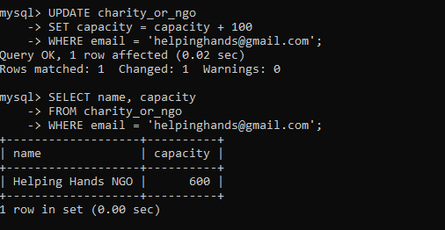

6.2.4 Update Allocation Status

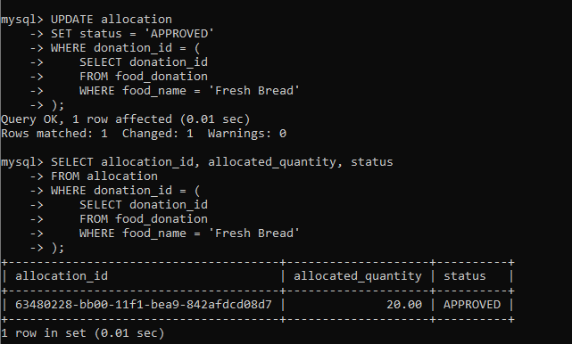

6.3 DELETE Operations

6.3.1 Delete a Food Request

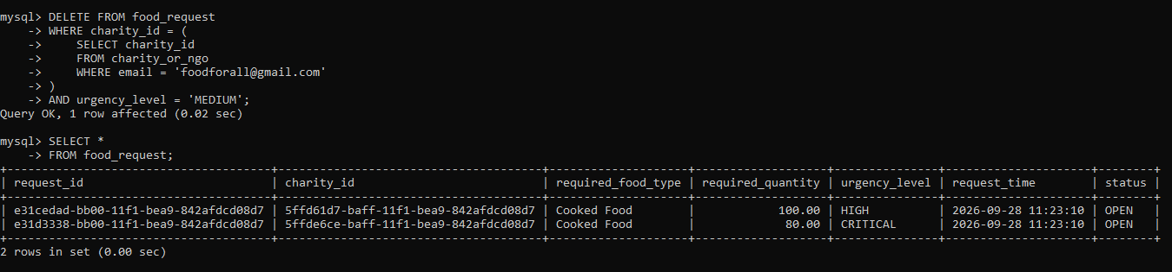

6.3.2 Delete an Unused Volunteer

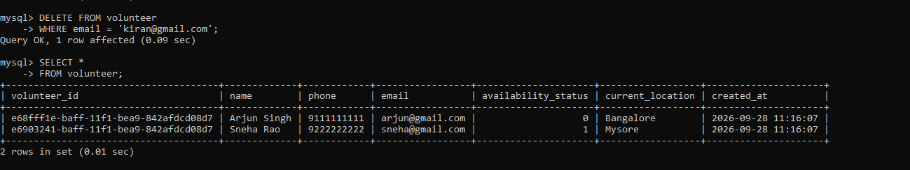

6.4 SELECT Operations

6.4.1 Display All Food Donations

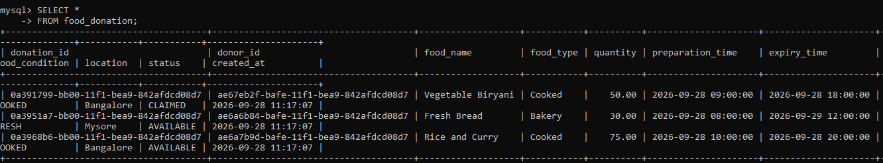

6.4.2 Display Available Food

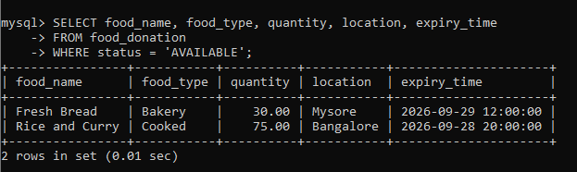

6.4.3 Display High-Quantity Donations

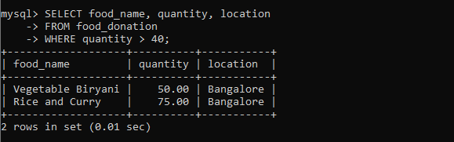

6.4.4 Display Donations by Earliest Expiry

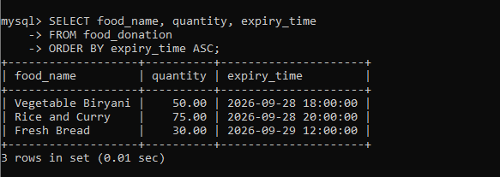

6.4.5 Display High-Urgency Food Requests

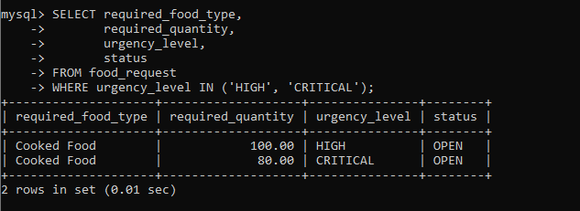

6.5 JOIN Operations

6.5.1 Donor + Food Donation
Question: Display the donor name, food name, quantity and location.
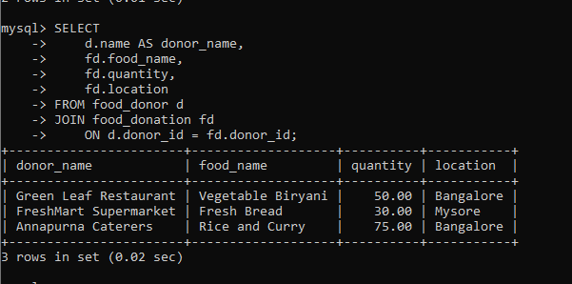

6.5.2 Donation + Charity
Question: Display which food was allocated to which charity.
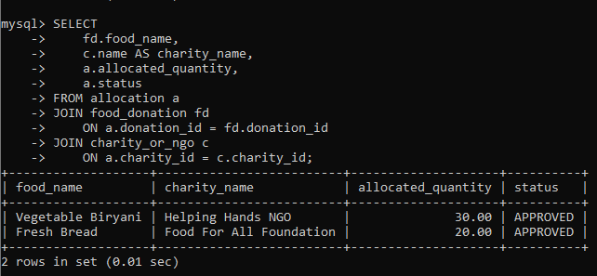

6.5.3 Complete Delivery Information ⭐
Question: Display the food, donor, volunteer and charity involved in each delivery.

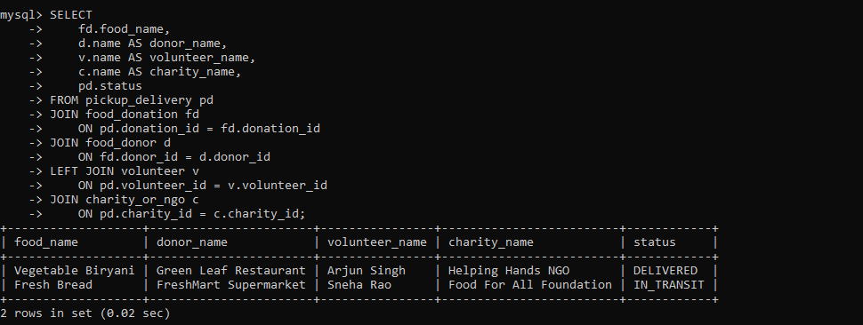

6.6 Aggregate Functions

6.6.1 COUNT()

Question:
Find the total number of food donations.
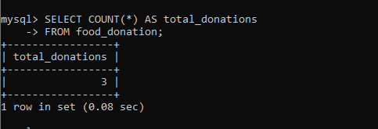

6.6.2 SUM()

Question:
Find the total quantity of food donated.
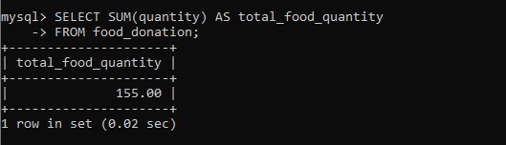

6.6.3 AVG()

Question:
Find the average quantity of food donated.
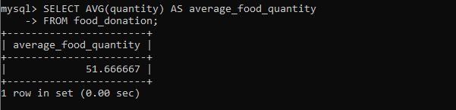

6.6.4 MAX()

Question:
Find the largest food donation.
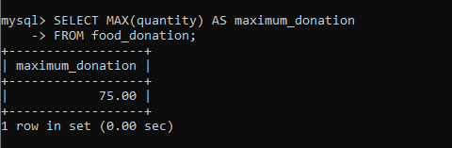

6.6.5 MIN()

Question:
Find the smallest food donation.
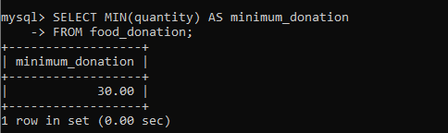

6.6.6 All Aggregate Functions Together

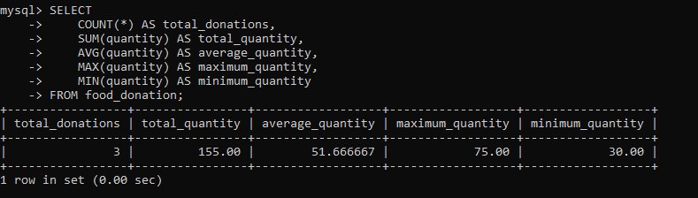

6.7 GROUP BY Operations

6.7.1 Total Food Donated by Each Donor

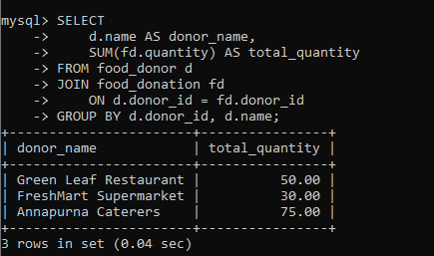

6.7.2 Total Food Received by Each Charity

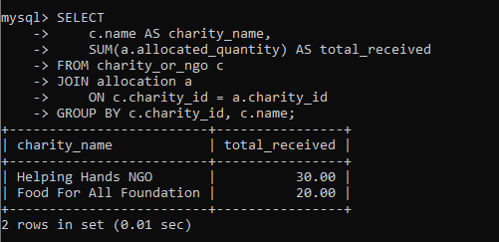

6.8 HAVING Operations

6.8.1 Donors with More Than 40 kg Total Donations

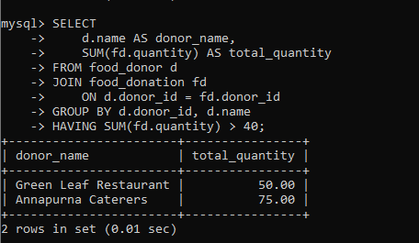

6.8.2 Charities Receiving More Than 20 kg

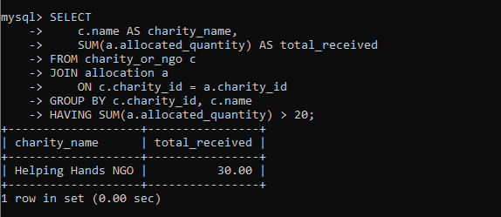

6.9 ORDER BY Operations

6.9.1 Donations by Quantity

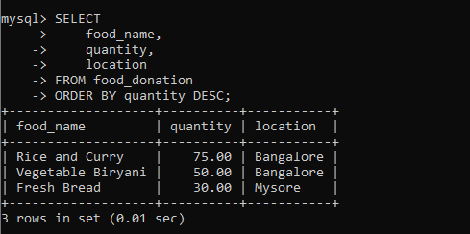

6.9.2 Donations by Earliest Expiry

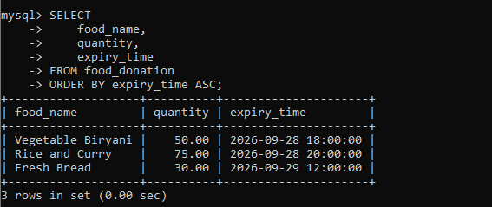

6.10 Subqueries

6.10.1 Donations Above Average Quantity

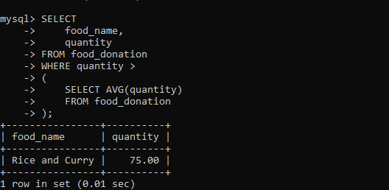

6.10.2 Donation with Maximum Quantity

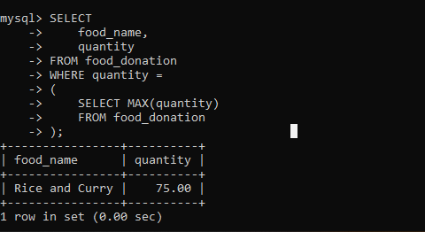

6.10.3 Charities Above Average Capacity

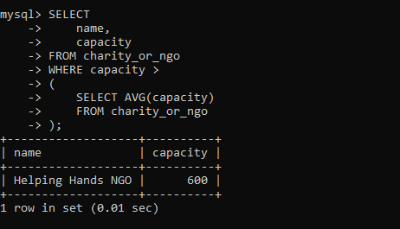

6.11 Complex Queries

6.11.1 Donors with More Than 40 kg, Sorted by Quantity

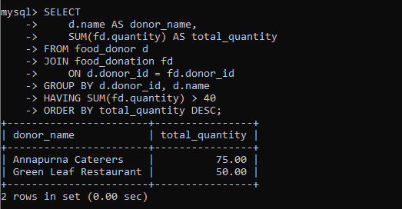

6.11.2 Complete Food Allocation Information
Display:
- Food name
- Donor
- Charity
- Allocated quantity
- Allocation status

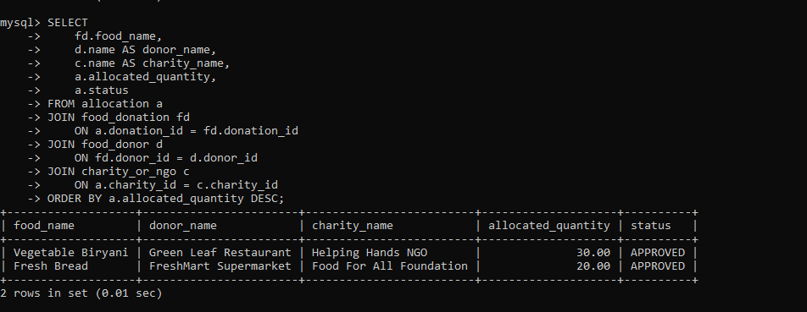

ADVANCED DATABASE MANAGEMENT SYSTEM

6. VIEW
  - Creation of View for Active Deliveries
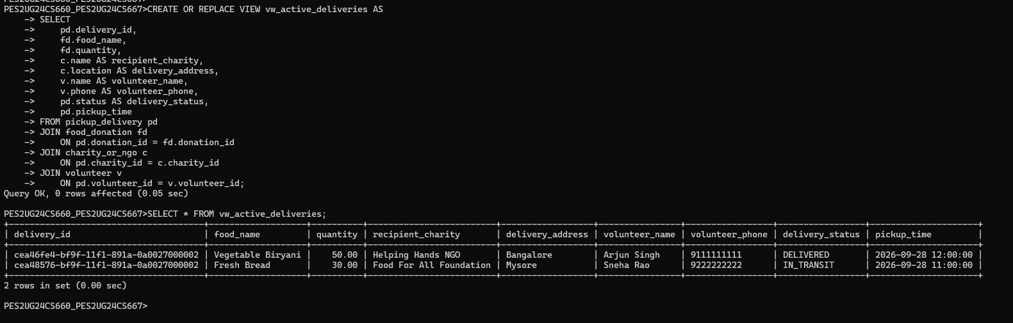

7. INDEXING AND QUERY OPTIMIZATION

7.1 Displaying Indexes on food_donation
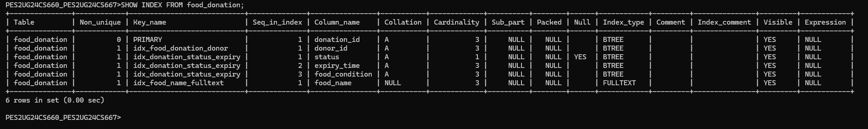

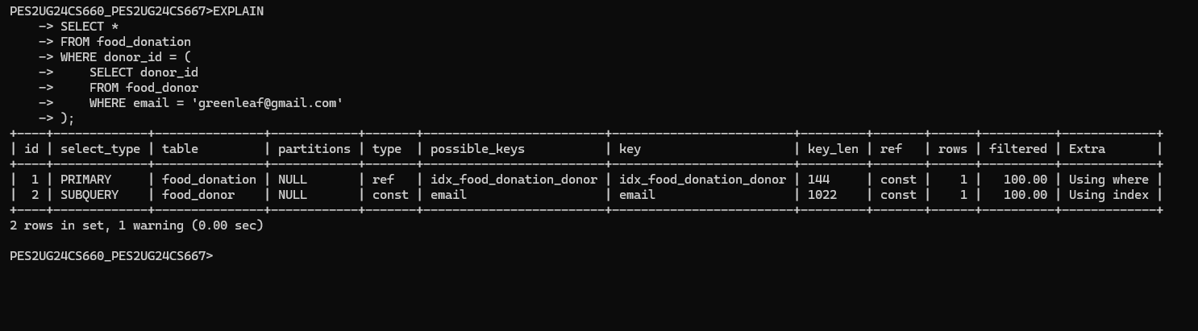

7.2 Composite Index Optimization
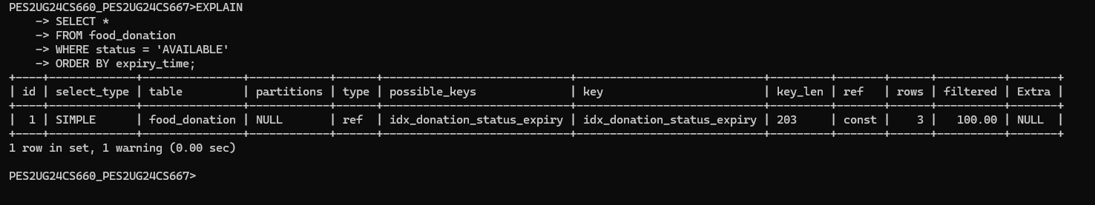

8. STORED PROCEDURES
8.1 Stored Procedure to Retrieve Available Food by Location

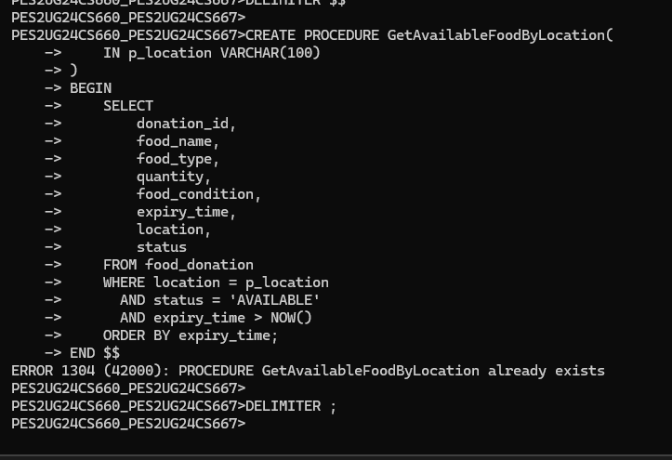

8.2 Stored Procedure for Donation Allocation summary
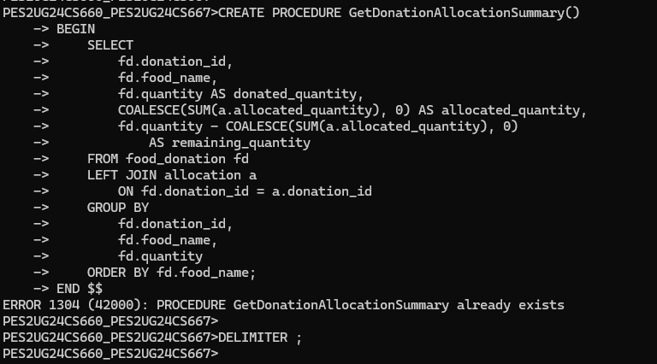

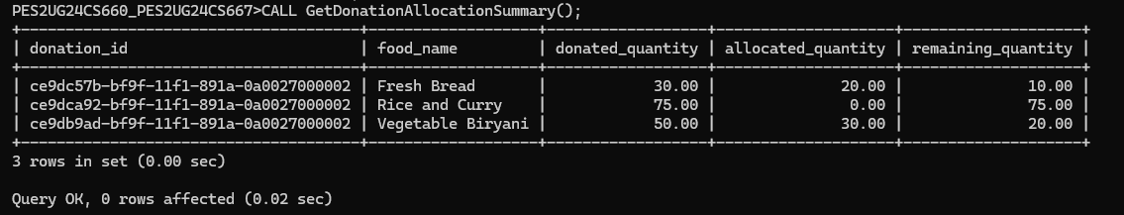

9. STORED FUNCTION

9.1 Creation of Stored Function
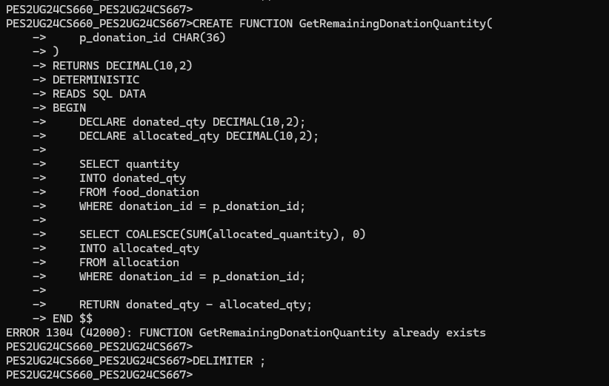

9.2 Testing the Stored Function

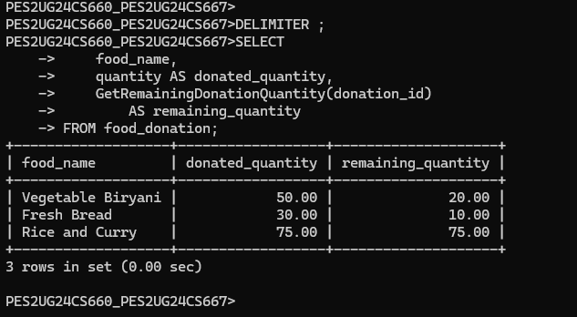

9.3 Verification of Stored Function

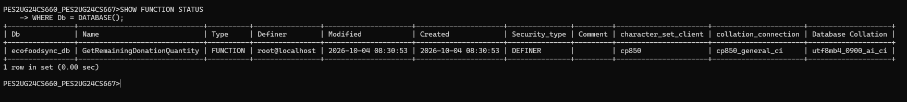

10. TRIGGERS

10.1 Trigger to Prevent Excess Food Allocation

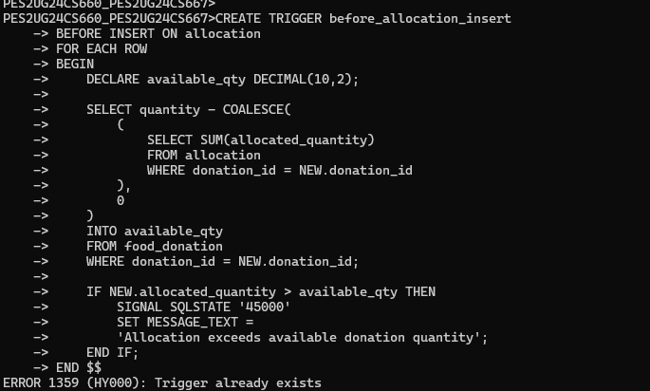

10.2 Trigger to Validate Food Expiry Time

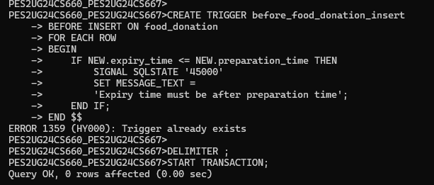

10.3 Testing the Allocation Trigger — Valid Operation

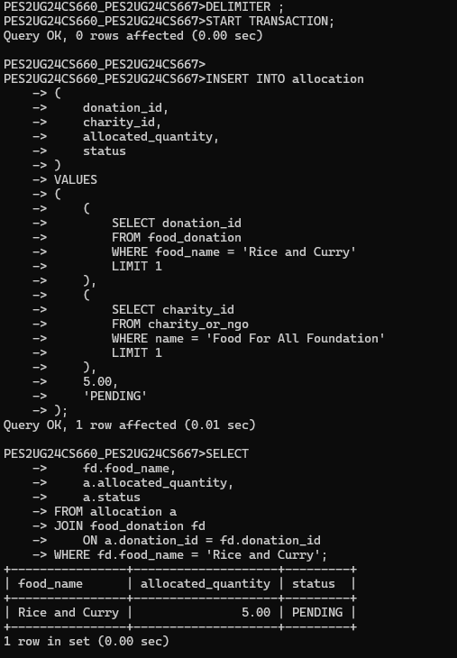

10.4 Testing the Allocation Trigger — Invalid Operation

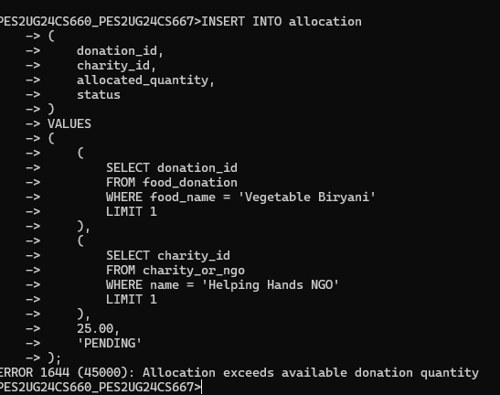

10.5 Testing the Food Expiry Trigger

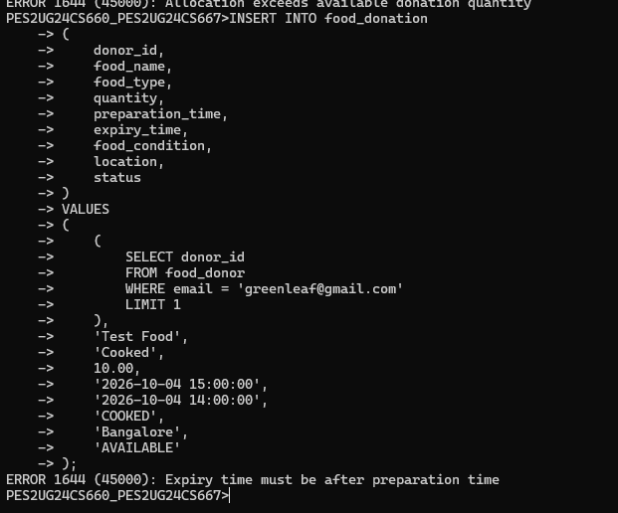

10.6 Verifying That the Invalid Donation Was Not Inserted

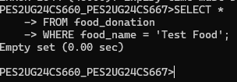

11. TRANSACTIONS

- START TRANSACTION
- SAVEPOINT
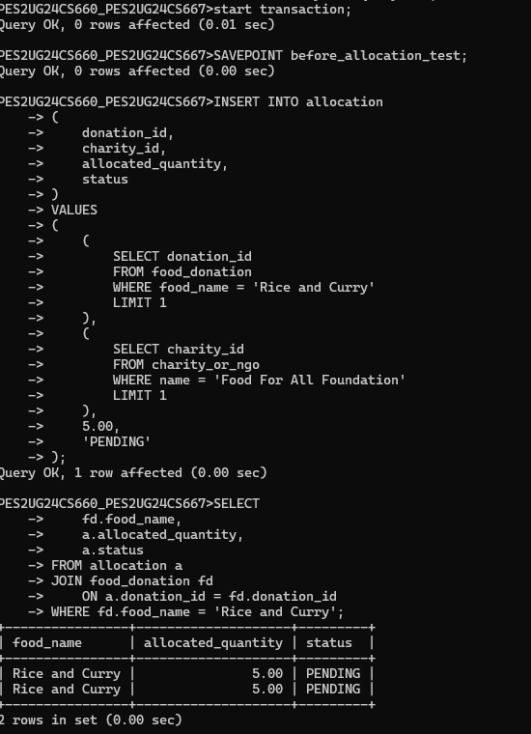

- ROLLBACK TO SAVEPOINT
- COMMIT
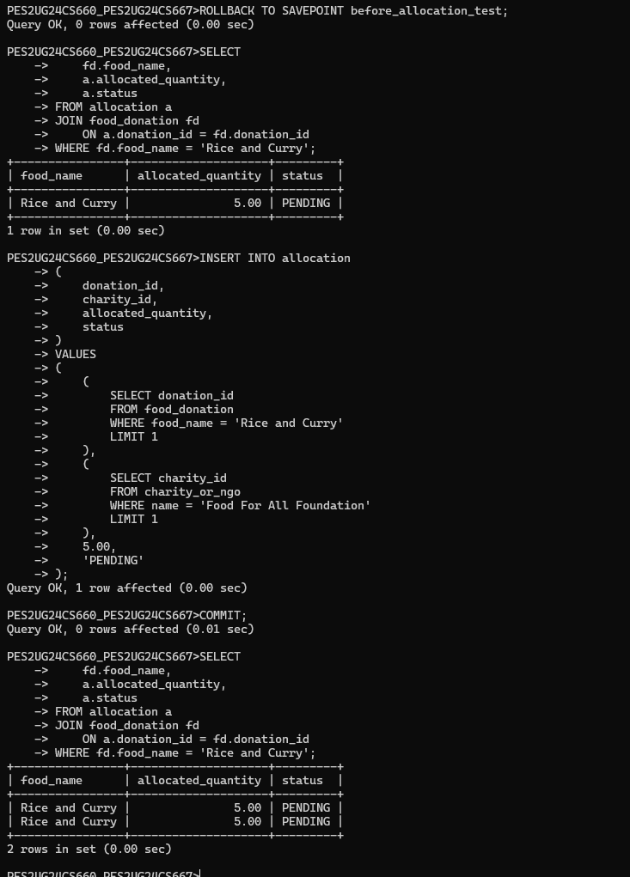

12. CURSORS

12.1 CURSORS FOR PROCESSING FOOD DONATIONS
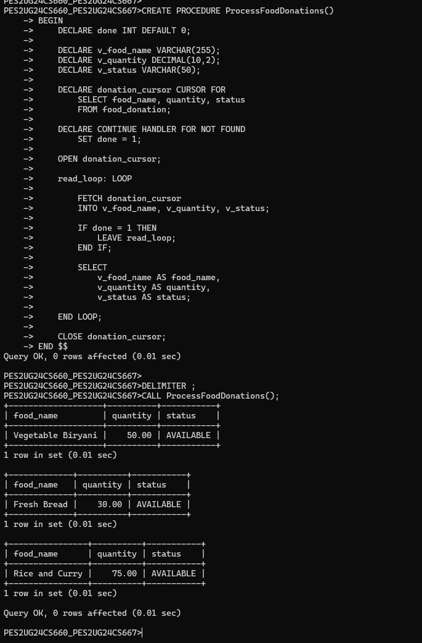

13. COMMON TABLE EXPRESSIONS

13.1 CTE FOR DONATION ANALYSIS AND WINDOW FUNCTION RANKING
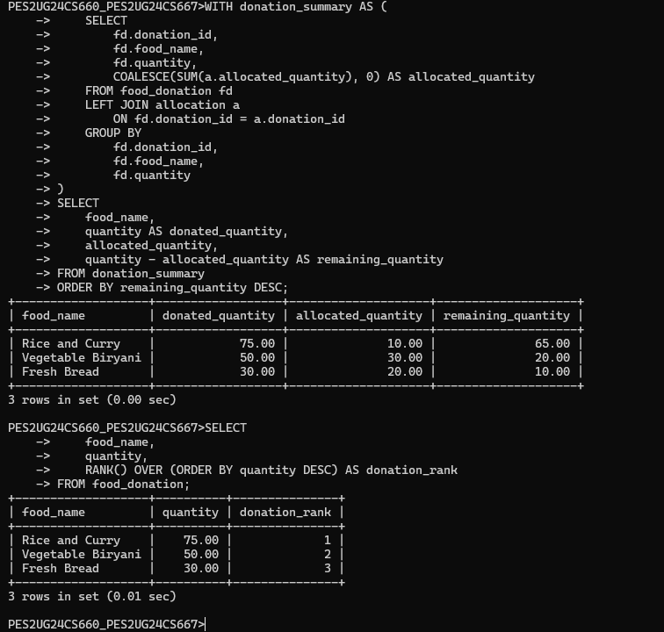

13.2 ADVANCED QUERY – CORRELATED SUBQUERY AND ALLOCATION PERCENTAGE

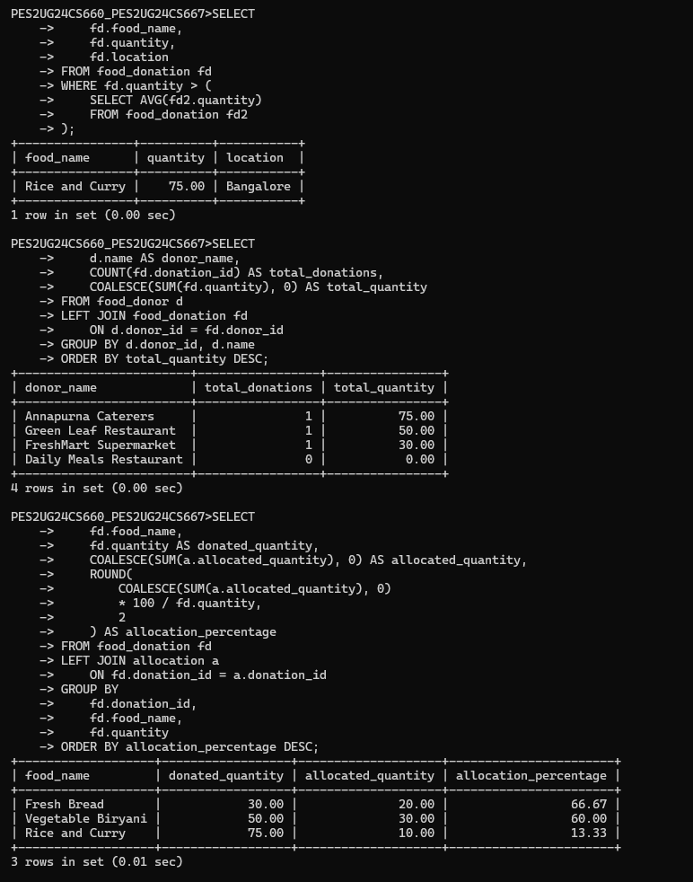

14. FINAL VERIFICATION & PROJECT COMPLETION

14.1 Verification of database tables and viwe tables

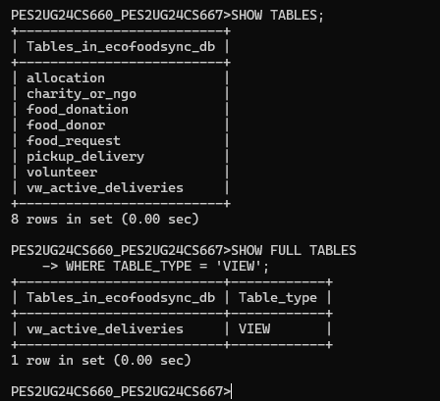

14.2 Verification of Stored Procedures and functions

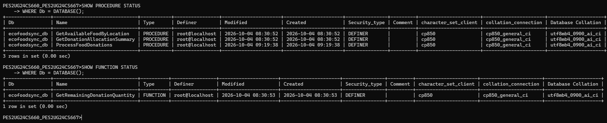

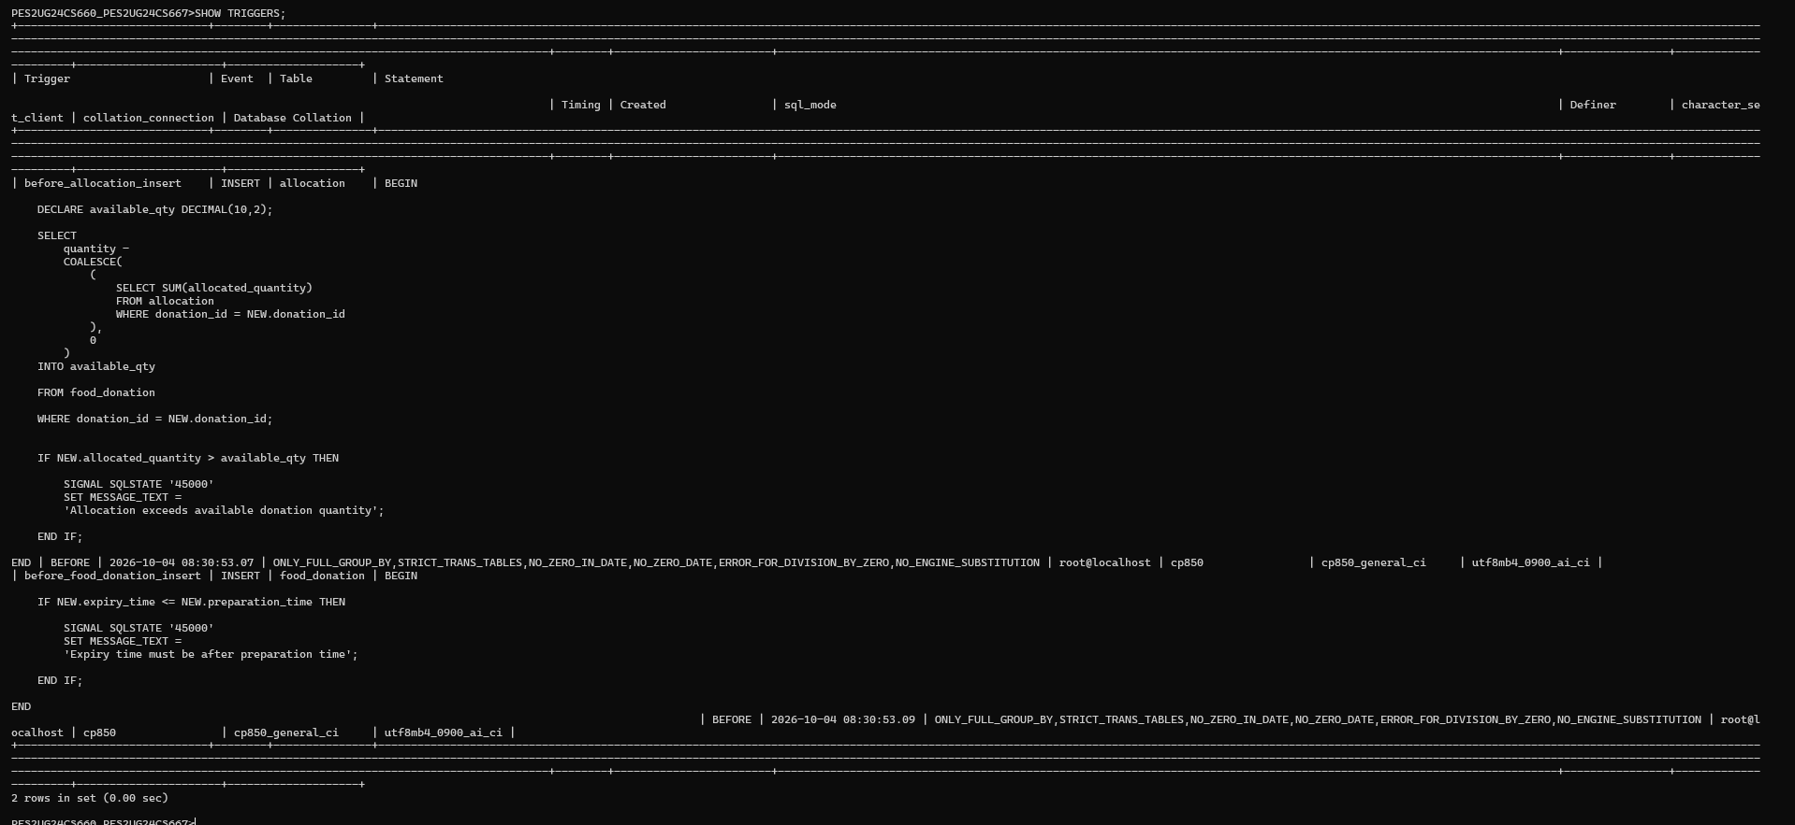

14.3 VERIFY INDEX

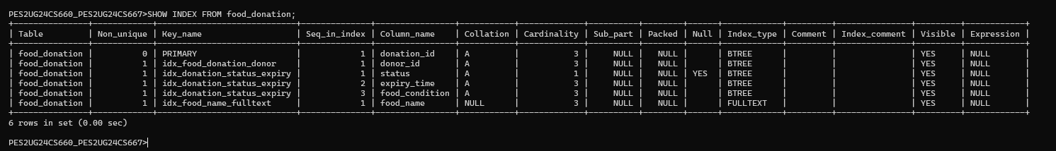

14.4 VERIFICATION OF TRANSACTION TABLE

