LAB level 3 PROJECT
EcoFoodSync: Polyglot Database System for Automated Perishable Food Rescue

DBMS Engine: MySQL 8.0 | Course: DBMS Experiential Learning – Level 3
Lab Task: ER Diagram & DDL Schema Implementation
Team : G14

SRN1: PES2UG24CS660 SRN2:PES2UG24CS676 SECTION

Lab Objective
To design a normalised relational schema, define logical entities, construct an Entity-Relationship (ER) Diagram using standard Chen notation, and implement database structures using Data Definition Language (DDL) commands in MySQL 8.0 with primary keys, foreign keys, constraints, and performance indexes.

System Architecture & Core Entities
The EcoFoodSync system coordinates perishable food rescue across 7 key relational entities:
  - FOOD_DONOR: Stores donor business profiles (Restaurants, Supermarkets, Caterers, Individuals).
  - FOOD_DONATION: Tracks surplus food batches, preparation/expiry timestamps, and condition types.
  - CHARITY_OR_NGO: Manages recipient organisations, contact details, operational areas, and food capacity.
  - ALLOCATION: Maps food donations to charities while enforcing allocation status and quantities.
  - VOLUNTEER: Stores driver information, real-time availability status, and current locations.
  - PICKUP_DELIVERY: Handles physical transportation and logistics logs from donor to recipient charity.
  - FOOD_REQUEST: Tracks specific food demand requests submitted by charities based on urgency level.

Entity-Relationship (ER) Diagram (Chen Notation)
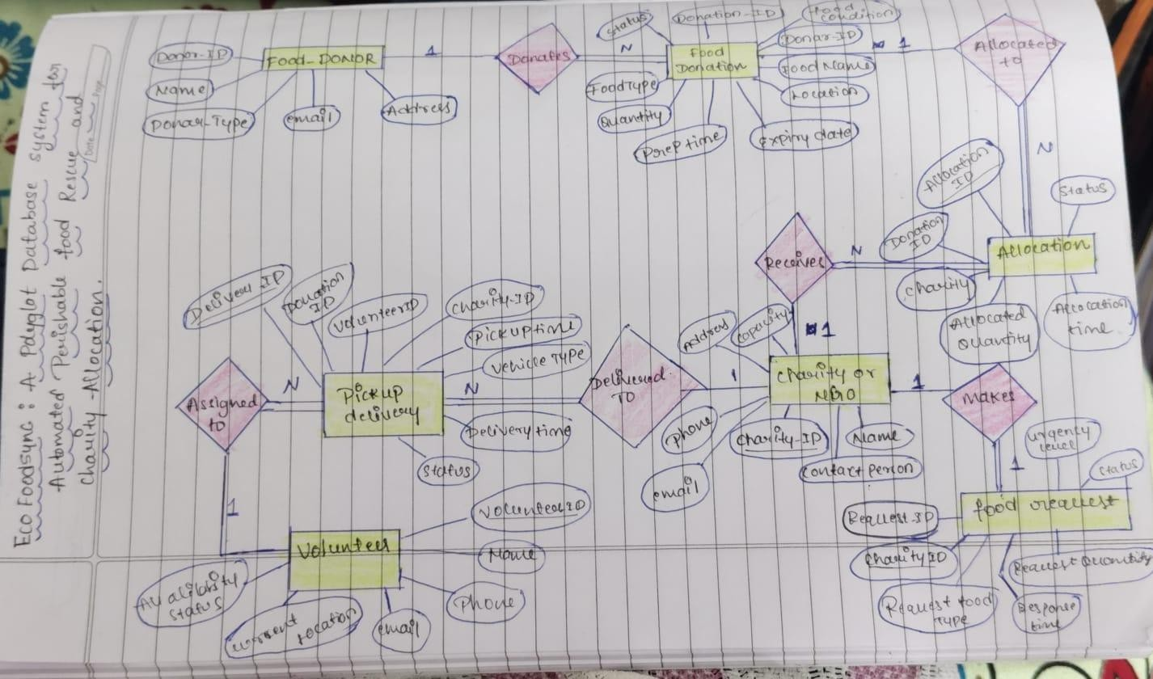

Cardinality & Relationship Summary
  - FOOD_DONOR (1) : DONATES : FOOD_DONATION (N) — One donor can generate multiple food donation listings.
  - FOOD_DONATION (1) : ALLOCATED TO : ALLOCATION (M) — One donation batch can be split into multiple allocations.
  - ALLOCATION (N) : RECEIVES ALLOCATION : CHARITY_OR_NGO (1) — One charity can receive multiple allocations.
  - CHARITY_OR_NGO (1) : MAKES REQUEST : FOOD_REQUEST (N) — One charity can issue multiple food requests.
  - VOLUNTEER (1) : ASSIGNED TO : PICKUP_DELIVERY (N) — One volunteer driver handles multiple delivery tasks.
  - FOOD_DONATION (1) : PICKED UP / DELIVERED : PICKUP_DELIVERY (N) — One donation batch links to logistics tasks.
  - PICKUP_DELIVERY (N) : DELIVERED TO : CHARITY_OR_NGO (1) — Multiple delivery actions arrive at a single target charity.

SCHEMA DIAGRAM

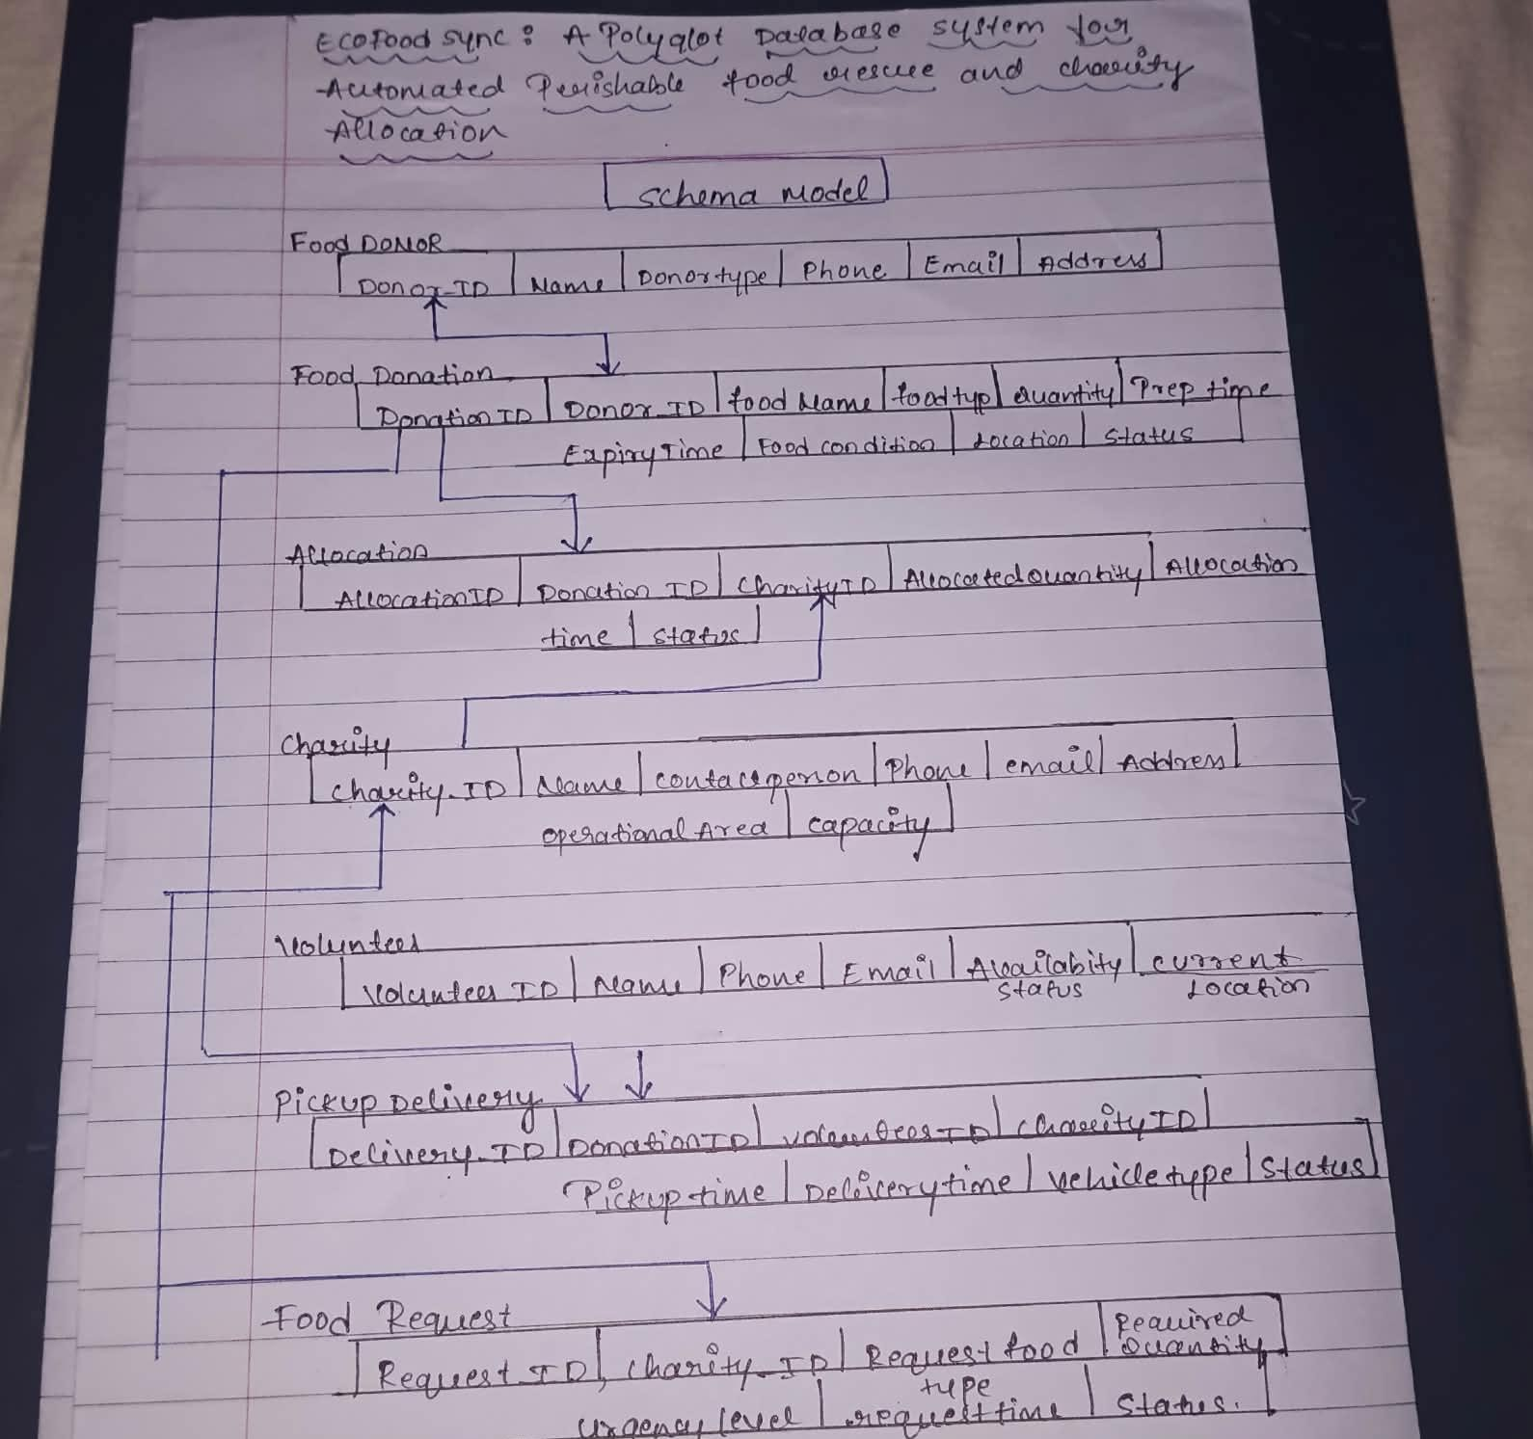

Data Dictionary

Table Name | Attribute Name | Data Type | Constraint | Description
food_donor | donor_id | CHAR(36) | PRIMARY KEY | UUID string generated via DEFAULT (UUID())
food_donor | name | VARCHAR(255) | NOT NULL | Legal name of donor entity
food_donor | donor_type | ENUM(...) | NOT NULL | Type (RESTAURANT, SUPERMARKET, etc.)
food_donor | email | VARCHAR(255) | UNIQUE, NOT NULL | Unique donor contact email

food_donation | donation_id | CHAR(36) | PRIMARY KEY | Unique food donation batch ID
food_donation | donor_id | CHAR(36) | FOREIGN KEY | FK referencing food_donor(donor_id)
food_donation | quantity | DECIMAL(10,2) | CHECK (>0) | Total quantity/weight in KG
food_donation | expiry_time | DATETIME | CHECK (>prep) | Timestamp before which food expires
allocation | allocation_id | CHAR(36) | PRIMARY KEY | Unique allocation claim ID
allocation | donation_id | CHAR(36) | FOREIGN KEY | FK referencing food_donation
allocation | charity_id | CHAR(36) | FOREIGN KEY | FK referencing charity_or_ngo
pickup_delivery | delivery_id | CHAR(36) | PRIMARY KEY | Unique logistics tracking ID
pickup_delivery | volunteer_id | CHAR(36) | FOREIGN KEY | FK referencing volunteer (NULL allowed)

MySQL 8.0 DDL Implementation Script Create :
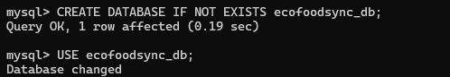
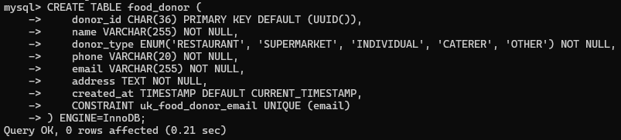
-- Database Creation

-- 1. FOOD_DONOR Table

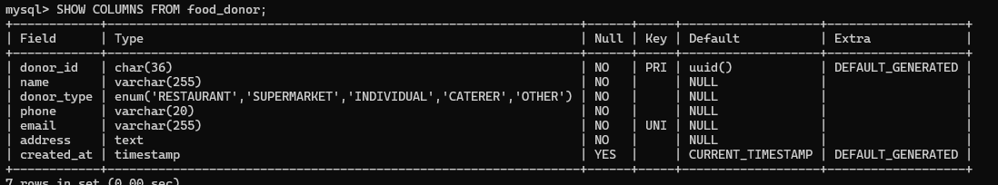
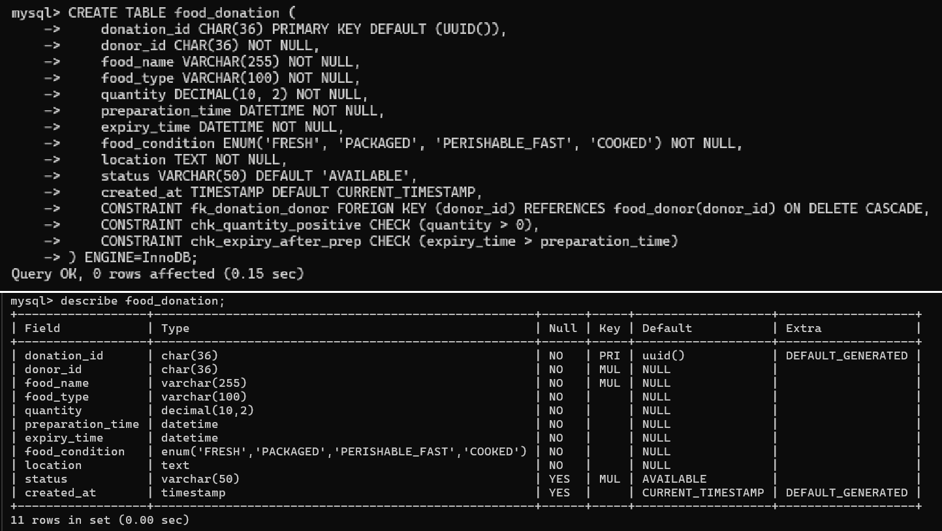
-- 2. FOOD_DONATION Table

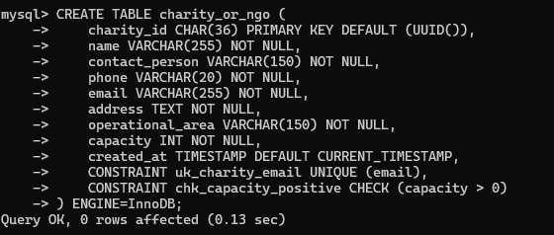
-- 3. CHARITY_OR_NGO Table

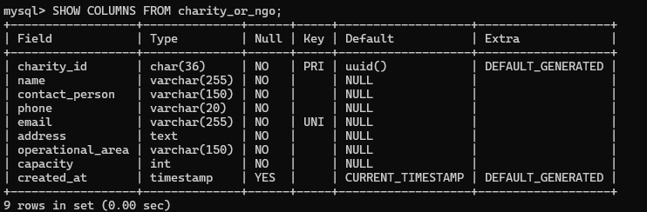

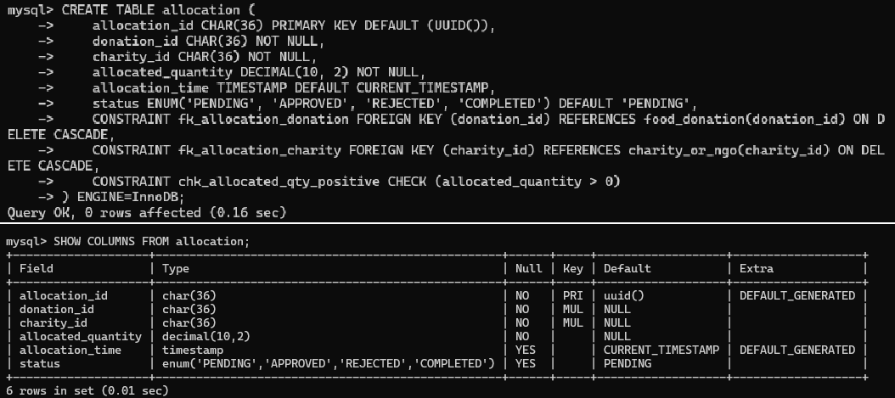
-- 4. ALLOCATION Table
-- 5. VOLUNTEER Table
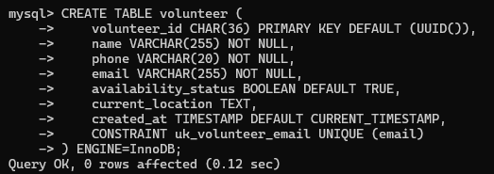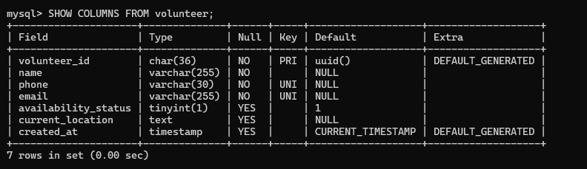

-- 6. PICKUP_DELIVERY Table

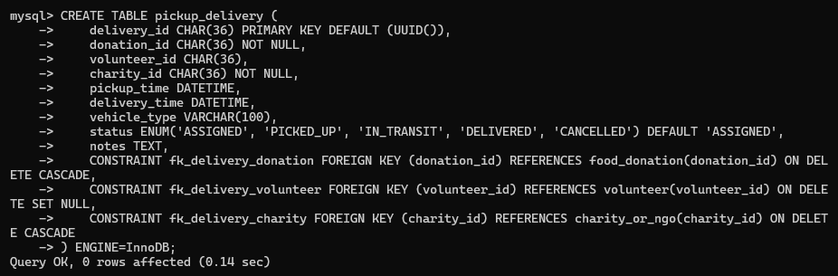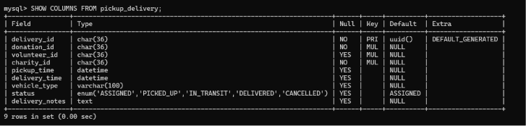

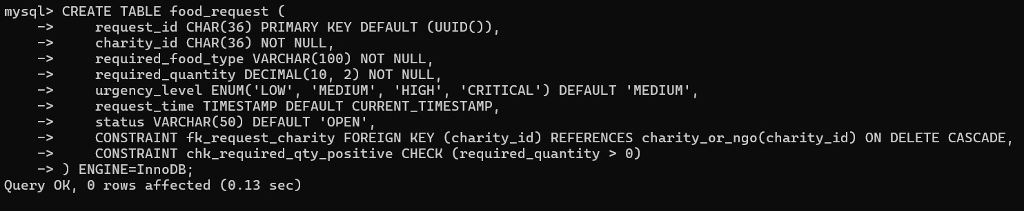
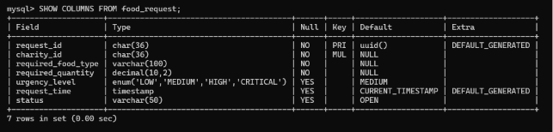
-- 7. FOOD_REQUEST Table

Indexing :

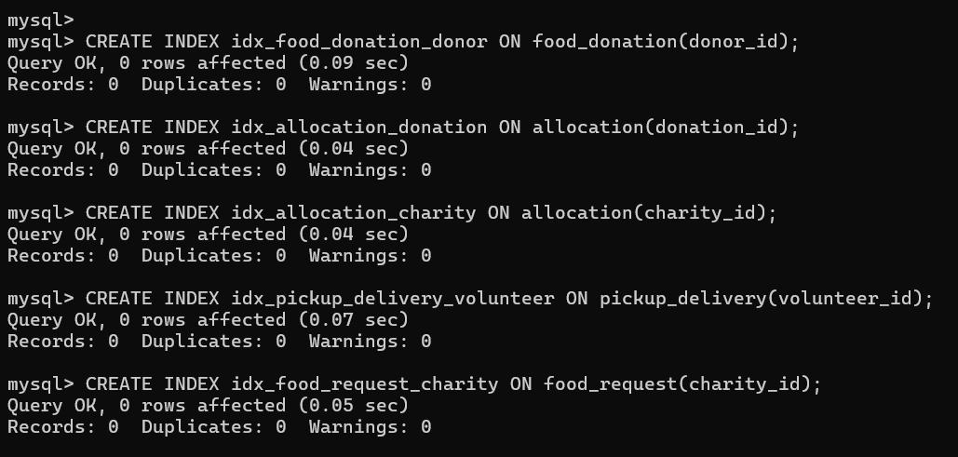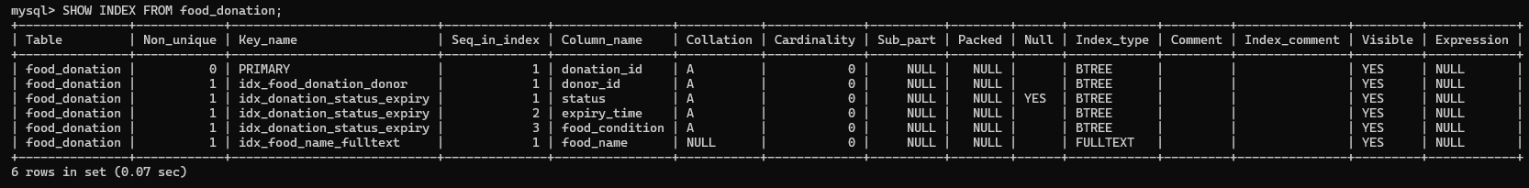

-- 1. ALTER OPERATIONS

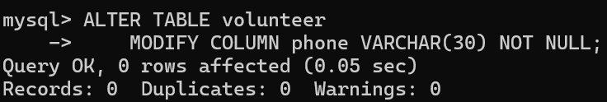
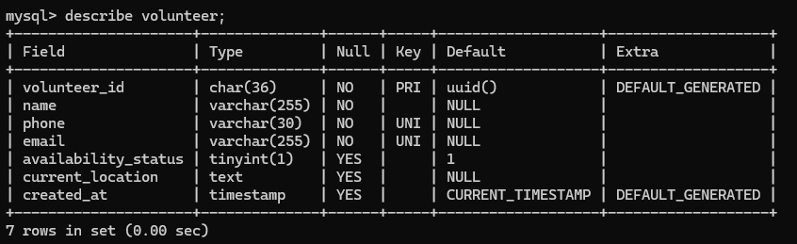
-- 1. Modify phone column in volunteer
-- 2. Rename notes column in pickup_delivery
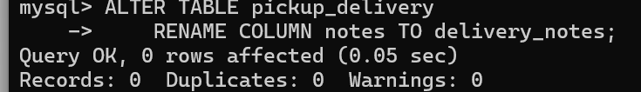

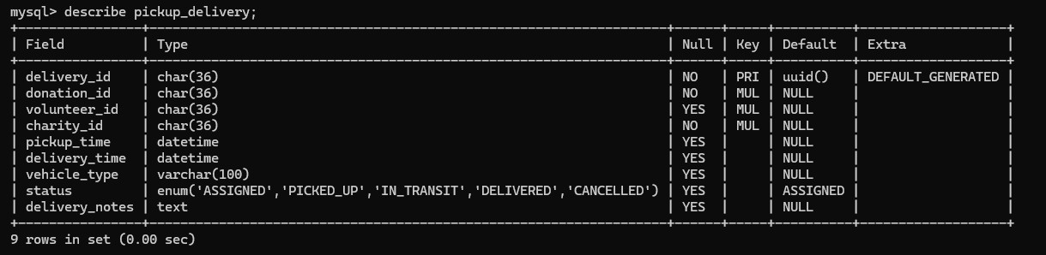

-- 3. DROP Operation (Demonstration)
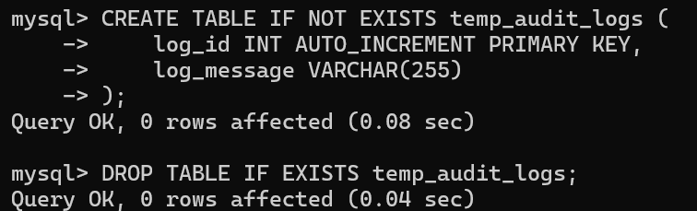

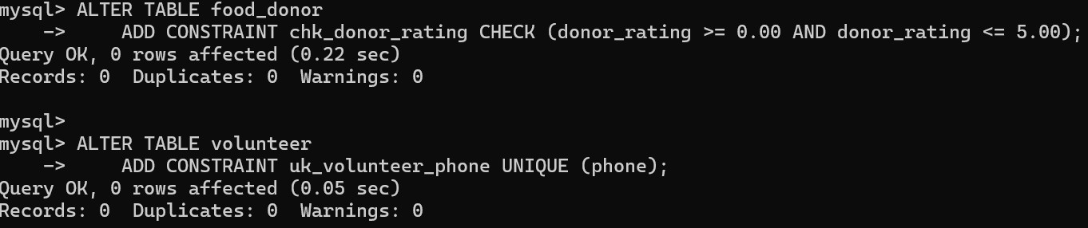
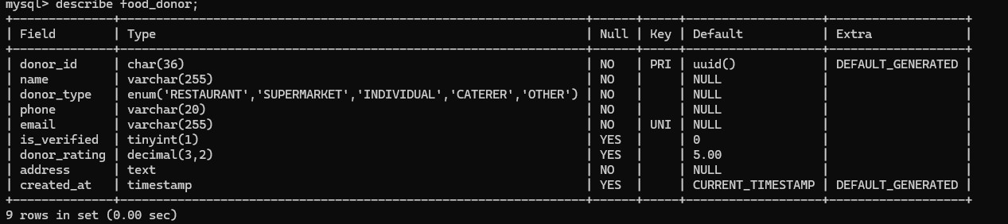
-- 4. Add Constraints

-- 5. Create Indexes

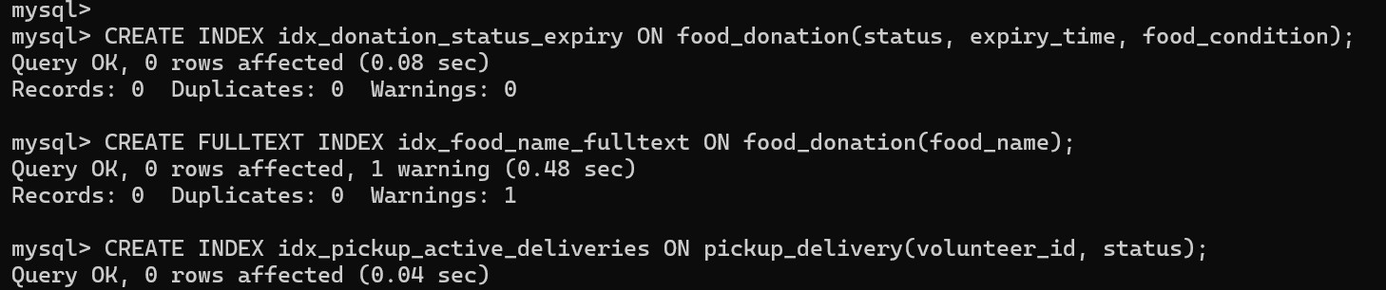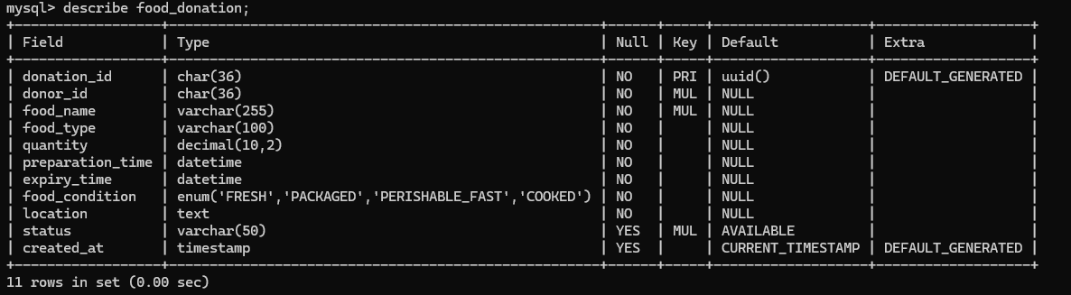
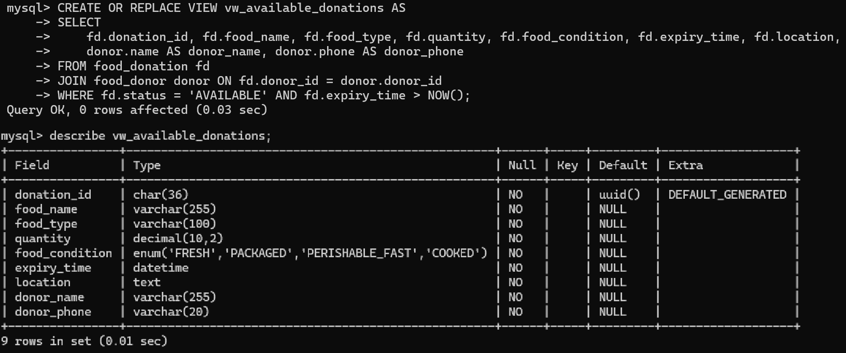
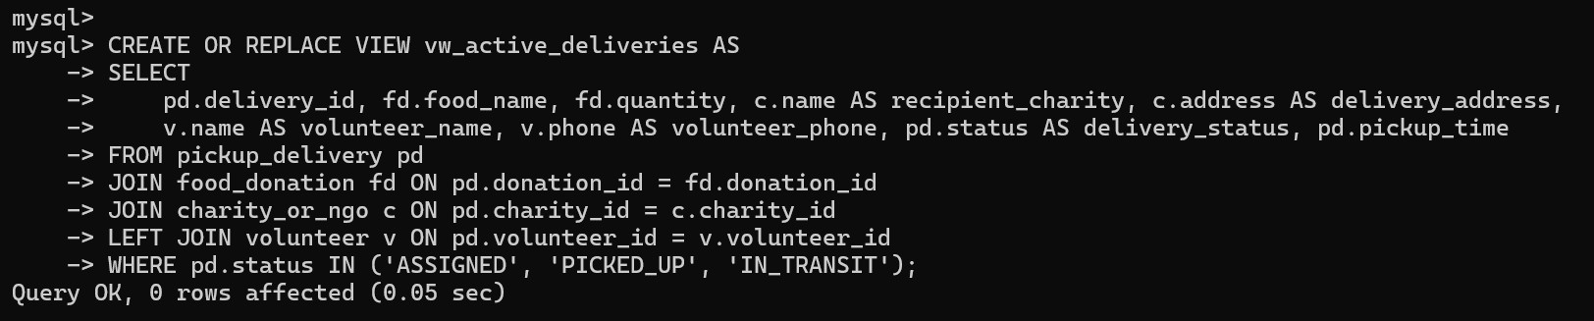
-- 6. Create Views

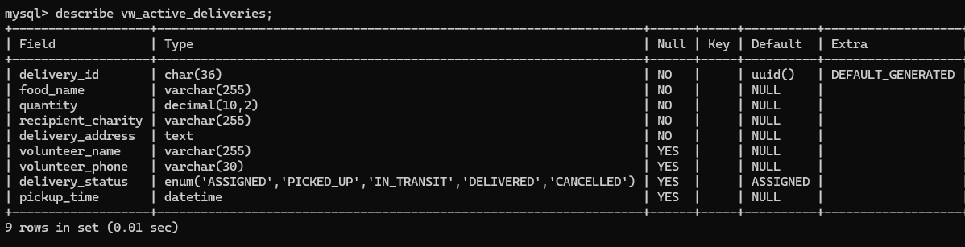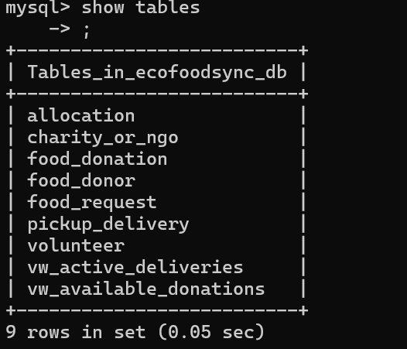
Tables after

DML IMPLEMENTATION

6.1 INSERT Operations
- Insert records into food_donor
- Insert records into charity_or_ngo
- Insert records into volunteer
- Insert records into food_donation
- Insert records into allocation
- Insert records into pickup_delivery
- Insert records into food_request

6.1.1 Insert data into food_donor
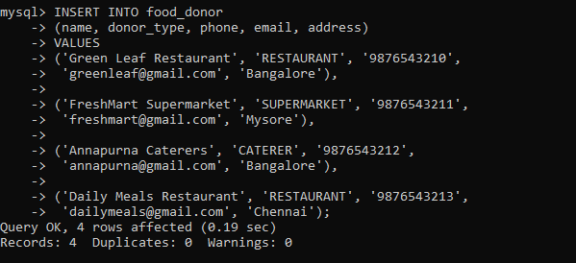

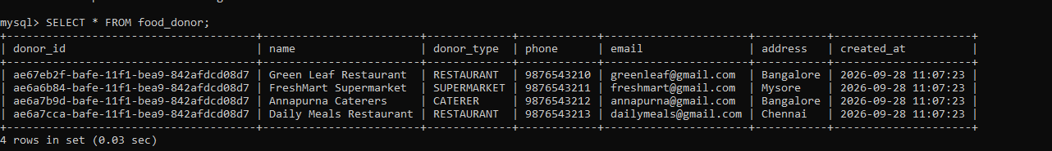

6.1.2 Insert data into charity_or_ngo

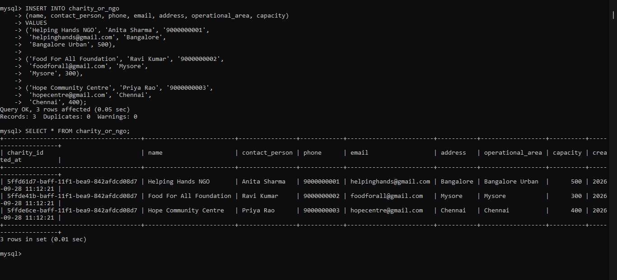

6.1.3 Insert data into volunteer

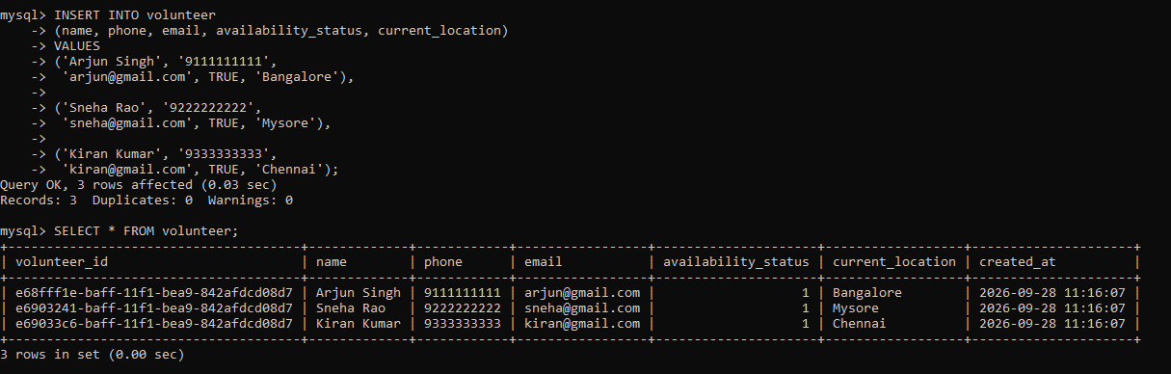

6.1.4 Insert data into food_donation

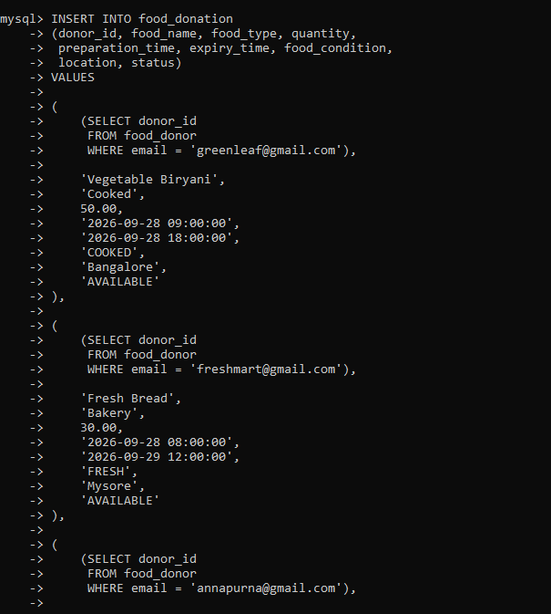

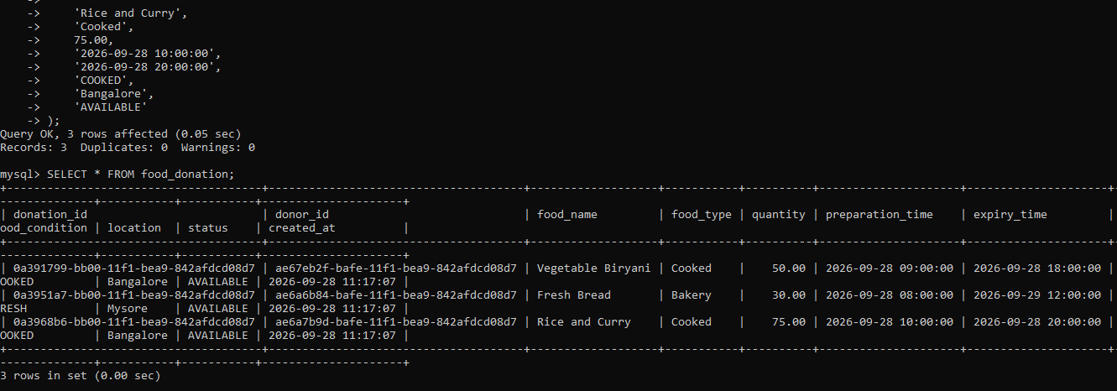

6.1.5 Insert data into allocation

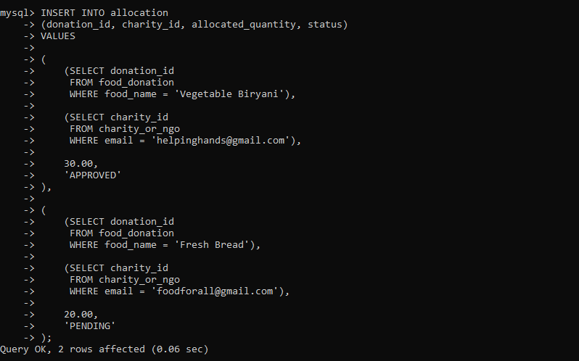

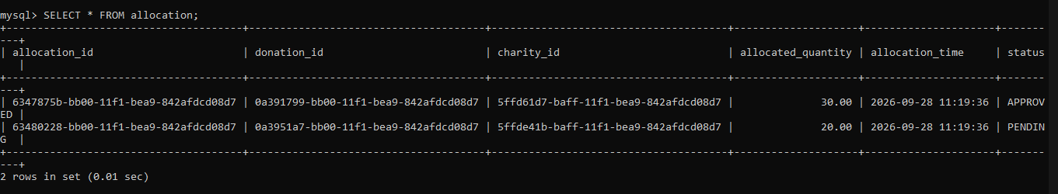

6.1.6 Insert data into pickup_delivery

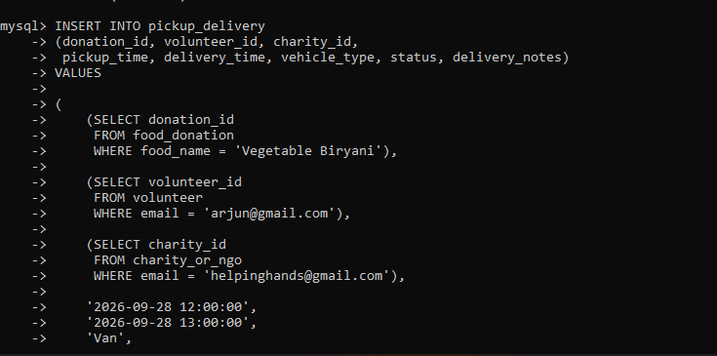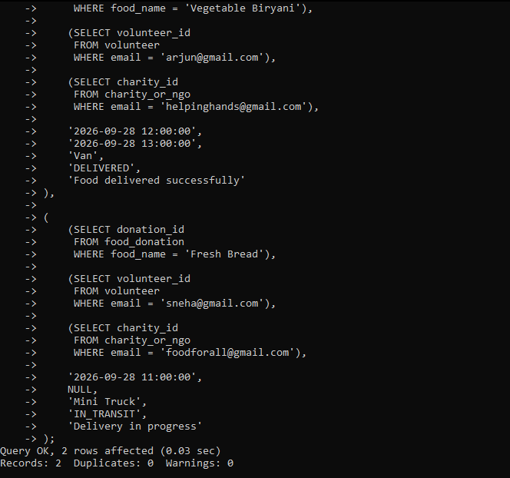

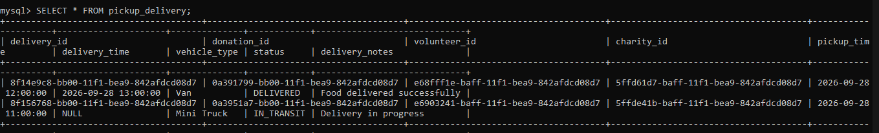

6.1.7 Insert data into food_request

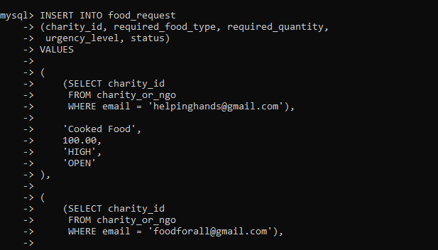
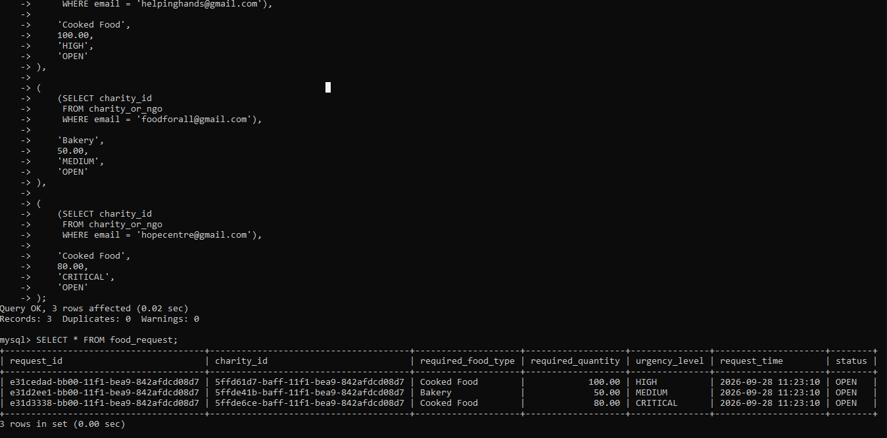

6.2 UPDATE Operations

6.2.1 Update Food Donation Status

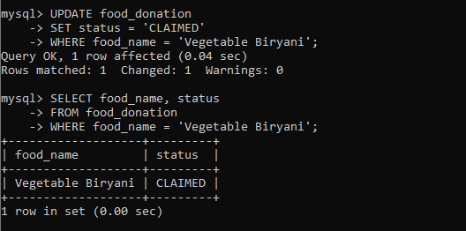

6.2.2 Update Volunteer Availability

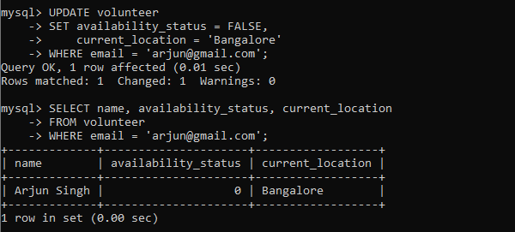

6.2.3 Update Charity Capacity

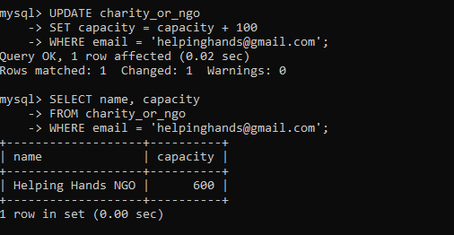

6.2.4 Update Allocation Status

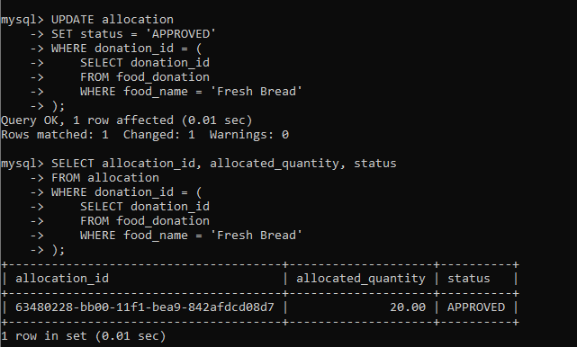

6.3 DELETE Operations

6.3.1 Delete a Food Request

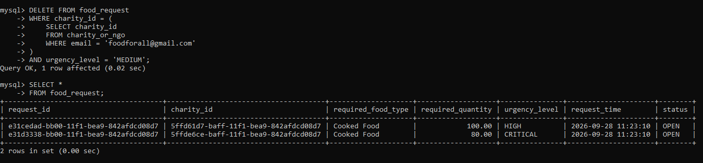

6.3.2 Delete an Unused Volunteer

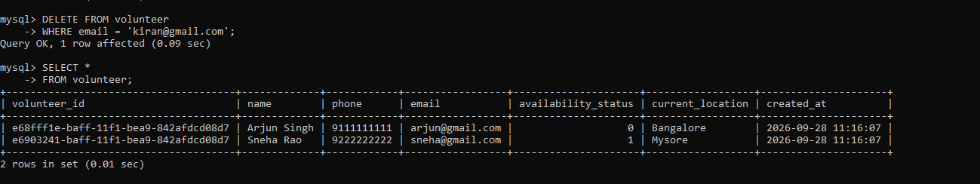

6.4 SELECT Operations

6.4.1 Display All Food Donations

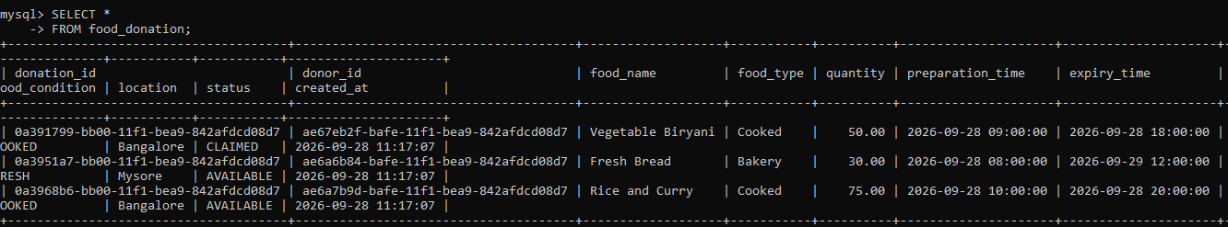

6.4.2 Display Available Food

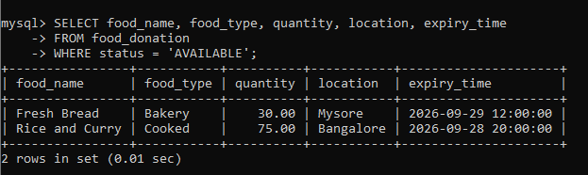

6.4.3 Display High-Quantity Donations

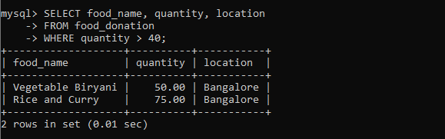

6.4.4 Display Donations by Earliest Expiry

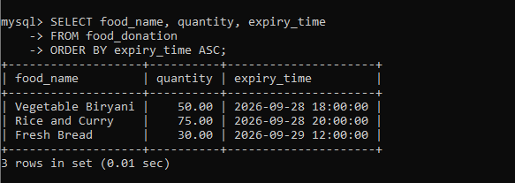

6.4.5 Display High-Urgency Food Requests

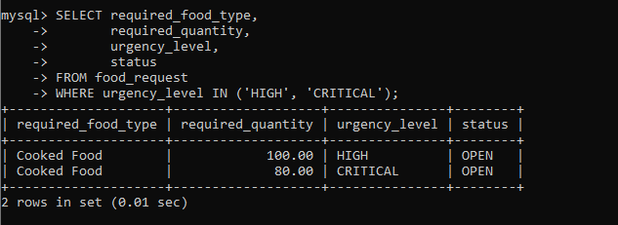

6.5 JOIN Operations

6.5.1 Donor + Food Donation
Question: Display the donor name, food name, quantity and location.
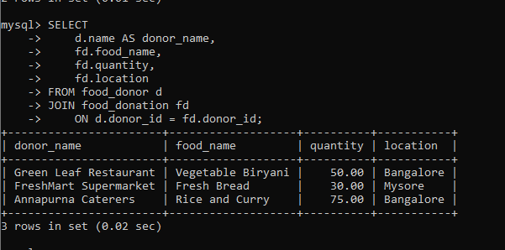

6.5.2 Donation + Charity
Question: Display which food was allocated to which charity.
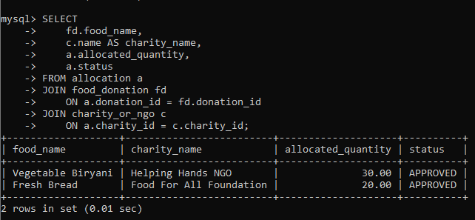

6.5.3 Complete Delivery Information ⭐
Question: Display the food, donor, volunteer and charity involved in each delivery.

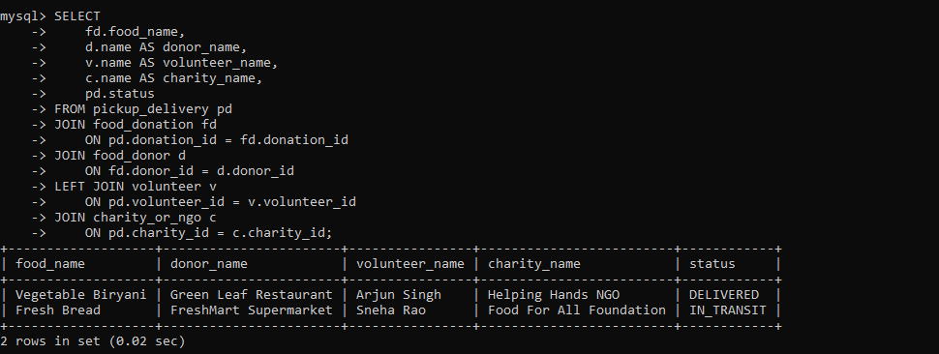

6.6 Aggregate Functions

6.6.1 COUNT()

Question:
Find the total number of food donations.
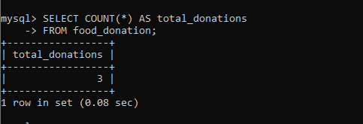

6.6.2 SUM()

Question:
Find the total quantity of food donated.
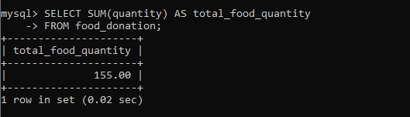

6.6.3 AVG()

Question:
Find the average quantity of food donated.
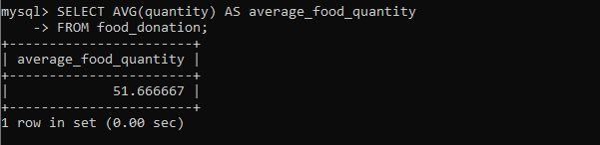

6.6.4 MAX()

Question:
Find the largest food donation.
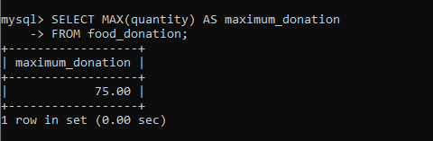

6.6.5 MIN()

Question:
Find the smallest food donation.
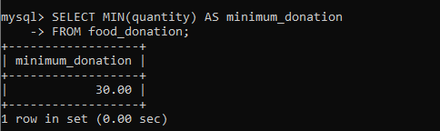

6.6.6 All Aggregate Functions Together

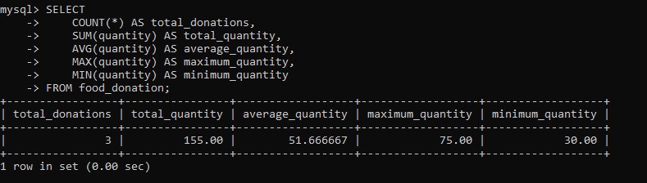

6.7 GROUP BY Operations

6.7.1 Total Food Donated by Each Donor

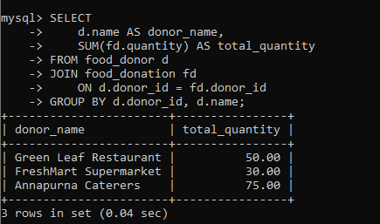

6.7.2 Total Food Received by Each Charity

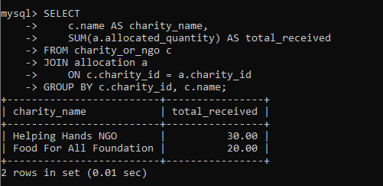

6.8 HAVING Operations

6.8.1 Donors with More Than 40 kg Total Donations

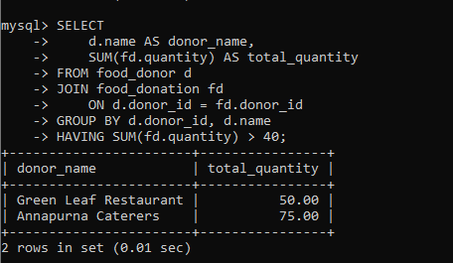

6.8.2 Charities Receiving More Than 20 kg

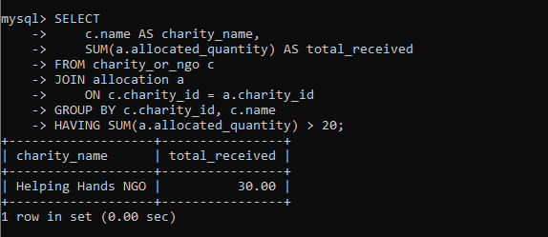

6.9 ORDER BY Operations

6.9.1 Donations by Quantity

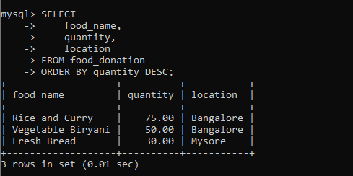

6.9.2 Donations by Earliest Expiry

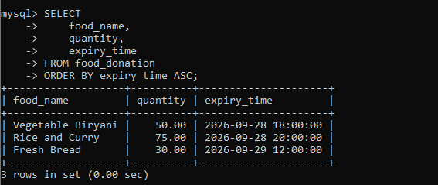

6.10 Subqueries

6.10.1 Donations Above Average Quantity

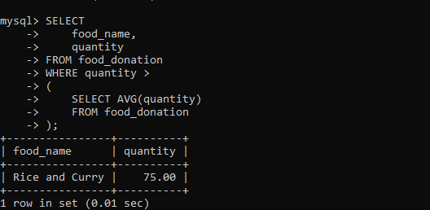

6.10.2 Donation with Maximum Quantity

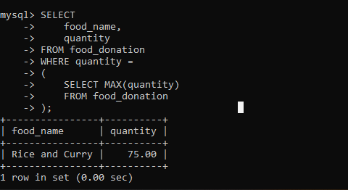

6.10.3 Charities Above Average Capacity

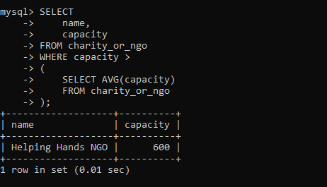

6.11 Complex Queries

6.11.1 Donors with More Than 40 kg, Sorted by Quantity

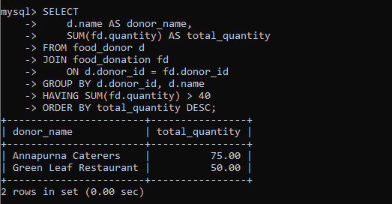

6.11.2 Complete Food Allocation Information
Display:
- Food name
- Donor
- Charity
- Allocated quantity
- Allocation status

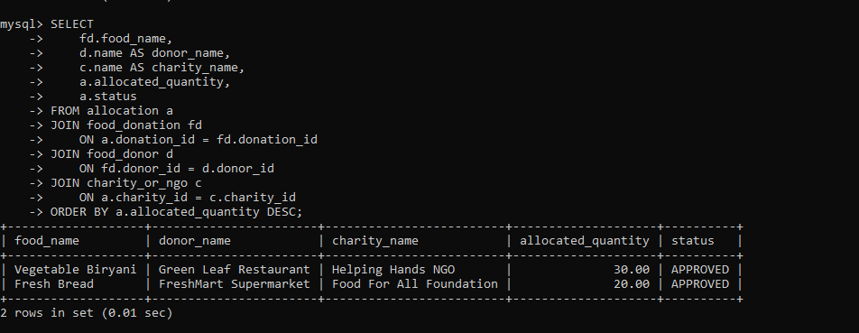

ADVANCED DATABASE MANAGEMENT SYSTEM

6. VIEW
  - Creation of View for Active Deliveries
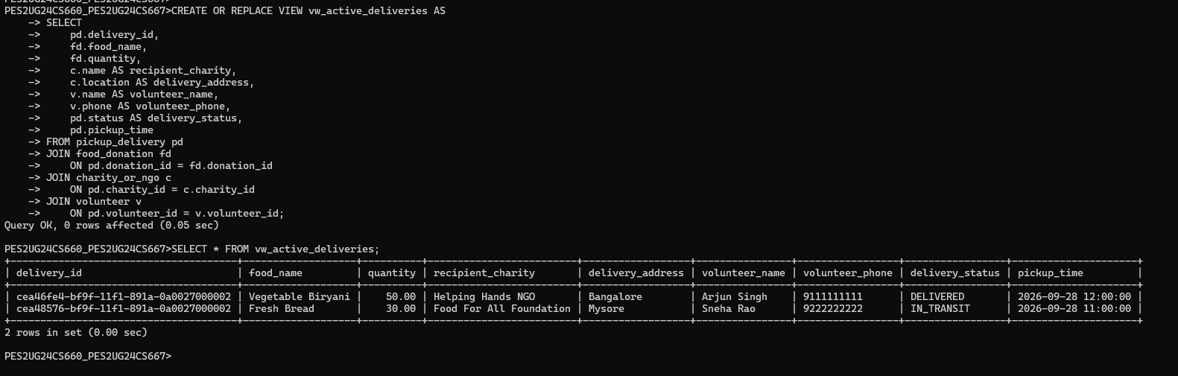

7. INDEXING AND QUERY OPTIMIZATION

7.1 Displaying Indexes on food_donation
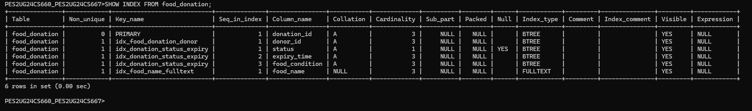

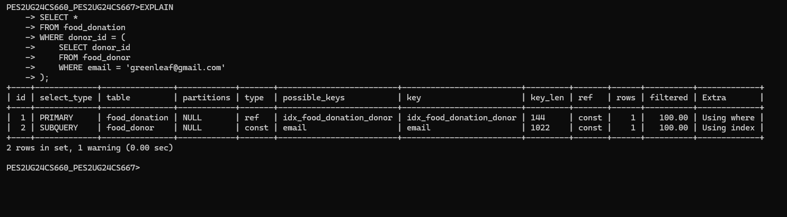

7.2 Composite Index Optimization
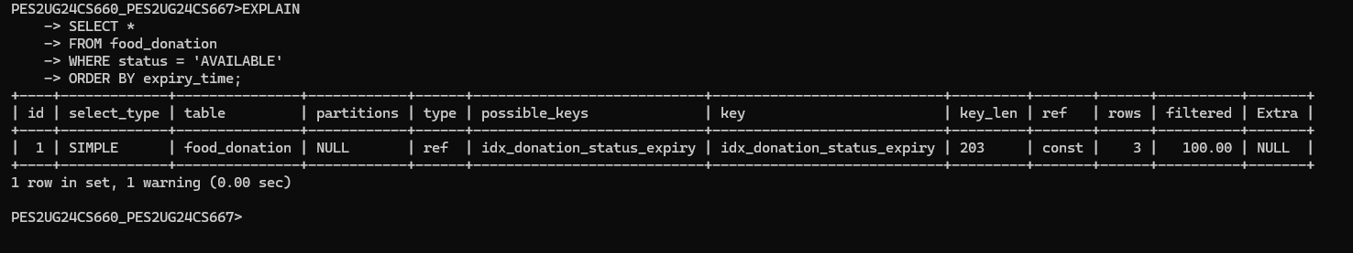

8. STORED PROCEDURES
8.1 Stored Procedure to Retrieve Available Food by Location

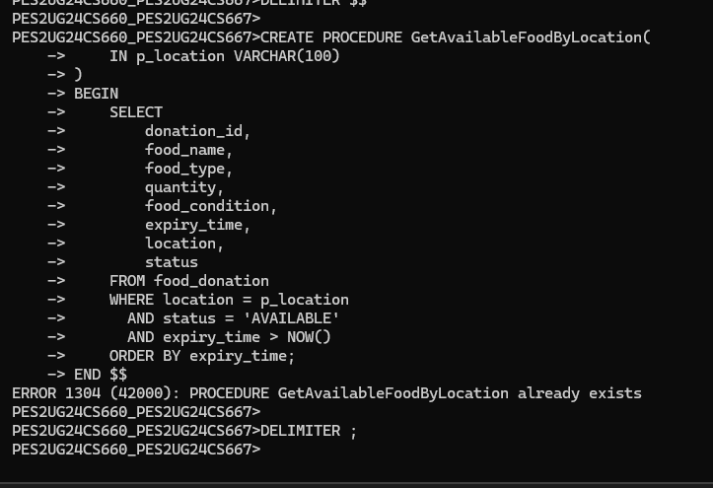

8.2 Stored Procedure for Donation Allocation summary
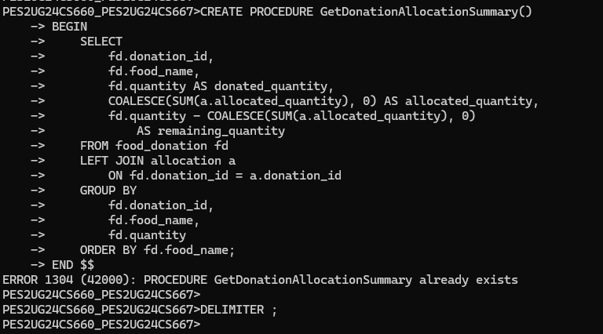

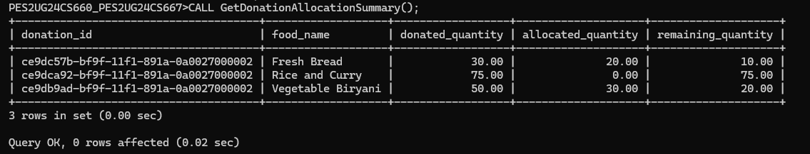

9. STORED FUNCTION

9.1 Creation of Stored Function
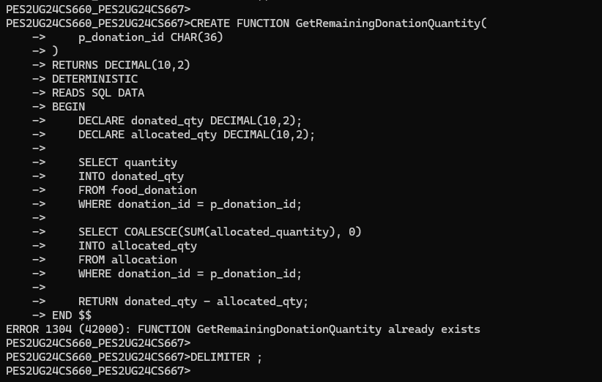

9.2 Testing the Stored Function

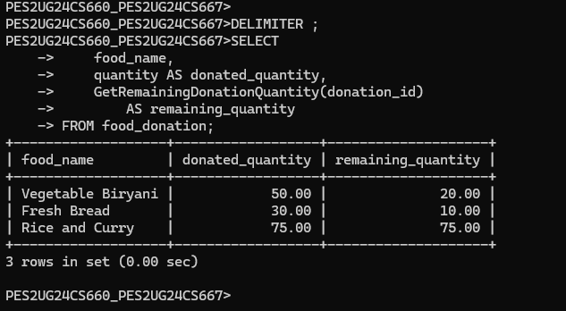

9.3 Verification of Stored Function

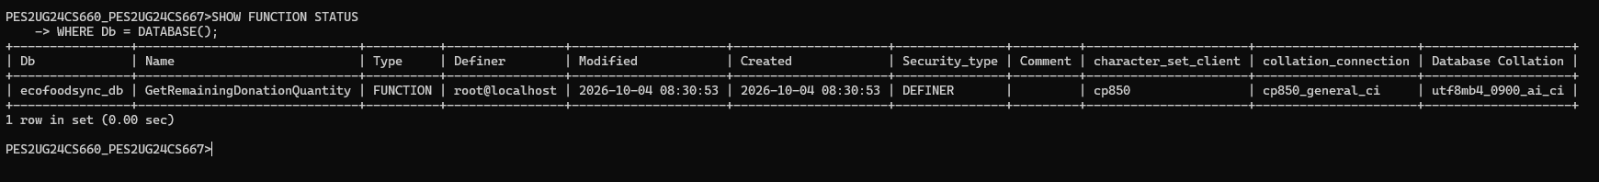

10. TRIGGERS

10.1 Trigger to Prevent Excess Food Allocation

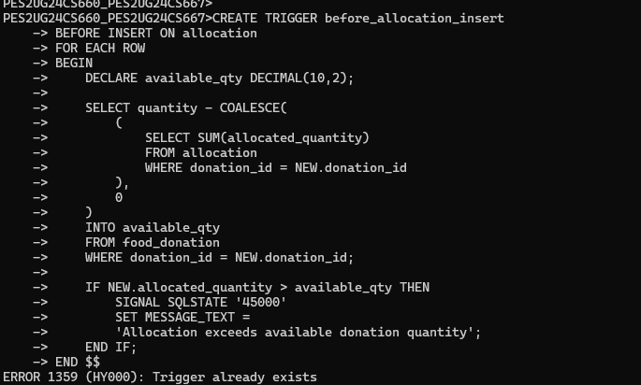

10.2 Trigger to Validate Food Expiry Time

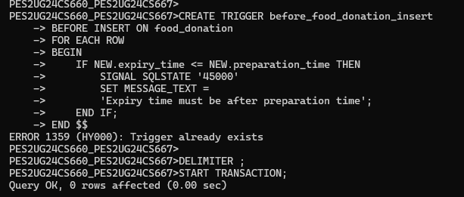

10.3 Testing the Allocation Trigger — Valid Operation

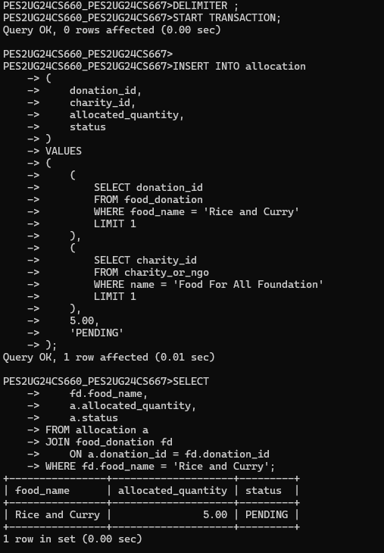

10.4 Testing the Allocation Trigger — Invalid Operation

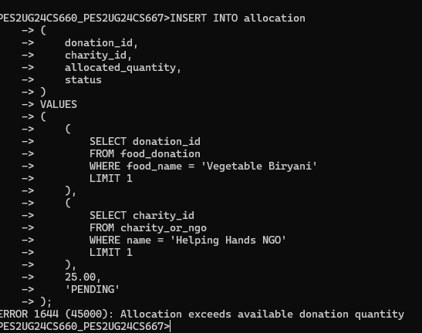

10.5 Testing the Food Expiry Trigger

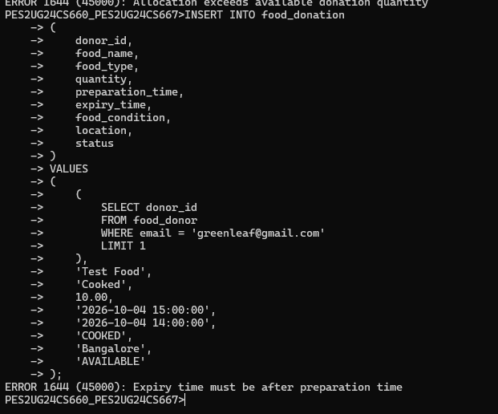

10.6 Verifying That the Invalid Donation Was Not Inserted

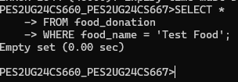

11. TRANSACTIONS

- START TRANSACTION
- SAVEPOINT
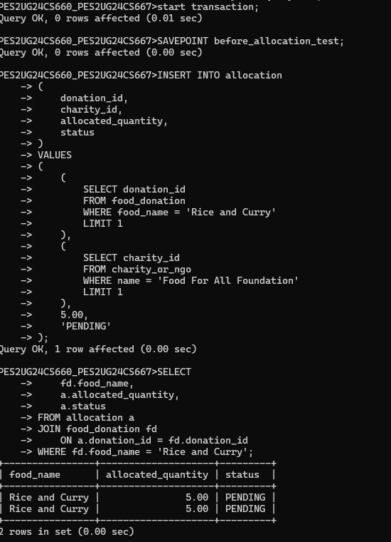

- ROLLBACK TO SAVEPOINT
- COMMIT
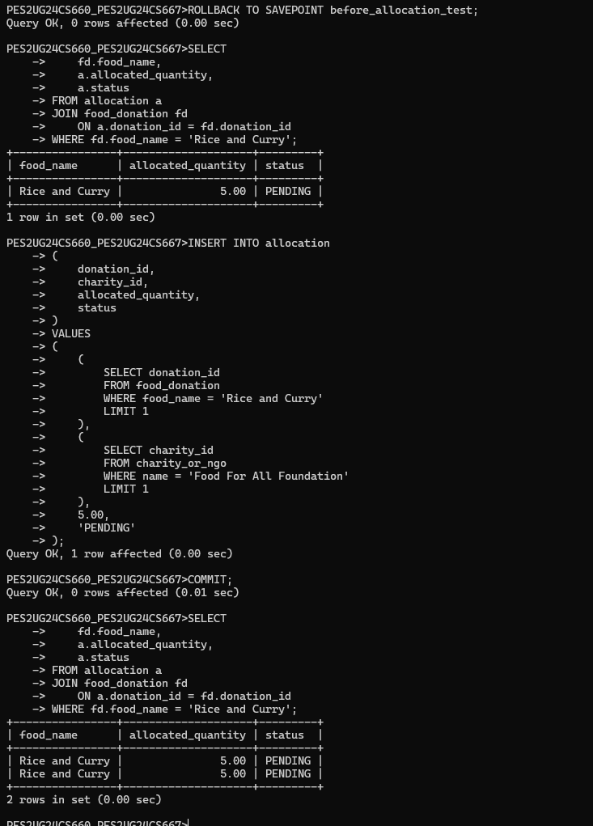

12. CURSORS

12.1 CURSORS FOR PROCESSING FOOD DONATIONS
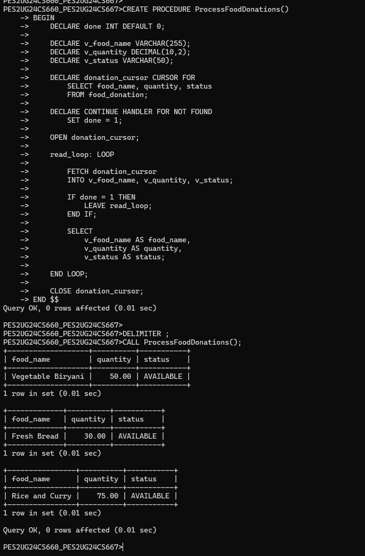

13. COMMON TABLE EXPRESSIONS

13.1 CTE FOR DONATION ANALYSIS AND WINDOW FUNCTION RANKING
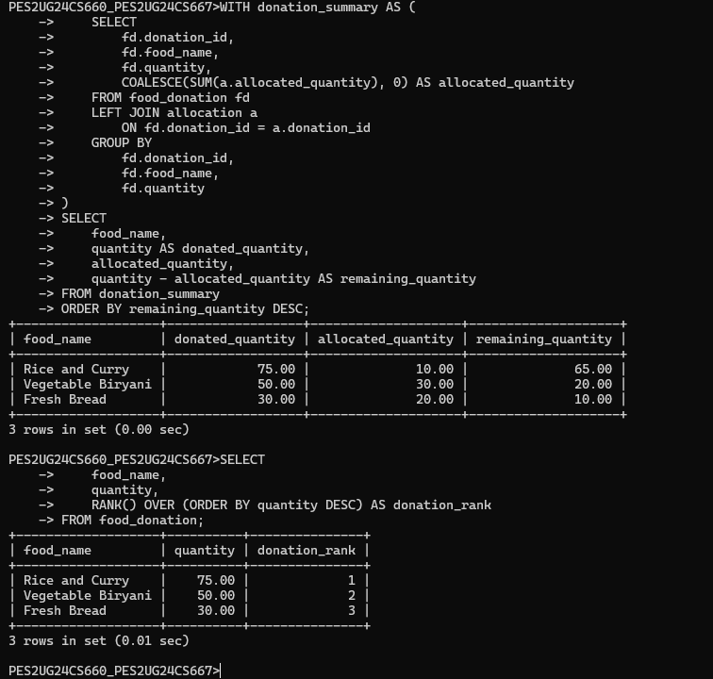

13.2 ADVANCED QUERY – CORRELATED SUBQUERY AND ALLOCATION PERCENTAGE

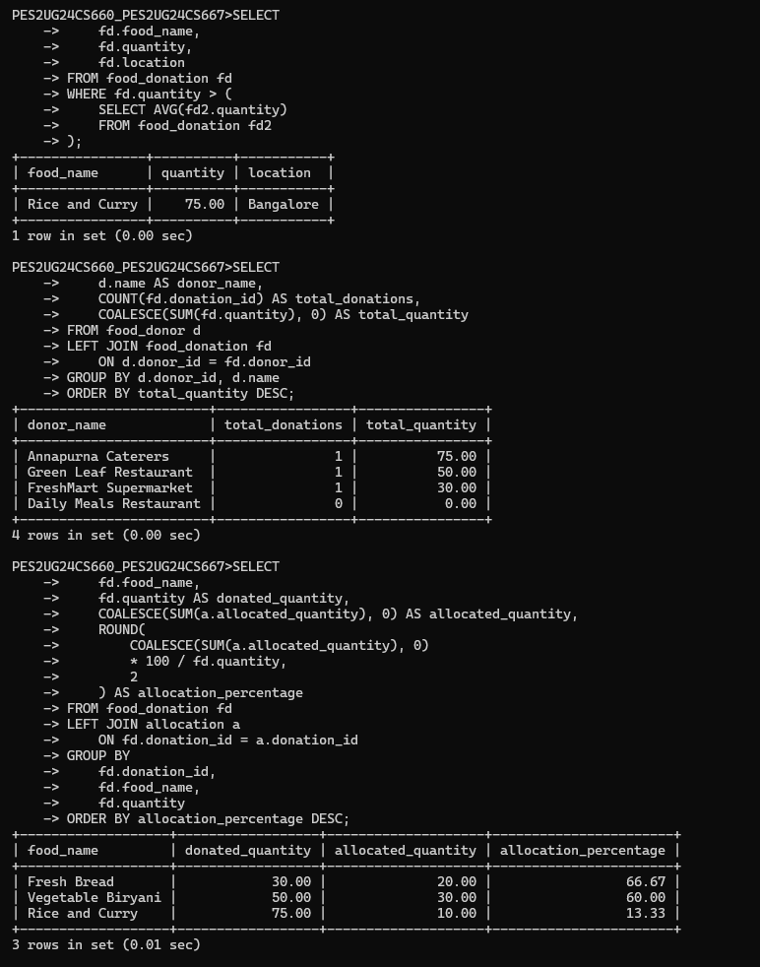

14. FINAL VERIFICATION & PROJECT COMPLETION

14.1 Verification of database tables and viwe tables

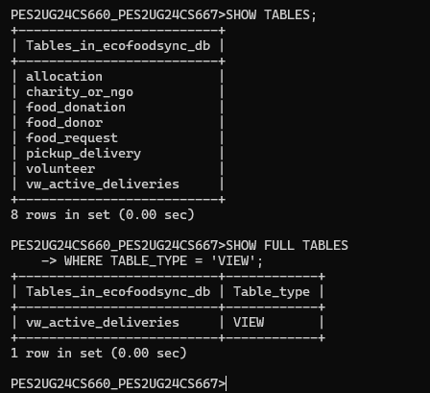

14.2 Verification of Stored Procedures and functions

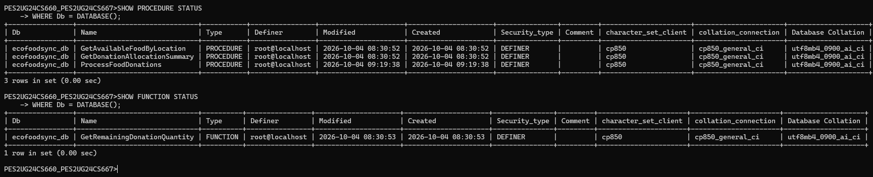

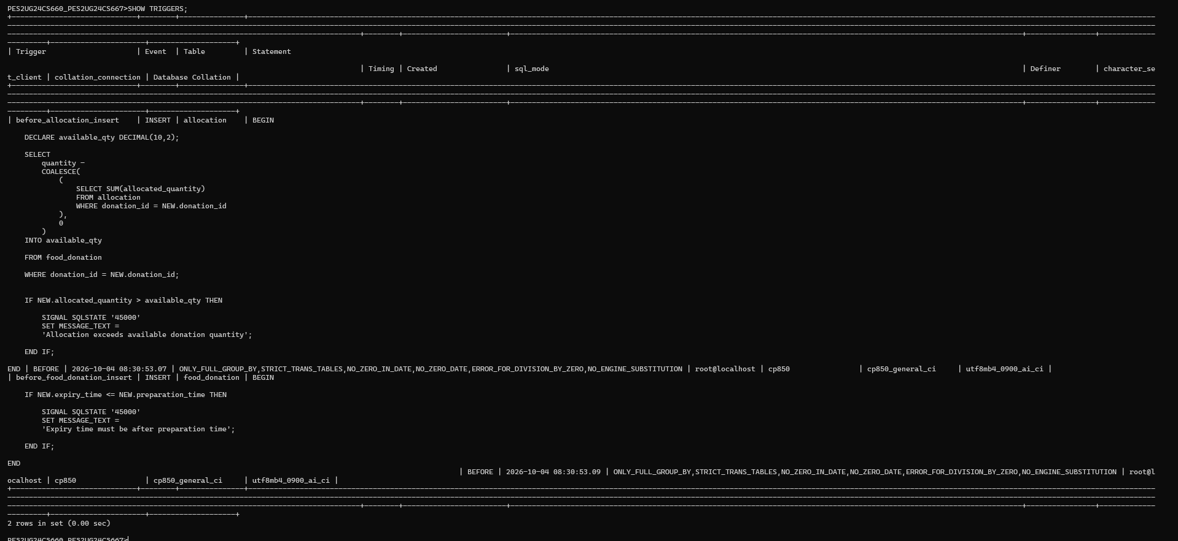

14.3 VERIFY INDEX

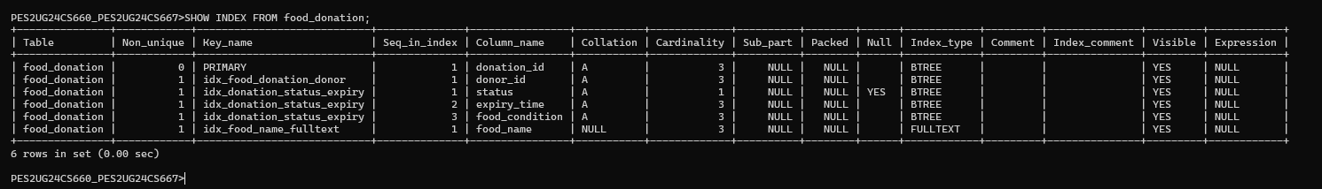

14.4 VERIFICATION OF TRANSACTION TABLE

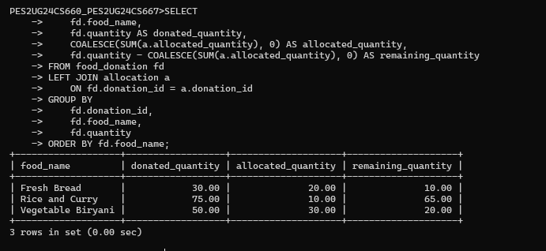

12. NoSQL IMPLEMENTATION USING MONGODB

12.1 Introduction
EcoFoodSync uses a polyglot database approach combining MySQL and MongoDB. MySQL stores structured information such as donors, donations, charities, volunteers and allocations. MongoDB is used for flexible food-condition and inspection records, including condition observations, storage details, expiry information and inspection notes. MongoDB complements MySQL through document-based storage without replacing the existing relational database.

12.2 Database Design
A MongoDB Atlas database named EcoFoodSync is created. The collection currently created and verified in Atlas is food_condition_logs. It stores condition-related snapshots associated with a MySQL donation through the common donation_id value.
Field Name | Purpose
_id | MongoDB-generated unique document identifier
donation_id | Reference to the corresponding MySQL food_donation record
food_name | Name of the donated food
quantity_kg | Recorded food quantity in kilograms
food_condition | Condition recorded for the donation
location | Donation location
donation_status | Donation status copied from the MySQL snapshot
expiry_time | Recorded expiry date and time
record_type | Identifies the document as a historical snapshot
source | Identifies MySQL food_donation as the source
Database structure:
EcoFoodSync
└── food_condition_logs
└── Documents

12.3 Document Structure
MongoDB stores data as BSON documents, represented in a JSON-like format. The following document reflects the historical MySQL donation record inserted into food_condition_logs. Its expiry date is in the past; therefore, it is labelled as a historical snapshot and must not be treated as currently available or fresh food.
{
"donation_id": "0a391799-bb00-11f1-bea9-842afdcd08d7",
"food_name": "Vegetable Biryani",
"quantity_kg": 50,
"food_condition": "COOKED",
"location": "Bangalore",
"donation_status": "CLAIMED",
"expiry_time": "2026-09-28 18:00:00",
"record_type": "historical_snapshot",
"source": "MySQL food_donation"
}

12.4 INSERT Operation
The insert operation adds a document to the food_condition_logs collection. The following mongosh command shows the equivalent insertion operation. The document above was inserted through MongoDB Atlas Data Explorer.
db.food_condition_logs.insertOne({
donation_id: "0a391799-bb00-11f1-bea9-842afdcd08d7",
food_name: "Vegetable Biryani",
quantity_kg: 50,
food_condition: "COOKED",
location: "Bangalore",
donation_status: "CLAIMED",
expiry_time: "2026-09-28 18:00:00",
record_type: "historical_snapshot",
source: "MySQL food_donation"
})
Result evidence: one document was inserted and MongoDB generated a unique _id value.

12.5 READ Operation
The find() operation retrieves documents matching a specified condition. The following query searches for a document using its MySQL donation_id.
db.food_condition_logs.find({
donation_id: "0a391799-bb00-11f1-bea9-842afdcd08d7"
})
Observed Atlas result: one matching document was displayed, containing the Vegetable Biryani historical snapshot.

12.6 UPDATE Operation
The updateOne() operation modifies selected fields in a matching document. This example adds a historical note without changing the original MySQL donation record.
db.food_condition_logs.updateOne(
{ donation_id: "0a391799-bb00-11f1-bea9-842afdcd08d7" },
{ $set: {
historical_note: "Imported from MySQL for historical reference. Expiry date has passed."
}}
)
Expected result: matchedCount = 1 and modifiedCount = 1 when the field is newly added. Execute this operation in Atlas or mongosh and capture its actual output before marking it as completed.

12.7 DELETE Operation
The deleteOne() operation removes a matching document. To preserve the historical donation snapshot, this demonstration uses a separate temporary test document. Insert the temporary document first, then delete it.
db.food_condition_logs.insertOne({
test_record: true,
purpose: "Delete operation demonstration"
})
db.food_condition_logs.deleteOne({
test_record: true
})
Expected result: deletedCount = 1. Run this only after inserting the temporary test document. Do not delete the retained historical donation document.

12.8 AGGREGATION
MongoDB aggregation processes documents through a pipeline. This example groups stored condition records by food_condition and counts the records in each group.
db.food_condition_logs.aggregate([
{
$group: {
_id: "$food_condition",
total_records: { $sum: 1 },
total_quantity_kg: { $sum: "$quantity_kg" }
}
},
{ $sort: { total_records: -1 } }
])
The output summarises the number of stored records and their recorded quantity for each condition. The current collection contains only one historical record, so meaningful analysis requires additional verified records.

12.9 INDEXING
An index improves query performance by helping MongoDB locate matching documents. Since donation_id is used to retrieve condition records, an ascending index can be created on this field.
db.food_condition_logs.createIndex({ donation_id: 1 })
The indexes can be checked using:
db.food_condition_logs.getIndexes()
Atlas currently displays one index for the collection. Verify that the donation_id index has been created before documenting it as an additional index.

12.10 MySQL–MongoDB INTEGRATION
MySQL remains the primary relational database for core EcoFoodSync entities, including FOOD_DONATION. MongoDB stores flexible condition-related documents. The two databases are logically linked through the common donation_id value. This is an application-level reference; MongoDB does not enforce a foreign-key constraint against MySQL.
MySQL: ecofoodsync_db.food_donation
|
| donation_id
v
MongoDB: EcoFoodSync.food_condition_logs
The application backend can retrieve a donation from MySQL and use its donation_id to retrieve related condition documents from MongoDB. Connection strings and credentials must be stored in environment variables and must not be committed to source control. Application-level integration must be verified with the Next.js/backend implementation.

12.11 SCREENSHOTS AND RESULTS
Add screenshots captured from the actual MongoDB Atlas interface as implementation evidence:
MongoDB Atlas cluster overview showing the active cluster.
• MongoDB Atlas cluster overview showing the active cluster.
• Data Explorer showing the EcoFoodSync database and food_condition_logs collection.
• Inserted document displayed in the collection.
• Find query and its matching result.
• Updated document showing the historical_note field.
• Delete operation result showing deletedCount = 1 for the temporary test document.
• Aggregation pipeline and its actual output.
• Indexes tab showing the donation_id index.
• Application/backend output demonstrating retrieval across MySQL and MongoDB, once integration is completed.

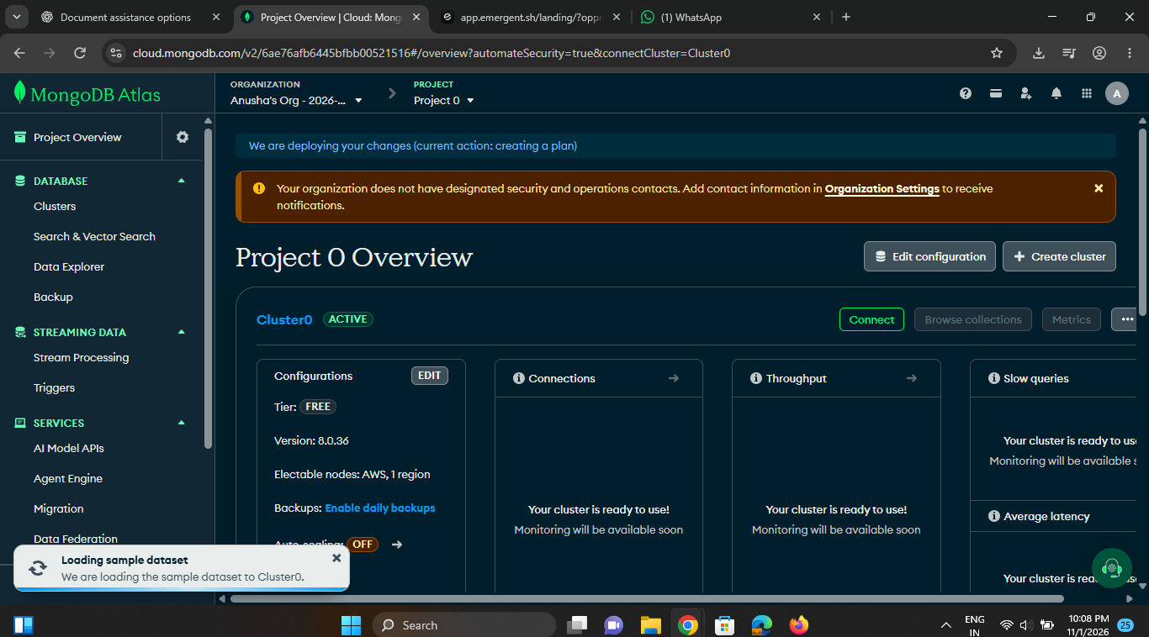
Figure 12.1: MongoDB Atlas cluster overview
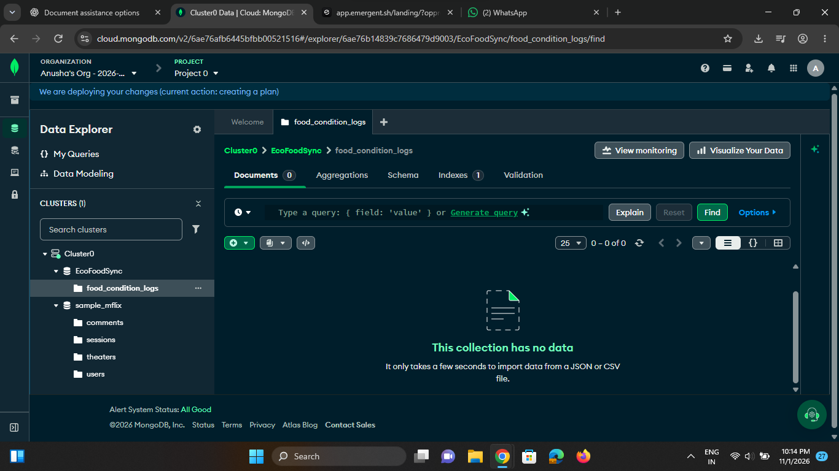
Figure 12.2: EcoFoodSync database and food_condition_logs collection in Data Explorer
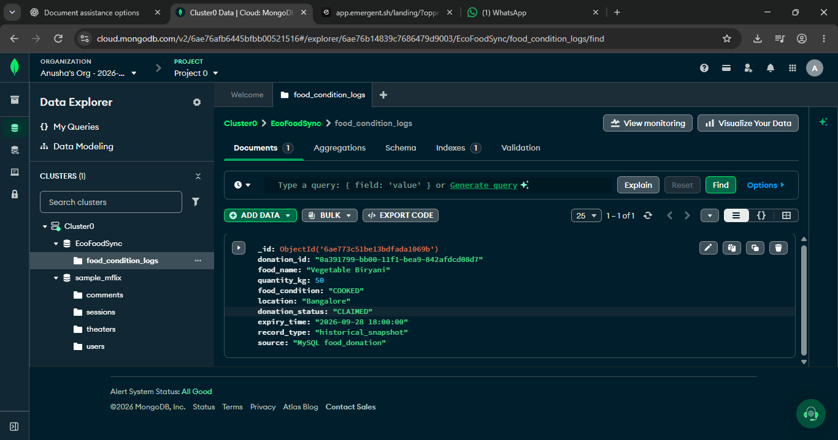
Figure 12.3: Inserted historical donation document in MongoDB
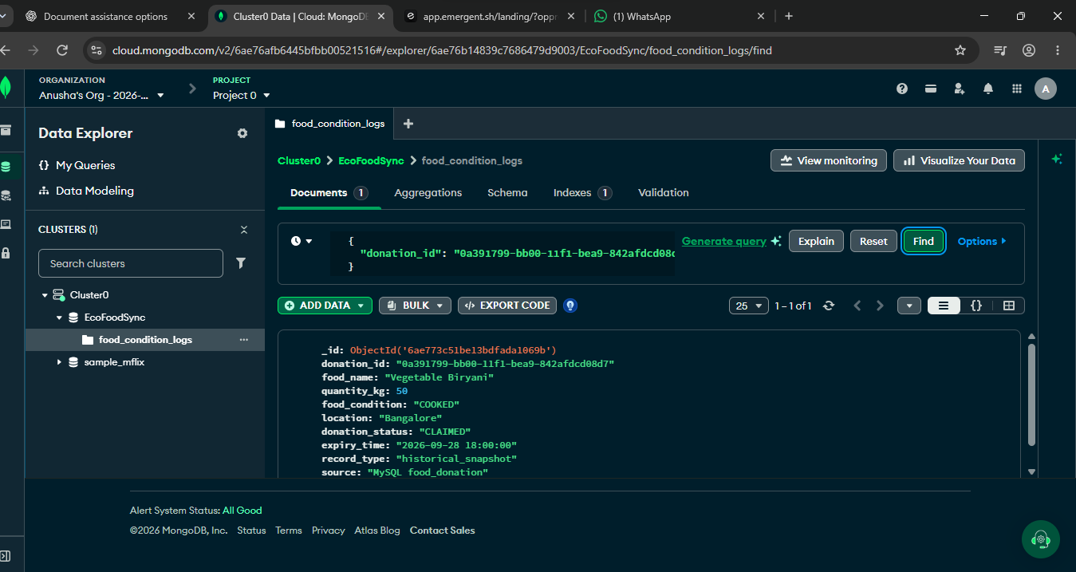
Figure 12.4: Find query and matching donation document

12.12 Summary
MongoDB has been added as the NoSQL component of EcoFoodSync to store flexible food-condition records. A MongoDB Atlas database and food_condition_logs collection were created, and a historical donation document was inserted and retrieved using donation_id. Update, delete, aggregation, indexing and application-level integration are included as implementation steps to execute and verify. Together, MySQL and MongoDB provide complementary relational and document-oriented data storage.
Implementation evidence note: Insert and Find have been observed in MongoDB Atlas. The remaining commands and integration steps must be executed and their actual outputs captured before final submission.

