
PES
UNIVERSITY
Electronic City, Hosur Road, Bengaluru – 560 100, Karnataka, India
MINI PROJECT REPORT ON
EcoFoodSync: Polyglot Database System for
Automated Perishable Food Rescue
Submitted in partial fulfilment of the requirements for the award of the degree of
BACHELOR OF TECHNOLOGY
in
COMPUTER SCIENCE AND ENGINEERING
DBMS Experiential Learning – Level 3
Submitted by
Team | Student Registration Number
G14 | PES2UG24CS676 B ANUSHA
G14 | PES2UG24CS660 SHUBHA R

Under the guidance of
Dr. Shilpa S
Assistant Professor
PES University
NOVEMBER 2026
DEPARTMENT OF COMPUTER SCIENCE AND ENGINEERING
FACULTY OF ENGINEERING
PES UNIVERSITY
(Established under Karnataka Act No. 16 of 2013)

CERTIFICATE

This is to certify that the mini project entitled
EcoFoodSync: Polyglot Database System for
Automated Perishable Food Rescue

is a bonafide work carried out by

B ANUSHA  SHUBHA R | PES2U24CS676  PES2UG24CS676

In partial fulfilment for the completion of fifth semester DBMS Project (UE24CSS351A) in the Program of Study -Bachelor of Technology in Computer Science and Engineering under rules and regulations of PES University, Bengaluru during the period AUG. 2026 – DEC. 2026. It is certified that all corrections / suggestions indicated for internal assessment have been incorporated in the report. The project has been approved as it satisfies the 5th semester academic requirements in respect of project work.

Signature
Dr. Shilpa S
Assistant Professor

DECLARATION

We hereby declare that the DBMS Project entitled ECO FOOD SYNC has been carried out by us under the guidance of Dr. Shilpa S, Assistant Professor and submitted in partial fulfilment of the course requirements for the award of degree of Bachelor of Technology in Computer Science and Engineering of PES University, Bengaluru during the academic semester AUG – DEC 2026.

B ANUSHA PES2UG24CS676

SHUBHA R
PES2UG24CS660

ACKNOWLEDGEMENT

I would like to express my gratitude to Dr. Shilpa S, Department of Computer Science and Engineering, PES University, for her continuous guidance, assistance, and encouragement throughout the development of this UE23CS351A - DBMS Project.
I take this opportunity to thank Dr. Sandesh B J, C, Professor, ChairPerson, Department of Computer Science and Engineering, PES University, for all the knowledge and support I have received from the department.
I am deeply grateful to Prof. Jawahar Doreswamy, Chancellor – PES University, Dr. Suryaprasad J, Vice-Chancellor, PES University for providing to me various opportunities and enlightenment every step of the way. Finally, this DBMS Project could not have been completed without the continual support and encouragement I have received from my family and friends.

ABSTRACT
EcoFoodSync is a database-driven system designed to support the rescue and redistribution of surplus perishable food. The system models the flow of food from donors such as restaurants and supermarkets to recipient charities and non-governmental organisations. It also records volunteers, allocations, pickup and delivery activities, and food requests.
The project adopts a polyglot database approach. MySQL 8.0 is used as the primary relational database for structured operational data. The relational design contains seven core entities: FOOD_DONOR, FOOD_DONATION, CHARITY_OR_NGO, ALLOCATION, VOLUNTEER, PICKUP_DELIVERY and FOOD_REQUEST. The implementation includes ER modelling, relational schema creation, keys and constraints, DML operations, joins, aggregate queries, subqueries, views, indexes, stored procedures, a stored function, triggers, transactions, cursors and common table expressions.
MongoDB Atlas is introduced as the NoSQL component for flexible food-condition and inspection records. The database EcoFoodSync and collection food_condition_logs have been created. The available evidence confirms insertion and retrieval of one historical donation snapshot using the common donation_id. Other MongoDB operations and application-level integration are documented as pending verification rather than completed features.
The project demonstrates how relational and document-oriented databases can complement one another: MySQL maintains structured relationships and integrity, while MongoDB can hold flexible condition-related snapshots. The implementation status and evidence are presented transparently throughout this report.
Keywords: Food rescue, MySQL, MongoDB Atlas, polyglot persistence, relational database, NoSQL, food donation.

TABLE OF CONTENTS
Chapter | Title
1 | INTRODUCTION
2 | PROBLEM DEFINITION AND OBJECTIVES
3 | SYSTEM ANALYSIS AND DESIGN
4 | ER MODEL AND RELATIONAL MAPPING
5 | MYSQL DDL IMPLEMENTATION
6 | MYSQL DML IMPLEMENTATION
7 | SQL QUERIES AND DATA ANALYSIS
8 | ADVANCED DATABASE FEATURES
9 | NOSQL IMPLEMENTATION USING MONGODB
10 | SYSTEM VERIFICATION, RESULTS AND LIMITATIONS
11 | CONCLUSION AND FUTURE ENHANCEMENTS
 | REFERENCES
 | APPENDIX A – IMPLEMENTATION SCREENSHOTS

LIST OF TABLES
Table No. | Title
3.1 | Core relational entities
4.1 | Relationship cardinalities
5.1 | Database tables and key constraints
6.1 | Sample data inserted into the system
9.1 | MongoDB food_condition_logs document fields
10.1 | Implementation verification status

LIST OF FIGURES
Figure No. | Title
3.1 | EcoFoodSync system entities and data flow
4.1 | ER diagram in Chen notation (source project evidence)
5.1 onwards | MySQL DDL, schema, query and advanced feature screenshots
9.1 onwards | MongoDB Atlas screenshots included in the source project

1. INTRODUCTION

1.1 Background
Large quantities of edible food may remain unused at restaurants, supermarkets, caterers and other food businesses. At the same time, charities and community organisations may need food supplies. Coordinating donations, checking food condition and expiry, allocating quantities, and arranging transportation requires reliable information management.

1.2 Project Overview
EcoFoodSync models this process as a database system. Donors register surplus food, charities submit requests, donations are allocated to recipients, and volunteers perform pickup and delivery activities. The database records the status and quantities associated with each stage.

1.3 Polyglot Database Approach
The project uses MySQL 8.0 for structured entities and relationships. MongoDB Atlas is used for flexible food-condition records. The two data stores are logically associated through donation_id. This is an application-level reference; MongoDB does not enforce a foreign key to the MySQL database.

1.4 Scope
- Maintain donor, donation, charity, volunteer, allocation, delivery and request information.
- Enforce data integrity using primary keys, foreign keys, unique constraints and CHECK constraints.
- Support operational queries and reporting using SQL.
- Store a flexible historical food-condition snapshot in MongoDB.
- Document the current implementation evidence and identify remaining verification work.

2. PROBLEM DEFINITION AND OBJECTIVES

2.1 Problem Definition
Food rescue coordination involves multiple participants and time-sensitive information. Without a centralised data model, it becomes difficult to track which donor supplied a food batch, how much was allocated, which charity received it, which volunteer handled delivery, and whether a donation is still available or has expired.

2.2 Objectives
- Design a normalised relational schema for the food rescue workflow.
- Represent entities and their relationships using an ER model.
- Implement the schema in MySQL 8.0 with integrity constraints and indexes.
- Insert and manipulate representative records across all core entities.
- Write SQL queries for retrieval, joins, aggregation, grouping and nested analysis.
- Demonstrate advanced database features such as views, procedures, functions, triggers, transactions, cursors and CTEs.
- Create a MongoDB Atlas collection for flexible food-condition snapshots.

2.3 Expected Outcome
The expected outcome is a consistent database foundation that supports tracking of food donations and rescue operations, with a relational store for operational records and a document store for flexible condition history.

3. SYSTEM ANALYSIS AND DESIGN

3.1 Core Entities
Entity | Purpose
FOOD_DONOR | Stores donor business profiles, contact details and donor type.
FOOD_DONATION | Stores food name, type, quantity, preparation time, expiry time, condition, location and status.
CHARITY_OR_NGO | Stores recipient organisation details, operational area and capacity.
ALLOCATION | Associates a donation with a charity and records allocated quantity and status.
VOLUNTEER | Stores volunteer contact details, availability and current location.
PICKUP_DELIVERY | Tracks donation transportation, volunteer assignment, recipient and delivery status.
FOOD_REQUEST | Stores requested food type, required quantity and urgency level submitted by a charity.

3.2 High-Level Workflow
- A donor profile is stored in FOOD_DONOR.
- A surplus food batch is recorded in FOOD_DONATION and linked to its donor.
- A charity can submit a demand record in FOOD_REQUEST.
- An available donation can be assigned through ALLOCATION.
- A volunteer can be associated with a pickup and delivery record.
- The delivery status records the progress of transportation to the recipient charity.
- A related food-condition snapshot can be stored in MongoDB using the donation_id reference.

3.3 Data Integrity and Design
The relational schema uses UUID-style CHAR(36) identifiers for primary keys. Foreign keys connect dependent records to their parent entities. NOT NULL and UNIQUE constraints protect required and unique attributes, while CHECK constraints validate positive quantities, capacities and valid time ordering. ENUM columns restrict selected status and category values.

4. ER MODEL AND RELATIONAL MAPPING

4.1 ER Model
The project ER diagram uses Chen notation. Rectangles represent entities, ovals represent attributes, diamonds represent relationships, and cardinality labels describe one-to-many associations.
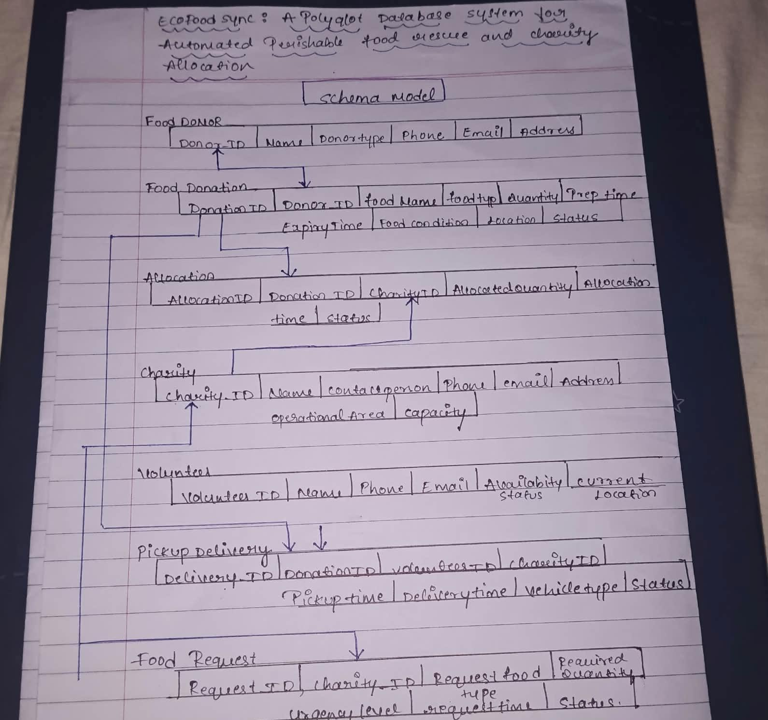
Figure 4.1: ER diagram and schema evidence from the project file.

4.2 Relationship Cardinalities
Relationship | Cardinality | Description
FOOD_DONOR – FOOD_DONATION | 1 : N | One donor can create multiple donation listings.
FOOD_DONATION – ALLOCATION | 1 : N | One donation can be split into multiple allocations.
CHARITY_OR_NGO – ALLOCATION | 1 : N | One charity can receive multiple allocations.
CHARITY_OR_NGO – FOOD_REQUEST | 1 : N | One charity can submit multiple food requests.
VOLUNTEER – PICKUP_DELIVERY | 1 : N | One volunteer can handle multiple delivery tasks.
FOOD_DONATION – PICKUP_DELIVERY | 1 : N | One donation can be linked to logistics tasks.
CHARITY_OR_NGO – PICKUP_DELIVERY | 1 : N | A charity can be the recipient of multiple deliveries.

4.3 Relational Mapping
Each strong entity is mapped to a relation with its own primary key. The primary key of the parent entity is included as a foreign key in the child relation for one-to-many relationships. ALLOCATION contains references to both FOOD_DONATION and CHARITY_OR_NGO, thereby representing the allocation relationship. PICKUP_DELIVERY references FOOD_DONATION, VOLUNTEER and CHARITY_OR_NGO.

5. MYSQL DDL IMPLEMENTATION

5.1 Database Creation
CREATE DATABASE IF NOT EXISTS ecofoodsync_db;
USE ecofoodsync_db;
The database ecofoodsync_db is created in MySQL 8.0 and selected before the table definitions are executed.

5.2 Table Creation
Seven core tables are created: food_donor, food_donation, charity_or_ngo, allocation, volunteer, pickup_delivery and food_request. The implementation uses InnoDB to support relational constraints and transactions.
Table | Important keys / constraints
food_donor | donor_id PRIMARY KEY; email UNIQUE; required donor name and type.
food_donation | donation_id PRIMARY KEY; donor_id FOREIGN KEY; quantity CHECK; expiry after preparation.
charity_or_ngo | charity_id PRIMARY KEY; email UNIQUE; capacity CHECK.
allocation | allocation_id PRIMARY KEY; donation_id and charity_id FOREIGN KEY; allocated quantity CHECK.
volunteer | volunteer_id PRIMARY KEY; email UNIQUE; availability status.
pickup_delivery | delivery_id PRIMARY KEY; donation, volunteer and charity references; delivery status.
food_request | request_id PRIMARY KEY; charity_id FOREIGN KEY; required quantity CHECK; urgency level.

5.3 Constraints and Schema Modification
- PRIMARY KEY and FOREIGN KEY constraints establish entity identity and relationships.
- NOT NULL constraints ensure required fields are supplied.
- UNIQUE constraints prevent duplicate contact emails and other unique values.
- CHECK constraints validate positive quantities and valid expiry/preparation ordering.
- ALTER TABLE operations modify the volunteer phone column and rename the pickup_delivery notes column to delivery_notes.
- Additional constraints are added for donor rating and volunteer phone uniqueness.
- A temporary audit table is created and dropped to demonstrate DROP TABLE.

5.4 Indexing and Views
Indexes are created on frequently used relationship and search columns, including donor_id, donation_id, charity_id, volunteer_id, status, expiry_time and food_name. The project also demonstrates a composite index and a FULLTEXT index. Two views are created: vw_available_donations and vw_active_deliveries.
CREATE INDEX idx_food_donation_donor ON food_donation(donor_id);
CREATE INDEX idx_allocation_donation ON allocation(donation_id);
CREATE INDEX idx_allocation_charity ON allocation(charity_id);
CREATE INDEX idx_pickup_delivery_volunteer ON pickup_delivery(volunteer_id);
CREATE INDEX idx_food_request_charity ON food_request(charity_id);

5.5 DDL Verification
SHOW TABLES, SHOW COLUMNS and DESCRIBE statements are used to inspect the created tables and verify column types, nullability, keys and defaults.

6. MYSQL DML IMPLEMENTATION

6.1 INSERT Operations
Sample records are inserted into all seven relational tables. The project data includes donors such as Green Leaf Restaurant, FreshMart Supermarket and Annapurna Caterers; charities such as Helping Hands NGO and Food For All Foundation; and volunteer records.

6.2 UPDATE Operations
- Update the status of a food donation to CLAIMED.
- Update volunteer availability and current location.
- Increase a charity's capacity.
- Update an allocation status to APPROVED.

6.3 DELETE Operations
DELETE statements demonstrate removal of a selected food request and an unused volunteer record. The project verifies the remaining records after deletion.

6.4 SELECT Operations
- Display all food donations.
- Display donations whose status is AVAILABLE.
- Display high-quantity donations using a quantity condition.
- Sort donations by earliest expiry time.
- Display food requests with HIGH or CRITICAL urgency.

7. SQL QUERIES AND DATA ANALYSIS

7.1 JOIN Operations
The project demonstrates joins to combine information across related tables. Examples include donor and food donation details, donation and recipient charity details, and complete delivery information involving food, donor, volunteer and charity.

7.2 Aggregate Functions
Function | Purpose in EcoFoodSync
COUNT() | Find the total number of food donations.
SUM() | Calculate the total quantity of food donated.
AVG() | Calculate the average donation quantity.
MAX() | Find the largest food donation.
MIN() | Find the smallest food donation.

7.3 GROUP BY and HAVING
GROUP BY is used to calculate the total food donated by each donor and the total food received by each charity. HAVING filters grouped results, such as donors whose total donations exceed 40 kg and charities receiving more than 20 kg.

7.4 ORDER BY and Subqueries
ORDER BY sorts donations by quantity and earliest expiry. Subqueries identify donations above average quantity, the donation with maximum quantity and charities whose capacity is above average.

7.5 Complex Queries
Complex queries combine donor, donation, allocation and charity details to display complete food allocation information, including food name, donor, charity, allocated quantity and allocation status.

8. ADVANCED DATABASE FEATURES

8.1 Views
The project creates vw_available_donations to display available donations with donor information and vw_active_deliveries to display active delivery details with food, recipient and volunteer information.

8.2 Stored Procedures
Two stored procedures are included: one retrieves available food by location, and another provides an allocation summary.

8.3 Stored Function
A stored function is created and tested as part of the advanced database implementation. The source project includes verification of the function.

8.4 Triggers
Two triggers are implemented: one prevents allocation quantities from exceeding the available donation quantity, and another validates food expiry time. The project tests valid and invalid allocation operations and verifies that an invalid donation is not inserted.

8.5 Transactions
Transaction control is demonstrated using START TRANSACTION, SAVEPOINT, ROLLBACK TO SAVEPOINT and COMMIT. These statements illustrate controlled changes and partial rollback.

8.6 Cursors
A cursor is included for processing food donations. It demonstrates row-by-row processing of query results within a stored-program context.

8.7 Common Table Expressions and Window Functions
A CTE is used for donation analysis and window-function ranking. An additional advanced query demonstrates a correlated subquery and allocation percentage.

9. NOSQL IMPLEMENTATION USING MONGODB

9.1 Purpose of MongoDB
MongoDB complements MySQL by storing flexible food-condition and inspection records, including condition observations, storage details, expiry information and inspection notes. The MongoDB Atlas database is named EcoFoodSync and the collection is food_condition_logs.

9.2 Document Structure
Field | Purpose
_id | MongoDB-generated unique document identifier.
donation_id | Logical reference to the corresponding MySQL food_donation record.
food_name | Name of the donated food.
quantity_kg | Recorded quantity in kilograms.
food_condition | Condition recorded for the donation.
location | Donation location.
donation_status | Status copied from the MySQL snapshot.
expiry_time | Recorded expiry date and time.
record_type | Identifies the record as a historical snapshot.
source | Identifies MySQL food_donation as the source.

9.3 Insert and Read – Verified
db.food_condition_logs.insertOne({
donation_id: "0a391799-bb00-11f1-bea9-842afdcd08d7",
food_name: "Vegetable Biryani", quantity_kg: 50,
food_condition: "COOKED", location: "Bangalore",
donation_status: "CLAIMED",
expiry_time: "2026-09-28 18:00:00",
record_type: "historical_snapshot",
source: "MySQL food_donation"
})
The historical donation document was inserted through MongoDB Atlas Data Explorer. The corresponding find() query using donation_id returned one matching document. The source project explicitly records Insert and Find as observed operations.
db.food_condition_logs.find({
donation_id: "0a391799-bb00-11f1-bea9-842afdcd08d7"
})

9.4 Other MongoDB Operations – Pending Verification
The source project documents updateOne(), deleteOne(), aggregation and index creation as implementation steps. Their expected results are described, but the report states that the commands must be executed and actual outputs captured before they can be marked complete.
db.food_condition_logs.updateOne(
{ donation_id: "0a391799-bb00-11f1-bea9-842afdcd08d7" },
{ $set: { historical_note: "Imported from MySQL for historical reference." } }
)
db.food_condition_logs.aggregate([
{ $group: { _id: "$food_condition", total_records: { $sum: 1 },
total_quantity_kg: { $sum: "$quantity_kg" } } },
{ $sort: { total_records: -1 } }
])
db.food_condition_logs.createIndex({ donation_id: 1 })

9.5 MySQL–MongoDB Logical Association
MySQL remains the primary relational store for FOOD_DONATION. MongoDB stores condition-related documents. The common donation_id connects the records at the application level; MongoDB does not enforce a foreign-key constraint against MySQL. Application/backend retrieval across both stores is not confirmed as complete in the source report.

10. SYSTEM VERIFICATION, RESULTS AND LIMITATIONS

10.1 MySQL Verification
The MySQL implementation evidence includes table creation outputs, schema inspection, inserted records, update and delete results, SELECT query outputs, joins, aggregate results, views, indexes, stored-program tests, trigger tests, transaction operations and final verification queries.

10.2 MongoDB Verification Status
Feature | Status according to project evidence
Atlas database and collection creation | Created and shown in project evidence.
Insert historical donation document | Observed / completed.
Find document by donation_id | Observed / completed.
Update historical_note | Documented command; execution/output pending verification.
Delete temporary test document | Documented demonstration; execution/output pending verification.
Aggregation pipeline | Documented command; actual output pending verification.
Additional donation_id index | Creation/check must be verified before claiming an additional index.
Application-level MySQL–MongoDB integration | Not yet verified in the source report.

10.3 Limitations
- MongoDB currently contains one historical donation snapshot, so aggregation results have limited analytical value.
- The historical document has an expiry time in the past and must not be treated as currently available food.
- MongoDB update, delete, aggregation and additional index outputs need execution evidence.
- Application-level retrieval across MySQL and MongoDB needs to be implemented and verified.
- The current report does not demonstrate a vector database or vector search.

10.4 Future Enhancements
- Insert more verified food-condition and inspection records in MongoDB.
- Complete and test update, delete, aggregation and indexing operations.
- Implement backend logic to retrieve MySQL donation details and associated MongoDB condition records using donation_id.
- Add validation for freshness and condition history before food allocation.
- Develop a user-facing interface and operational dashboards if required by the project scope.

11. CONCLUSION
EcoFoodSync demonstrates the design and implementation of a database system for coordinating surplus food rescue. The MySQL 8.0 component provides a structured relational foundation across seven core entities and demonstrates a broad range of DBMS concepts, including schema design, integrity constraints, DML, joins, aggregation, subqueries, views, indexes, stored procedures, functions, triggers, transactions, cursors and CTEs.
The project also introduces MongoDB Atlas as a document-oriented store for flexible food-condition snapshots. The available evidence confirms the creation of the database and collection, and the insertion and retrieval of one historical donation document. Additional MongoDB operations and application-level integration remain to be verified. The combined approach illustrates the complementary roles of relational and NoSQL databases in a polyglot data architecture.

REFERENCES
- MySQL 8.0 Reference Manual, Oracle. https://dev.mysql.com/doc/
- MongoDB Manual. https://www.mongodb.com/docs/manual/
- MongoDB Atlas Documentation. https://www.mongodb.com/docs/atlas/
- EcoFoodSync Team G14 project implementation document and captured database outputs.

APPENDIX A – IMPLEMENTATION SCREENSHOTS
The following figures are screenshots extracted from the submitted EcoFoodSync implementation document. They are included as evidence of the actual work recorded in that document. Captions identify them as source implementation evidence; they are not substituted with generated mock screenshots.
Figure A.1: Screenshot evidence reproduced from the EcoFoodSync source project document.
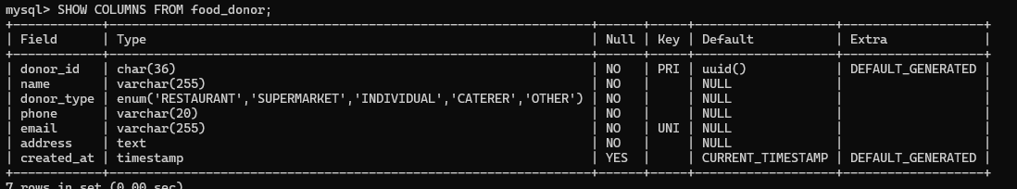
Figure A.2: Screenshot evidence reproduced from the EcoFoodSync source project document.
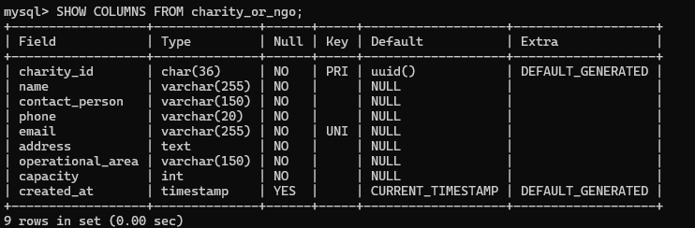
Figure A.3: Screenshot evidence reproduced from the EcoFoodSync source project document.
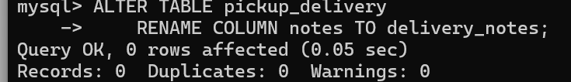
Figure A.4: Screenshot evidence reproduced from the EcoFoodSync source project document.
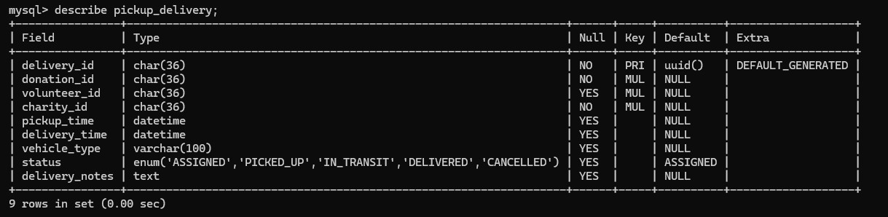
Figure A.5: Screenshot evidence reproduced from the EcoFoodSync source project document.
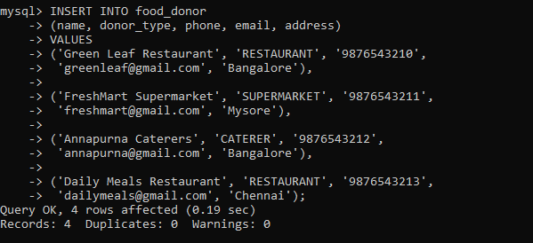
Figure A.6: Screenshot evidence reproduced from the EcoFoodSync source project document.
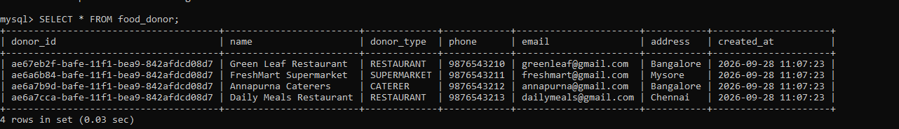
Figure A.7: Screenshot evidence reproduced from the EcoFoodSync source project document.
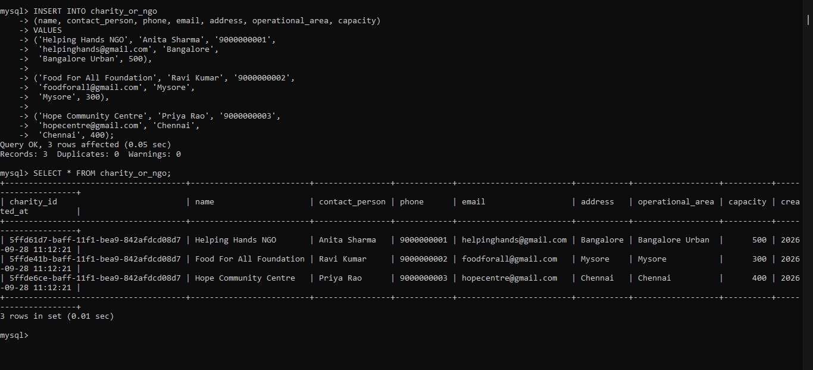
Figure A.8: Screenshot evidence reproduced from the EcoFoodSync source project document.
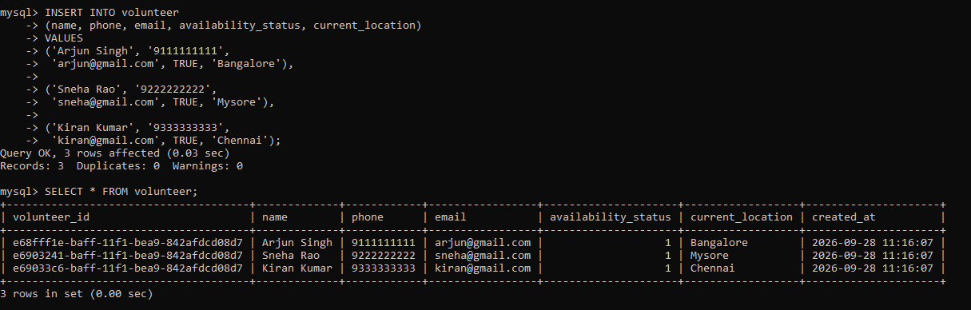
Figure A.9: Screenshot evidence reproduced from the EcoFoodSync source project document.
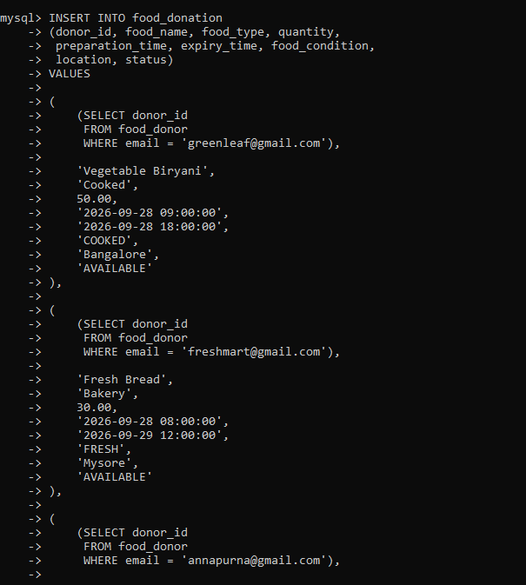
Figure A.10: Screenshot evidence reproduced from the EcoFoodSync source project document.
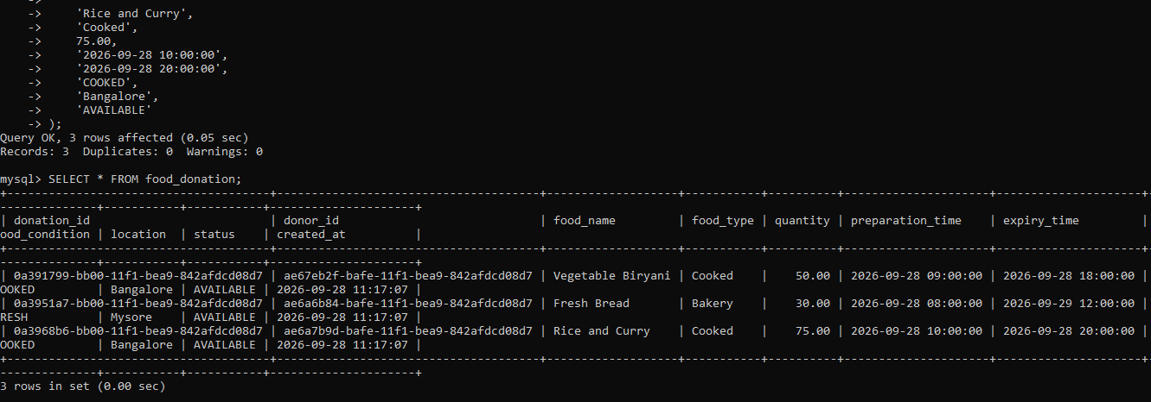
Figure A.11: Screenshot evidence reproduced from the EcoFoodSync source project document.
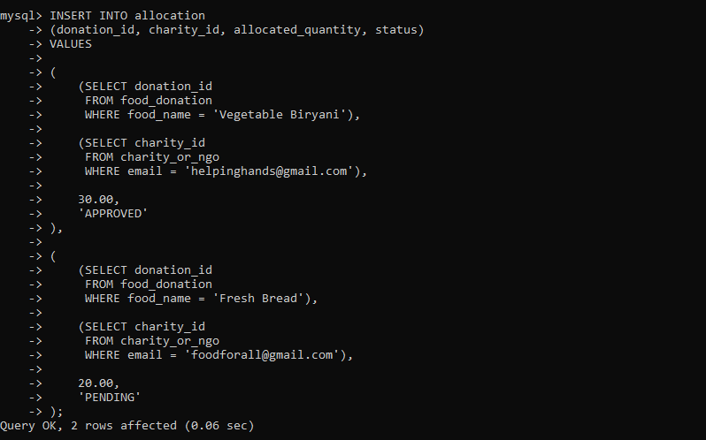
Figure A.12: Screenshot evidence reproduced from the EcoFoodSync source project document.
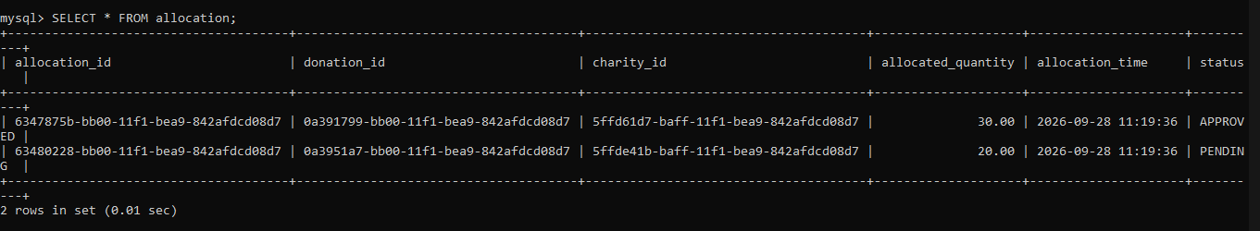
Figure A.13: Screenshot evidence reproduced from the EcoFoodSync source project document.
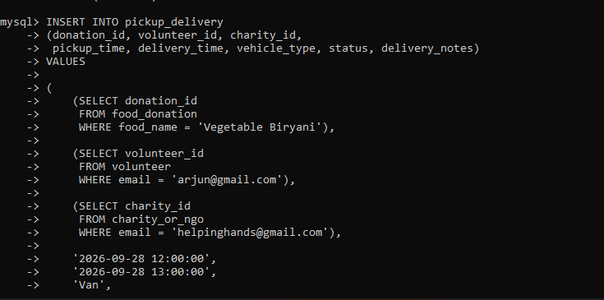
Figure A.14: Screenshot evidence reproduced from the EcoFoodSync source project document.
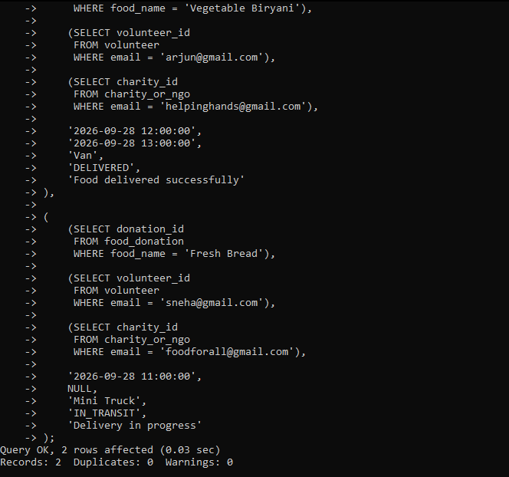
Figure A.15: Screenshot evidence reproduced from the EcoFoodSync source project document.
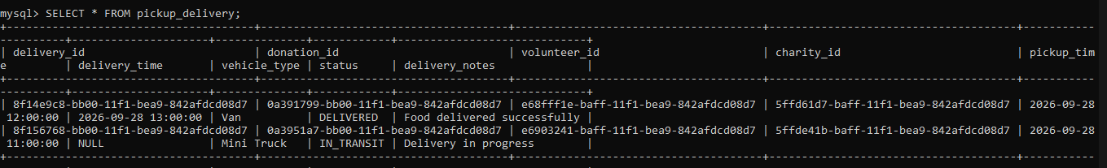
Figure A.16: Screenshot evidence reproduced from the EcoFoodSync source project document.
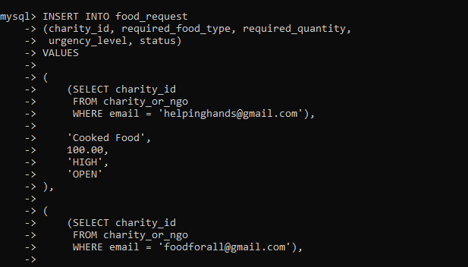
Figure A.17: Screenshot evidence reproduced from the EcoFoodSync source project document.
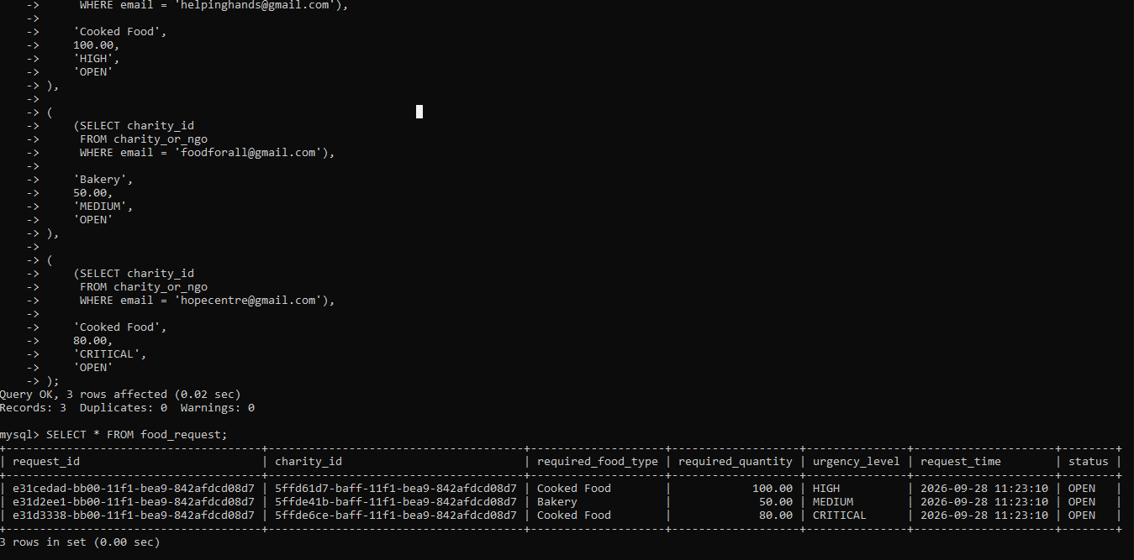
Figure A.18: Screenshot evidence reproduced from the EcoFoodSync source project document.
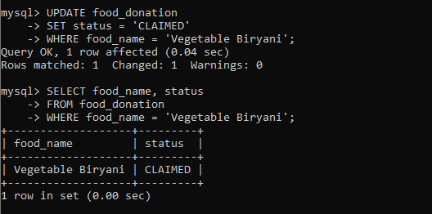
Figure A.19: Screenshot evidence reproduced from the EcoFoodSync source project document.
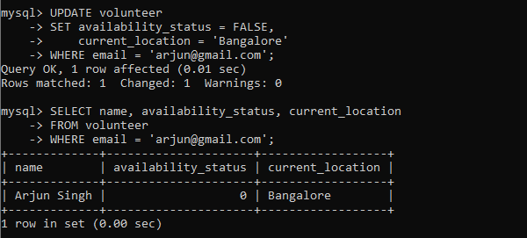
Figure A.20: Screenshot evidence reproduced from the EcoFoodSync source project document.
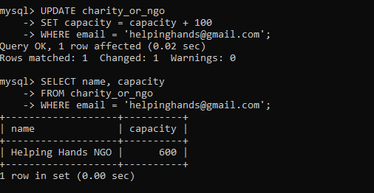
Figure A.21: Screenshot evidence reproduced from the EcoFoodSync source project document.
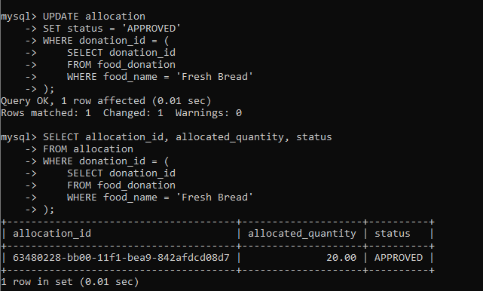
Figure A.22: Screenshot evidence reproduced from the EcoFoodSync source project document.
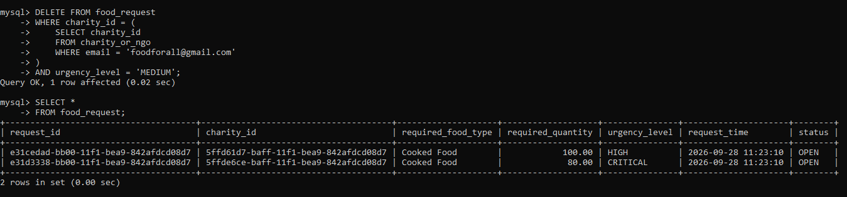
Figure A.23: Screenshot evidence reproduced from the EcoFoodSync source project document.
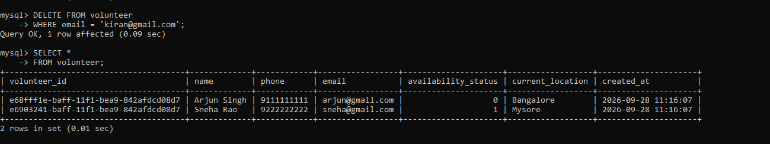
Figure A.24: Screenshot evidence reproduced from the EcoFoodSync source project document.
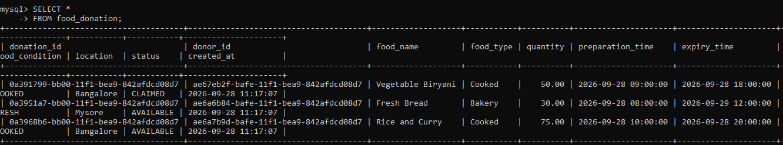
Figure A.25: Screenshot evidence reproduced from the EcoFoodSync source project document.
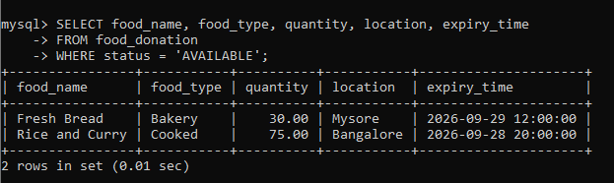
Figure A.26: Screenshot evidence reproduced from the EcoFoodSync source project document.
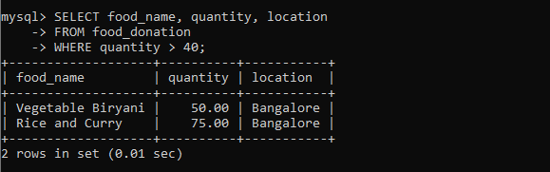
Figure A.27: Screenshot evidence reproduced from the EcoFoodSync source project document.
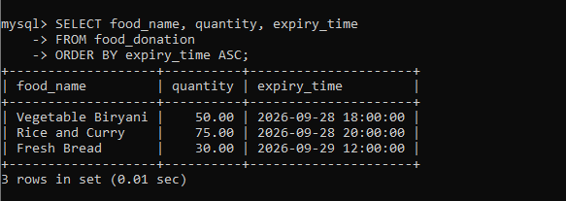
Figure A.28: Screenshot evidence reproduced from the EcoFoodSync source project document.
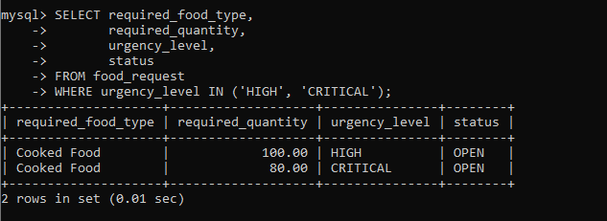
Figure A.29: Screenshot evidence reproduced from the EcoFoodSync source project document.
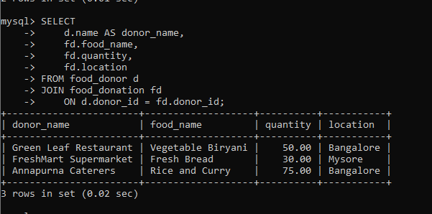
Figure A.30: Screenshot evidence reproduced from the EcoFoodSync source project document.
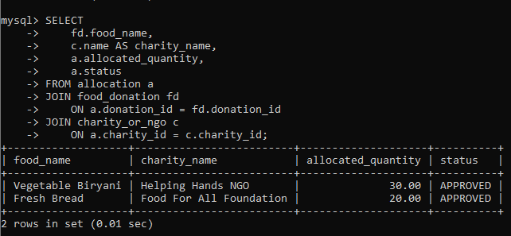
Figure A.31: Screenshot evidence reproduced from the EcoFoodSync source project document.
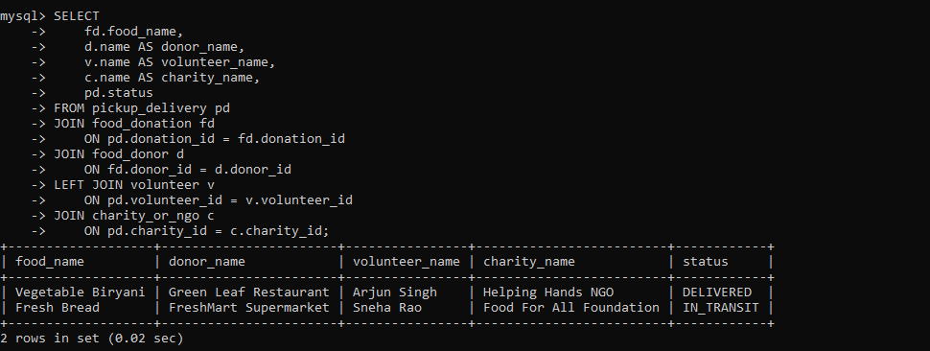
Figure A.32: Screenshot evidence reproduced from the EcoFoodSync source project document.
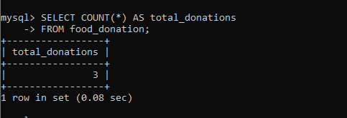
Figure A.33: Screenshot evidence reproduced from the EcoFoodSync source project document.
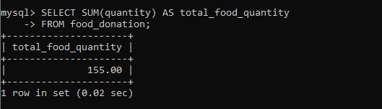
Figure A.34: Screenshot evidence reproduced from the EcoFoodSync source project document.
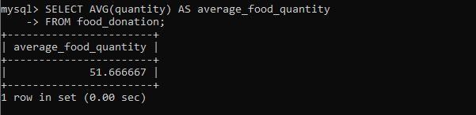
Figure A.35: Screenshot evidence reproduced from the EcoFoodSync source project document.
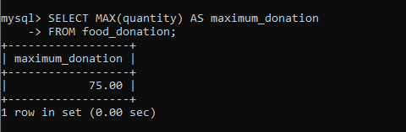
Figure A.36: Screenshot evidence reproduced from the EcoFoodSync source project document.
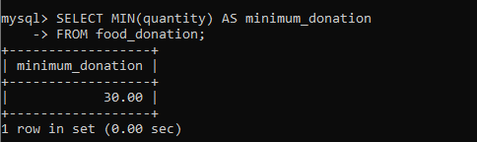
Figure A.37: Screenshot evidence reproduced from the EcoFoodSync source project document.
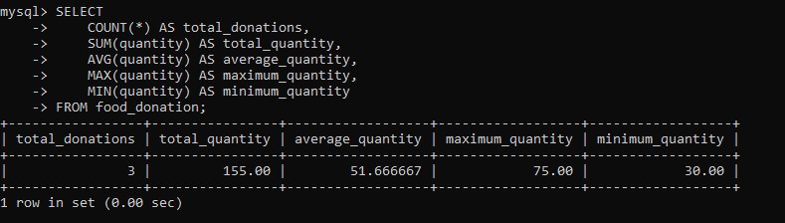
Figure A.38: Screenshot evidence reproduced from the EcoFoodSync source project document.
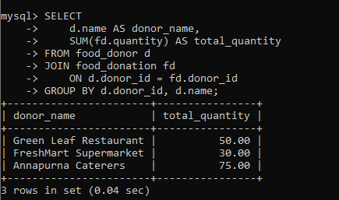
Figure A.39: Screenshot evidence reproduced from the EcoFoodSync source project document.
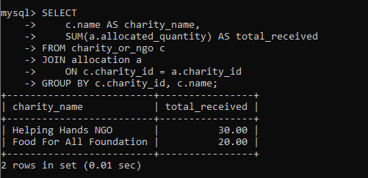
Figure A.40: Screenshot evidence reproduced from the EcoFoodSync source project document.
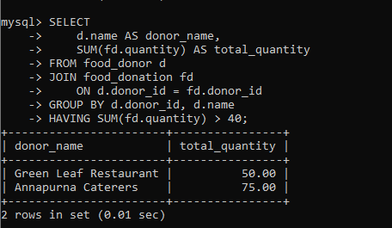
Figure A.41: Screenshot evidence reproduced from the EcoFoodSync source project document.
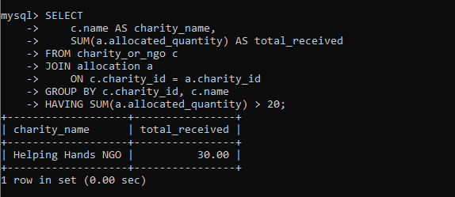
Figure A.42: Screenshot evidence reproduced from the EcoFoodSync source project document.
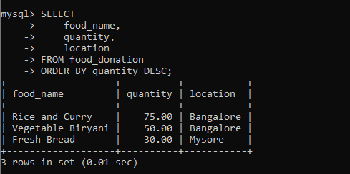
Figure A.43: Screenshot evidence reproduced from the EcoFoodSync source project document.
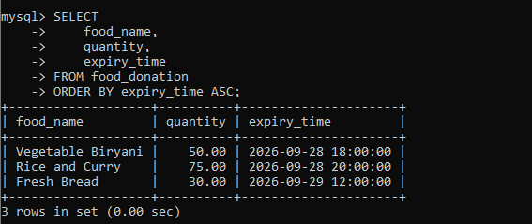
Figure A.44: Screenshot evidence reproduced from the EcoFoodSync source project document.
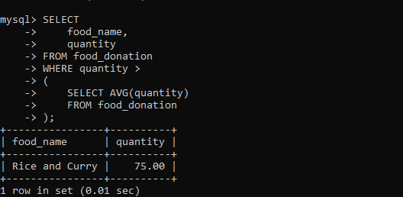
Figure A.45: Screenshot evidence reproduced from the EcoFoodSync source project document.
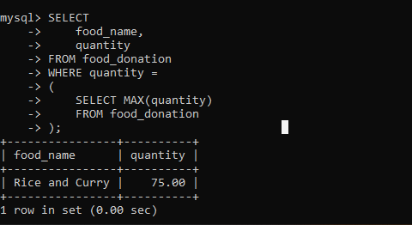
Figure A.46: Screenshot evidence reproduced from the EcoFoodSync source project document.
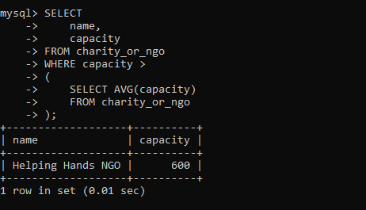
Figure A.47: Screenshot evidence reproduced from the EcoFoodSync source project document.
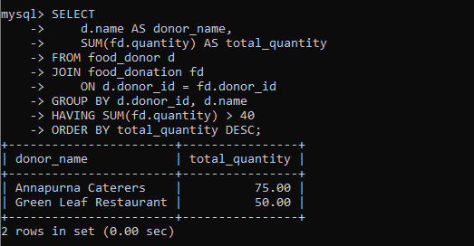
Figure A.48: Screenshot evidence reproduced from the EcoFoodSync source project document.
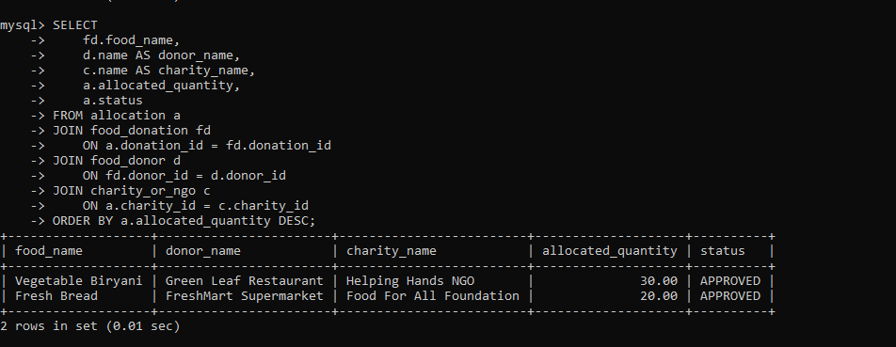
Figure A.49: Screenshot evidence reproduced from the EcoFoodSync source project document.
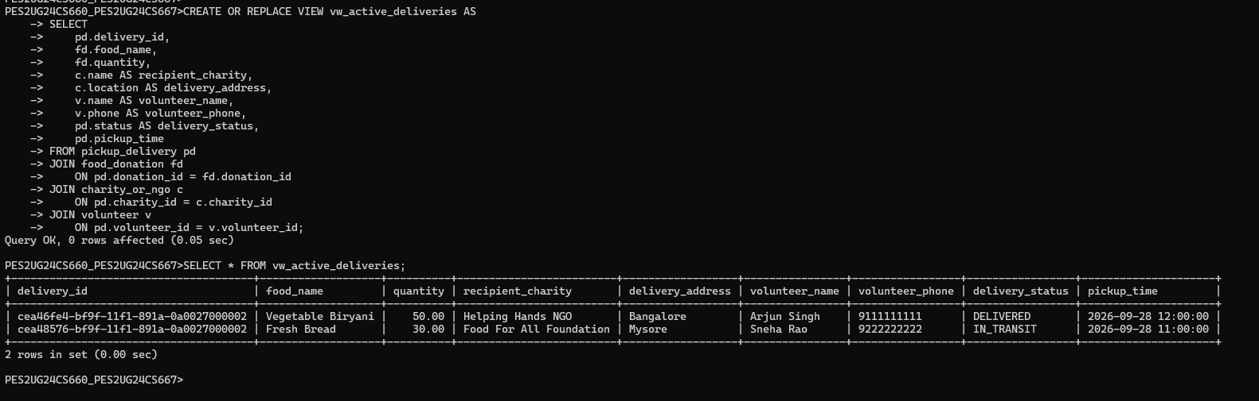
Figure A.50: Screenshot evidence reproduced from the EcoFoodSync source project document.
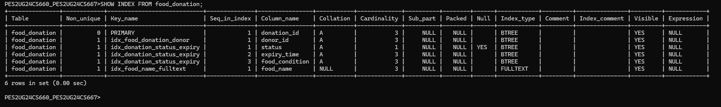
Figure A.51: Screenshot evidence reproduced from the EcoFoodSync source project document.
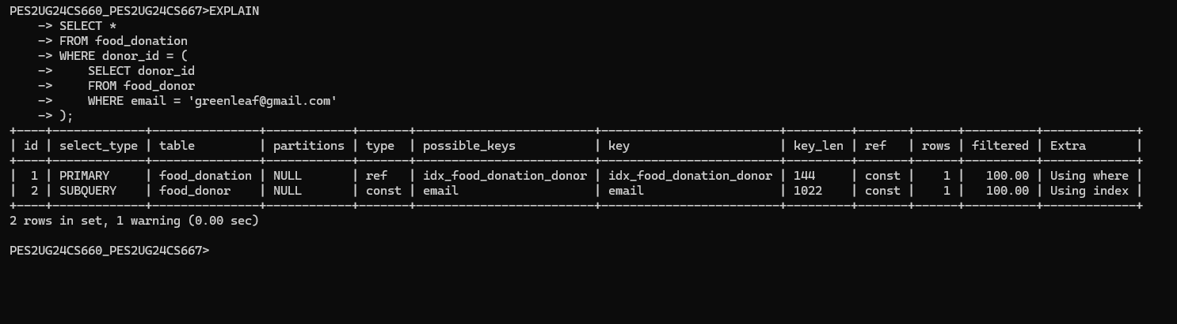
Figure A.52: Screenshot evidence reproduced from the EcoFoodSync source project document.
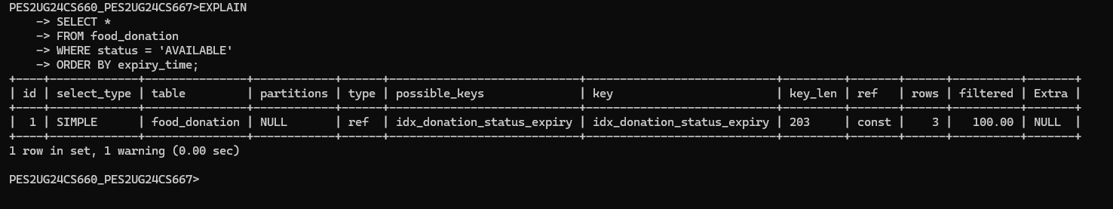
Figure A.53: Screenshot evidence reproduced from the EcoFoodSync source project document.
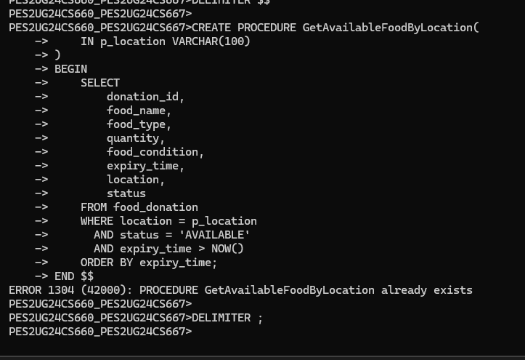
Figure A.54: Screenshot evidence reproduced from the EcoFoodSync source project document.
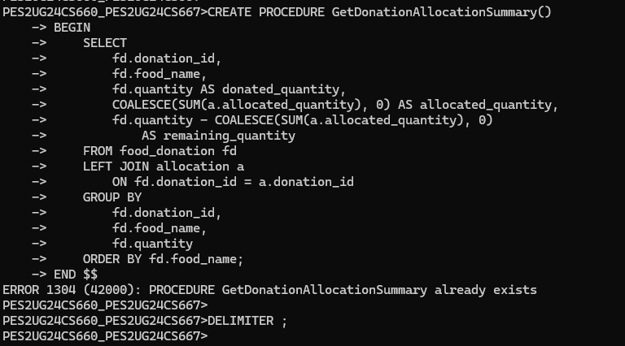
Figure A.55: Screenshot evidence reproduced from the EcoFoodSync source project document.
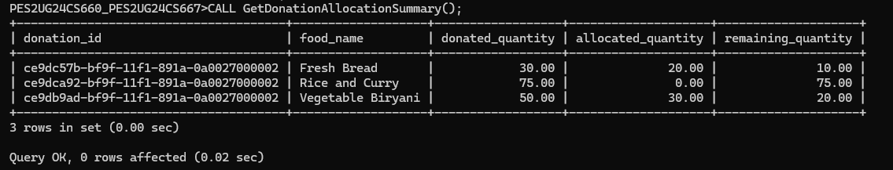
Figure A.56: Screenshot evidence reproduced from the EcoFoodSync source project document.
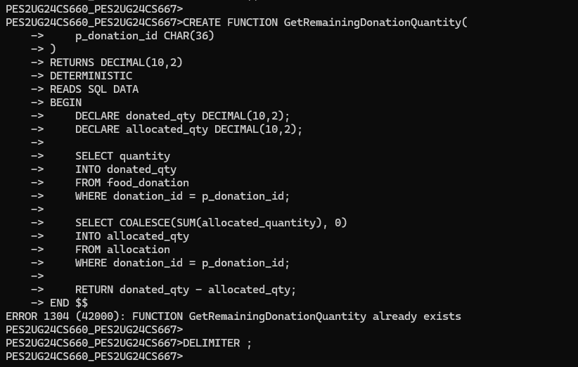
Figure A.57: Screenshot evidence reproduced from the EcoFoodSync source project document.
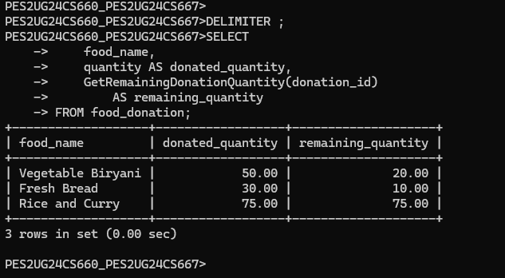
Figure A.58: Screenshot evidence reproduced from the EcoFoodSync source project document.
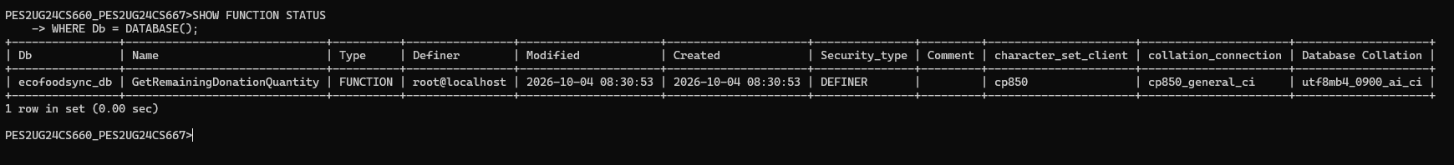
Figure A.59: Screenshot evidence reproduced from the EcoFoodSync source project document.
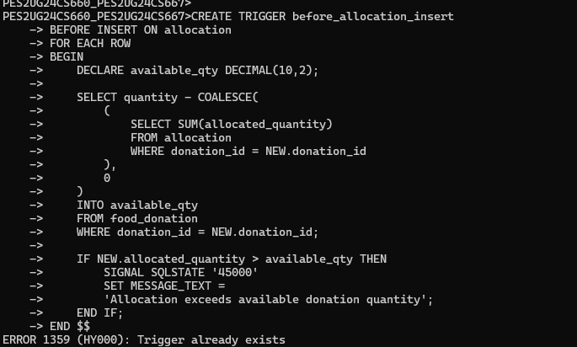
Figure A.60: Screenshot evidence reproduced from the EcoFoodSync source project document.
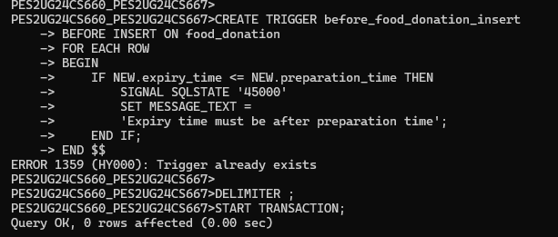
Figure A.61: Screenshot evidence reproduced from the EcoFoodSync source project document.
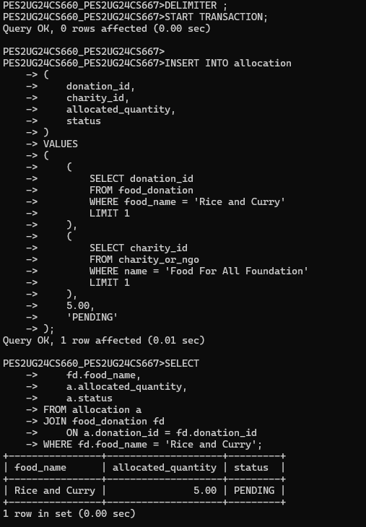
Figure A.62: Screenshot evidence reproduced from the EcoFoodSync source project document.
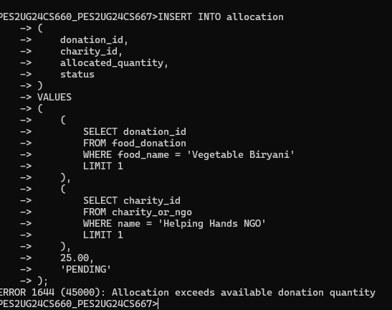
Figure A.63: Screenshot evidence reproduced from the EcoFoodSync source project document.
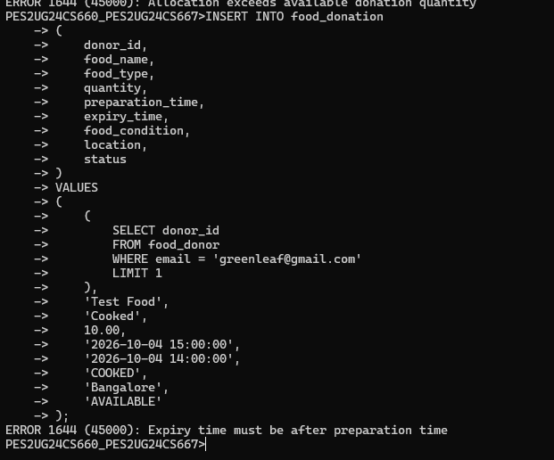
Figure A.64: Screenshot evidence reproduced from the EcoFoodSync source project document.
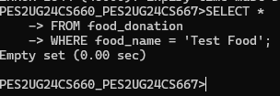
Figure A.65: Screenshot evidence reproduced from the EcoFoodSync source project document.
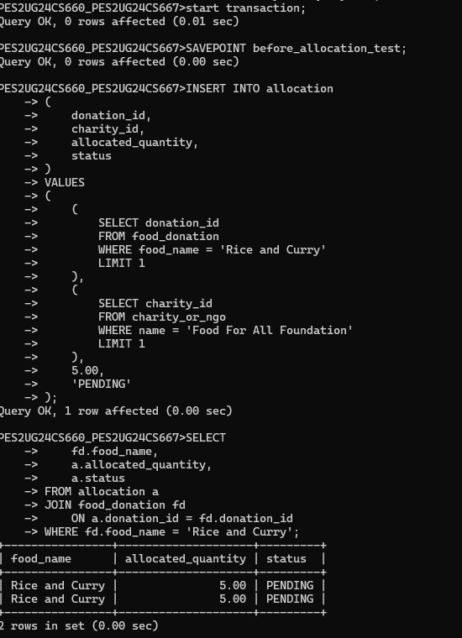
Figure A.66: Screenshot evidence reproduced from the EcoFoodSync source project document.
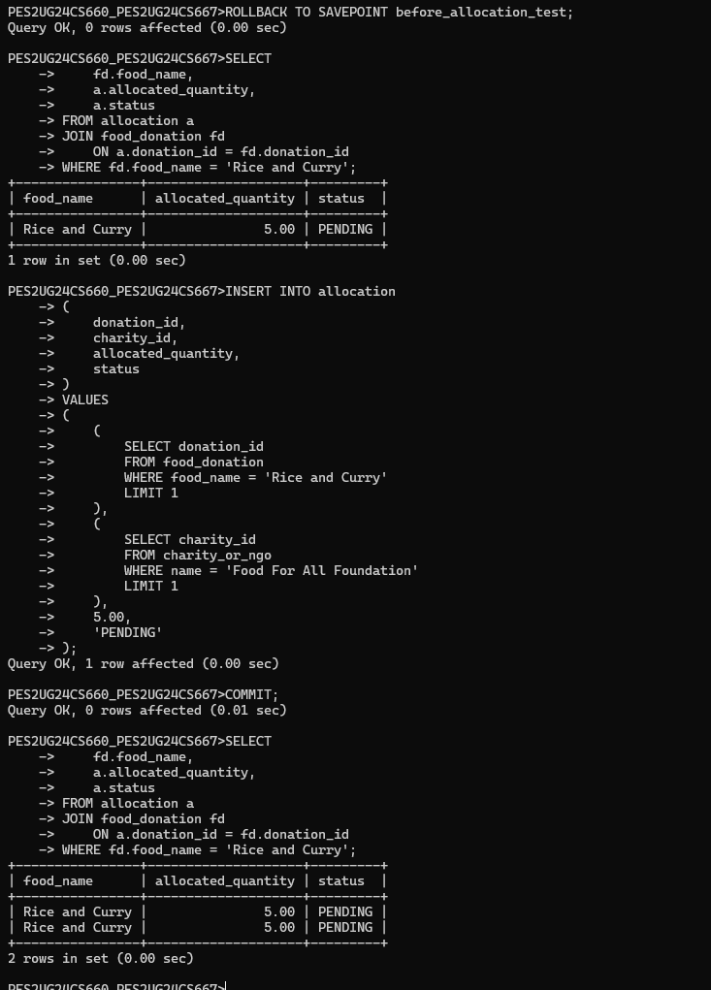
Figure A.67: Screenshot evidence reproduced from the EcoFoodSync source project document.
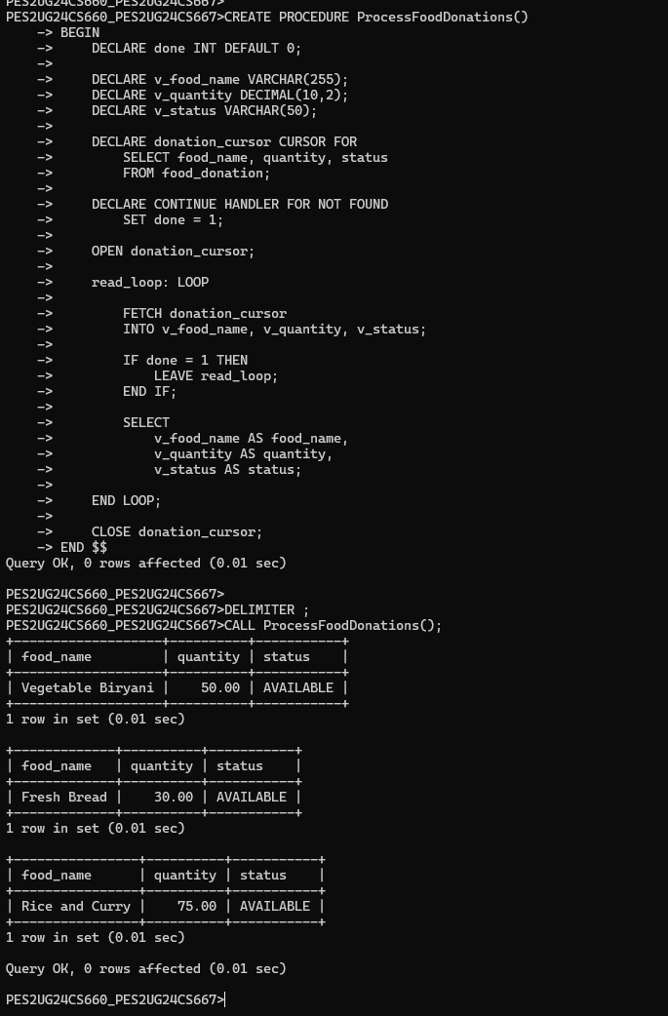
Figure A.68: Screenshot evidence reproduced from the EcoFoodSync source project document.
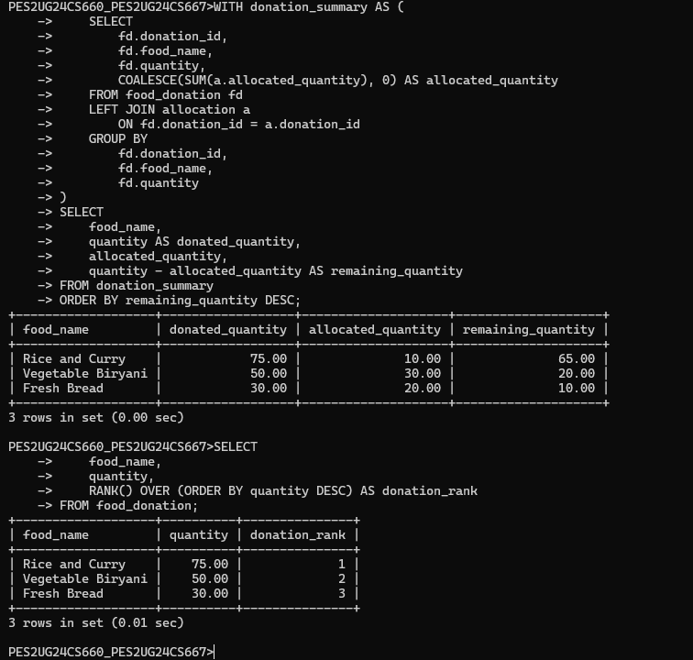
Figure A.69: Screenshot evidence reproduced from the EcoFoodSync source project document.
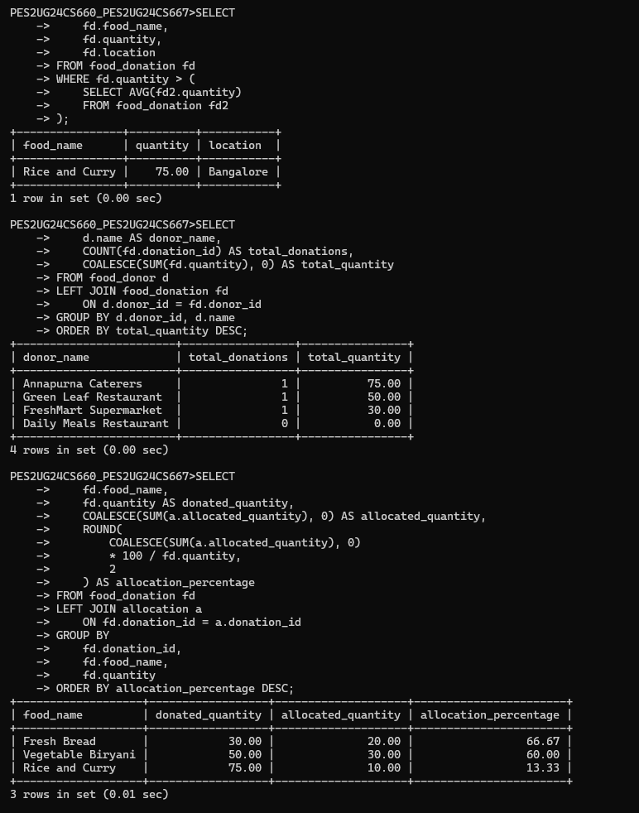
Figure A.70: Screenshot evidence reproduced from the EcoFoodSync source project document.
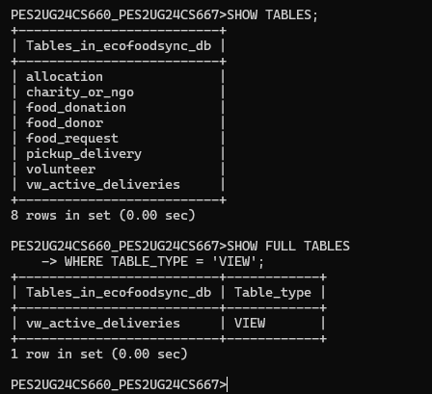
Figure A.71: Screenshot evidence reproduced from the EcoFoodSync source project document.
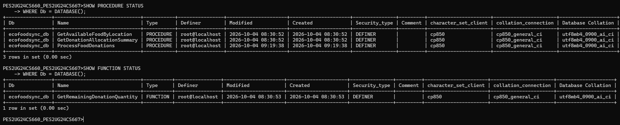
Figure A.72: Screenshot evidence reproduced from the EcoFoodSync source project document.
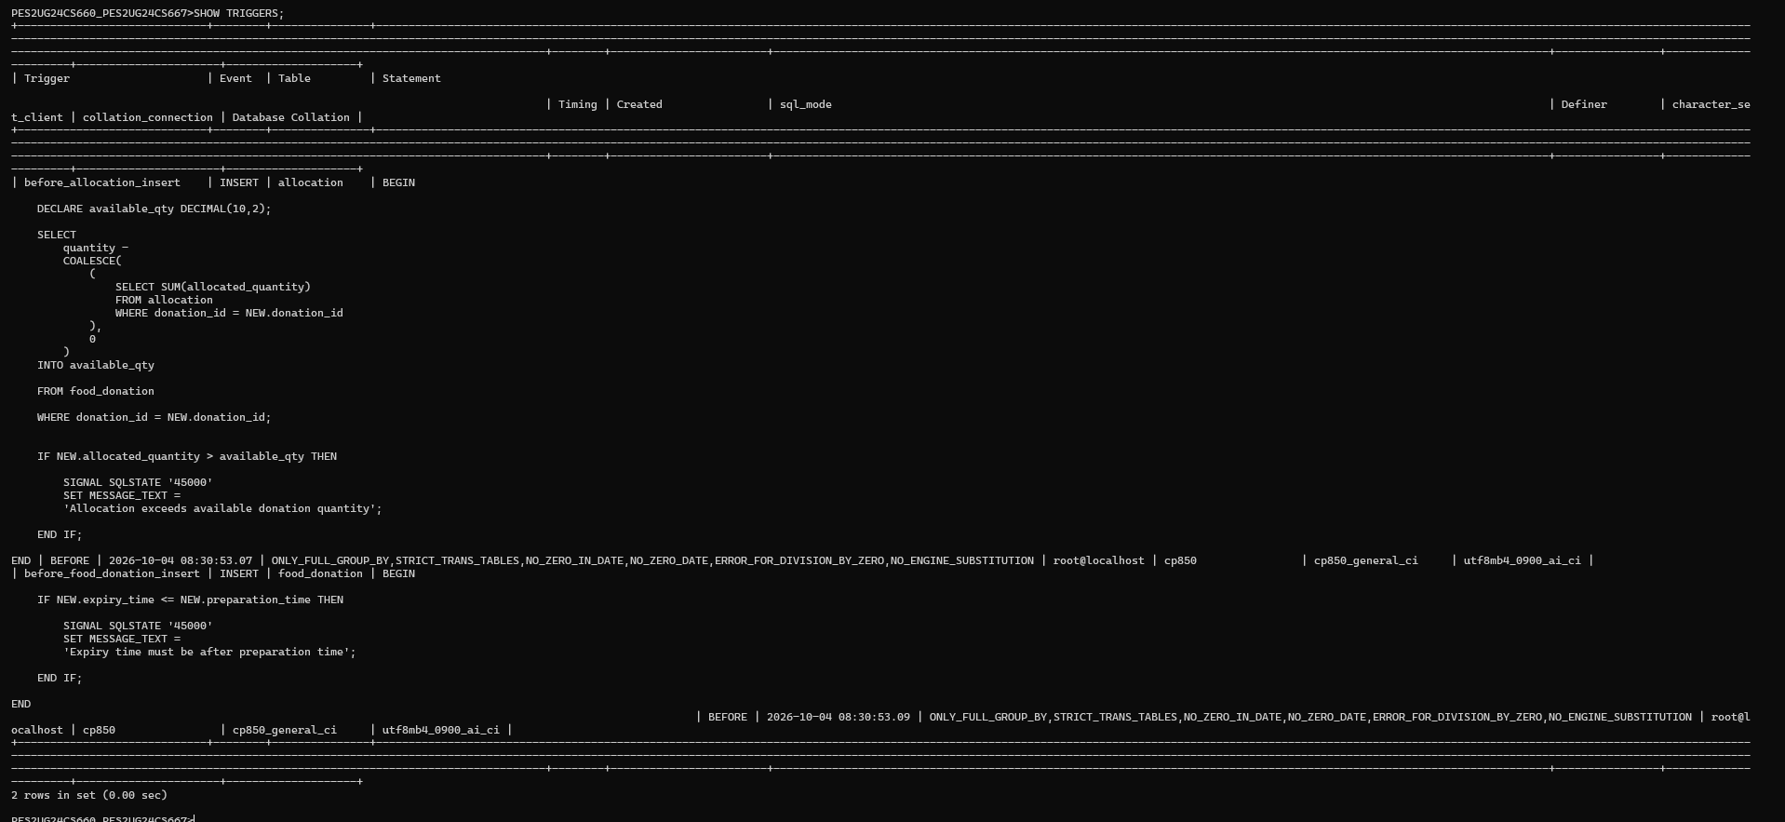
Figure A.73: Screenshot evidence reproduced from the EcoFoodSync source project document.
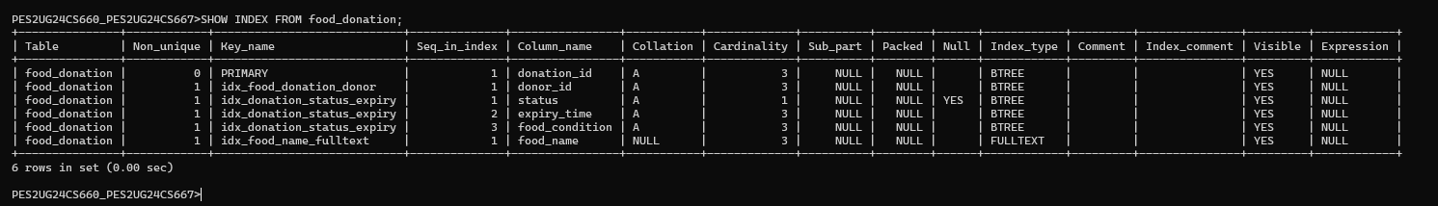
Figure A.74: Screenshot evidence reproduced from the EcoFoodSync source project document.
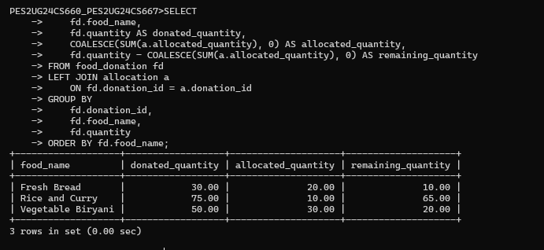
Figure A.75: Screenshot evidence reproduced from the EcoFoodSync source project document.
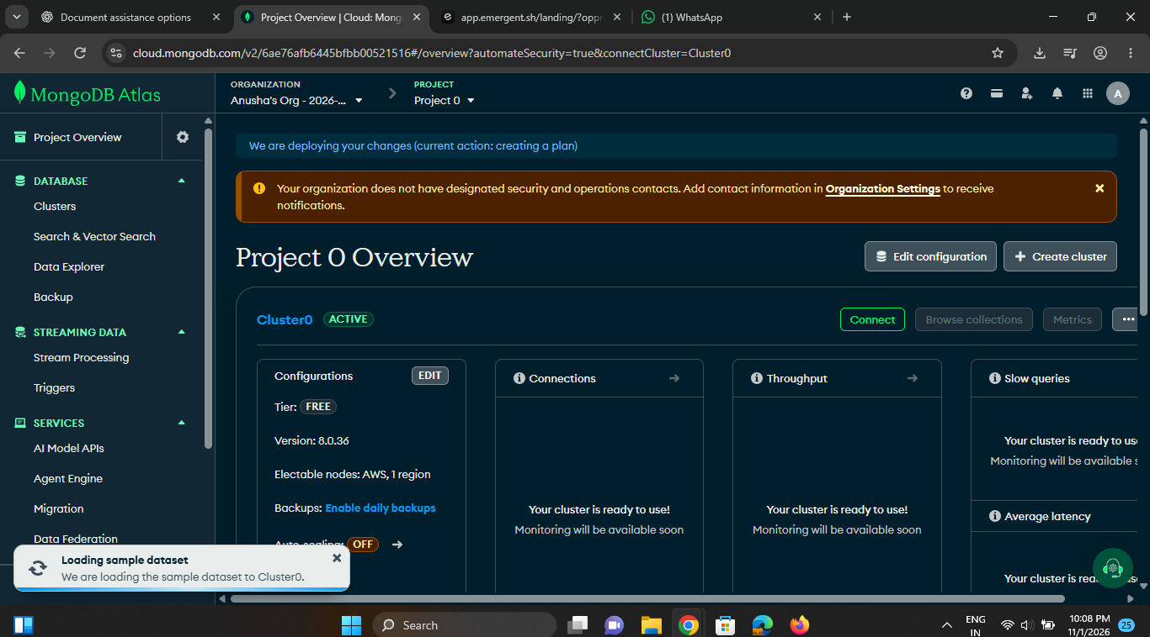
Figure A.76: Screenshot evidence reproduced from the EcoFoodSync source project document.
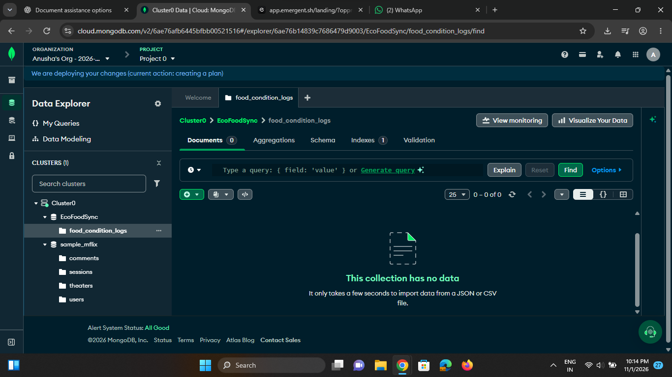
Figure A.77: Screenshot evidence reproduced from the EcoFoodSync source project document.
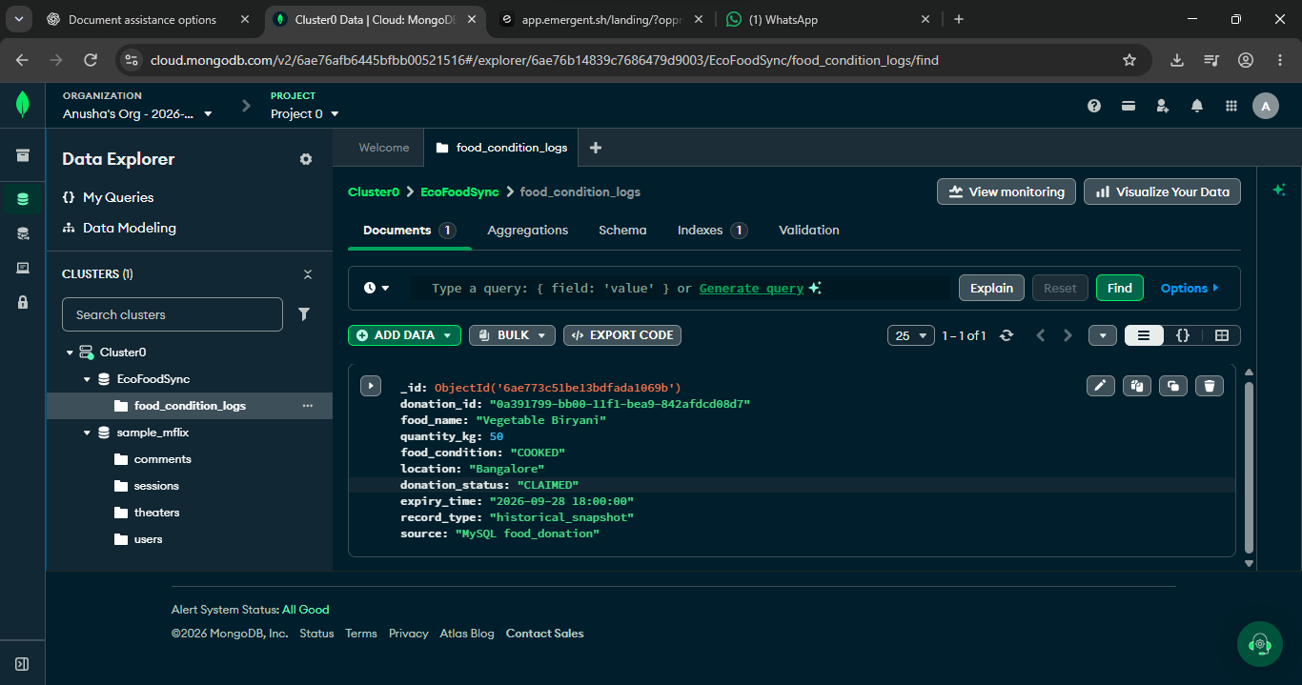
Figure A.78: Screenshot evidence reproduced from the EcoFoodSync source project document.
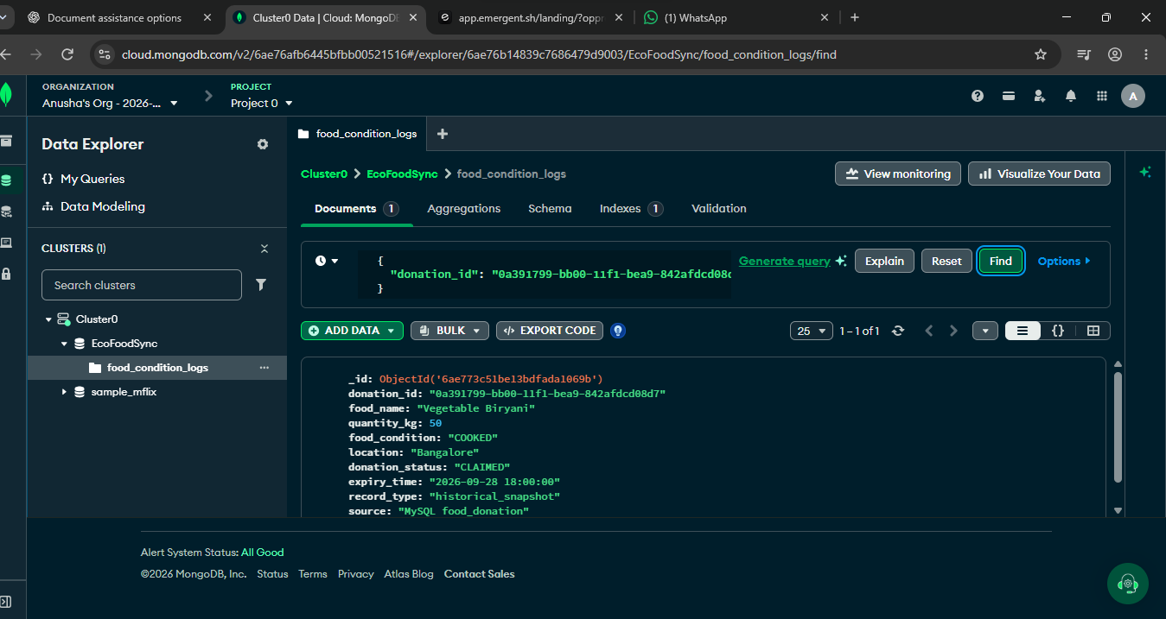
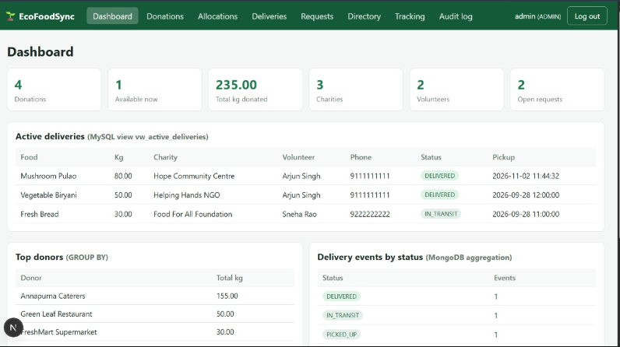
ADMIN WHEN LOGGED IN
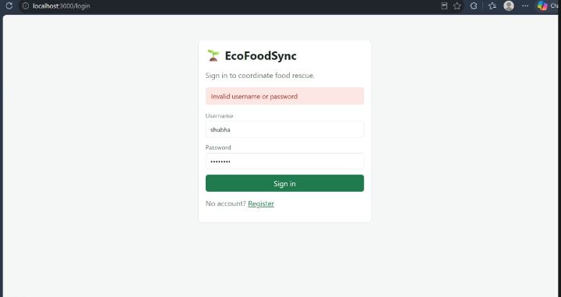
INVALID PASSWORD CASE

GIT HUB LINK : https://github.com/shubhar-tech/EcoFoodSync

