**Student Name : Shubharthak Sangharsha**

**UID : 20BCS6872**

**Subject : Institutional Training**

**Q1:-**

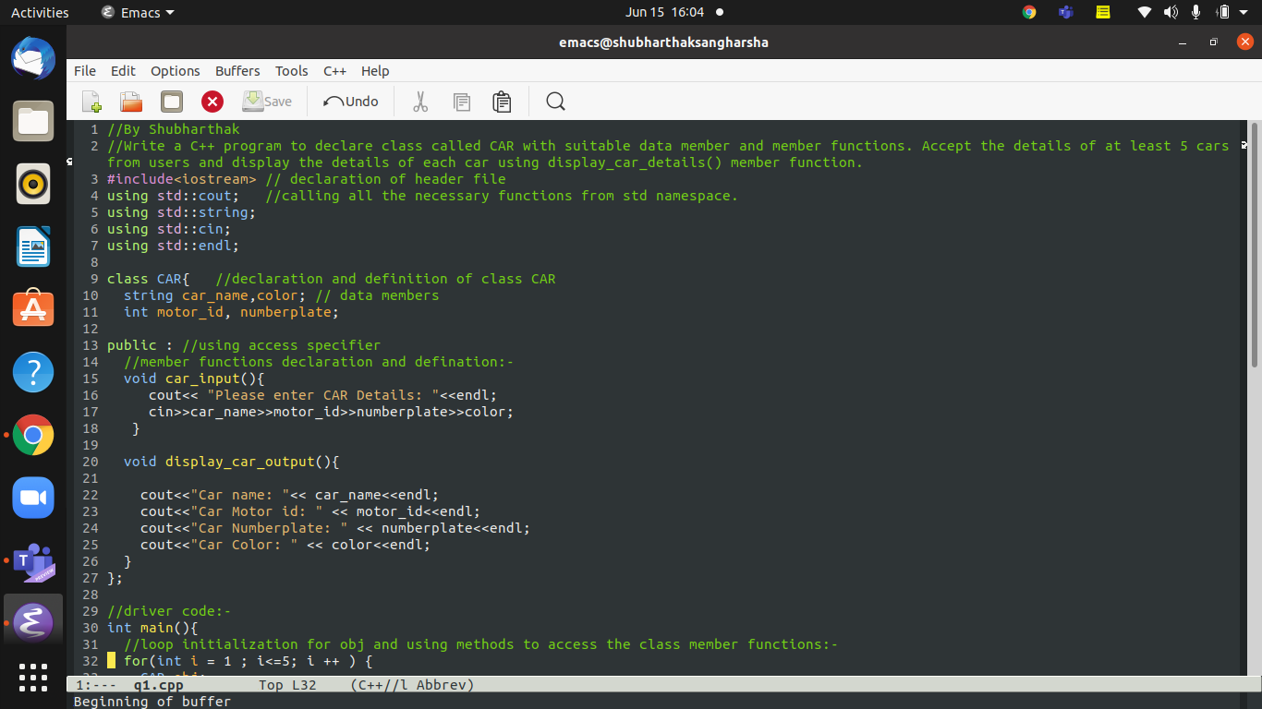

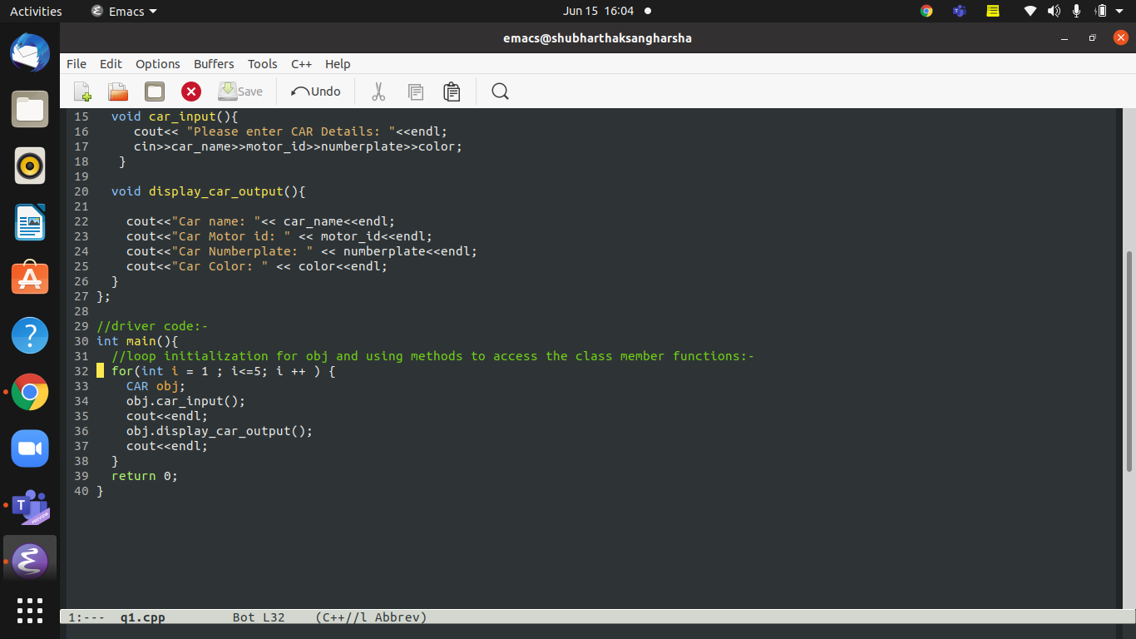

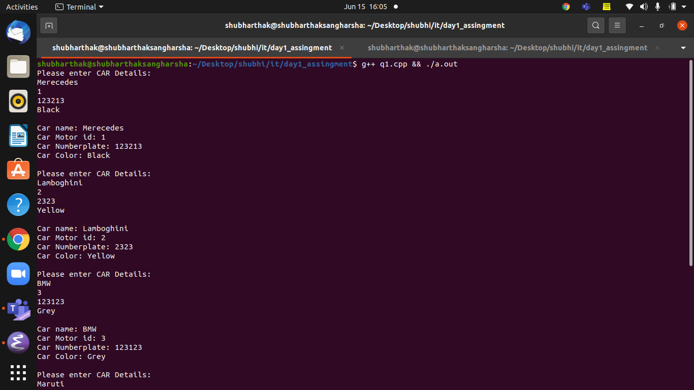

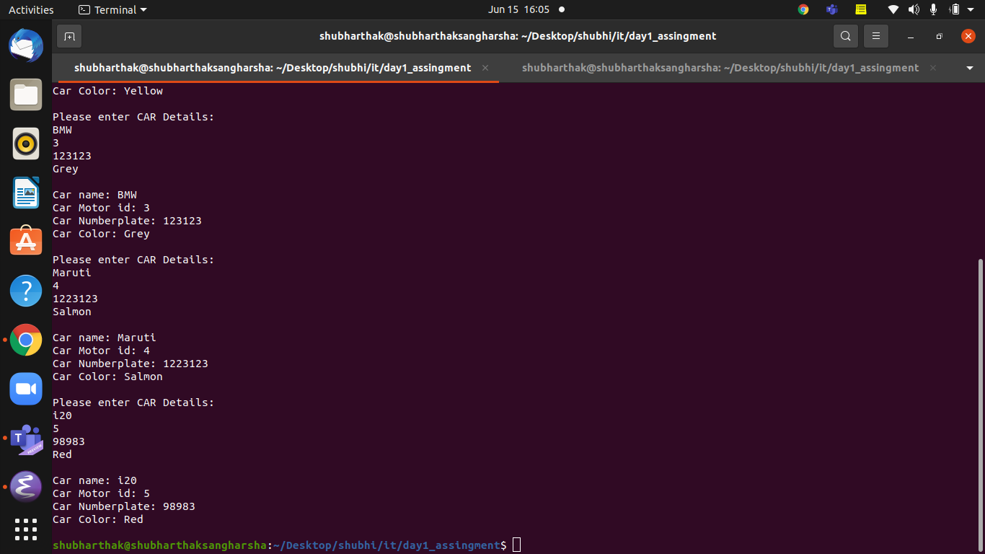

Q2: Output will be **1**. The output is one byte because Empty class should have some size to call the function.

Q3: **8 4**

The (Test * ) will print 4 bytes as pointer size is allocated as 4 bytes as per the assumptions.

While the object size will be of 8 bytes because static int x doesn’t accompile the size .

**Q4:**

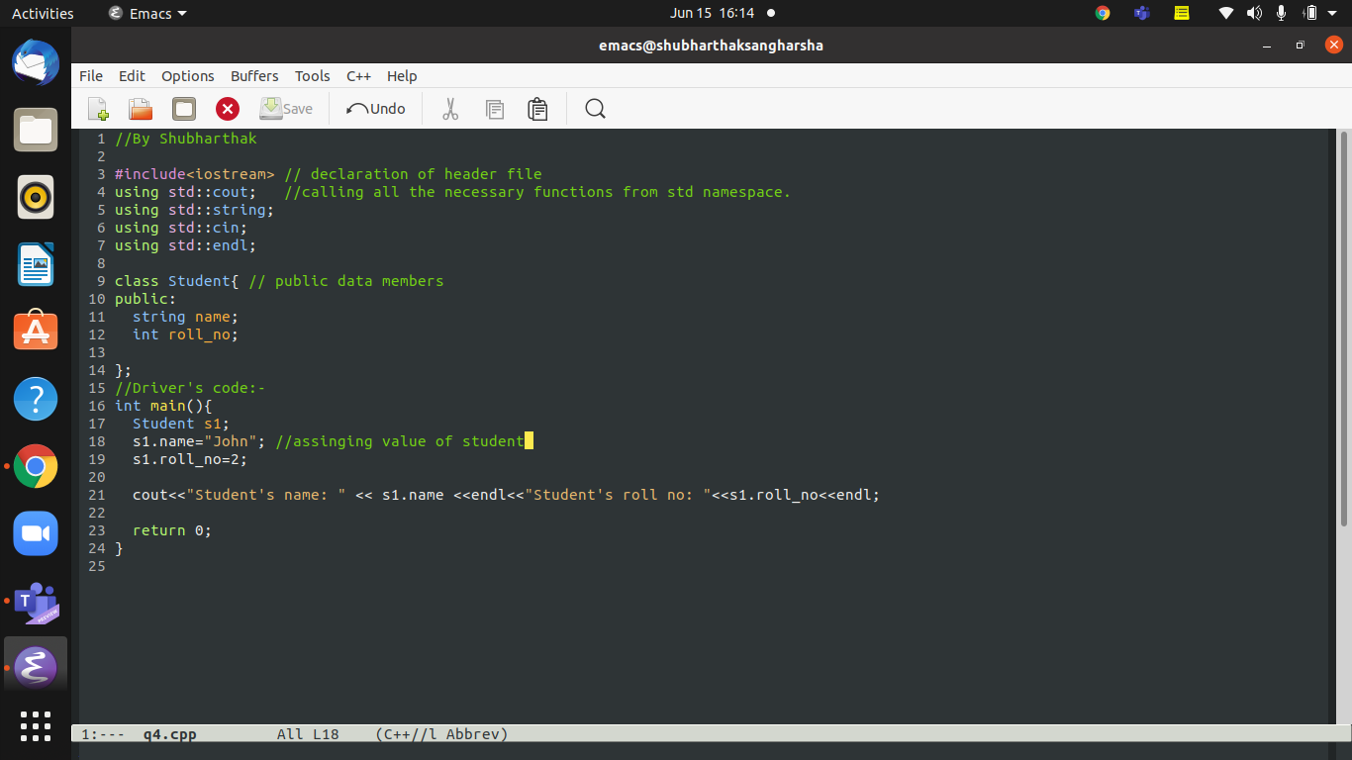

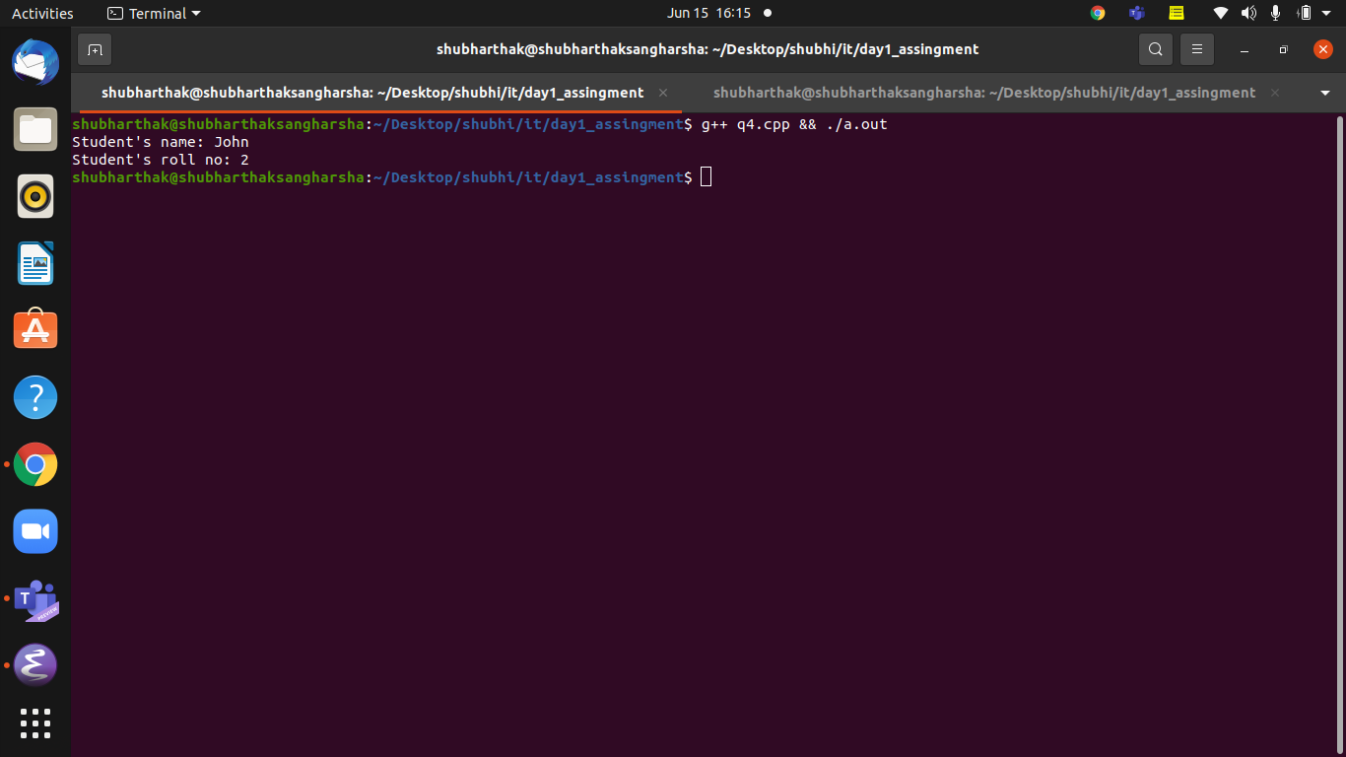

**Q5:-**

