Institutional Training

June-July, 2021

**Department of AIT-CSE**

**Daily Worksheet - Day-2**

**Constructor and Destructor Worksheet**

**Name -Shubharthak Sangharsha Section-AIML-4-C**

**UID- 20BCS6880**

**Date-17-6-21 Group-B**

**Que1:** Write a C++ program that will display if a students is pass or not in his exam. (50% or more is pass). If the student is Pass than your program should display which letter the student has obtained. ?? 85% or more E for excellent  
?? 75% or more but less than 85% O for Outstanding  
?? 65% or more but less than 75% G for good  
?? Less than 65% S for satisfactory  
If however the student is Fail (below 50% marks) your program should display: 1  
whether the student should Resit or Redo depending on the following criteria.  
?? 33% or more Resit in exam  
?? Less than 33% Redo course

**CODE** :

//by shubharthak

#include <iostream>

using namespace std;

class grades {

public :

grades(int percent){

if(percent>=50)

{

if(percent>=85)

{

cout<<"E : Excellent work"<<endl;

}

if(percent<85)

{

if(75<=percent)

cout<<"O : Outstanding work"<<endl;

}

if(percent<75)

{

if(65<=percent)

cout<<"G : Good work"<<endl;

}

if(percent<65)

{

cout<<"S: Satisfactory "<<endl;

}

}

else

{

if(percent>=33)

{

cout<<"Resit in exam"<<endl;

}

else

{

cout<<"Redo course"<<endl;

}

}

}

};

int main()

{

int percent, n;

cout<<"Please enter number of students: " ;

cin>>n;

for(int i = 0 ; i <n ; i++ ) {

cout<<"Enter students percentage: ";

cin>>percent;

grades obj1=percent;

}

return 0;

}

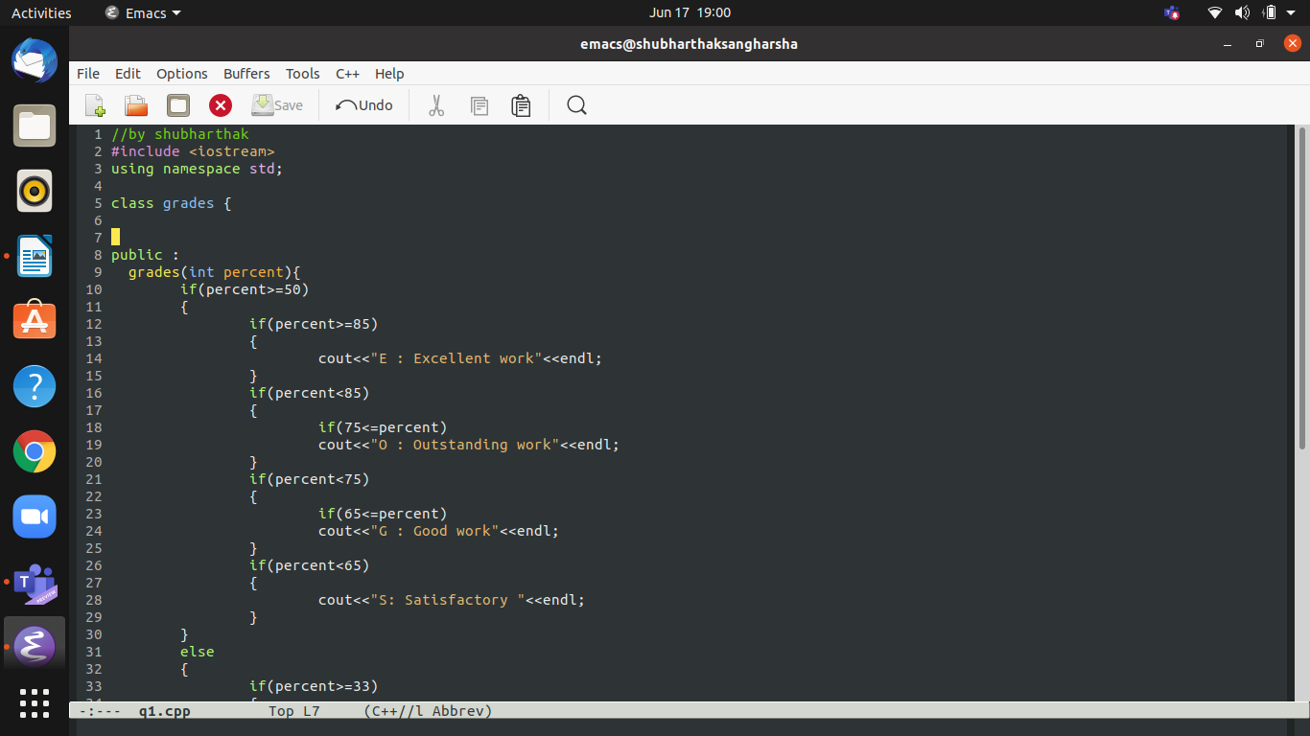

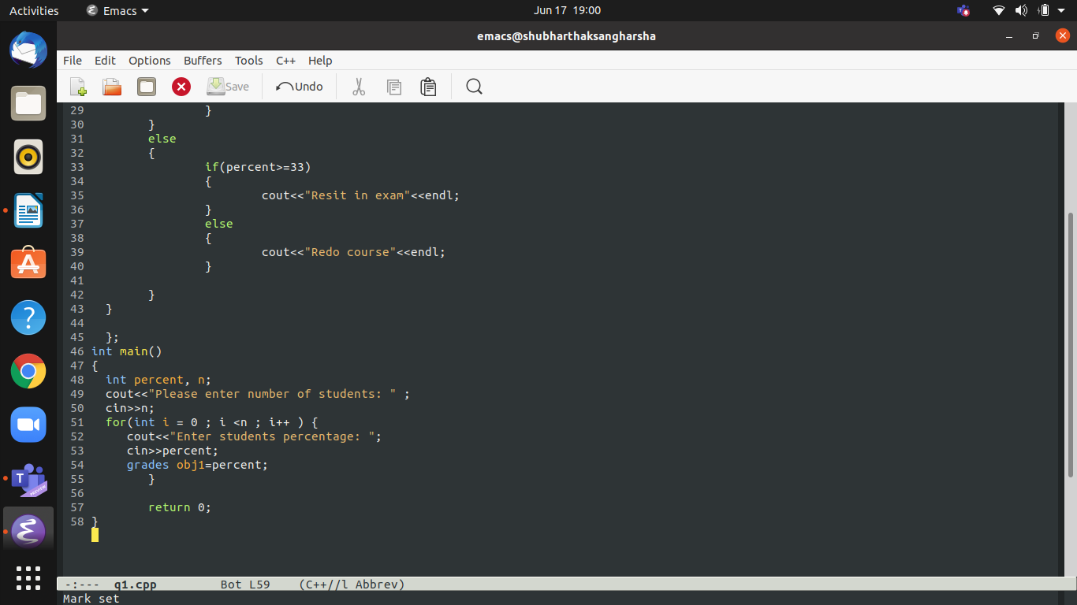

**Output :**

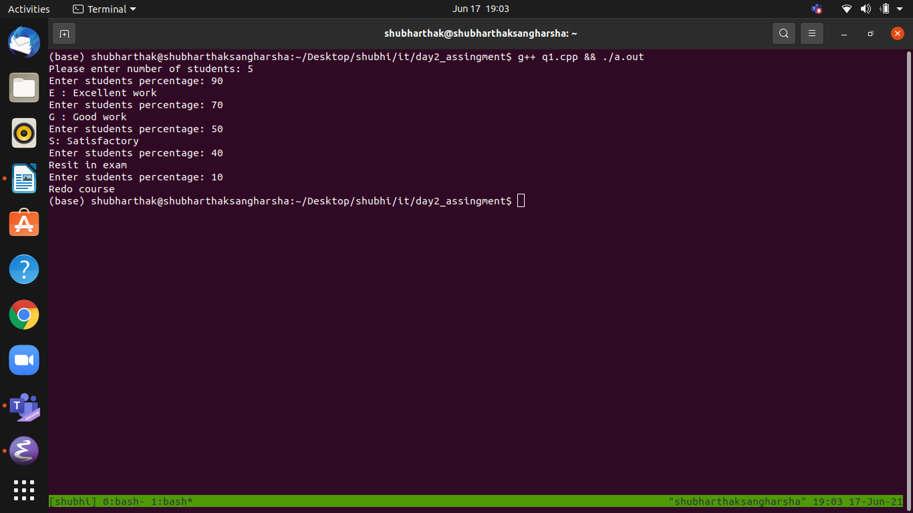

**Que2:** Write a C++ program in which user enter his NTS and F.Sc marks and your program will help student in selection of university. Based on these marks Student will be allocated a seat at different department of different university University Name Departments Criteria Oxford University IT Above 70% in Fsc. and 70 % in NTS Electronics Engr: Above 70% in Fsc. and 60 % in NTS Telecommunication Above 70% in Fsc. and 50 % in NTS MIT IT 70% -60 % in Fsc. and 50 % in NTS Chemical Engr: 59% – 50 % in Fsc. and 50 % in NTS Computer Engr: Above 40% and below 50 % in Fsc. And 50 % in NTS

**Note:** Use Nested if structure to solve the problem. Don’t use logical operators. Violation of this condition will result in zero marks.

**CODE :**

//by shubharthak

#include<iostream>

using namespace std;

class scores{

public:

scores(int fsc, int nts){

if(fsc>70)

{

if(nts>=70)

{

cout<<"\nYou have secured your seat in IT Department in oxford University";

}

else if(nts>=60)

{

cout<<"\n You have secured your seat in electronics Department in oxford University";

}

else if(nts>=50)

{

cout<<"\n You have secured your seat in tele comm. Department in oxford University.";

}

}

else if(fsc<=70)

{

if(fsc>=60)

{

if(nts>=50)

{

cout<<"\n You have secured your seat in IT Department in MIT University";

}

}

else if(fsc<=59)

{

if(fsc>=50)

{

if(nts>=50)

{

cout<<"\n You have secured your seat in chemical Eng. Department in MIT University";

}

}

}

else if(fsc<50)

{

if(fsc>40)

{

if(nts>=50)

{

cout<<" You have secured your seat in Computer Engr Department in MIT University";

}

}

}

}

else

{

cout<<"Invalid Details";

}

}

};

int main()

{

int n,fsc,nts;

cout<<"Enter number of students: " ;

cin>>n;

for(int i = 0 ; i< n ; i++ ) {

cout<<"Enter Your Fsc SCORE : ";

cin>>fsc;

cout<<"Enter Your NTS SCORE : ";

cin>>nts;

scores obj1(fsc,nts);

cout<<endl;

}

return 0;

}

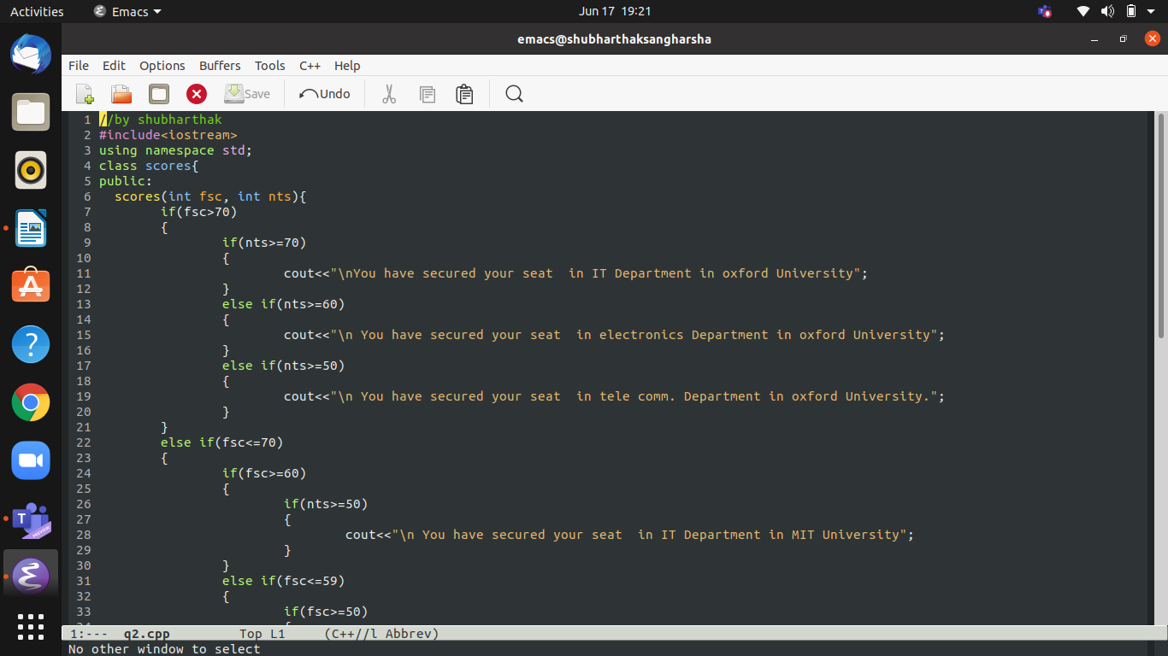

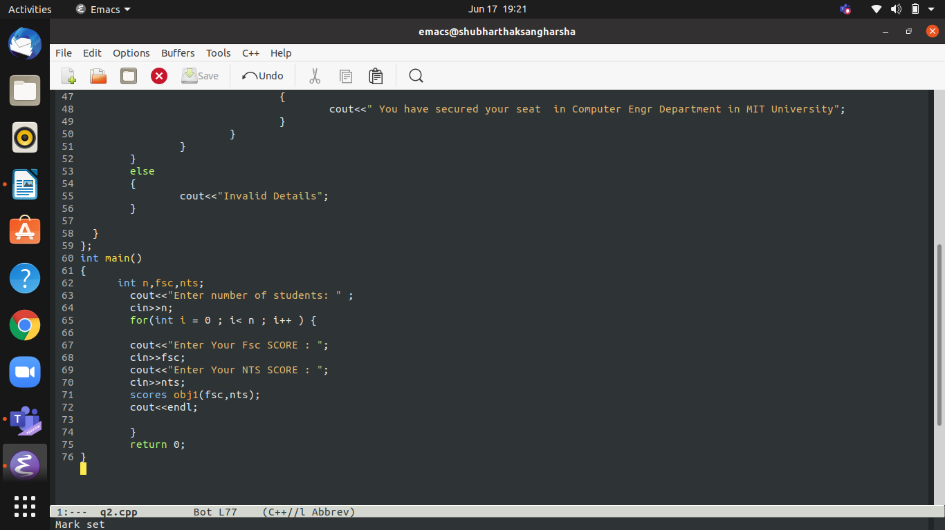

**OUTPUT**

