**Code:-**

//By Shubharthak

#include<iostream>

#include<vector>

using namespace std ;

//aglorithim

int algo(std::vector<int>ivec){ //function declaration and defination

int max = 0; //creating temp variable to store the value

for(int i= 0; i< ivec.size()-1; i++){

for(int j= i+1; j<ivec.size(); j++){

if((ivec[i]*ivec[j]) > max)

max = ivec[i] * ivec[j];

}

}

return max;

}

//Driver Code:-

int main(){

//varibale declarations

int c;

cin>>c; //for taking number of input values

vector<int>ivec(c); //creating vector for adding numbers

for(int i= 0; i< ivec.size(); i++){ //input numbers

cin>>ivec[i];

}

cout<<algo(ivec)<<endl; //result

return 0;

}

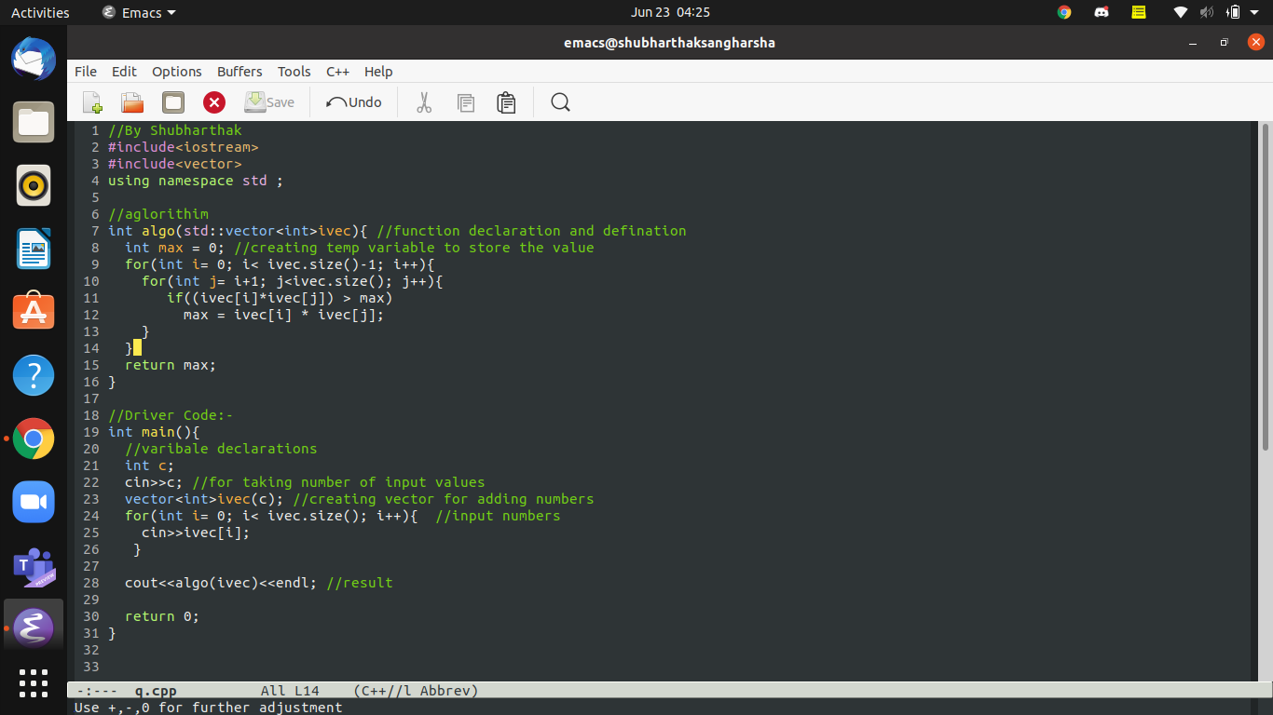

**OUTPUT:-**

