Institutional Training

June-July, 2021

**Department of AIT-CSE**

**Daily Worksheet - Day-4**

**Type conversion and File Handling - Worksheet**

**Que1:** If a scientists knows the wavelength of an electromagnetic wave, he or she can determine what type of radiation it is.  Write a program that asks for the wavelength of an electromagnetic wave in meters and then displays what the wave is according to the chart below.  (For example, a wave with a wavelength of 1E-10 meters would be an X-ray.

**CODE:**

//By Shubharthak

#include<iostream>

using namespace std;

class WaveType{

double wavelength;

public:

void input(){

cout<<"The program determines the type of electromagnetic wave\n";

cout<<"Please enter the wavelength in meters of an electromagnetic wave: ";

cin>>wavelength;

}

void display(){

if(wavelength <=1e-11)

cout<<"Gamma Ray Radiation Type \n";

else if(wavelength <=1e-8)

cout<<"X-Ray Radiation Type \n";

else if(wavelength <=4e-7)

cout<<"Ultraviolet Radiation Type \n";

else if(wavelength <=7e-7)

cout<<"Visible Light Radiation Type \n";

else if(wavelength <=1e-3)

cout<<"Infrared Radiation Type \n";

else if(wavelength <= 1e-2)

cout<<"Microwave Radiation Type \n";

else

cout<<"Radio Wave Radiatation Type \n";

}

};

int main(){

WaveType obj;

obj.input();

obj.display();

return 0;

}

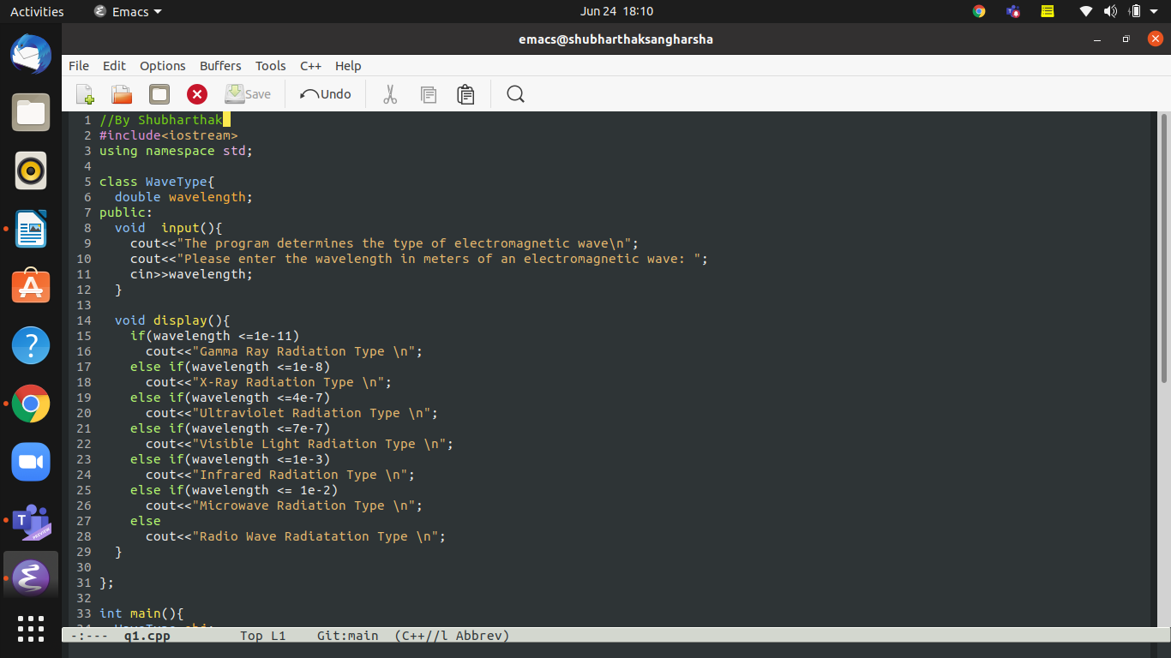

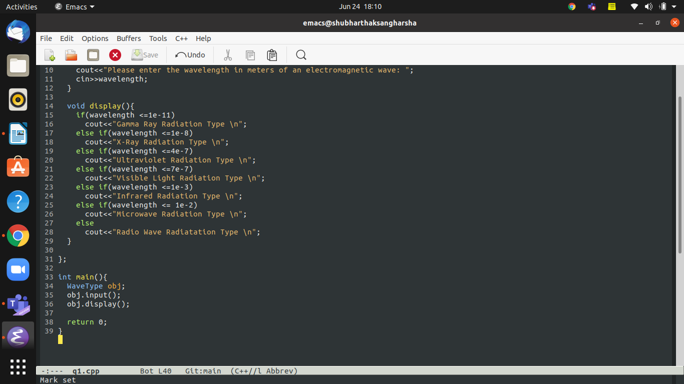

**OUTPUT:-**

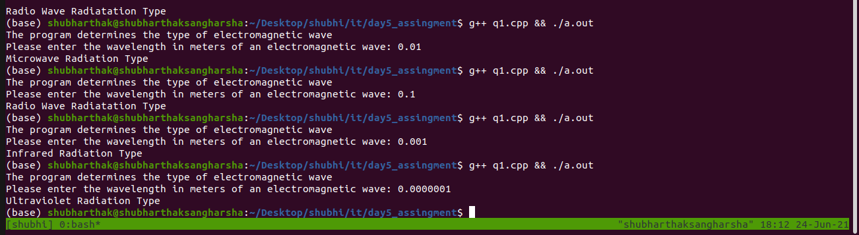

**Que2:** Write a program that calculates and displays a person’s body mass index (BMI).  The

BMI is often used to determine whether a person with sedentary lifestyle is overweight

or underweight for his or her height.  A person’s BMI is calculated with the

following formula:

BMI = weight * 703/height^2

where weight is measured in pounds and height is measured in inches.  The program

should display a message indicating whether the person has optimal weight, is

underweight, or is overweight.  A sedentary person’s weight is considered to be optimal

if his or her BMI is between 18.5 and 25.  If the BMI is less than 18.5, the person is

considered to be underweight.  If the BMI value is greater than 25, the person is

considered to be overweight.

**CODE:-**

//By Shubharthak

#include<iostream>

#include<math.h>

using namespace std;

class Calculate_BMI{

double bmi,height,weight;

public:

void input(){

cout << "Enter weight(in pounds): " << endl;

cin >> weight;

cout << "Enter height(in inches): " << endl;

cin >> height;

}

void compute(){

bmi = weight * (703/ pow(height,2));

}

void display(){

if (bmi >= 18.5 && bmi <= 25)

cout << "Weight optimal." << endl;

else if (bmi >= 0 && bmi <= 18.5)

cout << "Weight underweight." << endl;

else if (bmi >= 25)

cout << "Weight overweight." << endl;

}

};

int main(){

Calculate_BMI obj;

obj.input();

obj.compute();

obj.display();

return 0;

}

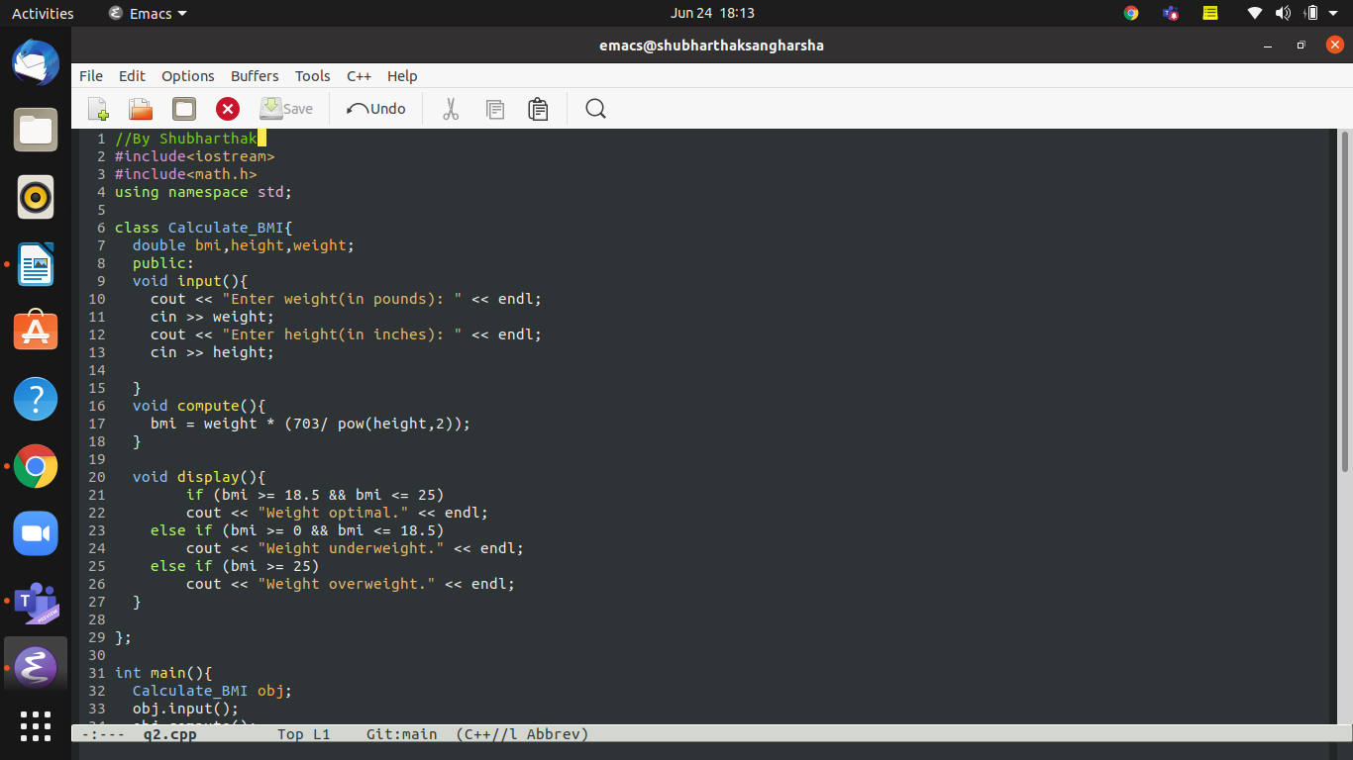

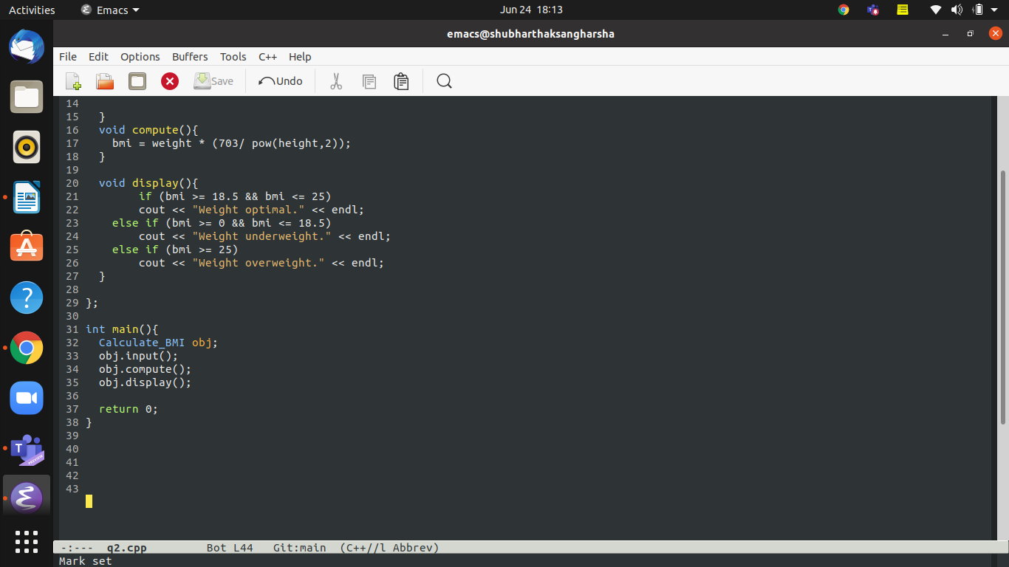

**OUTPUT:-**

