Annotated PTP Dataset
EDA Visual Report
CreditNirvana PS1 • annotated_ptp_sample.csv
Purpose: document the completed exploratory analysis of the annotation/ground-truth dataset and explain what each visualization tells us for the Real-Time Fake PTP Detection problem.

Executive Summary
The dataset contains 200 annotated PTP records across six PTP categories. All 200 PTP IDs are unique, and the completed data-quality checks found no missing or empty values, duplicate records, unexpected category values, or leading/trailing whitespace. The analysis also shows that annotation confidence is not uniform across PTP types, so low-confidence examples should be treated as candidates for manual label review.

1. PTP Type Distribution
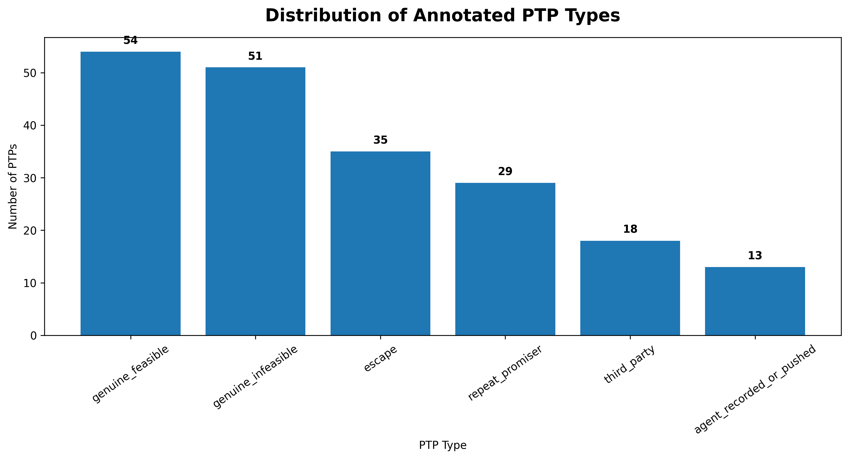
What the graph shows: The graph shows the number of annotated PTPs in each of the six ground-truth categories.
What we learn: genuine_feasible is the largest class with 54 records (27.0%), followed by genuine_infeasible with 51 (25.5%). escape has 35 (17.5%), repeat_promiser has 29 (14.5%), third_party has 18 (9.0%), and agent_recorded_or_pushed is the smallest class with 13 (6.5%). Therefore, the label distribution is imbalanced, with the two smallest classes having relatively few examples.
ML implication: When this annotation table is joined to the real PTP/call dataset, model evaluation should not rely only on overall accuracy. Per-class precision, recall, F1, confusion matrices and calibration should be examined, especially for minority classes.

2. PTP Type Percentage Distribution
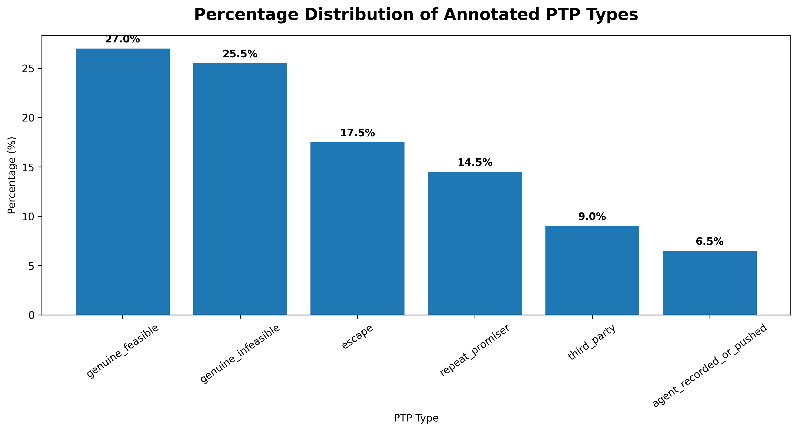
What the graph shows: The same class distribution expressed as percentages, making the relative share of every label directly comparable.
What we learn: The six categories are not equally represented. genuine_feasible and genuine_infeasible together account for 52.5% of all annotations, while third_party and agent_recorded_or_pushed together account for only 15.5%.
ML implication: The eventual training pipeline should preserve minority-class visibility. Stratified splitting and class-aware evaluation are appropriate; synthetic balancing or class weights should only be introduced after inspecting the actual feature dataset and validation behaviour.

3. Annotator Confidence Distribution
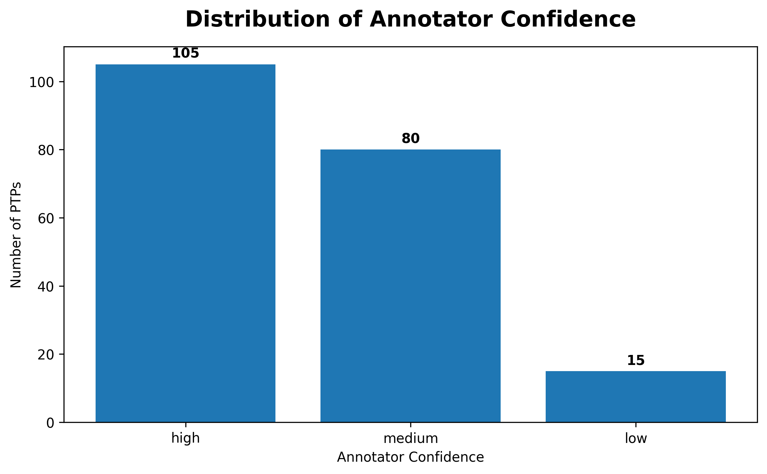
What the graph shows: The graph summarizes how confident annotators were when assigning the labels.
What we learn: 105 annotations (52.5%) have high confidence, 80 (40.0%) have medium confidence, and 15 (7.5%) have low confidence. Thus 92.5% of the annotations are high or medium confidence, while a smaller 7.5% are explicitly uncertain.
ML implication: Confidence is useful as label-quality metadata. Low-confidence records should be prioritized for manual review before they are treated as equally reliable ground truth.

4. PTP Type × Annotator Confidence
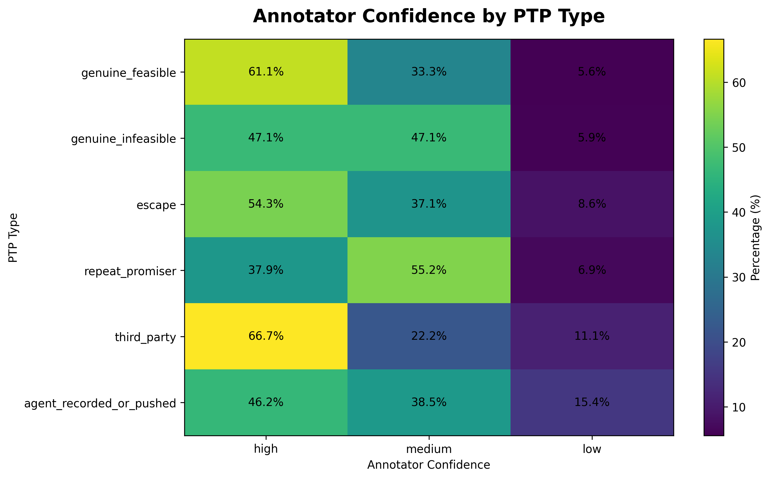
What the graph shows: Each row is a PTP type and each cell shows the percentage of that type that received high, medium, or low annotator confidence.
What we learn: Confidence varies by class. For example, genuine_feasible has 61.1% high-confidence labels, while agent_recorded_or_pushed has 46.2% high-confidence labels and 15.4% low-confidence labels. third_party has the highest low-confidence share among the other classes at 11.1%. This indicates that some categories are harder to distinguish consistently.
ML implication: The annotation process itself may have class-dependent ambiguity. These uncertain classes deserve review and may require clearer labeling rules or additional examples.

5. Low-Confidence Annotation Rate by PTP Type
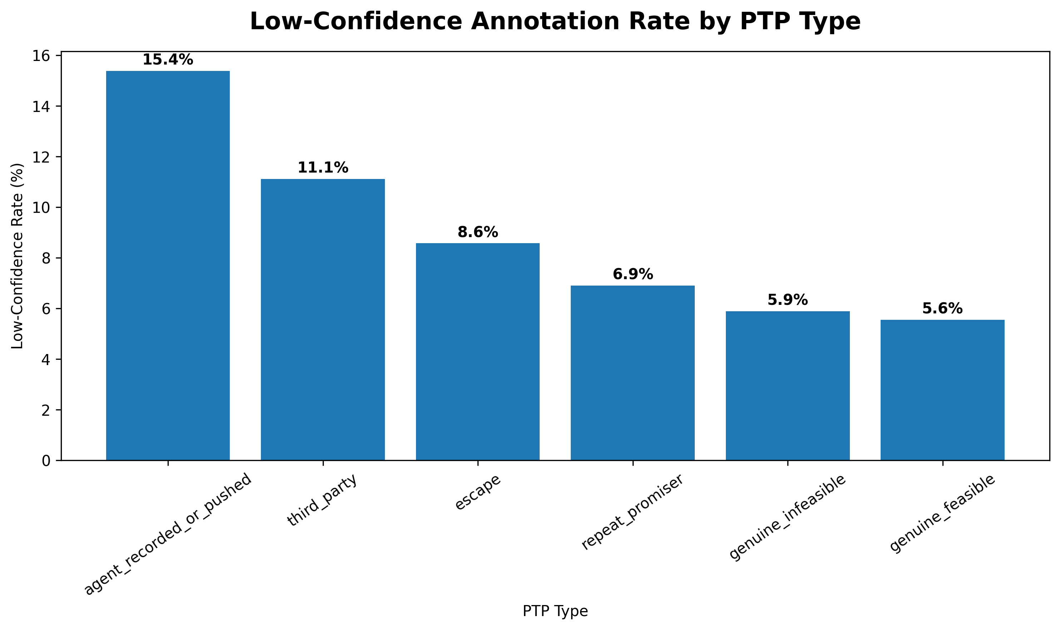
What the graph shows: The percentage of each PTP class whose annotation confidence is explicitly marked low.
What we learn: agent_recorded_or_pushed has the highest low-confidence rate at 15.4%, followed by third_party at 11.1%, escape at 8.6%, repeat_promiser at 6.9%, genuine_infeasible at 5.9%, and genuine_feasible at 5.6%. This identifies where label-review effort can be prioritized.
ML implication: Before model training, review low-confidence samples, particularly in agent_recorded_or_pushed and third_party. Do not automatically discard them without checking the underlying conversations because rare classes can be especially valuable.

Data Quality Checks Completed
- 200 rows and 3 columns.
- 200 unique PTP IDs; no duplicate PTP IDs.
- No duplicate complete rows.
- No missing/null or empty values in the three columns.
- No leading/trailing whitespace detected.
- All PTP type values matched the expected six categories.
- All annotator confidence values matched high, medium, or low.

Important Scope Limitation
This file is an annotation/ground-truth table, not the complete predictive dataset. It does not contain the call transcript, audio signals, payment outcome, account history, PTP amount/date behaviour, or other behavioural evidence needed to build the real-time Fake PTP model. The next modelling stage should join these labels to the corresponding operational PTP/call/account data using ptp_id.

Final Takeaway
The annotation dataset is clean and usable as a ground-truth reference, but it contains class imbalance and class-dependent annotation uncertainty. The most useful next step is to validate low-confidence labels and then join the labels with the richer operational dataset before performing feature engineering and model training.

