CreditNirvana PS1
Post-Call Events EDA
Real-Time Fake PTP Detection | Operational Event Analysis
Exploratory analysis of downstream events associated with captured Promises-to-Pay (PTPs)

1. Executive Summary
The post_call_events dataset captures operational events associated with PTPs after a promise has been recorded. The analysis focuses on event frequency, downstream workflow progression, event timing, event combinations, channel/source differences, and temporal leakage.
This dataset is particularly useful for understanding what happens after a PTP is captured. It can therefore support workflow optimization, outcome analysis, and future label construction.
However, post-call events must be treated carefully in the real-time PS1 model. An event occurring after PTP capture cannot be used as an input feature for a prediction that must be generated during the original call.

2. Dataset Profile
Metric | Value
Total events | 8,466
Unique PTPs represented | 3,304
Event types | 6
PTPs in ptps.csv | 3,696
Missing values | 0
Observed event types include payment-link activity, WhatsApp confirmation activity, confirmation responses, and inbound customer calls.

3. Key Findings
- The dataset contains 8,466 post-call events across 3,304 unique PTPs.
- WhatsApp confirmation and payment-link workflows form a major part of the observed downstream process.
- Not every PTP reaches the same downstream event stages, creating useful funnel and workflow segmentation.
- Event ordering and time gaps reveal how quickly the post-call workflow progresses.
- Different event combinations indicate distinct customer engagement patterns after a PTP.
- Channel, source, and promised-amount segmentation can reveal operational differences that should be considered during model development.
- Confirmation replies indicate customer interaction with the workflow, but they should not automatically be treated as proof that payment was actually made.

4. Important Visual EDA

4.1 Event Type Distribution
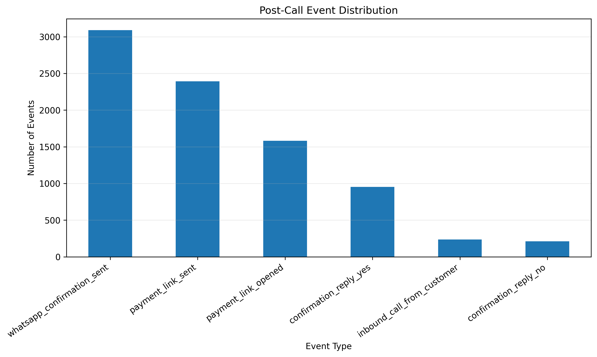
What the graph shows: The graph shows how the 8,466 observed events are distributed across the six event types.
What we learn: The post-call workflow is not evenly distributed. Certain operational actions occur substantially more frequently than others.
PS1 / ML implication: Event frequency can help prioritize workflow instrumentation and identify which downstream signals are sufficiently common to be useful for analysis.

4.2 Unique PTP Coverage by Event Type
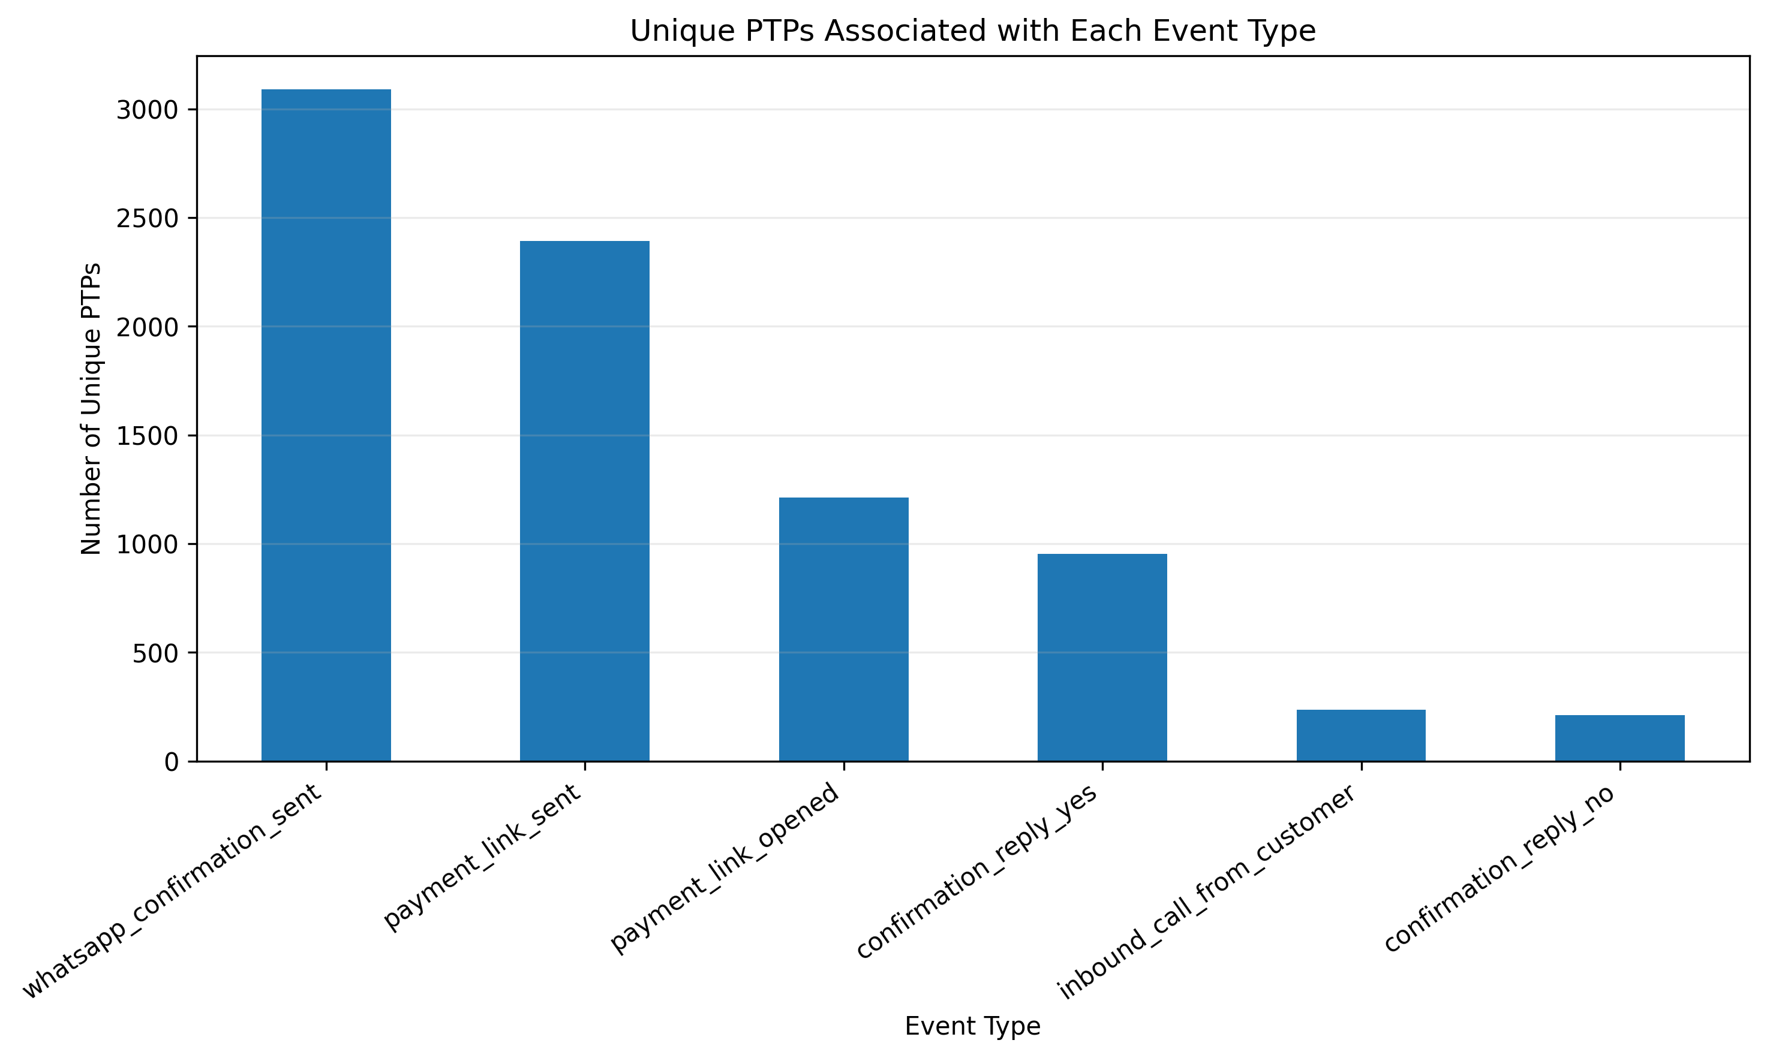
What the graph shows: This graph measures how many distinct PTPs reach each event type rather than simply counting event occurrences.
What we learn: It distinguishes widespread workflow stages from events that occur only for a smaller subset of PTPs.
PS1 / ML implication: Coverage is important when selecting downstream signals. Rare events may be useful as high-information signals but may not be suitable as universal features.

4.3 Daily Event Volume
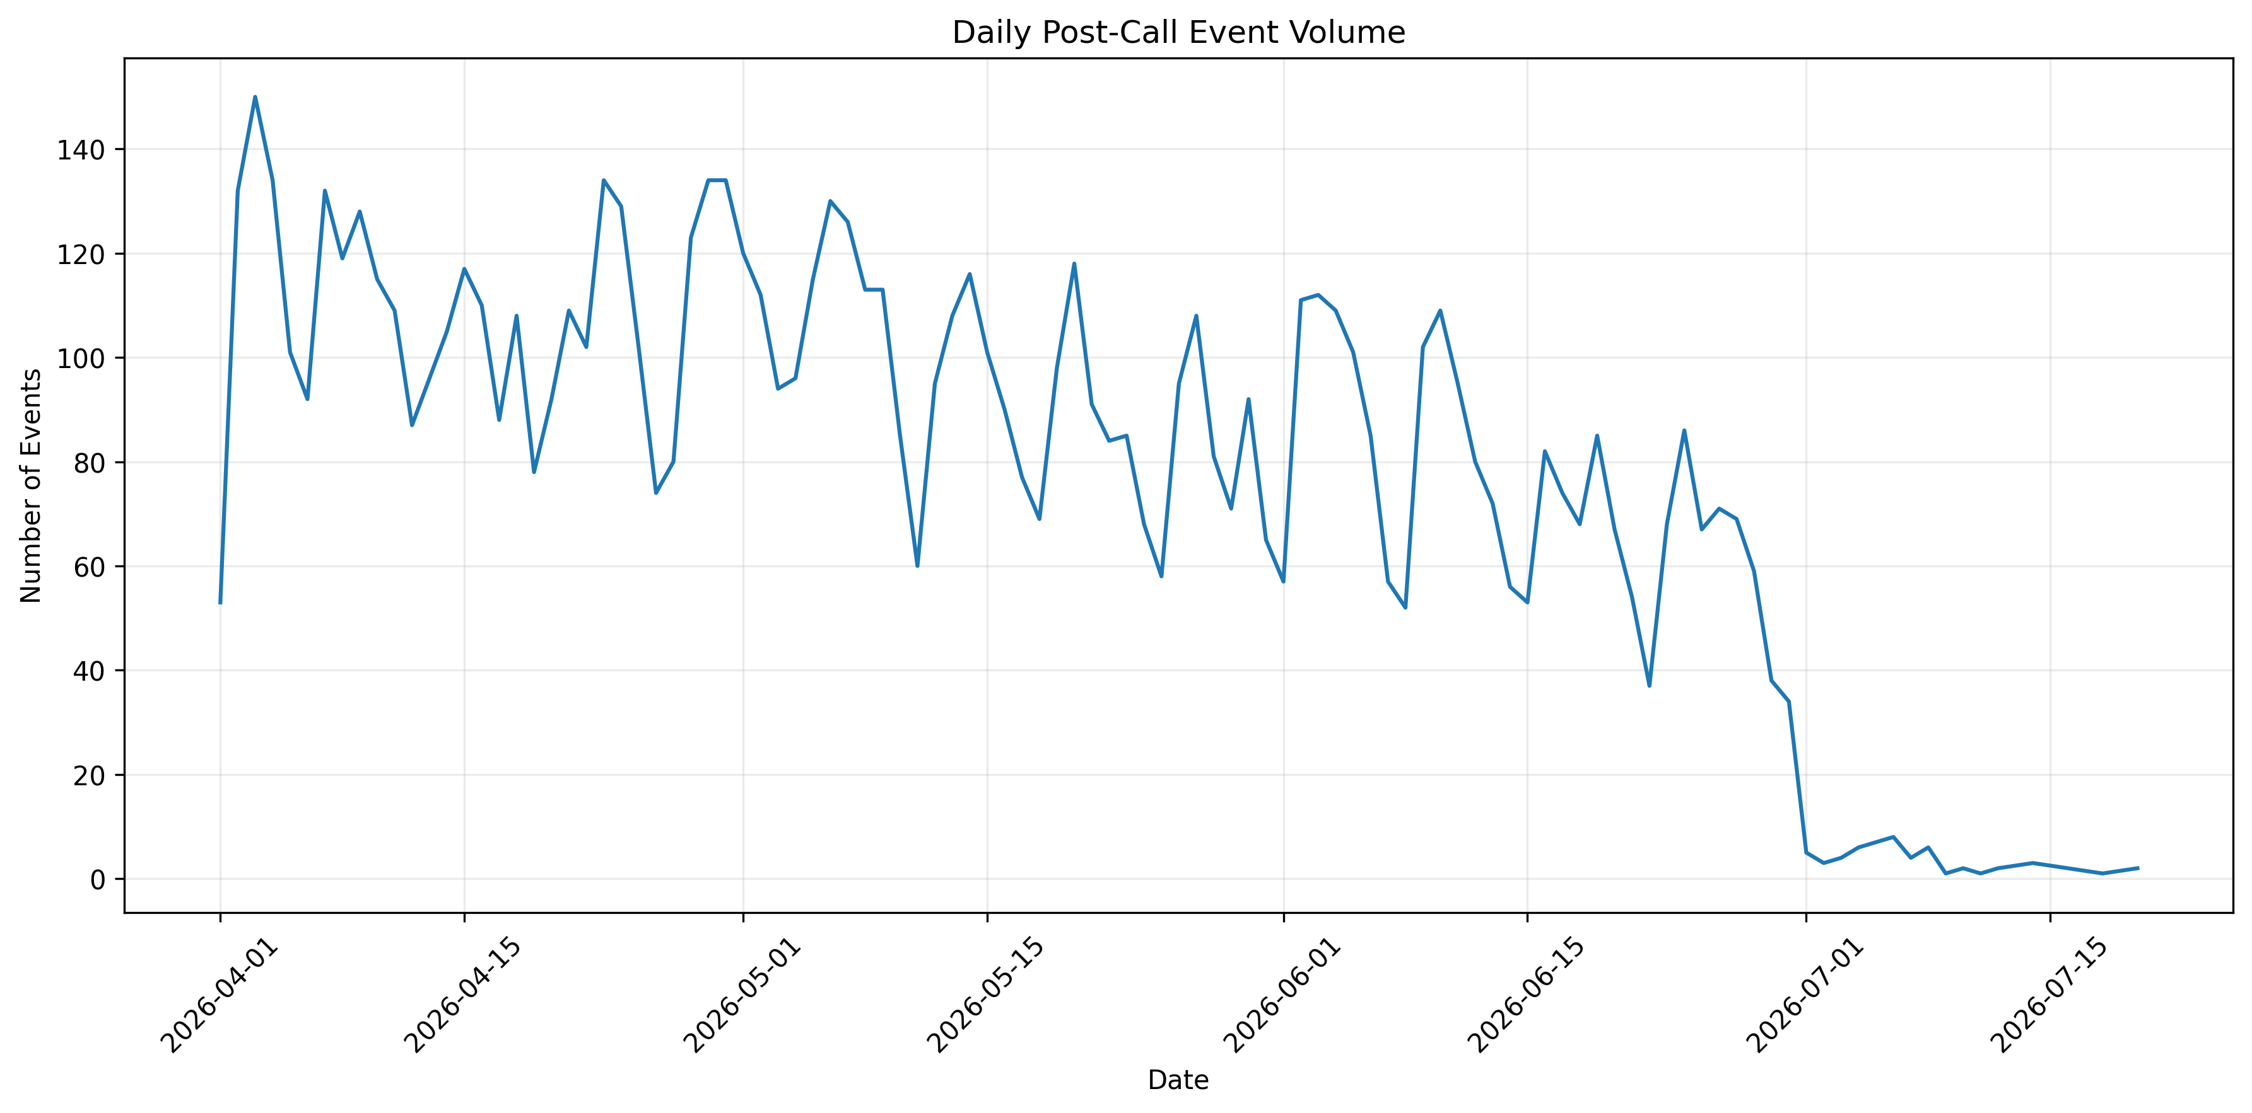
What the graph shows: The graph shows how post-call event activity changes over time.
What we learn: Temporal variation can indicate campaign cycles, operational patterns, or changes in workflow usage.
PS1 / ML implication: Time-based variation should be checked during model validation to prevent random train-test splitting from hiding temporal drift.

4.4 Event Volume by Hour
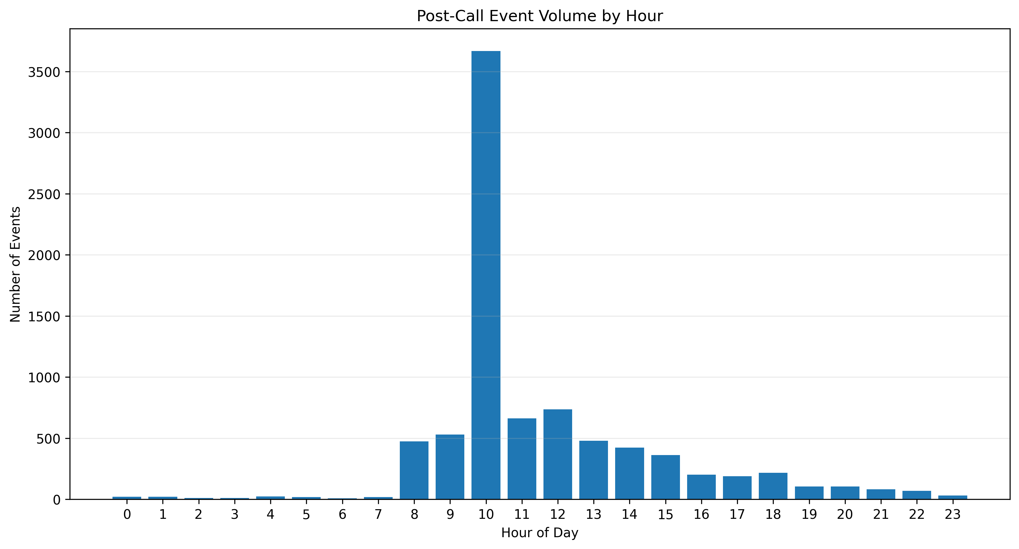
What the graph shows: This graph shows when downstream events are generated during the day.
What we learn: Operational event activity is time-dependent rather than uniform throughout the day.
PS1 / ML implication: Hour-of-day can be useful for operational planning and workflow analysis, but only information available at the prediction timestamp should enter the live model.

4.5 Event Sequence Position
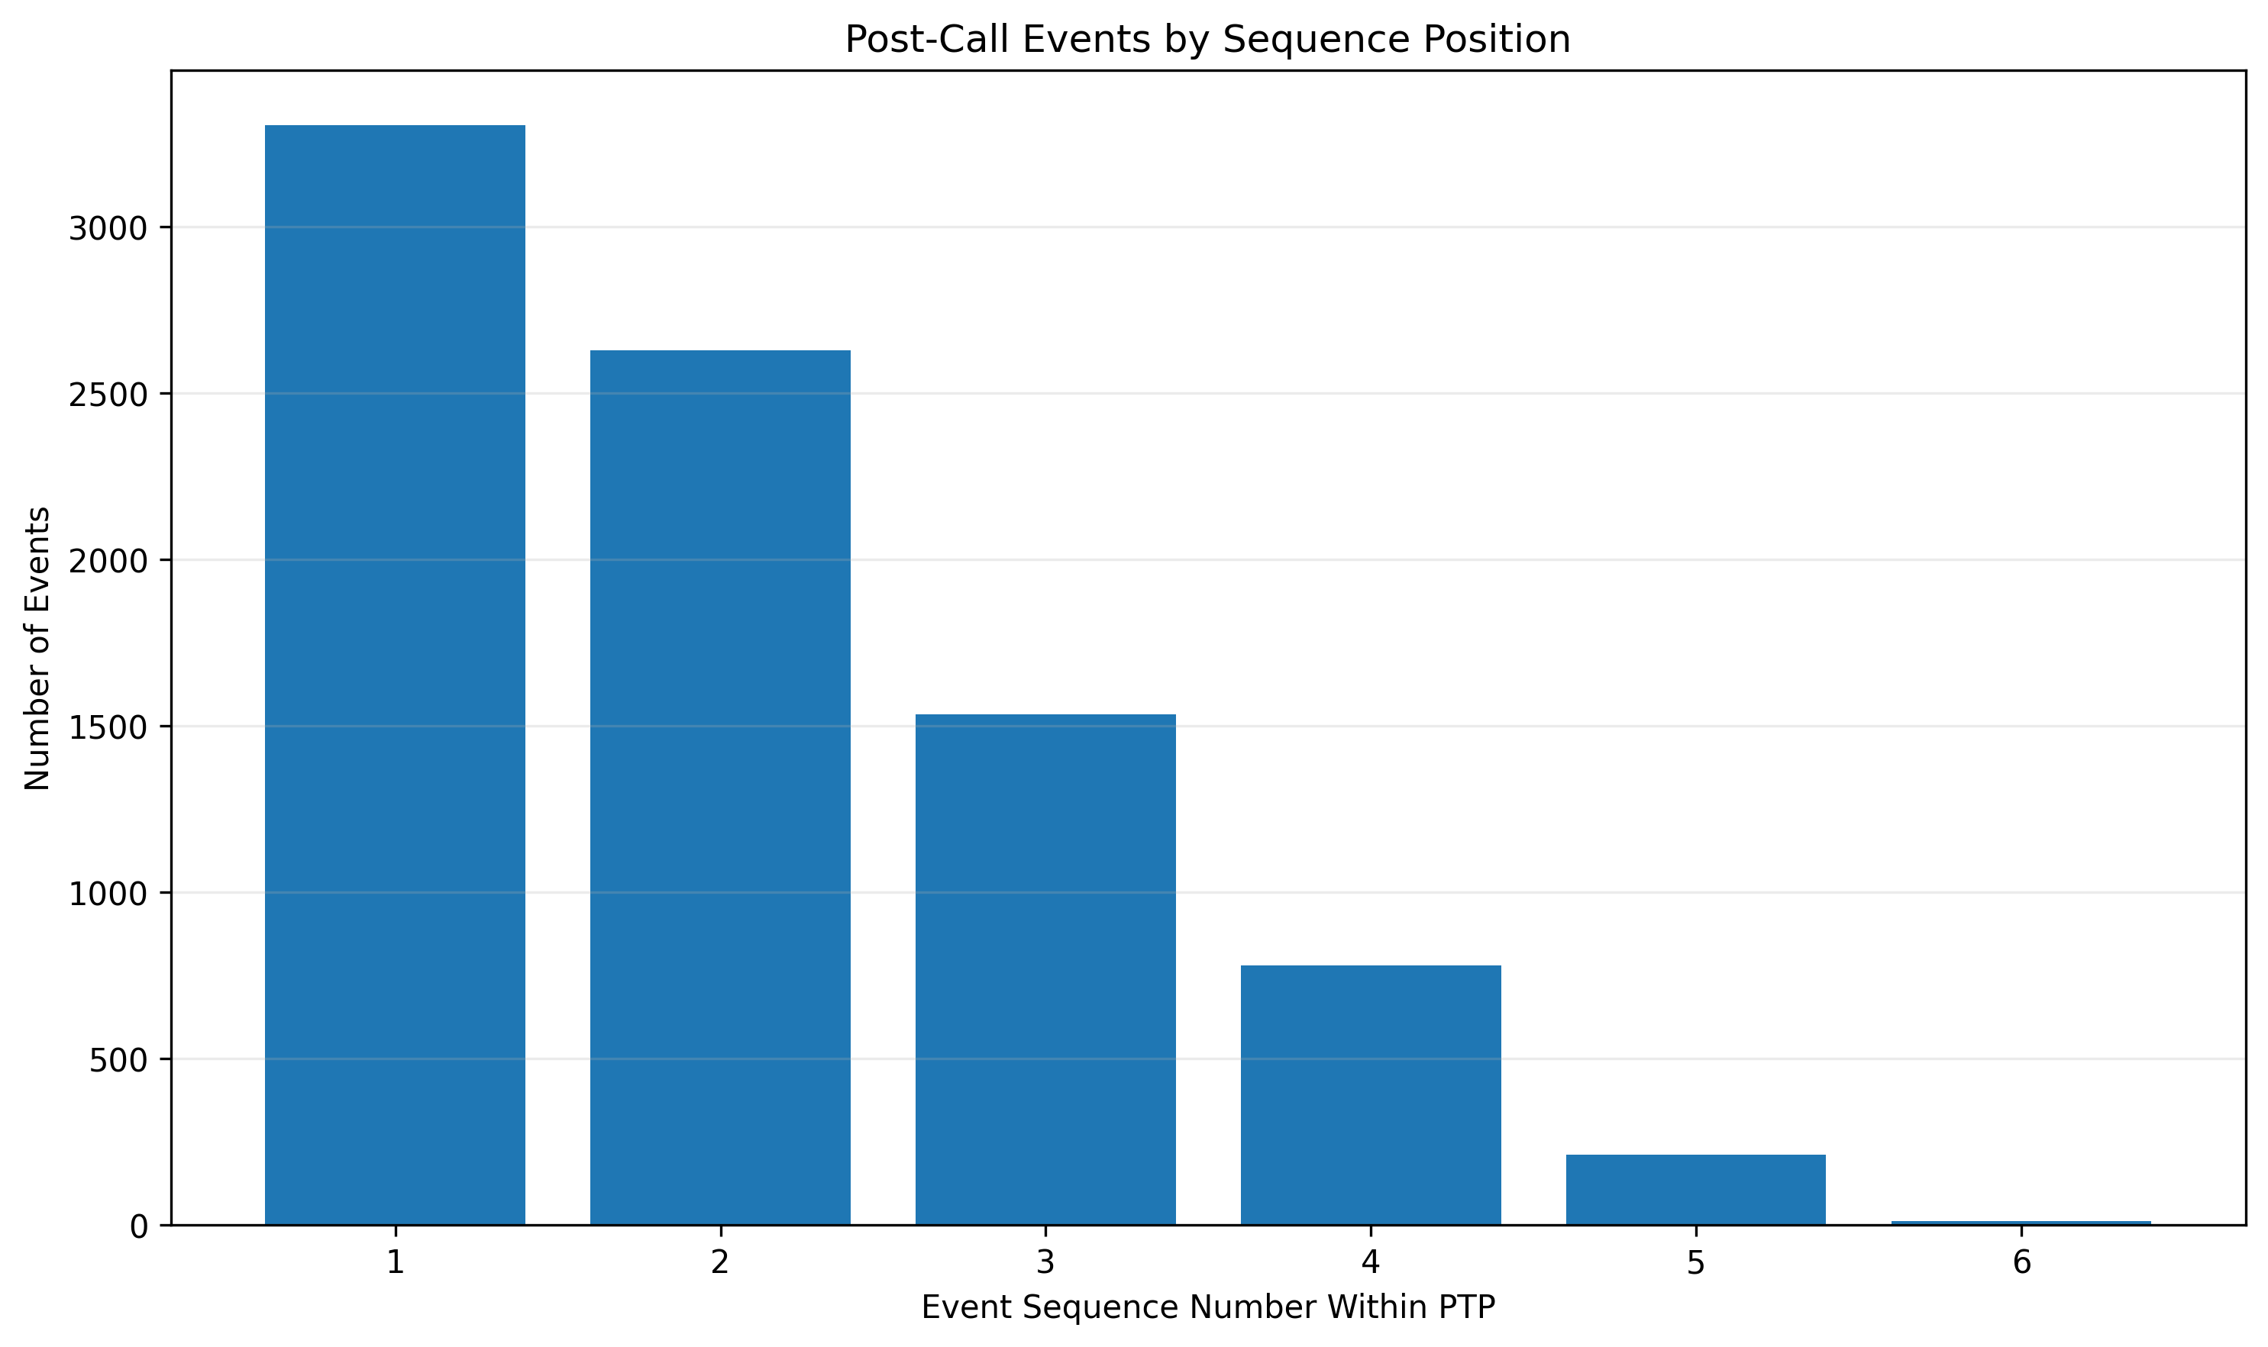
What the graph shows: The graph examines where different event types tend to appear within a PTP's event sequence.
What we learn: The workflow contains recognizable stages rather than being a completely random sequence of events.
PS1 / ML implication: Sequence-aware features can later be considered for post-call outcome modelling, provided their timestamps are compatible with the prediction task.

4.6 Time Between Events
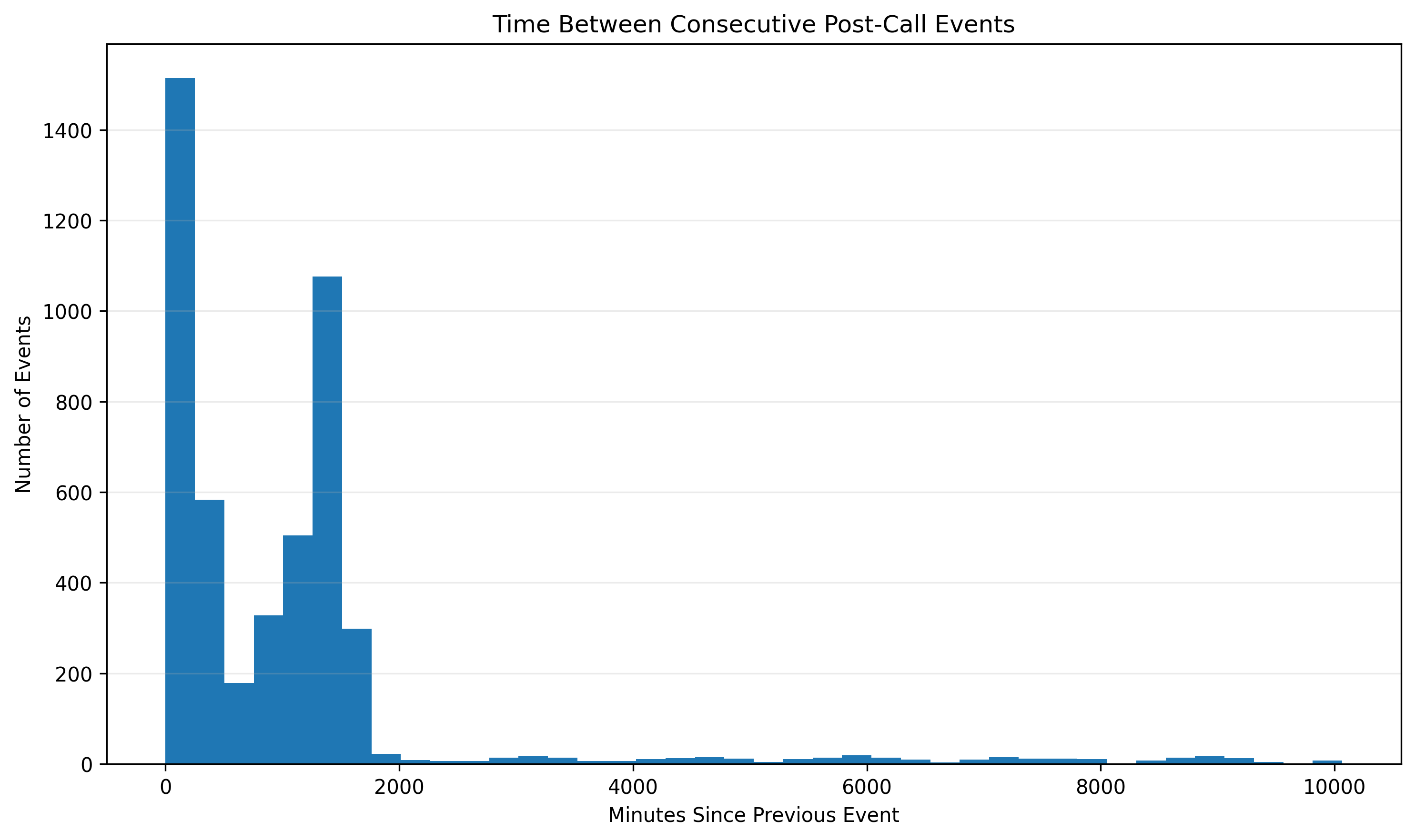
What the graph shows: The graph shows the distribution of elapsed time between successive post-call events.
What we learn: Some downstream actions happen quickly while others occur after longer delays.
PS1 / ML implication: Time-to-event features can help characterize customer engagement and workflow progression.

4.7 Event Transition Matrix
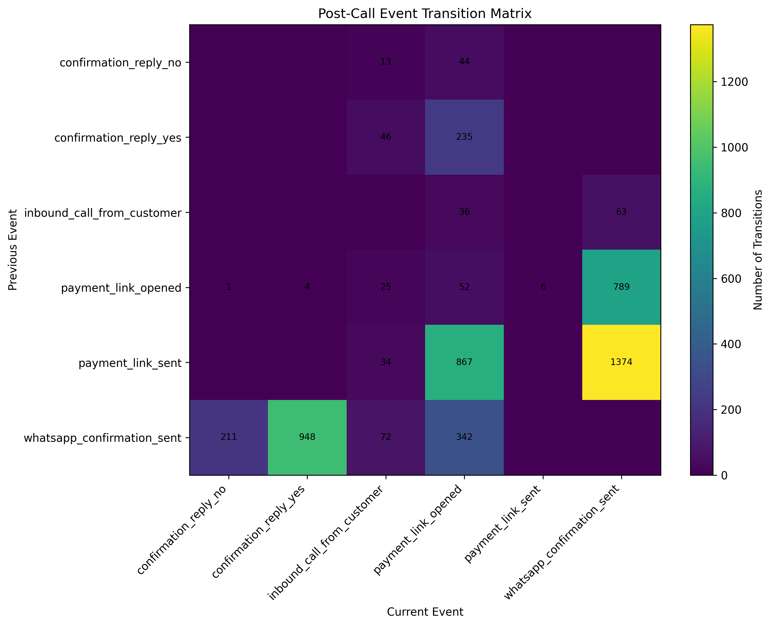
What the graph shows: The transition matrix shows which event types tend to follow other event types.
What we learn: This reveals the structure of the downstream operational funnel.
PS1 / ML implication: The transition structure can support sequence modelling, workflow optimization, and anomaly detection.

4.8 Payment-Link and Confirmation Funnel
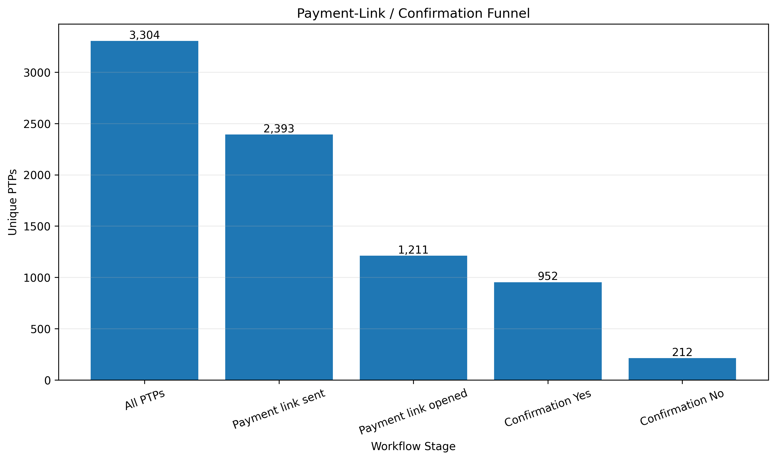
What the graph shows: The funnel tracks progression through important downstream customer-engagement stages.
What we learn: There is a measurable drop-off between successive workflow stages, which is operationally important.
PS1 / ML implication: The funnel can help identify where customer engagement breaks down after a PTP and where follow-up interventions may have the highest value.

4.9 Confirmation Outcome Coverage
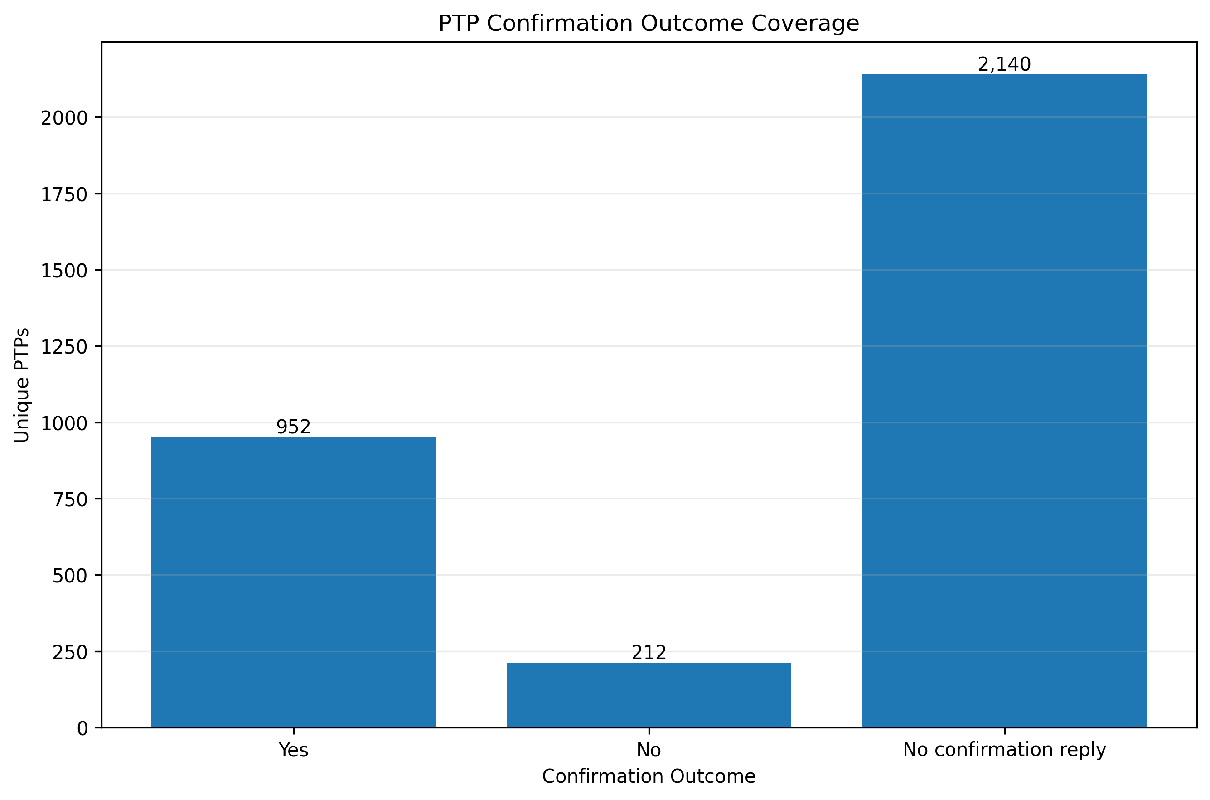
What the graph shows: The graph compares confirmation outcomes across the observed PTP population.
What we learn: Positive, negative, and absent responses represent different post-call engagement states.
PS1 / ML implication: These signals may be useful for downstream outcome modelling, but a confirmation response must not be equated directly with a successful payment.

4.10 Event Combination Patterns
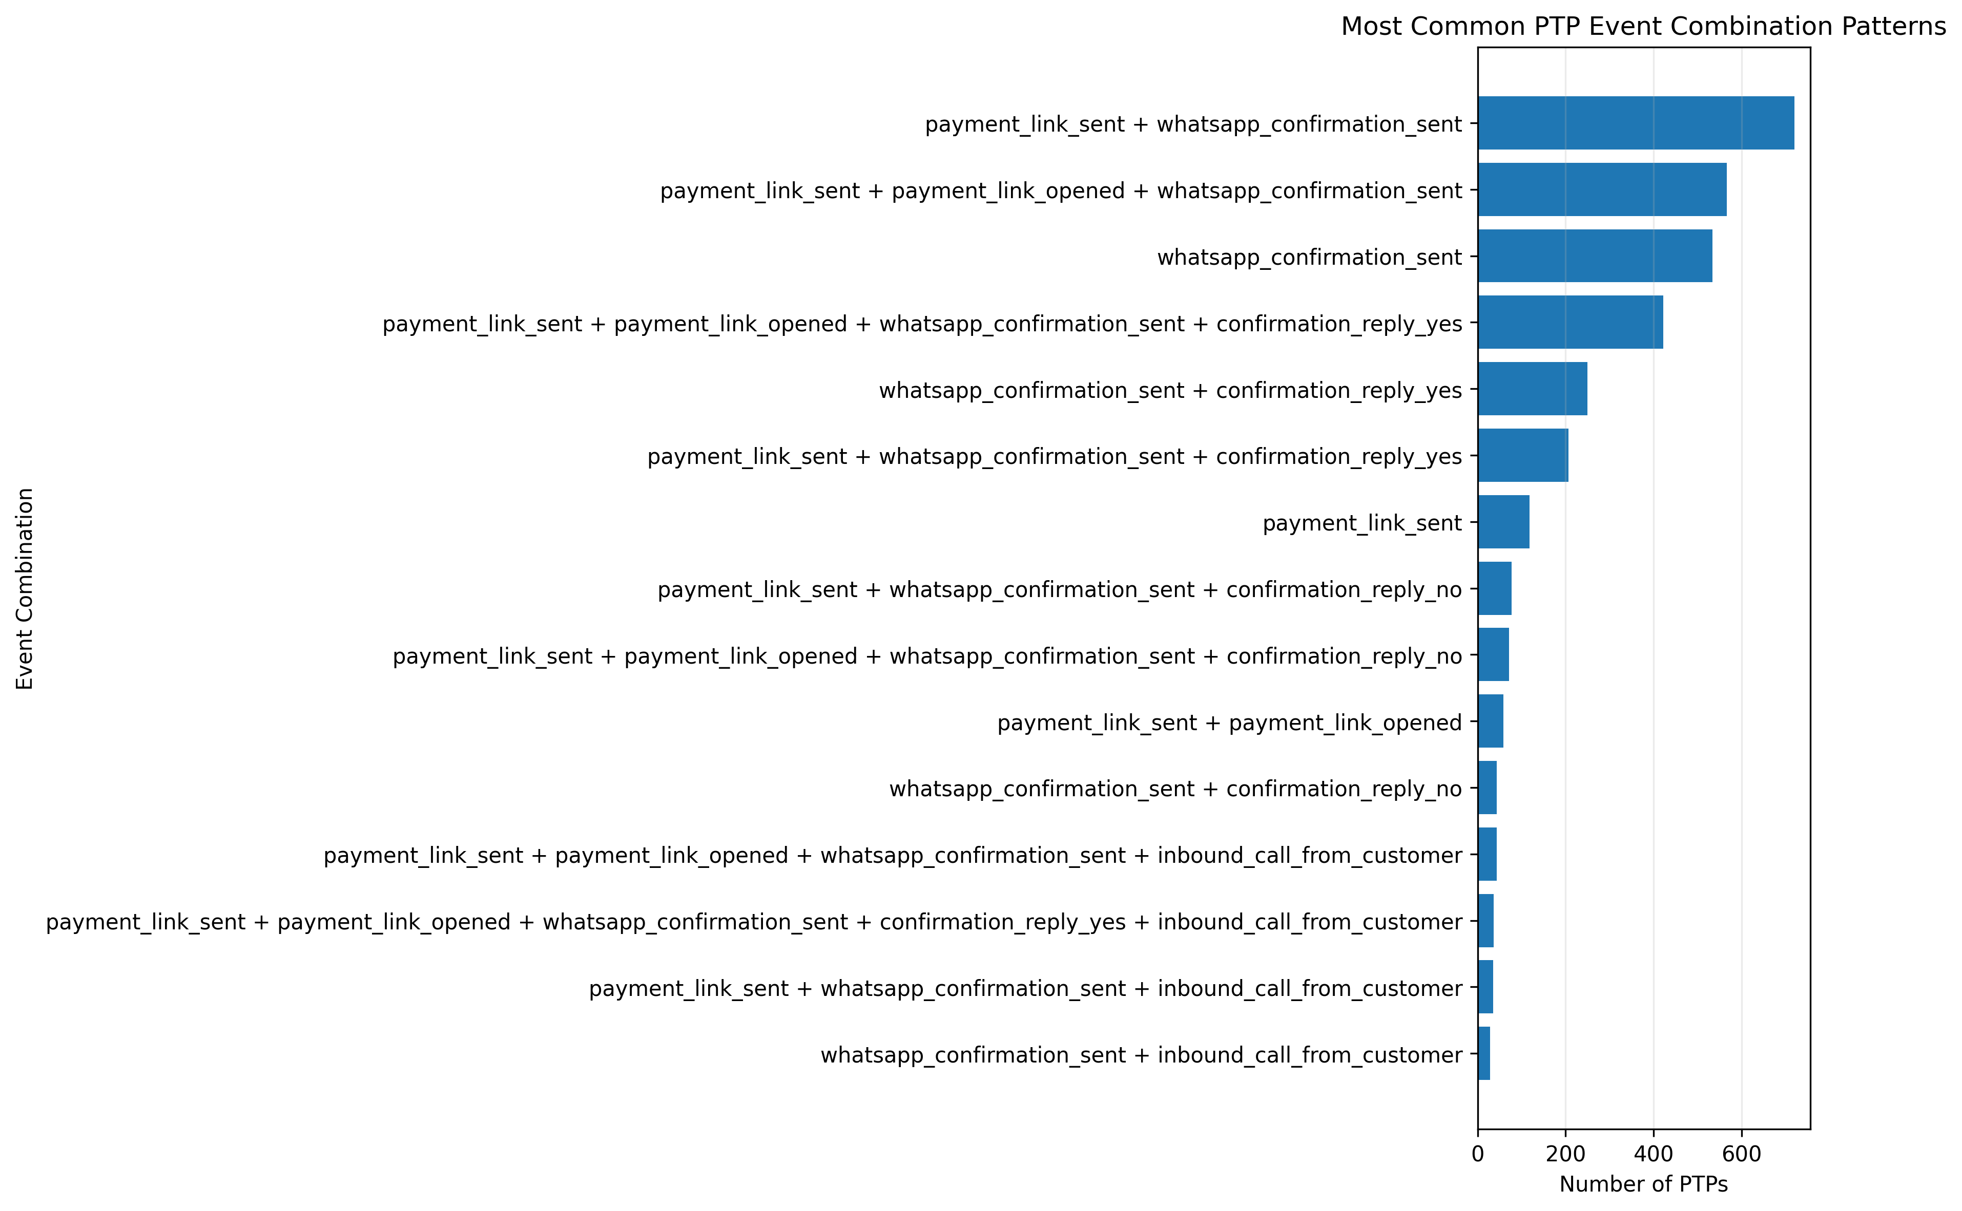
What the graph shows: The graph groups PTPs according to the combination of downstream events they experience.
What we learn: Different PTPs follow substantially different operational paths after capture.
PS1 / ML implication: Event-pattern features can help segment PTPs and identify different follow-up strategies.

4.11 Payment Link Sent vs Opened
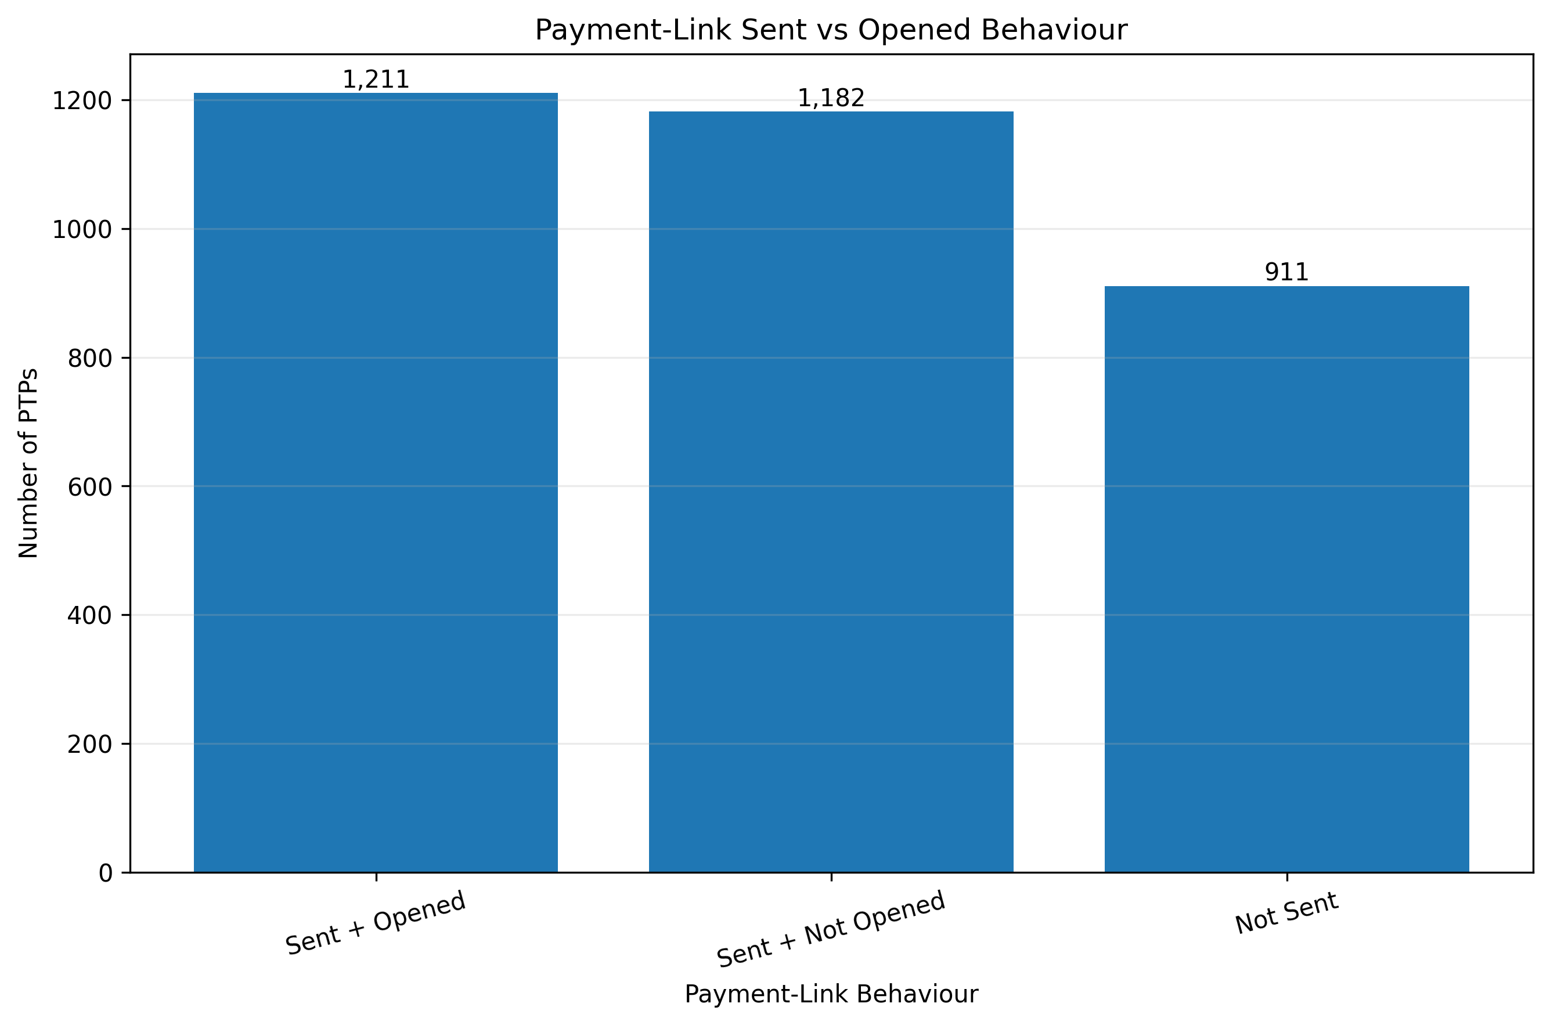
What the graph shows: The graph compares payment-link delivery with subsequent opening behaviour.
What we learn: Sending a payment link does not necessarily imply that the customer engages with it.
PS1 / ML implication: This distinction is important for measuring workflow effectiveness and customer intent.

4.12 WhatsApp Confirmation Outcomes
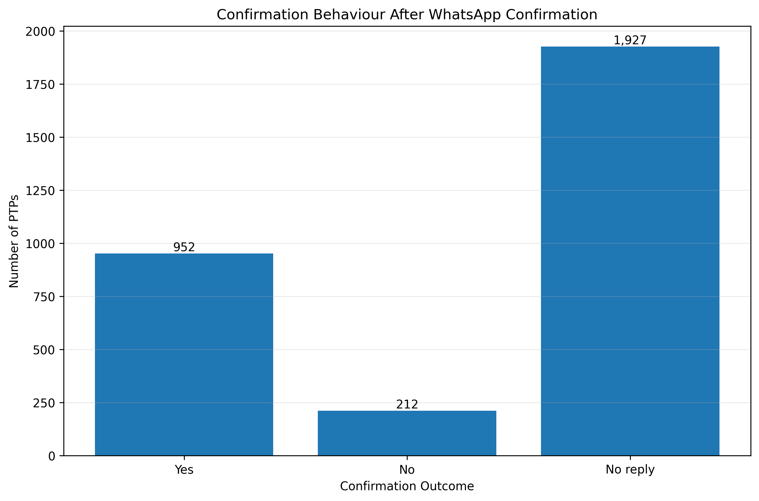
What the graph shows: The graph examines customer responses to WhatsApp confirmation.
What we learn: Confirmation behaviour provides an additional downstream signal beyond the original PTP capture.
PS1 / ML implication: It can be used for post-call segmentation and follow-up optimization, subject to timestamp and leakage constraints.

4.13 Event Coverage by Channel
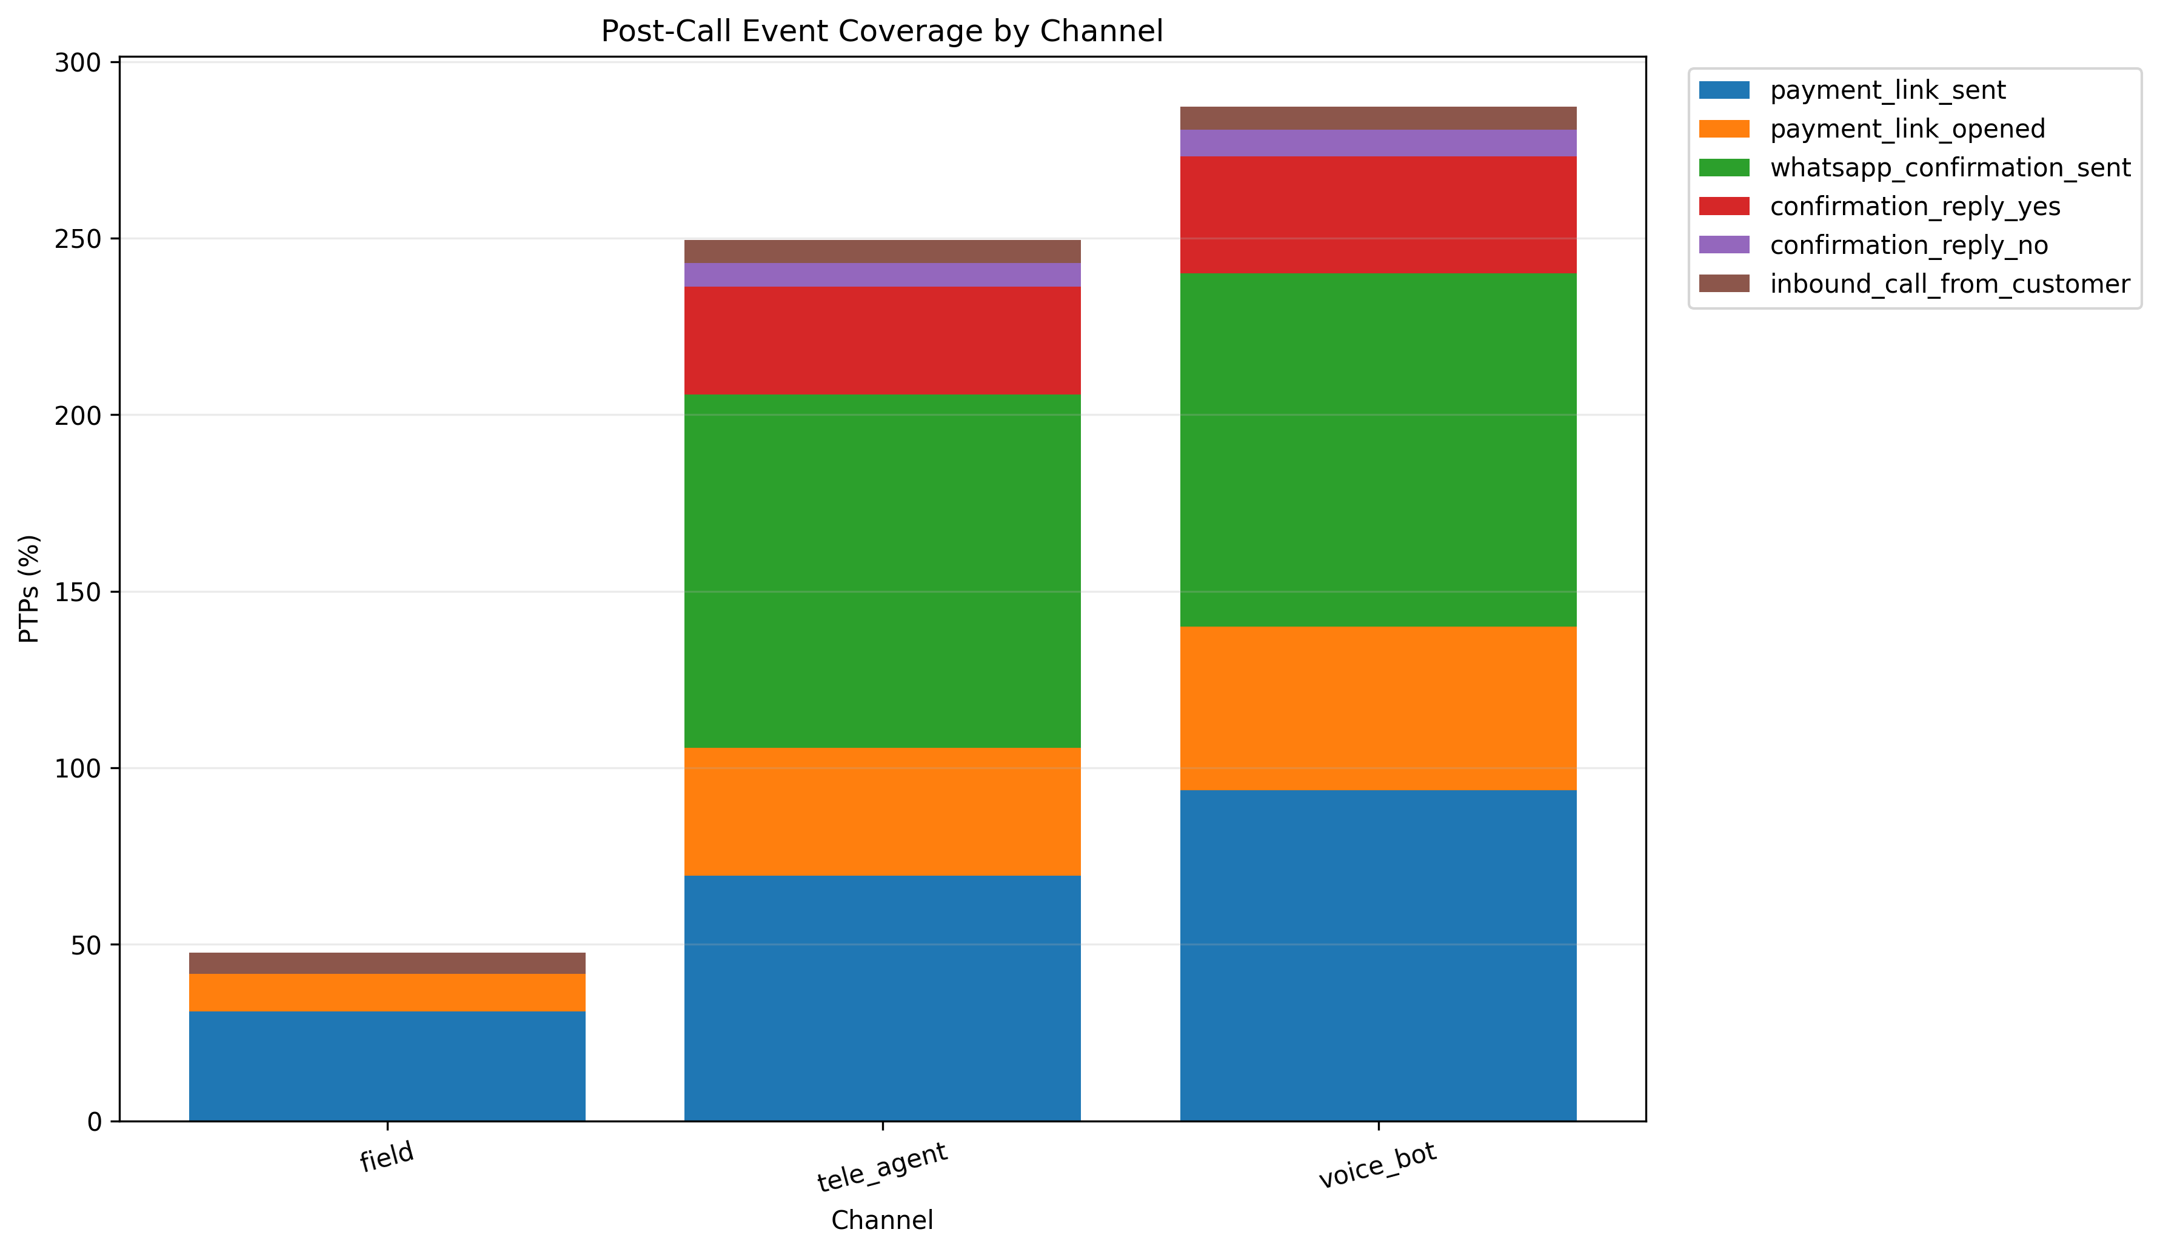
What the graph shows: The graph compares downstream event coverage across PTP capture channels.
What we learn: Operational workflows differ depending on whether the PTP originated through different collection channels.
PS1 / ML implication: Channel should be retained as an important contextual feature and evaluated for calibration and fairness.

4.14 Event Coverage by Source
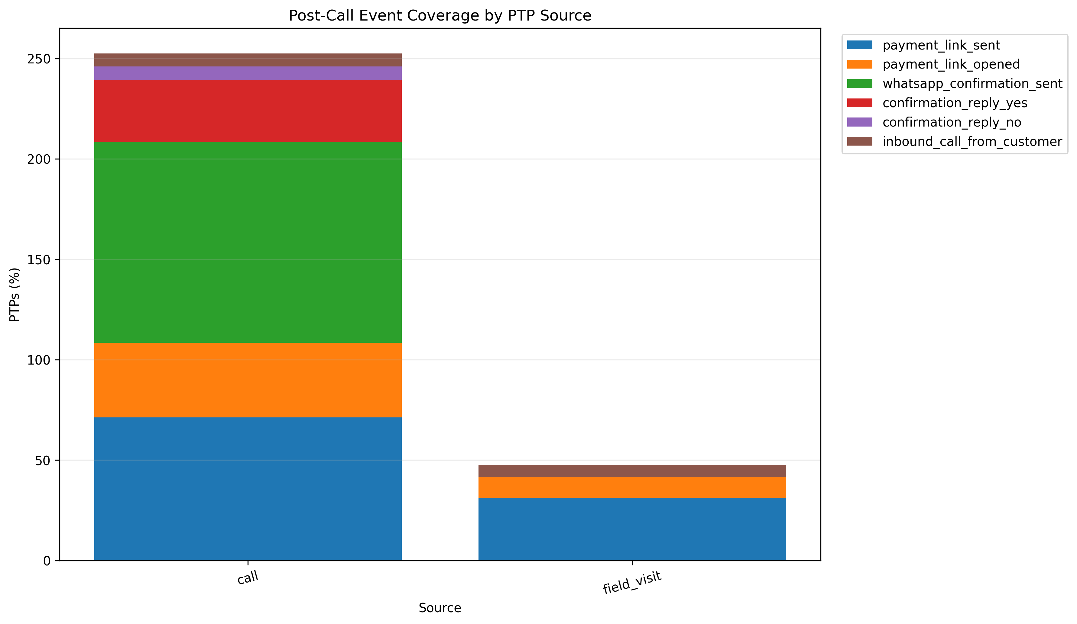
What the graph shows: The graph compares downstream event coverage between different PTP sources.
What we learn: Different acquisition sources can produce different post-call engagement patterns.
PS1 / ML implication: Source should be considered during model evaluation and drift monitoring.

4.15 Event Coverage by Promised Amount
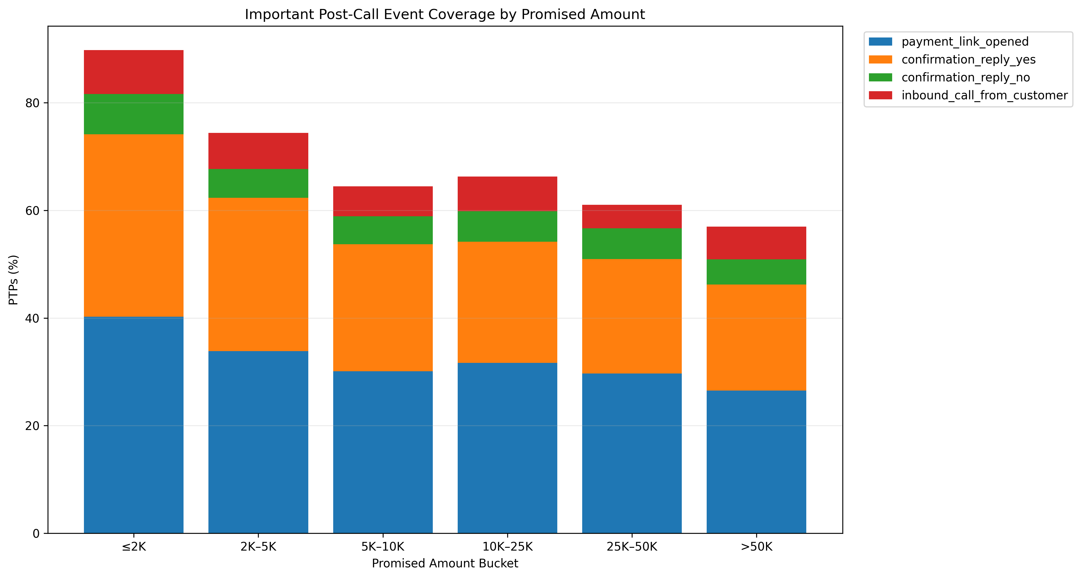
What the graph shows: The graph examines downstream event behaviour across promised-amount groups.
What we learn: Customer engagement can vary with the financial magnitude of the PTP.
PS1 / ML implication: Amount-related segmentation may improve calibration, but should be evaluated carefully to avoid unfair treatment.

4.16 Event Timing Relative to PTP Capture
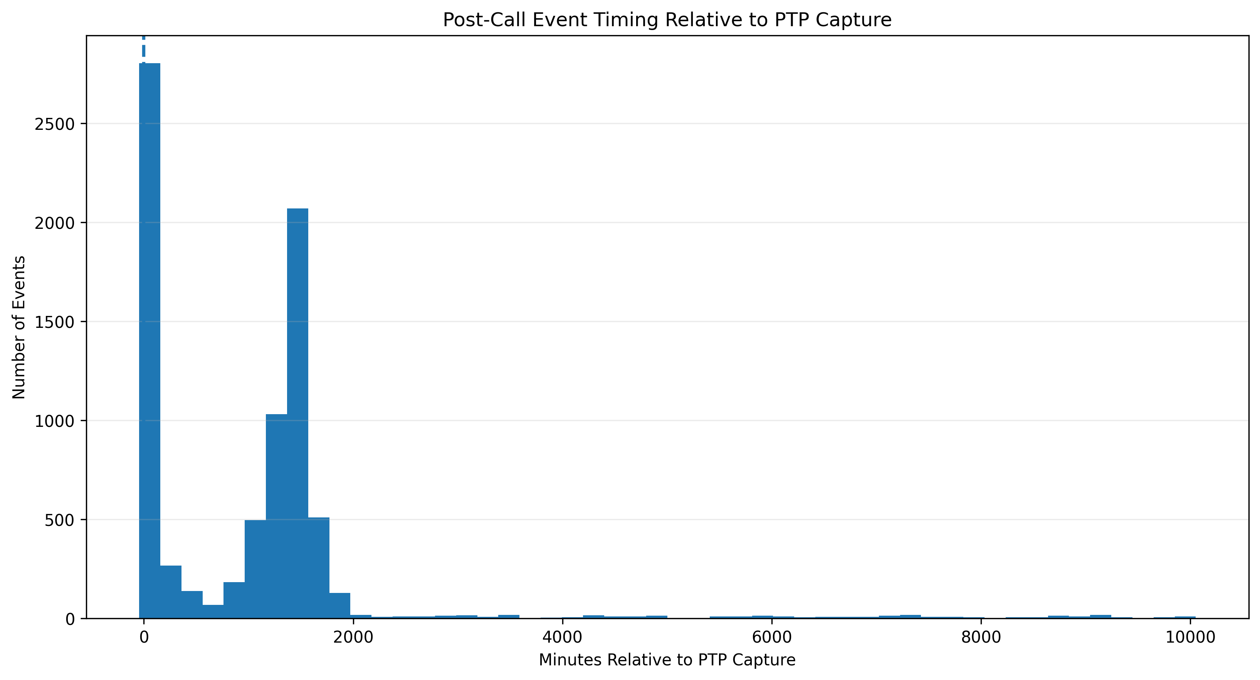
What the graph shows: This graph places downstream event timestamps relative to the original PTP capture time.
What we learn: It shows whether events occur before, at, or after the prediction point.
PS1 / ML implication: This is critical for preventing temporal leakage. Events that occur after PTP capture must not be used as live prediction inputs for the original call.

5. PS1 Modeling Implications
The post_call_events dataset should primarily be treated as downstream operational data. Its strongest immediate value is understanding what happens after a PTP and constructing outcome-oriented analyses.
- Do not directly feed future post-call events into the real-time PTP quality model.
- Use event timestamps to enforce strict feature cutoffs.
- Use downstream events for label construction only when the business definition of a kept PTP is clearly established.
- Confirmation replies are engagement signals, not direct payment evidence.
- For live prediction, rely on information available during the call, such as transcript signals, negotiation behaviour, historical account behaviour, and other permitted real-time signals.
- Use post-call workflow data to evaluate whether a predicted PTP quality score corresponds to meaningful downstream behaviour.

6. Critical Data Leakage Warning
Important: post_call_events contains information generated after the PTP is captured. Therefore, its events are generally downstream of the real-time decision point.
For PS1, the model must estimate PTP quality while the collection interaction is still occurring. Consequently, any feature whose timestamp is after the prediction timestamp must be excluded from the live feature set.
This distinction should be enforced explicitly in the feature-engineering pipeline rather than relying only on random train-test splitting.

7. Final Conclusion
The post_call_events analysis establishes the downstream operational structure surrounding captured PTPs. The data contains meaningful workflow signals including payment-link activity, confirmation behaviour, customer responses, event sequences, and timing.
The strongest value of this dataset for PS1 is therefore not as a direct source of real-time prediction features, but as a source for understanding downstream behaviour, building outcome-oriented analyses, evaluating workflow effectiveness, and supporting future PTP quality labels.
The next modelling stage should combine temporally valid in-call features with historical account behaviour and carefully defined downstream outcomes, while explicitly controlling for temporal leakage and business-policy bias.

