CreditNirvana PS1
Complete PTP Exploratory Data Analysis
Real-Time Fake PTP Detection
3,696 PTP records | 1,933 accounts | 200 labelled PTPs

Executive Summary
- The operational dataset contains 3,696 PTPs across 1,933 accounts, with 3,696 unique PTP IDs.
- The capture window is 2026-04-01 to 2026-06-29.
- Promised and overdue amounts are heavily skewed and contain long tails.
- Promise lead time, answerer type, channel and account history are the main interpretable operational signals available before/at PTP capture.
- Repeated PTP behaviour is material, making account sequence and recency important for repeat-promiser detection.
- Payment-link fields are useful for workflow analysis but require strict temporal-leakage checks before live use.
- The 200-row annotated sample joins completely to the operational table (200/200).
- Label-wise analysis is exploratory because 200 labelled records are insufficient for final model training or reliable population-level performance claims.
- PS1 modelling should combine these operational signals with transcript/audio evidence and actual payment outcomes.

Important Data Limitation
The PTP operational table does not itself contain the conversation transcript/audio features or the final payment outcome. Therefore this EDA identifies feature availability, distributions, history patterns and labelled associations, but it does not prove which features predict whether a promise is actually kept.

Dataset Profile
Property | Value
Rows | 3,696
Columns | 13
Unique PTP IDs | 3,696
Unique accounts | 1,933
Call records | 3,091
Field visits | 605
Annotated records | 200
Annotated classes | 6

Complete Visual EDA
Every figure is followed by: What the graph shows, What we learn, and ML / engineering implication.

1. Ptp Operational Distribution
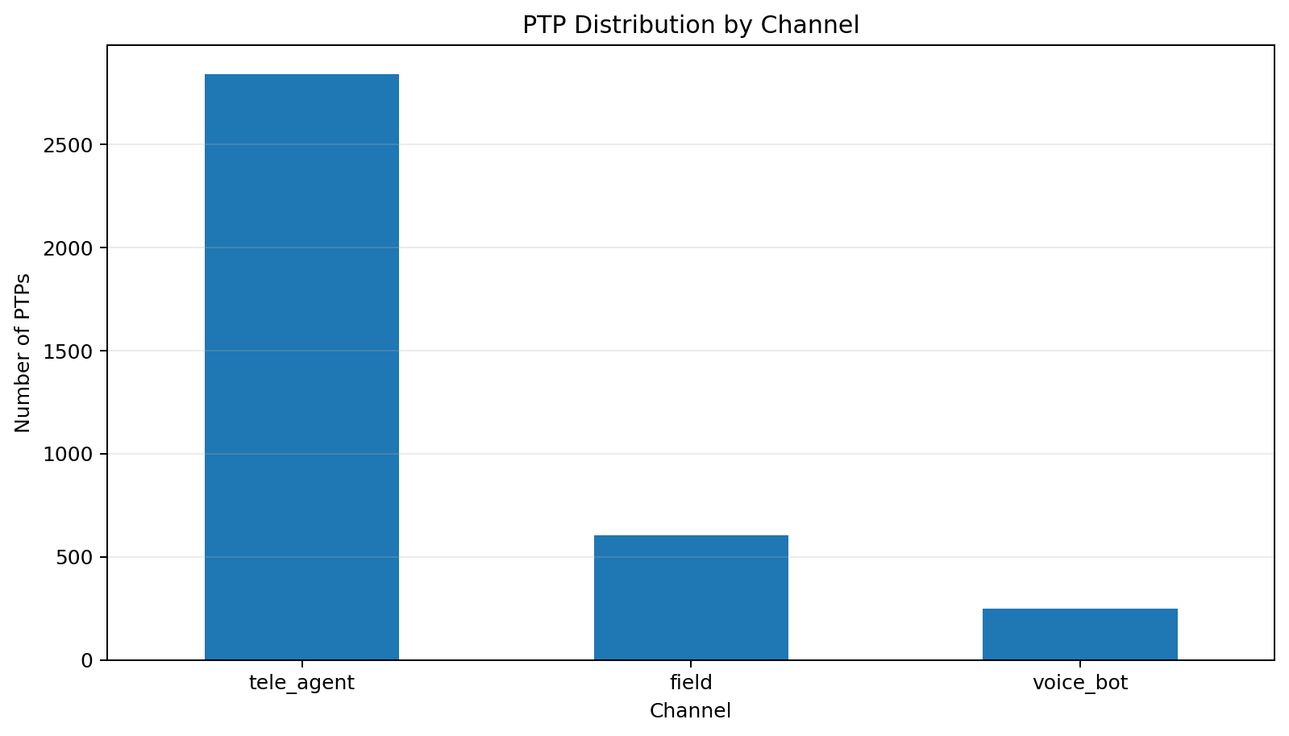
What the graph shows: Operational channel mix.
What we learn: Channel volume is concentrated in tele-agent interactions, with smaller field and voice-bot groups.
ML / engineering implication: Channel should be retained as context and evaluated with channel-specific calibration.

2. Ptp Temporal Distribution
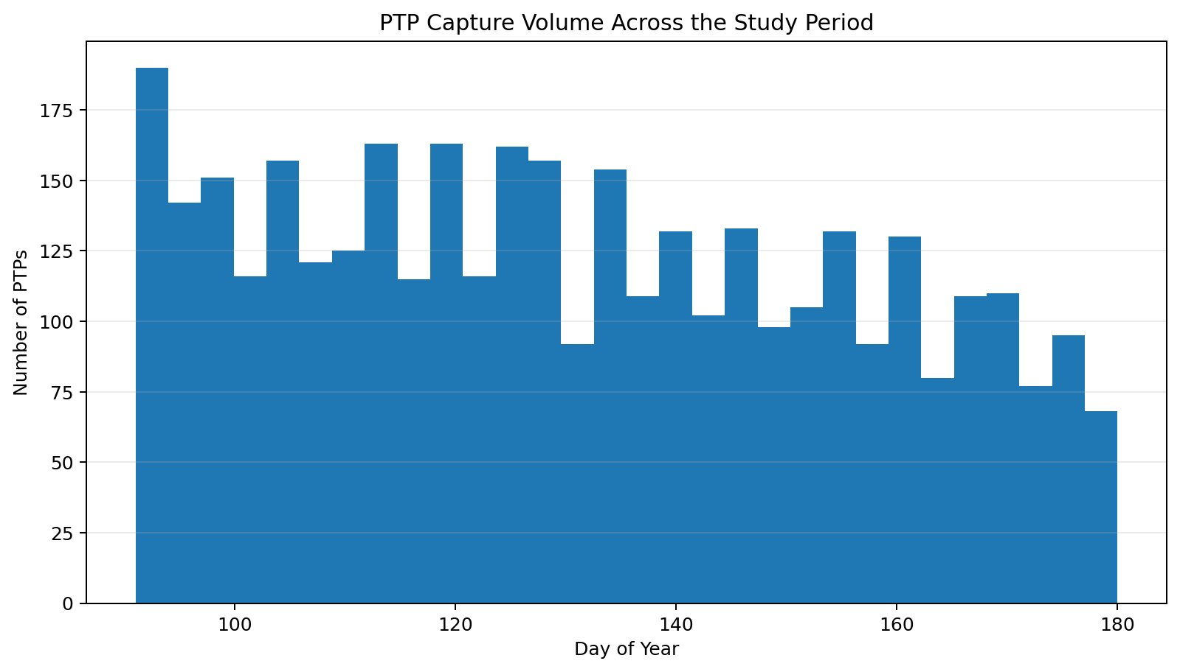
What the graph shows: Capture activity over time.
What we learn: The study window runs from 2026-04-01 to 2026-06-29.
ML / engineering implication: Use time-aware validation to detect temporal drift.

3. Promised Amount Distribution
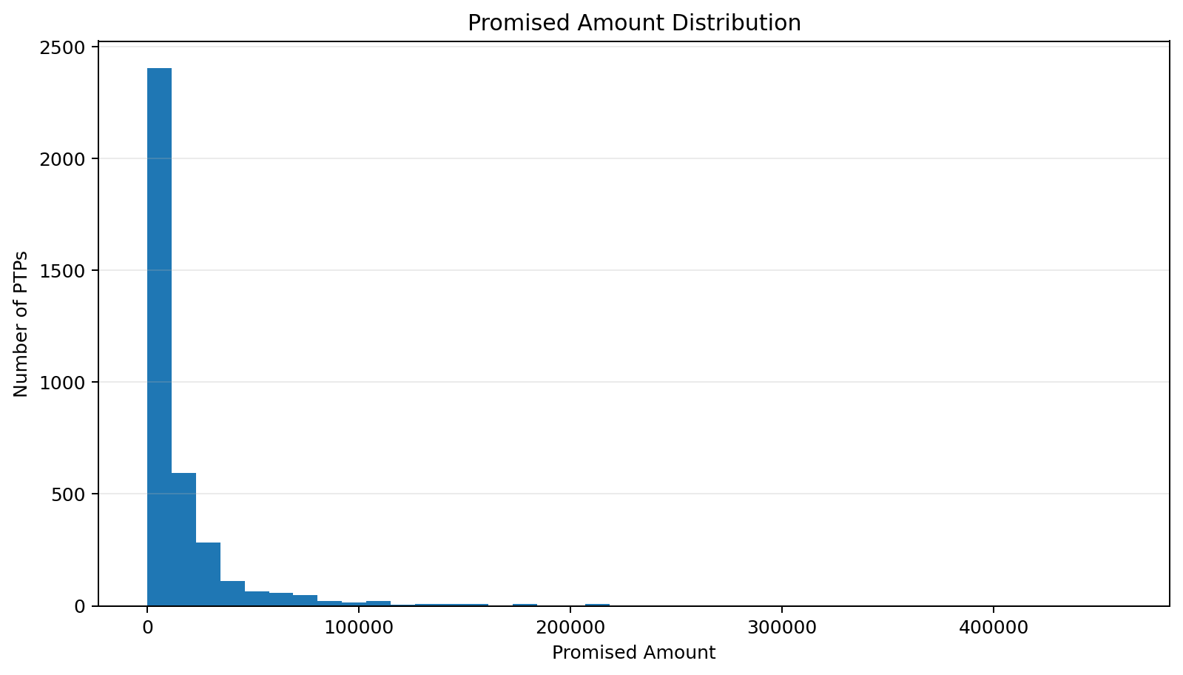
What the graph shows: Promised-amount distribution.
What we learn: Promised amount spans ₹50 to ₹460,200 and is strongly skewed.
ML / engineering implication: Use robust/log-scaled amount features.

4. Overdue Amount Distribution
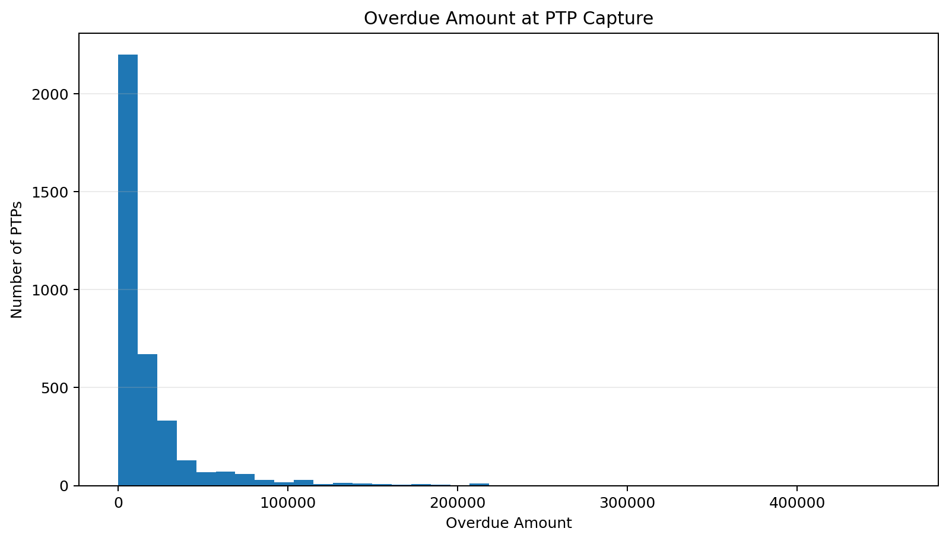
What the graph shows: Overdue amount distribution.
What we learn: Overdue exposure spans ₹50 to ₹460,200.
ML / engineering implication: Retain amount context while handling the long tail robustly.

5. Promised Vs Overdue Amount
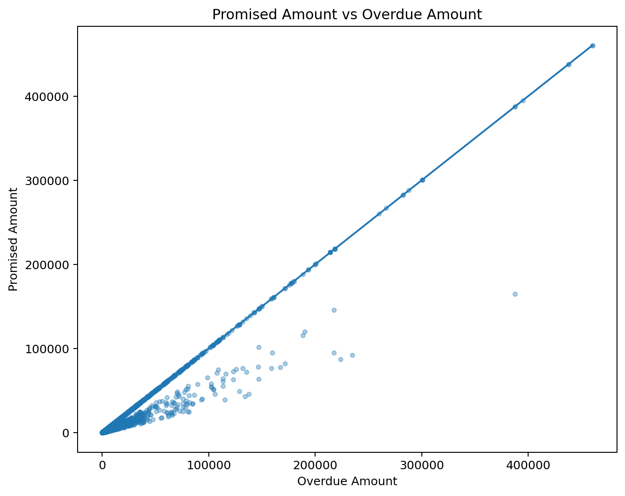
What the graph shows: Promised amount versus overdue amount.
What we learn: The relationship is broad rather than deterministic, with meaningful deviations from the diagonal.
ML / engineering implication: Use ratio/gap features in addition to the two raw amounts.

6. Promise To Overdue Ratio
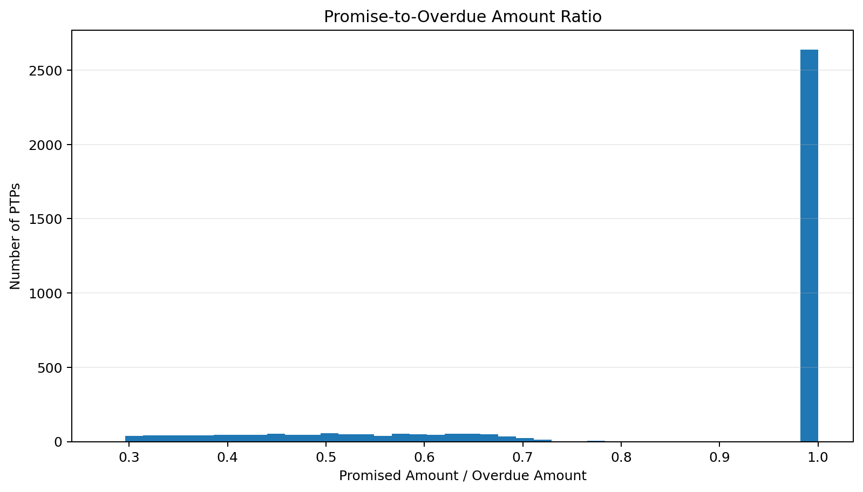
What the graph shows: Promise-to-overdue ratio.
What we learn: Promises vary from full-balance commitments to partial or unusual amounts.
ML / engineering implication: The ratio is a useful interpretable financial feature.

7. Promise Lead Time Distribution
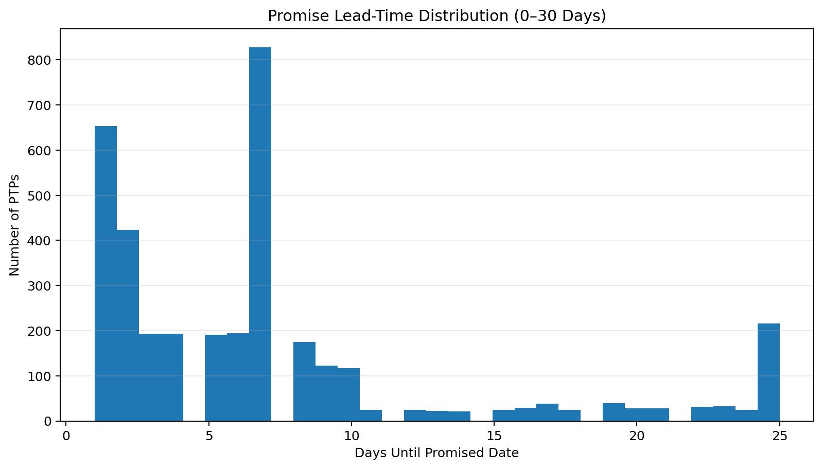
What the graph shows: Promise lead time.
What we learn: Most commitments are relatively near-term, with a smaller long-horizon tail.
ML / engineering implication: Lead time is a natural live feature for feasibility.

8. Promise Lead Time By Channel
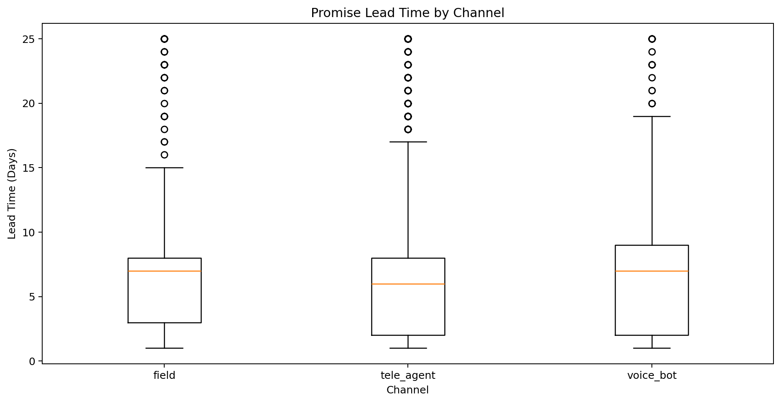
What the graph shows: Lead time by channel.
What we learn: Promise timing distributions differ across channels.
ML / engineering implication: Test channel interactions and calibrate separately if needed.

9. Promise Timing Buckets
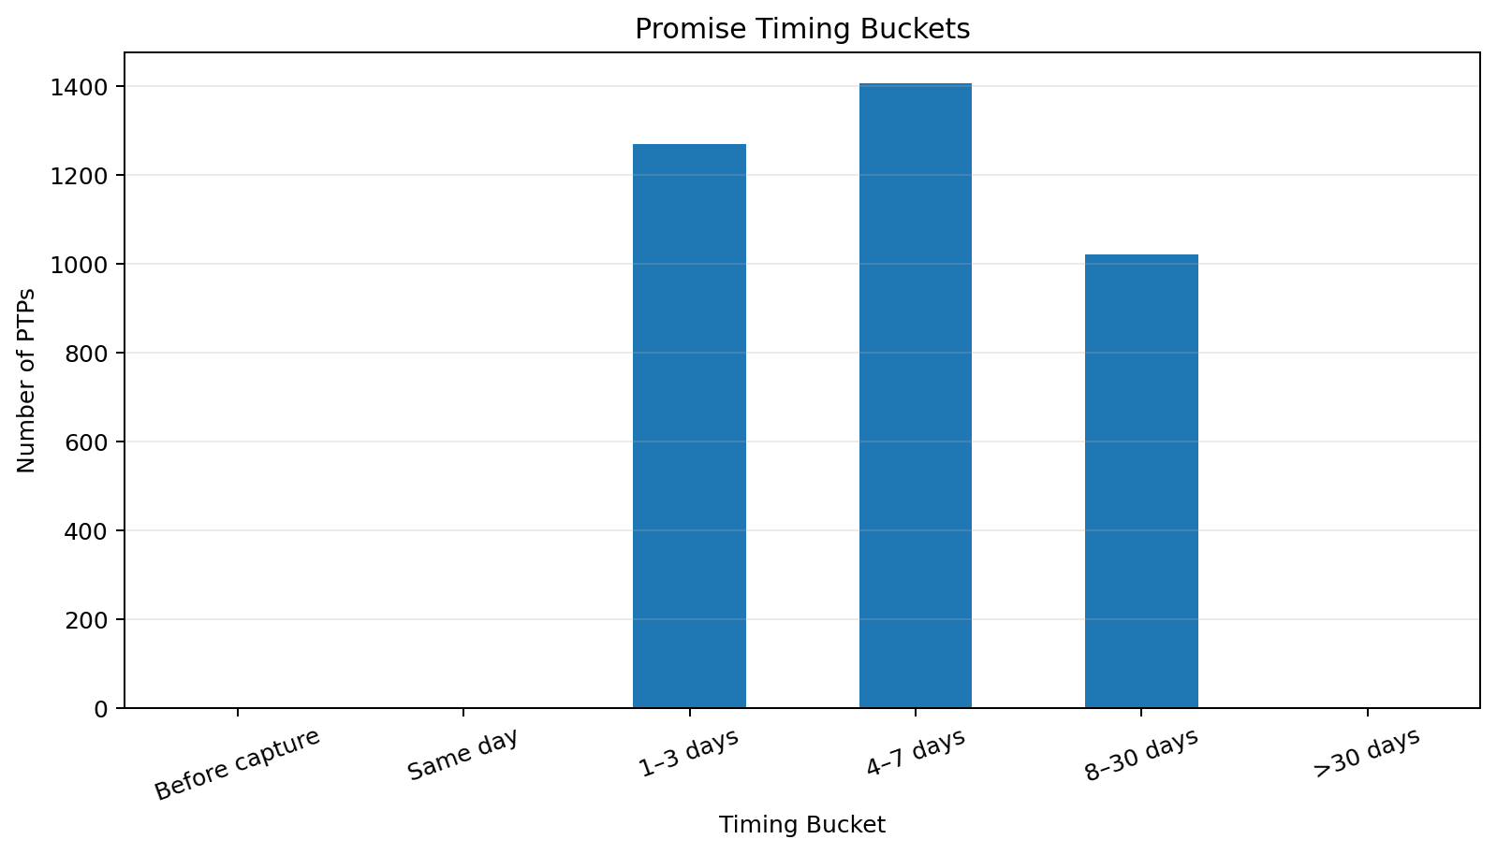
What the graph shows: Timing buckets.
What we learn: The buckets expose same-day and short-horizon promises separately from long commitments.
ML / engineering implication: Bucketed timing improves interpretability alongside continuous lead time.

10. Ptp Count Per Account
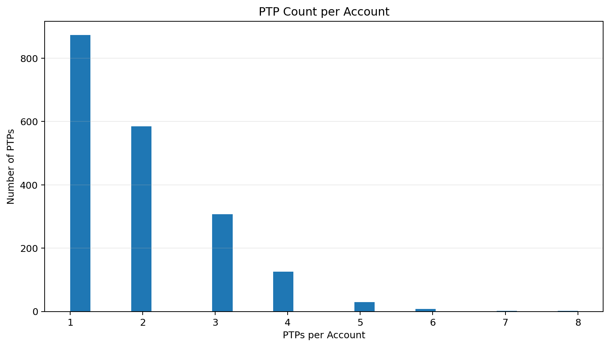
What the graph shows: PTP frequency per account.
What we learn: 1,933 accounts generate 3,696 PTPs, so repeat history is material.
ML / engineering implication: Account-level history should be part of the feature state.

11. First Vs Repeat Ptp
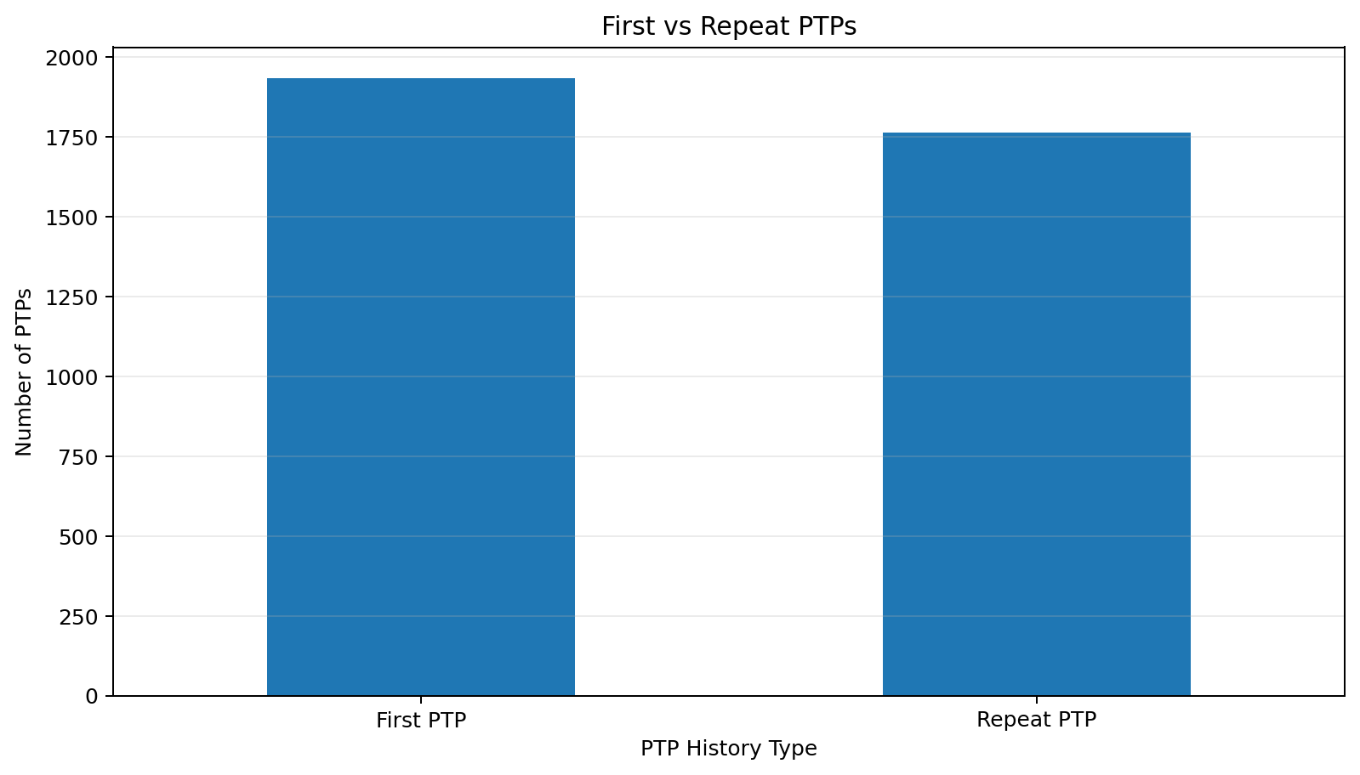
What the graph shows: First versus repeat PTPs.
What we learn: A substantial fraction of PTPs are repeats rather than first commitments.
ML / engineering implication: Prior-Promise history is important for repeat-promiser detection.

12. Account Ptp Frequency Buckets
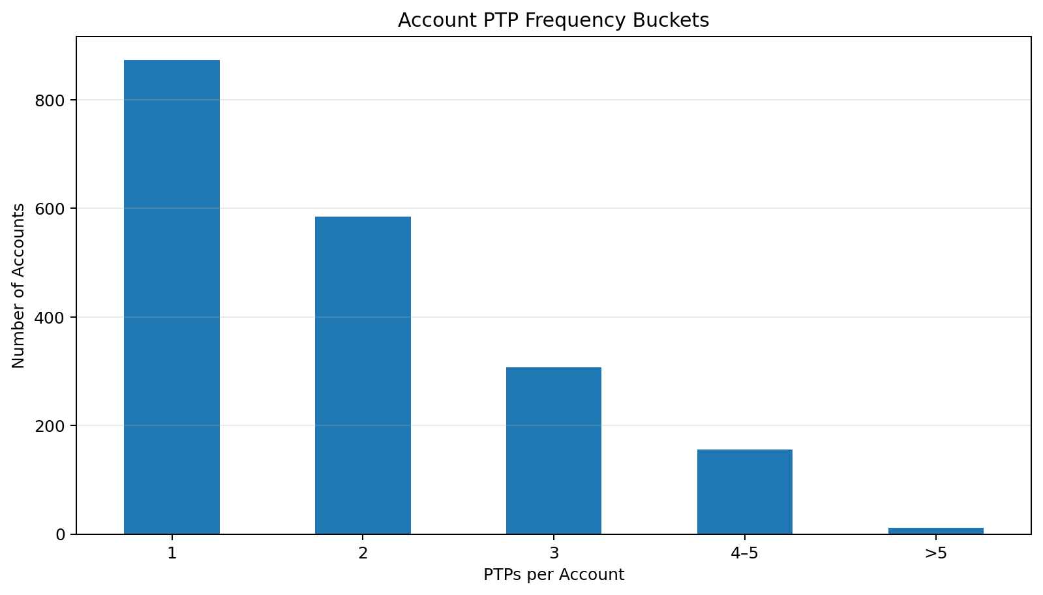
What the graph shows: Account frequency buckets.
What we learn: Account-level PTP frequency has a long tail.
ML / engineering implication: Frequency can be converted into stable historical features.

13. Ptp Volume By Agent
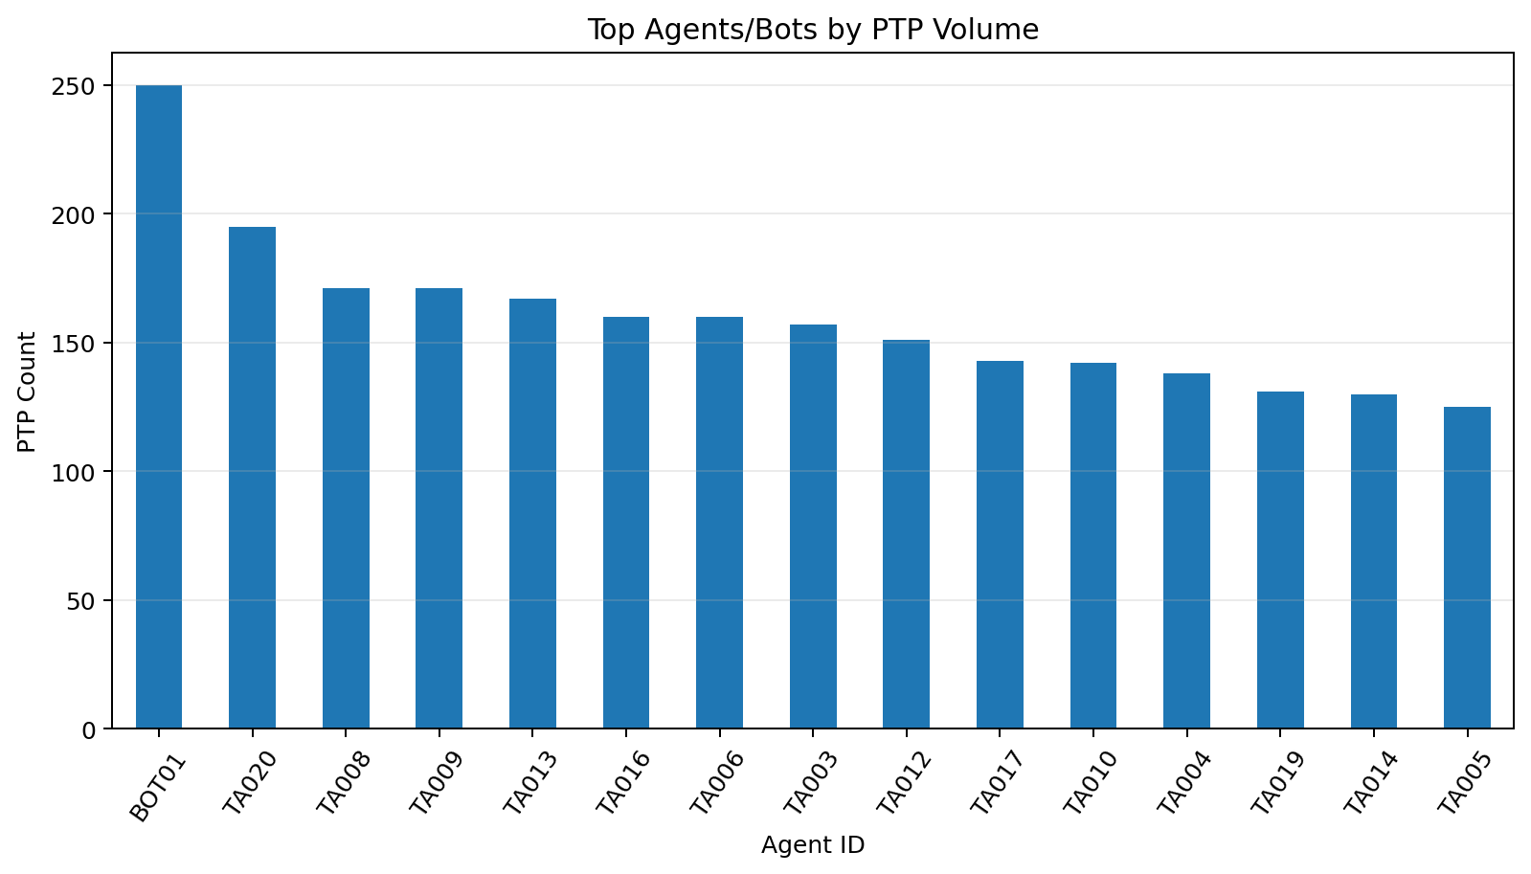
What the graph shows: PTP volume by agent/bot.
What we learn: Operational exposure is uneven across collection actors.
ML / engineering implication: Avoid overfitting to raw IDs; prefer stable aggregate process features.

14. Agent Ptp Volume Distribution
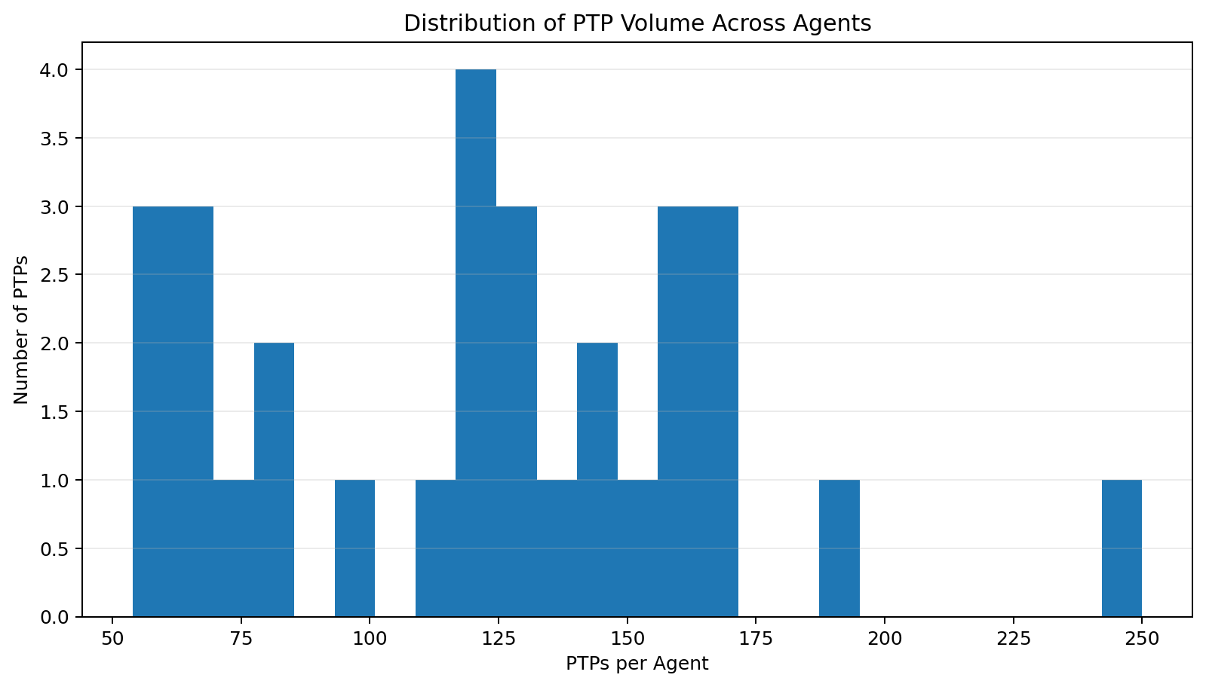
What the graph shows: Agent volume distribution.
What we learn: Agent/bot workloads are not uniform.
ML / engineering implication: Evaluate metrics with volume-aware confidence intervals.

15. Payment Link Rate By Agent
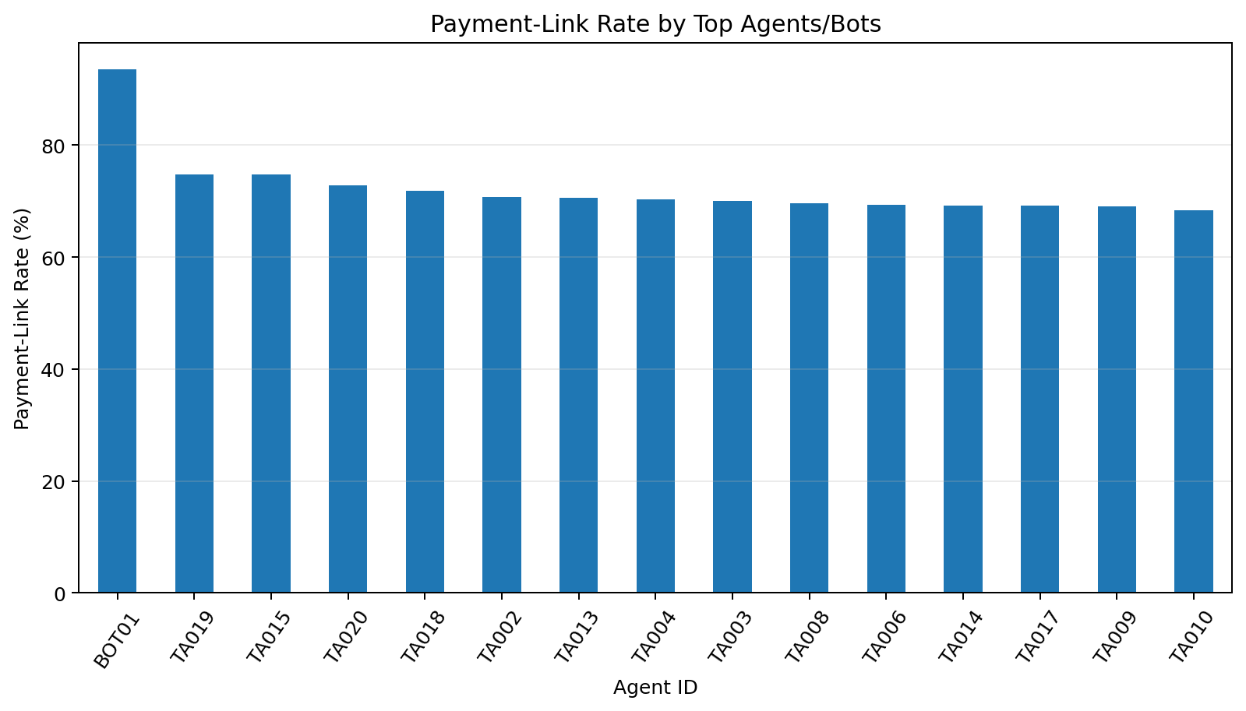
What the graph shows: Payment-link rate by agent/bot.
What we learn: Follow-up behaviour varies across collection actors.
ML / engineering implication: Verify event timing before using this as a live feature.

16. Ptp Distribution By Answerer
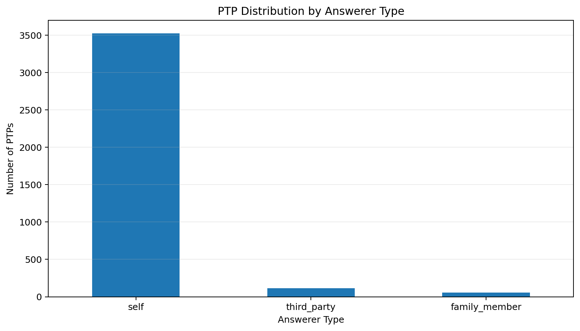
What the graph shows: Answerer distribution.
What we learn: Self answerers dominate, with smaller third-party and family-member groups.
ML / engineering implication: Answerer type is a useful interpretable categorical signal.

17. Answerer Type By Channel
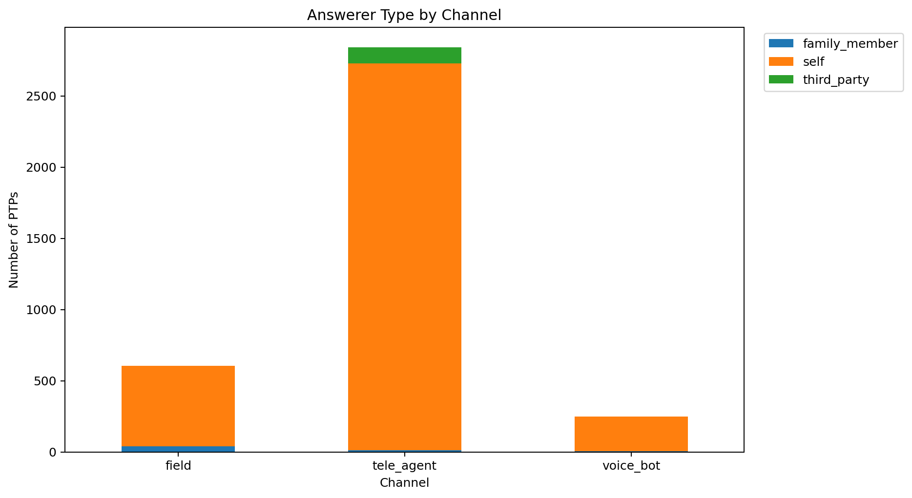
What the graph shows: Answerer by channel.
What we learn: Answerer composition differs by channel.
ML / engineering implication: Model channel-answerer interaction.

18. Payment Link Rate By Answerer
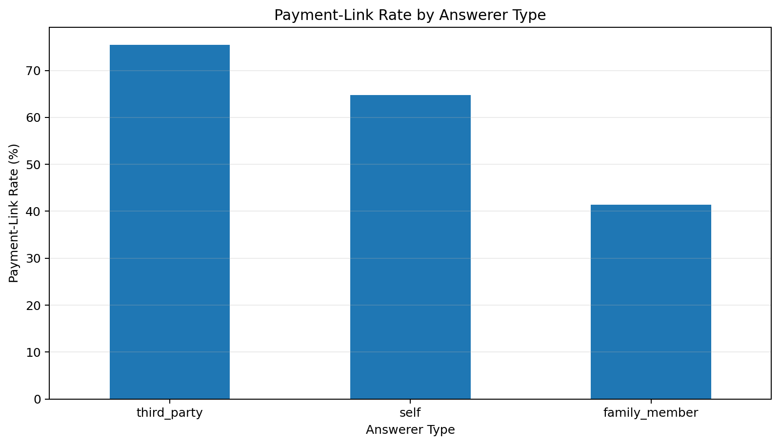
What the graph shows: Payment-link rate by answerer.
What we learn: Follow-up behaviour varies by answerer type.
ML / engineering implication: Useful for downstream workflow analysis; check temporal ordering for live scoring.

19. Payment Link Distribution
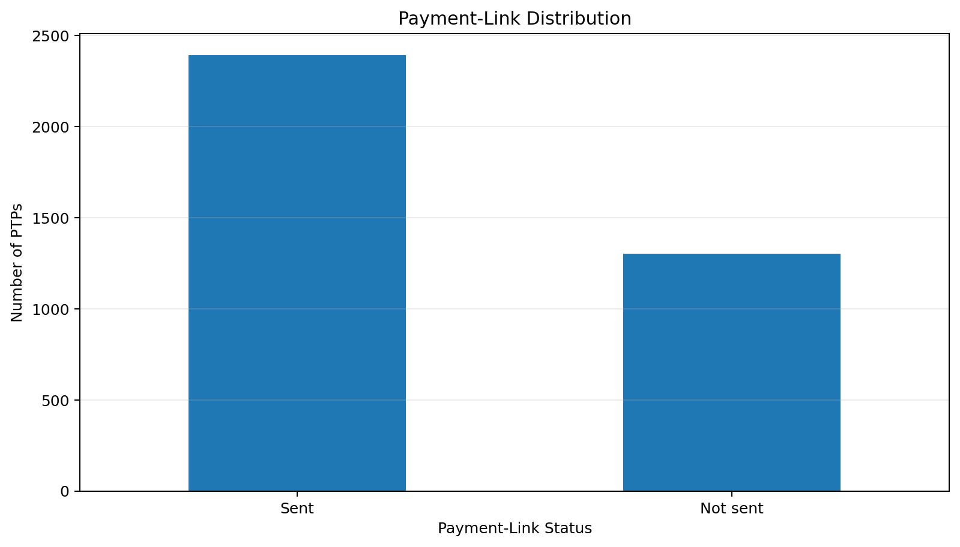
What the graph shows: Overall payment-link split.
What we learn: Payment links are sent for a majority of records.
ML / engineering implication: Treat this as an event/outcome field unless proven available before scoring.

20. Payment Link Rate By Channel
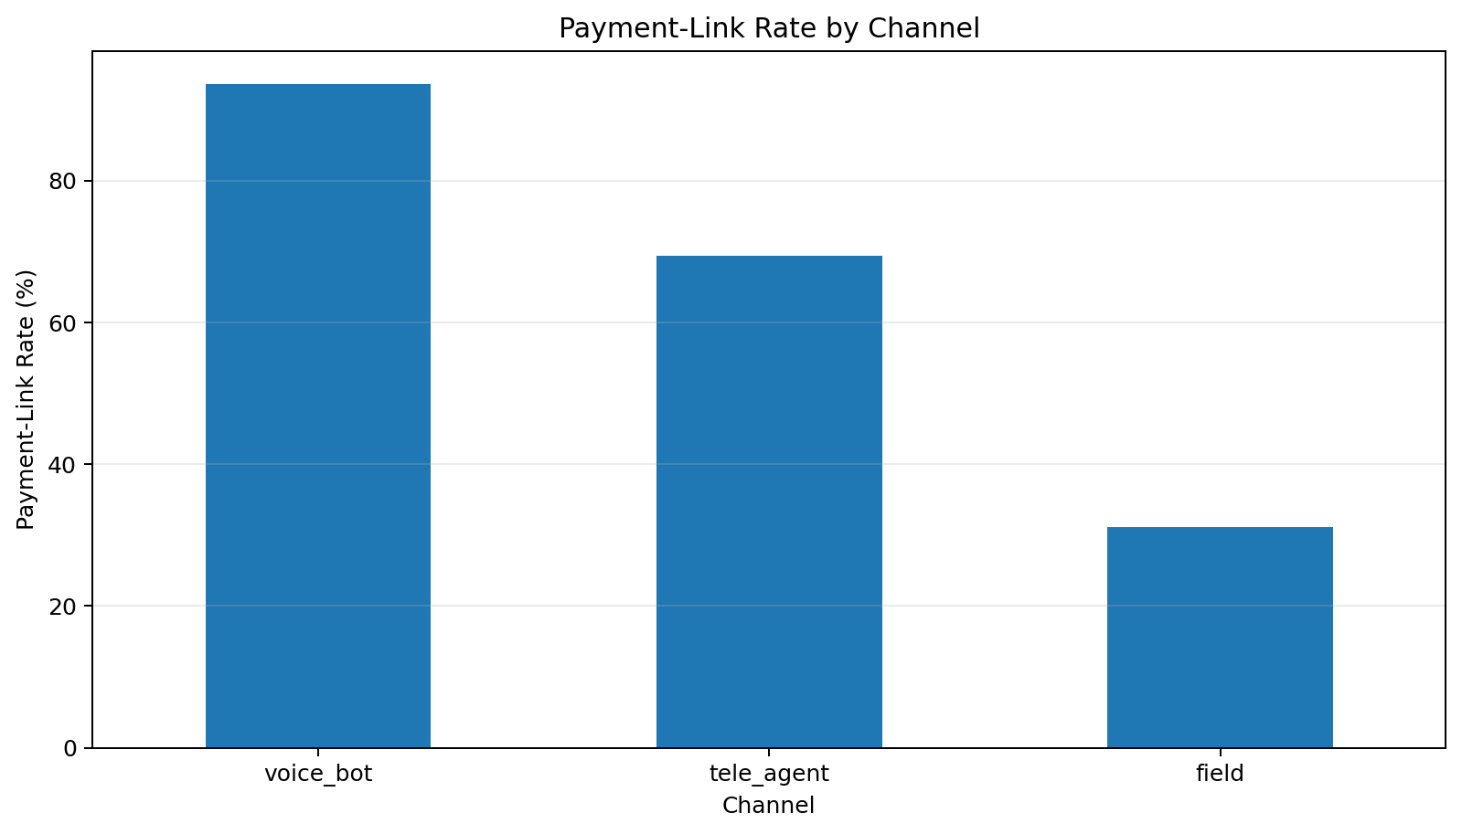
What the graph shows: Payment-link rate by channel.
What we learn: Follow-up behaviour differs across channels.
ML / engineering implication: Use channel-specific campaign policies.

21. Payment Link Rate By Amount
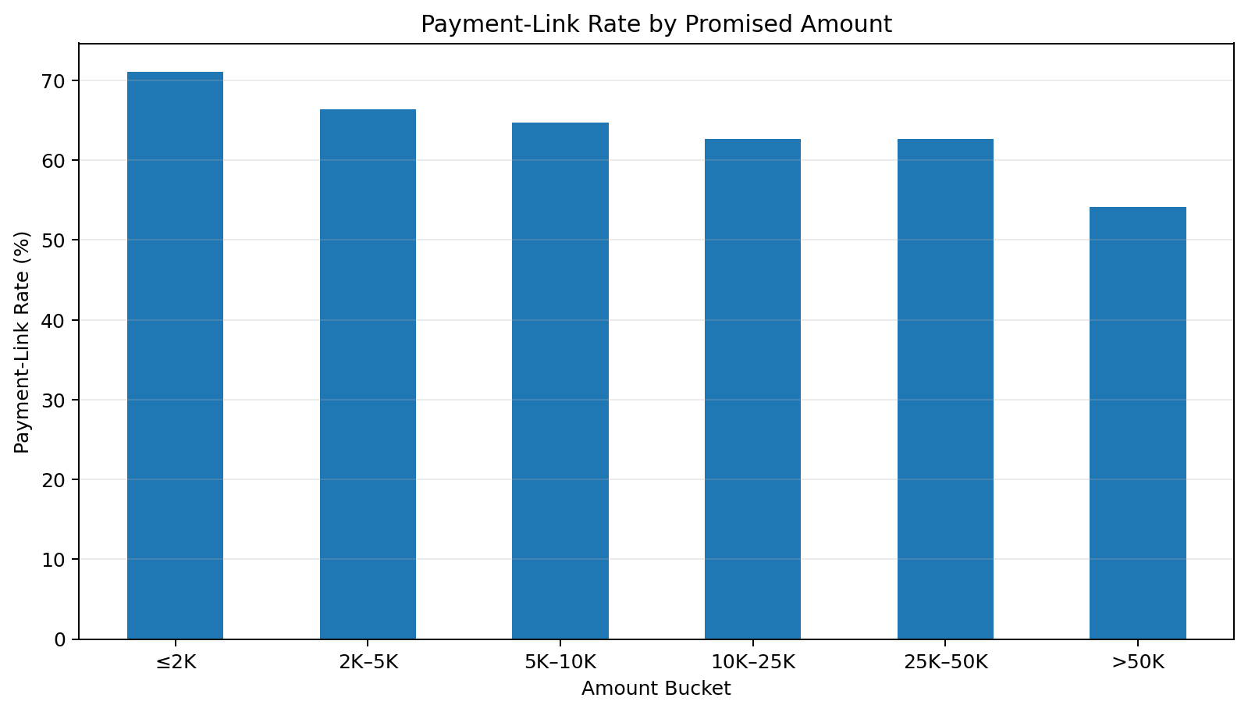
What the graph shows: Payment-link rate by amount.
What we learn: Follow-up rates vary with promised amount.
ML / engineering implication: Amount buckets can support post-call workflow segmentation.

22. Payment Link Rate By Source
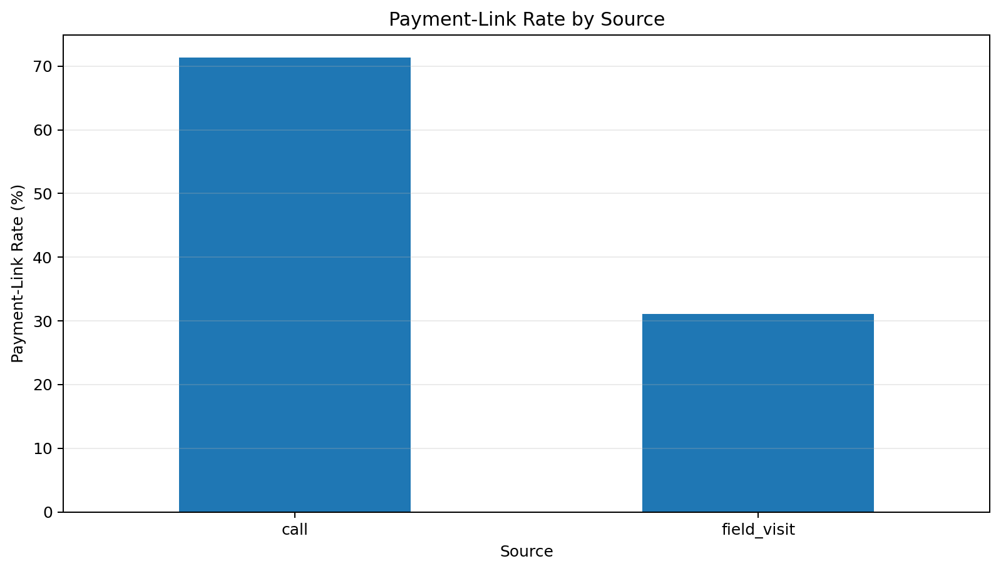
What the graph shows: Payment-link rate by source.
What we learn: Call and field workflows differ in follow-up behaviour.
ML / engineering implication: Source is useful process context.

23. Overdue Vs Promised Relationship
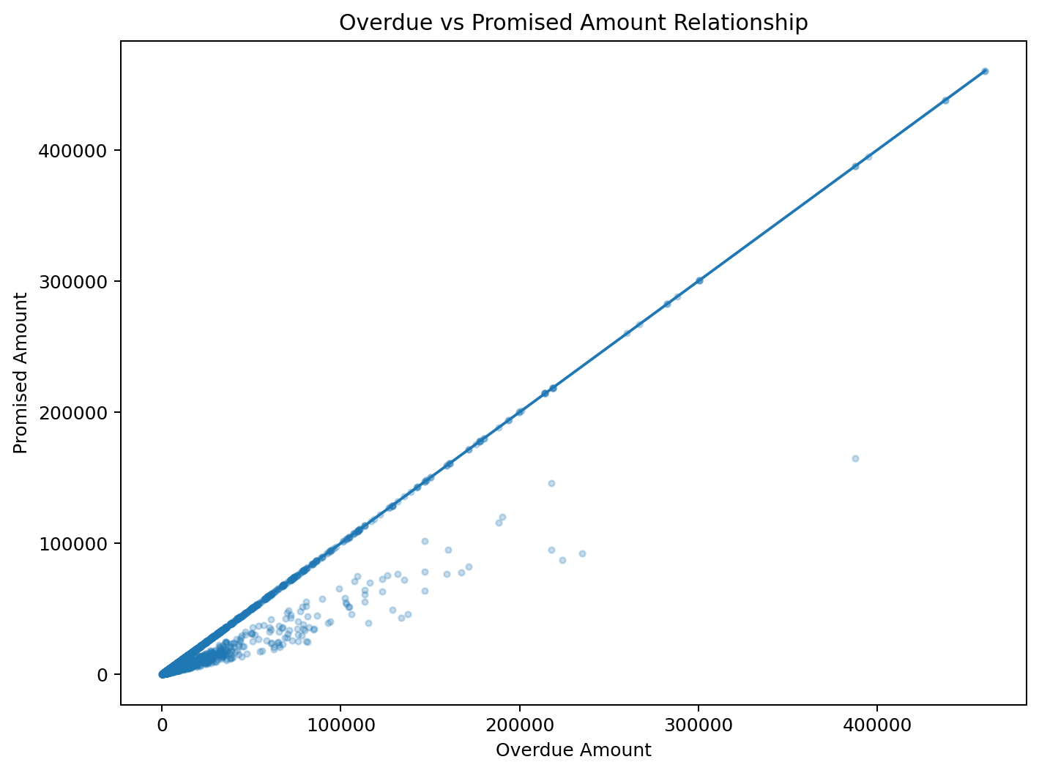
What the graph shows: Overdue versus promised relationship.
What we learn: The financial relationship contains substantial variation around the diagonal.
ML / engineering implication: Deviation from the diagonal is a useful engineered feature.

24. Promise Timing Vs Amount
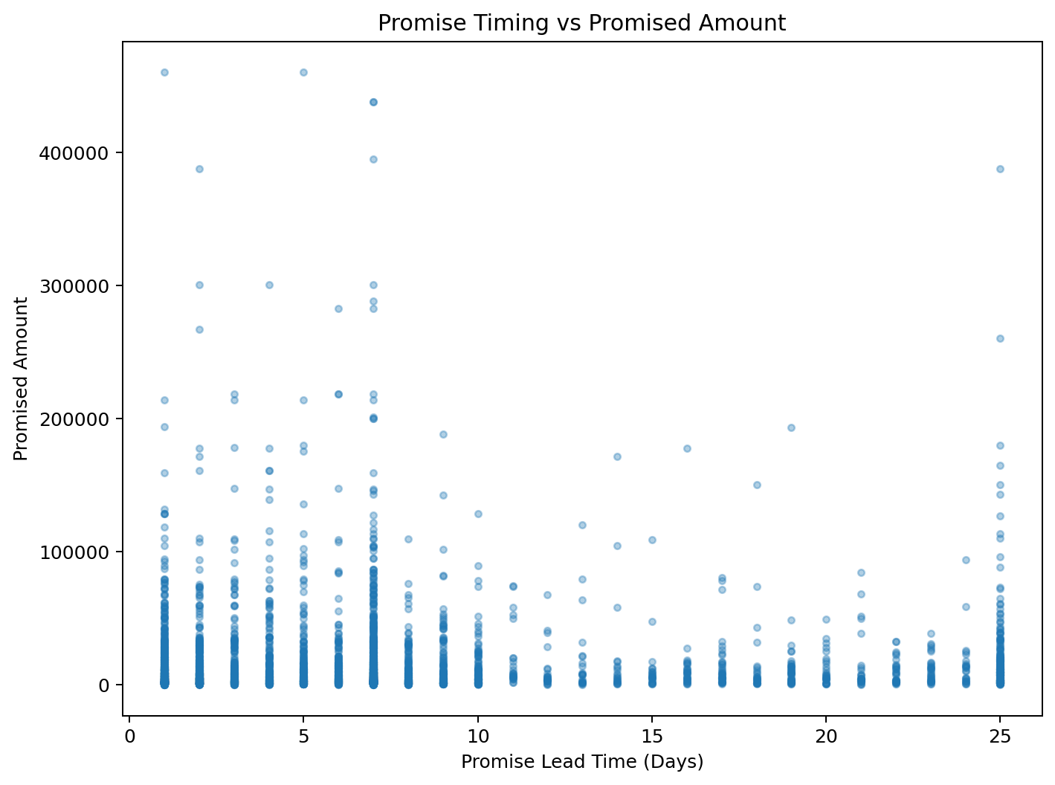
What the graph shows: Promise timing versus amount.
What we learn: Timing and amount show independent variation rather than a simple deterministic rule.
ML / engineering implication: Keep both features.

25. Promised Amount By Channel
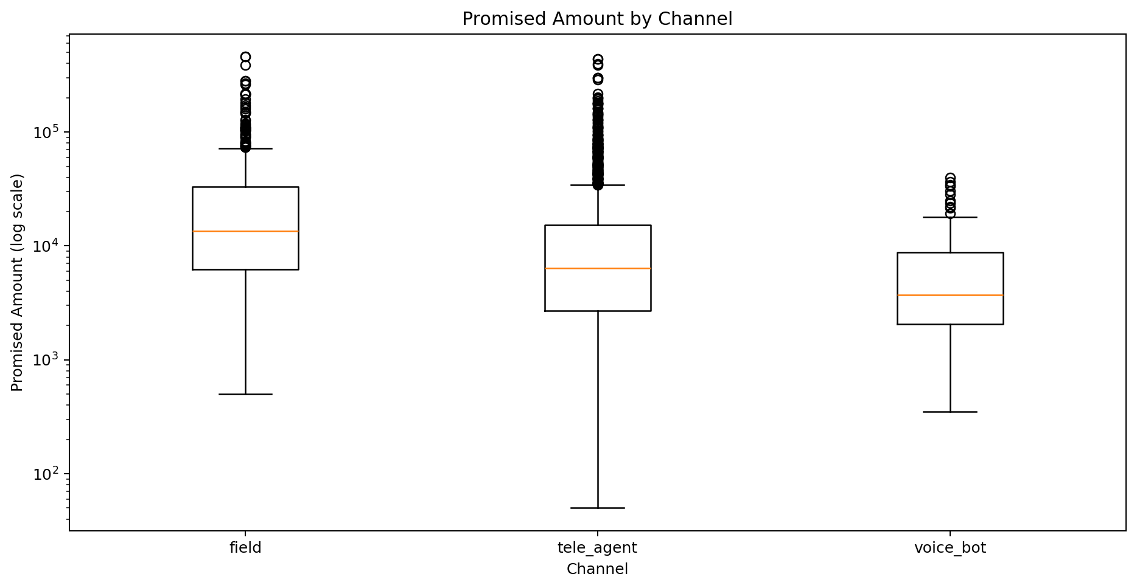
What the graph shows: Promised amount by channel.
What we learn: Amount distributions differ in spread across channels.
ML / engineering implication: Use robust transformations and interactions.

26. Promised Amount By Answerer
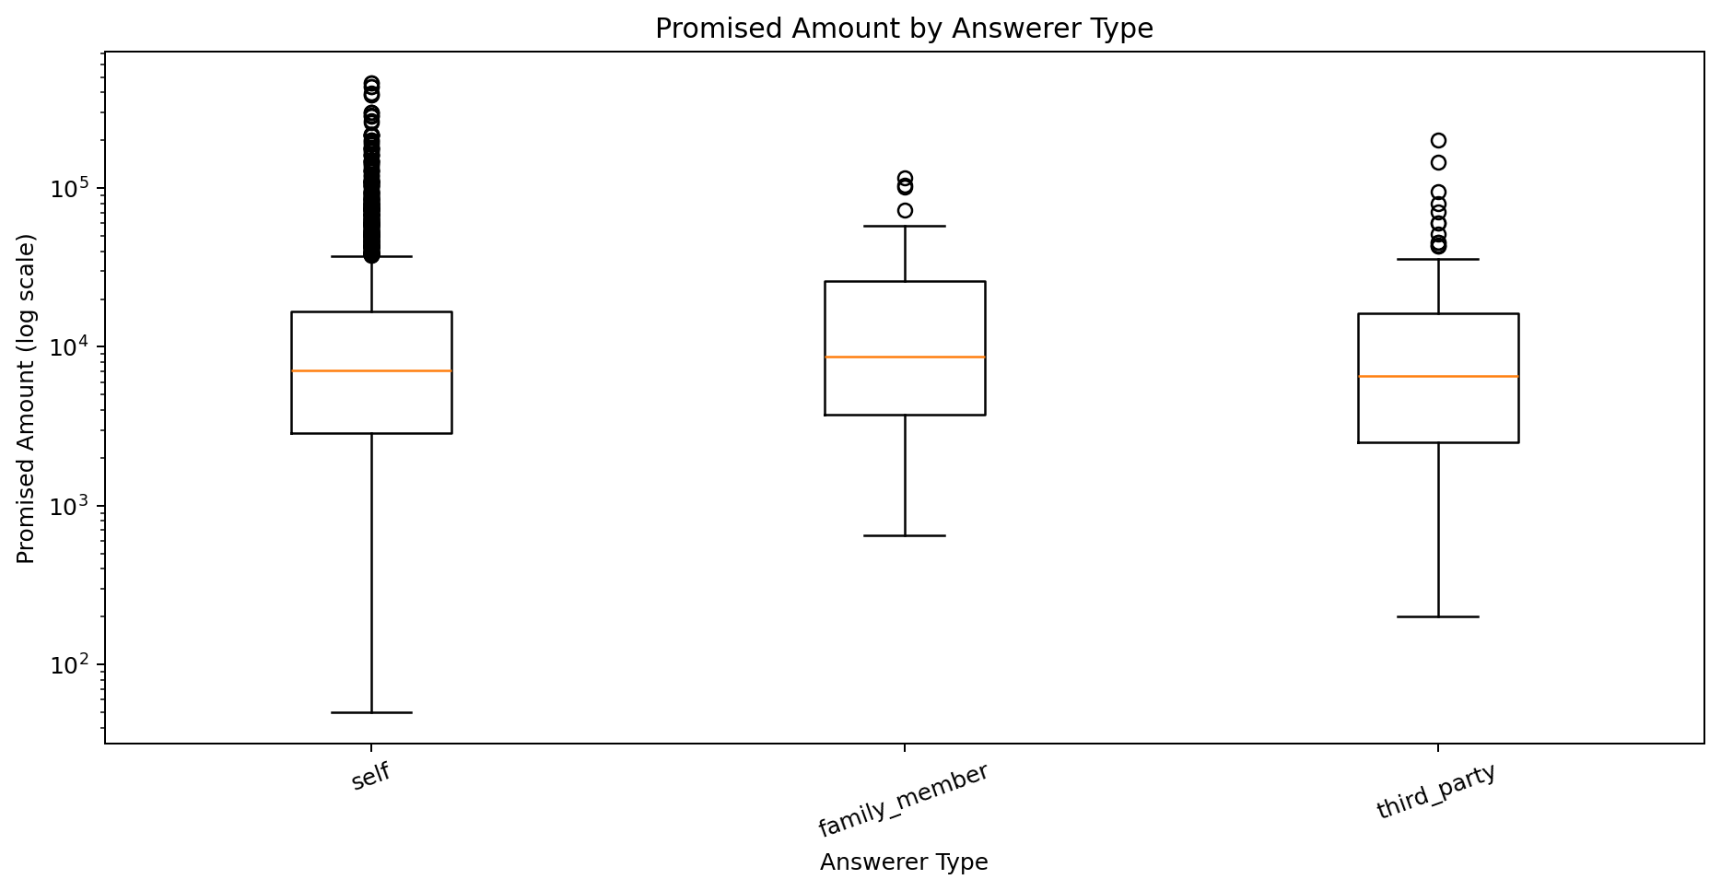
What the graph shows: Promised amount by answerer.
What we learn: Answerer groups have overlapping but different amount distributions.
ML / engineering implication: Use cautiously because minority groups are smaller.

27. Numeric Feature Correlation
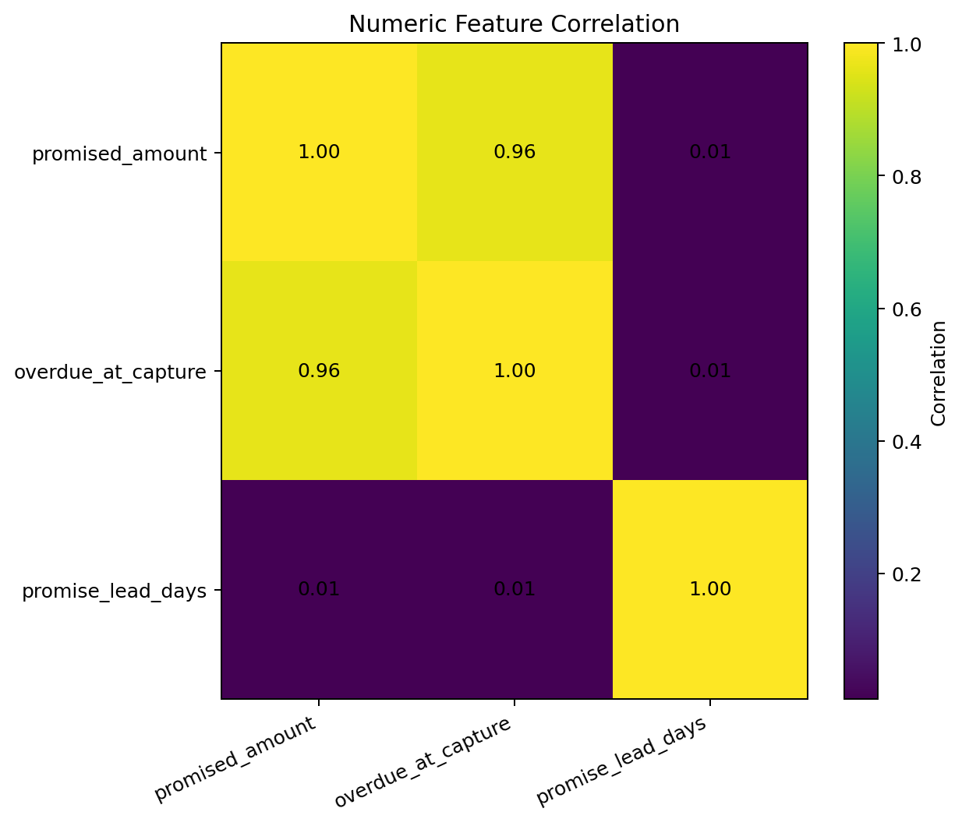
What the graph shows: Numeric correlation.
What we learn: Promised and overdue amounts are related; lead time adds another dimension.
ML / engineering implication: Correlation helps detect redundancy but does not establish causality.

28. Ptp Validation Status
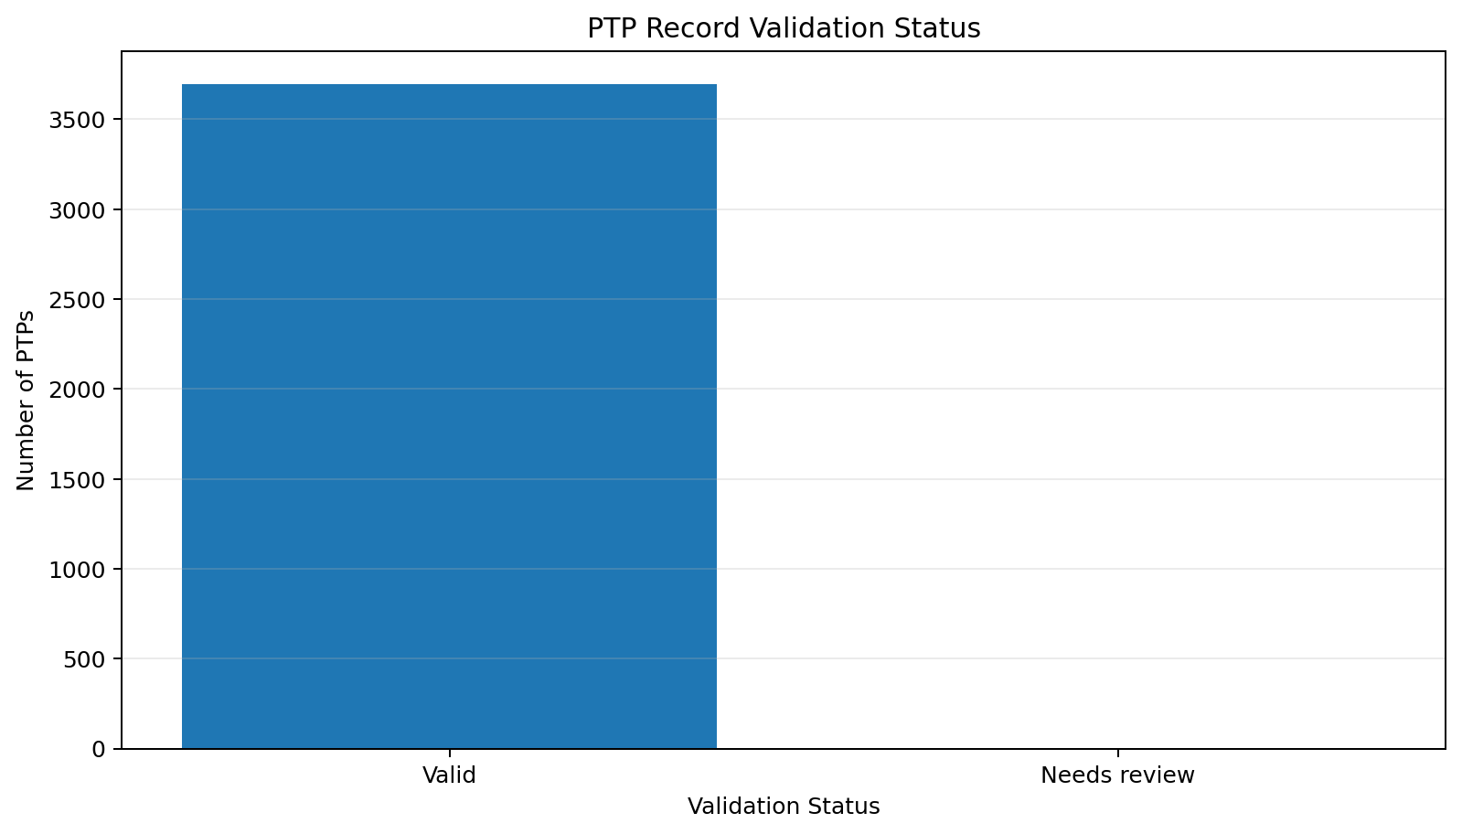
What the graph shows: Validation status.
What we learn: The validation step is diagnostic and does not delete records.
ML / engineering implication: Production should enforce these checks automatically.

29. Business Rule Validation Issues
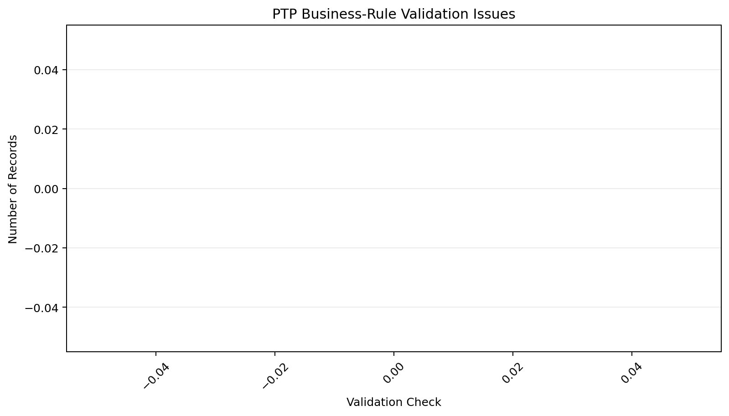
What the graph shows: Business-rule issues.
What we learn: Structural missingness and true invalid values need to be distinguished.
ML / engineering implication: Turn validated rules into pipeline quality checks.

30. Promised Amount Outliers
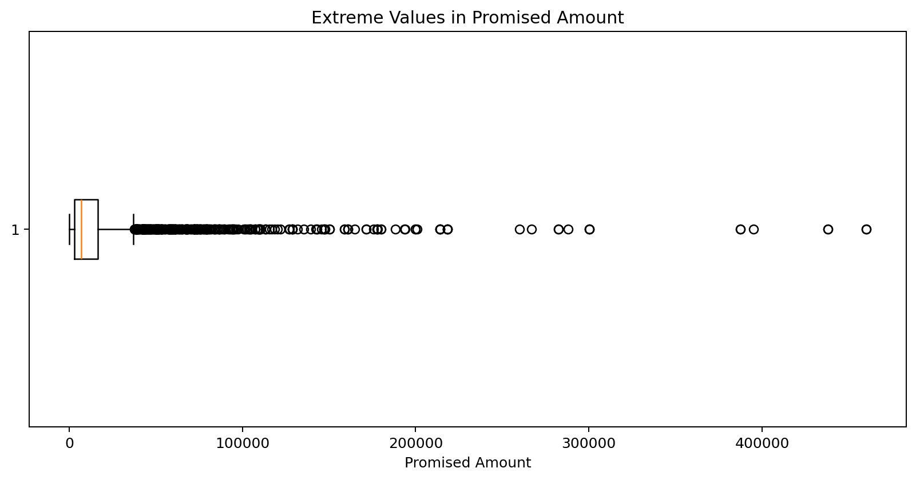
What the graph shows: Promised-amount outliers.
What we learn: The amount variable has a long tail.
ML / engineering implication: Prefer robust/log transforms over arbitrary deletion.

31. Overdue Amount Outliers
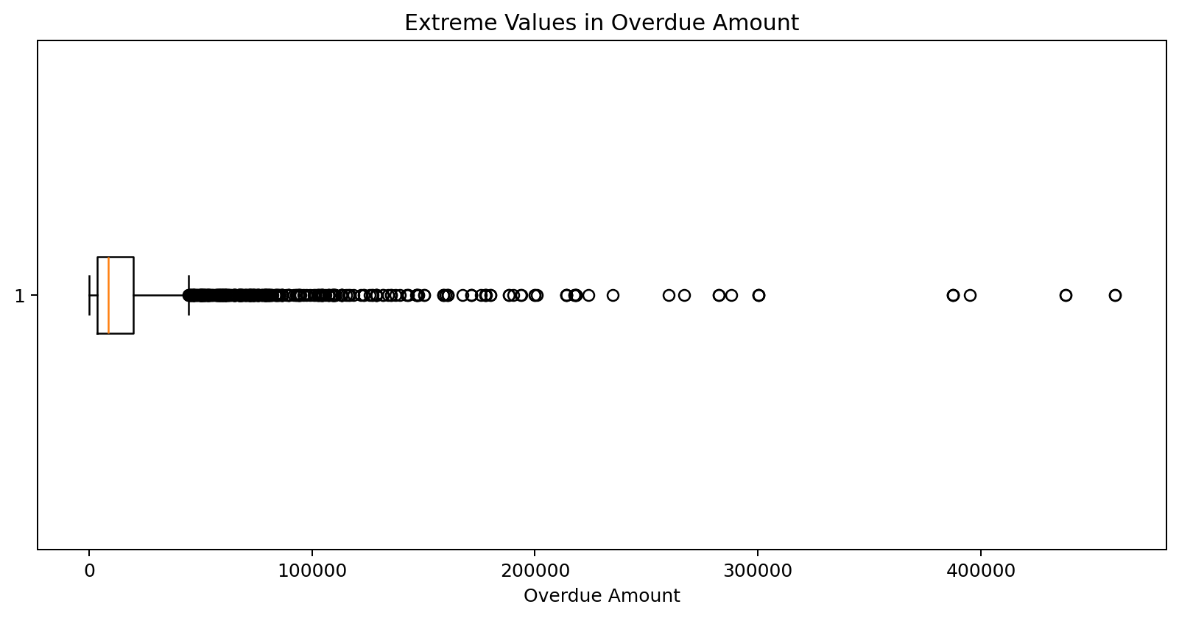
What the graph shows: Overdue-amount outliers.
What we learn: Overdue exposure also contains extreme values.
ML / engineering implication: Retain genuine high-value cases because business impact may be large.

32. Promise Lead Time Outliers
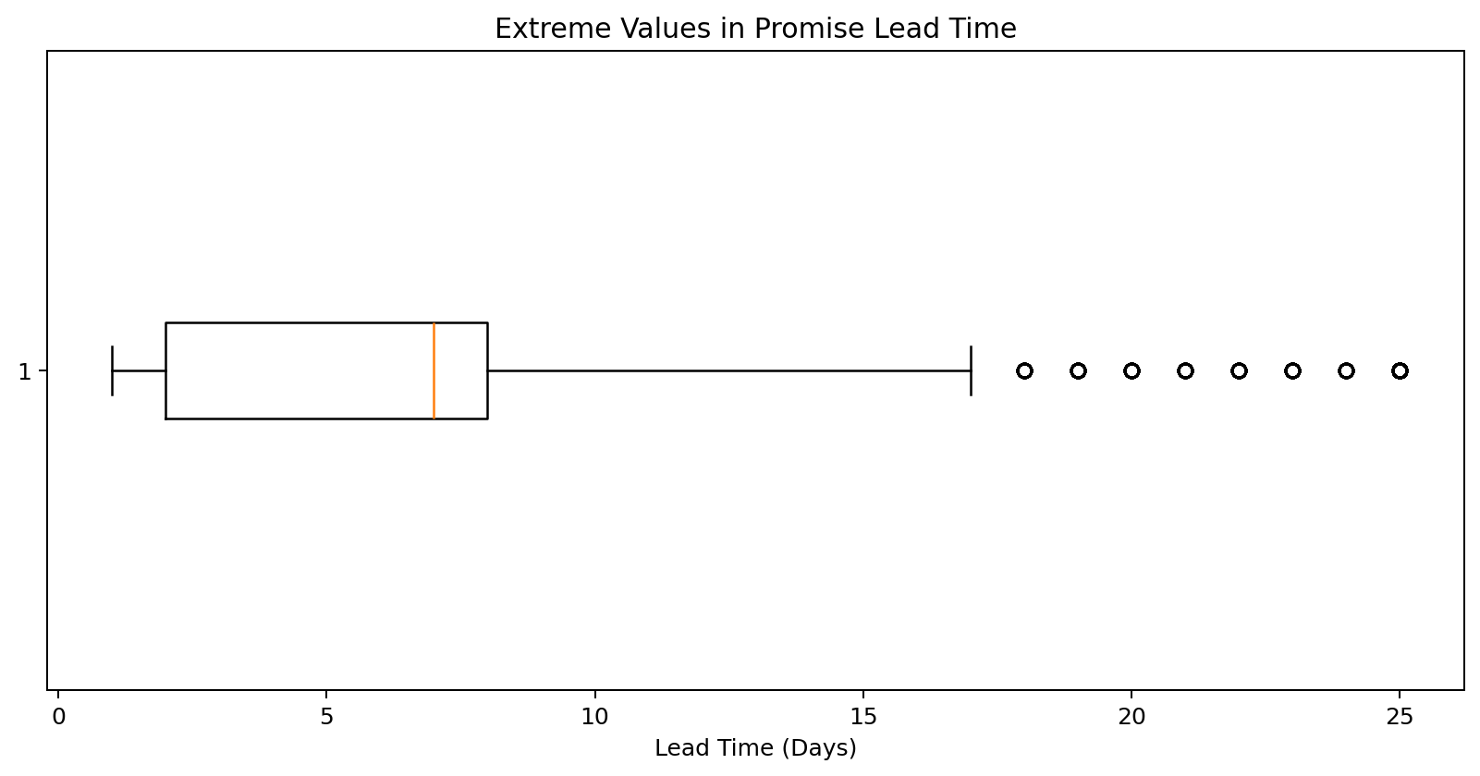
What the graph shows: Lead-time outliers.
What we learn: A small tail contains unusually distant promises.
ML / engineering implication: Consider capped and indicator versions while preserving the raw value.

33. High Value Ptp Distribution
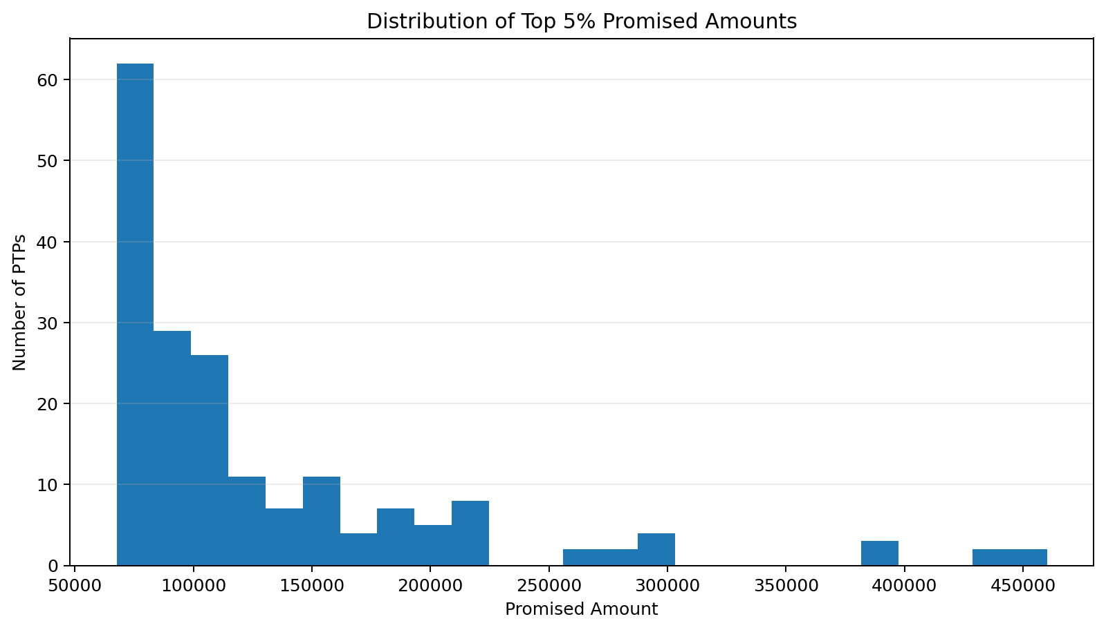
What the graph shows: Top 5% promised amounts.
What we learn: The 95th percentile is ₹67,612.
ML / engineering implication: High-value promises deserve separate calibration and business-impact analysis.

34. Ptp Sequence Distribution
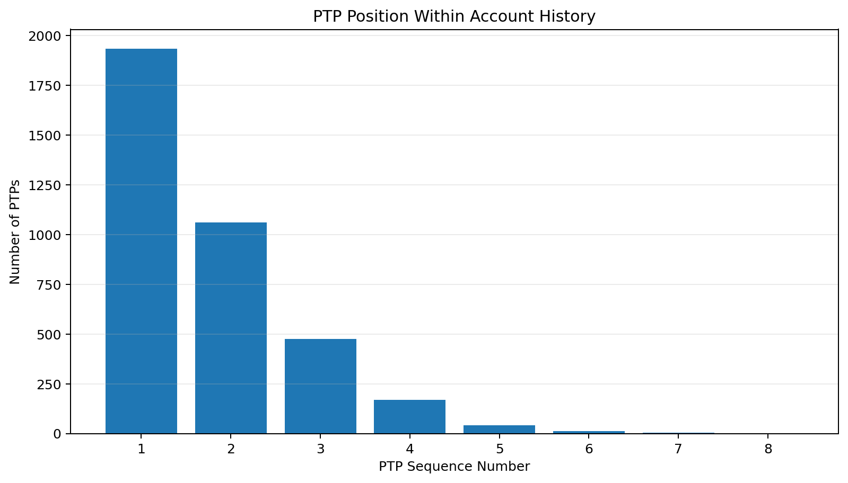
What the graph shows: PTP sequence in account history.
What we learn: Many records occur after an earlier PTP.
ML / engineering implication: Sequence position is a direct repeat-promiser signal.

35. Gap Between Consecutive Ptps
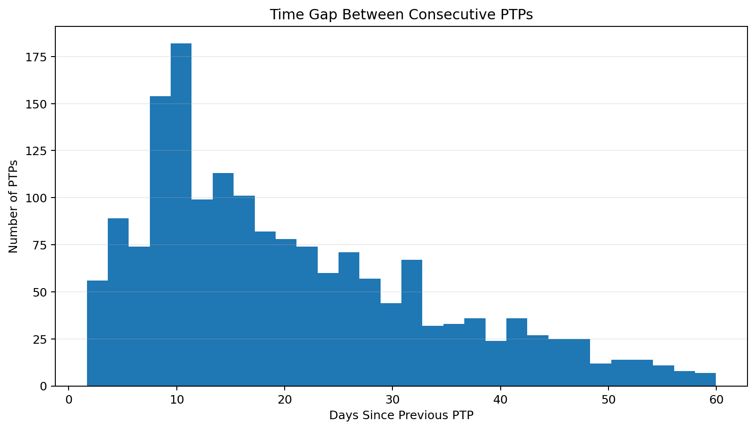
What the graph shows: Gap between consecutive PTPs.
What we learn: Repeat commitments can occur within short intervals.
ML / engineering implication: Recency since the last PTP should be engineered.

36. Repeated Promised Amount
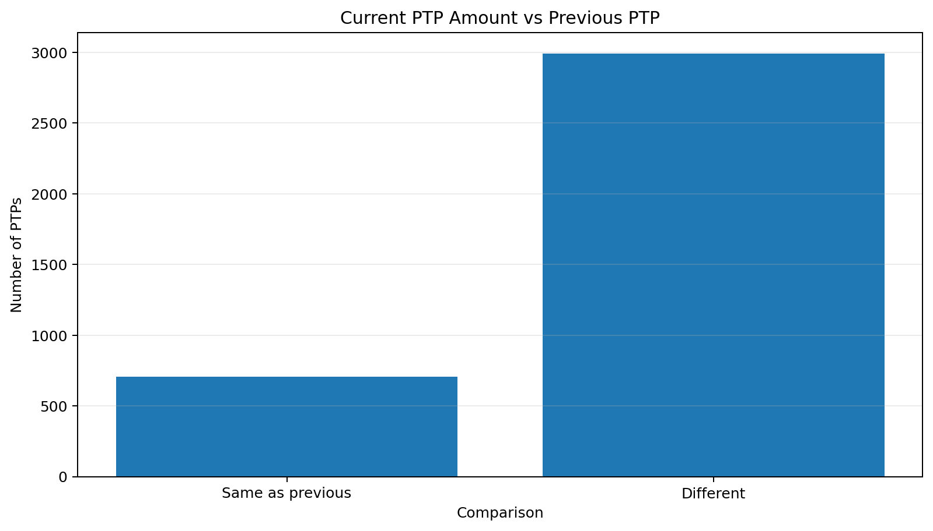
What the graph shows: Repeated promised amount.
What we learn: Some repeat PTPs preserve the previous amount while others change it.
ML / engineering implication: Amount-change magnitude is a useful history feature.

37. Repeated Promised Date
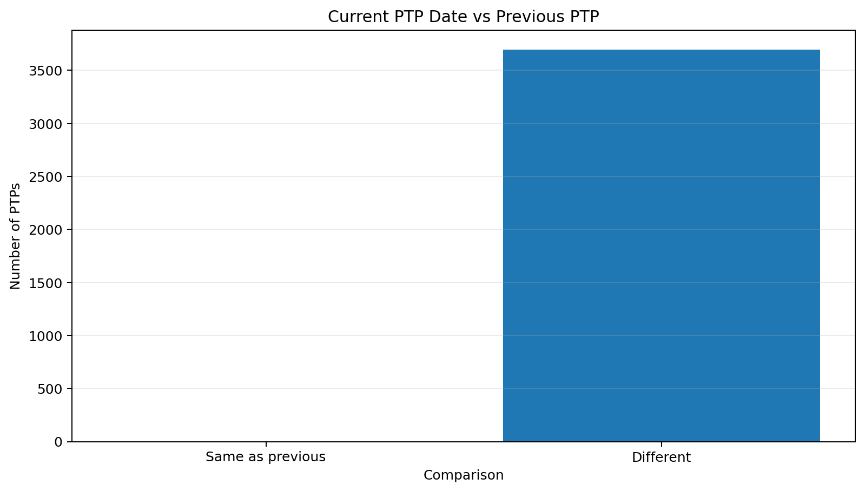
What the graph shows: Repeated promised date.
What we learn: Repeat PTPs can preserve or move the previous date.
ML / engineering implication: Date postponement is a useful behavioural signal.

38. Annotated Join Coverage
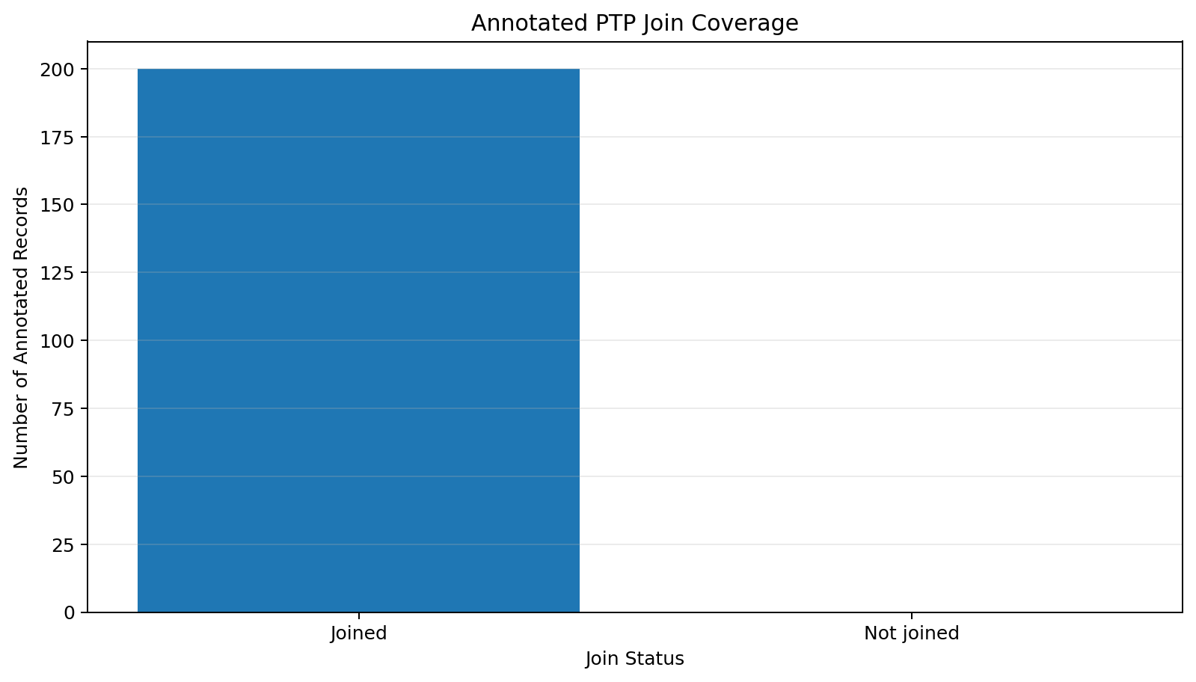
What the graph shows: Annotated join coverage.
What we learn: All 200 annotated records join to the operational table.
ML / engineering implication: The labelled subset can therefore be analysed without unmatched-label loss.

39. Annotated Ptp Type Distribution
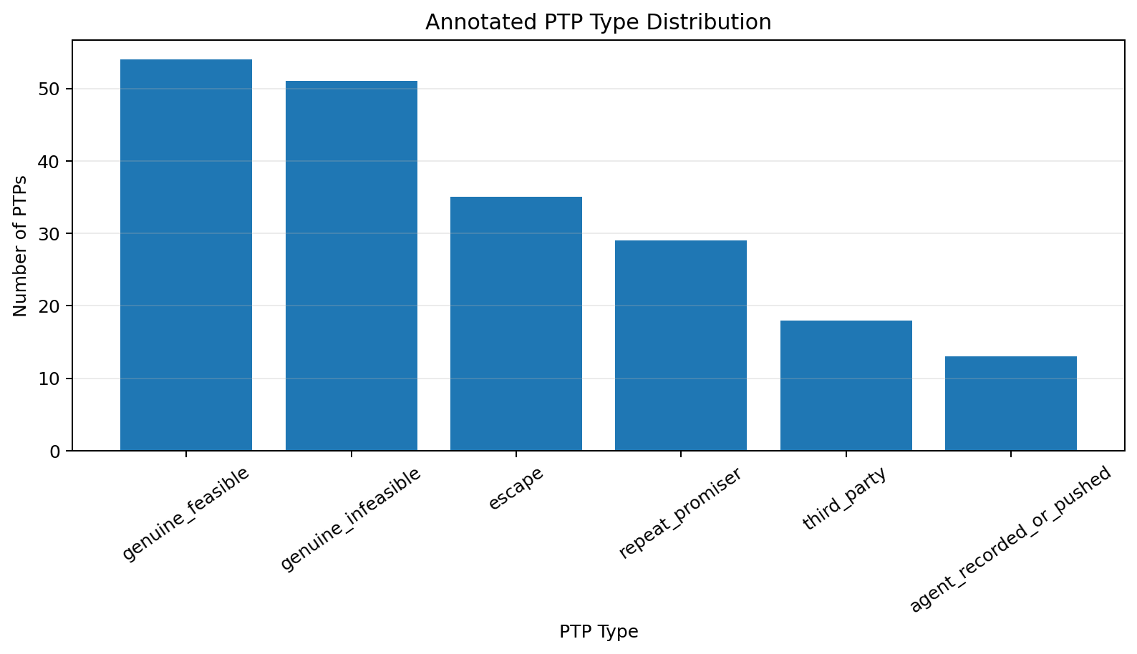
What the graph shows: Annotated PTP types.
What we learn: The labelled sample contains six operational classes.
ML / engineering implication: The target is multiclass and should preserve genuine hardship versus insincerity distinctions.

40. Ptp Type By Channel
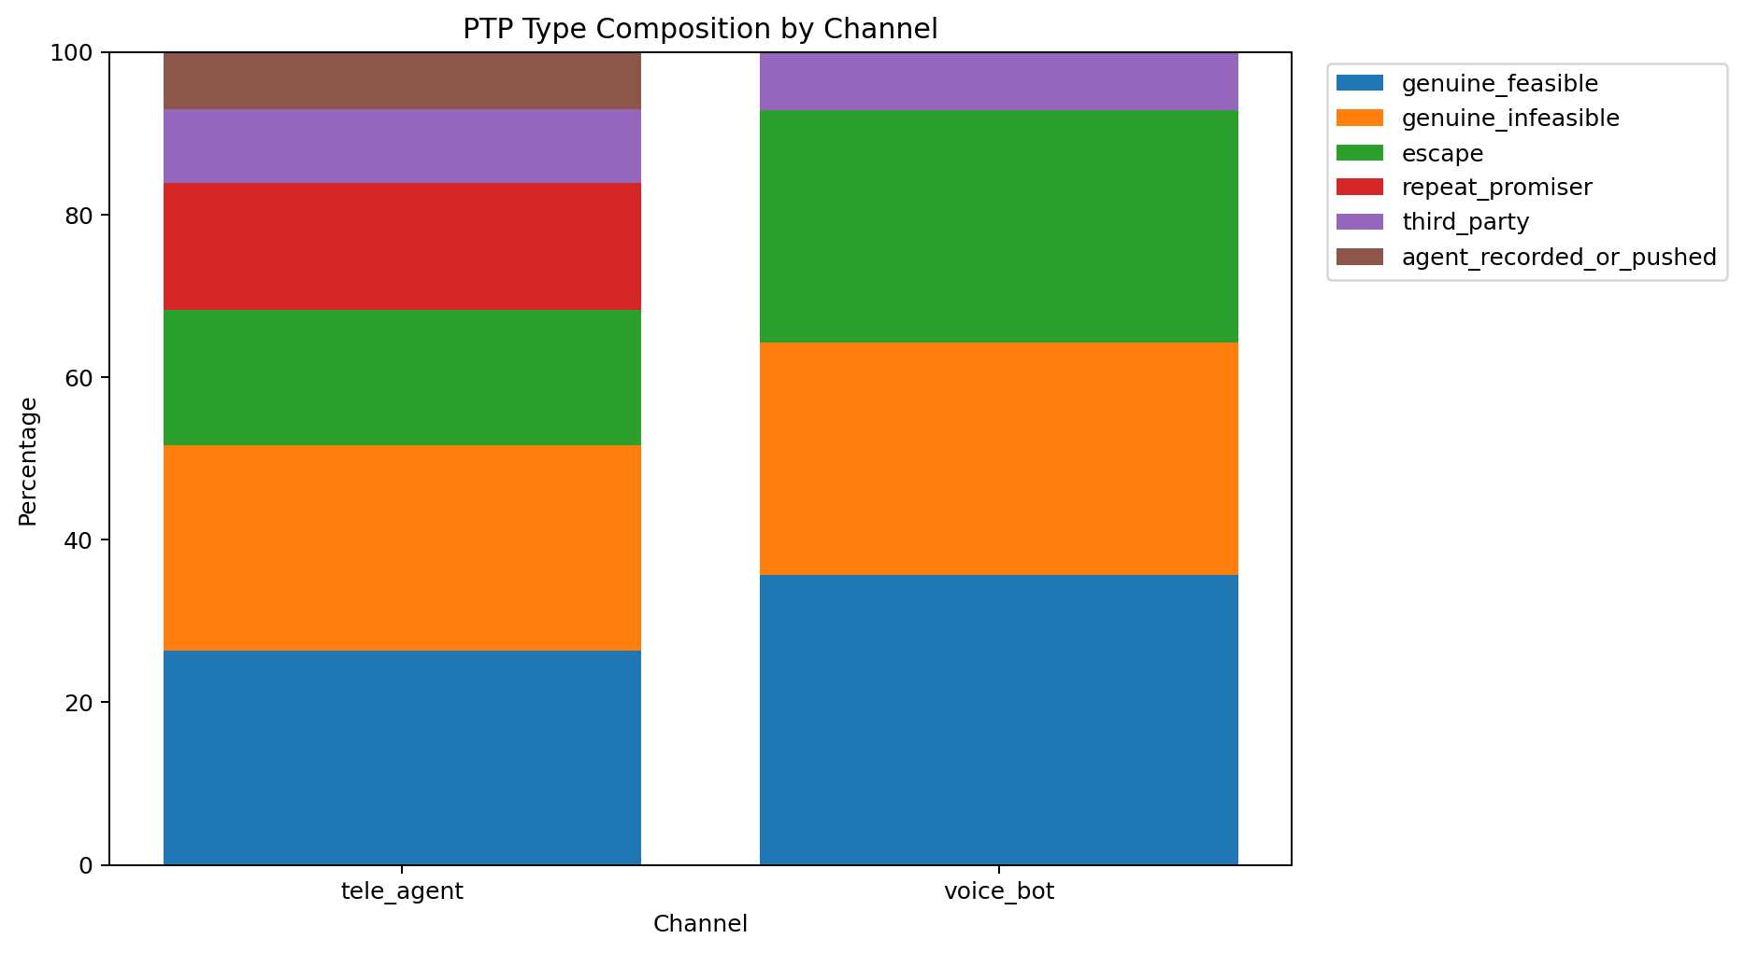
What the graph shows: PTP type by channel.
What we learn: Class composition varies across channels in the labelled sample.
ML / engineering implication: Channel is informative but must not become a shortcut.

41. Ptp Type By Answerer
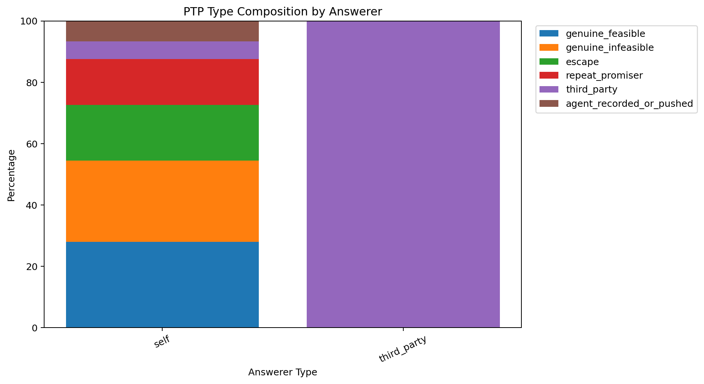
What the graph shows: PTP type by answerer.
What we learn: Answerer categories show different label mixtures.
ML / engineering implication: This is especially relevant for third-party promises.

42. Promised Amount By Ptp Type
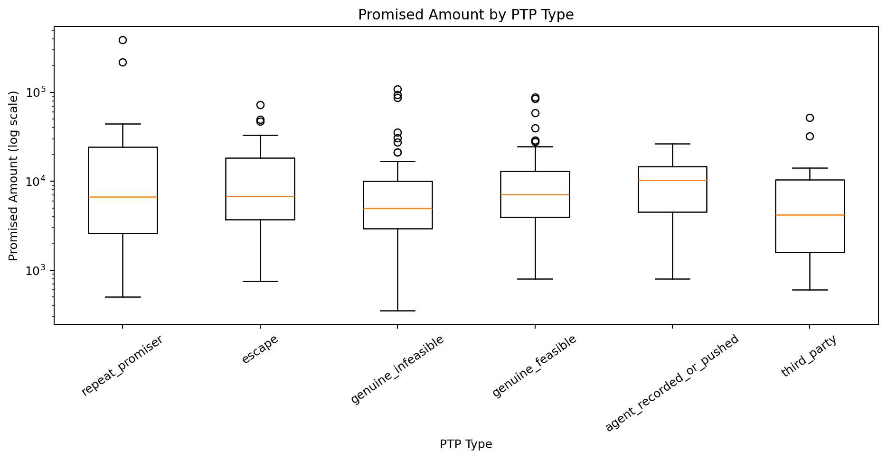
What the graph shows: Promised amount by PTP type.
What we learn: Amount distributions overlap substantially between classes.
ML / engineering implication: Amount should be combined with conversation and history signals.

43. Overdue Amount By Ptp Type
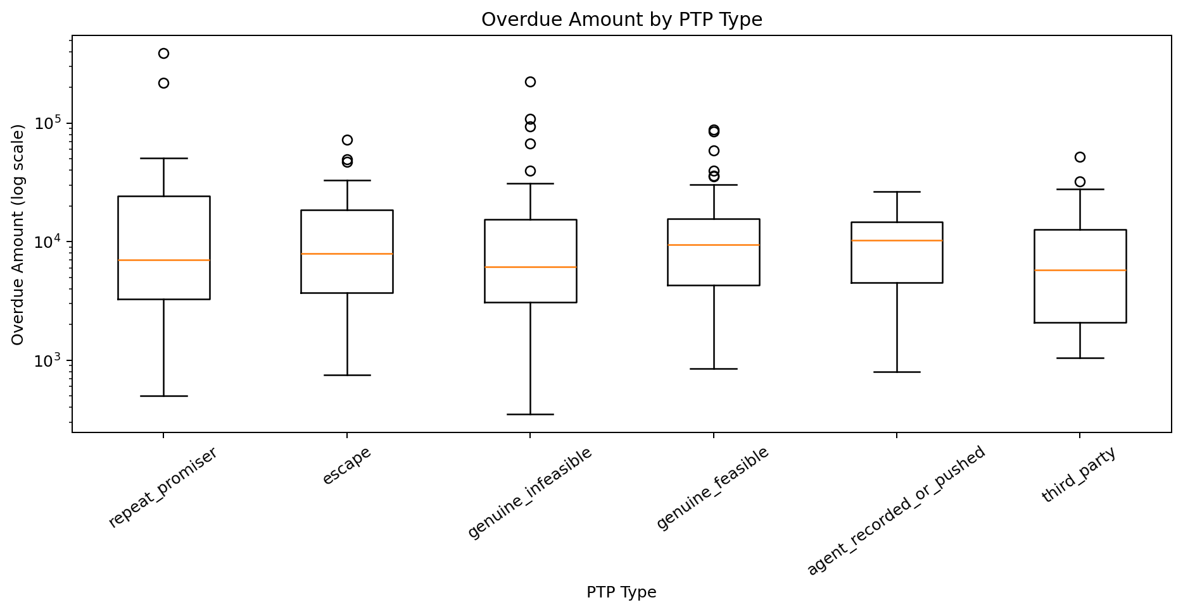
What the graph shows: Overdue amount by PTP type.
What we learn: Financial exposure varies within every class.
ML / engineering implication: Overdue amount alone cannot identify insincerity.

44. Promise Lead Time By Ptp Type
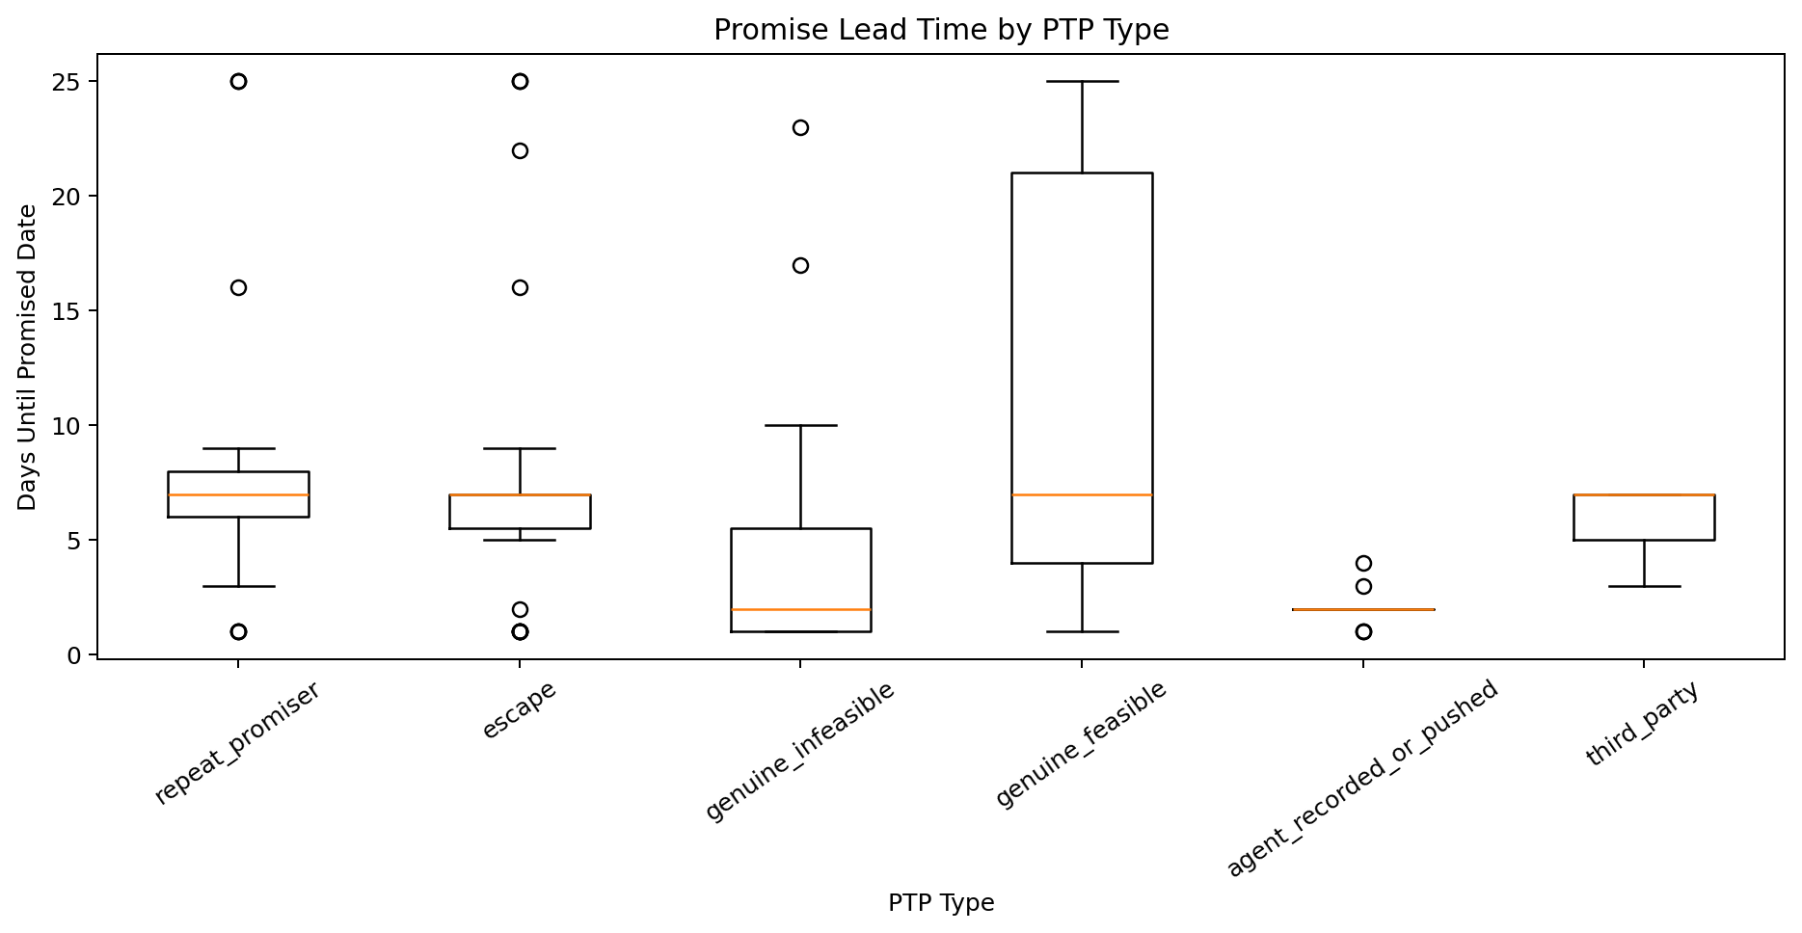
What the graph shows: Lead time by PTP type.
What we learn: Timing distributions overlap but can differ in central tendency.
ML / engineering implication: Lead time is a useful interpretable class signal.

45. Payment Link By Ptp Type
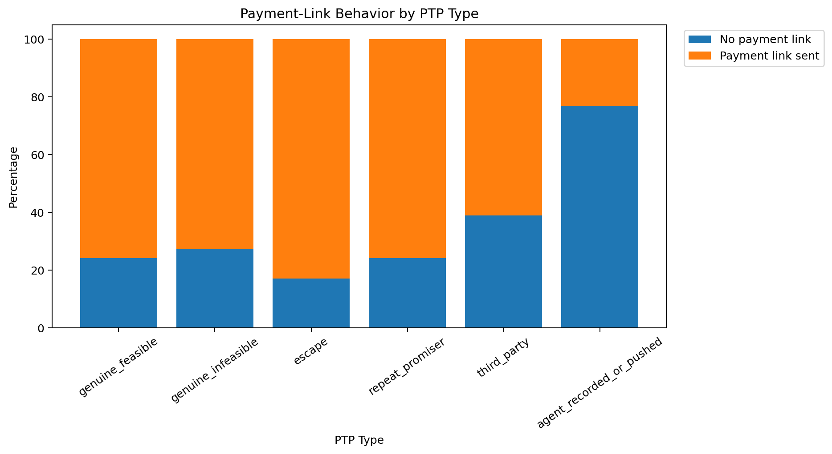
What the graph shows: Payment-link behaviour by PTP type.
What we learn: Follow-up events differ across labels.
ML / engineering implication: Use only after proving temporal availability at the scoring point.

46. Ptp Type By Account Sequence
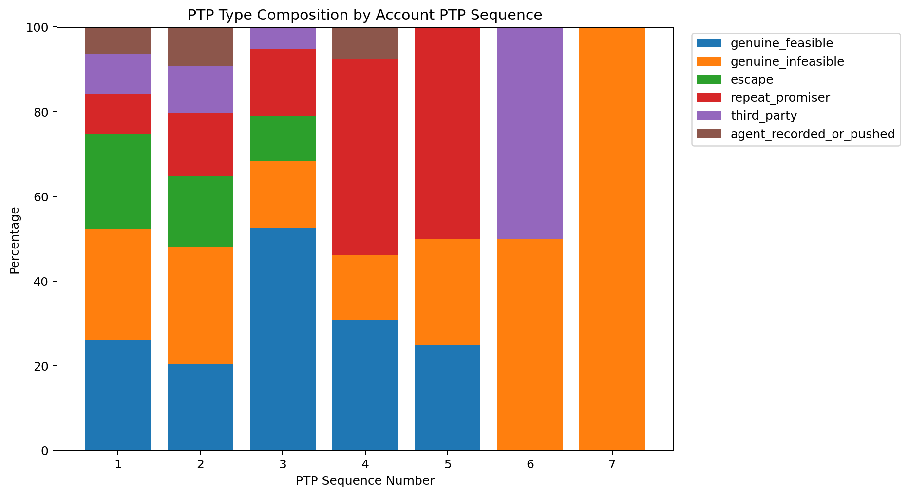
What the graph shows: PTP type by account sequence.
What we learn: Class mixture changes with account history position.
ML / engineering implication: History is a strong candidate for repeat-promiser detection.

47. Confidence By Ptp Type
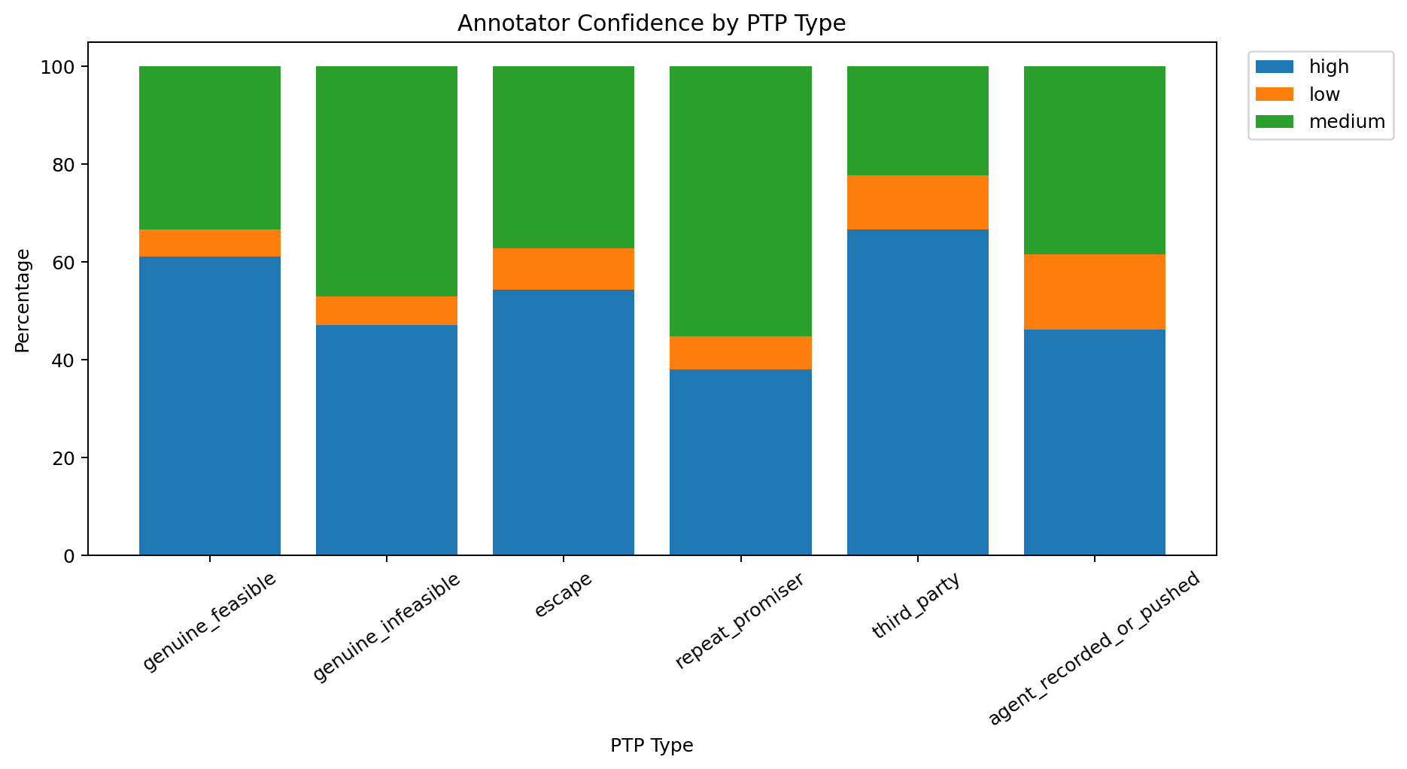
What the graph shows: Annotator confidence by PTP type.
What we learn: Confidence differs across classes.
ML / engineering implication: Use confidence-aware review and avoid treating every label as equally certain.

48. Annotated Feature Correlation
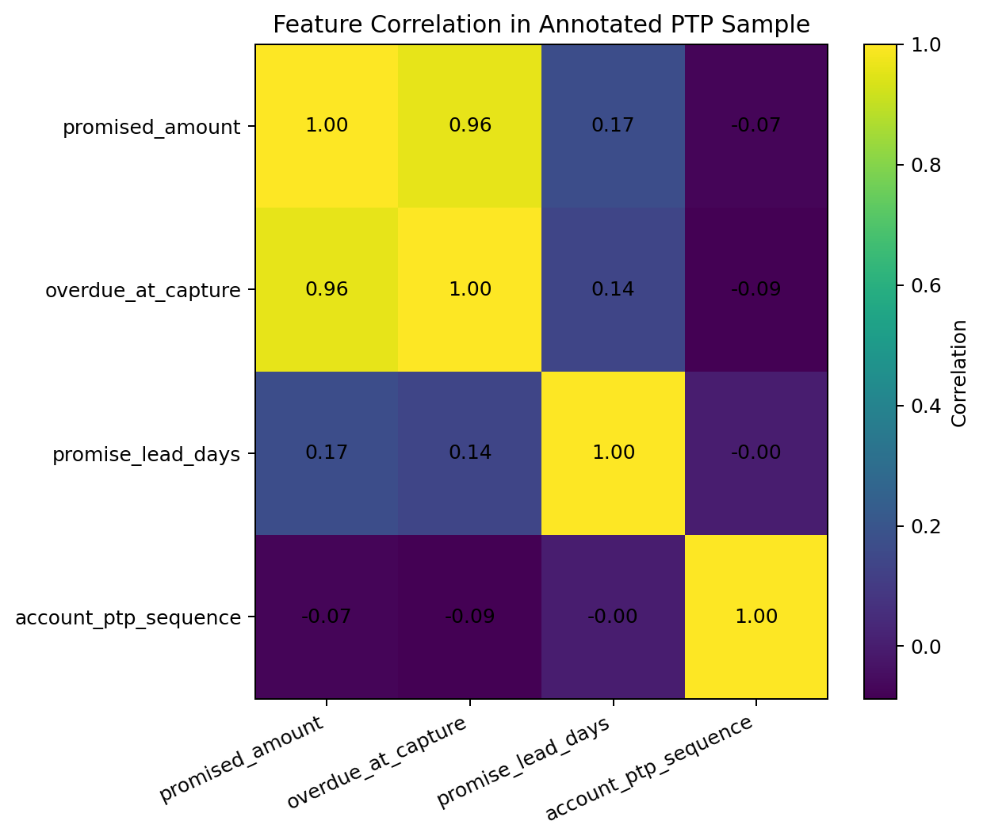
What the graph shows: Numeric correlations in labelled data.
What we learn: Financial magnitude features are related while timing and history add distinct dimensions.
ML / engineering implication: Feature design should consider leakage and availability, not correlation alone.

PS1-Oriented Final Takeaways

Account history is first-class
Sequence, recency, repeated amounts and date movement directly support repeat-promiser detection.

Live scoring needs a strict feature contract
Only information available by the prediction timestamp should enter the real-time score.

Conversation evidence remains essential
The current PTP table cannot capture hedging, conditional language, negotiation, borrower-vs-agent proposal or vocal hesitation.

Hardship must remain distinct from insincerity
The labelled classes explicitly separate genuine infeasibility from escape promises; the model should preserve this distinction.

Label scale is the immediate bottleneck
The current labelled sample contains only 200 records, so more reviewed examples are required before serious supervised modelling.

Evaluation must be business-aware
AUC alone is insufficient. Calibration, early detection of broken PTPs, hardship misclassification, recovered amount and randomized prompt evaluation matter.

Recommended Next Step
- Join call transcripts and post-call/payment events using PTP/account/attempt identifiers.
- Define the exact prediction timestamp and remove post-event leakage.
- Engineer transcript features for specificity, hedging, conditions, negotiation, pressure and who proposed the commitment.
- Build account-history features from prior PTP behaviour.
- Create a calibrated multiclass or hierarchical model with explicit treatment of label uncertainty.
- Use account-aware and time-based validation.
- Evaluate the in-call prompt through a randomized trial because the intervention can change the outcome.
Report note: No source rows were deleted as part of EDA. Visual restrictions and derived columns were used only for analysis/plot readability.

