CreditNirvana PS1
Call Transcripts EDA
Real-Time Fake PTP Detection | Conversation-Level Analysis
Exploratory analysis of transcript structure, text characteristics, and annotated PTP conversations.

1. Executive Summary
The call_transcripts dataset provides turn-level conversation data including speaker identity, relative timestamps, pauses, transcript text, and ASR confidence.
The analysis examines the dataset at both turn level and call level, followed by a focused comparison of conversations associated with the six annotated PTP types.
The purpose of this EDA is to understand the structure and quality of the available conversation data. The analysis is exploratory and does not claim that any observed pattern is predictive or causal.

2. Dataset Profile
The transcript dataset contains 39,194 transcript turns across 3,367 unique calls. The available fields describe who spoke, when the turn occurred, the transcript text, and the confidence associated with automatic speech recognition.
- 39,194 transcript turns.
- 3,367 unique calls.
- Speaker information is available at turn level.
- Relative start and end timestamps are available.
- Pause-before-turn information is available.
- ASR confidence is available for transcript turns.
- The annotated PTP sample provides six labelled PTP categories for a smaller subset of conversations.

3. Core Transcript Structure

3.1 Speaker Distribution
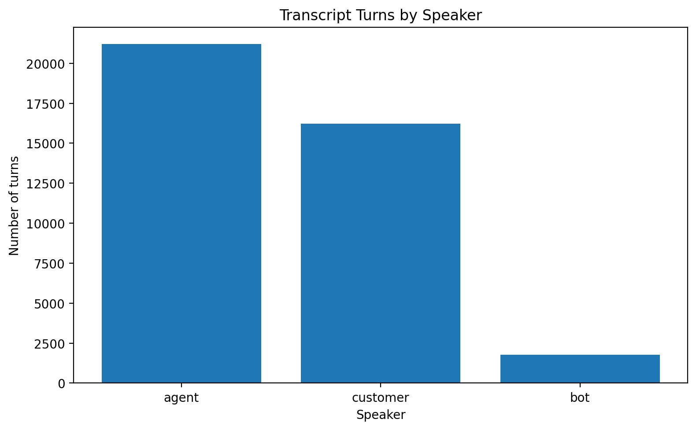
What the graph shows: The graph shows the number of transcript turns attributed to each available speaker category.
What we learn: The transcript dataset contains multiple speaker roles, allowing the conversation to be analysed as an interaction rather than as a single block of text.
EDA implication: Speaker identity is an important dimension for interpreting conversation behaviour because borrower/customer statements must be distinguished from agent or bot statements.

3.2 Turns per Call
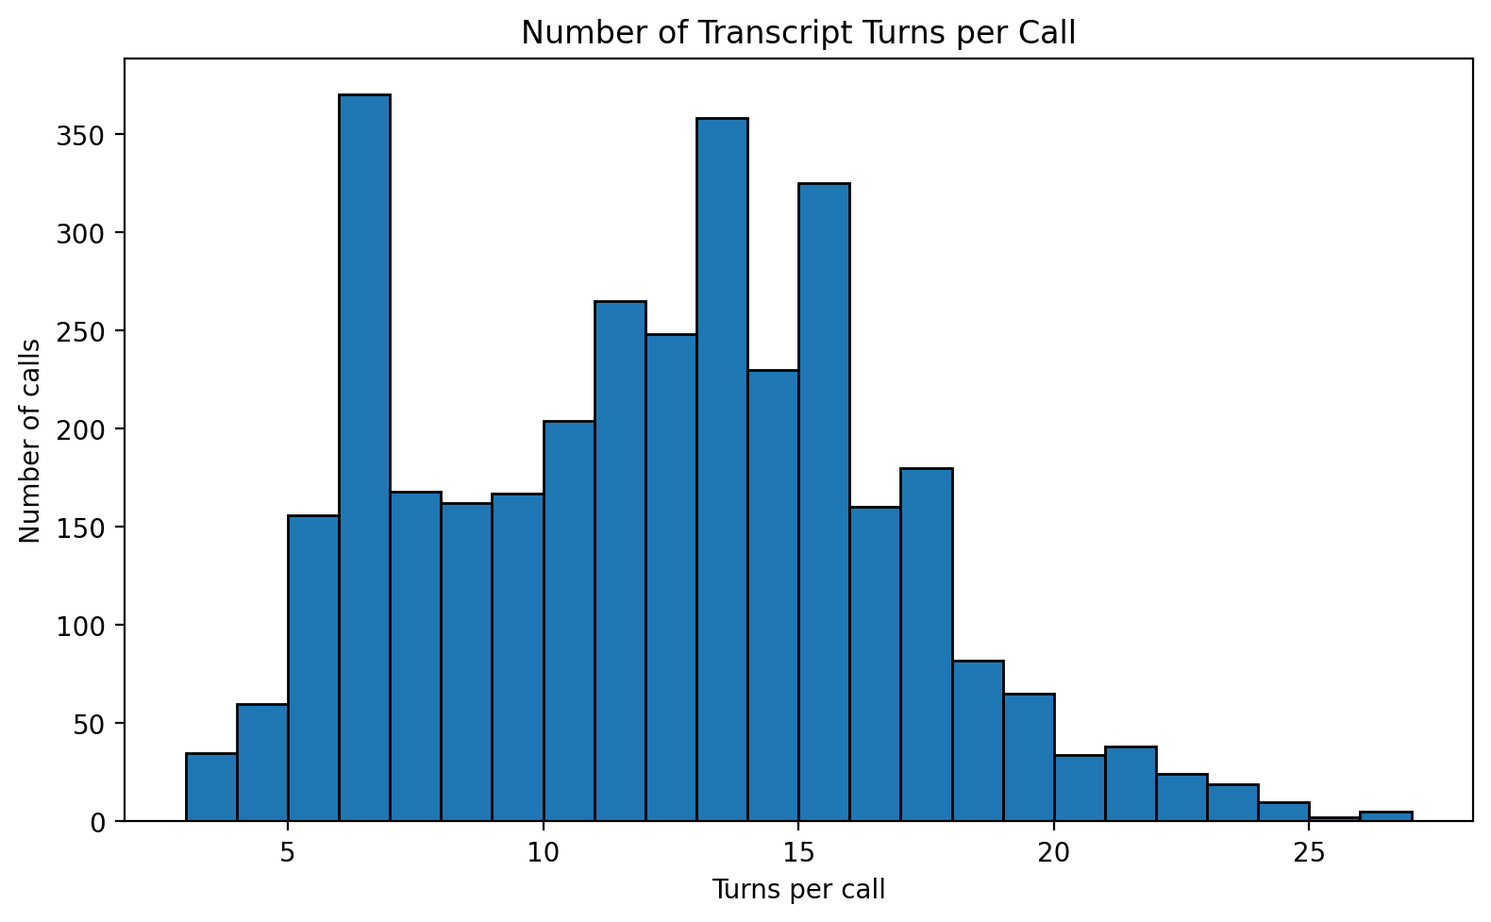
What the graph shows: The graph shows how many transcript turns occur within individual calls.
What we learn: Calls vary in conversational length and interaction depth.
EDA implication: Call-level summaries should preserve this variation rather than treating every transcript turn as an independent call.

3.3 Call Duration
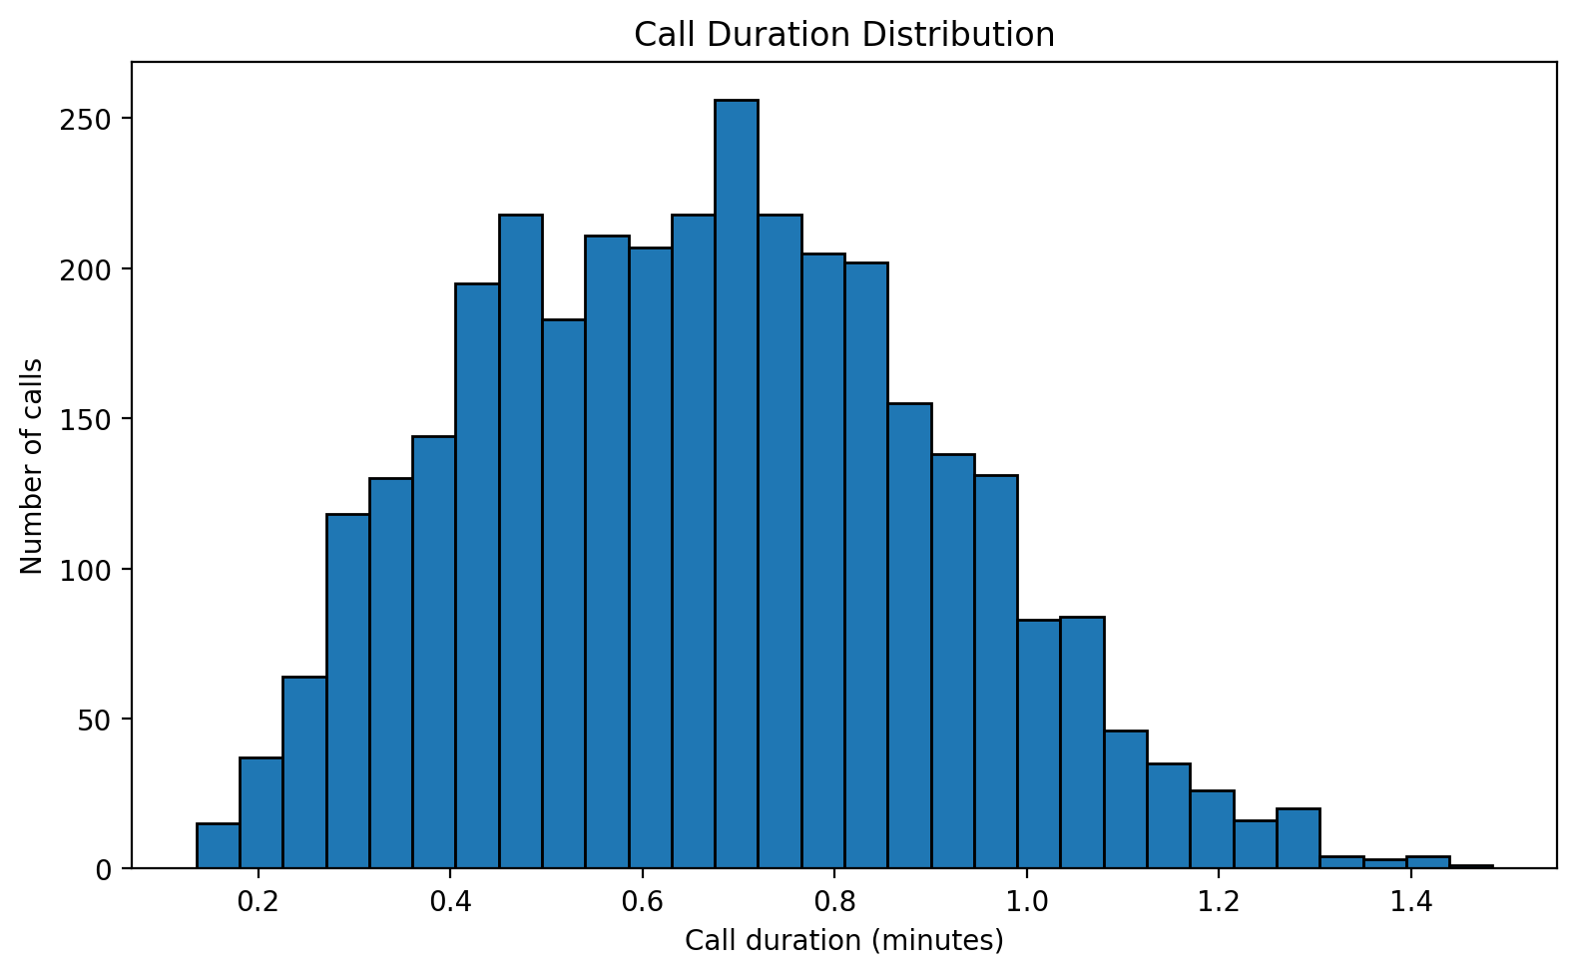
What the graph shows: The graph shows the distribution of call duration.
What we learn: The collection conversations have varying temporal lengths.
EDA implication: Duration provides useful context for interpreting the amount of conversational evidence available within a call.

3.4 Transcript Length
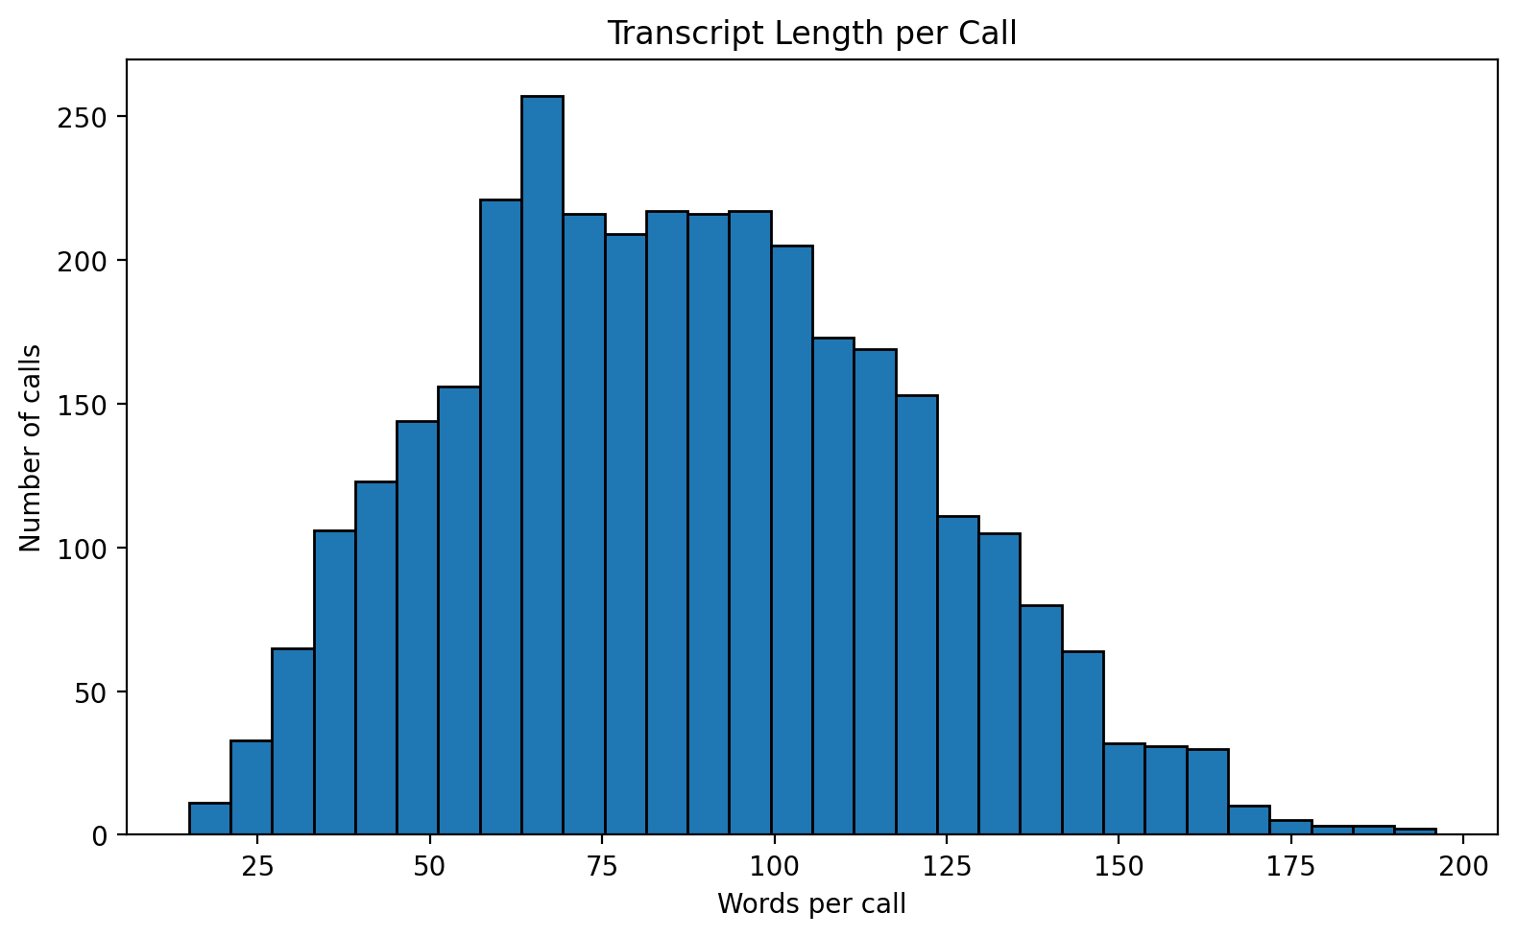
What the graph shows: The graph shows the number of words represented in each call.
What we learn: Some calls contain substantially more textual information than others.
EDA implication: Transcript length should be considered when interpreting conversation-level statistics.

3.5 ASR Confidence Distribution
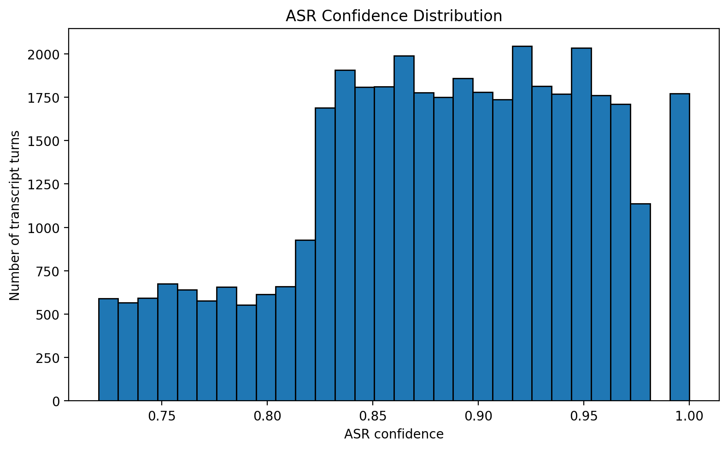
What the graph shows: The graph shows the distribution of ASR confidence across transcript turns.
What we learn: Transcript quality is not necessarily uniform across all turns.
EDA implication: ASR confidence should be retained as an important quality indicator when interpreting transcript-derived patterns.

3.6 Pause Before Turn
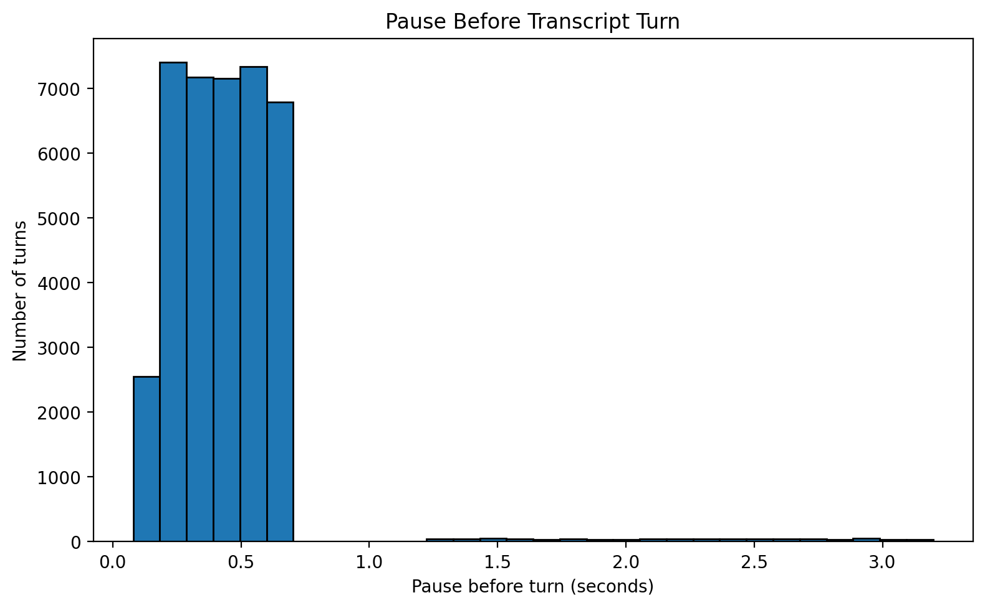
What the graph shows: The graph shows the distribution of pauses preceding transcript turns.
What we learn: The dataset contains timing information that captures interaction dynamics beyond the text itself.
EDA implication: Pause behaviour can be examined as conversational context, while avoiding treating it as standalone evidence of intent.

3.7 Speaker Composition Across Calls
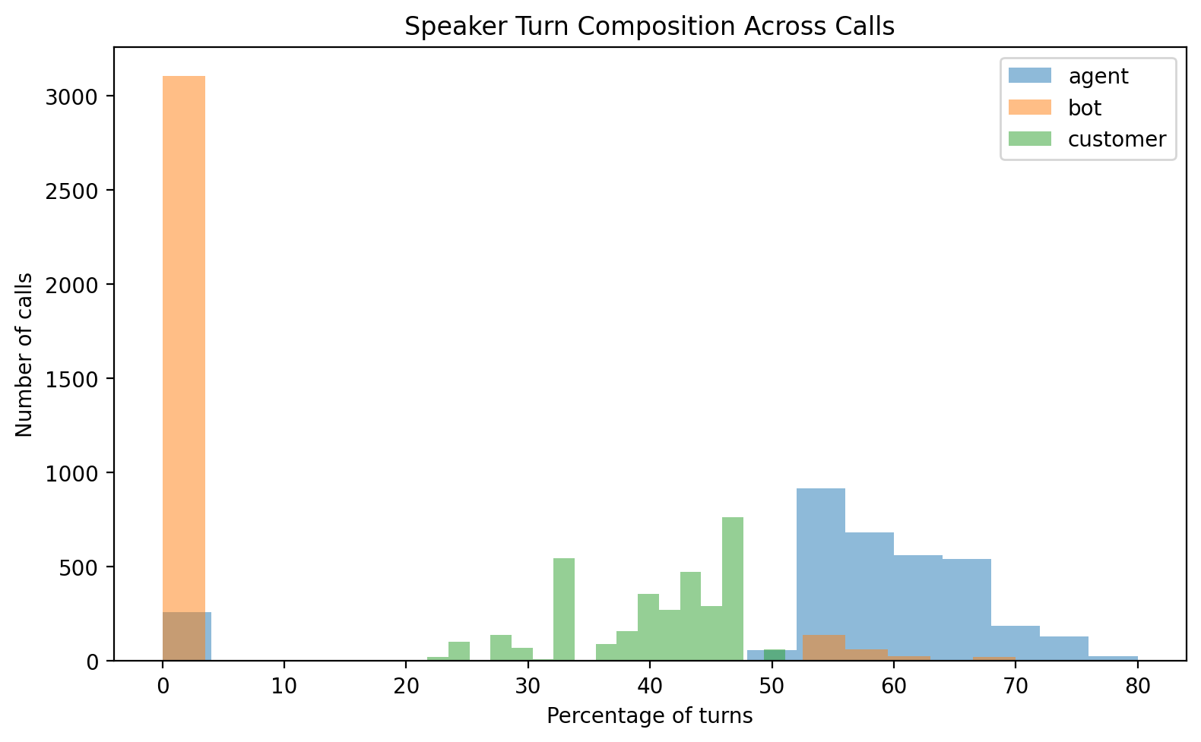
What the graph shows: The graph shows how the proportion of turns attributed to different speakers varies across calls.
What we learn: Calls differ in how conversational participation is distributed.
EDA implication: This provides useful context when comparing calls and interpreting customer-versus-agent interaction.

3.8 ASR Confidence by Speaker
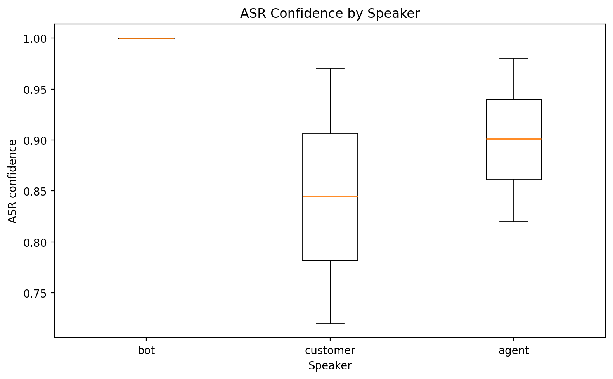
What the graph shows: The graph compares ASR confidence distributions across speaker categories.
What we learn: Transcript quality can vary by speaker.
EDA implication: Speaker-specific ASR quality should be considered when interpreting transcript differences.

4. Text-Level Analysis

4.1 Words per Transcript Turn
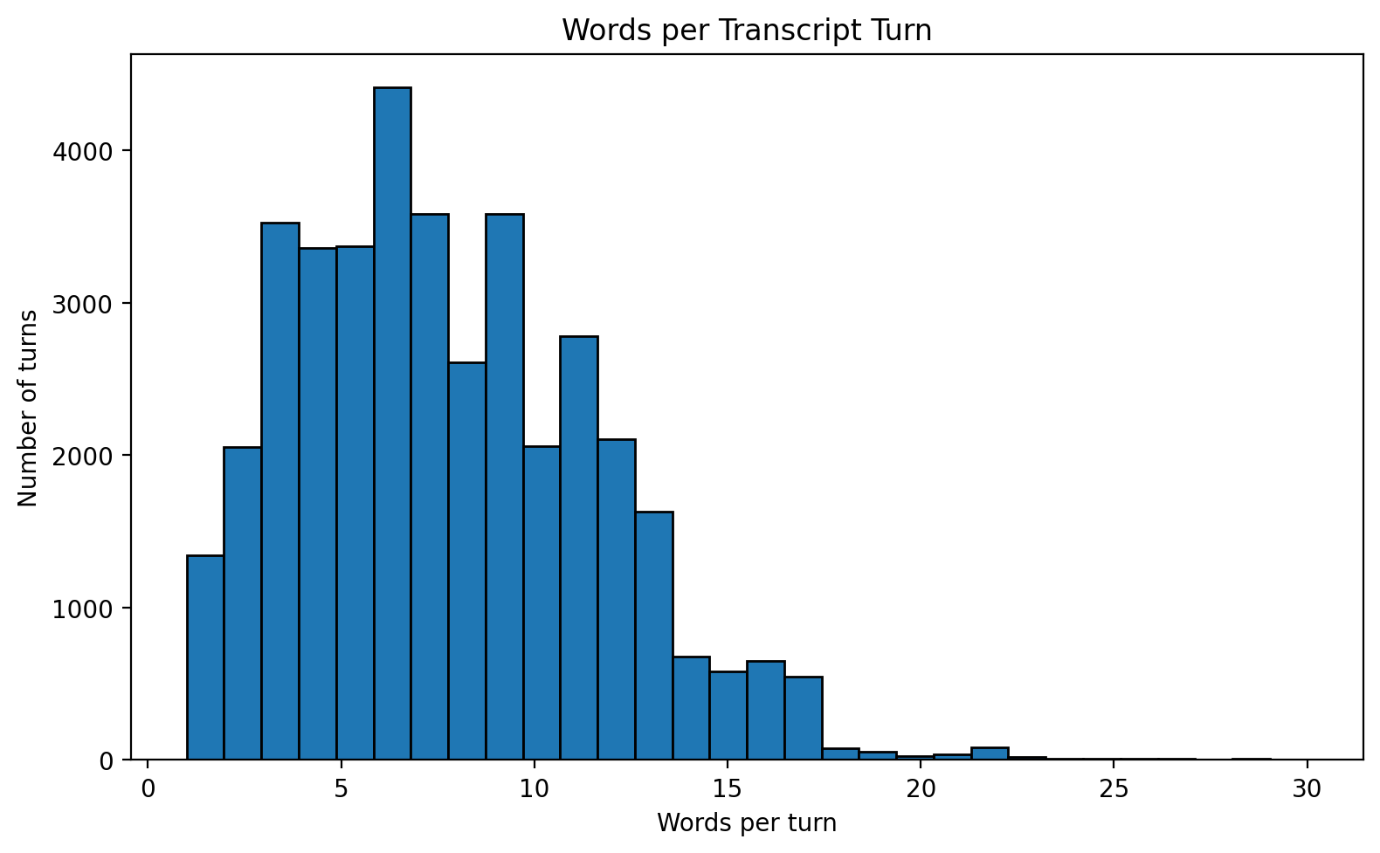
What the graph shows: The graph shows the distribution of transcript length at individual turn level.
What we learn: Conversation turns vary substantially in how much text they contain.
EDA implication: Turn-level text statistics provide a basic description of conversational density.

4.2 Transcript Length by Speaker
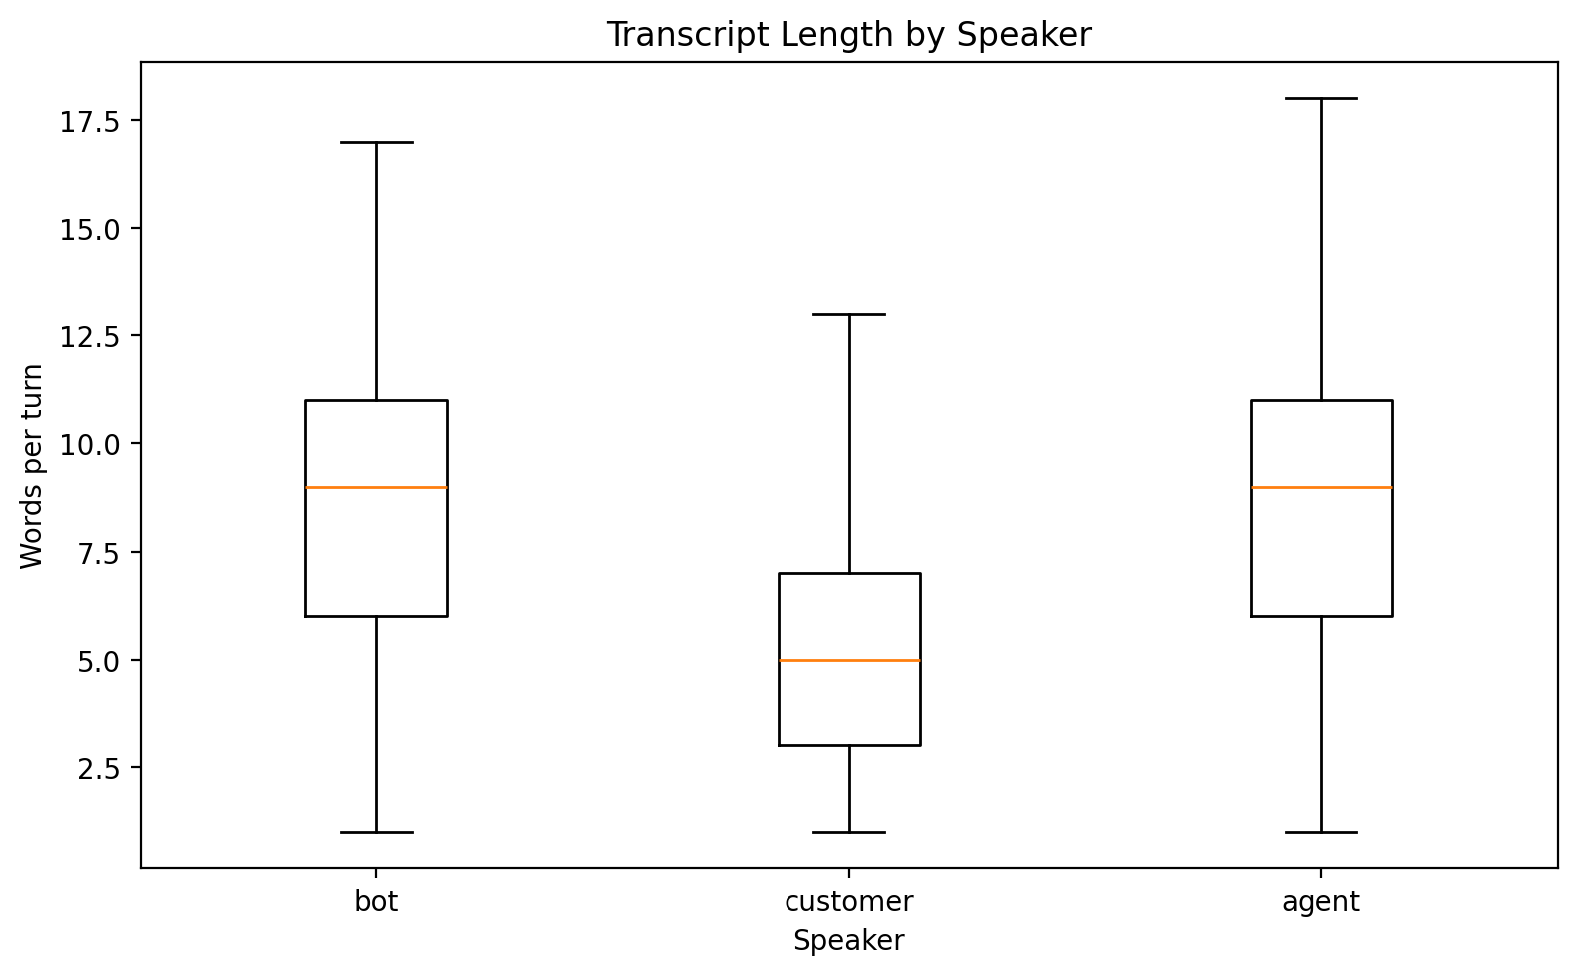
What the graph shows: The graph compares words per turn across speaker categories.
What we learn: Different speakers may contribute differently sized turns.
EDA implication: Speaker-aware analysis is important when interpreting textual behaviour in collection conversations.

4.3 ASR Confidence vs Transcript Length
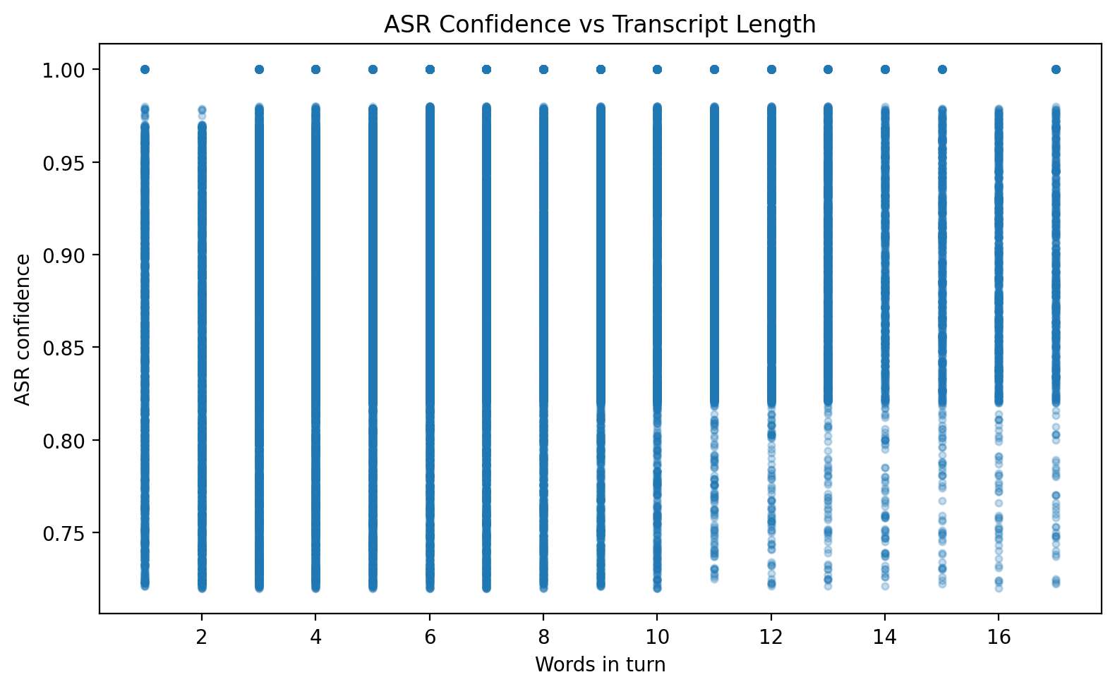
What the graph shows: The graph examines the relationship between transcript length and ASR confidence.
What we learn: ASR confidence can be examined alongside transcript characteristics rather than in isolation.
EDA implication: This helps identify whether transcript quality varies systematically with turn length.

4.4 Speaking Rate by Speaker
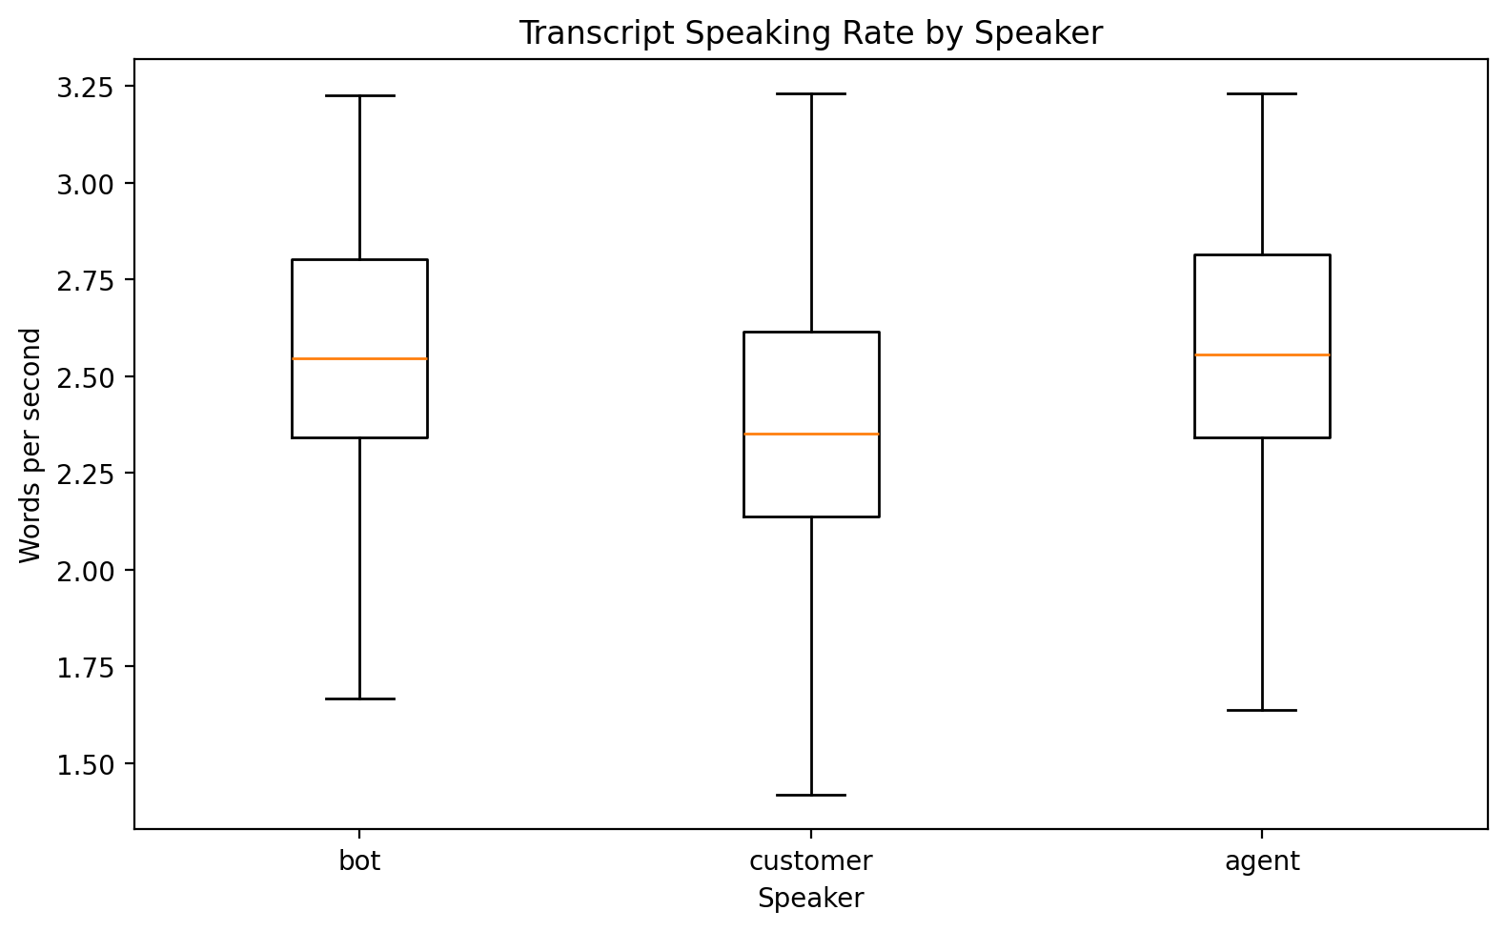
What the graph shows: The graph compares words-per-second distributions across speaker categories.
What we learn: Speaking rate varies across the conversation participants.
EDA implication: Timing and text volume together provide additional context for analysing conversational behaviour.

5. Transcript Patterns by Annotated PTP Type
The annotated sample contains six PTP categories: genuine_feasible, genuine_infeasible, escape, repeat_promiser, third_party, and agent_recorded_or_pushed.
The following analysis is exploratory because only 200 PTPs are annotated. Differences between categories should therefore not be interpreted as population-level conclusions.

5.1 Transcript Turns by Annotated PTP Type
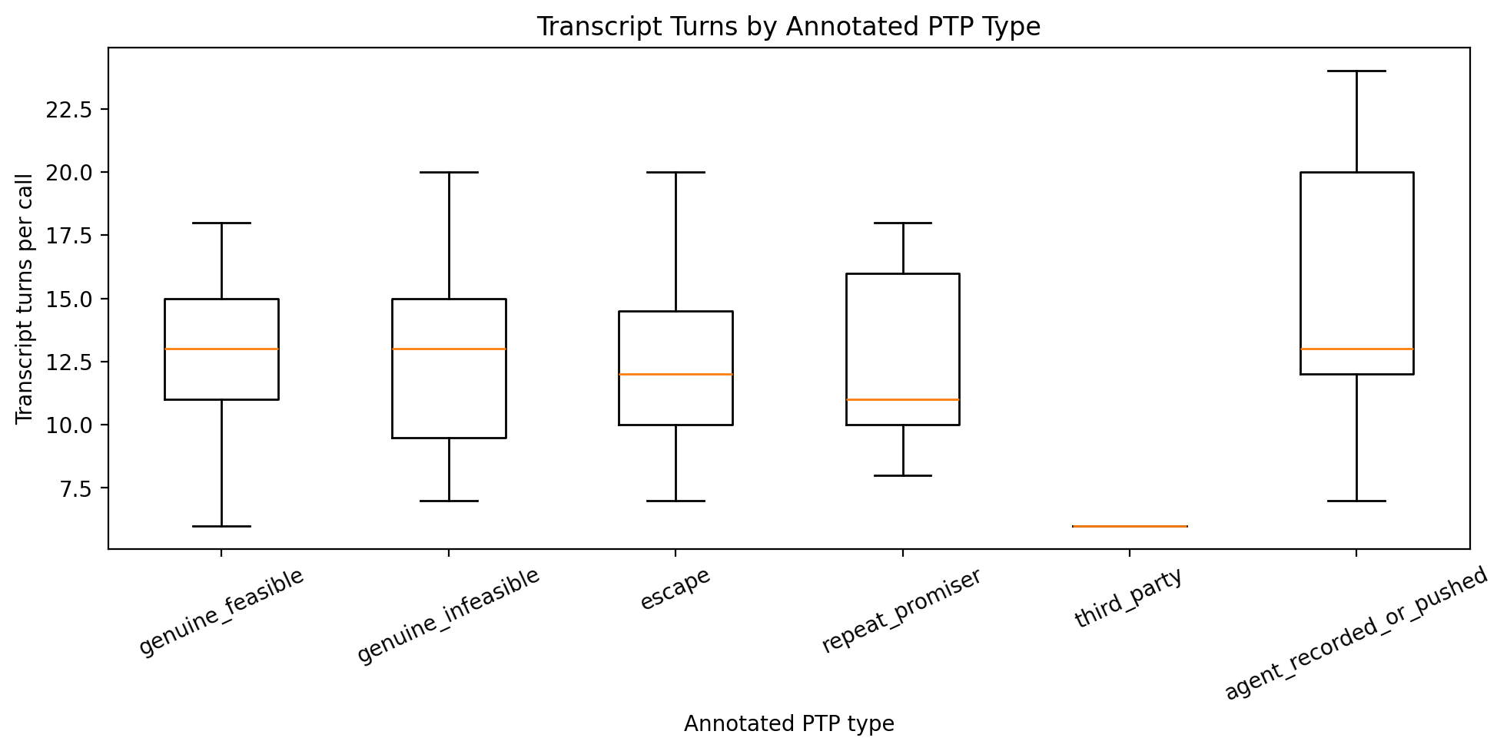
What the graph shows: The graph compares the number of transcript turns across the six annotated PTP categories.
What we learn: Conversation interaction depth may differ across annotated PTP categories.
EDA implication: This is useful for exploratory understanding of how conversation structure varies across the labelled sample.

5.2 Call Duration by Annotated PTP Type
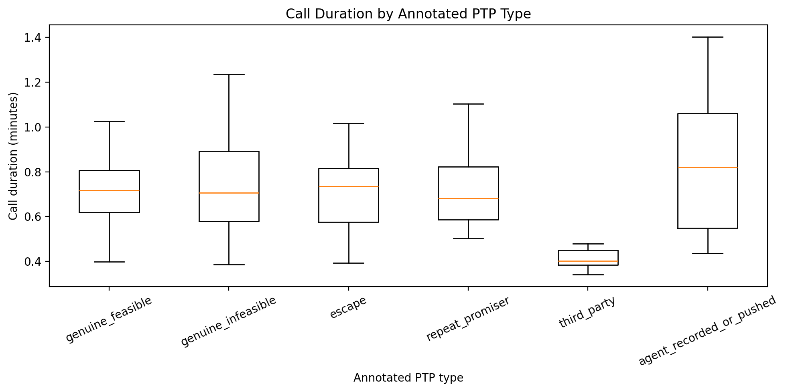
What the graph shows: The graph compares call duration across annotated PTP types.
What we learn: Some PTP categories may occur in conversations with different durations.
EDA implication: Duration differences should be treated as descriptive patterns rather than evidence of causation.

5.3 Speaker Composition by Annotated PTP Type
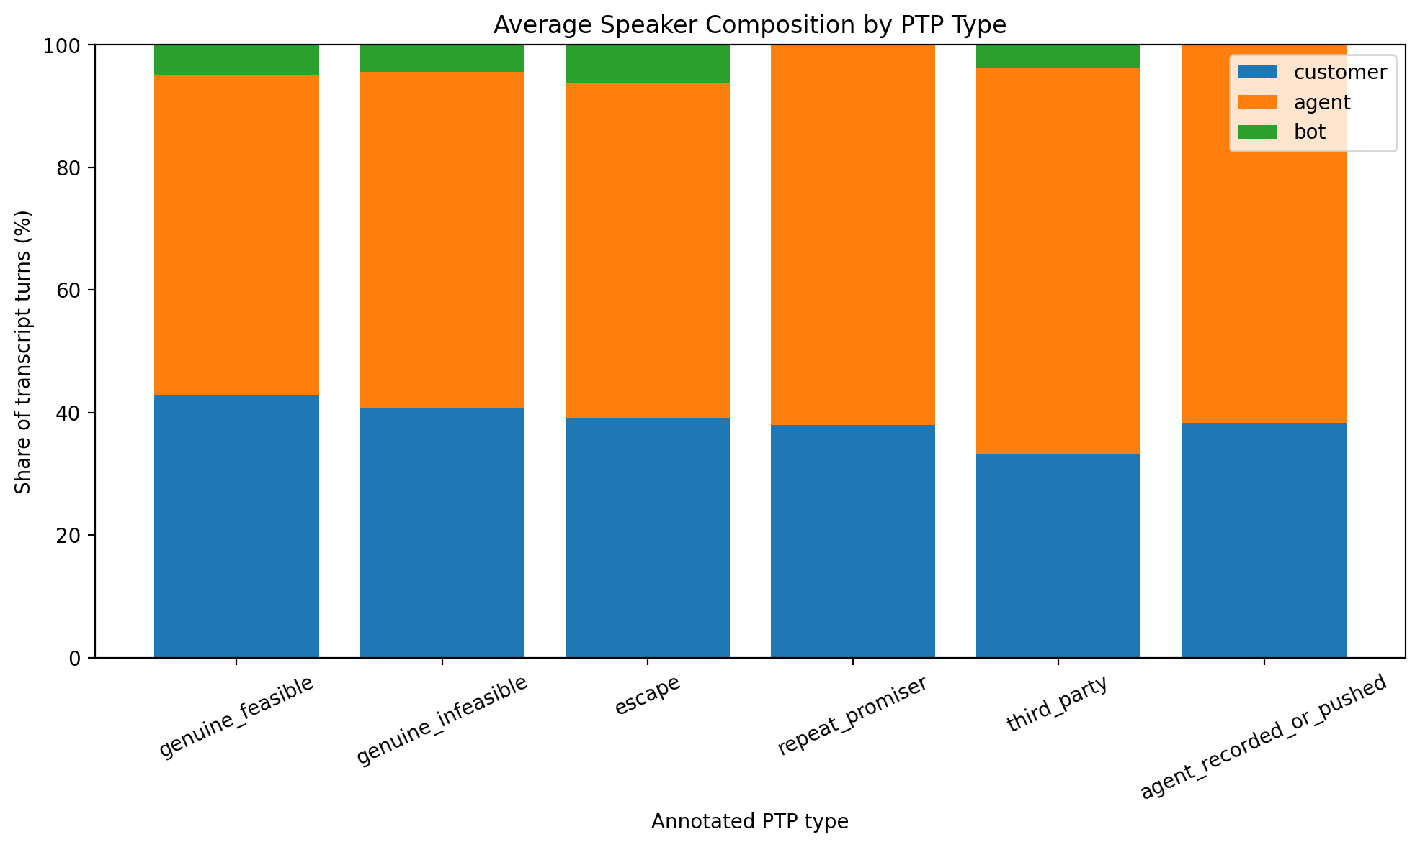
What the graph shows: The graph compares the average share of transcript turns contributed by different speakers across PTP categories.
What we learn: The balance of customer, agent, and bot participation can vary across annotated PTP types.
EDA implication: This is particularly relevant because the PS1 problem requires distinguishing what the borrower actually said from what the agent recorded or proposed.

5.4 Transcript Length by Annotated PTP Type
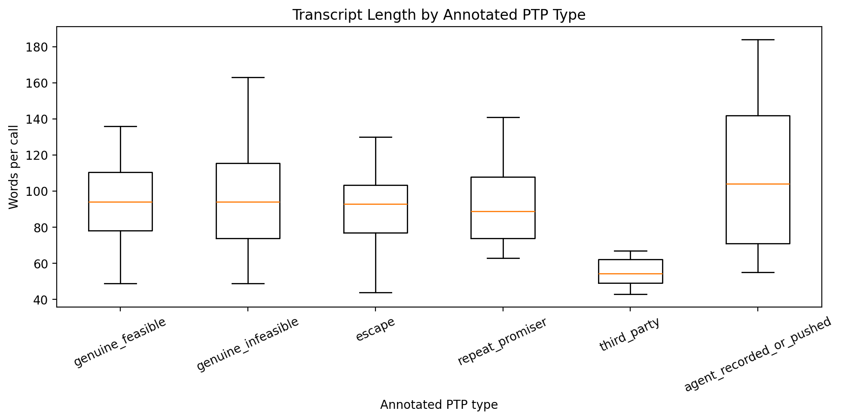
What the graph shows: The graph compares total transcript words across the annotated PTP categories.
What we learn: Conversation length and textual volume can differ across the labelled sample.
EDA implication: These patterns help describe the conversation data but should not be interpreted as standalone evidence of PTP quality.

6. Data Quality and Validation
The final audit checks missing values, duplicate rows, turn ordering, timestamp consistency, text availability, ASR confidence validity, and PTP-to-transcript coverage.
- Turn ordering and timestamp consistency were explicitly checked.
- Negative durations and negative pauses were checked.
- Empty transcript turns were checked.
- ASR confidence values outside the expected range were checked.
- PTP attempt-to-transcript call coverage was checked.
- Annotated PTP-to-transcript coverage was checked.

7. Important Limitations
- The annotated PTP sample contains only 200 labelled records.
- The six annotated categories therefore provide an exploratory reference rather than a large population-level ground truth.
- Transcript patterns do not by themselves establish whether a PTP will ultimately be kept.
- ASR confidence indicates transcript quality but does not measure the truthfulness of the underlying conversation.
- Future transcript turns must not be used when analysing an earlier point inside a live call.

8. Relevance to CreditNirvana PS1
The PS1 problem statement emphasizes real-time analysis of partial, code-mixed transcript and audio during the collection call. The transcript dataset provides the structural information required to study this conversational evidence.
The EDA particularly establishes that the available conversation data contains speaker identity, timing, pauses, text, and ASR confidence. These dimensions are important for understanding the conversation before considering any downstream modelling.
The annotated sample also preserves the distinction between genuine hardship and potentially insincere promises, which is a critical distinction in the PS1 framing.

9. Final Takeaway
The call_transcripts EDA establishes a clear picture of the available conversation data: its speaker structure, call-level variation, text characteristics, ASR quality, timing information, and exploratory differences across annotated PTP categories.
The most important conclusion is that the transcript dataset contains substantially richer conversational information than the operational PTP table alone. However, the labelled sample is small, so the observed category differences should remain descriptive.
This completes the exploratory analysis of the four core PS1 datasets without moving into model training or feature engineering.

