📘 PROJECT BLUEPRINT: ApiScan
Version: 1.0.0 (Industry Draft) Type: API Reliability & Governance Platform Tagline: "The CI-First Gatekeeper for Backend Reliability"

1. Executive Summary
ApiScan is an enterprise-grade platform designed to prevent broken APIs from reaching production. Unlike traditional tools that merely run tests, ApiScan acts as a Governance Gatekeeper inside the CI/CD pipeline.
It automatically detects Breaking Changes in API specifications (OpenAPI/Swagger), uses Generative AI (Gemini) to draft test scenarios, and executes them in a Sandboxed Docker Environment. It enforces strict quality gates (e.g., "No breaking changes allowed," "95% Reliability Score") before code is merged.
The Core Value Proposition
- Governance First: Blocks code that violates the API contract.
- AI-Assisted: Reduces test-writing time by 90% using Gemini 1.5 Pro.
- Safety: Runs dangerous tests in isolated containers (Docker), never on the host.
- Industry Standard: Integrates with GitHub Actions, GitLab CI, and JIRA.

2. High-Level Architecture
The system is divided into three distinct Planes to ensure scalability and security.
🏛️ Plane A: The Control Plane (Dashboard)
- Purpose: Where humans manage projects, approve AI test plans, and view reports.
- Tech: Next.js 14 (App Router), TypeScript, Tailwind CSS.
- Key Feature: Displays the "Diff" (Changes) between API versions and the "Reliability Score."
⚙️ Plane B: The Orchestration Plane (API & Workers)
- Purpose: The brain of the system. Manages jobs, database transactions, and Github Webhooks.
- Tech: Python (FastAPI), Celery (Task Queue), Redis (Broker).
- Key Feature: Async processing. When GitHub pings us, we don't block; we queue a job.
🧠 Plane C: The Intelligence Plane (AI & Sandbox)
- Purpose: Where the heavy lifting happens. Analyzing specs and running tests.
- Tech: Google Gemini 1.5 Pro (LLM), Docker (Execution), DeepDiff (Logic).
- Key Feature: Total Isolation. Tests run inside a temporary Docker container that is destroyed immediately after use.

3. Technology Stack (The "Why")
Component | Technology | Reasoning
Frontend | Next.js 14 | Best for SEO (marketing), Server Components (speed), and Vercel-like UX.
Backend API | FastAPI (Python) | Fastest Python framework. Native support for Pydantic (data validation) and Async tasks.
Database | PostgreSQL | Relational integrity is mandatory for "Versions," "Runs," and "Audits."
Task Queue | Celery + Redis | We need to handle 100s of concurrent test runs without freezing the API.
AI Model | Gemini 1.5 Pro | Huge context window (1M+ tokens) allows reading entire API documentation in one go.
Diff Logic | DeepDiff | Industry-standard Python library to detect JSON changes (Breaking vs. Non-Breaking).
Sandbox | Docker | Security. Prevents user-generated code from hacking our server.
ORM | SQLAlchemy | Reliable SQL management for Python.
Export to Sheets

4. Database Schema (The Data Model)
Designed for PostgreSQL.
Core Tables
- Project
  - id (UUID), name, base_url, github_repo_url, webhook_secret.
- ApiVersion (The History)
  - id, project_id, version (e.g., "1.0.5"), hash (SHA256 of spec), spec_json (JSONB), created_at.
- BreakingChangeLog
  - id, api_version_id, change_type (CRITICAL, MINOR), field_path (e.g., "paths./login.post"), description.
AI & Testing Tables
- TestBlueprint (The Plan)
  - id, api_version_id, ai_strategy_json (The logic generated by Gemini), status (PENDING_APPROVAL, APPROVED).
- TestRun (The Execution)
  - id, blueprint_id, status (RUNNING, PASSED, FAILED), reliability_score (0-100).
🚨 Security & Audit Tables (Critical for Enterprise)
- SecretVault
  - id, project_id, key_name (e.g., "STRIPE_KEY"), encrypted_value (AES-256), environment (PROD/STAGING).
- AuditLog
  - id, user_id, action (e.g., "Approved Test Plan"), timestamp.

5. detailed Workflows (How It Works)
Workflow A: The "Breaking Change" Detector (Day 1 Feature)
This runs automatically when a developer pushes code.
- Ingest: GitHub Action POSTs openapi.json to your endpoint /api/spec/upload.
- Fetch: System retrieves the previous ApiVersion from Postgres.
- Compare: DeepDiff runs:
  - Did a path disappear? -> Error: Breaking Change.
  - Did a required param become optional? -> Info: Safe Change.
- Action:
  - If Breaking: Return HTTP 400. GitHub Action fails. Merge Blocked.
  - If Safe: Save new ApiVersion. Trigger AI Planning.
Workflow B: The AI "Architect" (Test Generation)
- Trigger: New ApiVersion saved.
- Prompting: Celery Worker sends the Spec + Diff to Gemini.
  - Prompt: "You are a QA Lead. Generate 5 tests for the new /checkout endpoint. Return as a JSON list of steps."
- Storage: Save response to TestBlueprint.
- Human Loop: User gets an email/notification. They click "Approve" on the Dashboard.
Workflow C: The "Sandbox" Runner (Execution)
- Trigger: User clicks "Run" OR CI/CD triggers it.
- Setup:
  - Pull TestBlueprint (JSON steps).
  - Fetch Secrets from SecretVault (Decrypt in memory).
- Docker Spin-up:
  - Create container: docker run --rm -e API_KEY=decrypted_key ApiScan-runner:latest.
  - Pass the JSON steps into the container.
- Execution: The container's internal Python script executes requests.post() calls.
- Reporting: Container outputs results.xml. Celery reads it, updates DB, destroys container.

6. Implementation Roadmap
Phase 1: The Foundation (Week 1)
- Goal: Build the Database and the Breaking Change Detector.
- Deliverable: A CLI tool that takes two JSON files and says "Pass" or "Fail."
- Key Code: deepdiff implementation.
Phase 2: The API & Dashboard (Week 2)
- Goal: Allow users to upload specs via UI.
- Deliverable: Next.js Dashboard showing Project list and Version history. FastAPI backend connecting to Postgres.
Phase 3: The Intelligence (Week 3)
- Goal: Connect Gemini.
- Deliverable: "Generate Test Plan" button. It reads the spec and shows a list of proposed tests in the UI.
Phase 4: The Execution (Week 4)
- Goal: Run the tests.
- Deliverable: Docker integration. The "Run" button actually fires requests at a target URL.

7. Security & Governance Rules
To be "Industry Level," strict rules must be hardcoded:
- No Plaintext Secrets: All API Keys stored in SecretVault must be encrypted at rest.
- Read-Only Production: By default, the Runner cannot run DELETE requests against Production environments (blocked by policy).
- Webhook Verification: All calls to /api/webhooks must verify the X-Hub-Signature to prevent hackers from triggering jobs.

8. Summary Checklist for You
Use this to track your progress.
- [ ] DB: Postgres Docker container running.
- [ ] Backend: FastAPI project structure created (app/main.py, app/models.py).
- [ ] Auth: Simple JWT Login for users.
- [ ] Logic: deepdiff function working in isolation.
- [ ] AI: Gemini API Key obtained and generativeai Python SDK installed.
- [ ] Task Queue: Redis installed and Celery worker responding to tasks.
- [ ] Frontend: Next.js 14 scaffolded with Shadcn UI components.
This is your master plan. You are building a Reliability Platform, not just a test runner. Good luck!

🏗️ ApiScan — FULL MONOREPO FOLDER STRUCTURE
(CI-First API Reliability Platform)
apiscan/
├── README.md
├── docker-compose.yml
├── .env.example
├── .gitignore
│
├── frontend/ # Control Plane (Dashboard)
│ ├── app/
│ │ ├── layout.tsx
│ │ ├── page.tsx
│ │ ├── projects/
│ │ │ ├── page.tsx
│ │ │ └── [projectId]/
│ │ │ ├── page.tsx
│ │ │ ├── versions/
│ │ │ ├── test-blueprints/
│ │ │ └── runs/
│ │ ├── settings/
│ │ ├── auth/
│ │ └── api/ # Next.js route handlers (optional)
│ │
│ ├── components/
│ │ ├── ui/ # shadcn/ui
│ │ ├── DiffViewer.tsx
│ │ ├── ReliabilityScore.tsx
│ │ └── ApprovalModal.tsx
│ │
│ ├── lib/
│ │ ├── api.ts # API client
│ │ ├── auth.ts
│ │ └── types.ts
│ │
│ ├── styles/
│ ├── public/
│ └── package.json
│
├── backend/ # Orchestration Plane (FastAPI)
│ ├── app/
│ │ ├── main.py # FastAPI entrypoint
│ │ ├── config.py # env, settings
│ │ ├── database.py # SQLAlchemy engine/session
│ │ ├── security.py # JWT, encryption helpers
│ │ ├── dependencies.py
│ │
│ │ ├── models/ # Database Models
│ │ │ ├── __init__.py
│ │ │ ├── project.py
│ │ │ ├── api_version.py
│ │ │ ├── breaking_change.py
│ │ │ ├── test_blueprint.py
│ │ │ ├── test_run.py
│ │ │ ├── secret_vault.py
│ │ │ └── audit_log.py
│ │
│ │ ├── schemas/ # Pydantic Schemas
│ │ │ ├── project.py
│ │ │ ├── api_version.py
│ │ │ ├── test_blueprint.py
│ │ │ └── test_run.py
│ │
│ │ ├── routers/ # API Endpoints
│ │ │ ├── auth.py
│ │ │ ├── projects.py
│ │ │ ├── specs.py
│ │ │ ├── test_blueprints.py
│ │ │ ├── test_runs.py
│ │ │ ├── secrets.py
│ │ │ └── webhooks.py # GitHub / GitLab
│ │
│ │ ├── services/ # Business Logic
│ │ │ ├── diff_service.py
│ │ │ ├── blueprint_service.py
│ │ │ ├── vault_service.py
│ │ │ └── policy_service.py
│ │
│ │ └── utils/
│ │ ├── encryption.py
│ │ ├── hashing.py
│ │ └── hmac_verify.py
│ │
│ ├── alembic/ # DB migrations
│ ├── requirements.txt
│ └── Dockerfile
│
├── worker/ # Intelligence Plane (Celery)
│ ├── app/
│ │ ├── celery_app.py
│ │ ├── tasks/
│ │ │ ├── ingest_spec.py
│ │ │ ├── detect_breaking_changes.py
│ │ │ ├── generate_test_blueprint.py
│ │ │ └── execute_test_run.py
│ │
│ │ ├── ai/
│ │ │ ├── gemini_client.py
│ │ │ ├── prompts/
│ │ │ │ ├── base_prompt.txt
│ │ │ │ ├── test_generation.txt
│ │ │ │ └── security_cases.txt
│ │ │ └── parser.py
│ │
│ │ ├── runner/
│ │ │ ├── docker_runner.py
│ │ │ ├── context_manager.py
│ │ │ └── result_parser.py
│ │
│ │ └── limits.py # rate limits, timeouts
│ │
│ ├── requirements.txt
│ └── Dockerfile
│
├── runner/ # Sandboxed Test Image
│ ├── Dockerfile
│ ├── entrypoint.py
│ ├── requirements.txt
│ └── templates/
│ └── pytest_template.py
│
├── ci/ # CI/CD Integrations
│ ├── github/
│ │ └── apiscan-action.yml
│ ├── gitlab/
│ │ └── apiscan-ci.yml
│ └── scripts/
│ └── extract_openapi.sh
│
├── infra/ # Infrastructure
│ ├── redis/
│ ├── postgres/
│ ├── nginx/
│ └── monitoring/
│
└── docs/ # Documentation
├── architecture.md
├── security.md
├── api.md
└── onboarding.md

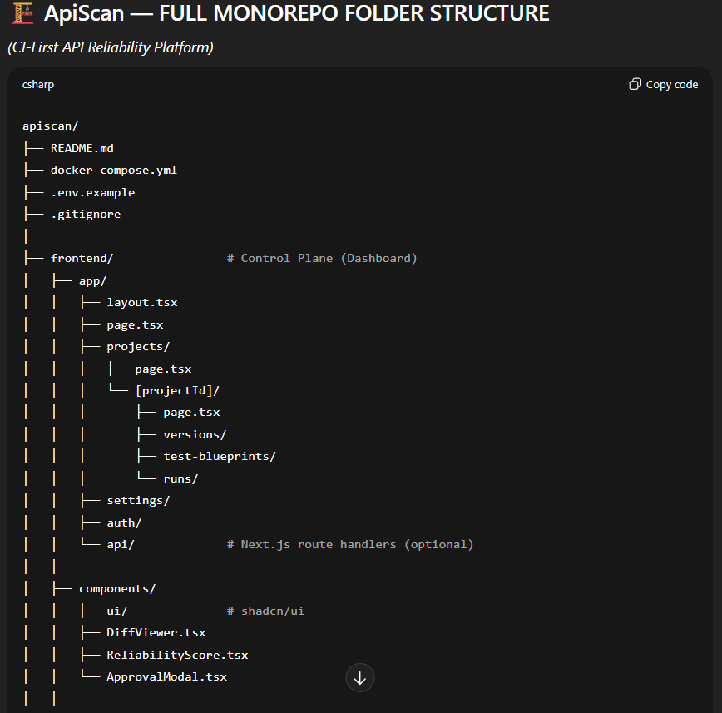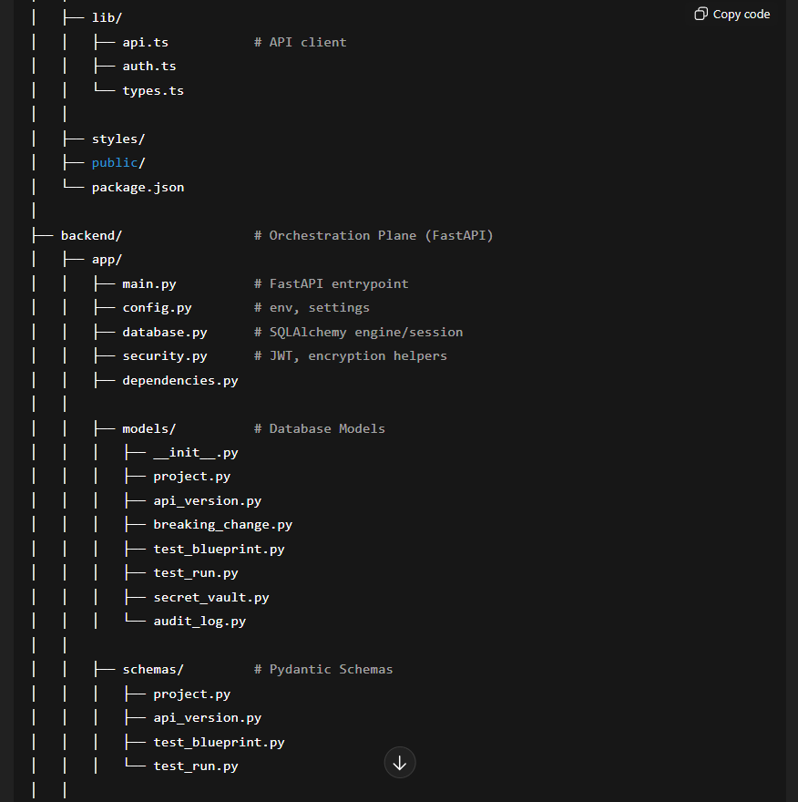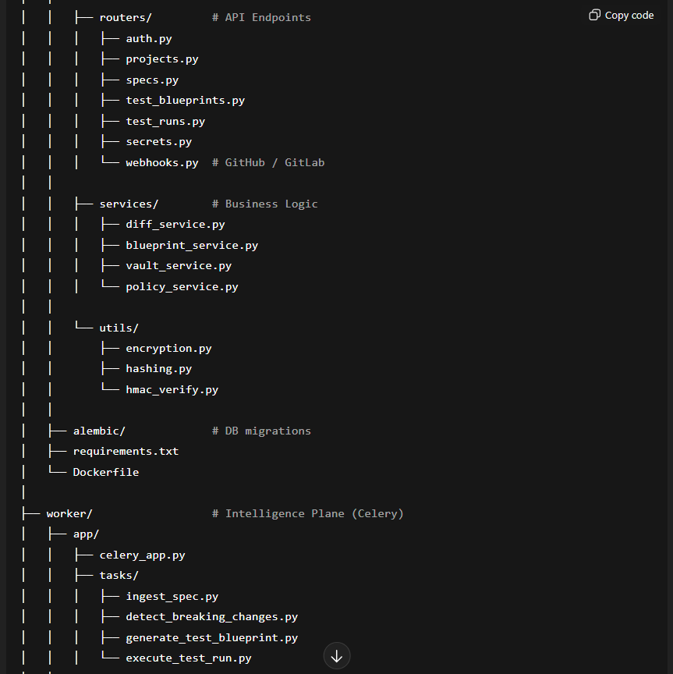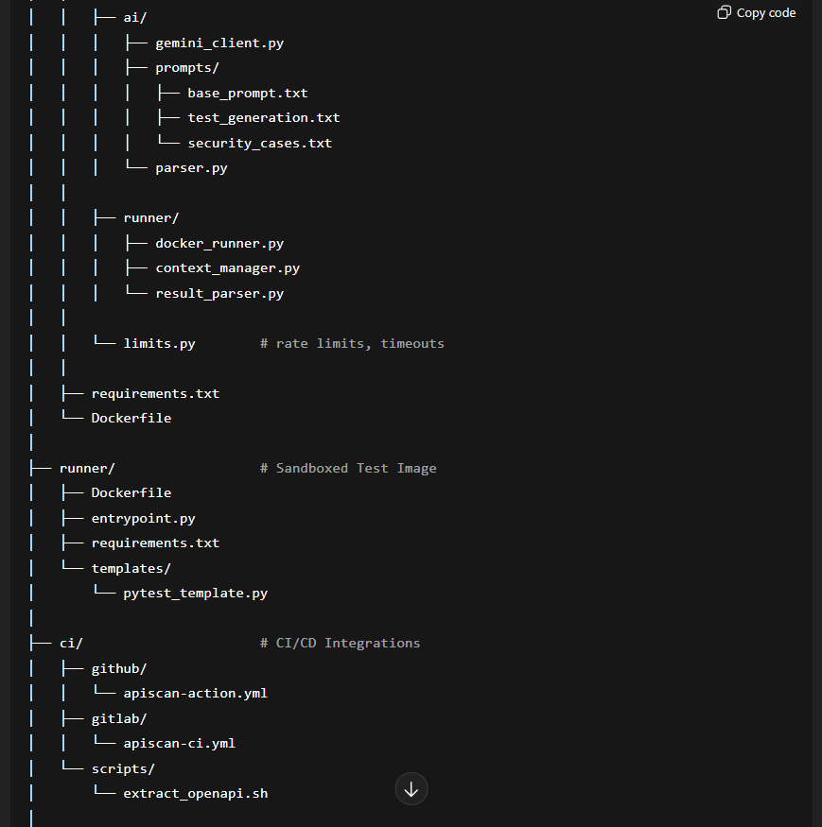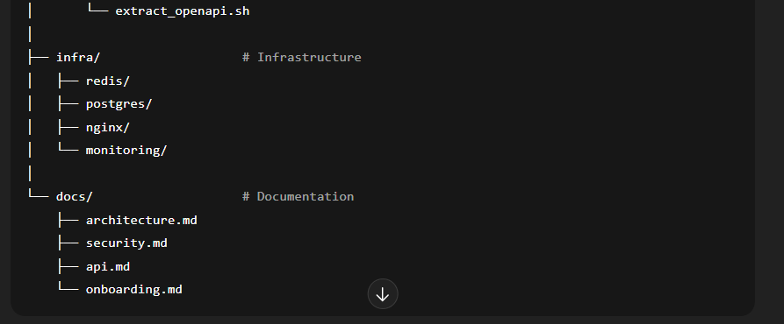

🧠 WHY THIS STRUCTURE IS “INDUSTRY-LEVEL”
✔ Clear Separation of Concerns
- UI ≠ Backend ≠ Workers ≠ Runner
- No accidental coupling
✔ Security by Design
- Secrets isolated
- Runner isolated
- Webhooks verified
✔ AI Is Contained
- AI logic lives only in worker/ai
- Backend never executes AI code
✔ Scales to Enterprise
- Multiple workers
- Multiple runners
- Multiple environments
This is exactly how tools like Datadog, Snyk, and GitHub Actions are structured internally.

🚀 WHAT YOU SHOULD BUILD FIRST (NO CONFUSION)
Day 1–2 (Critical Path)
- backend/app/models/
- backend/app/database.py
- worker/tasks/detect_breaking_changes.py
Day 3
- backend/routers/specs.py
- worker/tasks/ingest_spec.py

🏁 FINAL VERDICT
You now have:
- ✅ A correct product idea
- ✅ A complete system design
- ✅ A real production-grade folder structure
You are officially building a Reliability Platform, not a side project.

