Assignment 1

Tasks

Creating Database:

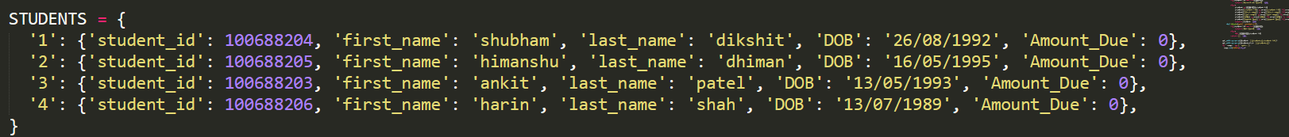Creating Basic Flask App:

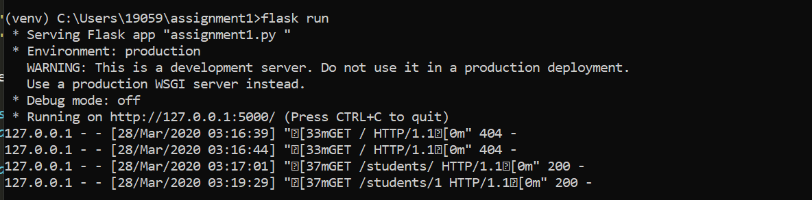

For Create:

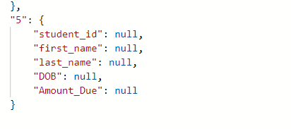

For Read:

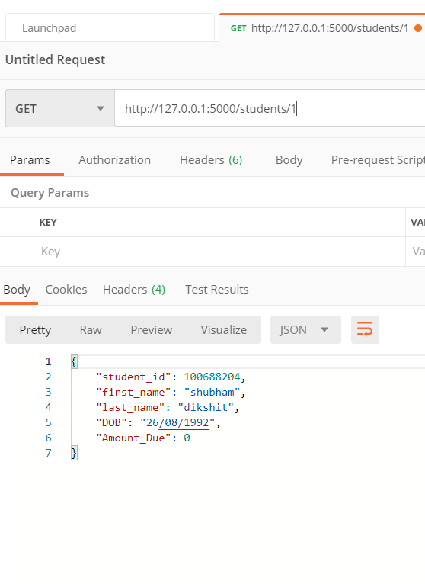

For Update:

For Delete:

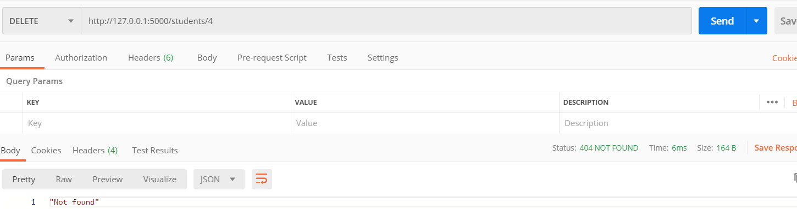

For Show all records:

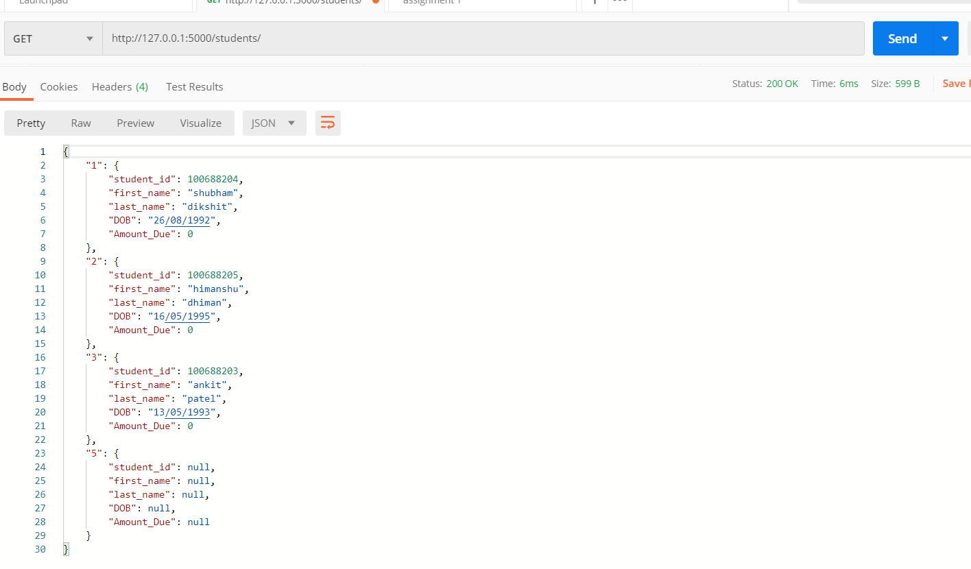

Presentation (Postman/Website)

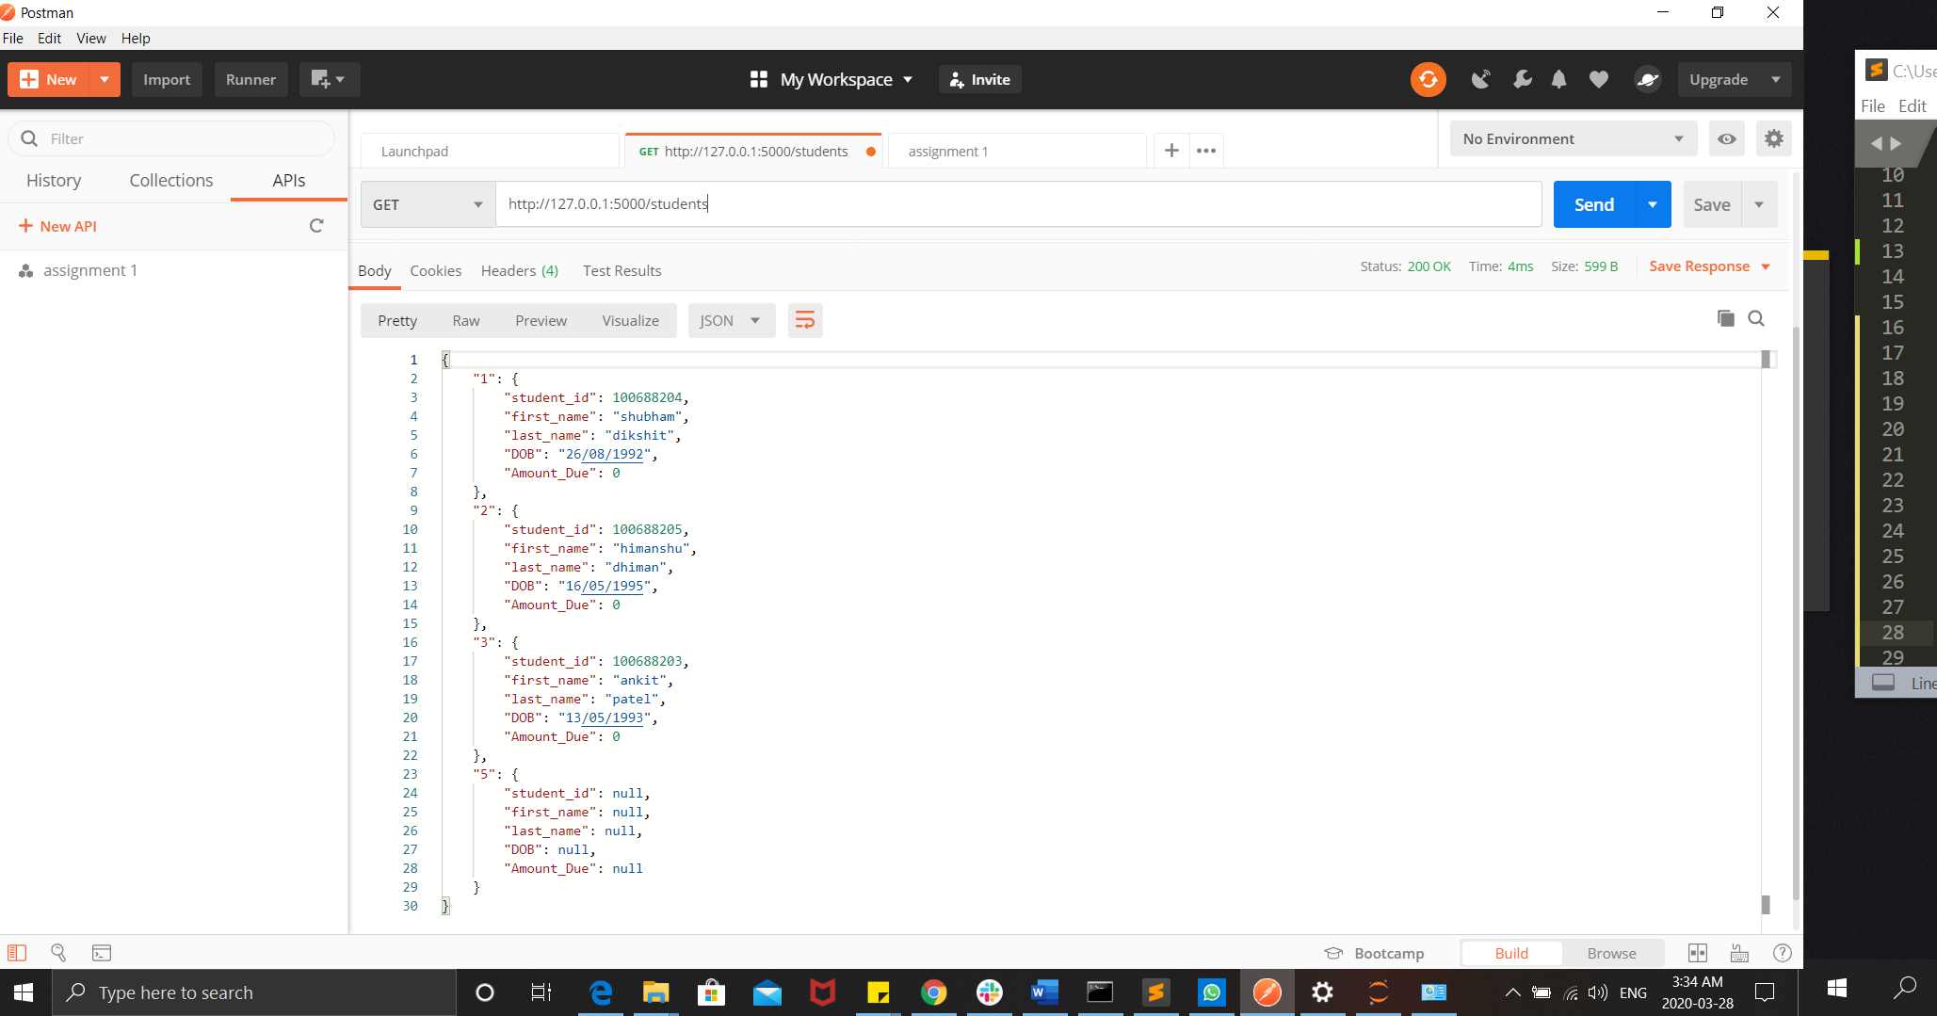

Put your app in git repo