Infosys Springboard Virtual Internship 7.0 Completion Report

Team Details
Batch Number: Batch
Start date: 21/07/2026
Names: Riya, Sanjana, Shamiha, Shubhdeep.
Internship Duration: 8 Weeks

1. Project Title
CivicPulse – Smart Governance Management Platform.

2. Project Objective

The objective of CivicPulse is to develop a smart governance platform that makes civic complaint management easier, faster, and more transparent.
The platform allows citizens to register complaints related to civic issues, track their complaint status, and receive updates. For administrators and department officers, it provides tools to manage complaints, assign them to appropriate departments, monitor their status, and analyze complaint information.
The project also includes intelligent features such as automated priority scoring and duplicate complaint detection to improve the efficiency of complaint management..

3. Project description in detail

CivicPulse is a web-based smart governance management platform designed to connect citizens with government departments through a centralized complaint management system.
The project follows a workflow where a citizen submits a complaint with details such as title, description, category, and location. The backend processes the complaint, identifies the appropriate department, calculates its priority, and stores the complaint in the database.
The system provides different interfaces for citizens, administrators, and department officers.

Citizen side
Citizens can:
- Register and log in
- Access the Citizen Dashboard
- Register civic complaints
- View complaint details
- Track complaint status
- Receive complaint-related information
- Provide feedback
Admin and Department side
Administrators and department officers can:
- View complaints
- Manage complaints
- Monitor complaint status
- Assign complaints to departments
- Update complaint status
- View dashboard information
- Monitor department-wise complaint information
Technologies Used
- Frontend: React.js, JavaScript, HTML, CSS
- Backend: Java, Spring Boot
- Database: MySQL/MariaDB
- API: REST APIs
- Development Tools: VS Code, Git, GitHub, Thunder Client
- Build Tool: Maven

Real-world impact
The platform can help reduce manual complaint handling by providing a centralized digital system. Citizens can report and track issues more conveniently, while administrators and departments can manage complaints systematically and monitor their progress.

4. Timeline Overview
Week | Activities Planned | Activities Completed
Week 1 | Project introduction, requirement analysis, team discussion | Understood project requirements, modules, roles, and overall CivicPulse workflow
Week 2 |  | Developed initial frontend and backend modules including Home Page, Registration, Login, Authentication, Citizen Management, Department Management, Complaint Management, Admin Dashboard, Status Updates, and Complaint Tracking
  Frontend and backend module development
Week 3 | Milestone 2 – Complaint Management & Dashboard | Completed Citizen Complaint Management, Admin Complaint Management, and Dashboard functionality
Week 4 | Milestone 3 – Citizen Module Development | Completed Citizen Dashboard, Register Complaint, and Track Complaint on both frontend and backend
Week 5 | Department and reporting modules | Developed Department Dashboard and Reports & Analysis functionality on frontend and backend
Week 6 | Milestone 4 – Remaining Feature Development | Completed remaining project features, including Smart Duplicate Complaint Detection, complaint validation, frontend-backend integration, UI improvements, and complaint workflow enhancements
Week 7 | Integration, testing, and debugging | Integrated developed modules, tested APIs and database operations, fixed frontend/backend issues, and verified complaint workflows
Week 8 | Final integration, documentation, and presentation | Completed final project integration, testing, documentation, presentation preparation, and final submission activities

5a. Key Milestones
Milestone | Description | Date Achieved
Project Kickoff | Understood project requirements, team responsibilities, and CivicPulse workflow | 21 July 2026
Prototype/First Draft | Initial frontend and backend modules developed and connected
Mid-Term Review | Reviewed implemented modules and integration progress
Final Submission | Completed major modules, testing, integration, and documentation
Presentation | Prepared and presented the CivicPulse project

5b. Project execution details

The CivicPulse – Smart Governance Management Platform was developed as a full-stack web application to provide a centralized platform for managing citizen complaints and improving communication between citizens and administrative departments.
The project was executed in multiple milestones, covering both frontend and backend development.
Phase 1 – Initial Module Development
The initial phase focused on understanding the project requirements, designing the application structure, and developing the basic modules. Authentication, Citizen Management, Department Management, Home Page, Citizen Registration, Citizen Login, Admin Dashboard, Complaint Management, Status Updates, and Complaint Tracking were developed.
Phase 2 – Complaint Management
The complaint management module was developed to allow citizens to submit complaints and enable administrators to manage them. Complaint information such as title, description, category, location, priority, status, citizen details, and department details was integrated with the backend and database.

Phase 3 – Citizen Module
The Citizen Dashboard, Register Complaint, and Track Complaint modules were developed. Citizens can access their dashboard, submit complaints, and track the status of submitted complaints through the platform.
Phase 4 – Department and Reporting Modules
Department Dashboard and Reports & Analysis modules were developed to provide department-level information and monitoring. These modules help in viewing complaint distribution, status information, and other administrative details.
Phase 5 – Remaining Features and Integration
The remaining project features were completed during the final milestone. This included Smart Duplicate Complaint Detection, complaint validation, frontend-backend integration, UI improvements, API testing, and bug fixing.
The duplicate complaint feature checks complaints based on category and location and compares the title and description to identify potentially similar complaints. This helps reduce repeated complaint submissions.
Phase 6 – Testing and Finalization
All major modules were integrated and tested. Frontend and backend APIs were verified, database operations were tested, and issues found during integration were resolved. The final application workflow was tested from complaint registration through tracking and status management.
Overall Execution Flow
Requirement Analysis → System Design → Frontend & Backend Development → Complaint Management → Citizen & Department Modules → Reports & Analysis → Smart Features → Integration → Testing → Documentation → Final Presentation
The project was developed using technologies including React.js, JavaScript, HTML, CSS, Java, Spring Boot, REST APIs, MySQL/MariaDB, Git, GitHub, Maven, and Thunder Client.

6. Snapshots / Screenshots

- Figure 1: CivicPulse Home Page
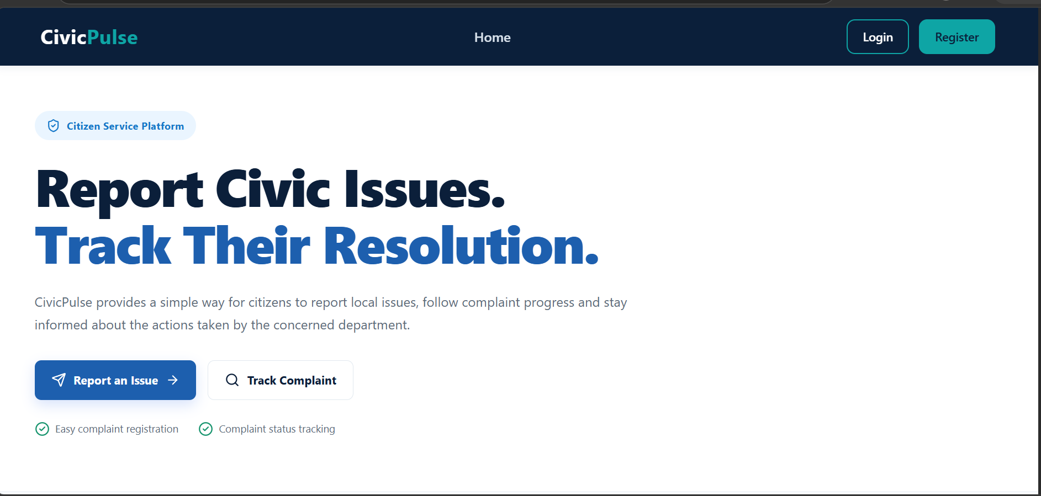
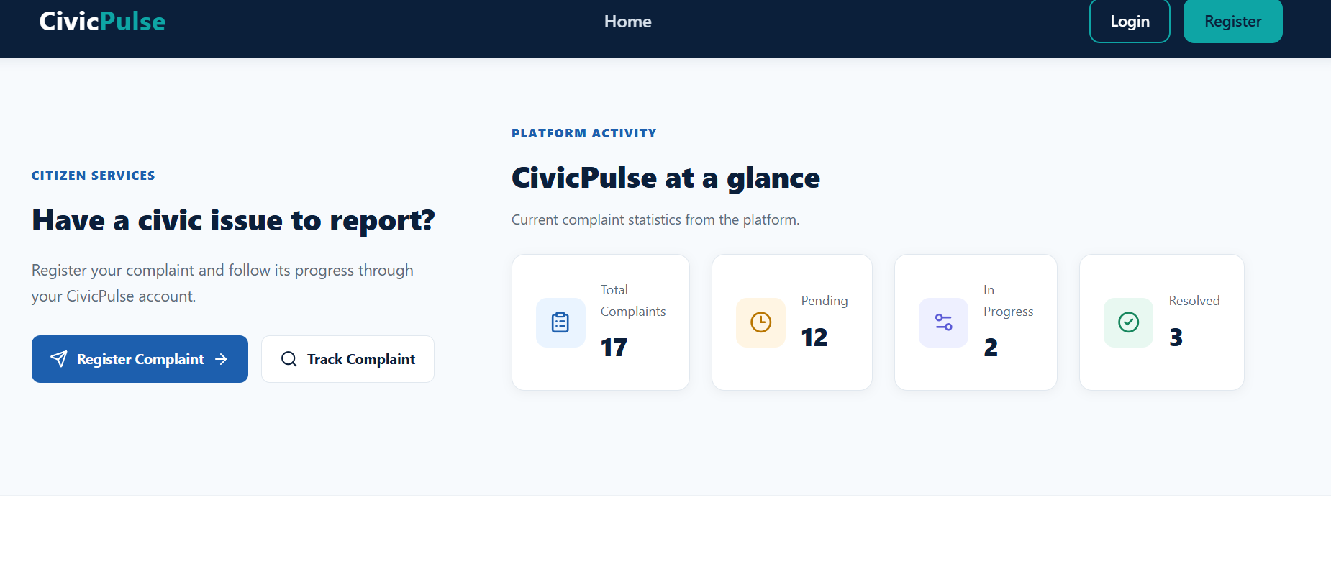

- Figure 2: Citizen Registration Page
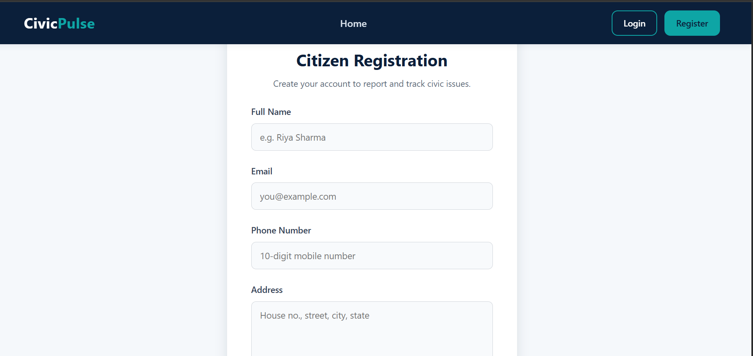
- Figure 3: Citizen Login Page
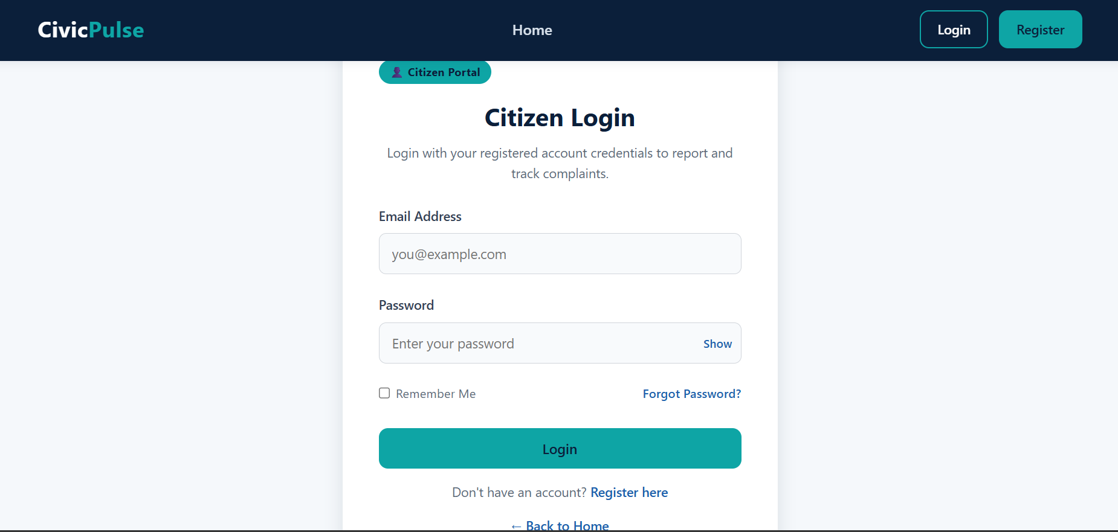

- Figure 4: Citizen Dashboard
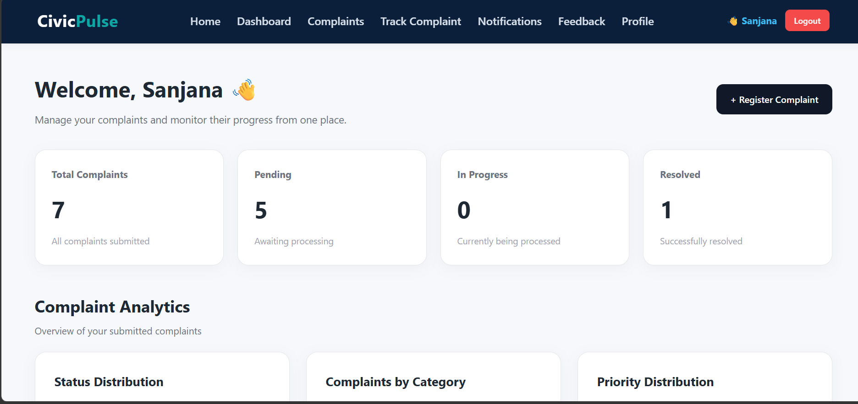

- Figure 5: Register Complaint Page
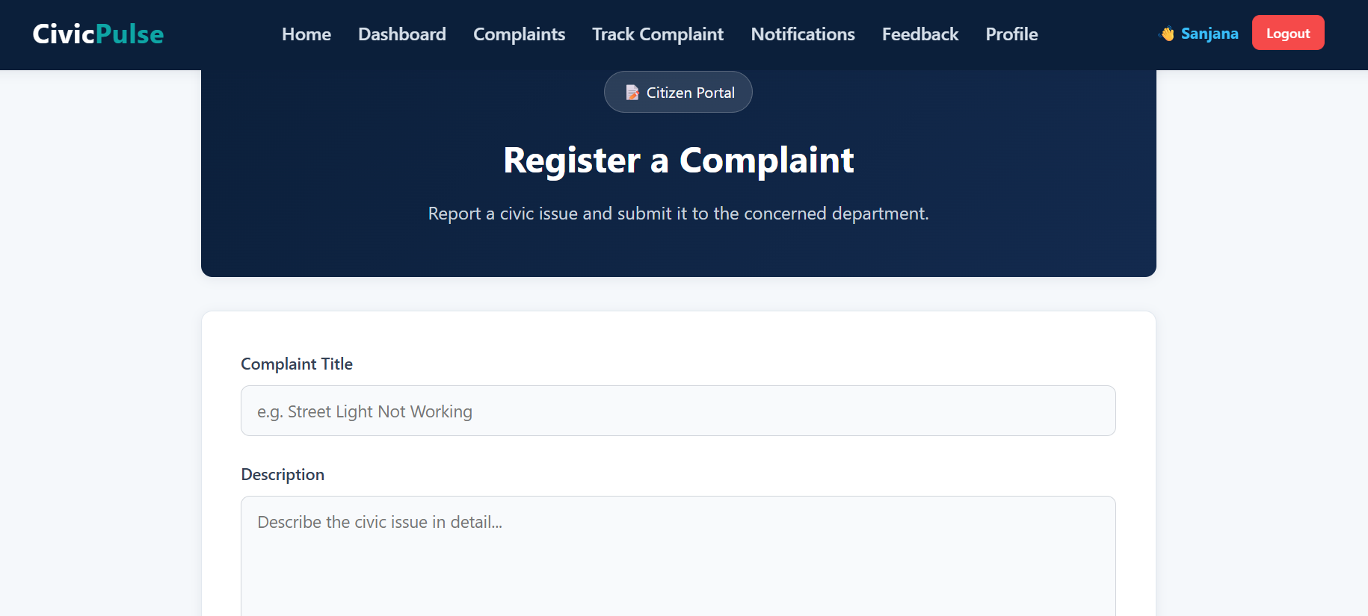

- Figure 6: Complaint Submission Success
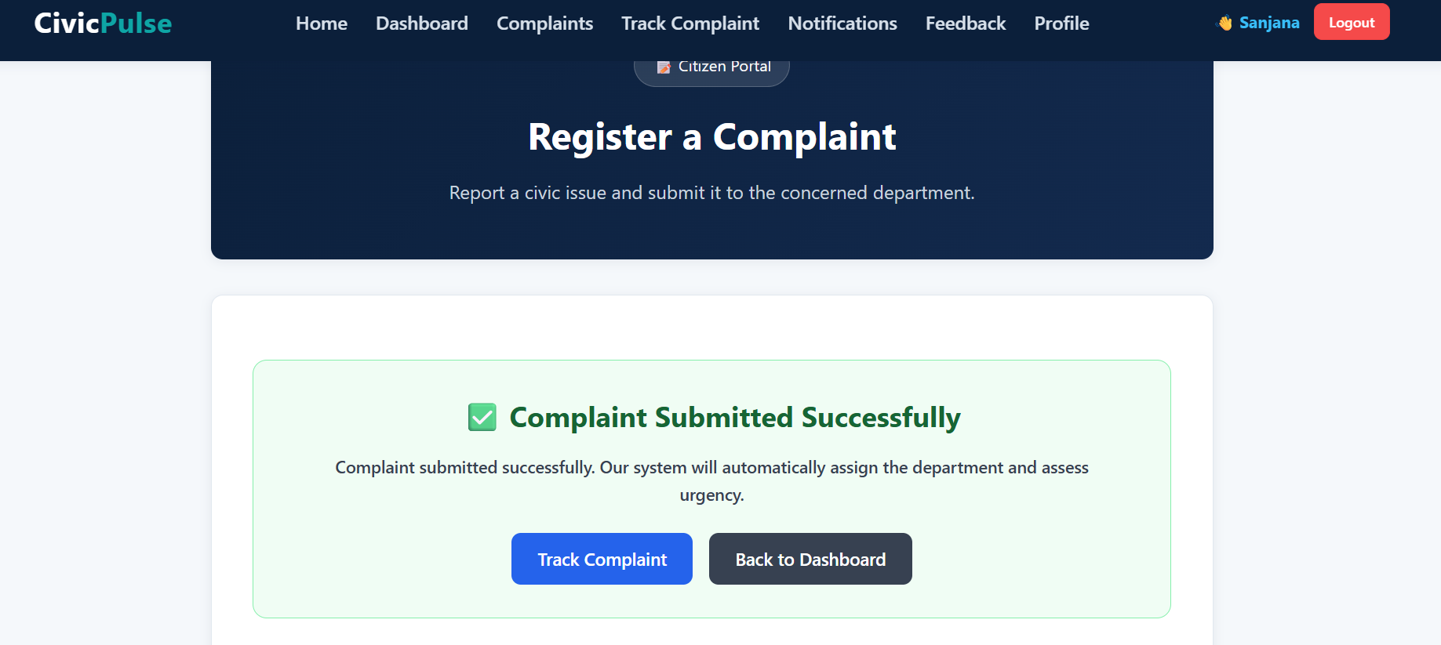
- Figure 7: Duplicate Complaint Detection
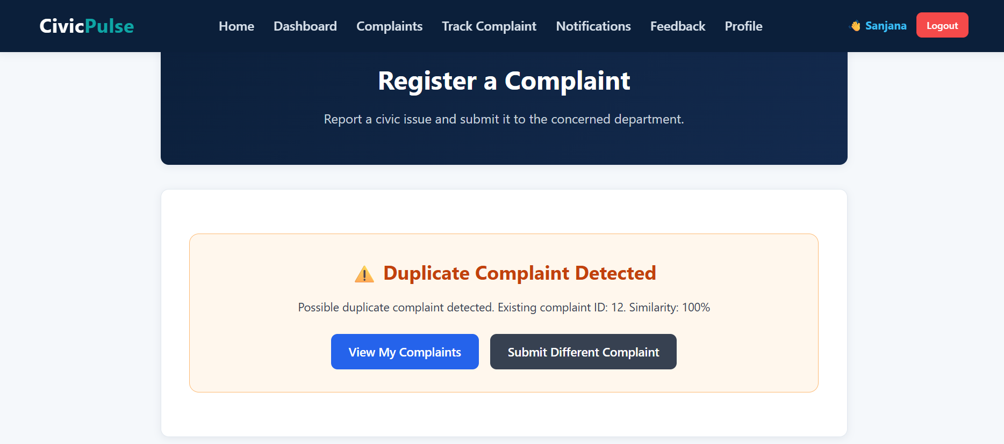
- Figure 8: Track Complaint Page
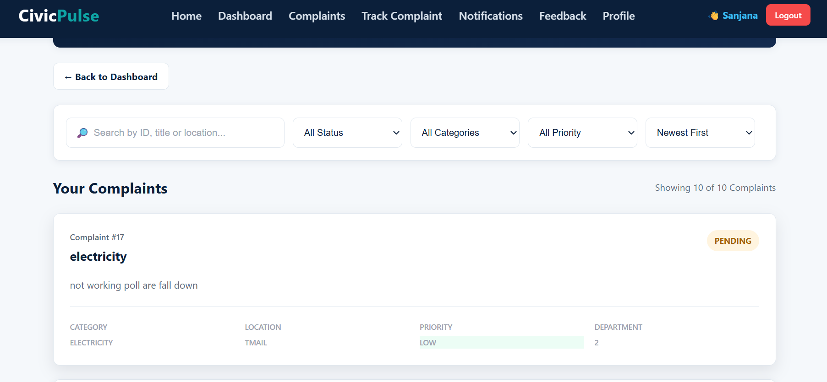

- Figure 9: Admin Dashboard
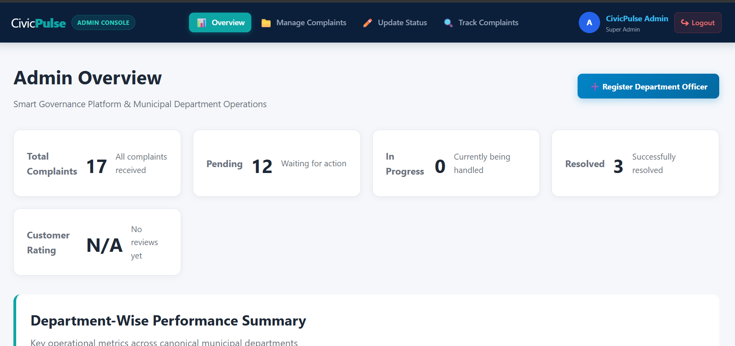

- Figure 10: Complaint Management
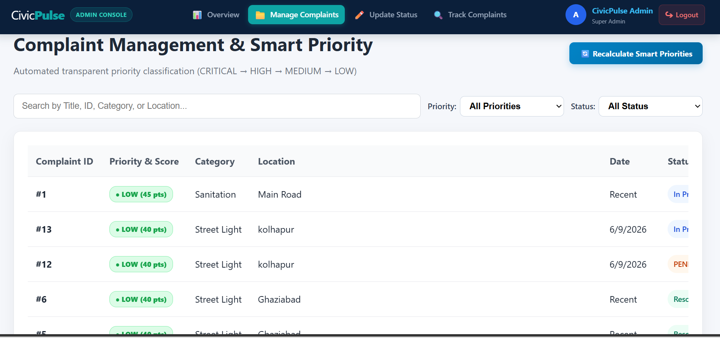
- Figure 11: Department Dashboard
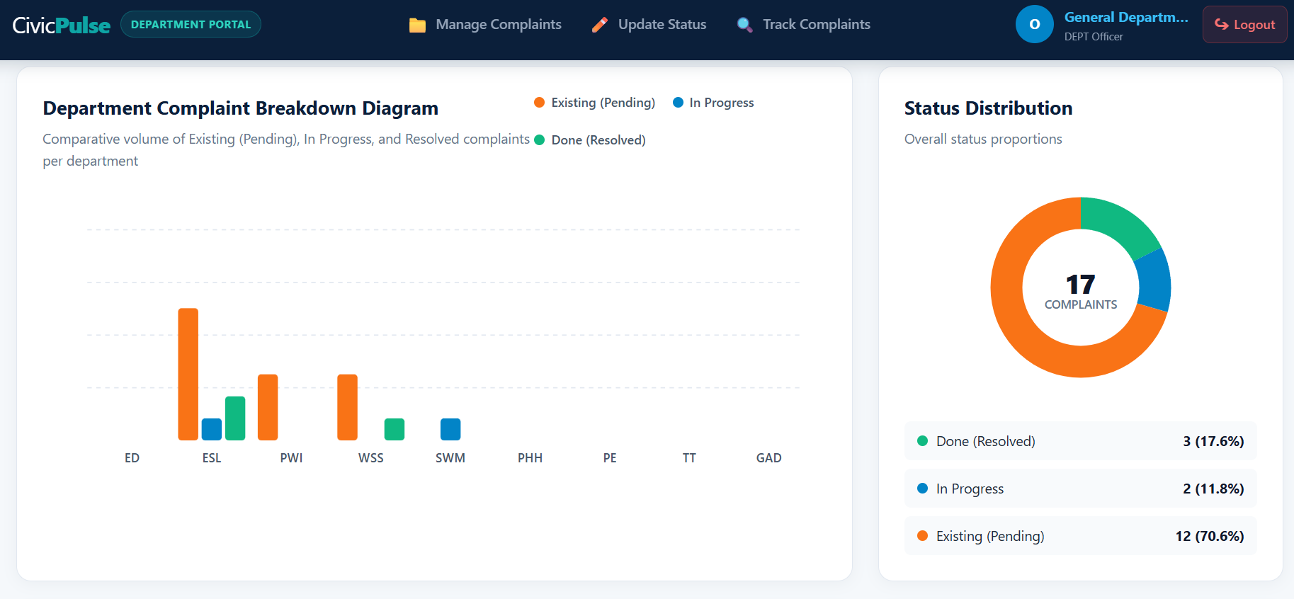

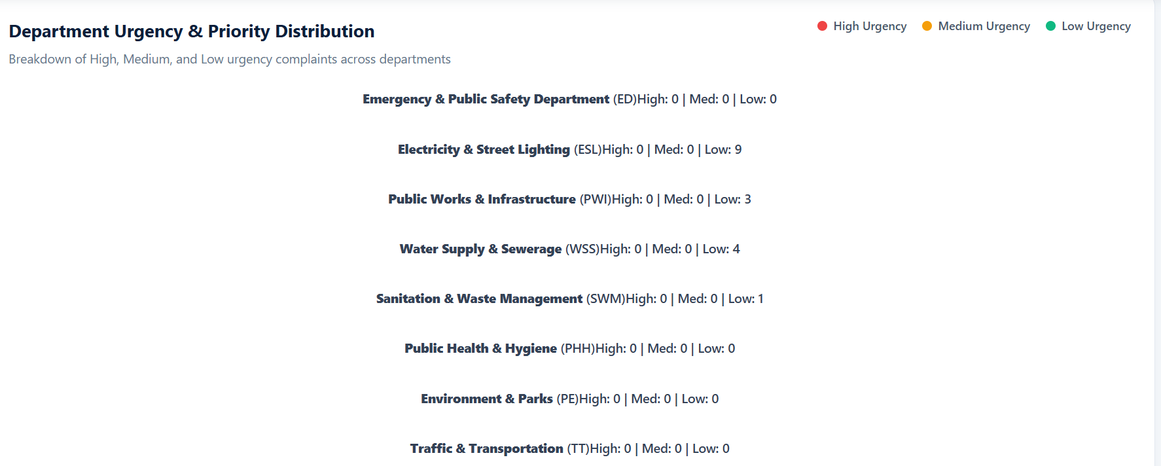
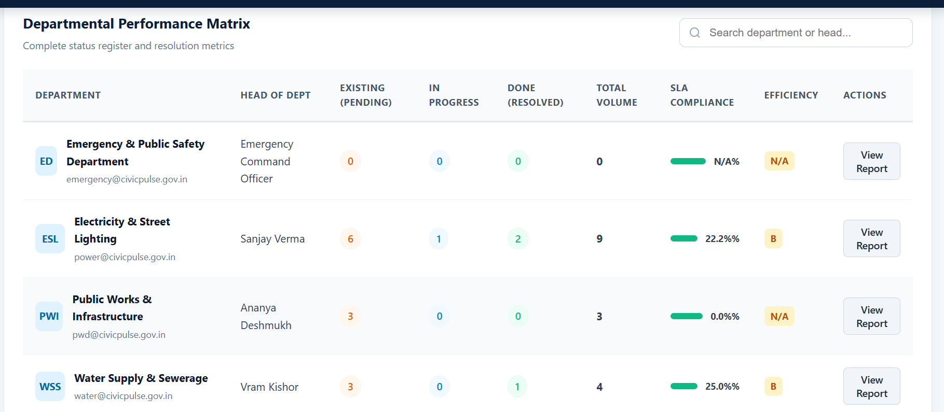

- Figure 12: Reports and Analysis
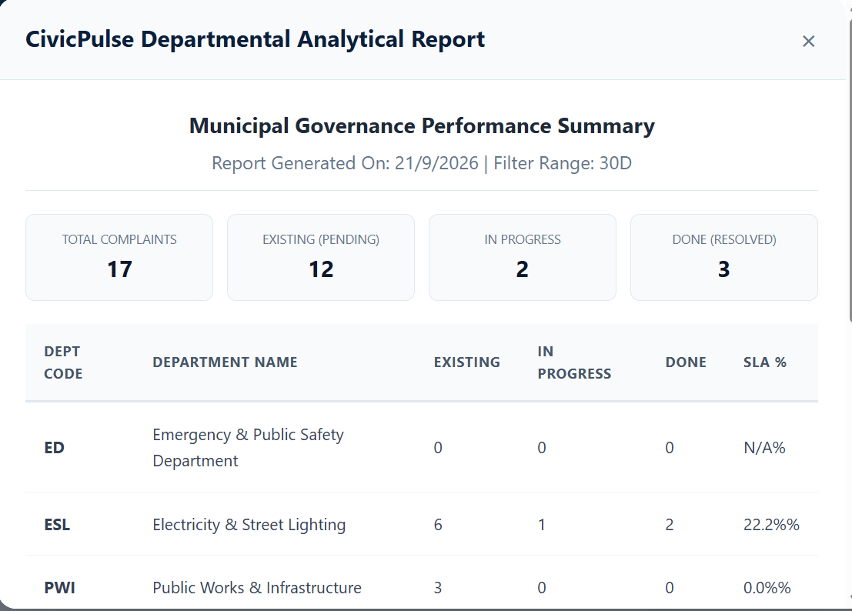

7. Challenges Faced

During the development of the CivicPulse project, the following challenges were faced:
- Frontend–Backend Integration: Connecting React frontend components with Spring Boot REST APIs and ensuring proper data flow between them.
- Database Integration: Managing complaint data and maintaining proper communication between the backend and MySQL/MariaDB database.
- Complaint Management: Handling different complaint statuses, priorities, departments, and user roles correctly.
- Duplicate Complaint Detection: Designing a mechanism to identify potentially duplicate complaints by comparing existing complaint information.
- Form Validation: Ensuring that users provide all required complaint details before submitting the form.
- API Testing and Debugging: Testing API endpoints and resolving errors during frontend-backend integration using Thunder Client.
- Team Integration: Combining different modules developed across frontend and backend while maintaining compatibility between components.
- UI and Navigation Issues: Fixing routing, navigation, error messages, and user interface issues during integration.
- Final Testing: Identifying and resolving issues that occurred when all project modules were integrated together.

How the Challenges Were Addressed
The challenges were addressed through regular testing, debugging, team discussions, API testing, database verification, and incremental integration of the modules. This helped ensure that the different components worked together as a complete application.

8. Learnings & Skills Acquired

During the internship, we gained practical experience in:
Technical Skills
- React.js frontend development
- Java and Spring Boot
- REST API development and integration
- MySQL/MariaDB database concepts
- CRUD operations
- Form validation
- API testing using Thunder Client
- Git and GitHub
- Backend service and repository architecture
- Complaint management workflows
- Text similarity and duplicate detection
Development Skills
- Frontend-backend integration
- Debugging and error handling
- Database interaction
- Testing application workflows
- Working with existing code developed by team members
- Version control and collaborative development
Soft Skills
- Team collaboration
- Task distribution
- Technical communication
- Problem solving
- Presentation skills
- Project documentation

9. Testimonials from team

The Infosys Springboard internship provided us with valuable practical exposure to full-stack application development. Working on the CivicPulse project helped us understand how frontend, backend, database, and REST APIs work together in a real-world application. We gained experience in developing different modules, integrating them, testing the application, and solving technical challenges as a team.
Working on CivicPulse gave us an opportunity to apply our technical knowledge to a practical problem. Developing features such as complaint management, dashboards, tracking, reporting, and duplicate complaint detection helped us improve our programming and problem-solving skills.
The internship also helped us improve our teamwork, communication, version-control, debugging, documentation, and presentation skills. Collaborating on different modules and integrating our work into one application was a valuable learning experience.”

10. Conclusion

The CivicPulse – Smart Governance Management Platform provided practical experience in developing a complete full-stack web application for managing citizen complaints and administrative operations.
During the internship, we worked on different modules including citizen services, complaint management, dashboards, department management, reports and analysis, complaint tracking, status updates, and smart duplicate complaint detection. The project helped us understand the integration of React.js, Java, Spring Boot, REST APIs, and MySQL/MariaDB in a real-world application.
Throughout the project, we also gained experience in team collaboration, API integration, database management, testing, debugging, version control, documentation, and presentation. The challenges faced during development helped us improve our problem-solving and technical skills.
Overall, the CivicPulse project was a valuable learning experience that allowed us to apply our academic knowledge to a practical application and develop a better understanding of the software development process.
Available next action: Create a downloadable DOCX file here in this chat containing the editable prose above

11. Acknowledgements

we would like to express our sincere gratitude to Infosys Springboard for providing us with the opportunity to participate in the Virtual Internship 7.0 program.
We would like to thank our mentors and coordinators for their guidance, support, and valuable feedback throughout the internship.
we am also grateful to my team members for their cooperation, teamwork, and contribution to the CivicPulse project.
Finally, we would like to thank everyone who supported us during the development, testing, documentation, and presentation of this project.

