

**Tribhuvan University**

**Institute of Science and Technology**

**“Medicine Recommendation System using Naïve Bayes Algorithm”**

**A Proposal Report**

**Submitted To:**

**CSIT Department**

**Bhaktapur Multiple Campus**

**Dudhpati, Bhaktapur, Nepal**

**Submitted By:**

**Diwash Adhikari, 15141/074**

**Saurav Dhami, 15159/074**

**Sujita Jonchhe, 15160/074**

# INTRODUCTION

In present context, the use of information technology is taking place all over. It may either be in local or commercial context. Telehealth or e-medicine is widely used by the user for their different health issues, which is the remote delivery of healthcare services, including exams and consultations, over the telecommunications infrastructure. [1]. Similarly, Mero Hospital is the online system that allows user to observe their diagnosis reports through online and also search for their required medicines and also this system tends to suggest the medicines to the users as per their reports. Similarly, the admin are allowed to update and add the user’s details and reports and also the available medicines. Here, the system conditions and reports.

Mero Hospital system uses the Naïve Bayes algorithm for the recommendation engine. Naïve Bayes Algorithm is a [classification technique](https://courses.analyticsvidhya.com/courses/introduction-to-data-science-2/?utm_source=blog&utm_medium=6stepsnaivebayesarticle) based on Bayes’ Theorem with an assumption of independence among predictors. In simple terms, a Naive Bayes classifier assumes that the presence of a particular feature in a class is unrelated to the presence of any other feature. Naive Bayes model is easy to build and particularly useful for very large data sets. Along with simplicity, Naive Bayes is known to outperform even highly sophisticated classification methods. For example, a fruit may be considered to be an apple if it is red, round, and about 3 inches in diameter. Even if these features depend on each other or upon the existence of the other features, all of these properties independently contribute to the probability that this fruit is an apple and that is why it is known as ‘Naive’. [2].

# PROBLEM STATEMENT

While observing the present context, everyone has to visit the hospitals and clinics for each and every health related issues. They are forced to wait a long day for a single appointment. Each task are to be performed physically. The reports are usually paper based. And Doctor’s availability are usually unknown. Similarly, Most of the people are unaware about the exact dates and timing of their next appointment. So, they miss most of their appointments. This is the problems faced by most of the patients in present context.

# OBJECTIVES

The main objective of this system is to recommend the medicine to the patient according to their prescription. However, the thorough set of objectives can be listed below:

* To allow the ticket booking through online.
* To allow the doctor’s availability details.
* To recommend the similar as well as well-rated medicines.
* To provide the doctor’s appointment remainder.

# METHODOLOGY

## a. Requirement Identification

### i. Literature Review

The online clinic and hospital services has made a great progress in the present context. Virtual Clinic is one of the online clinic services that allows user to find and book their required doctors, to know the details about a particular disease and their symptoms and also meetup the doctors online and pay their bills through online. They can find a doctor nearby them and get walk-in services through Virtual Clinic. But they doesn’t recommend any type of medicine as per their prescription. They initiate the walk-in services for reports and prescription gathering. [3].

Similarly, Mayo Clinic is also providing the clinic services through online mediums. They refers the process of telehealth for their services. It allow to book an appointment, give the location of the nearest clinic, and provide the detail of the doctor and their locations and paying the bills online but allow physical meetup. [4].

### ii. Requirement Analysis

Requirements Analysis can be defined as the process of defining the needs and expectations of the consumers for an application or product that is to be created or modified.

**Functional Requirement**

These are requirements that include functions needed for the product to perform well. It includes the functions performed by the particular module. Similarly, the main functional requirement suggested for this system are the user login, user details or user report, search for medicine as per their need. Similarly, for the admin side it requires admin login, report update and creation and even addition and deletion of medicines.

1. **User:** The end user will be the patient that are associated with the particular system. They will be allowed to update their previous prescription, view their recent reports and also search for their required medicine.
2. **Admin:**  The admin will be the receptionist or the one working on the counter who is responsible for updating, creating, deleting and inserting the user’s details and reports. They will also be responsible for the addition and deletion of the available medicines.
3. **Dataset:** We will be using open source dataset [5] and other datasets from github and other sources.

**Non-Functional Requirement**

Non-functional requirements are not directly related to the functions performed by the system. Simultaneously, non-functional requirements may relate not only to the software system itself: some may relate to the technological process of creating software. [6].

* **Usability**:

Our project is focused on the user preferences and convenient. So, it is created in such a manner that every user can easily access to every points and every data.

* **Reliability:**

For the better performance, the system will be able to work for user 24/7/365.

* **Performance:**

The lower the speed of the system, the lower the chance of system to get success. So, the system can be said to be faster and reliable.

## b. Feasibility Study

A feasibility study could be used to test a proposal for new system, which could be used because:

* The current system may no longer carry its purpose,
* Technological advancement may have rendered the current system obsolete,
* The business is expanding, allowing it to cope with extra work load,
* Competitors are now winning a big enough market share due to an effective integration of a computerized system. [7].

A feasibility study should examine three main areas:

**i. Operational Feasibility**

This system is operationally feasible as it is sustainable solution and also usable, maintainable and reliable.

**ii. Technical Feasibility**

The tools and software that are required for this project are easily available in the web. It do not require special environment to execute. Thus, it is affordable and it can be said to be technically feasible.

**iii. Economical Feasibility**

This system is aimed for the equipment and system that is already in present. So, not requirement of new equipment, it is economically feasible.

**iv. Schedule**

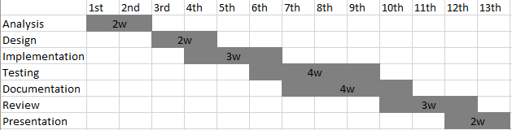

Fig: Gantt Chart showing the project schedule

## System Design

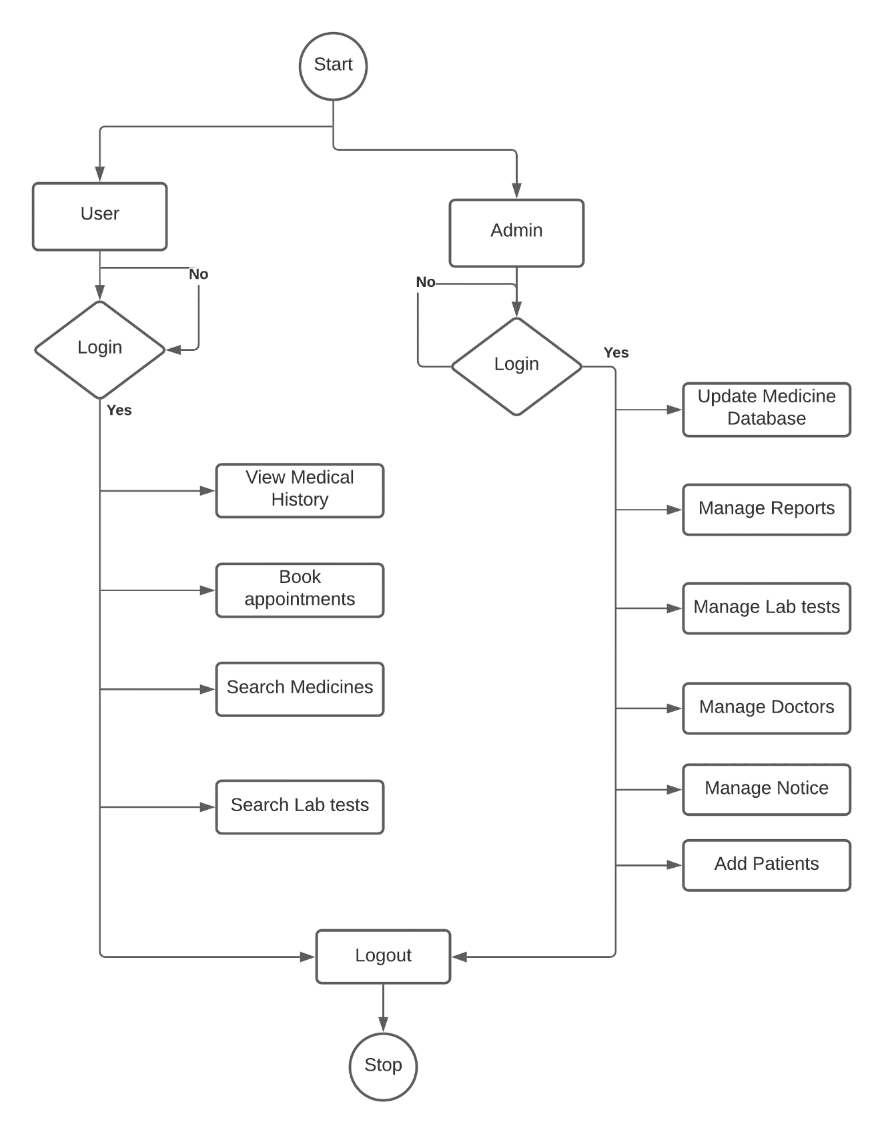

Fig: Flowchart for Medicine Recommendation System

**Naïve Bayes Algorithm:**

Naive Bayes model is easy to build and particularly useful for very large data sets. Bayes theorem provides a way of calculating posterior probability P(c|x) from P(c), P(x) and P(x|c). Look at the equation below:

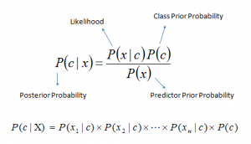

Above,

* P(c|x) is the posterior probability of class (c, target) given predictor (x, attributes).
* P(c) is the prior probability of class.
* P(x|c) is the likelihood which is the probability of predictor given class.
* P(x) is the prior probability of predictor.

**Working Mechanism of Naïve Bayes Algorithm:**

Step 1: Convert the data set into a frequency table

Step 2: Create Likelihood table by finding the probabilities

Step 3: Now, use [Naive Bayesian](https://courses.analyticsvidhya.com/courses/naive-bayes?utm_source=blog&utm_medium=naive-bayes-explained) equation to calculate the posterior probability for each class. The class with the highest posterior probability is the outcome of prediction.

# EXPECTED OUTCOME

This system will provide an easier option for any patient to contact their doctors and view their reports and prescriptions. The main focus of this project is on the easier meetup with the doctors, remainder of their upcoming appointments and also recommendation of the medicine as per their prescription.

# References

|  |  |
| --- | --- |
| [1] | " https://searchhealthit.techtarget.com/definition/telemedicine," [Online]. |
| [2] | "2 https://www.analyticsvidhya.com/blog/2017/09/naive-bayes-explained/," [Online]. |
| [3] | "3 https://missionhealth.org/provider-finder/home," [Online]. |
| [4] | "4 https://www.mayoclinic.org/appointments/find-a-doctor," [Online]. |
| [5] | "5. https://www.kaggle.com/deepalighodki/medicine," [Online]. |
| [6] | "6.https://gbksoft.com/blog/functional-and-nonfunctional-requirements-the-detailed-guide/," [Online]. |
| [7] | "7. https://reqtest.com/requirements-blog/how-to-conduct-a-feasibility-study/," [Online]. |