CrowdSafe: Zero-Shot Crowd Density Estimation and Uncertainty-Aware Forecasting for CCTV-Based Early Warning
Shruti Mishra
KIET Group of Institutions
Ghaziabad, India
shruti.2327cseml1093@kiet.edu

Shubhendra Singh
KIET Group of Institutions
Ghaziabad, India
shubhendra.2327cseml@kiet.edu

Riddhima Sangal
KIET Group of Institutions
Ghaziabad, India
riddhima.2327cseml10@kiet.edu

Sidharth Gautam
KIET Group of Institutions
Ghaziabad, India
sidharth.2327cseml10@kiet.edu

Nidhi Singh
KIET Group of Institutions
Ghaziabad, India
nidhi.singh@kiet.edu

Most camera systems are only able to count people in the entire image, and crowd safety relies on the number of people standing per square metre of floor. CrowdSafe transforms the footage from a stationary CCTV camera into a crowd density (persons/m²) for each zone of the floor, and alerts before a zone is overcrowded. First, a camera model is attached to desks of known size, and all image pixels are associated with a floor position in metres. Then the CLIP-EBC model generates a map of the density of people in each frame, and the RAFT optical flow computes the movement of the people. These maps are then translated into the density and walking speed of each floor zone, 1 second at a time, by the camera model. The Chronos-2 forecasting model forecasts the density of each zone 10-60 s in advance, and conformal calibration provides a safe upper limit for each forecast. All zones are categorized into 4 levels: Low, Medium, High, and Critical, and an alert is triggered if a zone is in the High or Critical level for 10 s. The system is evaluated using classroom CCTV recordings (6,715 hand-labeled heads), real crowd experiments at Jülich, and simulation experiments using JuPedSim. The average error in the number of people counted is 2.0-5.1 persons per frame, the zone density error is 0.08-0.10 persons/m², the upper limit applies for 84-96 % of the forecasts, the alerts are issued a median of 7.5 s in advance for 34 % of the simulated dangerous events, and the entire pipeline is executed on a single A100 GPU with a median delay of 0.49s.
Index Terms—crowd counting, crowd density estimation, zero-shot learning, time-series forecasting, conformal prediction, optical flow, early warning
I. INTRODUCTION
Crowd disasters are caused by local density, not by the total number of people present. The dangerous condition starts at about 4-5 persons/m², and the stop and go flow and turbulent flow occur at higher densities [1], [2]. There are already a number of venues with fixed CCTV. Most of the methods used for crowd counting and the analytics used for deployment report on the number of people per image [3], [4], [5]. Such a count cannot provide any indication of where the density is accumulating, and cannot be compared to density limits without taking into account the floor area covered by each image region, which needs camera calibration that existing installations do not typically holds. A forecaster for anticipation of danger also needs to be one that can operate without venue-specific training data, since dangerous events are rare. The problem is to estimate the density of each floor zone at each second, to predict with a good upper bound the density of each zone, and to raise an alarm before a zone is dangerous, while avoiding too many false alarms, given an existing CCTV camera and a few measured dimensions in the scene. The goals are: (i) zone density (persons/m²) without training a counting model; (ii) a forecast obliged with coverage evaluated on independent test data; (iii) alert lead time and false alarms on real and simulated dense crowds; and (iv) live latency on one GPU. The contributions are:
1) A camera calibration that fits a camera model with lens distortion to desk tops of known length and to straight edges in the room to ensure that each image pixel corresponds to a floor position in metres, but not used in the fitting.
2) A zero-shot density model that is evaluated using a counting evaluation on real CCTV across rooms, surpassing existing person detectors along with matching the detector–density combinations within 0.06.
3) Zero-shot forecasting of zone density with an upper bound conformally calibrated.
4) Real and simulated dense crowd evaluation with early-warning protocol with clear lead time.
5) A real-time implementation with latency measurement and a dashboard for replay.
II. RELATED WORK
A. Crowd Counting: Detection versus Density Estimation
The density map methods compute a density per pixel, the sum of which equals the count. The ShanghaiTech benchmark [3] has been introduced by MCNN. The pooling replaced through CSRNet via dilated convolutions [4]. CLIP-EBC reformulated counting as blockwise classification problem on the backbone of CLIP trained on NWPU-Crowd [5], [6]. The models trained on CrowdHuman are only able to detect visible persons, e.g., YOLO11 [7], [8].
B. Crowd Dynamics and Danger Indicators
The transition from laminar to stop-and-go to turbulent flow is observed in the video of the 2006 Hajj disaster and crowd pressure is suggested as a danger indicator, which is the product of density and velocity variance [2]. Trajectories of controlled high-density experiments are available in the Jülich archive [9]. PedPy analyses and JuPedSim simulates such pedestrian data [10], [11].
C. Crowd Density and Flow Forecasting
ST-ResNet predicts the flows in and out of the city regions [12]. A two-stream recurrent network predicts crowd distributions in the future from video [13]. New series forecast without training [14], [15] using Chronos and Chronos-2. Split conformal prediction provides a bound with finite-sample coverage [16].
D. Integrated Crowd Monitoring and Early-Warning Systems
A video-based system estimates and predicts the crowd density over a multi-camera network for wide-area surveillance [17]. Forecasting Future crowd distributions predict warnings for overcrowded areas [13].
E. Research Gap
The reviewed studies are summarised in Table I. No evaluation founded that integrates density (persons/m² per floor zone) from an existing uncalibrated camera, a forecast with verified coverage and alert lead time on real dense crowds. CrowdSafe provides this combination of pretrained components.
TABLE I: Research Gap per Reviewed Study
Study | Approach and evaluated setting | Difference relevant to CrowdSafe | Relation to this work
MCNN [3], CSRNet [4] | CNN density maps, trained per dataset (ShanghaiTech and others) | count per image; trained on the target data | compared on ShanghaiTech (Section V-A)
CLIP-EBC [5] | CLIP backbone, blockwise count classification; state of the art on NWPU-Crowd | image-level counts | used zero-shot, projected to persons/m² per zone
CrowdHuman [8] | full, visible and head boxes in crowded images | detectors count visible people only | detectors used as counting baselines
Crowd-disaster analysis [2] | empirical analysis of the 2006 Hajj disaster video; crowd pressure | empirical study, not a forecasting system | crowd pressure computed for every zone
ST-ResNet [12] | forecasts city-region inflow/outflow from trajectory data | grid flows, not CCTV zones | motivates the inflow/outflow baseline
Crowd-distribution forecasting [13] | forecasts future crowd distribution from video frames and density maps | image-plane density | CrowdSafe forecasts zone density in persons/m² with a calibrated bound
Wide-area density prediction [17] | multi-camera density estimation with minutes-ahead prediction | different data and metrics | closest system; not directly comparable
Chronos-2 [15] | pretrained, zero-shot time-series forecaster | not evaluated on crowd density | used as the forecaster

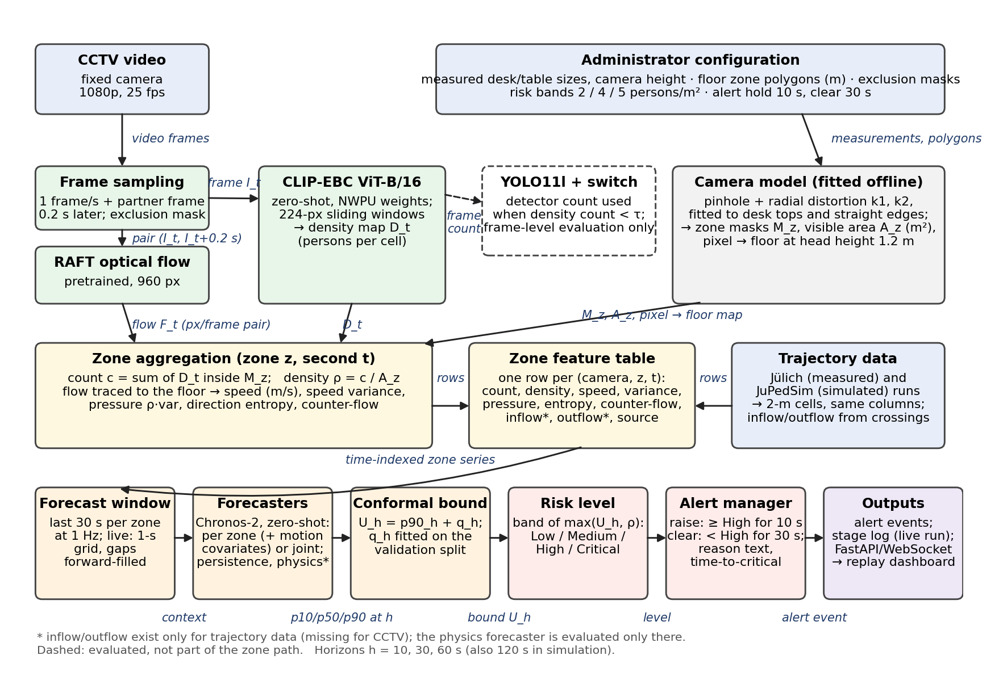
Fig. 1. CrowdSafe pipeline: solid blocks form the deployed path; the dashed detector block serves frame-level counting comparison only.
III. PROPOSED METHODOLOGY
CrowdSafe is a series of steps which converts frames from the camera into alerts, with each step operating on the result of the previous step, as illustrated in Fig. 1. Once set up, a camera model establishes a relationship between image pixels and the floor. Each second, a frame is captured as a map of where people are, and a pair of frames is captured as a field of how people move, both of which are aggregated per floor zone into densities (persons/m²) and motion statistics (stored as one row per zone, per second), respectively. The recent rows of each zone are forecast every 5 s, the upper calibrated limit of the forecast is set as a risk level and high levels maintained for a long time are set as alerts on a dashboard. One step is described in each subsection and an example from the real CCTV, Jülich and simulated data is provided.
- Camera Calibration
To calculate density in persons/m², requires knowing the floor area represented in each part of the image. CrowdSafe robustly fits a camera model (a pinhole camera with radial lens distortion (k1,k2), focal length, position and tilt) to a few objects of known size in a still frame and to straight edges, that must appear straight when the distortion is removed. The only additional material needed is a tape measure. The fitted model takes any pixel to a point on the floor at a selected height, which the zone and motion steps depend on. Desk tops of measured length (1.00 m) are used as rectangles in the classrooms, and each desk is at left free position so that the row and column spacing can be used as independent checks, while the door frames and ceiling duct are used as straight edges. In the computer lab, most desktops are covered by the monitors, so long table edges at measured positions, vertical edges and measured camera height are used instead.
- Zone Definition and Area Computation
The floor is then subdivided into zones on a plan in metres, so that a dangerous corner is not "averaged out" by a blank corner. The camera model maps each zone into the image at the height where the heads are visible, resulting in the image region Mz that corresponds to the zone z, and the floor area Az that the camera can see. These two quantities will later be used to convert a number of people into a density. The seating blocks are 3×3 with the front aisle (4-16 m²) each, at seated head height (1.2 m).
- People Counting
A video frame is fed to the pretrained density model CLIP-EBC ViT-B/16 with NWPU-Crowd weights, without any training, every second [5], [6]. The model runs on non-overlapping 224-pixel windows (45 windows for a 1080p frame) and outputs a density map Dt of 135×240 cells, each corresponding to an 8×8 pixels window, containing the expected number of heads, and thus can be summed over any region of the image. The density model is selected over person detectors because many people are seated in rooms and desks and monitors blocked by detectors, which are only detected as a person as a separate box. Other baselines are combinations of detector and density-model frame counts: a hard switch to the detector below a threshold τ, a constant or 50/50 weighting, and a learned per-frame weight. YOLO11l and a YOLO11 head detector trained on CrowdHuman [7], [8] are used as detectors. In the recordings, 1 frame/s of all the classroom and lab videos is passed through CLIP-EBC, and the detectors and combinations are executed on the 160 hand labelled frames to select the counting route, as described in Section V-B.
- Zone Density Estimation in Persons per m²
The density map obtained from the counting step overlaps the zone regions and areas of the zone step. The number of people in the zone region can be obtained by summing the map inside the zone region: cz,t=Σ Dt⊙ Mz; the density of the people in the zone region can be obtained by dividing by the visible area: ρz,t=cz,t/Az persons/m². Areas with less than 2 m² of view are not included since the density of these small areas is unstable. This is the number that the rest of the pipeline is watching per second. This step generates 10 densities per second for one classroom, one for each seating block and aisle.
- Crowd Motion Feature Extraction
Density is the degree of occupancy of a zone, motion is the way the crowd is moving. The same sampled frame and a second frame 0.2 s later are sent to pretrained RAFT-large optical flow at 544×960 pixels with 12 refinement iterations, which is averaged into the same 135×240 cells as Dt [18]. The camera model applies each displacement to the floor, resulting in velocities in m/s, weighted by the density map, which means that no velocity is added if the floor is empty. The mean speed, velocity variance, crowd pressure ρ·var, entropy of an 8-bin direction histogram and the percentage of counter-flow [2] are calculated per zone. The number of people crossing a zone boundary per second (inflow and outflow) must be associated with individual trajectories, and as such are only available at the locations where trajectories are available. All motion values are extracted from RAFT for the real CCTV data, and inflow and outflow are empty; for the data from Jülich and the simulated data, speeds and boundary crossings are taken directly from each trajectory.
- Zone Feature Table Construction
All measurements are gathered in a single table, one row per camera (or run), zone and second, with count, density, the motion values, the inflow and the outflow as well as the data source. All sources that fill the table are evaluated in the same way, and are forecasted and alerted read only this table. The real CCTV data are filled in the table by the density and motion steps. The table is filled directly by the Jülich and the simulated data, with 2 m×2 m floor cells as zones, and the Jülich densities are exactly the same as the PedPy in six runs checked [10]. Classrooms recordings has no dense crowd, therefore pass through the same downstream steps.
G. Crowd Density Forecasting
The final 30 s of each zone are read as a standard 1 Hz series every 5 s and the 10, 30 and 60 s ahead forecasts are calculated. Chronos-2 is a pretrained time-series model used as a forecaster, in a zero-shot fashion [15]. The selection of a zero-shot model is due to the fact that dangerous crowd events are too infrequent to train a forecaster on venue data. The model can be run per zone, with pressure, inflow, outflow and mean speed as additional inputs (set to zero if not provided), or jointly across all zones of a single camera, with neighbouring zones providing information to each other, and it returns the 10, 50 and 90 % quantiles for each zone and horizon. Two simple forecasters are used as baselines: persistence, which is the last value, and a physics fill-rate model, ρ+(qin-qout) h/Az, which requires inflow and outflow. During live operation a second that is skipped by a slow cycle will be filled with the previous value to keep the series regular. Warning time is not the horizon; the horizon is a limitation on the warning time. Most of the Jülich runs are of short duration (1-3 min) and therefore have horizons of 10-60 s on these data and on the real CCTV data, 120 s on the longer simulations; physics model runs are only performed on the Jülich and simulated data.
H. Reliable Upper Bound via Conformal Calibration
The 90 % quantile of a forecaster does not mean that the forecaster will be exceeded 10 % of the time, and point forecasts have no spread whatsoever. The upper bound is thus calibrated using split conformal prediction [16] in the context of CrowdSafe. During the validation runs, the difference between the realized density and the 90 % quantile is calculated, and the finite-sample 90% quantile of these differences is an offset qh for each horizon. The bound Uz,h is then updated to be the worst case, max(0, p90z,h+qh), on which the risk step operates in the new forecasts. The offsets are applied to two validation cameras, 39 Jülich validation runs and four validation scenarios and are only used for the test data. The Chronos-2 offsets on the real CCTV data are very small (0.001–0.02 persons/m²) and for persistence the offset of 0.14–0.18 persons/m² is the entire bound.
I. Risk Classification (Low, Medium, High, Critical)
The calibrated bounds over all horizons and the current density are combined into a worst case, Wz=max(maxh Uz,h, ρz), which is mapped to Low (<2), Medium (2–4), High (4–5) or Critical (≥ 5 persons/m²). The time to critical is reported for the first horizon whose bound reaches 5 persons/m². Only current density is used prior to the first forecast of a run. As seen in Fig. 2, a zone of 1.6 persons/m² is classified as Medium in a classroom recording, since the forecast bound of that zone is above 2 persons/m².
J. Alert Generation
The levels change every 5 s and can flicker so an alert manager introduces hysteresis: an alert will trigger when a zone is High or above for 10 s and will be dismissed when a zone is below High for 30 s. For each alert the zone, the highest level attained, the time to critical and a brief reason are recorded, e.g. “forecast upper bound 4.2 persons/m² (now 1.8)”. The bound of one zone exceeds 4 persons/m² and an alert is triggered at 219 s, 49 s prior to the zone reaching 4 persons/m² in a Jülich corridor run as shown in Fig. 3.
K. Dashboard Visualisation
The dashboard displays the zones, levels, forecasts and alerts to an operator. A FastAPI/WebSocket server re-runs a stored run by re-running the risk and alert steps on the feature rows and forecasts of the run, and streams one message per second to a Next.js dashboard: the camera video with zones coloured by level and labelled with density, the forecast of a selected zone, and the alert feed. The live pipeline in Section V-G performs the same steps directly on a camera stream. In Fig. 2, the dashboard is playing back a classroom recording.
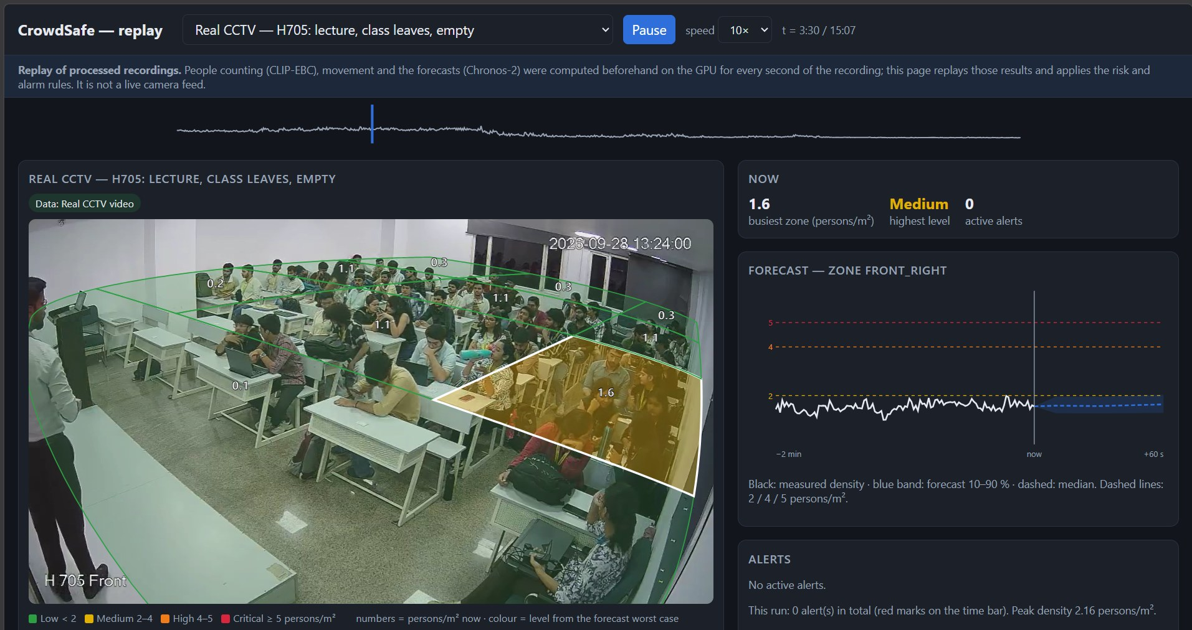
Fig. 2. Replay dashboard on a classroom recording.
IV. DATASETS AND EXPERIMENTAL SETUP
Table II lists the four data sources, the split of each and the role of each in the evaluation.
TABLE II: Datasets and Their Role
Dataset | Content and split | Use
Real CCTV data | 4 cameras, 2 classrooms and 1 computer lab, 2.6 h; 160 labelled frames, 6,715 heads; 2 validation and 2 test cameras | counting, zone density, forecasting, latency
ShanghaiTech A/B [3] | test sets, 182 / 316 images | counting check
Jülich data [9] | validation: 39 runs; test: corridor [19] (9 runs) and entrance [20] (1 run) | real dense crowds
Simulated data [11] | 16 scenarios; 4 validation, 5 test | dense crowd events (up to 8 persons/m²)

A. Real CCTV Data
Four fixed cameras (2.6 h, 1080p) are used to record two classrooms and one computer lab. Head points on 160 frames are annotated by correcting model pre-labels. The highest zone is 3.2 persons/m², which means that there is no dangerous density in the real CCTV data. Faces and identities are not stored.
B. ShanghaiTech Benchmark
The test sets are used here to validate the zero-shot models [3],[4] and the ShanghaiTech A and B are standard counting benchmarks.
C. Jülich Data
The first test experiment is a unidirectional corridor which has been analysed for fundamental diagrams in [19],[21]. The second is an entrance crowd, previously studied for collective crowd behaviour [20],[22]. The two experiments achieve 5.3 and 9.0 persons/m² respectively.
D. Simulated Data
Sixteen scenarios in four layouts (classroom, corridor bottleneck, two-exit hall, bidirectional corridor) include arrival surges and exit closures. Desired walking speeds follow 𝒩(1.34, 0.26²) m/s [23]. Simulations follow model rules not real behaviour.
E. Train, Validation, and Test Splits
No training of models. Combinations are fitted in 2 rooms and tested in the third room, in turn. Conformal offsets are based on validation cameras, experiments or scenarios and applied to separate test ones. Test data serve no fitting.
F. Evaluation Metrics
The mean absolute error (MAE) in people/frame (Table III and Table IV) is used for counting and the mean absolute error (MAE) in persons/m² is used for zone density. Forecasts are based on the MAE and the coverage, which is the percentage of forecasts at or below the bound (target 0.90), reported in Table V. Alerts are the first second in which a zone has 4 (or 5) persons/m² after monitoring has begun. An event is warned in time if an alert is issued at most 10 s before the event and at least 15 s after the monitoring is started. The time between alert and event (lead time) and the number of false alarms (no event within 120 s per zone-hour) are reported in Table VI. The median time from frame arrival to alert state is reported as runtime with model sizes in Table VII.
G. Hardware and Software
Density maps, flow, Chronos-2 and latency run on a single NVIDIA A100 (40 GB); label-based counting is done with ONNX models on a CPU. JuPedSim 1.4.2 is used for simulations and PedPy 1.5.1 for analysis. No model is trained, the deployed path contains approximately 222 M parameters, feature extraction of all 2.6 h of real CCTV data takes 33.5 min on the A100, and the 16 simulations take 9.7 min on a CPU.
V. RESULTS AND DISCUSSION
A. Counting Accuracy on ShanghaiTech
Some comparisons of counting models are given in Table III. Compared with CSRNet (68.2) and MCNN (110.2) trained on ShanghaiTech [3], [4], the MAE for Zero-shot CLIP-EBC is 66.95 and 11.66 on part A and B, respectively. Most people are not detected in these high density images via detectors.
TABLE III: Counting MAE (People per Frame)
Model | Class. 1 | Class. 2 | Lab | ShanghaiTech A / B
CLIP-EBC (zero-shot) | 5.10 | 2.58 | 1.97 | 66.95 / 11.66
YOLO11l | 6.36 | 6.53 | 17.63 | 418.3 / 92.8
CrowdHuman heads | 8.04 | 6.23 | 28.23 | 374.2 / 70.2
MCNN† [3] | – | – | – | 110.2 / 26.4
CSRNet† [4] | – | – | – | 68.2 / 10.6
†Published results, trained on ShanghaiTech. Frames: 100 / 30 / 30.
B. Counting Accuracy on CCTV and Model Selection
Compared with YOLO11l, CLIP-EBC is the most accurate model in every room on real CCTV data (Table III): the error of CLIP-EBC falls from 6.36 to 5.10 in the first classroom, 6.53 to 2.58 in the second, and 17.63 to 1.97 in the computer lab. The bodies are hidden by desks, students and monitors, reducing the number of people detected in a frame by 6–17 people. The mean MAE of the hard switch reaches 3.16 with the combinations fitted on two rooms tested on the third room, and for the learned per-frame weight, 5.22, for CLIP-EBC, 3.22. Thus, all the zone measurements are made using CLIP-EBC density maps, as the zone step requires a spatial map and the CLIP-EBC result is within 0.06 of the best frame-level result.
TABLE IV: Counting MAE with Each Room Held Out in Turn
Method | Class. 1 | Class. 2 | Lab | Mean
Hard switch | 5.08 | 2.51 | 1.89 | 3.16
CLIP-EBC alone | 5.10 | 2.58 | 1.97 | 3.22
50/50 average | 1.68 | 3.45 | 8.31 | 4.48
Constant weight | 4.17 | 2.72 | 6.79 | 4.56
Learned per-frame weight | 4.30 | 3.08 | 8.29 | 5.22
YOLO11l alone | 6.36 | 6.53 | 17.63 | 10.17

C. Calibration Accuracy
Reprojection errors are 3.6-4.2 px. The row spacing in the first classroom is 0.99 m vs. 0.96 m (+3 %), the mean desk spacing varies by -5 %; a door in the second classroom has a measure of 1.23 m vs. 1.12 m (+10 %); and the edge of tables in the computer lab is between 0.03 m and 0.18 m. The accuracy of calibration is thus estimated as being within ± 5 %.
D. Zone Density Accuracy
In the two classrooms zone-density MAE is 0.101 and 0.081 persons/m² and in computer lab 0.078 persons/m², 94-98 % of heads are within a zone, and a change in head height of 1.1-1.6 m changes MAE by at most 0.03. The errors are approximately 20 times less than the width of each risk band (2 persons/m²).
E. Forecasting Accuracy and Upper-Bound Reliability
The forecasting results on the test splits are reported in Table V. Chronos-2 is comparable in terms of average error, and performs better than that of real CCTV data with 0.064-0.097 persons/m² vs. 0.074-0.105 persons/m². The calibrated bound for the Chronos-2 stays near the 90 % target and the persistence bound is reduced to 0.66 for the Jülich data at 30 s. For the true density of at least 4 persons/m², the bound of the Chronos-2 bound is better by up to 20% points compared to the bound of persistence (0.76–0.88 vs 0.56–0.78).
TABLE V: Forecasting on Test Splits (Ranges over Horizons)
Data | Model | MAE (persons/m²) | Coverage | Cov., ρ≥ 4
Real CCTV | Chronos-2 joint | .064–.097 | .89–.91 | –
 | Persistence | .074–.105 | .91–.93 | –
Jülich | Chronos-2 per zone | .38–.73 | .88–.93 | .76–.88
 | Persistence | .39–.71 | .66–.85 | .56–.78
Simulated | Chronos-2 joint | .16–.76 | .91–.96 | .77–.84
 | Persistence | .17–.75 | .87–.93 | .62–.71
Horizons 10–60 s (simulated data 10–120 s). Target coverage 0.90.
F. Early-Warning Performance
The results of the alerts are shown in Table VI. The value of forecasting is demonstrated by alerts of current density alone gives no warning before a zone reaches the value 4 persons/m². The 47 simulated events, covered by the physics model and Chronos-2, trigger a forecast-driven alert in 32 % and 34 % of the cases, respectively, with a median lead time of 25 s and 7.5 s, including a mean of 2.1 and 1.6 false alarms per zone-hour, respectively. The data in Jülich is used as an example here. On this data, the person/m² warning is issued 49 s before the zone is reached (cf. Fig. 3), with the Chronos-2 per-zone forecaster. For a 5 persons/m² event, alerts warn in for 38% of the 34 simulated events. The data generated by the real CCTV produce no events and no false alarms in 8.6 zone-hours. Zones reaches from safer level to 4 persons/m² within 10–20 s to fill, thereby quantifying the lead times.
TABLE VI: Events Warned in Time (Median Lead; False Alarms per Zone-Hour)
Alert driver | Sim., 4 persons/m² 47 events | Jülich, 4 persons/m² 9 events | Sim., 5 persons/m² 34 events
Current density | 0 % | 0/9 | 38 % (5 s; 0.6)
Persistence | 0 % | 1/9 (4 s; 0) | 38 % (10 s; 0.7)
Physics | 32 % (25 s; 2.1) | 1/9 (59 s; 11.9) | 23.5 % (47.5 s; 3.2)
Chronos-2 per zone | 34 % (7.5 s; 1.6) | 1/9 (49 s; 1.8) | 26.5 % (35 s; 2.8)
Chronos-2 joint | 30 % (7.5 s; 1.5) | 1/9 (18 s; 0.5) | 26.5 % (25 s; 2.7)

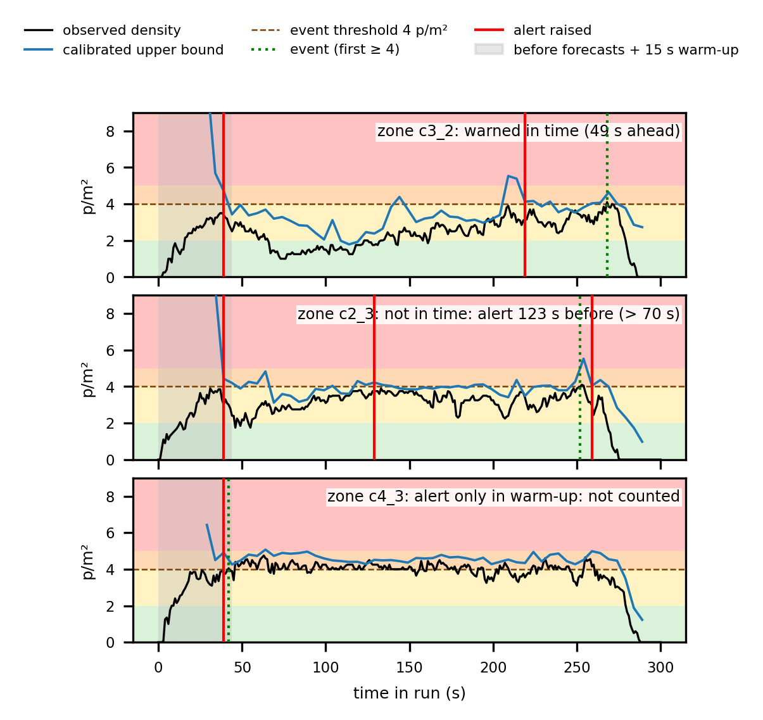
Fig. 3. Alert timeline of a Jülich corridor run (Chronos-2 per zone).
G. Runtime Performance
The live pipeline is on one shared A100 with a classroom recording played back at real speed, with a median latency of 0.49 s (p95 1.6 s), 94 % of 1-s cycles on time and 2.0 GB of GPU memory, and a median of 159 ms (CLIP-EBC), 103 ms (RAFT) and 54 ms (Chronos-2, every 5 s). Unpaced, 908 s of video take 196 s (4.6× real time). The size, input, output and time of each model is shown in Table VII, with each model from the cited source, and the entire pipeline being the proposed system.
TABLE VII: Models: Size, Data Passed and Time per Call
Model | Params | Input | Output | A100 time
CLIP-EBC ViT-B/16 [5] | ≈97 M | 45 windows of 224×224 | density map, 135×240 | 159 ms
RAFT-large [18] | ≈5.3 M | 2 frames, 544×960 | flow, 135×240 cells | 103 ms
Chronos-2 [15] | 120 M | last 30 s per zone | 3 quantiles × 3 horizons | 54 ms per 5 s
YOLO11l [7] (baseline) | ≈25 M | frame at 1280 px | person boxes | 15.5 ms
Proposed CrowdSafe pipeline | ≈222 M | video frame | zone levels and alerts | 0.49 s
≈: estimated from the fp32 model file size; Chronos-2 from the model card. Times: live medians (YOLO11l: single benchmark).
H. Comparison with Existing Systems
As shown in Table III, the zero-shot CLIP-EBC achieves a smaller error than both trained on the same dataset, CSRNet and MCNN, on ShanghaiTech A, leading to CrowdSafe's ability to generate density maps without any training data. CrowdSafe reports density in persons/m² and will have an error of between 0.08 and 0.10 persons/m² per floor zone. At the image level, counters only count people per image [3], [4]. Because there are differences in the data and metrics employed in system level studies, no numerical comparison can be made [13], [17]. The evaluation is based on seated rooms for CCTV, so dense-crowd results are based on nine real Jülich events as well as simulated data and the assumption of seated head height.

VI. CONCLUSION AND FUTURE WORK
A. Conclusion
CrowdSafe transforms any existing CCTV camera into a crowd-density monitor for any floor zone, without training any of the models. An error of 2.0–5.1 persons per frame (up to 9 times lower than a person detector) and zone density measurement of 0.08–0.10 persons/m² are gained. The calibrated forecast bound is observed to cover 84-96 % of forecasts and is within 20 percentage points of target in dense crowds. With simulated data, alerts are predicted 7.5 s in advance (median value), with up to 49 s lead time on real Julich data, using current density data from Jülich data; the entire workflow takes 0.49 s with 1 GPU.
B. Future Work
A single camera warning lead time is defined by the area that the camera can see. Forecaster inputs of counts from entrance cameras and the inflow across the zone boundaries, as calculated from CCTV, increase the warning horizon beyond the field of view. Evaluation based on live CCTV footage of dense crowds, using several cameras run on a single GPU, further validates the solution and quantifies the throughput capacity of the pipeline with several cameras.
REFERENCES
[1] J. J. Fruin, Pedestrian Planning and Design. New York, NY, USA: Metropolitan Association of Urban Designers and Environmental Planners, 1971.
[2] D. Helbing, A. Johansson, and H. Z. Al-Abideen, “Dynamics of crowd disasters: An empirical study,” Phys. Rev. E, vol. 75, no. 4, p. 046109, 2007, doi: 10.1103/PhysRevE.75.046109.
[3] Y. Zhang, D. Zhou, S. Chen, S. Gao, and Y. Ma, “Single-image crowd counting via multi-column convolutional neural network,” in Proc. IEEE Conf. Comput. Vis. Pattern Recognit. (CVPR), 2016, pp. 589–597.
[4] Y. Li, X. Zhang, and D. Chen, “CSRNet: Dilated convolutional neural networks for understanding the highly congested scenes,” in Proc. IEEE Conf. Comput. Vis. Pattern Recognit. (CVPR), 2018, pp. 1091–1100, doi: 10.1109/CVPR.2018.00120.
[5] Y. Ma, V. Sanchez, and T. Guha, “CLIP-EBC: CLIP can count accurately through enhanced blockwise classification,” in Proc. IEEE Int. Conf. Multimedia Expo (ICME), 2025, arXiv:2403.09281.
[6] Q. Wang, J. Gao, W. Lin, and X. Li, “NWPU-Crowd: A large-scale benchmark for crowd counting and localization,” IEEE Trans. Pattern Anal. Mach. Intell., vol. 43, no. 6, pp. 2141–2149, 2021, doi: 10.1109/TPAMI.2020.3013269.
[7] G. Jocher and J. Qiu, “Ultralytics YOLO11,” version 11.0.0, 2024. [Online]. Available: https://github.com/ultralytics/ultralytics
[8] S. Shao, Z. Zhao, B. Li, T. Xiao, G. Yu, X. Zhang, and J. Sun, “CrowdHuman: A benchmark for detecting human in a crowd,” arXiv:1805.00123, 2018.
[9] Forschungszentrum Jülich, “Data archive of experimental data from studies about pedestrian dynamics.” [Online]. Available: https://ped.fz-juelich.de/da/ (accessed Oct. 2026).
[10] T. Schrödter and The PedPy Development Team, “PedPy: Pedestrian dynamics analysis library,” version 1.5.1, Zenodo, doi: 10.5281/zenodo.21476844.
[11] The JuPedSim Development Team, “JuPedSim: Simulating pedestrian dynamics,” version 1.4.2. [Online]. Available: https://www.jupedsim.org
[12] J. Zhang, Y. Zheng, and D. Qi, “Deep spatio-temporal residual networks for citywide crowd flows prediction,” in Proc. AAAI Conf. Artif. Intell., vol. 31, no. 1, 2017, doi: 10.1609/aaai.v31i1.10735.
[13] Y. Niu, W. Shi, W. Liu, S. He, J. Pan, and A. B. Chan, “Over-crowdedness alert! Forecasting the future crowd distribution,” arXiv:2006.05127, 2020.
[14] A. F. Ansari et al., “Chronos: Learning the language of time series,” Trans. Mach. Learn. Res., 2024.
[15] A. F. Ansari et al., “Chronos-2: From univariate to universal forecasting,” arXiv:2510.15821, 2025.
[16] A. N. Angelopoulos and S. Bates, “Conformal prediction: A gentle introduction,” Found. Trends Mach. Learn., vol. 16, no. 4, pp. 494–591, 2023, doi: 10.1561/2200000101.
[17] L. Cao and K. Huang, “Video-based crowd density estimation and prediction system for wide-area surveillance,” China Commun., vol. 10, no. 5, pp. 79–88, 2013, doi: 10.1109/CC.2013.6520940.
[18] Z. Teed and J. Deng, “RAFT: Recurrent all-pairs field transforms for optical flow,” in Proc. Eur. Conf. Comput. Vis. (ECCV), 2020, pp. 402–419.
[19] Forschungszentrum Jülich, “Pedestrian flow in a unidirectional corridor (BaSiGo project),” Pedestrian Dynamics Data Archive, 2013, doi: 10.34735/ped.2013.6.
[20] Forschungszentrum Jülich, “Entrance 1, entry without guiding barriers (semicircle setup),” Pedestrian Dynamics Data Archive, 2013, doi: 10.34735/ped.2013.2.
[21] S. Cao, A. Seyfried, J. Zhang, S. Holl, and W. Song, “Fundamental diagrams for multidirectional pedestrian flows,” J. Stat. Mech.: Theory Exp., 2017, doi: 10.1088/1742-5468/aa620d.
[22] A. Sieben, J. Schumann, and A. Seyfried, “Collective phenomena in crowds—Where pedestrian dynamics need social psychology,” PLOS ONE, vol. 12, no. 6, 2017, doi: 10.1371/journal.pone.0177328.
[23] U. Weidmann, “Transporttechnik der Fussgänger,” Schriftenreihe des IVT, no. 90, ETH Zürich, Zürich, Switzerland, 1993.

