BSCG24-6

Balanced score card course

End Term Submission

G24044

GMP 24-25

Section A

Answer 1 c:

How our hiring decisions and technology contract decisions were affected by Emergent strategy framework .

Brief detail :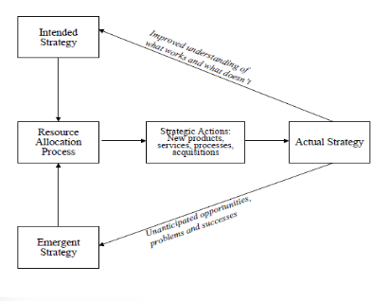

Our company (Talentica) dealt with making customized softwares for car companies.

It was a stratup and not everyone followed strict rules, constant disagreements happened because no one followed one pathway regarding a particular product.

Our company had two decisions to weigh and process.

1. Continuing outsourcing our software development tool to a firm which brought automation and affordable price for maintenance of our ongoing process.  
   (This would cause decrease in hiring experienced developers)
2. Decrease the reliance on outsourced work and hire more experienced developers.

Intention – To reduce friction between developers, maintaining high quality code

Action – Developers understood the need to communicate and document processes to decrease friction between them

Problem that had to be solved - Decrease the percentage of software bugs with increased efficiency

Intended strategy : Delegation and division of labor

Result : While outsourcing and reducing hiring caused a temporary hapiness and relaxation, the outsourced tool needed more effort to govern and fresh talents because level of customization was high

Realization : The documentation of the development work could bring more efficiency and the ongoing staff did not need to be trained in an unstable tool.

Hiring more experienced developers would reduce cost as well as increase quality.

Resource allocation – This Realization meant that they would have to increase collaboration between developers and need more experienced hands.

Emergent strategy : Hired more experienced developers who could improve their outpu as well as keep the cost down.

Strategic action : Hiring of more experienced developers through referral and high trust environment induction .

Better quality working conditions

Better training

Actual Strategy :

1. Removing waterfall development process with more agile methodology to address high customization .
2. Steps to be followed were passed through tests and standards (codification) set by senior developers
3. Thorough documentation to help incoming fresh talents .

(Tacit knowledge internalization)

1. Implement training and observation oriented learning (External knowledge) and also keeping communications textual (Articulation)
2. Development practices which were more successful , were discussed through meetups and followed closely, discussed, after having discussions and agreed (internalization)

Hence result oriented approach of our organization was able to change our strategy which improved our throughput, culture, work quality and profitability

Answer 2 b:

Part A of answer

**Strategy statement :**

To transform 100,000 working professionals by 2028 into modern corporate warriors by infusing them with high quality education from top 10 management institutes , through comprehensive learning powered by our seamless digital reinforcement.

The stage of our company is in : Growth stage .

Hence we are a tested product of high quality and are now aiming volumes and high capability while scaling up.

We had priorities of creation and infusion earlier. But not anymore since we are at growth stage

Source of revenue - direct payment by students and funding

Part B of answer

**Strategy map**

**(I have drawn the same below )**

**Company Vision:** To be the leading and most trusted education company, delivering high-quality, affordable products that enhance student growth.

**Company Mission:** To achieve sustainable growth by focusing on consumer satisfaction, operational excellence, and platform development.

**I. Financial Perspective (How do we look to shareholders?)**

* **Objectives:**
  + Increase revenue growth.
  + Improve profitability.
  + Enhance return on assets (ROA).
  + Control operational costs.
* **Measures:**
  + Revenue growth rate (e.g., year-over-year).
  + Gross profit margin.
  + Net profit margin.
  + Return on assets (ROA).
  + Operating expense ratio.
  + Inventory turnover rate.
* **Targets:**
  + Revenue growth of 20% annually.
  + Gross profit margin of 30%.
  + ROA of 12%.
  + Operational expense ratio below 2%.
* **Initiatives:**
  + Implement strategic pricing and promotion strategies.
  + Optimize high quality cloud infrastructure for cost reduction.
  + Introduce high-margin product lines.

**II. Customer Perspective (How do customers see us?)**

* **Objectives:**
  + Increase market share.
  + Enhance customer satisfaction.
  + Improve brand loyalty.
  + Increase product availability.
* **Measures:**
  + Market share percentage.
  + Customer retention rate.
  + Distribution reach.
* **Targets:**
  + Increase market share by 30%.
  + Customer retention rate of 70%.
  + Achieve 20% distribution reach.
* **Initiatives:**
  + Develop targeted marketing campaigns.
  + Enhance customer service and feedback mechanisms.
  + Launch loyalty programs.
  + Expand tie ups with top management institutes
  + Improve brand value

**III. Internal Processes Perspective (What must we excel at?)**

* **Objectives:**
  + Improve platform efficiency.
  + Enhance new product development (new modules, new subjects).
  + Optimize platform cloud costs.
  + Improve sales force effectiveness.
  + Ensure quality control.
  + Regular campaigns to attract top professors and encourage them to take part in the program
* **Measures:**
  + Conversion time.
  + efficiency rate.
  + Sales conversion rate.
  + Order fulfillment rate.
* **Targets:**
  + Sales conversion rate of 30%.
  + Order fulfillment rate of 100%.
* **Initiatives:**
  + Invest in technology for platform and management.
  + Streamline processes.
  + Provide sales training and development.
  + Enhance quality assurance procedures.

**IV. Learning & Growth Perspective (How will we sustain our ability to change and improve?)**

* **Objectives:**
  + Enhance employee skills and capabilities.
  + Foster a culture of innovation.
  + Improve employee satisfaction and retention.
  + Implement effective information systems.
* **Measures:**
  + Employee training hours.
  + Number of new institutes joined.
  + Employee turnover rate.
  + IT system uptime.
  + Knowledge management adoption rate.
* **Targets:**
  + Average training hours per employee of 50hrs.
  + Employee satisfaction rate of 80%.
  + IT system uptime of 100%.
* **Initiatives:**
  + Implement employee training and development programs.
  + Encourage innovation through R&D and employee suggestions.
  + Improve communication and employee engagement.
  + Invest in IT infrastructure and systems.
  + Implement knowledge management systems.

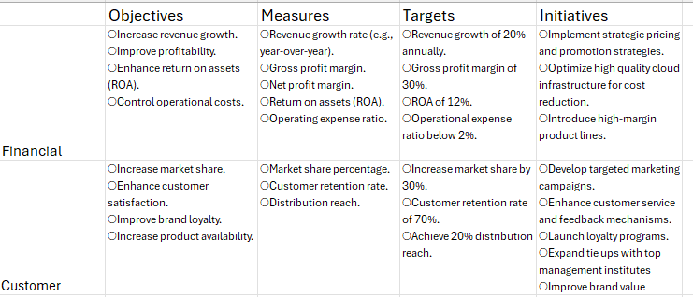

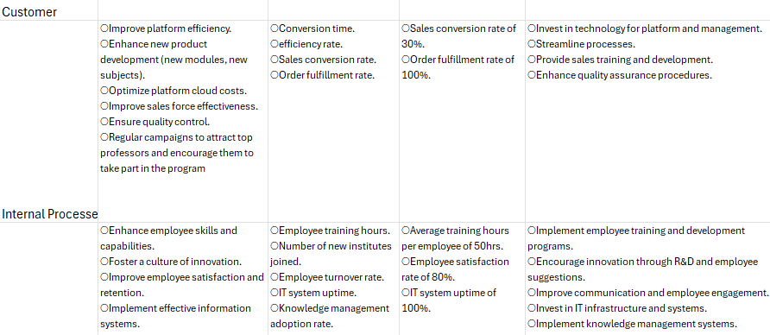

Part C of answer

Domain :

Process.

Measures :

1. Customer satisfaction rate
2. Engagement rate

Initiatives to achieve the above objectives for process :

**Key Considerations for Activities:**

* **Alignment:** Ensure all objectives and measures align with the company's overall vision and strategy.
* **Data Collection:** Establish robust data collection and reporting systems.
* **Regular Review:** Conduct regular reviews of the scorecard to track progress and make adjustments.
* **Communication:** Communicate the scorecard to all employees