The Waterfall Model was first Process Model to be introduced. It is also referred to as a **linear-sequential life cycle model**.  It is very simple to understand and use.  In a waterfall model, each phase must be completed fully before the next phase can begin.   At the end of each phase, a review takes place to determine if the project is on the right path and whether or not to continue or discard the project

**Diagram of Waterfall-model:**

[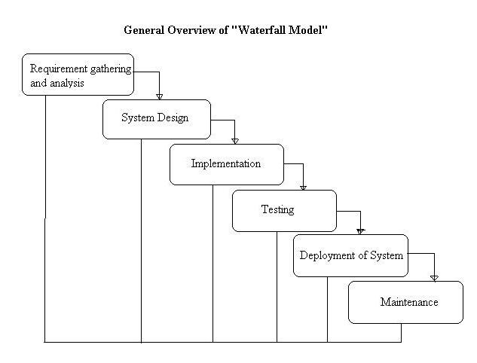](http://istqbexamcertification.com/wp-content/uploads/2012/01/Waterfall-model.jpg)

**Advantages of waterfall model:**

* Simple and easy to understand and use.
* Easy to manage due to the rigidity of the model – each phase has specific deliverables and a review process.
* Phases are processed and completed one at a time.
* Works well for smaller projects where requirements are very well understood.

**Disadvantages of waterfall model:**

* Once an application is in the testing stage, it is very difficult to go back and change something that was not well-thought out in the concept stage.
* No working software is produced until late during the life cycle.
* High amounts of risk and uncertainty.
* Not a good model for complex and object-oriented projects.
* Poor model for long and ongoing projects.
* Not suitable for the projects where requirements are at a moderate to high risk of changing.

**When to use the waterfall model:**

* Requirements are very well known, clear and fixed.
* Product definition is stable.
* Technology is understood.
* There are no ambiguous requirements
* Ample resources with required expertise are available freely
* The project is short.

**Prototype model:**

The basic idea here is that instead of freezing the requirements before a design or coding can proceed, a throwaway prototype is built to understand the requirements. This prototype is developed based on the currently known requirements. By using this prototype, the client can get an “actual feel” of the system, since the interactions with prototype can enable the client to better understand the requirements of the desired system.  Prototyping is an attractive idea for complicated and large systems for which there is no manual process or existing system to help determining the requirements. The prototypes are usually not complete systems and many of the details are not built in the prototype. The goal is to provide a system with overall functionality.

**Diagram of Prototype model:**

[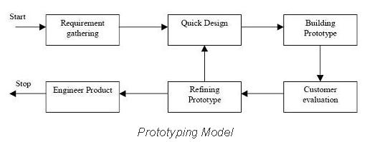](http://istqbexamcertification.com/wp-content/uploads/2012/01/Prototype-model.jpg)

**Advantages of Prototype model:**

* Users are actively involved in the development
* Since in this methodology a working model of the system is provided, the users get a better understanding of the system being developed.
* Errors can be detected much earlier.
* Quicker user feedback is available leading to better solutions.
* Missing functionality can be identified easily
* Confusing or difficult functions can be identified  
  Requirements validation, Quick implementation of, incomplete, but  
  functional, application.

**Disadvantages of Prototype model:**

* Leads to implementing and then repairing way of building systems.
* Practically, this methodology may increase the complexity of the system as scope of the system may expand beyond original plans.
* Incomplete application may cause application not to be used as the  
  full system was designed  
  Incomplete or inadequate problem analysis.

**When to use Prototype model:**

* Prototype model should be used when the desired system needs to have a lot of interaction with the end users.
* Typically, online systems, web interfaces have a very high amount of interaction with end users, are best suited for Prototype model. It might take a while for a system to be built that allows ease of use and needs minimal training for the end user.
* Prototyping ensures that the end users constantly work with the system and provide a feedback which is incorporated in the prototype to result in a useable system. They are excellent for designing good human computer interface systems.

**Spiral Model:**

The spiral model is similar to the incremental model, with more emphasis placed on risk analysis. The spiral model has four phases: Planning, Risk Analysis, Engineering and Evaluation. A software project repeatedly passes through these phases in iterations(called Spirals in this model). The baseline spiral, starting in the planning phase, requirements are gathered and risk is assessed. Each subsequent spirals builds on the baseline spiral. **Requirements** are gathered during the planning phase.  In the **risk analysis phase**, a process is undertaken to identify risk and alternate solutions.  A prototype is produced at the end of the risk analysis phase.

Software is produced in the **engineering phase**, along with testing at the end of the phase.  The **evaluation phase** allows the customer to evaluate the output of the project to date before the project continues to the next spiral.

**Diagram of Spiral model:**

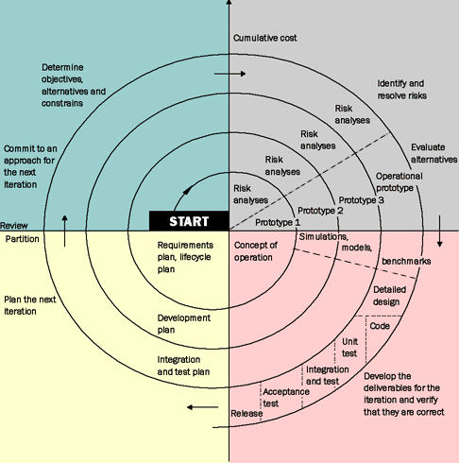

**Advantages of Spiral model:**

* High amount of risk analysis hence, avoidance of Risk is enhanced.
* Good for large and mission-critical projects.
* Strong approval and documentation control.
* Additional Functionality can be added at a later date.
* Software is produced early in the software life cycle.

**Disadvantages of Spiral model:**

* Can be a costly model to use.
* Risk analysis requires highly specific expertise.
* Project’s success is highly dependent on the risk analysis phase.
* Doesn’t work well for smaller projects.

**When to use Spiral model:**

* When costs and risk evaluation is important
* For medium to high-risk projects
* Long-term project commitment unwise because of potential changes to economic priorities
* Requirements are complex
* New product line
* Significant changes are expected (research and exploration)