On hue Impala:

Problem Statement 1:

Use 2 groups by clauses, 1 nested select, 1 sum operation.

Query:

SELECT sum(S.Units_Sold),S.item_type,S.country FROM

(select * from sales where sales.sales_channel='Online')

AS S GROUP BY

S.item_type,S.country;

Execution time = 1.77 sec

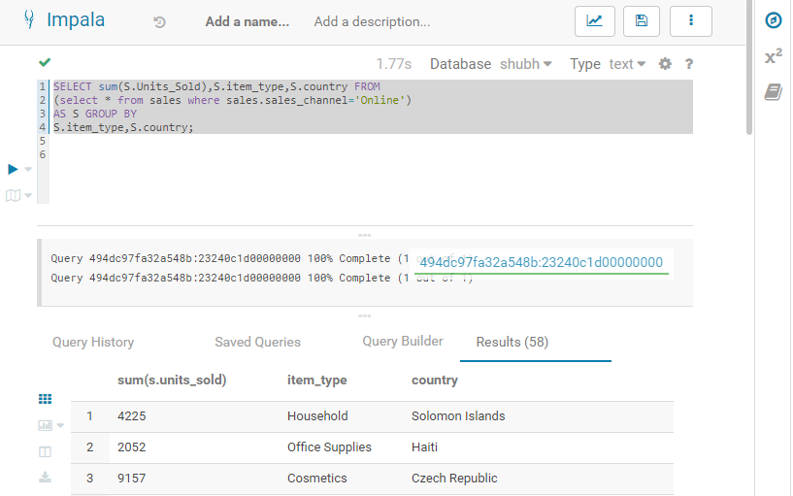

Problem Statement 2:

1 sort clause, 1 group by and 1 average clause.

Query:

SELECT avg(S.Units_Sold),S.country FROM

(select * from sales where sales.sales_channel='Online')

AS S GROUP BY

S.country ORDER BY s.country;

Execution Time: 2.20 Sec

