import sqlalchemy as db

from sqlalchemy import create_engine

import pandas as pd

sales = pd.read_csv("C:\\Users\\dell\\Downloads\\data\\Assignment_no_2_Shubham\\Python\\SortTestData1.csv")

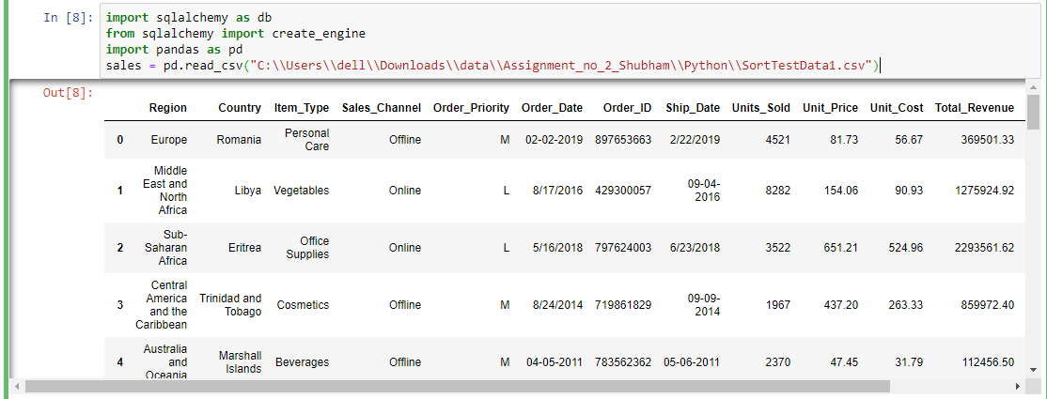

engine = create_engine('sqlite:///:memory:')

sales.to_sql('data_table',engine)

#1st query

Query1 = pd.read_sql_query("SELECT Region, Sales_Channel, SUM(Total_Profit) FROM (SELECT * FROM data_table WHERE Order_Priority = \"H\") GROUP BY Region, Sales_Channel", engine)

print(Query1)

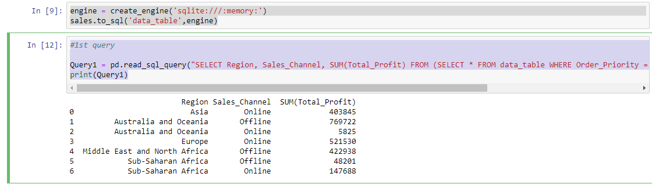

Query2 = pd.read_sql_query("SELECT Region, Sales_Channel, AVG(Total_Revenue) FROM (SELECT * FROM data_table) GROUP BY Region ORDER BY Region, Total_Cost", engine)

print(Query2)

