**Problem Statement:**

1. Create three(3) tables customer, transition and store.
2. Insert data into those tables.
3. Generate join query and fetch data from mentioned tables containing columns store, gender, age group and max values.

**Answer:**

I am using oracle RDBMS database and sql developer GUI for table creation and data fetching.

**Part 1.**

**Table creation:**

Schema Name – HR

Table Name – Coustomer

CREATE TABLE "HR"."COUSTOMER"

( "CUST_ID" NUMBER(10,0),

"NAME" VARCHAR2(15),

"AGE" NUMBER(3,0),

"GENDER" VARCHAR2(6),

"LOCATION" VARCHAR2(30)

) ;

**Data Insert:**

insert into coustomer values(1,'amit',7,'M','gwalior');

insert into coustomer values(2,'palash',18,'M','indore');

insert into coustomer values(3,'renuka',26,'F','dewas');

insert into coustomer values(4,'ramesh',53,'M','bhopal');

insert into coustomer values(5,'neha',65,'F','goa');

insert into coustomer values(6,'salini',32,'F','delhi');

insert into coustomer values(7,'ronak',38,'M','indore');

insert into coustomer values(8,'akash',15,'M','gwalior');

insert into coustomer values(9,'priyanshi',28,'F','mumbai');

insert into coustomer values(10,'narender',30,'M','delhi');

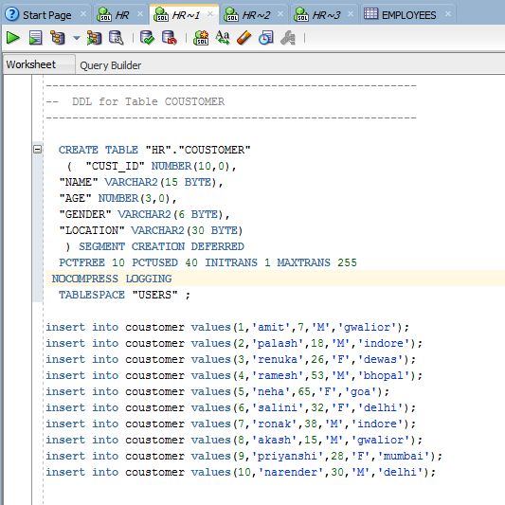

Schema Name – HR

Table Name – Store

CREATE TABLE "HR"."STORE"

( "STORE_ID" NUMBER(10,0),

"STORE_NAME" VARCHAR2(20),

"STORE_LOCATION" VARCHAR2(20)

);

**Data Insert:**

insert into store values(101,'Anna Punjabi','Andheri East');

insert into store values(102,'Apana Dhaba','JB Nagar');

insert into store values(103,'TAP Restro','Time square');

insert into store values(104,'dominos','khargar');

insert into store values(105,'pizza hut','kharagar');

insert into store values(106,'ramesh electricals','Andheri East');

insert into store values(107,'titan eye plus ','belapur');

insert into store values(108,'dekathlon','belapur');

insert into store values(109,'bikaner sweets','khargar');

insert into store values(110,'burger king','Andheri East');

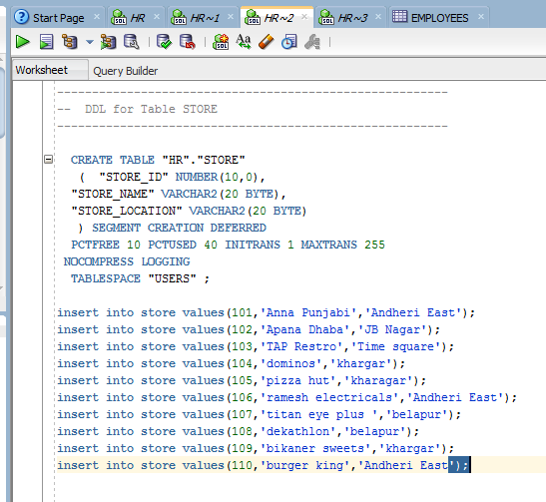

Schema Name – HR

Table Name – TXN

CREATE TABLE "HR"."TXN"

( "TXN_ID" NUMBER(10,0),

"CUST_ID" NUMBER(10,0),

"TXN_DATE" DATE,

"STORE_ID" NUMBER(10,0),

"AMOUNT" NUMBER(10,0),

"PRODUCT_ID" VARCHAR2(15)

) ;

**Data Insert:**

insert into TXN values(1001,1,'12-JAN-19',101,54651,'BPN124');

insert into TXN values(1002,2,'13-JAN-18',102,4554651,'SDN122');

insert into TXN values(1003,3,'12-JUN-19',103,5647651,'FGS567');

insert into TXN values(1004,4,'17-AUG-19',104,564246,'BVX456');

insert into TXN values(1005,5,'26-JAN-19',105,7654,'ERN314');

insert into TXN values(1006,6,'02-SEP-19',106,1257675,'BFT589');

insert into TXN values(1007,7,'16-FEB-19',107,653673,'BVS345');

insert into TXN values(1008,8,'30-MAY-18',108,9870786,'IOU276');

insert into TXN values(1009,9,'17-MAR-19',109,868946,'QWE574');

insert into TXN values(1010,10,'09-OCT-19',110,6747356,'SEN456');

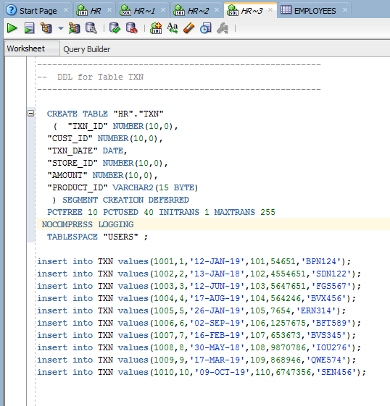

**Part - 2**

Fetch data using sql query for different age groups.

**Age < 20**

SELECT s.store_id,AGE,GENDER, count(c.cust_id)as cust_id_count,max(t.Amount) as Max_Amount

FROM COUSTOMER c,txn t, store s where c.CUST_ID = t.CUST_ID and t.store_id = s.store_id

group by s.store_id,gender,age having age < 20;

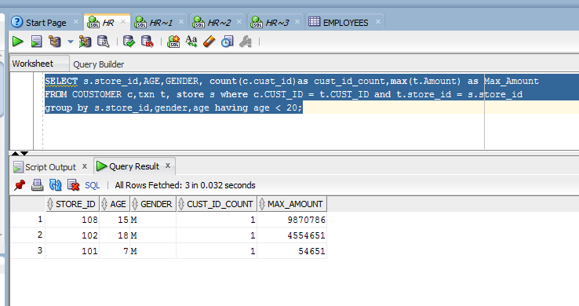

**Age between 20 and 60**

SELECT s.store_id,AGE,GENDER, count(c.cust_id)as cust_id_count,max(t.Amount) as Max_Amount

FROM COUSTOMER c,txn t, store s where c.CUST_ID = t.CUST_ID and t.store_id = s.store_id

group by s.store_id,gender,age having age between 20 and 60;

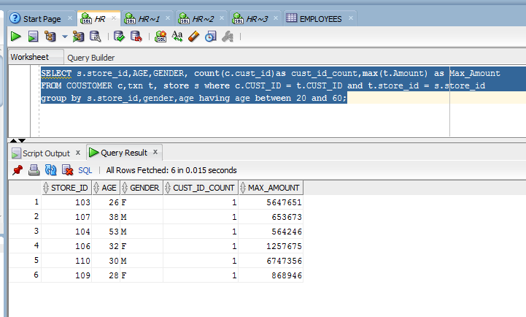

**Age > 60**

SELECT s.store_id,AGE,GENDER, count(c.cust_id)as cust_id_count,max(t.Amount) as Max_Amount

FROM COUSTOMER c,txn t, store s where c.CUST_ID = t.CUST_ID and t.store_id = s.store_id

group by s.store_id,gender,age having age > 60;

