Customer Shopping Behaviour
Analytics Dashboard
Data Analysis Project Report

Problem Statement
"How can the company leverage consumer shopping data to identify trends, improve customer engagement, and optimize marketing and product strategies?"
Technologies Used
Python · SQL (MySQL) · Power BI

1. Project Overview

This project performs end-to-end data analysis on a retail consumer shopping dataset to uncover actionable insights. The workflow spans data cleaning and transformation in Python, business question analysis via SQL, and visualization through an interactive Power BI dashboard. The objective is to enable data-driven decisions in marketing, product strategy, and customer engagement.

3,900  Customer Records | 19  Features Analysed | 4  Product Categories

10  SQL Business Queries | 68%  Male Customers | 27%  Subscribers

2. Dataset Description

The dataset contains 3,900 unique customer records across 19 columns covering demographics, purchasing behaviour, product details, shipping preferences, and engagement history.

Attribute Group | Columns
Demographics | customer_id, age, gender, location, age_group
Product Info | item_purchased, category, size, color, season
Transaction | purchase_amount, payment_method, discount_applied
Behaviour | previous_purchases, frequency_of_purchases, purchase_frequency_days
Engagement | review_rating, subscription_status, shipping_type

3. Methodology & Technologies

Technology | Tool / Library | Purpose
Python | Pandas, NumPy, Matplotlib, Seaborn | Data cleaning, transformation, EDA, and statistical visualisation
SQL | MySQL | Querying structured data to answer 10 targeted business questions
Power BI | Power BI Desktop | Interactive dashboard for KPI tracking, trend analysis, and segment insights

3.1 Python — Data Cleaning & EDA
- Removed duplicates, handled missing values, and standardised column formats
- Engineered derived features: age_group and purchase_frequency_days
- Conducted EDA via histograms, box plots, correlation heatmaps, and segment distributions
- Exported the cleaned dataset for downstream SQL and Power BI consumption

3.2 SQL — Business Intelligence Queries
- Loaded the cleaned CSV into a MySQL table (customer_shopping_behavior_cleaned → customer)
- Authored 10 analytical queries covering revenue, segmentation, and product performance
- Used CTEs, window functions (ROW_NUMBER), and CASE logic for advanced segmentation

3.3 Power BI — Interactive Dashboard
- Imported cleaned dataset and modelled relationships for slicing and filtering
- Built KPI cards, bar charts, donut charts, and trend lines for stakeholder consumption
- Enabled dynamic filtering by gender, category, season, subscription status, and age group

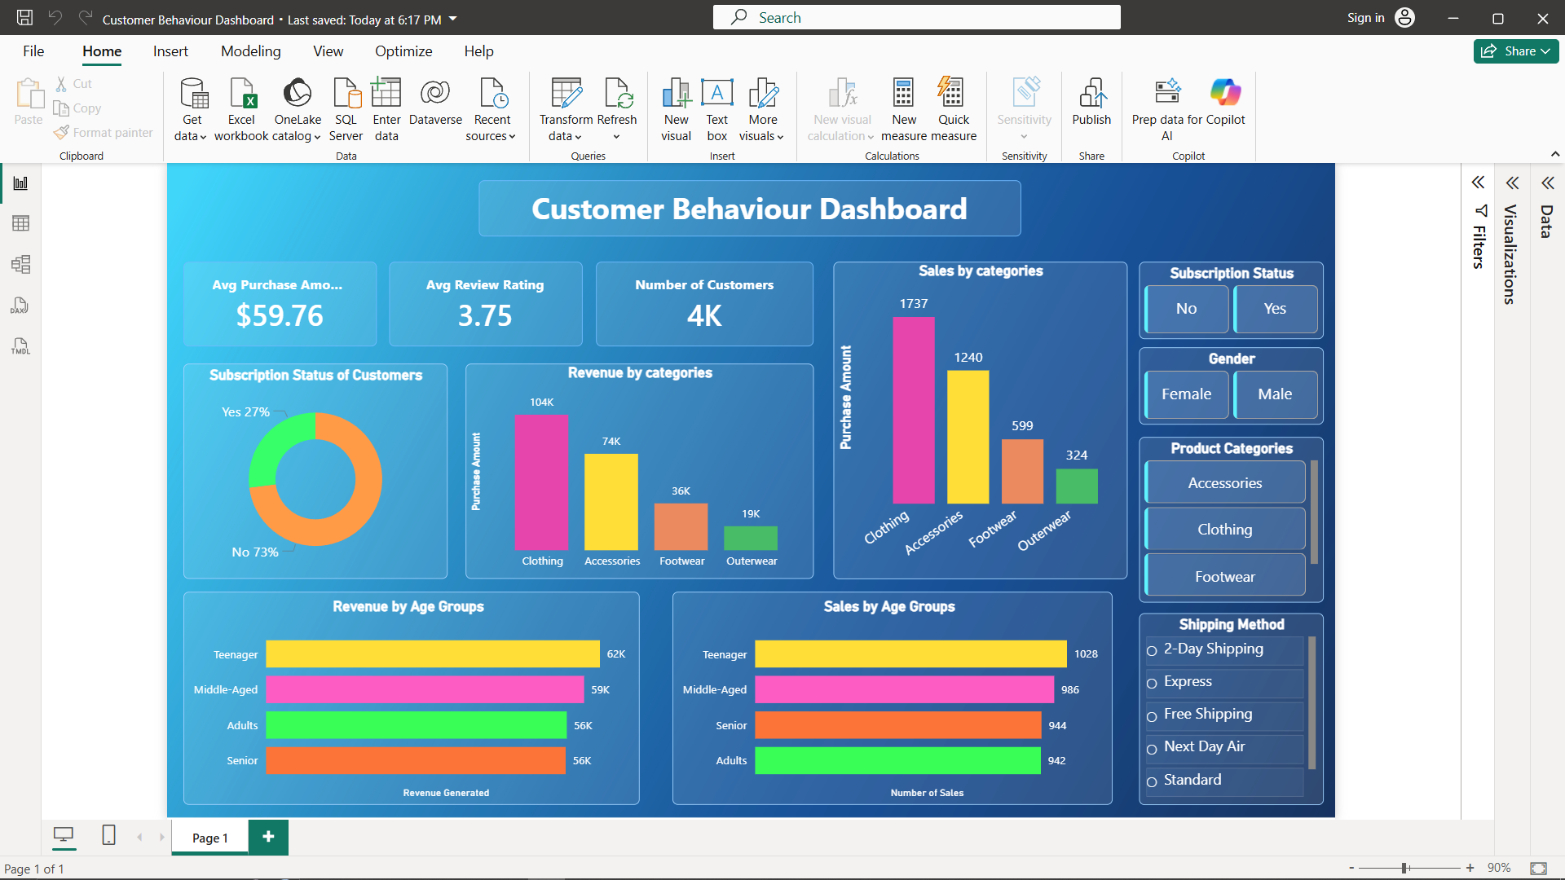

4. SQL Business Questions & Key Findings

# | Business Question | Key Finding
1 | Total revenue by gender | Male customers generated higher total revenue, reflecting the 68% male composition of the customer base
2 | Discount users spending above average | A notable subset of customers who applied discounts still exceeded the average purchase amount, suggesting high-value deal-seekers
3 | Top 5 products by average review rating | Identified the five highest-rated items to guide featured product placements and marketing priorities
4 | Avg. spend: Express vs. Standard shipping | Compared spending behaviour across shipping preferences to determine which cohort spends more per order
5 | Subscriber vs. non-subscriber spend | Subscribed customers (27% of base) showed higher average spend and total revenue contribution per head
6 | Top 5 products by discount usage rate | Products with the highest discount dependency identified — important for margin and pricing strategy reviews
7 | Customer segmentation: New / Returning / Loyal | CTE-based segmentation revealed the split across lifecycle stages, highlighting retention opportunities
8 | Top 3 products per category | Window function (ROW_NUMBER) identified best-sellers across Clothing, Footwear, Outerwear, and Accessories
9 | Repeat buyers (>5 purchases) & subscription | High-frequency buyers show a propensity for subscriptions, validating loyalty-driven subscription campaigns
10 | Revenue contribution by age group | Middle-Aged and Adult segments contributed the highest revenue; Teenagers and Seniors present growth potential

5. Key Insights & Recommendations

5.1 Customer Segmentation
- The customer base skews male (68%) — consider targeted campaigns for the underrepresented female segment
- Loyal and returning customers are prime candidates for subscription upgrade campaigns
- Middle-aged adults drive the most revenue; tailor premium product lines to this segment

5.2 Product & Category Strategy
- Promote top-rated products prominently to leverage their review authority
- Reassess discount strategies for items with high discount rates but questionable margin contribution
- Invest in category-level inventory for the top 3 best-sellers per category

5.3 Marketing & Engagement
- Subscribers spend more — grow this base through loyalty perks and early-access offers
- Repeat buyers (>5 purchases) are subscription-ready — activate targeted conversion flows
- Seasonal and category filters in the Power BI dashboard allow real-time campaign adjustments

6. Conclusion

This project successfully demonstrates an end-to-end data analytics pipeline — from raw data ingestion and cleaning in Python, through structured business querying in SQL, to stakeholder-ready visual storytelling in Power BI. The combined approach surfaced actionable insights across revenue drivers, customer lifecycle segments, product performance, and engagement strategies.
The interactive Power BI dashboard serves as a living tool for ongoing decision-making, allowing business teams to slice data dynamically and respond to emerging trends with confidence.

