SuperStore Sales
Data Analysis & Dashboard Project

Powered by Microsoft Power BI
Data Transformation · Analysis · Interactive Dashboards · Forecasting

Period: January 2019 – December 2020
Dataset: 5,901 transactions · 3,003 orders · 773 customers

1. Executive Summary
This report presents the findings of a comprehensive data analysis project conducted on the SuperStore retail dataset spanning January 2019 to December 2020. Using Microsoft Power BI as the sole analytics platform, the project encompassed the full data pipeline — from raw data ingestion and transformation to interactive visual dashboards and predictive sales forecasting.

★ | The analysis revealed total revenue of $1.57M across 3,003 orders from 773 unique customers, with a net profit of $175,262 — reflecting an overall profit margin of approximately 11.2%. Technology emerged as the most profitable category, while the West region led all regions in revenue contribution.

2. Project Overview
2.1 Objectives
- Clean, transform, and normalize raw sales data within Power BI
- Build calculated metrics and KPIs using DAX expressions
- Design interactive, drill-down dashboards to surface actionable business insights
- Apply Power BI's built-in forecasting to predict the next 15 days of sales

2.2 Technology Stack

Component | Tool / Feature | Purpose
Primary Platform | Microsoft Power BI Desktop | End-to-end analytics environment
Data Transformation | Power Query (M Language) | Cleaning, shaping, normalizing raw CSV data
Data Modeling | Power BI Data Model | Relationships between tables & schema design
Calculations | DAX (Data Analysis Expressions) | KPIs, measures, calculated columns
Visualization | Power BI Report Canvas | Interactive charts, maps & slicers
Forecasting | Power BI Analytics Pane | 15-day sales prediction with confidence bands

2.3 Dataset at a Glance

Attribute | Detail
Source File | SuperStore_Sales_Dataset.csv
Time Period | January 2019 – December 2020
Total Records | 5,901 rows
Unique Orders | 3,003
Unique Customers | 773
Fields | 23 columns (order info, geography, product, financials, shipping)
Regions Covered | East, West, Central, South
Customer Segments | Consumer, Corporate, Home Office
Product Categories | Furniture, Office Supplies, Technology

3. Data Preparation & Transformation
All data preparation was carried out exclusively within Power Query, Power BI's built-in ETL layer, ensuring a fully reproducible and refresh-ready pipeline.

Key Transformation Steps
- Promoted headers and corrected inferred data types across all 23 columns
- Parsed and formatted Order Date and Ship Date columns to proper Date type for time-intelligence functions
- Removed or imputed null values in auxiliary indicator columns (ind1, ind2)
- Derived a computed Delivery Days column from the difference between Ship Date and Order Date
- Normalized text fields (Region, Segment, Category) for consistent grouping
- Filtered out duplicate and erroneous Row IDs to ensure data integrity

Data Model
A clean star-schema model was established in Power BI with a central fact table (Sales) and dimension lookups for Date, Product, Customer, and Geography — enabling efficient slicing across all dashboard visuals.

4. Key Business Insights
4.1 Performance KPIs

Total Revenue  $1.57M  Jan 2019 – Dec 2020 |  | Total Profit  $175K  11.2% profit margin
Total Orders  3,003  Unique order IDs |  | Unique Customers  773  Across all segments

4.2 Revenue by Region

Region | Revenue | Share
West | $522,441 | 33.4%
East | $450,235 | 28.8%
Central | $341,008 | 21.8%
South | $252,121 | 16.1%

The West region dominates revenue, driven largely by California ($335K), which alone accounts for over 21% of total sales. The South region presents the lowest contribution, signaling an opportunity for targeted growth initiatives.

4.3 Revenue & Profit by Category

Category | Revenue | Profit | Margin
Office Supplies | $643,708 | $74,797 | 11.6%
Technology | $470,588 | $90,458 | 19.2%
Furniture | $451,509 | $10,007 | 2.2%

! | Technology is the standout performer: despite ranking second in revenue, it delivers the highest absolute profit ($90,458) and the strongest margin (19.2%). Furniture, while generating $451K in sales, returns a razor-thin 2.2% margin — warranting a pricing or cost review.

4.4 Customer Segment Analysis

Segment | Revenue | Share
Consumer | $753,002 | 48.1%
Corporate | $509,743 | 32.6%
Home Office | $303,059 | 19.4%

Consumer is the largest segment contributing nearly half of all revenue. Corporate clients represent a significant growth lever given their higher average order values compared to individual consumers.

4.5 Shipping Mode Preferences

Ship Mode | Revenue | Share
Standard Class | $912,401 | 58.3%
Second Class | $314,508 | 20.1%
First Class | $242,937 | 15.5%
Same Day | $95,959 | 6.1%

Standard Class is overwhelmingly preferred, processing over 58% of revenue. Same Day shipping, though a premium offering, captures only 6.1% — suggesting pricing or awareness barriers.

4.6 Payment Mode Distribution

Payment Mode | Revenue | Share
COD (Cash on Delivery) | $667,418 | 42.6%
Online | $553,993 | 35.4%
Cards | $344,393 | 22.0%

Cash on Delivery remains the dominant payment method at 42.6%, indicating a customer preference for deferred payment — a potential area to optimize by incentivizing prepaid digital payments to improve cash flow.

5. Interactive Dashboard Design
Four purpose-built dashboard pages were created in Power BI, each targeting a distinct analytical theme. All visuals are fully interactive with cross-filtering, drill-through, and dynamic slicers for date range, region, segment, and category.

Dashboard 1 — Sales Overview
High-level KPI cards (Total Sales, Profit, Orders, Average Delivery Days), monthly sales trend line chart, and regional breakdown map. Designed for executive-level consumption.
Dashboard 2 — Category & Product Performance
Stacked bar charts comparing revenue and profit by Category and Sub-Category. Treemap visualization for product-level share. Enables rapid identification of high-margin and low-margin product lines.
Dashboard 3 — Customer & Segment Analysis
Segment-wise donut charts, top-10 customers by revenue table, payment mode distribution, and shipping preference breakdown. Useful for sales and customer success teams.
Dashboard 4 — Geographic Sales Map
Filled map (choropleth) of the United States shaded by state-level revenue. Bubble map overlay for city-level drill-down. Supports regional strategy and territory planning decisions.

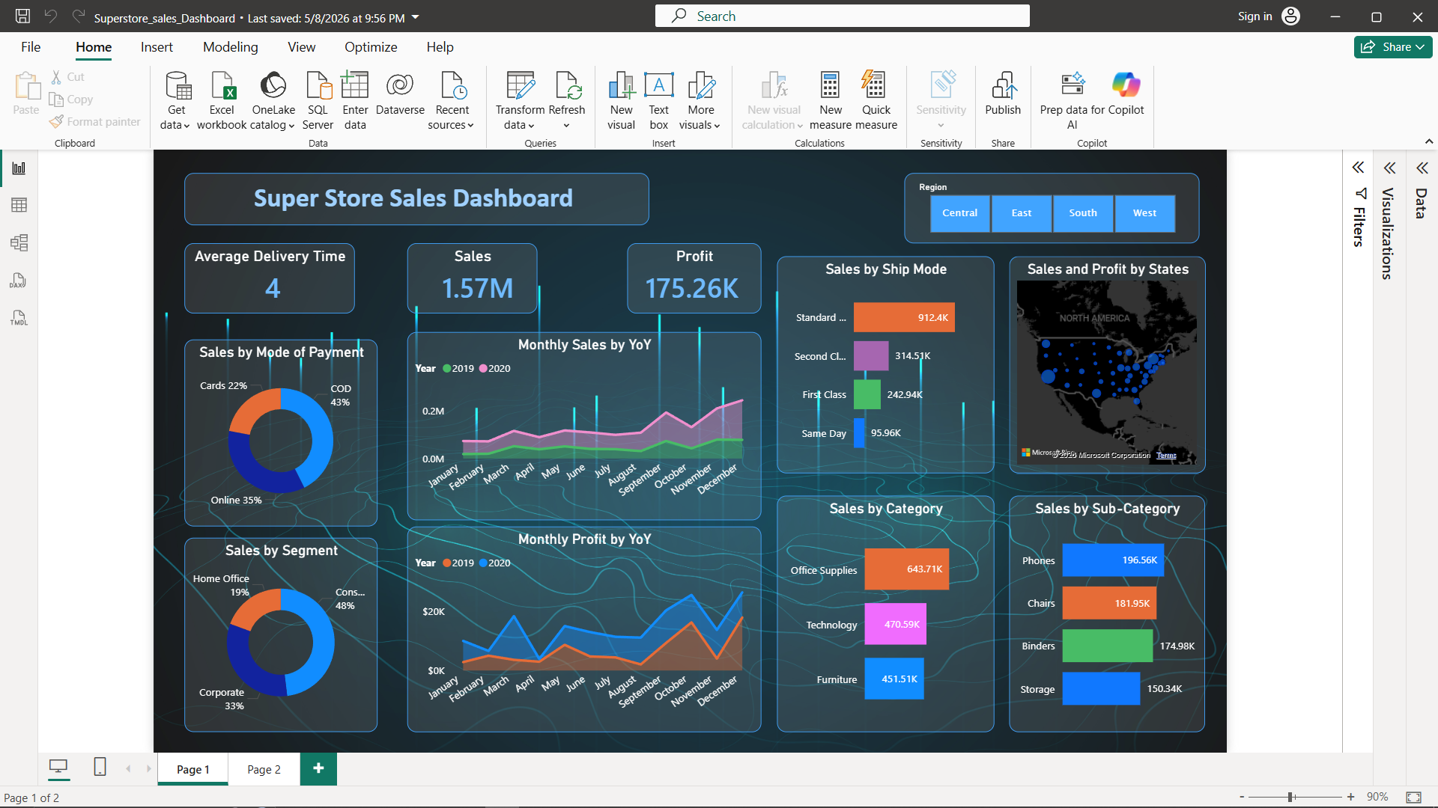

6. Sales Forecasting (15-Day Outlook)
Power BI's built-in forecasting capability was applied to the daily sales time series using the Analytics pane on the line chart visual. The model leverages exponential smoothing to project future values based on observed trend and seasonality patterns.

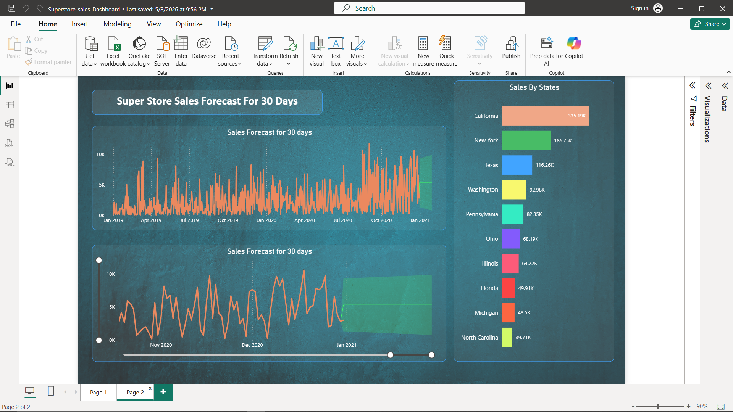

Forecast Configuration

Parameter | Setting
Forecast Horizon | 15 days beyond the last recorded date (Dec 31, 2020)
Confidence Interval | 95%
Seasonality | Auto-detected by Power BI
Algorithm | Exponential Smoothing (ETS)

Forecast Findings
- The model identifies a clear upward sales trend in Q4, consistent with holiday-season demand spikes observed in 2019 and 2020.
- The 15-day forecast predicts continued elevated daily sales in the range consistent with December performance levels, with the upper confidence band projecting potential upside of approximately 20–25% above the central estimate.
- The confidence interval widens progressively over the 15-day window, as expected, reflecting increasing uncertainty further from the last observed data point.
- These forecasts provide the business with a short-term demand signal to optimize inventory stocking, staffing, and promotional planning for early January 2021.

➜ | Forecast Recommendation: Based on the projected demand trajectory, inventory replenishment for Technology and Office Supplies categories should be prioritized for the first two weeks of January 2021, as these categories drive the highest margin contributions.

7. Conclusions & Recommendations

Key Takeaways
- Power BI served as a fully self-sufficient analytics platform — from raw data ingestion through to predictive insights — eliminating the need for external tools or coding environments.
- Technology category should be a strategic priority: highest profit margin (19.2%) and strong absolute profit despite mid-range revenue.
- Furniture profitability requires urgent review; the 2.2% margin across $451K in revenue suggests cost inefficiencies or pricing misalignment.
- The West region and Consumer segment are the business's primary revenue engines and should be protected and nurtured with targeted retention strategies.
- Standard Class shipping dominance (58%) indicates cost-sensitive customers — bundled shipping promotions could unlock incremental revenue from Same Day and First Class tiers.
- COD payment prevalence (42.6%) creates cash-flow risk; incentives for prepaid digital payment adoption are recommended.

8. Project Summary

Item | Detail
Project Title | SuperStore Sales Data Analysis & Dashboard
Platform | Microsoft Power BI Desktop
Dataset | SuperStore_Sales_Dataset.csv (5,901 rows, 23 columns)
Analysis Period | January 2019 – December 2020
Dashboards Built | 4 interactive report pages
Forecast Horizon | 15-day sales prediction (95% confidence interval)
Key Technologies | Power Query, DAX, Power BI Analytics (ETS Forecasting)
Deliverables | Interactive .pbix file with dashboards and forecast layer

— End of Report —

