
SENTRYYIQ – COPILOT
SYSTEM FLOW – SCREEN SHOTS

July 13, 2026

table of CONTENTS
TELEGRAM COMMANDS 2
Welcome screen 2
Help 3
Services & Regions 5
Knowledge base QUERIES: 6
Run Book/Error Catalog 6
System Design Queries 7
Example 1 7
Example 2 8
Example 3 9
Operational Queries 10
Example 1 & 2 10
Example 3 12
Incident Management & Worflow management 13
Show open issues/Incidents 13
Alert Details 15
Forensic, Raw data Queries for Incidents/Alerts 16
User Related Queries 20
Assignment Workflow 21
Notification for Assignment 22
Assignment History 23
Dashboard Summary 24
AI Intelligence – REASONING Examples 25

TELEGRAM COMMANDS

Welcome screen

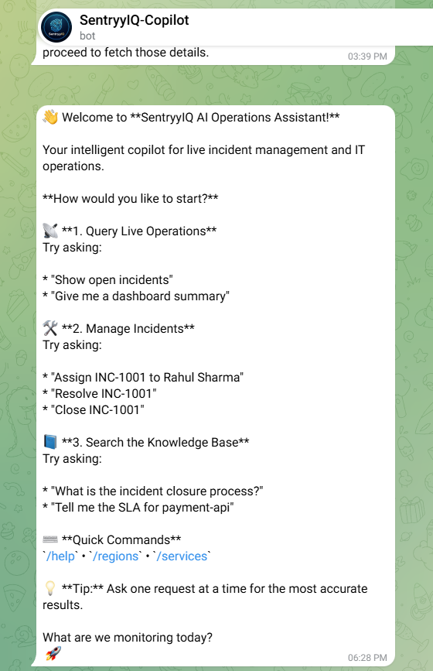

Help

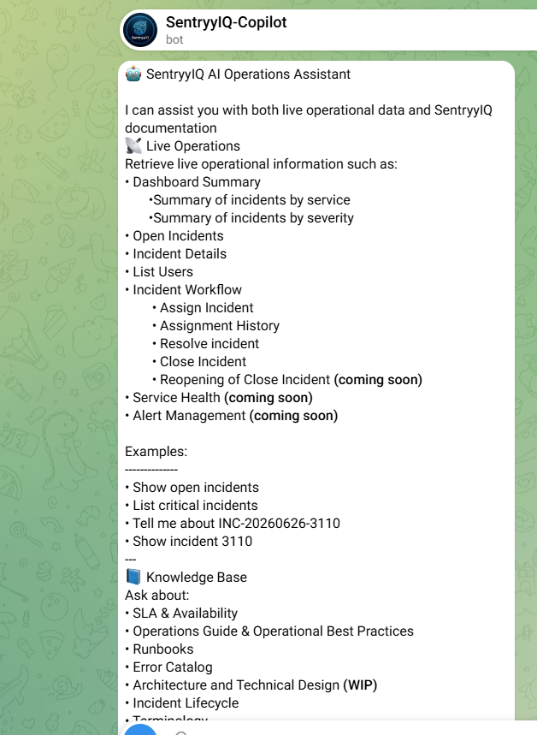
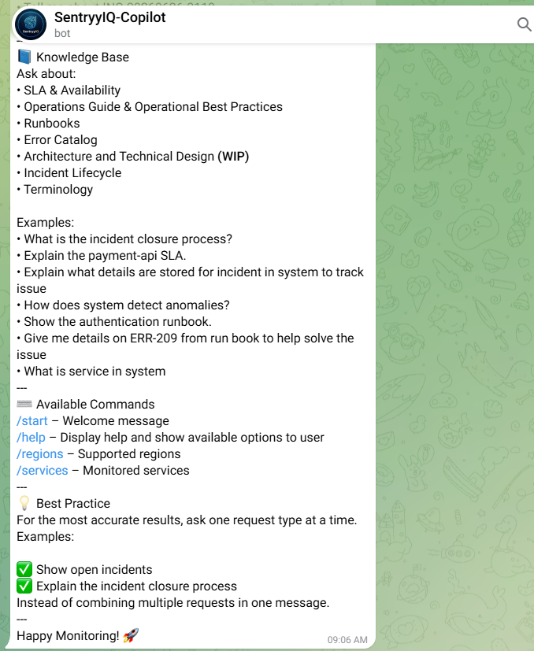

Services & Regions
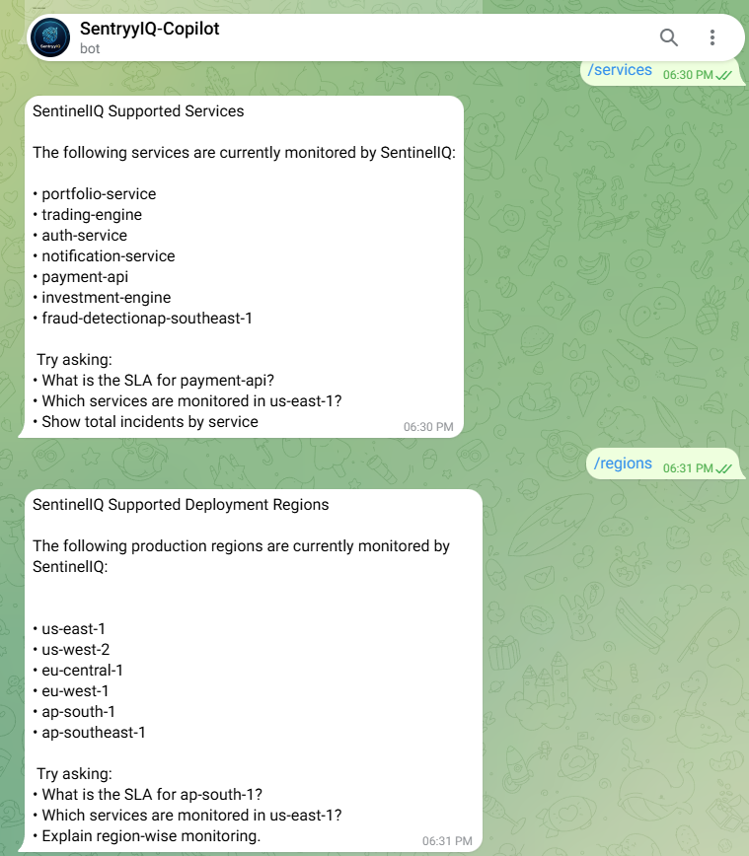

Knowledge base QUERIES:

Run Book/Error Catalog

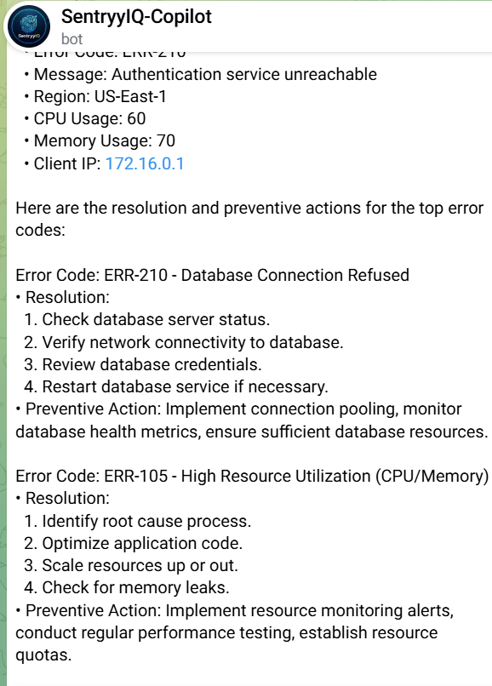

System Design Queries

Example 1

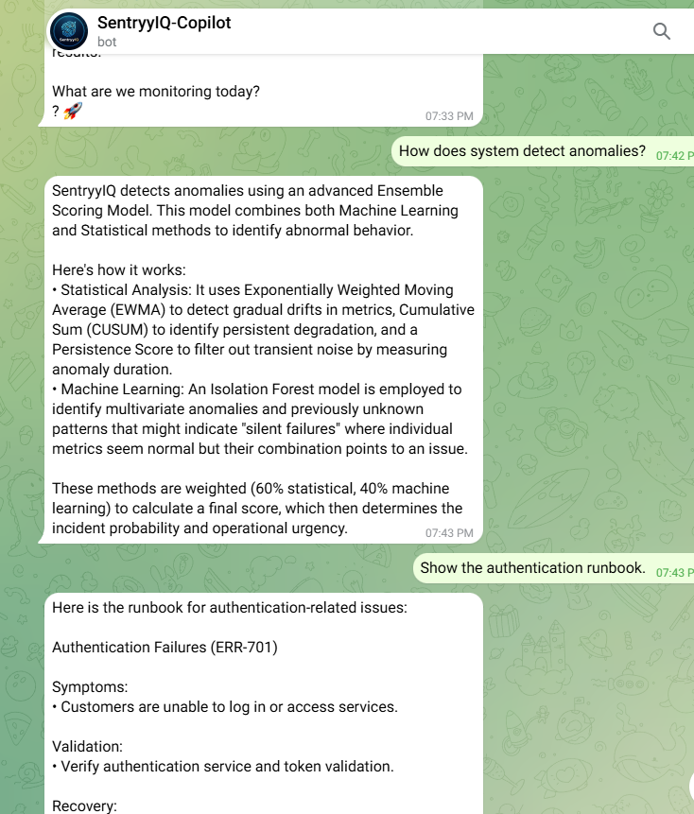

Example 2

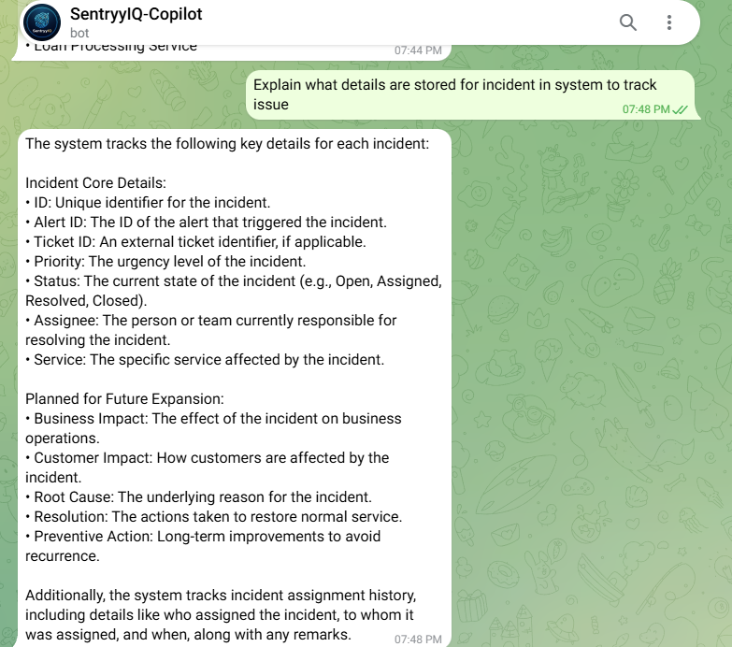

Example 3

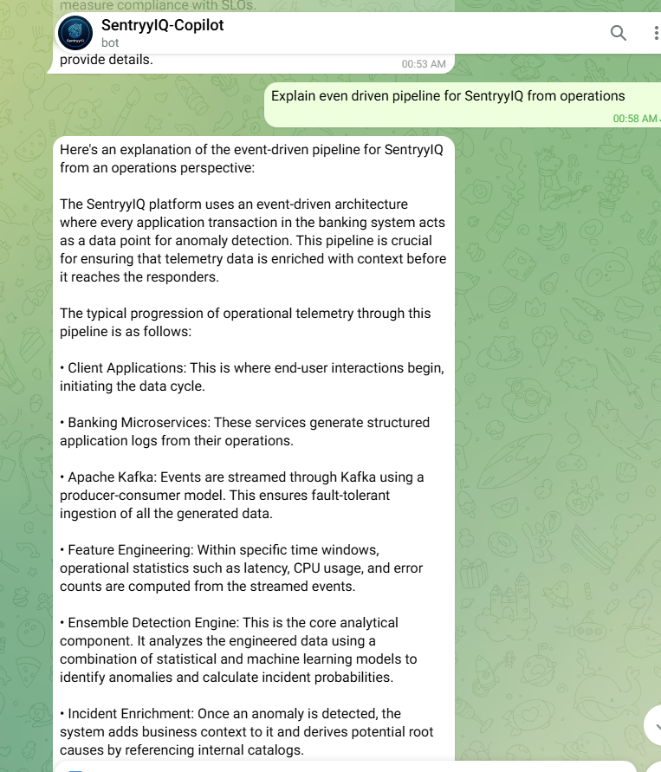

Operational Queries

Example 1 & 2

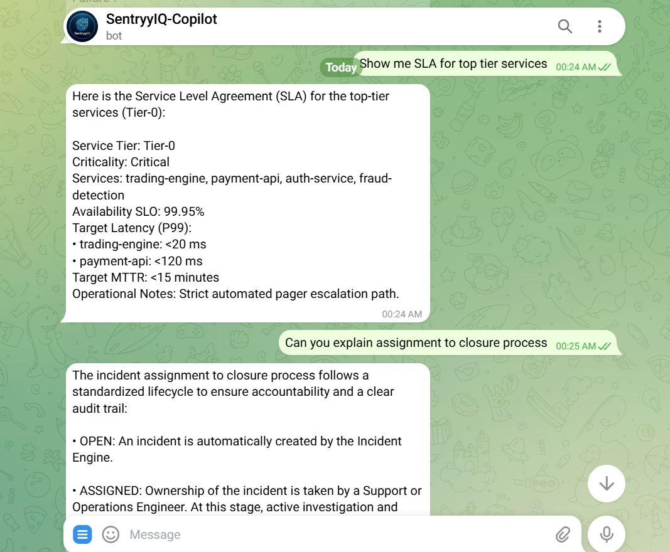

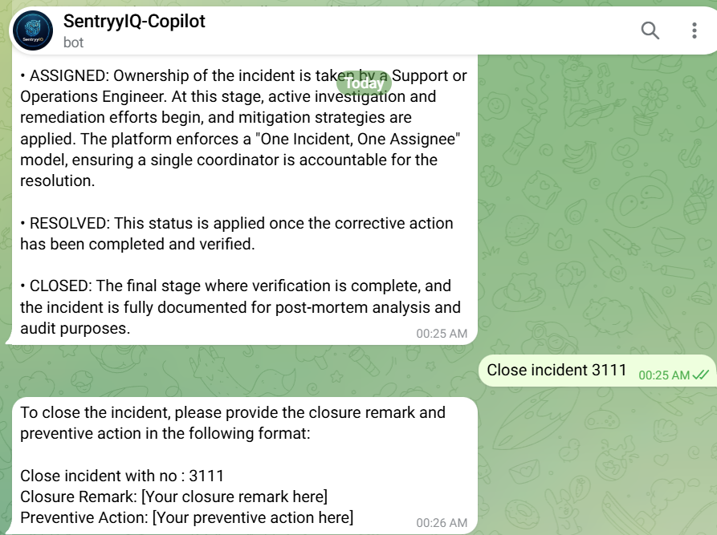

Example 3

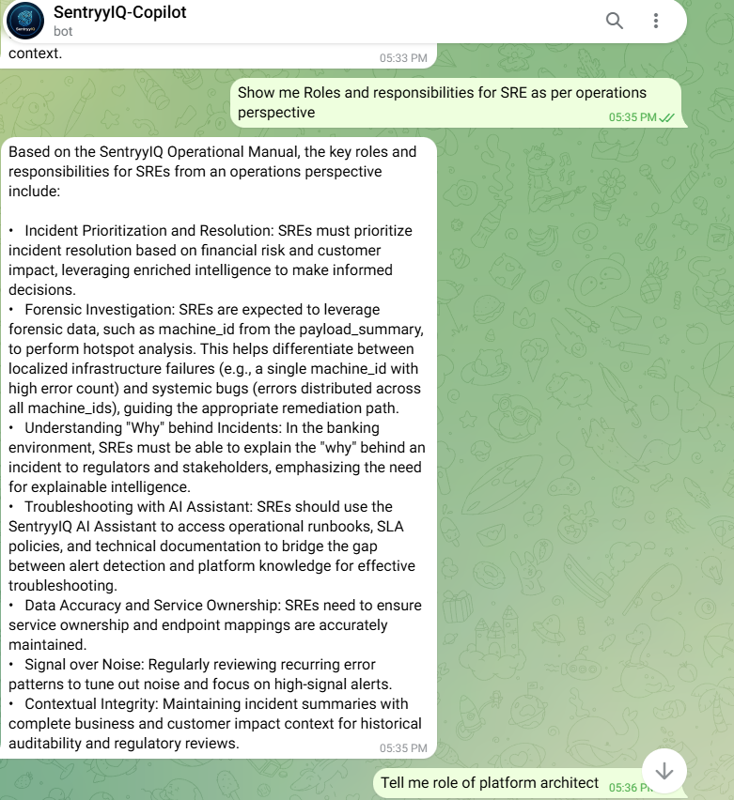

Incident Management & Worflow management

Show open issues/Incidents

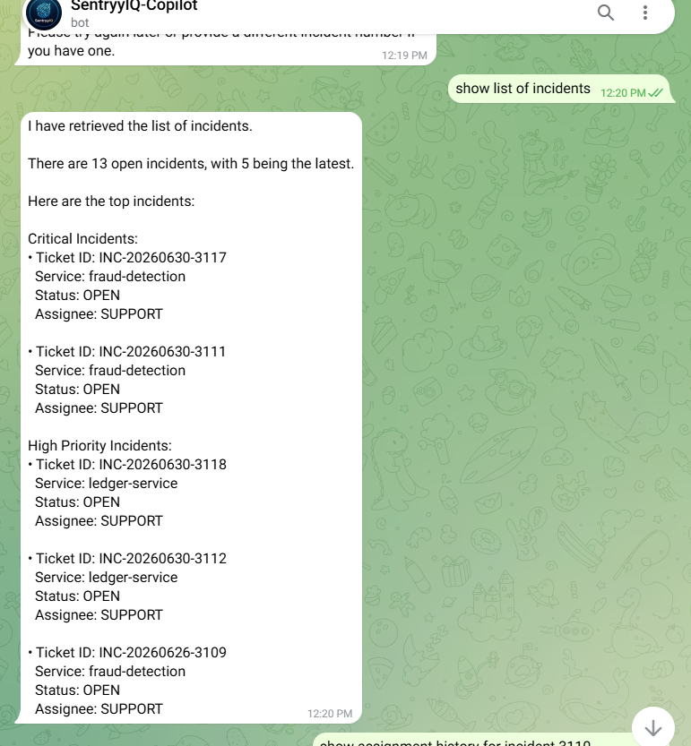
List incident Details
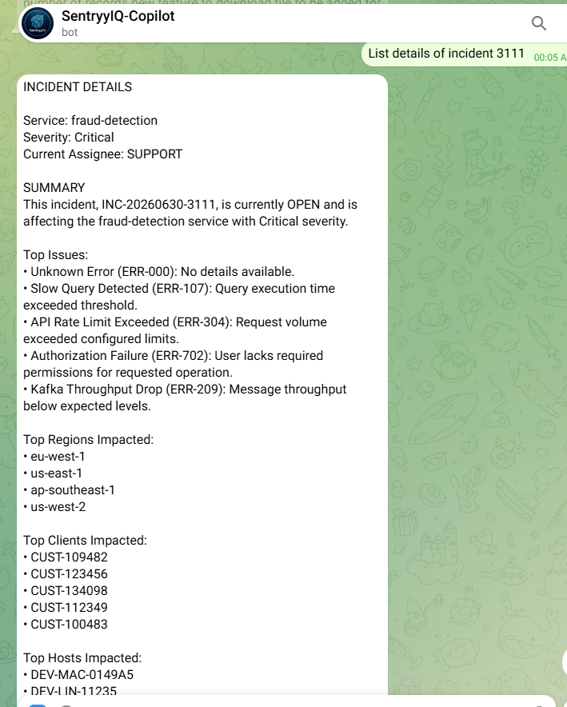

Alert Details

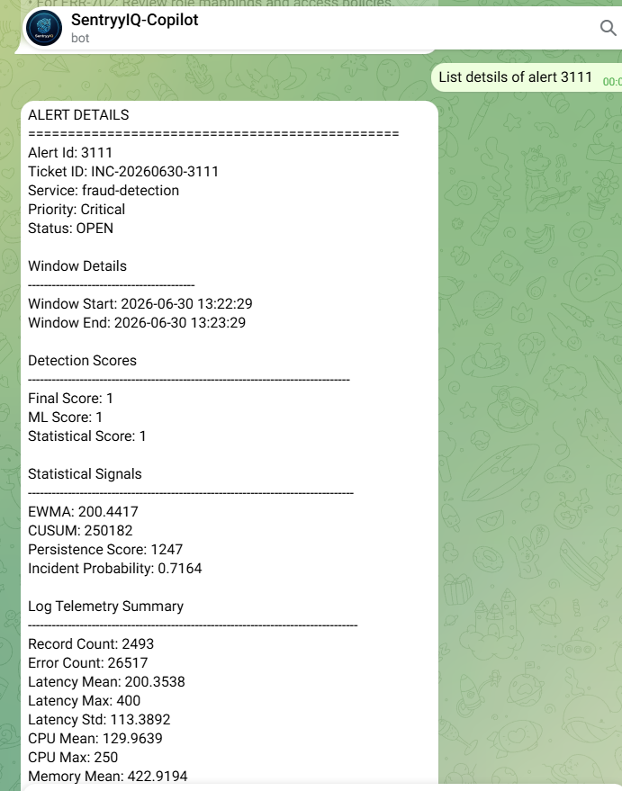

Forensic, Raw data Queries for Incidents/Alerts

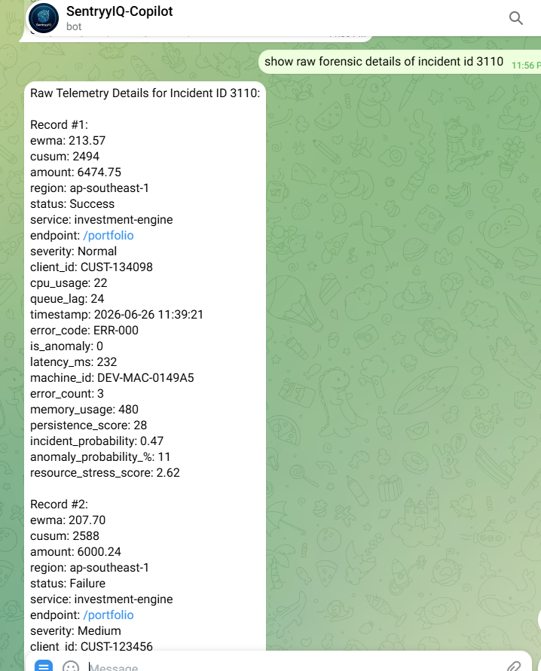
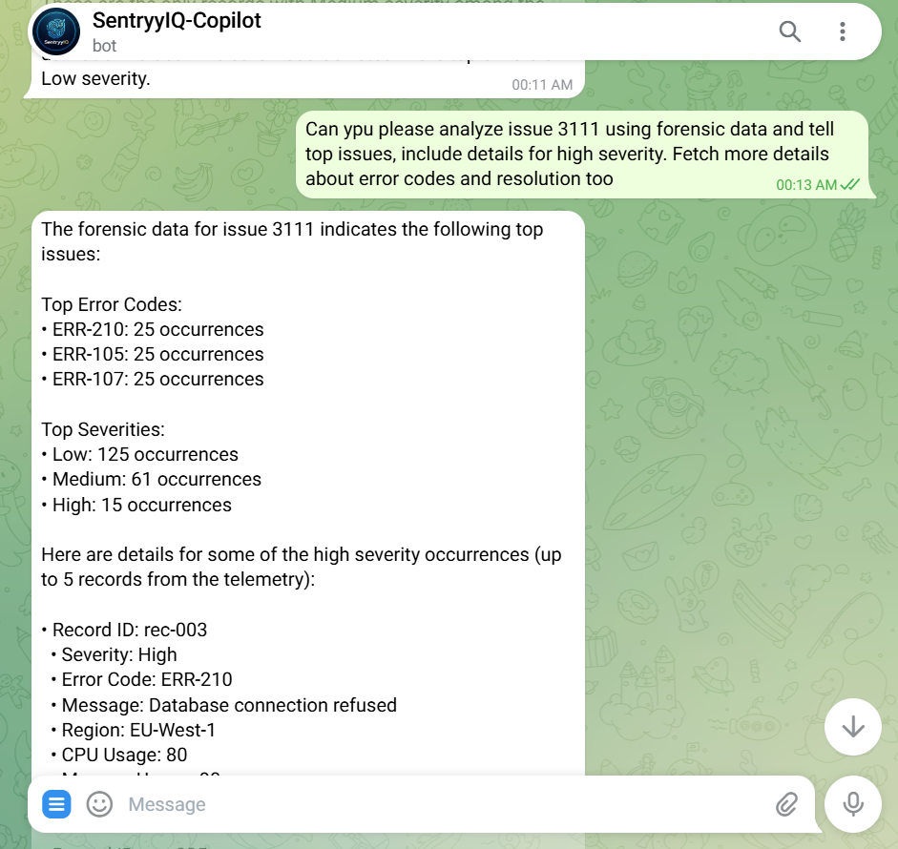
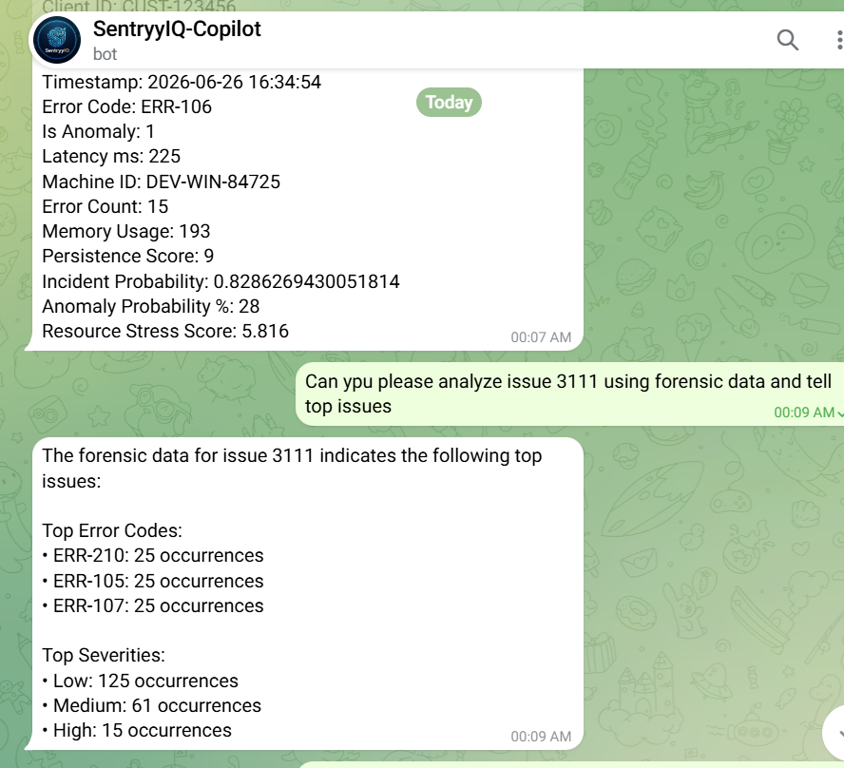

User Related Queries

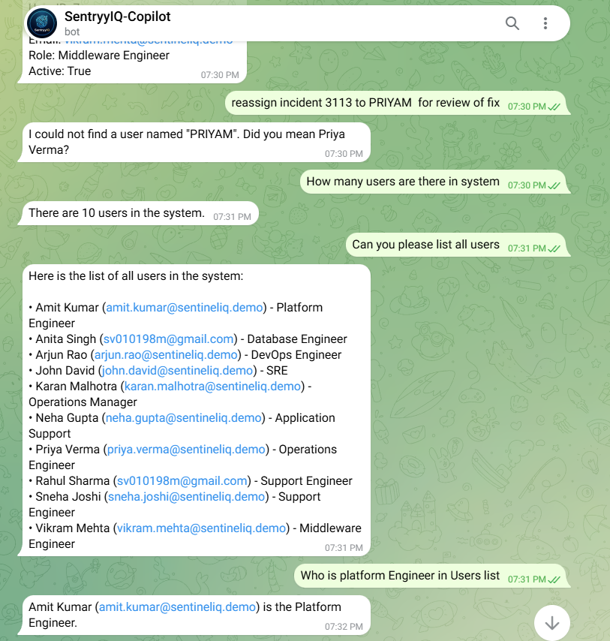

Assignment Workflow

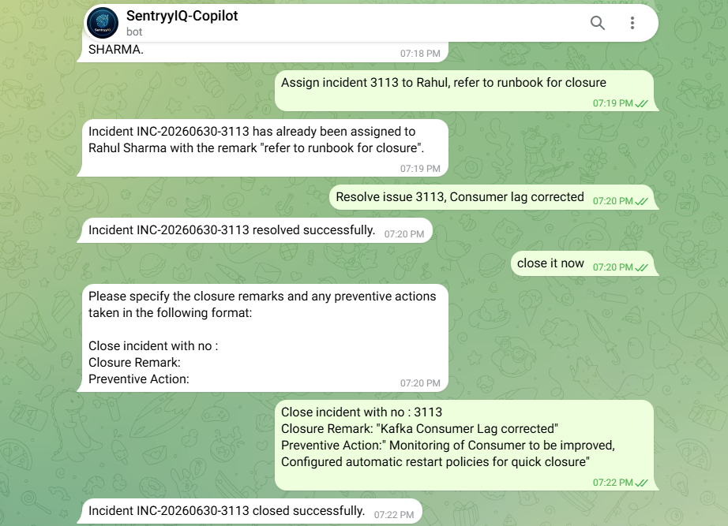

Notification for Assignment

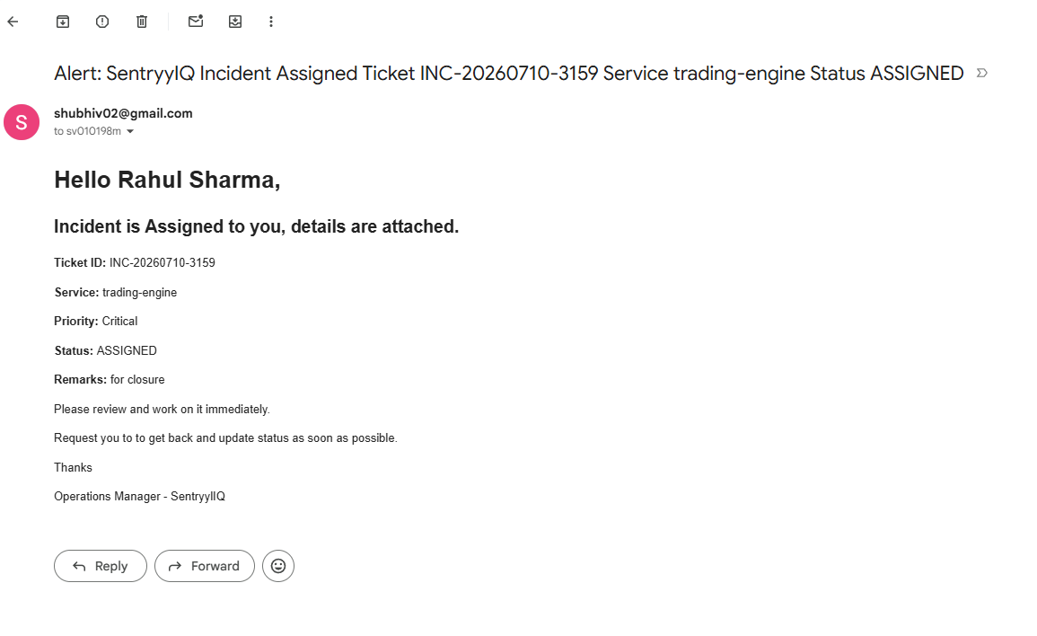

Assignment History
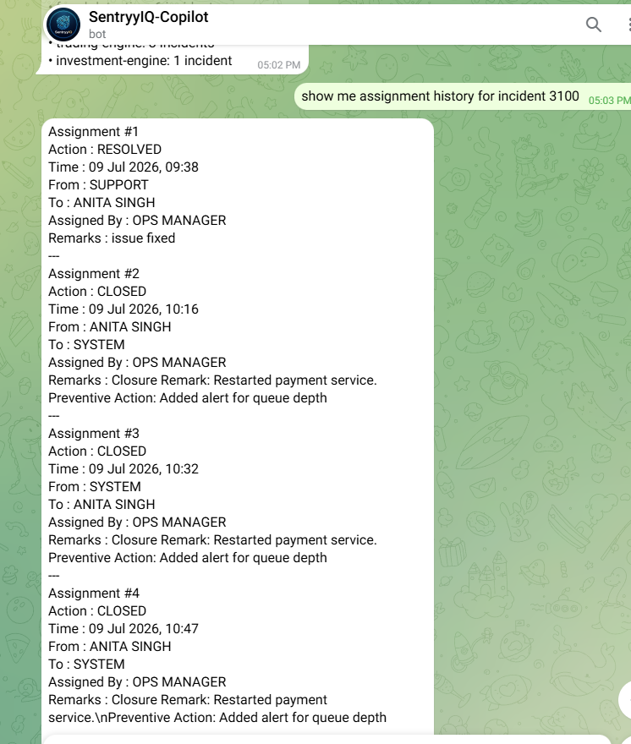

Dashboard Summary

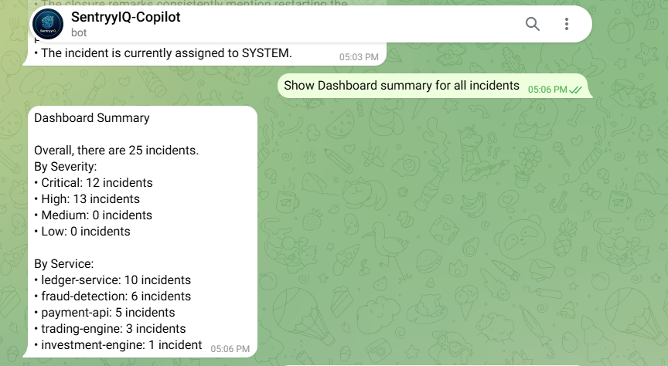

AI Intelligence – REASONING Examples

