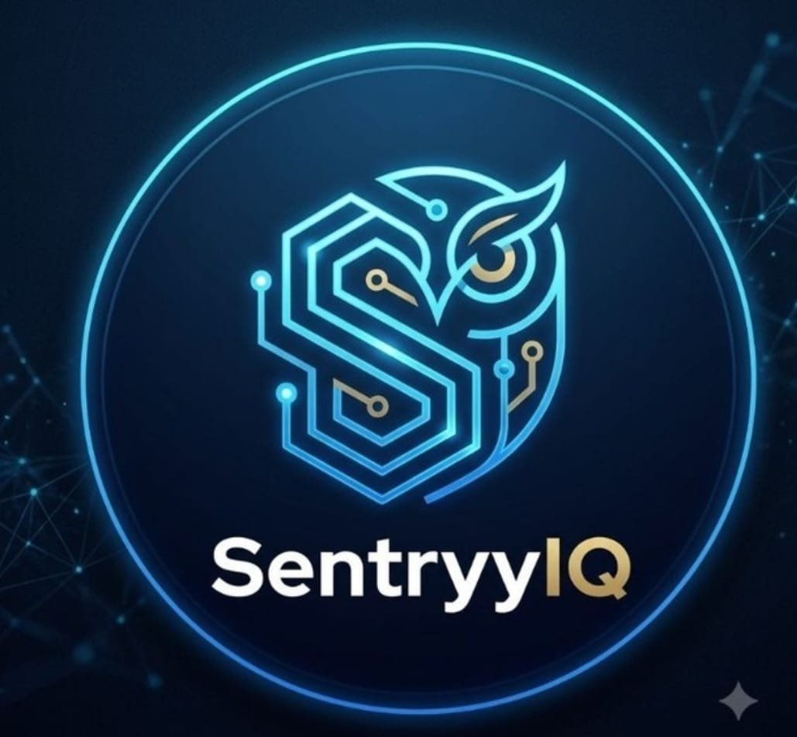

SentryyIQ : Operations Copilot
Telegram Bot: @Sentineliq_bot
Fast API deployment link
Backend deployed on render : https://sentryyiq-backend-hackathon.onrender.com
Postgres Database for Service is deployed on NEON

Problem statement
Modern banking production environments generate hundreds of telemetry events and alerts every day. While monitoring systems can detect anomalies, engineers still spend valuable time correlating information across multiple tools before taking corrective action.
Key challenges include:
- Fragmented Incident Investigation: Engineers must switch between monitoring dashboards, logs, runbooks, architecture documents, and ticketing systems to understand the root cause.
- Manual Correlation of Operational Data: Live telemetry, alert history, and troubleshooting documentation are analyzed manually, increasing investigation effort.
- Delayed Incident Response: Manual triage increases Mean Time to Detect (MTTD) and Mean Time to Resolve (MTTR), delaying service restoration.
- Dependency on Senior Engineers: Effective diagnosis often relies on experienced personnel, creating operational bottlenecks and slowing knowledge transfer.
- High Alert Volumes: Large numbers of production alerts make it difficult to prioritize critical incidents and respond consistently.
Business Impact
- Prolonged banking service disruptions and financial transaction failures.
- Revenue loss resulting from extended service outages.
- Increased risk of regulatory non-compliance and SLA violations.
- Reduced customer trust and satisfaction due to degraded service availability.
- Increased operational costs caused by longer incident investigation and resolution cycles.

Who is the problem for?

Target Users
This solution is designed for Site Reliability Engineers (SREs), DevOps Engineers, Network Operations Centre (NOC) teams, and IT Operations Managers within the banking and financial services sector.
These technical teams are responsible for maintaining highly available, mission-critical distributed systems. They operate in complex microservices-based environments that generate large volumes of operational alerts and telemetry, where rapid incident detection, investigation, and resolution are essential to meet stringent Service Level Agreements (SLAs), regulatory compliance requirements, and customer availability expectations.
SentryyIQ enables these teams to reduce manual effort, accelerate incident response, improve operational efficiency, and minimize Mean Time to Detect (MTTD) and Mean Time to Resolution (MTTR).
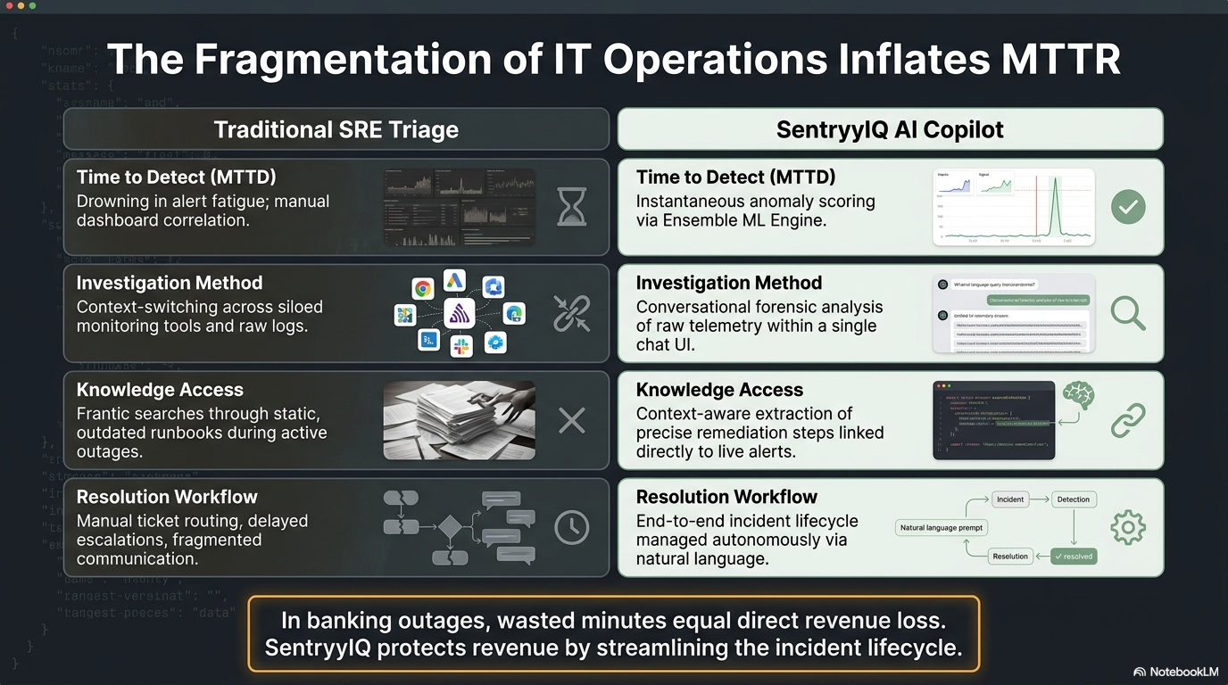

How does your solution use AI?

Generative AI–Powered Operations Agent
SentryyIQ uses a Generative AI–powered Operations Copilot to automate and accelerate the incident management lifecycle—from investigation and Root Cause Analysis (RCA) to assignment, remediation, and closure. Instead of requiring engineers to manually search across multiple operational tools, the AI agent brings together live operational data and enterprise knowledge to provide evidence-based recommendations through a conversational interface.

How AI Addresses Operational Challenges
- Eliminates Fragmented Investigation
Retrieves live incident, alert, telemetry, dashboard, and workflow data through FastAPI services, while simultaneously accessing runbooks, error catalogs, architecture documents, SOPs, and SLA guidelines from Google Docs using n8n workflows.
- Automates Correlation of Operational Data
Correlates telemetry, statistical and ML anomaly scores, incident history, and operational documentation to provide a unified view instead of requiring engineers to manually analyze multiple sources.
- Accelerates Incident Response
Performs context-aware Root Cause Analysis (RCA), summarizes evidence, recommends remediation steps, and supports incident assignment, status updates, notifications, resolution, and closure—reducing Mean Time to Detect (MTTD) and Mean Time to Resolution (MTTR).
- Reduces Dependency on Senior Engineers
Provides consistent, evidence-based explanations and guidance using organizational knowledge, enabling less experienced engineers to investigate and resolve incidents with greater confidence.
- Simplifies High-Volume Alert Management
Prioritizes critical incidents, summarizes complex telemetry into actionable insights, and allows engineers to investigate incidents using natural language instead of manually navigating multiple dashboards, logs and tools

Technical Implementation
The AI layer is implemented using a Large Language Model (LLM) integrated with n8n workflow automation. The LLM receives structured operational context through FastAPI REST APIs, which retrieve real-time information from PostgreSQL, including alerts, incidents, telemetry summaries, anomaly scores, window metrics, service metadata, user assignments, and operational history.
Operational knowledge is dynamically retrieved from Google Docs using Google Workspace tools within n8n. HTML extraction and text processing nodes convert the documentation into contextual input for the LLM, ensuring responses are grounded in current organizational knowledge rather than relying solely on the model's pre-trained knowledge.
The conversational agent integrates with Telegram and Email, enabling engineers to interact with the platform using natural language while the AI performs the underlying retrieval, correlation, reasoning, and workflow automation.

Technology Stack
Backend: Python, FastAPI, SQLAlchemy
Database: PostgreSQL
Workflow Orchestration: n8n
Large Language Model (LLM): Google Gemini (interchangeable with compatible LLMs)
Knowledge Source: Google Docs & Google Drive APIs, Complete RAG implementation is planned
Document Processing: HTML Extraction and Text Transformation Nodes (n8n)
Communication: Telegram Bot and SMTP Email
Data Exchange: REST APIs (JSON)
Event Streaming: Apache Kafka for real-time telemetry ingestion (Not part of demo)
By combining live operational data, enterprise documentation, and AI-driven reasoning, SentryyIQ transforms incident management from manual investigation across multiple tools into an intelligent, conversational, evidence-based operational workflow.

System Overview

SentryyIQ is an AI-powered Operations Copilot that enables IT Operations, Site Reliability Engineering (SRE), and DevOps teams to investigate and resolve production incidents through a conversational interface.
The solution addresses the challenges of fragmented operational data by combining live telemetry, incident information, operational workflows, and enterprise knowledge into a single AI-assisted experience. Instead of switching between monitoring dashboards, ticketing systems, runbooks, and documentation, engineers interact with SentryyIQ through Telegram to retrieve incident information, perform Root Cause Analysis (RCA), receive remediation guidance, assign incidents, update incident status, and complete the incident lifecycle from investigation to closure.
Behind the scenes, backend services retrieve real-time operational data from the incident management platform and contextual information from operational documentation. This information is provided to the Large Language Model (LLM), enabling evidence-based reasoning and context-aware responses rather than generic AI-generated answers.
By unifying operational data, organizational knowledge, and AI-driven reasoning, SentryyIQ reduces Mean Time to Detect (MTTD) and Mean Time to Resolution (MTTR), improves decision consistency, preserves operational knowledge, and enables both experienced and new engineers to resolve incidents more efficiently.
High-Level AI Workflow
- User interacts with the AI Copilot through Telegram.
- n8n orchestrates the conversation workflow and routes user requests.
- Google Gemini interprets the request and determines the required actions.
- FastAPI services retrieve live incident, alert, telemetry, dashboard, and user information from PostgreSQL.
- Google Docs APIs retrieve relevant operational knowledge, including runbooks, error catalogs, architecture documents, and SLA guidelines.
- The LLM combines live operational data with retrieved documentation to perform evidence-based reasoning and generate contextual responses.
- SentryyIQ returns recommendations or executes operational actions such as incident assignment, status updates, notifications, resolution, and closure.

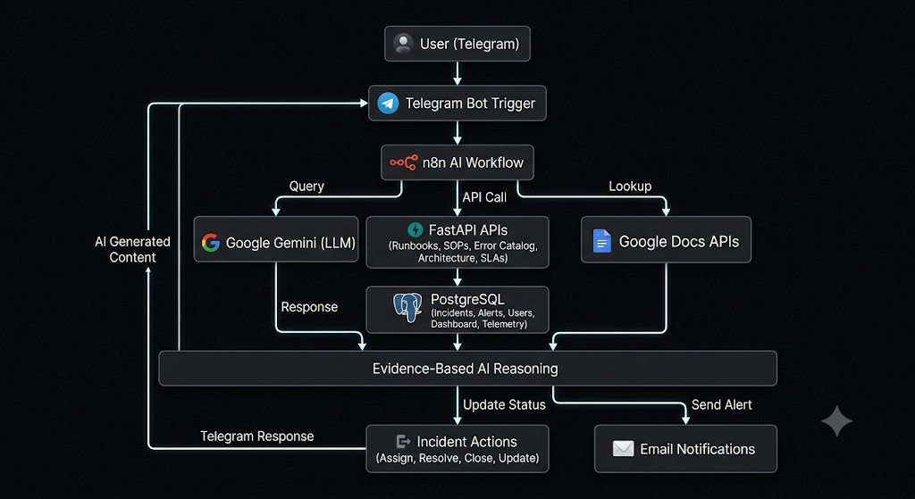

Overall System Workflow Diagram (For Completeness)

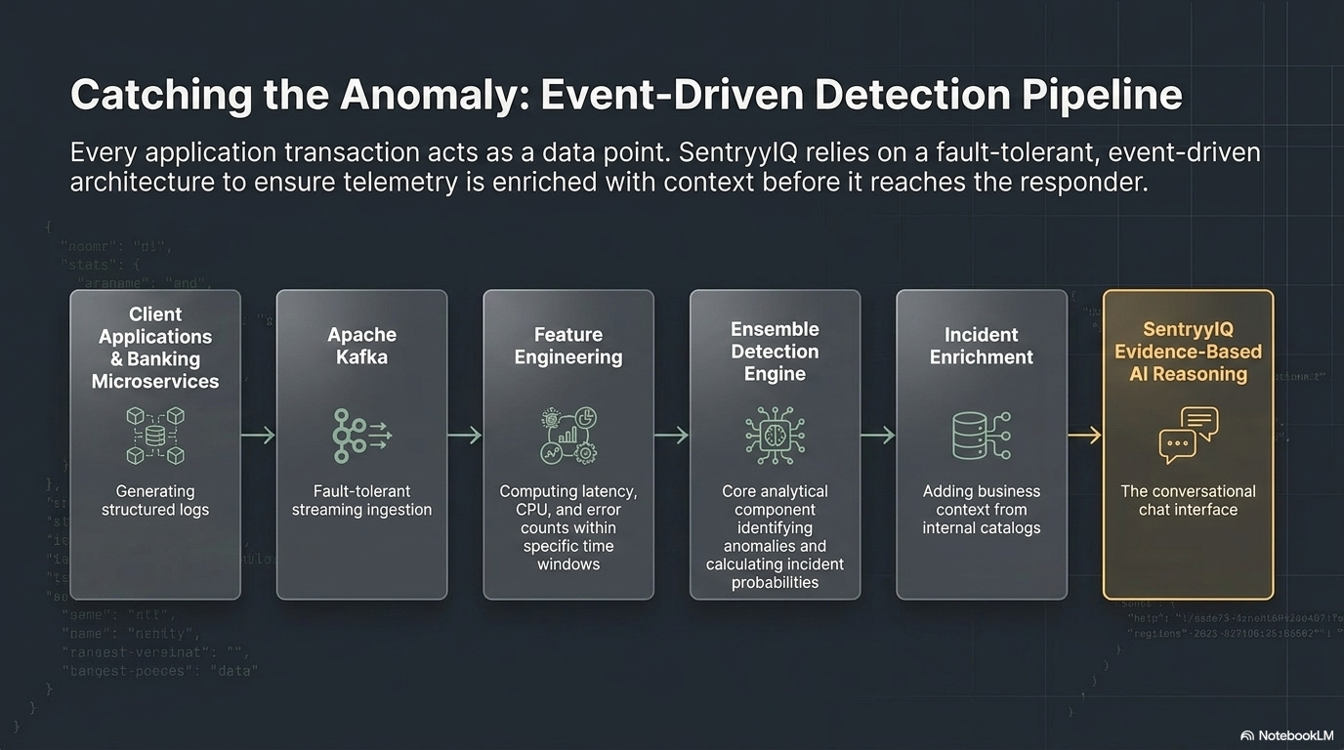

System Flow

Anomaly Detection & Observability Dashboard
Kafka for real-time log ingestion
Python/FastAPI for anomaly detection and business logic
React/Vite dashboards for telemetry visualization, alerts, and health monitoring
AI-Driven Incident Management
Automatic incident creation, assignment, investigation, resolution, and closure workflows
Integrated notification service (Telegram & Email)
Operational Knowledge Retrieval
Retrieves contextual information from Runbooks, Error Catalog, Operations Manual, Architecture Documents, and SLA Guidelines.
Evidence-Based AI Reasoning
Combines live operational data with retrieved documentation to perform Root Cause Analysis (RCA), recommend remediation steps, answer operational queries, and support incident resolution.

What SentryyIQ Answers

Question | Capability
What happened? | List incidents, incident details, alert investigation, dashboard summaries, service and regional health.
Why did it happen? | Correlates telemetry, statistical analysis, ML anomaly scores, and raw logs to explain the probable cause of an incident.
What should we do now? | Provides Root Cause Analysis (RCA), remediation guidance, incident assignment, workflow management, and notifications.
How can we prevent it? | Recommends preventive actions, captures resolutions, and builds organizational knowledge for future incidents.
What does our knowledge base say? | Answers questions from runbooks, error catalogs, architecture documents, operational procedures, and SLA guidelines.

Core Intelligence
The AI Copilot derives its intelligence from:
- Well-structured operational and incident data.
- Multiple curated operational knowledge sources.
- Context-aware retrieval of live data and documentation.
- Evidence-based prompting and reasoning.
- LLM responses grounded in operational context rather than assumptions.

AI Copilot Capabilities
- Maintains conversational context across interactions.
- Correlates evidence from multiple operational sources.
- Explains the reasoning behind recommendations.
- Acknowledges uncertainty when sufficient evidence is unavailable.
- Supports natural language interaction for incident investigation and operations.

Demonstrated Functions

Incident Operations: List incidents, incident details, assignments, resolution, closure, assignment history, and alert investigation.
Dashboard Queries: Incident summaries, severity trends, service health, regional analysis, and operational dashboards.
Knowledge Queries: Runbooks, Error Catalog, Architecture, Operations Manual, Processes, and SLA guidance.
Representative Data flow and agent capabilities :
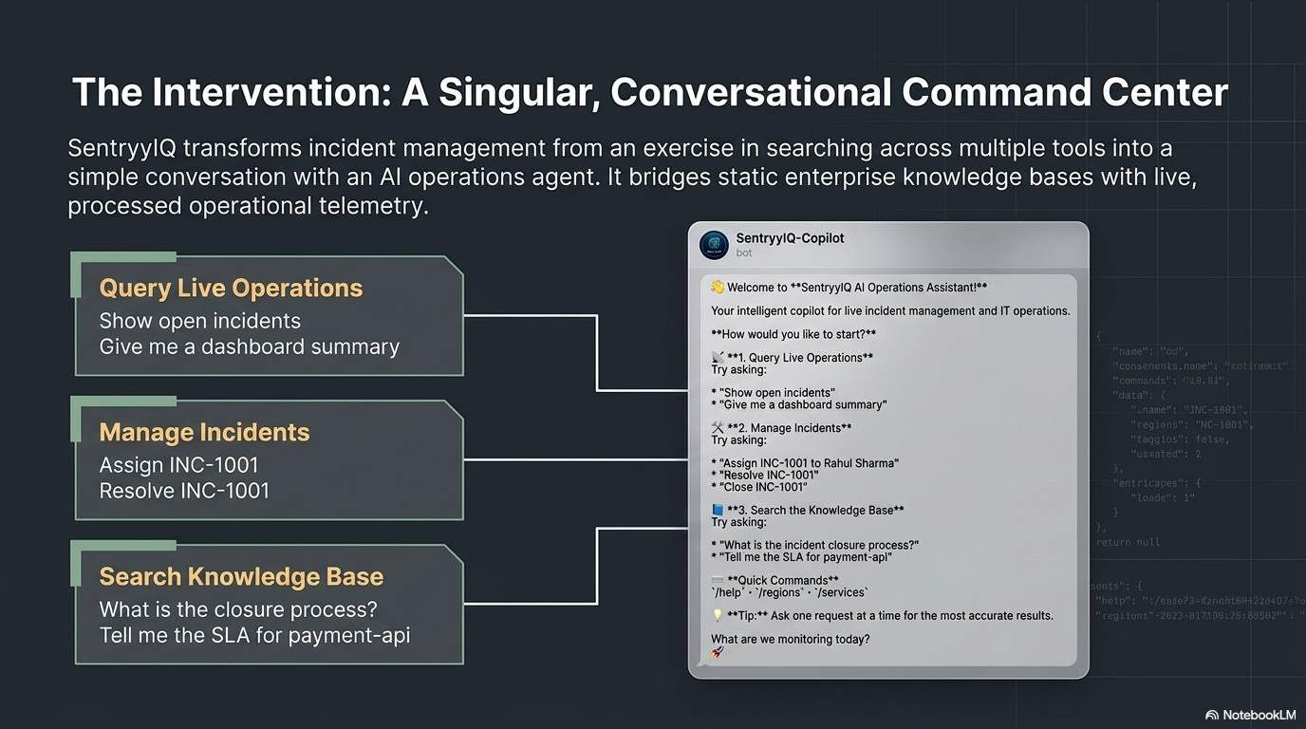
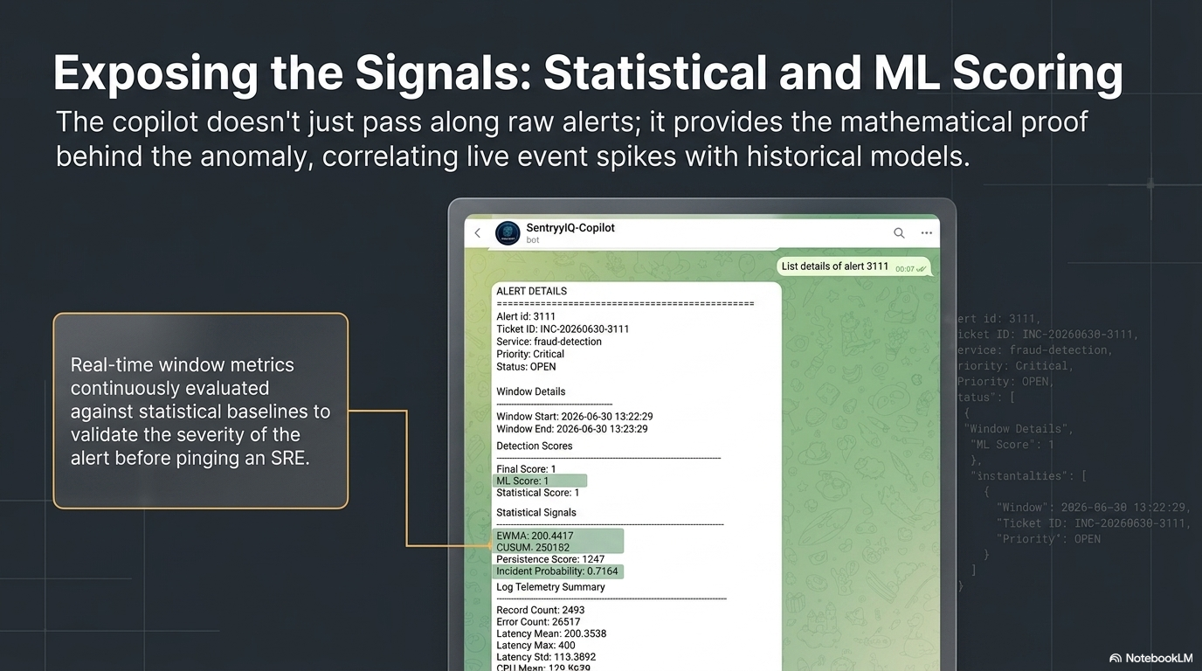
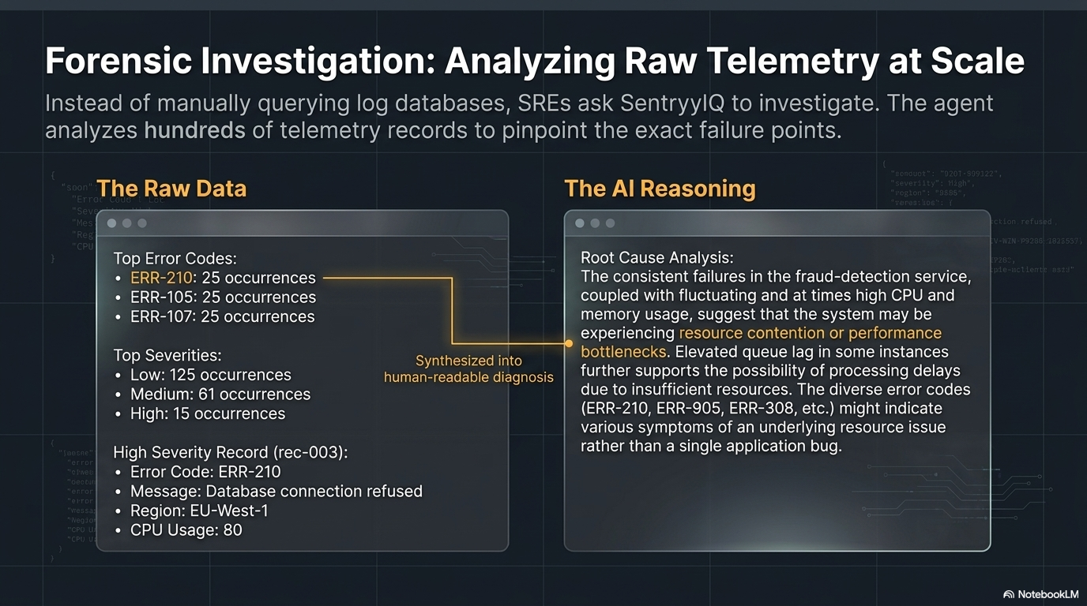
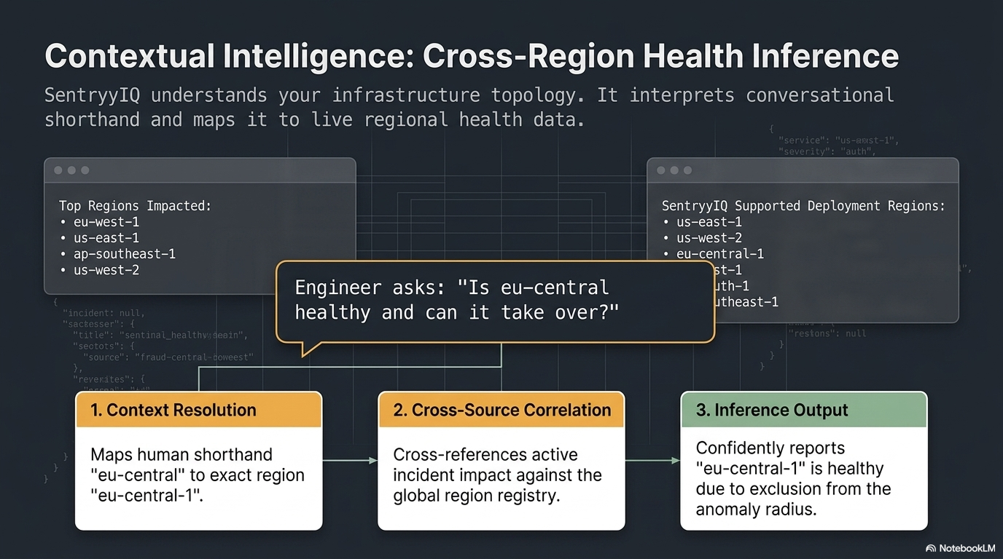

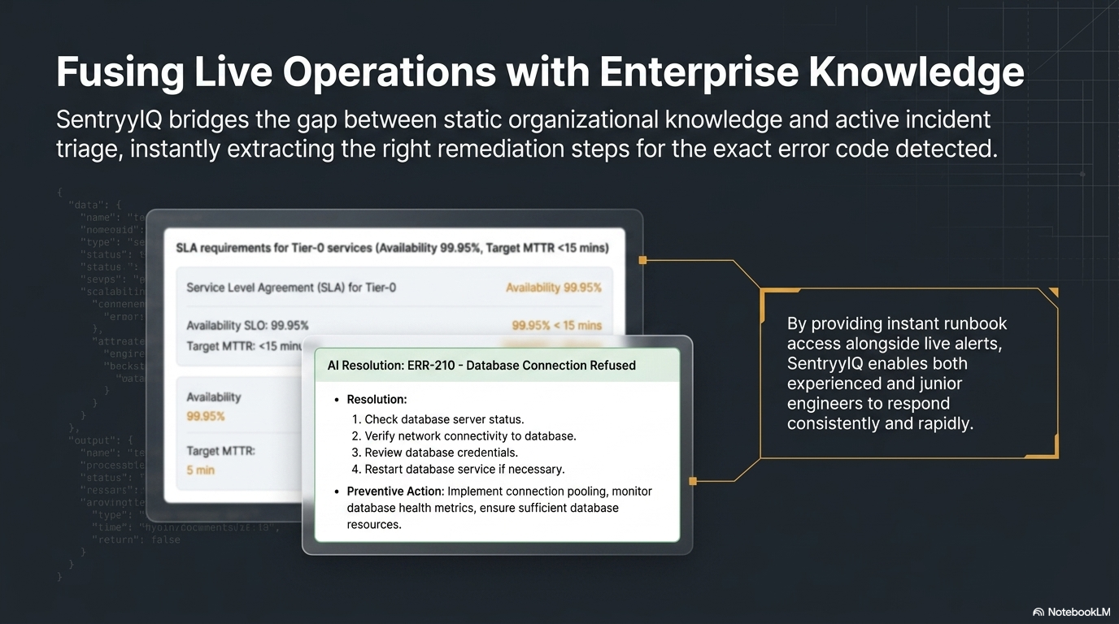
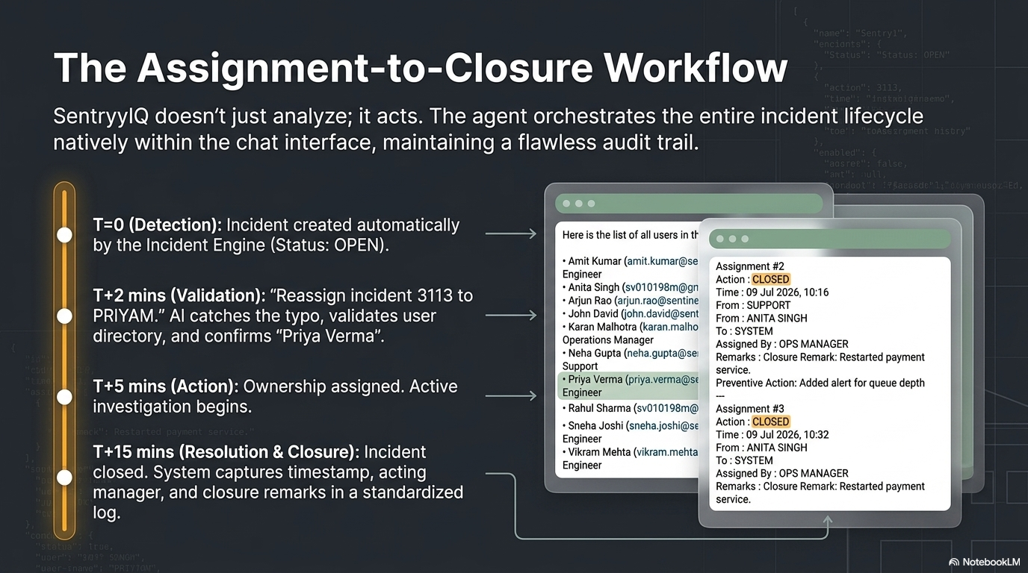
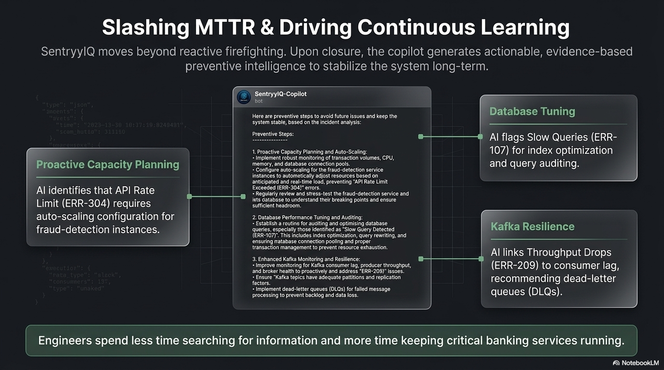

Detailed list of commands:

Live Queries
Show list of users
Show list of open incidents
Show incident details of 3110 and investigate same
Assign incident <no> to John, Start work ASAP
Assign incident <no> to Rahul ,
assign twice to same person
Assign incident 3113 to Rahul, refer to runbook for closure
Show Dashboard summary for all open incidents
Resolve incident ….. with <remarks >
Close incident <no> with <remarks> and <preventive action>
Negative case – reclosure or assignment of close request

Analytical Questions
1. For incident 3111 show me incident details and tell me is eu central healthy and takeover affected regions
2. For incident 3159 show me incident details and tell me is eu central healthy and takeover affected regions
3. /services, Now you listed 9 services but using summary of incidents by system, tell me which services are running healthy
4. Analyze issue 3163 using forensic data and alert details. What is the corelation between raw telemetry and statistical and ml prediction for issue

Knowledgebase Queries
- What is the incident closure process?
- Explain the payment-api SLA.
- Tell me SLA for service payment-api
- Tell me SLA for us-east-1
- How does SentinelIQ detect anomalies?
- Show the authentication runbook.
- Which services are monitored in us-east-1?
- What is service/incident/alert in context of system
- Tell me operational procedure to close incident
- Explain me component functionality
- Explain me Incident detection and prioritization from operations perspective
- Show me Roles and responsibilities as per operations perspective
- List the role and responsibility of all roles in short as mentioned in operations
- Describe error Code ERR-701 from Runbook
- How to resolve and work on Authorization Failures, guide me through runbook available
- Give me details on ERR-209 from run book help solve the issue
- Do you have details of ensemble score used in system
- How is incident probability is calculated in system

Future Improvements planned to make it real AIOps Copilot.

Future Enhancements
The following capabilities are planned to further enhance SentryyIQ as an intelligent AIOps Copilot. Several of these features have already been prototyped or partially implemented and will be refined in future releases.
- Predictive Reasoning
  - Forecast potential incidents by analyzing telemetry trends and historical patterns.
  - Example: "Based on current trends, queue lag is likely to exceed the SLA threshold within the next 15 minutes."
- Impact Analysis
  - Analyze service dependencies to predict the operational and business impact of component failures.
  - Example: "If the auth-service becomes unavailable, the payment-api, fraud-detection, and associated regional services are likely to be affected."
- Hypothesis Generation
  - Generate evidence-based root cause hypotheses by correlating anomalies across metrics, logs, and system behavior.
  - Example: "The most probable root cause is Kafka consumer imbalance, as CPU utilization remains normal while queue lag and persistence scores continue to increase."
- AI-Assisted Decision Support
  - Recommend the most appropriate remediation actions based on system state, historical incidents, and operational best practices.
  - Example: "Scale Kafka consumers before increasing application pods, as the current bottleneck appears to be message processing rather than compute capacity."
- Proactive Incident Prevention
  - Detect emerging risks and recommend preventive actions before they result in customer-facing incidents.
- Continuous Learning
  - Improve recommendations over time by incorporating incident outcomes, operator feedback, and updated operational documentation.
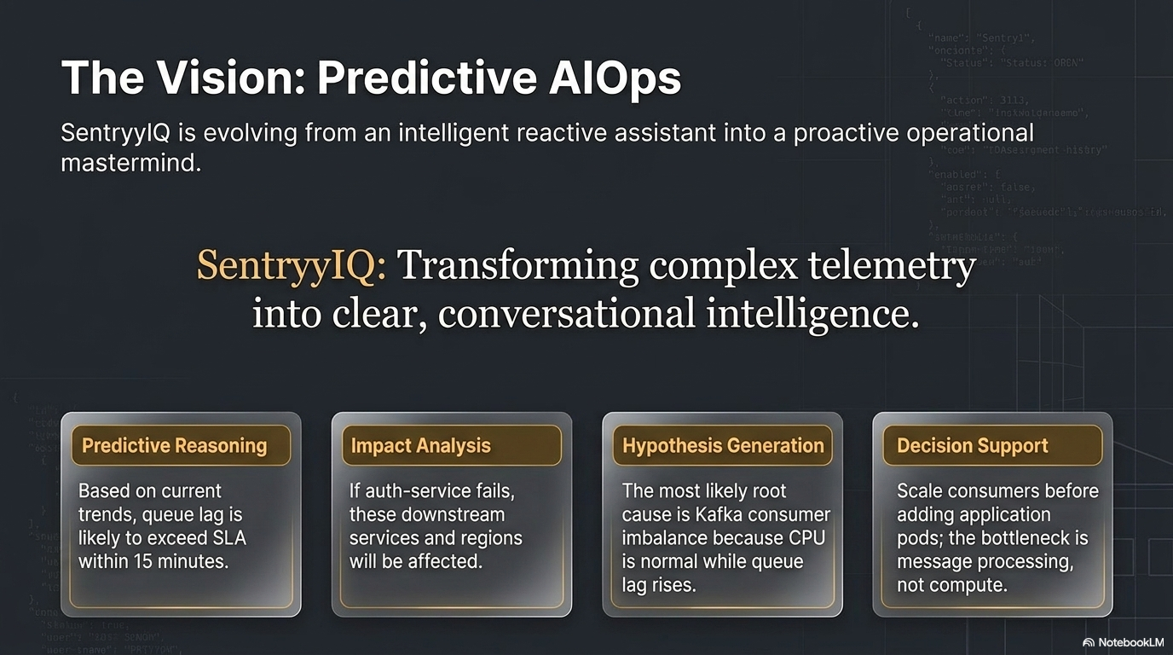

Thank You

