LAB ASSIGNMENT 4

19103112-Shubhjot Singh

Question :

We will use a simple linear regression model to describe the relationship between the Columns X and Y. A residual is the difference between what is plotted in your scatter plot at a specific point, and what the regression equation predicts "should be plotted" at this specific point. If the scatter plot and the regression equation "agree" on a y-value (no difference), the residual will be zero. Plot a residual graph for the given data using linear regression.

Code :

import pandas as pd  
from matplotlib import pyplot as plt  
import math  
import numpy as np  
  
train_set = pd.read_csv('train (1).csv')  
m=0  
c=0  
#y=mx+c  
#m=sum((x-mean(x))*(y-mean(y)))/sum(x-mean(x)))  
#c=mean(y)-m*(mean(x))  
s_x = 0  
s_y = 0  
  
def average(train_set):  
 s_x=0  
 s_y=0  
 num=len(train_set)  
 for i in range(num):  
 s_x = s_x+train_set['x'][i]  
 s_y = s_y + train_set['y'][i]  
 return s_x/num,s_y/num  
  
  
def slope_constant_calculate(s_x,s_y,train_set):  
 temp1=0  
 temp2=0  
 n=len(train_set)  
 for i in range(n):  
 temp1+=(train_set['x'][i]-s_x)*(train_set['y'][i]-s_y)  
 temp2+=(train_set['x'][i]-s_x)*(train_set['x'][i]-s_x)  
 m = temp1/temp2  
 c = s_y-m*s_x  
 return m,c  
  
  
def load_data(train_set):  
 n=len(train_set)  
 list_x=[]  
 for i in range(n):  
 list_x.append(train_set['x'][i])  
 return list_x  
  
  
  
#Performance calculator  
  
def performance(c,m,test_set):  
 n=len(test_set)  
 x=0  
 y=0  
 predicted_list=[]  
 predicted=0  
 temp1=0  
 temp2=0  
 residual_list=[]  
 y_mean=0  
 y_root=0  
 acc=0  
  
 for i in range(n):  
 x=test_set['x'][i]  
 y=test_set['y'][i]  
 predicted=(m*x+c)  
 predicted_list.append(m*x+c)  
 y_mean=y_mean+y  
 residual_list.append(y-predicted)  
 y_root+=(y-predicted)  
  
 y_mean=y_mean/n  
 for i in range(n):  
 y=test_set['y'][i]  
 temp1+=((predicted_list[i]-y_mean)*(predicted_list[i]-y_mean))  
 temp2+=((y-y_mean)*(y-y_mean))  
 acc = acc + (y - y_root) * (y - y_root)  
  
 R_square=temp1/temp2  
 return R_square,residual_list,math.sqrt(acc)  
  
  
  
  
  
  
  
  
  
  
list_x=load_data(train_set)  
s_x,s_y=average(train_set)  
m,c = slope_constant_calculate(s_x,s_y,train_set)  
  
  
  
#predictions  
  
test_set=pd.read_csv('test (1).csv')  
n=len(test_set)  
x=[]  
y=[]  
list_x=np.array(list_x)  
  
for i in range(n):  
 x.append(test_set['x'][i])  
 y.append(test_set['y'][i])  
  
plt.scatter(x,y,color='blue')  
plt.plot(list_x,m*list_x+c,color='red')  
plt.xlabel("Independent variable")  
plt.ylabel("Dependent variable")  
plt.show()  
  
  
R_square_measure,residual,accuracy=performance(c,m,test_set)  
plt.scatter(x,residual,color='green')  
plt.xlabel("Independent Variable")  
plt.ylabel("residuals ( y_predicted-y_dataset )")  
plt.title("Residual Graph")  
plt.show()  
  
print("R_square value of the model = ",R_square_measure)  
print("Root mean square error of the model = ",accuracy/(2*n))

OUTPUT :

Root mean square error and R Square value

Used to determine the accuracy of the model

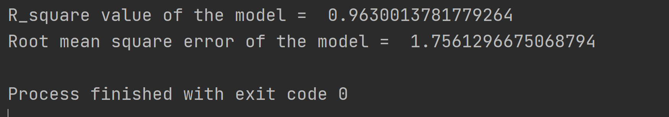

Graphical Outputs:

1. Actual value and predicted regression graph

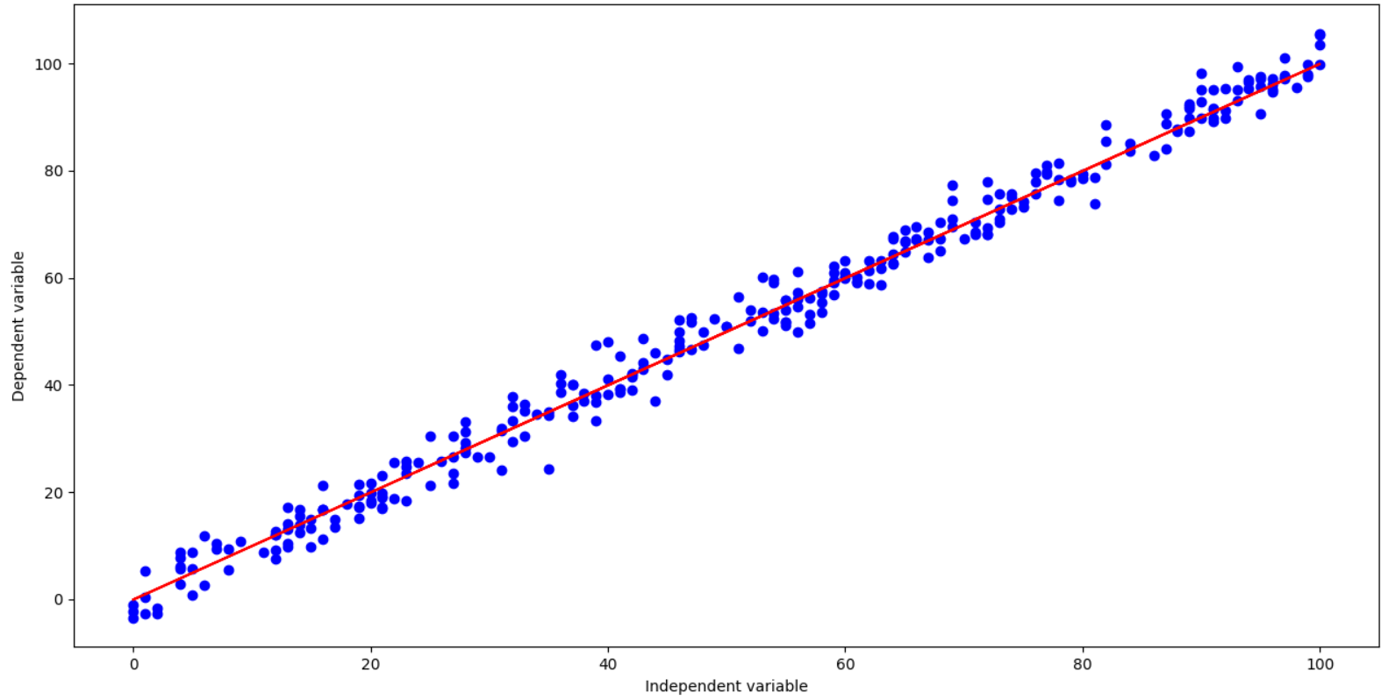

2.

Residual Graph:

