STATISTICAL ANALYSIS OF K-MEAN CLUSTER ANALYSIS OF CLIMATE CHANGE ON RICE PRODUCTION IN ODISHA DURING THE TIME PERIOD OF 2000 -2018

PROJECT REPORT SUBMITTED IN PARTIAL FULFILLMENT OF THE REQUIREMENT

FOR THE AWARD OF DEGREE OF

**MASTER OF SCIENCE**

**IN**

**STATISTICS**

SUBMITTED BY

**SHUBHAM KUMAR**

(ENROLLMENT NO. – 20/07/DSTAT/21)

ACADAMIC SESSION – 2020-2022

UNDER THE SUPERVISION OF

**Dr. MAHESH KUMAR PANDA**

ASSOCIATE PROFESSOR

DEPARTMENT OF STATISTICS

RAVENSHAW UNIVERSITY



DEPARTMENT OF STATISTICS

SCHOOL OF APPLIED SCIENCES

CENTRAL UNIVERSITY OF ODISHA

SUNABEDA, KORAPUT, 763004



# CERTIFICATE

This is to certify that the dissertation entitled **“STATISTICAL ANALYSIS OF K-MEAN CLUSTER ANALYSIS OF CLIMATE CHANGE ON RICE PRODUCTION IN ODISHA DURING THE TIME PERIOD OF 2000 -2018**” submitted by **Mr. Shubham kumar** (Enrollment No.- **20/07/DSTAT/21**) in partial fulfillment of requirements for the award of Master of Science in Statistics is a bona fide work carried out by him by my supervision. I consider that the dissertation has reached the standards and fulfilling the requirements of the rules and regulations relating to the nature of the degree.

The dissertation has not been submitted previously in part or in full to this or another University or Institution for the award of any degree or diploma.

**( Signature of Supervisor )**

**(Head of the Department)**



**DECLARATION**

I certify that the work contained in this dissertation is original and has been done myself under the supervision of my mentor Dr. Mahesh Kumar Panda, Assistant Professor (Head I/C), Department of Statistics, Central University of Odisha. This work is submitted to Department of Statistics, Central University of Odisha as a project report, as per the requirement of partial fulfilment for the award of degree Master of Science in Statistics. This work or similar title, has not been previously submitted for any academic purpose.

Date: 01/May/2022

Place: Koraput

(Signature of the Candidate)



# ACKNOWLEDGEMENT

I would first like to express my special thanks to my thesis supervisor **Dr. Mahesh Kumar Panda**, Associate Professor, Department of Statistics, Ravenshaw University, Koraput, who gave me the golden opportunity to do wonderful project which helped me to increase my knowledge, patience and understanding. My mentor has always been very supporting, inspiring, motivating and helping. The door of his office was always open whenever I faced any problem or had a question about my thesis work. He consistently allowed this project to be my own work, but steered me in the right direction whenever needed.

Finally, I must express my very profound gratitude to **Miss Lipsa Rani Bhoi**, Phd. Scholar, Department of Statistics Central University of Odisha, my family**,** Research Scholars, classmates and juniors for their support and continuous encouragement throughout my years of study and through the process of research and writing this thesis. This accomplishment would have never been possible without them.

**Thank You.**

## (Shubham kumar)

Enrollment No.-20/07/DSTAT/21

**Contents:**

**Chapter-1: Introduction: Page No.**

1.1Climate Change - - - - -- - - - - - - - - - - - - - - - - - - - - - - - - - - - - - - - - - - - - - 5

1.2 What is Climate Change - - - - - - - - - - - - - - - - - - - - - - - - - - - - - - - - - - - - 7

1.3 Impact of Climate Change - - - - - - - - - - - - - - - - - - - - - - - - - - - - - - - - - - - 9

**1.3.1** Climate Change: IPCC warns India of extreme heat waves , droughts- - - 9

**1.3.2** Climate Change: Is it Alarming For Agriculture - - - - - - - - - - - - - - - - - 11

**1.3.3** Impacts of Climate Change on Rice Poduction - - - - - - - - - - - - - - - -- - - 11

**1.3.4** Climatic Factors Affecting Rice Cultivation - - - - - - - - - - - - - - - - - - - - - - - 11

**1.3.5** Rice Production in India - - - - - - - - - - - - - - - - - - - - - - - - - - - - - - - - - - - 13

**1.3.6** Rice Production in Odisha- - - - - - - - - - - - - - - - - - - - - - - - - - - - - - - - - - - 14

**Chapter-2: Review of Literature:**

2.1 K-mean clustering - - - - - - - - - - - - - - - - - - - - - - - - - - - - - - - - - - - - - - - - - - -15

2.2 Impact of climate change in agricultural field - - - - - - - - - - - - - - - - - - - - - - - - 15

**2.2.1** Impact of global warming in agriculture - - - - - - - - - - - - - - - - - - - - - - - - 16

**2.2.2**Agriculture affects atmosphere by releasing green house gases- - - - - - - - - - 16

2.3 Agricultural activities are affected by climate change - - - - - - - - - - - - - - - - - - - 17

2.4Adaptation sceanarios to climate change - - - - - - - - - - - - - - - - - - - - - - -- - - - - -19

**Chapter-3: Statistical Analysis:**

3.1Methods - - - - - - - - - - - - - - - - - - - - - - - - - - - - - - - - - - - - - -- - - - - - - - - - - - 25

**3.1.1** Study design - - - - - - - - - - - - - - - - - - - - - - - - - - - - - - - - - - - - - - - - - - - 25

**3.1.2** Data set - - - - - - - - - - - - - - - - - - - - - - - - - - - - - - - - - - - - - - - - - - - - - - - 25

**3.1.3** Study participants - - - - - - - - - - - - - - - - - - - - - - - - - - - - - - - - - - - - - - - - 32

**3.1.4** Study variables - - - - - - - - - - - - - - - - - - - - - - - - - - - - - - - - - - - - - - - - - -32

3.2 Statistical analysis - - - - - - - - - - - - - - - - - - - - - - - - - - - - - - -- - - - - - - - - - - - - 32

3.3Results - - - - - - - - - - - - - - - - - - - - - - - - - - - - - - - - - - - - - - -- - - - - - - - - - - - - 33

**Chapter-4: Discussion and conclusion:**

4.1 Discussion - - - - - - - - - - - - - - - - - - - - - - - - - - - - - - - - - - - - -- - - - - - - - - - - - 45

4.2Conclusion - - - - - - - - - - - - - - - - - - - - - - - - - - - - - - - - - - - - - - - - - - - - - - - - - 47

**References** - - - - - - - - - - - - - - - - - - - - - - - - - - - - - - - - - - - - - - - - - - - - - - - - - - - 48

**Appendix**- - - - - - - - - - - - - - - - - - - - - - - - - - - - - - - - - - - - - - - - - - - - 52

**CHAPTER I**

**INTRODUCTION**

**CHAPTER I**

**INTRODUCTION**

* 1. **Climate change**

Climate change is a controversial topic in today’s day and age. Some are skeptical as to whether it is actually happening and some know for a fact that climate change is real and is really a threat. Even if one doesn’t believe that the globe is warming up, one should at least be concerned about the carbon footprint that we are leaving behind us and how all our waste and is hurting the environment. But the issue has been so politicized that if someone on the Left says he believes in climate change and wants to help prevent it, someone on the Right will fight against him because of the political divide and the unwillingness of to get along. That is unfortunate for this simple reason: Climate change is a very serious issue in our today. It is a rapidly worsening issue and there aren’t enough people trying to prevent this issue from getting worse and becoming irreversible. In the twenty-first century, rapid change in global climate is a serious concern worldwide. According to the special report of IPPC (Intergovernmental Panel on Climate Change), global temperature has raised by 1.5 °C during the last century which is the most remarkable increase in global temperature over the last 1000 years. Climate change is also a change in Earth's climate. This could be a change in Earth's usual temperature. Or it could be a change in where rain and snow usually fall on Earth. Weather can change in just a few hours. Climate takes hundreds or even millions of years to change. Earth's climate is always changing. There have been times when Earth's climate has been warmer than it is now. There have been times when it has been cooler. These times can last thousands or millions of years. People who study Earth see that Earth's climate is getting warmer. Earth's temperature has gone up about one degree Fahrenheit in the last 100 years. This may not seem like much. But small changes in Earth's temperature can have big effects. Some effects are already happening. Warming of Earth's climate has caused some snow and ice to melt. The warming also has caused oceans to rise. And it has changed the timing of when certain plants grow.

As our climate continues to heat up and the impacts of that warming grow more frequent and severe, farmers and farm communities around the world will be increasingly challenged. And Indian farmers won’t be spared the damage that climate change is already beginning to inflict. In fact, the industrial model that dominates our nation’s agriculture—a model that neglects soils, reduces diversity, and relies too heavily on fertilizers and pesticides—makes Indian farms susceptible to climate impacts in several ways.

Climate change has a strong association with agriculture production and 20% greenhouse gases (GHGs) emission caused by agriculture. Food security has been susceptible by different factors, and it is expected to face new challenges in near future Researchers of modern era and policymakers are evaluating the impact of climate change on agricultural production in order to ensure food security. Many factors are responsible for climate change and posing a negative impact on crops especially rice such as temperature variability, salt stress, water scarcity (drought), heavy rains, floods, and melting of glaciers.

The world’s climate is changing rapidly, and it has a significant impact on agricultural production by increasing carbon dioxide (CO2) regimes, global temperature, and unpredictable changes in rainfall pattern. Such as, the intensity and frequency of extreme heat is expected to increase, which could harm overall food systems. While C3 agricultural crops for example rice, soybean, and wheat may get benefit from rising levels of CO2 regimes. To increase the intensity and frequency of global temperature in the next few decades because of climate change, which is directly responsible to decrease the crop yields. Crop yield and growth is strongly associated with weather conditions. Some other research also reported that crop yields reduce as temperatures increase. So, a warming climatic weather could damage crop productions and world food security

Rice is the primary staple crop after wheat and is the source of 50% calories for the almost 50% population of the world, and its demand will increase by 28% in 2050. However, rice production has stagnated in 35% of all rice-growing regions. Rice cultivation is very important because rice consumption is more as compare to other staple food. Rice cultivation is the source of earning for approximately 145 million people of the world and covering 165 mha which is about 11% of agriculture land. In current agriculture system, rice cultivation and farming system are coping with two tasks, one is providing adequate and nutritious food to meet the increased requirement of population and market, and second is to overcome climate change issue through sustainable agriculture escalation. So, rice cultivation deserves special attention concerning an interaction with climate change considering the increasing population pressure in future. It also affects arable land and productivity of crops. Therefore, it is essential to understand the factors responsible for low rice growth and production caused by climate change. Previous different studies also showed that rice yield and production directly affected by increasing the global temperature. It’s very important to understand the present scenario of global climate change because it is directly linked to crop production and yield.

1.2 **What is Climate Change?**

Climate is the average weather in a place over many years. While the weather can change in just a few hours, Climate takes hundreds, thousands, even million of years to change. And as you probably already know, there are lots of different types of climates on Earth. For example, hot regions are normally closest to the equator. The climate is hotter there because the Sun’s light is most directly overhead at the equator. And the North and South Poles are cold because the Sun’s light and heat are least direct there.

Climate is the average weather in a place over many years. Climate change is a shift in those average conditions. The rapid climate change we are now seeing is caused by humans using oil, gas and coal for their homes, factories and transport. When these fossil fuels burn, they release greenhouse gases - mostly carbon dioxide (CO2). These gases trap the Sun's heat and cause the planet's temperature to rise.

The world is now about 1.2C warmer than it was in the 19th Century – and [the amount of CO2 in the atmosphere has risen by 50%](https://www.carbonbrief.org/met-office-atmospheric-co2-now-hitting-50-higher-than-pre-industrial-levels).

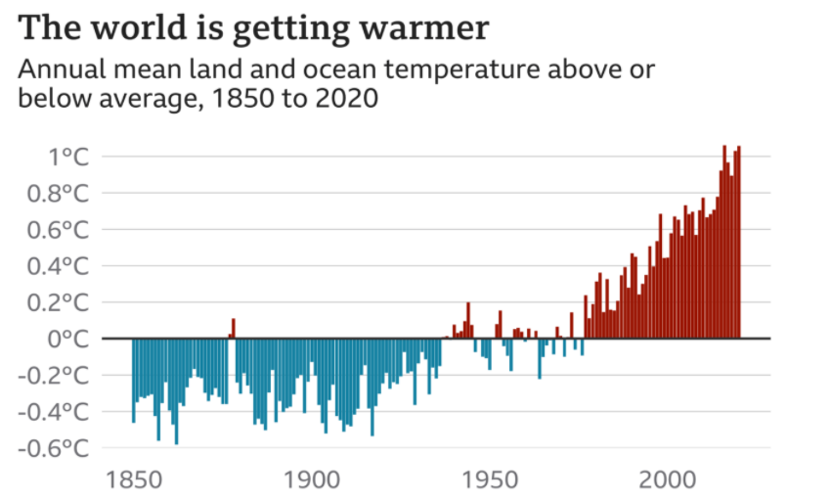

**Source: NOAA (National Oceanic and Atmospheric Administration)**

Temperature rises must slow down if we want to avoid the worst consequences of climate change, scientists say. They say global warming needs to be [kept to 1.5C by 2100](https://www.bbc.co.uk/news/science-environment-45678338).

**1.3 Impact of Climate Change**

The impacts of climate change on different sectors of society are interrelated. Drought can harm food production and human health. Flooding can lead to disease spread and damages to ecosystems and infrastructure. Human health issues can increase mortality, impact food availability, and limit worker productivity. Climate change impacts are seen throughout every aspect of the world we live in. Climate change is happening so fast that many plants and animal species are struggling to cope. Many terrestrial, freshwater and marine species have already moved to new locations. Some plant and animal species will be at increased risk of extinction if global average temperatures continue to rise unchecked.

We see climate change affecting our planet from pole to pole.

* [Global temperatures](https://climate.gov/news-features/understanding-climate/climate-change-global-temperature) rose about 34.7°F (1.5°C) from 1901 to 2021.
* [Sea level rise](https://climate.gov/news-features/understanding-climate/climate-change-global-sea-level) has accelerated from 1.7 mm/year throughout most of the twentieth century to 3.2 mm/year since 1993.
* [Glaciers](https://climate.gov/news-features/features/climate-change-glacier-mass-balance)are shrinking: average thickness of 30 well-studied glaciers has decreased more than 60 feet since 1980.
* The area covered by [sea ice](https://climate.gov/news-features/understanding-climate/climate-change-minimum-arctic-sea-ice-extent) in the Arctic at the end of summer has shrunk by about 40% since 1979.
* The amount of [carbon dioxide](https://climate.gov/news-features/understanding-climate/climate-change-atmospheric-carbon-dioxide) in the atmosphere has risen by 25% since 1958, and by about 40% since the Industrial Revolution.
* [Snow](https://climate.gov/news-features/understanding-climate/climate-change-spring-snow-cover) is melting earlier compared to long-term averages.

Burning fossil fuels generates greenhouse gas emissions that act like a blanket wrapped around the Earth, trapping the sun’s heat and raising temperatures. Examples of greenhouse gas emissions that are causing climate change include carbon dioxide and methane. These come from using gasoline for driving a car or coal for heating a building, for example. Clearing land and forests can also release carbon dioxide. Landfills for garbage are a major source of methane emissions. Energy, industry, transport, buildings, agriculture and land use are among the [main emitters](https://www.unep.org/interactive/six-sector-solution-climate-change/).

**Greenhouse gas concentration are at their highest levels in 2 million years:**

And[emissions continue to rise](https://wedocs.unep.org/bitstream/handle/20.500.11822/36991/EGR21_ESEN.pdf). As a result, [the Earth is now about 1.1°C warmer](https://www.ipcc.ch/2021/08/09/ar6-wg1-20210809-pr/) than it was in the late 1800s. Many people think climate change mainly means warmer temperatures. But temperature rise is only the beginning of the story. Because the Earth is a system, where everything is connected, changes in one area can influence changes in all others.

**People are experiencing climate change in diverse ways:**

Climate change can affect our health, ability to grow food, housing, safety and work. Some of us are already more vulnerable to climate impacts, such as people living in small island nations and other developing countries. Conditions like sea-level rise and saltwater intrusion have advanced to the point where whole communities have had to relocate, and protracted droughts are putting people at risk of famine.

**Every increase in Global Warming matters:**

In a series of [UN reports](https://www.ipcc.ch/report/sixth-assessment-report-cycle/), thousands of scientists and government reviewers agreed that limiting global temperature rise to no more than 1.5°C would help us avoid the worst climate impacts and maintain a livable climate. Yet based on current national climate plans, global warming is [projected to reach around 3.2°C](https://www.ipcc.ch/report/ar6/wg3/resources/spm-headline-statements/) by the end of the century.

**We face a huge challenge but already know many solutions:**

Many climate change solutions can deliver economic benefits while improving our lives and protecting the environment. We also have global frameworks and agreements to guide progress, such as the [Sustainable Development Goals](https://www.un.org/en/climatechange/17-goals-to-transform-our-world), the [UN Framework Convention on Climate Change](https://unfccc.int/process-and-meetings/the-convention/what-is-the-united-nations-framework-convention-on-climate-change) and the [Paris Agreement](https://www.un.org/en/climatechange/paris-agreement). Three broad categories of action are: cutting emissions, adapting to climate impacts and financing required adjustments. Switching energy systems from fossil fuels to[renewables like solar or wind](https://iea.blob.core.windows.net/assets/5ae32253-7409-4f9a-a91d-1493ffb9777a/Renewables2021-Analysisandforecastto2026.pdf) will reduce the emissions driving climate change.

**We can pay the bill now, or pay dearly in the future:**

Climate action requires significant [financial investments](https://www.un.org/en/climatechange/raising-ambition/climate-finance) by governments and businesses. But climate inaction is vastly more expensive. One critical step is for industrialized countries to fulfil their commitment to provide $100 billion a year to developing countries so they can adapt and move towards greener economies.

**1.3.1 Climate change: IPCC warns India of extreme heat waves, droughts**

India will likely face irreversible impacts of climate change, with increasing heat waves, droughts and erratic rainfall events in the coming years if no mitigation measures are put in place, experts warn. "Heat extremes have increased while cold extremes have decreased, and these trends will continue over the coming decades," the report said regarding the Indian subcontinent. Experts say India, and South Asia in general, is particularly vulnerable to climate change."The threat of climate change is real dangers are imminent and the future is catastrophic. This message from the IPCC report confirms what we already know and can see in the world around us". Climate change has already hit India hard, causing huge economic and social losses past few years.

**1.3.2 Climate Change: Is It Alarming For Agriculture**

Climate change is adversely influencing the global community and ecosystem by affecting the temperature of the earth, frequency of precipitation, solar radiation, winds, relative humidity and hydrological cycles. Due to the anthropogenic activities, fossil fuels burning and solar irradiance, earth is becoming hotter causing global warming. These combined effects of climatic factors decrease the agricultural production of many important crops. Climate change has positive and negative impacts on agriculture by having noticeable effects on plant production, disease infestation, weed dynamics, soil properties, and microbial composition of the farming system. Temperature change could severely effect food production in tropical areas with a predicted 30% loss of food production in South Asia in 2050.

**1.3.3 Impacts of Climate Change on Rice Production**

Global climate change is projected to have wide ranging effects on environment, socio-economic and related sectors.[**Indian agriculture scientists**](http://www.indiaenvironmentportal.org.in/feature-article/assessment-climate-change-impact-rice-using-controlled-environment-chamber-tamil)have found that rising temperature will adversely hit rice productivity in the country. Experiments done in Tamil Nadu show that elevated temperature will have a negative impact on rice productivity, even nullifying the positive effects of higher level of carbon dioxide. Researchers at the Coimbatore-based Tamil Nadu Agricultural University (TNAU) conducted a study on rice which is a staple food for most people in the region. According to Manila-based International Rice Research Institute, rice provides 23 per cent of global human per capita energy and 16 per cent of global human per capita protein.

Rice is a key staple food crop; however, its growth and productivity are affecting by climate change. The low production along with high demand is due to climate change which affecting food security and economy of the world. Amongst the impacts of climate change, the high duration and intensity of high temperature results in drought, floods, and tropical storms and effects the distribution of rainfall, cause soil degradation, and intrusion of agricultural land by saltwater due to rise of sea level. Overall, elevated temperature was found to have a negative impact on rice productivity, even nullifying the positive effects of higher level of carbon dioxide.

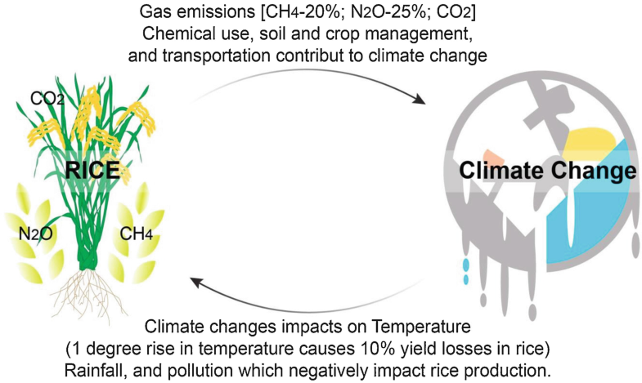

**Source: Department of Agriculture & Farmers Welfare**

**1.3.4 Climatic Factors Affecting Rice Cultivation**

There are many climate factors affecting the rice cultivation such as: rainfall, temperature, day length and sunshine. Rainfall is the most important element among the climate factors for rice cultivation. The rainfall distribution in different areas is influenced by the topographic factors such as mountains and plateau. Temperature is an important climatic factor having some positive and negative impacts on the growth, development and yield of rice. Rice is grown in tropical and sub-tropical climate and requires relatively higher temperature, optimally from 20 °C to 40 °C, with 30 °C and 20 °C day and night temperature. Rice requires different critical temperature at different growth stages such as ranging from 16 °C to 20 °C at flowering and fertilization, and 18 °C to 32 °C at ripening. If temperature is favorable for rice cultivation throughout the year then, two or three crops of rice could be grown in a year. Where rainfall is high and winter temperature is fairly low, only one crop of rice is grown.

**1.3.5 Rice Production in India**

Rice production in India is an important part of the national economy. India is the world's second-largest producer of rice, and the largest exporter of rice in the world. Rice is one of the chief [grains](https://en.wikipedia.org/wiki/Grains) of India. Moreover, this country has the largest area under rice cultivation. As it is one of the principal food crops. It is, in fact, the dominant crop of the country. India is one of the leading producers of this crop. Rice is the basic food crop and being a tropical plant, it flourishes comfortably in a hot and humid climate. Rice is mainly grown in rain-fed areas that receive heavy annual rainfall. That is why it is fundamentally a [kharif crop](https://en.wikipedia.org/wiki/Kharif_crop) in India. It demands a temperature of around 25 degrees Celsius and above, and rainfall of more than 100 cm. Rice is also grown through irrigation in those areas that receive comparatively less rainfall. Rice is the staple food of [eastern](https://en.wikipedia.org/wiki/Eastern_India) and [southern](https://en.wikipedia.org/wiki/Southern_India) parts of India. In financial year 2021, India's production volume of rice was over 122 million metric tons. Except for a few years, the production of rice in the country has increased over the last decade.

Rice can be [cultivated](https://en.wikipedia.org/wiki/Agriculture) by different methods based on the type of region. But in India, traditional methods are still in use for harvesting rice. The fields are initially plowed and fertilizer is applied which typically consists of cow dung, and then the field is smoothed. The seeds are transplanted by hand and then through proper [irrigation](https://en.wikipedia.org/wiki/Irrigation), the seeds are cultivated. Rice grows on a variety of soils like [silts](https://en.wikipedia.org/wiki/Silt), [loams](https://en.wikipedia.org/wiki/Loam) and [gravels](https://en.wikipedia.org/wiki/Gravel). It can tolerate [alkaline](https://en.wikipedia.org/wiki/Alkaline) as well as [acid soils](https://en.wikipedia.org/wiki/Acid_soil).

**1.3.6 Rice Production in Odisha**

Rice covers about 69% of the cultivated area and is the major crop, covering about 63% of the total area under food grains. It is the staple food of almost the entire population of Odisha; therefore, the state economy is directly linked with improvements in production and productivity of rice in the state. In the 1950s Odisha was a leading rice-producing state in the country and it used to supply a sizable amount of rice grain to the central pool of food stocks. But, the situation was strongly reversed in the post-high-yielding variety period. However, during the last 35 years, the state’s rice area has stagnated around 4 million hectares, about 10% of the total rice area of the country. Odisha’s share in the country’s rice production was more than 11% in the pre-HYV period, which gradually declined to 7.9% in 2008-09. Rice in Odisha is now grown on an area of 4.4 million hectares, which accounts for 91% of the area under cereals and contributes about 94% of total cereal production in the state.

The state is located in the subtropical belt of India. The state broadly falls under hot and dry subhumid, warm and humid, hot and humid, and hot and moist subhumid regions and experiences four major seasons: winter, summer, rainy, and autumn. The monthly average minimum and maximum temperatures range between 14 °C in December to 38 °C in May. Whereas the mean maximum temperature is 32 °C in the coastal districts of the state, it sometimes goes up to 42° C in hilly areas. The location of the state, near the Bay of Bengal, moderates the temperature and adds humidity to its climate. The relative humidity of the state varies from 36% to 98%; the average bright sunshine hours range between 3.7 hours/day in July-August to 8.8 hours/day during March to May. Soils of Odisha are broadly divided into eight groups: Red Sandy and Red Loamy, Lateritic, Red and Yellow, Coastal Alluvial, Deltaic Alluvial, Black, Mixed Red and Black, and Brown Forest Soils. The soils are mostly red lateritic and acidic in nature.

The southwest monsoon enters the state during the second half of June and continues up to the first week of October. The annual normal rainfall of the state is 1,451.2 mm, with a unimodal distribution. More than 80% of the precipitation is received from mid-June to September. The rainfall pattern is highly unpredictable in timing, amount, and distribution and therefore the state suffers from either drought or flood. Odisha agriculture depends much on monsoon rains. The normal distribution of rainfall influences crop yield: failure of rain in drought years causes scarcity, while excess rainfall causes flood.

**CHAPTER II**

**REVIEW OF LITERATURE**

**CHAPTER II**

**REVIEW OF LITERATURE**

**2.1 K-mean clustering**

Clustering, as a generic tool for finding groups or clusters in multivariate data, has found wide application in biology, psychology and economics .One of the main difficulties for cluster analysis is that, the correct number of clusters of different types of datasets is seldom known in practice. However, most of clustering algorithms are designed only to investigate the inherited grouping or partition of data objects according to a known number of clusters. Thus, identifying the number of clusters is an important task for any clustering problem in practice albeit it must be faced with many operational challenges. A tractable way for cluster analysis is to ask the end user to input the number of clusters in advance, which needs the expert domain knowledge over the underlying datasets (**Trupti M Kodinariya et al.,2013**). On the other hand, many statistical criteria or clustering validity indices have been investigated in the sense of automatically selecting an appropriate number of clusters. Several algorithms have been proposed in the literature for clustering. The k-means clustering algorithm is the most commonly used because of its simplicity. In this paper, we focus on one of problem of K-mean i.e .automation of number of cluster. In the literature several approaches have been proposed to determine the number of clusters for k-mean clustering algorithm. We focus on six different approaches : i) By rule of thumb; ii) Elbow method; iii) Information Criterion Approach; iv) An Information Theoretic Approach; v) Choosing k Using the Silhouette and vi) Cross-validation ([**Banerji**](https://www.analyticsvidhya.com/blog/author/ankita4992/) **et al.,2021**).

We describe here a novel 3-D image segmentation technique capable of robust segmentation using -mean clustering and knowledge-based morphological operations. This technique aims at solving the problems encountered in the segmentation of images consisting of regions that may be separate in anatomy but indistinguishable in intensity. The proposed adaptive K-mean clustering algorithm is adopted from and is capable of initial segmentation of the structures characterized by spatially varying intensity distributions. Spatial constraints are incorporated in the form of Gibbs random fields in our adaptive K-mean clustering algorithm to enforce the neighborhood configuration to overcome the noise in the given image. Simple morphological operations are then applied to clear the results obtained from K-mean clustering to form the initial segmented regions. Although we are able to overcome the difficulties originating from spatially varying intensity distributions and image acquisition noise with adaptive K-mean clustering and simple morphological operations, resolving the anatomical ambiguity presented in many biomedical image segmentations is still a challenging task. It is this challenge that motivated the development of the algorithm for knowledge based morphological operations which determines desired final segmentation according to the a priori anatomical knowledge of the region-of-interest(**Chang-Wen Chen**. **et. Al,1983**) To illustrate the effectiveness of this proposed algorithm, we have successfully implemented a robust segmentation on a sequence of cardiac CT volumetric images to extract time-varying chamber of left ventricle. The volumes of left ventricle extracted using this approach compare favorably with the volumes obtained using operator manual outlining. However, such knowledge-based segmentation is fast, reproducible, and without operator bias.

The application of the proposed algorithm to other applications of image segmentation can be easily adopted as long as the a priori knowledge of the structure-of-interest is available. In many biomedical image segmentation tasks, such knowledge is usually available since we often study certain biomedical structures with known anatomical information. The anatomical information can be used in the design of K- mean clustering when it is necessary to set the value and to incorporate the spatial characteristics of each class. Such information is crucial in the design of knowledge based morphological operations since it is the only way of intelligently identifying the anatomical structures from the possibly ambiguous segmentations obtained through adaptive K-mean clustering. It is true that a particular implementation scheme of 3-D image segmentation would depend on individual applications. However, the principles of this knowledge-based approach will provide, without doubt, the methodology in the design of an individualized 3-D image segmentation algorithms (**Rizwan et. al,2020)**.

Climate change is a long term change in the statistical distribution of weather patterns over periods ranging from decades to millions of years. It may be a change in average weather conditions or the distributions of events around that averages (i.e. more and fewer extreme weather events. It may be limited to a specific region or may occur across the whole world. Climate change reflects a change in the energy balance of the climate system i.e. changes the relative balance between incoming solar radiation and outgoing infrared radiation from .Earth.In the context of climate variation, anthropogenic factors are human activities which affect climate. The scientific consensus on climate change is that climate is changing and these changes are in large part caused by human activities and it is largely irreversible. Consequently, the debate is shifting to reduce further human impact and to find ways to adapt to change that has already occurred and is anticipated to occur in the future.

**2.2 Impact of climate change in agricultural field**

In order to study climate change on a regional scale using Earth System Models, it is useful to partition the spatial domain into regions according to their climate changes. The aim of this work is to divide the European domain into regions of similar projected climate changes using a simulation of daily total precipitation, minimum and maximum temperatures for the recent-past (1986–2005) and long-term future (2081–2100) provided by the [Coupled Model Inter-comparison Project](https://www.sciencedirect.com/topics/earth-and-planetary-sciences/cmip) (CMIP5). The difference between the long-term future and recent-past daily [climatologies](https://www.sciencedirect.com/topics/earth-and-planetary-sciences/climatology) of these three variables is determined. Aiming to objectively identify the grid points with coherent climate changes, a K-Mean Cluster Analysis is applied to these differences. This method is performed for each variable independently (univariate version) and for the aggregation of the three variables (multivariate version). A mathematical approach to determine the optimal number of clusters is pursued ([**Carvalho, M. J.**](https://ui.adsabs.harvard.edu/search/q=author:%22Carvalho%2C+M.+J.%22&sort=date%20desc,%20bibcode%20desc) **et. al,2016**). However, due to the [method characteristics](https://www.sciencedirect.com/topics/earth-and-planetary-sciences/method-of-characteristics), a sensitivity test to the number of clusters is performed by analysing the consistency of the results. This is a novel method, allowing for the determination of regions based on the climate change of multiple variables. Results from the univariate application of this method are in accordance with results found in the literature, showing overall similar regions of changes. The regions obtained for the multivariate version are mainly defined by latitude over European land, with some features of land-sea interaction. Furthermore, all regions have statistically different distributions of at least one of the variables, providing confidence to the regions obtained.

This document is a synthesis of science literature on the effects of climate change on agriculture and issues associated with agricultural adaptation to climate change. Information is presented on how long-term changes in air temperatures, precipitation, and atmospheric levels of carbon dioxide will affect crop production, livestock production, natural resources, the agricultural economy, and sociological networks that support farming communities. The publication provides an overview of how changes in climate affect both biotic and abiotic aspects of agricultural production. A-biotic components include air temperature, the hydrologic cycle, atmospheric carbon dioxide and ozone levels, and factors that can limit the amount of sunlight reaching the Earth’s surface, such as cloud cover and ambient particulate matter concentrations. Biotic components include weeds and invasive species that can compete with crops and overrun productive farmlands and rangelands; insect pests, pathogen diversity, migration, and evolution; and threats to insect pollinators. The report also details how adaptations in current agricultural practices will enable farmers to continue crop and animal production in ways that partially offset the negative direct and indirect effects of climate changes—and even take advantage of new opportunities that may result (**C.L., Hatfield et. al, 2013**).

**2.2.1 Impact of global warming in agriculture**

Climate change caused by anthropogenic greenhouse emissions leads to impacts on a global and a regional scale. A quantitative picture of the projected changes on a regional scale can help to decide on appropriate mitigation and adaptation measures. In the past, regional climate change results have often been presented on rectangular areas. But climate is not bound to a rectangular shape and each climate variable shows a distinct pattern of change. Therefore, the regions over which the simulated climate change results are aggregated should be based on the variable(s) of interest, on current mean climate as well as on the projected future changes. A cluster analysis algorithm is used here to define regions encompassing a similar mean climate and similar projected changes. The number and the size of the regions depend on the variable(s) of interest, the local climate pattern and on the uncertainty introduced by model disagreement. The new regions defined by the cluster analysis algorithm include information about regional climatic features which can be of a rather small scale. Comparing the regions used so far for large scale regional climate change studies and the new regions it can be shown that the spacial uncertainty of the projected changes of different climate variables is reduced significantly, i.e. both the mean climate and the expected changes are more consistent within one region and therefore more representative for local impacts (**Eri Saikawa et. al, 2017**).

**2.2.1 Agriculture affects atmosphere by releasing green house gases**

Agriculture affects atmosphere by releasing green house gases and get affected in turn, from climate change. This paper reviews the literature on both the aspects and test empirically that what affects emissions of carbon dioxide to the atmosphere. Data on carbon emissions, energy consumption and agriculture related national level variables are obtained for 120 countries from the World Bank's Green Data Book. Multiple linear regression analysis revealed that agricultural land, irrigation, forest area, biomass energy, and energy use efficiency negatively affect the Carbon dioxide emission. But, fertilizer use and per capita energy use affect it positively. The analysis confirms that the people in rich countries are more responsible for carbon emission than the people in poor countries. It recommends for cross subsidization for low external input agriculture, particularly for organic farming in poor countries.

These adaptations could include altering planting dates, using more water-efficient crops, supplementing precipitation shortfalls with irrigation, and altering tillage practices. Livestock producers, in turn, could focus on breeding and maintaining animals that can tolerate higher temperatures, have more natural resistance to pests, and can meet their dietary needs with existing vegetation. An important message is that adaptation will require a balance of new crop and livestock types and new management strategies that enable production while providing stewardship of soil resources. Discussions are included on how to support effective decision-making for future climate scenarios across multiple dimensions of the U.S. agricultural system, and the need for climate information and near-term forecasts that is scaled appropriately to ensure their relevance for local and regional decision-making, and strategic planning. At the same time, regional and national near-term and longer-term climate projections will be needed for effective research, development, and adaptation planning and policy-making by state and federal governments and agribusiness. More complete modeling/simulation systems will allow scientists to study how a diverse and simultaneous range of environmental and sociological stressors might interfere with the U.S. agricultural system (**National Climate Assessment Report, 2013**).

The implications of climate change for agriculture and food are global concerns, and they are very important for China. The country depends on an agricultural system which has evolved over thousands of years to intensively exploit environmental conditions. The pressures on the resource base are accentuated by the prospect of climate change. This paper synthesizes information from a variety of studies on Chinese agriculture and climate. Historical studies document the impacts of past climate changes and extremes, and the types of adjustments which have occurred, the vulnerability of Chinese agriculture to climate change. Climate change scenarios are assessed relative to the current distribution of agro-climatic regions and farming systems. Notwithstanding the yield enhancing effects of warming and elevated CO2 levels, expected moisture deficits and uncertain changes in the timing and frequency of critical conditions indicate that there are serious threats to the stability and adaptability of China's food production system **(**[**B Smit**](https://scholar.google.com/citations?user=XJ2fResAAAAJ&hl=en&oi=sra)**, Y Cai Global Environmental Change, 1996).**

we examine the major predictions made so far regarding the nature of climate change and its impacts on our region in the light of the known errors of the set of models and the observations over this century. The major predictions of the climate models about the impact of increased concentration of greenhouse gases are at variance with the observations over the Indian region during the last century characterized by such increases and global warming. It is important to note that as far as the Indian region is concerned, the impact of year-to-year variation of the monsoon will continue to be dominant over longer period changes even in the presence of global warming. Recent studies have also brought out the uncertainties in the yields simulated by crop models. It is suggested that a deeper understanding of the links between climate and agricultural productivity is essential for generating reliable predictions of impact of climate change. Such an insight is also required for identifying cropping patterns and management practices (**S Gadgil et. al, 1995**).

The unimpeded growth of greenhouse gas emissions is raising the earth’s temperature. The consequences include melting glaciers, more precipitation, erratic weather events, and shifting seasons. The accelerating pace of climate change, combined with global population and income growth, threatens food security everywhere. Agriculture is extremely vulnerable to climate change. Population in the developing world, which are already vulnerable and food insecure, are likely to be the most seriously affected. Despite the fact that much remains to be explored in terms of the role and potential of ICTs within the climate change field, the analysis conducted here sheds light on key conceptual foundations that help better understand the complex linkages that exist within vulnerable livelihood systems, and that ultimately determine the role of digital technologies in achieving development outcomes amidst an uncertain climatic future. It may be suggested that, in the event of climate change related shocks or trends within a particular context, the capacity of the system (at the household, community or national level) to respond through adaptation can be understood either as a set of components or as a set of properties, which interact to create the adaptive capacity of the system.

**2.3 Agricultural activities are affected by climate change**

This paper reviews various articles and documents on relationship between climate change and agriculture. The two-way relationship of climate change and agriculture is of great significance in particular to developing countries due to their large dependence on agricultural practice for livelihoods and their lack of infrastructure for adaptation when compared to developed countries. Agricultural activities are affected by climate change affects due to their direct dependence on climatic factors. In high latitude areas with low temperature, increased temperature due to climate change could allow for longer growing season. Agriculture affects climate through emissions of greenhouse gases (GHGs) such as carbon dioxide, methane and nitrous oxide. These emissions come directly from use of fossil fuels, tillage practices, fertilized agricultural soils and livestock manure in large proportion. Conversely, agriculture could be a solution for climate change by the widespread adoption of mitigation and adaptation actions. This happens with the help of best management practices such as organic farming, agro forestry practice and manure management etc (**H. Yohannes et.al, 2016**).

Climate change is a global threat to the food and nutritional security of the world. As greenhouse-gas emissions in the atmosphere are increasing, the temperature is also rising due to the greenhouse effect. The average global temperature is increasing continuously and is predicted to rise by 2 °C until 2100, which would cause substantial economic losses at the global level. The concentration of CO2, which accounts for a major proportion of greenhouse gases, is increasing at an alarming rate, and has led to higher growth and plant productivity due to increased photosynthesis, but increased temperature offsets this effect as it leads to increased crop respiration rate and evaporation, transpiration, higher pest infestation, a shift in weed flora, and reduced crop duration. Climate change also affects the microbial population and their enzymatic activities in soil. This paper reviews the information collected through the literature regarding the issue of climate change, its possible causes, its projection in the near future, its impact on the agriculture sector as an influence on physiological and metabolic activities of plants, and its potential and reported implications for growth and plant productivity, pest infestation, and mitigation strategies and their economic impact (**GS Malhi et. al, 2021**).

**2.4 Adaptation scenarios to climate change**

Two possible adaptation scenarios to climate change for Sub-Saharan Africa are analyzed under the SRES B2 scenario. The first scenario doubles the irrigated area in Sub-Saharan Africa by 2050, compared to the baseline, but keeps total crop area constant. The second scenario increases both rainfed and irrigated crop yields by 25% for all Sub-Saharan African countries. The two adaptation scenarios are analyzed with IMPACT, a partial equilibrium agricultural sector model combined with a water simulation module, and with GTAP-W, a general equilibrium model including water resources. The methodology combines the advantages of a partial equilibrium approach, which considers detailed water-agriculture linkages, with a general equilibrium approach, which takes into account linkages between agriculture and nonagricultural sectors and includes a full treatment of factor markets. The efficacy of the two scenarios as adaptation measures to cope with climate change is discussed. Due to the limited initial irrigated area in the region, an increase in agricultural productivity achieves better outcomes than an expansion of irrigated area. Even though Sub-Saharan Africa is not a key contributor to global food production (rainfed, irrigated or total), both scenarios help lower world food prices, stimulating national and international food markets.

A large number of studies have been published examining the implications of climate change for agricultural productivity that, broadly speaking, can be divided into process-based modeling and statistical approaches. Despite a general perception that results from these methods differ substantially, there have been few direct comparisons. Here we use a data-base of yield impact studies compiled for the IPCC Fifth Assessment Report (**Porter et al ,2014**) to systematically compare results from process-based and empirical studies. Controlling for differences in representation of CO2 fertilization between the two methods, we find little evidence for differences in the yield response to warming. The magnitude of CO2 fertilization is instead a much larger source of uncertainty. Based on this set of impact results, we find a very limited potential for on-farm adaptation to reduce yield impacts. We use the Global Trade Analysis Project (GTAP) global economic model to estimate welfare consequences of yield changes and find negligible welfare changes for warming of 1 °C–2 °C if CO2 fertilization is included and large negative effects on welfare without CO2. Uncertainty bounds on welfare changes are highly asymmetric, showing substantial probability of large declines in welfare for warming of 2 °C–3 °C even including the CO2 fertilization effect **(**[**KO Yoro**](https://scholar.google.com/citations?user=ZCmdcuYAAAAJ&hl=en&oi=sra)**,**[**MO Daramola**](https://scholar.google.com/citations?user=0cqM65gAAAAJ&hl=en&oi=sra)**et. al, 2020).**

Resilience, thus, emerges as an important property to consider in the analysis of livelihood systems that are subject to climate related changes and uncertainty; a property that interacts with assets and other components to shape the trajectory of functioning and adaptation after any acute or chronic disturbance. The value of this approach resides in its contribution to better understand the complex set of relations between livelihood system components, properties and processes, which in turn are characterized by the presence of multiple development stressors. It can serve as a tool to explore the potential and challenges of ICTs’ role within processes of adaptation, while facilitating the identification of strategies that could contribute to the enhancement of adaptive capacities, and ultimately to the achievement of development outcomes in the face of long term climatic uncertainty.Ultimately, the challenge for developing countries resides not only in their capacity to withstand and recover from climatic events, but mostly in their capacity to adjust, change and transform amidst slow changing trends and unpredictable variability; while facing a future where the only certainty is uncertainty itself, and within which, development outcomes will be determined, to a large extent, by their ability to foster ‘development epiphanies’ and innovate with the support of tools such as ICTs (**P Nema, S Nema, P Roy et. al, 2012).**

Quantitative estimates of the impacts of climate change on economic outcomes are important for public policy. We show that the vast majority of estimates fail to account for well-established uncertainty in future temperature and rainfall changes, leading to potentially misleading projections. We reexamine seven well-cited studies and show that accounting for climate uncertainty leads to a much larger range of projected climate impacts and a greater likelihood of worst-case outcomes, an important policy parameter. Incorporating climate uncertainty into future economic impact assessments will be critical for providing the best possible information on potential impacts ([**A Costello**](https://scholar.google.com/citations?user=RhPlqiIAAAAJ&hl=en&oi=sra) **et. al, 2009**).

This investigates in the foreground the state of agricultural systems in interdependence with climate change, a condition synec vanon of decarbonization of agriculture. The relationship between ecologically responsible agricultural systems places the innovative design of agricultural processes as the first factor in achieving the success of environmental responsibilities in addressing any agricultural processes customized to the area through the symbiosis between production in order to protect the biosphere. Thus, the constraints of reducing the consumption of chemical fertilizers in agriculture have gained new value at the same time as the interest of producers to gradually comply with the new more sustainable environmental requirements by optimizing synergies in the vision of the Common Agricultural Policy (CAP). The paper also identifies the risks of degradation of natural resources as an effect of environmental change, such as phosphorus, a much-needed element in agriculture, a declining global re source. From the empirical analysis of the analyzed sources we followed on the basis of statistical data a calibration of the risk trends generated by the impact of the adaptability of agriculture to environmental requirements, in achieving an agriculture designed for sustainability **(**[**RL Fischman**](https://scholar.google.com/citations?user=I12VHb4AAAAJ&hl=en&oi=sra)**et. al, 2019).**

**CHAPTER III**

**MATERIALS AND METHODS**

**CHAPTER-3**

**STATISTICAL ANALYSIS**

**3.1 Methods**

The method used in this particular case is k mean clustering algorithm.

**3.1.1 Data set**

A secondary analysis of the impact of climate change on Rice Production of 13 districts of Odisha was carried out in this study. The data used was provided by the Department of Agriculture And Farmers’ Empowerment (Government Of Odisha).

**YEAR 2000**

|  |  |  |  |  |  |
| --- | --- | --- | --- | --- | --- |
| **DISTRICT** | **RICE PRODUCTION** | **RAIN FALL** | **MIN. TEMP** | **MAX.TEMP** | **HUMIDITY** |
| Balasore | 635.67 | 1700.1 | 31.6 | 21.9 | 71.63 |
| Bolangir | 211.5 | 900.6 | 31.2 | 23.2 | 70.58 |
| Cuttack | 564.24 | 1400.7 | 32.5 | 19.8 | 81.26 |
| Dhenkanal | 119.7 | 1040.7 | 33.12 | 21.5 | 75.12 |
| Ganjam | 400.15 | 1165.4 | 31.1 | 23.3 | 82.94 |
| Kalahandi | 373.83 | 2110.7 | 32.34 | 21.56 | 72.39 |
| Keonjhar | 210.37 | 1100.6 | 31.09 | 19.18 | 72.13 |
| Koraput | 537.41 | 1400.8 | 29.65 | 17.56 | 71.68 |
| Mayurbhanja | 389.75 | 1510.7 | 32.43 | 21.34 | 76.24 |
| Kandhamal | 76.17 | 1600 | 31.23 | 18.56 | 77.18 |
| Puri | 474.39 | 1300.7 | 31.3 | 23.5 | 81.28 |
| Sambalpur | 498.97 | 1709 | 31.6 | 20.1 | 72.41 |
| Sundargarh | 121.23 | 1234.6 | 33.76 | 19.2 | 70.69 |

**YEAR 2001**

|  |  |  |  |  |  |
| --- | --- | --- | --- | --- | --- |
| **DISTRICT** | **RICE PRODUCTION** | **RAIN FALL** | **MIN. TEMP** | **MAX.TEMP** | **HUMIDITY** |
| Balasore | 733.32 | 1842.1 | 31.6 | 21.9 | 71.83 |
| Bolangir | 536.93 | 1604.4 | 31.4 | 23.3 | 70.81 |
| Cuttack | 764.1 | 1892.5 | 32.4 | 20.5 | 82.58 |
| Dhenkanal | 416.75 | 1477.6 | 32.45 | 21.3 | 75.62 |
| Ganjam | 705.15 | 1663.4 | 31.16 | 22.58 | 84.25 |
| Kalahandi | 499.78 | 2366.1 | 32.5 | 21.2 | 72.52 |
| Keonjhar | 282.38 | 1389.9 | 31.08 | 19.2 | 71.91 |
| Koraput | 627.47 | 1630.1 | 29.34 | 17.65 | 72.56 |
| Mayurbhanja | 538.21 | 1720.3 | 32.1 | 21.16 | 78.16 |
| Kandhamal | 174.93 | 1965.5 | 31.66 | 13.75 | 76.82 |
| Puri | 598.3 | 1710.9 | 31 | 24.4 | 84.16 |
| Sambalpur | 1030.62 | 1802.7 | 31.6 | 23.7 | 72.1 |
| Sundargarh | 241.04 | 1720 | 31.2 | 20.4 | 71.69 |

**YEAR 2002**

|  |  |  |  |  |  |
| --- | --- | --- | --- | --- | --- |
| **DISTRICT** | **RICE PRODUCTION** | **RAIN FALL** | **MIN. TEMP** | **MAX.TEMP** | **HUMIDITY** |
| Balasore | 401.18 | 1314.7 | 31.75 | 22 | 71.66 |
| Bolangir | 188.31 | 831 | 33.01 | 20.19 | 72.65 |
| Cuttack | 493.58 | 1042.6 | 33.75 | 21.91 | 78.91 |
| Dhenkanal | 96.16 | 1489.2 | 33.84 | 20 | 74.54 |
| Ganjam | 254.2 | 952.2 | 30.83 | 23.41 | 81.91 |
| Kalahandi | 133.4 | 881.4 | 32.69 | 21.4 | 72.32 |
| Keonjhar | 108.42 | 952.6 | 31.08 | 19.08 | 69.83 |
| Koraput | 319.16 | 1012.5 | 29.12 | 17.49 | 72.65 |
| Mayurbhanja | 255.28 | 1153.7 | 32.1 | 21.12 | 75.39 |
| Kandhamal | 71.31 | 1285.6 | 31.12 | 18.29 | 77.98 |
| Puri | 241.65 | 1056.9 | 31 | 24.33 | 80.83 |
| Sambalpur | 607.47 | 1034.5 | 32 | 19.75 | 71.76 |
| Sundargarh | 73.48 | 1007.8 | 34.4 | 18.19 | 73.12 |

**YEAR 2003**

|  |  |  |  |  |  |
| --- | --- | --- | --- | --- | --- |
| **DISTRICT** | **RICE PRODUCTION** | **RAIN FALL** | **MIN. TEMP** | **MAX.TEMP** | **HUMIDITY** |
| Balasore | 676.28 | 1774.9 | 31.58 | 22.75 | 27.165 |
| Bolangir | 491.74 | 1669.8 | 31.6 | 22.4 | 27 |
| Cuttack | 627.04 | 1776.9 | 31.8 | 20.1 | 25.95 |
| Dhenkanal | 375.68 | 1127.6 | 32.56 | 21.2 | 26.88 |
| Ganjam | 506.55 | 1396.5 | 30.66 | 22.58 | 26.62 |
| Kalahandi | 492.13 | 2133.1 | 32.6 | 20.4 | 26.5 |
| Keonjhar | 341.63 | 1385.3 | 31.42 | 18.54 | 24.98 |
| Koraput | 686.93 | 1426.9 | 29.69 | 18.1 | 23.895 |
| Mayurbhanja | 496.76 | 1413.4 | 32.5 | 20.81 | 26.655 |
| Kandhamal | 214.37 | 2124.2 | 30.65 | 18.45 | 24.55 |
| Puri | 508.46 | 1466 | 31.5 | 22.7 | 27.1 |
| Sambalpur | 1069.33 | 1680.8 | 31 | 21.4 | 26.2 |
| Sundargarh | 246.84 | 1327.8 | 33.45 | 18.76 | 26.105 |

**YEAR 2004**

|  |  |  |  |  |  |
| --- | --- | --- | --- | --- | --- |
| **DISTRICT** | **RICE PRODUCTION** | **RAIN FALL** | **MIN. TEMP** | **MAX.TEMP** | **HUMIDITY** |
| Balasore | 781.56 | 1590.5 | 32 | 21.6 | 69.75 |
| Bolangir | 455.93 | 1121.6 | 31.6 | 24.1 | 67.45 |
| Cuttack | 842.15 | 1398.9 | 32.5 | 19.8 | 79 |
| Dhenkanal | 316.64 | 1471.7 | 33.43 | 20.13 | 72.76 |
| Ganjam | 446.44 | 979.4 | 31.08 | 22.58 | 80.5 |
| Kalahandi | 381.6 | 1743.5 | 33.2 | 21.11 | 65.34 |
| Keonjhar | 277.19 | 1093.3 | 31 | 18.91 | 70.45 |
| Koraput | 668.72 | 1401.8 | 29.58 | 17.75 | 75.75 |
| Mayurbhanja | 489.72 | 1294.2 | 32 | 21.18 | 76.51 |
| Kandhamal | 173.8 | 1545.2 | 30.91 | 18.41 | 80.91 |
| Puri | 569.58 | 1044 | 31.5 | 24.2 | 79.89 |
| Sambalpur | 889.99 | 1317.5 | 34.3 | 20.1 | 73.21 |
| Sundargarh | 244.17 | 1147.3 | 34.12 | 18.34 | 72.75 |

**YEAR 2005**

|  |  |  |  |  |  |
| --- | --- | --- | --- | --- | --- |
| **DISTRICT** | **RICE PRODUCTION** | **RAIN FALL** | **MIN. TEMP** | **MAX.TEMP** | **HUMIDITY** |
| Balasore | 721.74 | 2071.1 | 32.08 | 21.66 | 62.91 |
| Bolangir | 561.45 | 1146.7 | 33.15 | 20.2 | 63.66 |
| Cuttack | 958.1 | 2011.3 | 32.91 | 21.25 | 83.08 |
| Dhenkanal | 407.34 | 1428.7 | 32.96 | 20.92 | 72.65 |
| Ganjam | 392.26 | 1359.1 | 30.83 | 23.44 | 81.56 |
| Kalahandi | 416.15 | 1398 | 32.75 | 21.34 | 62.75 |
| Keonjhar | 286.82 | 1618.5 | 30.91 | 18.91 | 71.75 |
| Koraput | 636.35 | 1345 | 29.25 | 17.12 | 80.13 |
| Mayurbhanja | 472.21 | 1670.7 | 32.26 | 21.45 | 77.08 |
| Kandhamal | 178.96 | 1948.4 | 31.5 | 18.46 | 78.66 |
| Puri | 658.04 | 1527.4 | 30.91 | 22.9 | 81.08 |
| Sambalpur | 1029.07 | 1698 | 32.74 | 19.5 | 75.25 |
| Sundargarh | 244.48 | 1242 | 34.5 | 19.08 | 70.25 |

**YEAR 2006**

|  |  |  |  |  |  |
| --- | --- | --- | --- | --- | --- |
| **DISTRICT** | **RICE PRODUCTION** | **RAIN FALL** | **MIN. TEMP** | **MAX.TEMP** | **HUMIDITY** |
| Balasore | 666.71 | 1773.7 | 32.58 | 21.75 | 69.58 |
| Bolangir | 599.67 | 1718.7 | 33.33 | 20.08 | 65.75 |
| Cuttack | 680.63 | 1927.2 | 33.5 | 19.75 | 81.91 |
| Dhenkanal | 318.88 | 1300 | 34.56 | 20.23 | 72.32 |
| Ganjam | 648.93 | 1482.4 | 31.1 | 23.21 | 82.65 |
| Kalahandi | 414.19 | 2244.4 | 33.49 | 21.1 | 62.75 |
| Keonjhar | 264.93 | 1551.3 | 31.33 | 19.16 | 71.75 |
| Koraput | 677.73 | 1952.6 | 29.1 | 18.56 | 80.68 |
| Mayurbhanja | 501.43 | 1821.2 | 32 | 21.08 | 74.5 |
| Kandhamal | 191 | 2369.9 | 31.16 | 18.12 | 80 |
| Puri | 598.7 | 1932.7 | 31 | 24.25 | 82.5 |
| Sambalpur | 1088.36 | 1790.7 | 32.16 | 19.25 | 79.25 |
| Sundargarh | 276.95 | 1213.9 | 34.66 | 18 | 68.16 |

**YEAR 2007**

|  |  |  |  |  |  |
| --- | --- | --- | --- | --- | --- |
| **DISTRICT** | **RICE PRODUCTION** | **RAIN FALL** | **MIN. TEMP** | **MAX.TEMP** | **HUMIDITY** |
| Balasore | 706.65 | 2185.9 | 32 | 21.58 | 71.16 |
| Bolangir | 649.89 | 1389.6 | 33.58 | 20.08 | 64.14 |
| Cuttack | 819.25 | 1842.2 | 32.91 | 20.14 | 83.66 |
| Dhenkanal | 313.26 | 1384.6 | 34.2 | 20.34 | 72.54 |
| Ganjam | 696.05 | 1320.5 | 31.5 | 23.21 | 81.6 |
| Kalahandi | 563.16 | 1877.3 | 32.67 | 21.5 | 61.66 |
| Keonjhar | 341.02 | 1907.6 | 31.23 | 19.34 | 75.33 |
| Koraput | 754.64 | 1746.3 | 29.81 | 18.34 | 80.19 |
| Mayurbhanja | 574.85 | 2037.7 | 31.33 | 21.45 | 75.58 |
| Kandhamal | 182.35 | 1819 | 31.6 | 18.34 | 78.91 |
| Puri | 620.46 | 1340.2 | 30.83 | 24.33 | 78.41 |
| Sambalpur | 1128.08 | 1733 | 32.91 | 20.33 | 77.58 |
| Sundargarh | 305.16 | 1564.2 | 33.75 | 18.66 | 71.75 |

**YEAR 2008**

|  |  |  |  |  |  |
| --- | --- | --- | --- | --- | --- |
| **DISTRICT** | **RICE PRODUCTION** | **RAIN FALL** | **MIN. TEMP** | **MAX.TEMP** | **HUMIDITY** |
| Balasore | 696.03 | 1701 | 31.58 | 21.58 | 72.41 |
| Bolangir | 558.41 | 1641 | 33.83 | 19.83 | 68.83 |
| Cuttack | 781.47 | 1853 | 32.58 | 22.91 | 83.75 |
| Dhenkanal | 319.43 | 1741 | 33.12 | 20.5 | 73.45 |
| Ganjam | 518.16 | 1161.9 | 30.75 | 23.33 | 80.45 |
| Kalahandi | 500.73 | 1885.4 | 33.08 | 19.58 | 68.83 |
| Keonjhar | 278 | 1647.8 | 31 | 19.66 | 76.58 |
| Koraput | 619.52 | 1298.8 | 30 | 18.58 | 80.08 |
| Mayurbhanja | 542.59 | 1763 | 32.2 | 21.09 | 77.81 |
| Kandhamal | 167.13 | 1686.2 | 30.66 | 18 | 83.66 |
| Puri | 502.43 | 1419.5 | 30.5 | 24.16 | 80.5 |
| Sambalpur | 1131.5 | 1879 | 32.33 | 20.83 | 77.75 |
| Sundargarh | 300.56 | 1496.2 | 33.41 | 19.25 | 72.16 |

**YEAR 2009**

|  |  |  |  |  |  |
| --- | --- | --- | --- | --- | --- |
| **DISTRICT** | **RICE PRODUCTION** | **RAIN FALL** | **MIN. TEMP** | **MAX.TEMP** | **HUMIDITY** |
| Balasore | 715.25 | 1579.7 | 33.08 | 22.16 | 70.08 |
| Bolangir | 642.93 | 1442.6 | 34.41 | 20.36 | 64.0 |
| Cuttack | 964.19 | 1806.5 | 34 | 23.25 | 84.58 |
| Dhenkanal | 276.38 | 1046.4 | 32.87 | 20.8 | 72.78 |
| Ganjam | 620.4 | 1217.9 | 31.66 | 23.75 | 81.66 |
| Kalahandi | 551.81 | 1504.4 | 34.16 | 20 | 67.16 |
| Keonjhar | 282.17 | 1321.6 | 32 | 20.41 | 67.83 |
| Koraput | 617.83 | 1038.5 | 31.75 | 21.16 | 80.83 |
| Mayurbhanja | 458.72 | 1213.5 | 32.91 | 20.83 | 72.25 |
| Kandhamal | 185.12 | 1603.7 | 32.33 | 22.66 | 81.5 |
| Puri | 615.35 | 1463.4 | 31.33 | 24.75 | 80.33 |
| Sambalpur | 943.8 | 1294.5 | 34.91 | 20.41 | 71.66 |
| Sundargarh | 148.31 | 1076.6 | 33.25 | 19.43 | 69.41 |

**YEAR 2010**

|  |  |  |  |  |  |
| --- | --- | --- | --- | --- | --- |
| **DISTRICT** | **RICE PRODUCTION** | **RAIN FALL** | **MIN. TEMP** | **MAX.TEMP** | **HUMIDITY** |
| Balasore | 737.06 | 1264.5 | 32.75 | 22.41 | 71.08 |
| Bolangir | 717.03 | 1144.5 | 33.75 | 19 | 66.66 |
| Cuttack | 733.51 | 1390.5 | 33.58 | 23.25 | 84.5 |
| Dhenkanal | 178 | 1591.6 | 34.83 | 20.83 | 74.75 |
| Ganjam | 514.88 | 1476.8 | 31 | 23.75 | 83.41 |
| Kalahandi | 839.62 | 1542.4 | 34 | 21.08 | 70 |
| Keonjhar | 194.97 | 1213.4 | 31.75 | 19.75 | 72.66 |
| Koraput | 873.99 | 1533.3 | 29.75 | 18.41 | 70 |
| Mayurbhanja | 265.38 | 995.6 | 32.58 | 20.08 | 83.75 |
| Kandhamal | 150.21 | 1533.3 | 31.75 | 18.25 | 84.66 |
| Puri | 593.22 | 1513.1 | 31.16 | 24.75 | 81.33 |
| Sambalpur | 993.07 | 978.4 | 34.83 | 20.83 | 74.5 |
| Sundargarh | 140.22 | 945.6 | 33.33 | 20.11 | 71.83 |

**YEAR 2011**

|  |  |  |  |  |  |
| --- | --- | --- | --- | --- | --- |
| **DISTRICT** | **RICE PRODUCTION** | **RAIN FALL** | **MIN. TEMP** | **MAX.TEMP** | **HUMIDITY** |
| Balasore | 796.09 | 1487.5 | 31.74 | 21.5 | 81.21 |
| Bolangir | 364.9 | 1144.8 | 33.54 | 19.18 | 78.8 |
| Cuttack | 805.35 | 1502.1 | 32.46 | 23.12 | 86.72 |
| Dhenkanal | 274.2 | 1020.5 | 31.47 | 20.73 | 79.82 |
| Ganjam | 193.29 | 9138 | 31.42 | 24 | 81.35 |
| Kalahandi | 285.25 | 1174.1 | 34.15 | 21.18 | 72.12 |
| Keonjhar | 293.73 | 1910.1 | 31.89 | 19.89 | 76.41 |
| Koraput | 400.35 | 1198.4 | 30.1 | 19.05 | 81.21 |
| Mayurbhanja | 563.67 | 1669.3 | 32.15 | 20.65 | 77 |
| Kandhamal | 120.19 | 1340.7 | 32.06 | 19.27 | 88.43 |
| Puri | 434.65 | 1051.7 | 31.23 | 24.6 | 75.08 |
| Sambalpur | 1016.49 | 1639.4 | 34.46 | 21.06 | 78.8 |
| Sundargarh | 346.84 | 1580.7 | 33.12 | 20.4 | 66.63 |

**YEAR 2012**

|  |  |  |  |  |  |
| --- | --- | --- | --- | --- | --- |
| **DISTRICT** | **RICE PRODUCTION** | **RAIN FALL** | **MIN. TEMP** | **MAX.TEMP** | **HUMIDITY** |
| Balasore | 719.82 | 1028.8 | 31.91 | 22.52 | 68.91 |
| Bolangir | 1193.17 | 1267.8 | 34.1 | 20.1 | 76.54 |
| Cuttack | 1076.68 | 1634.6 | 33.69 | 23.54 | 85.32 |
| Dhenkanal | 402.23 | 1626.4 | 32.48 | 21 | 78.3 |
| Ganjam | 525.84 | 1220.4 | 31.45 | 24.12 | 82.92 |
| Kalahandi | 861.05 | 1423.4 | 33.83 | 21.34 | 73.87 |
| Keonjhar | 283.99 | 1253.5 | 31.59 | 20.3 | 75.76 |
| Koraput | 871.13 | 1508 | 29.98 | 19.4 | 79.76 |
| Mayurbhanja | 495.92 | 1289.9 | 32.75 | 20.07 | 76.98 |
| Kandhamal | 246.92 | 1552.9 | 31.79 | 19.52 | 86.89 |
| Puri | 759.04 | 1265 | 31.41 | 25.62 | 79.56 |
| Sambalpur | 1586.6 | 1887.2 | 34.56 | 21.02 | 73.96 |
| Sundargarh | 474.43 | 1426.9 | 33.42 | 21.11 | 73.87 |

**YEAR 2013**

|  |  |  |  |  |  |
| --- | --- | --- | --- | --- | --- |
| **DISTRICT** | **RICE PRODUCTION** | **RAIN FALL** | **MIN. TEMP** | **MAX.TEMP** | **HUMIDITY** |
| Balasore | 529.28 | 2093.9 | 31.66 | 21.33 | 70.16 |
| Bolangir | 1071.26 | 1422.9 | 33.87 | 20.45 | 78.14 |
| Cuttack | 630.32 | 1491.6 | 32.4 | 21.7 | 81.12 |
| Dhenkanal | 398.64 | 1639.8 | 32.34 | 20.12 | 78.52 |
| Ganjam | 126.18 | 1972.3 | 31.46 | 23.9 | 79.6 |
| Kalahandi | 830.89 | 1855.6 | 34.2 | 21.06 | 72.2 |
| Keonjhar | 272.65 | 1651.4 | 31.1 | 19.87 | 74.21 |
| Koraput | 1119.39 | 1831.1 | 29.91 | 20.12 | 79.83 |
| Mayurbhanja | 424.21 | 2246.2 | 32.32 | 21.1 | 75.69 |
| Kandhamal | 193.98 | 1704.9 | 31.5 | 20.45 | 84.5 |
| Puri | 364.58 | 1764.6 | 31.6 | 22.87 | 76.9 |
| Sambalpur | 1240.17 | 1423.9 | 32.32 | 21.3 | 76.8 |
| Sundargarh | 411.87 | 1450.6 | 32.08 | 18.14 | 78.83 |

**YEAR 2014**

|  |  |  |  |  |  |
| --- | --- | --- | --- | --- | --- |
| **DISTRICT** | **RICE PRODUCTION** | **RAIN FALL** | **MIN. TEMP** | **MAX.TEMP** | **HUMIDITY** |
| Balasore | 734.41 | 1931.2 | 32.15 | 20.6 | 69.91 |
| Bolangir | 1073.18 | 1411.6 | 33.76 | 20.83 | 75.16 |
| Cuttack | 910.11 | 1744.5 | 32.6 | 22 | 84.9 |
| Dhenkanal | 550.87 | 1429.8 | 30.96 | 19.45 | 74.34 |
| Ganjam | 772.5 | 1400.4 | 32.4 | 22.62 | 86.5 |
| Kalahandi | 746.19 | 1740 | 32.76 | 20.52 | 72.33 |
| Keonjhar | 412.75 | 1339.6 | 30.93 | 19.14 | 70.91 |
| Koraput | 978.68 | 1726.8 | 29.13 | 17.14 | 88 |
| Mayurbhanja | 687.42 | 1599.4 | 31.71 | 20.5 | 76.41 |
| Kandhamal | 221.6 | 1648.5 | 30.96 | 16.14 | 85.33 |
| Puri | 692.52 | 1569 | 31.41 | 23.5 | 75.33 |
| Sambalpur | 1567.98 | 1900.6 | 33.63 | 19.90 | 76.66 |
| Sundargarh | 496.44 | 1332.1 | 32.57 | 17.04 | 73.45 |

**YEAR 2015**

|  |  |  |  |  |  |
| --- | --- | --- | --- | --- | --- |
| **DISTRICT** | **RICE PRODUCTION** | **RAIN FALL** | **MIN. TEMP** | **MAX.TEMP** | **HUMIDITY** |
| Balasore | 783.5 | 1290.3 | 32.12 | 21.34 | 70.12 |
| Bolangir | 511.39 | 1024.4 | 34.32 | 21.01 | 74.33 |
| Cuttack | 806.7 | 1175.8 | 32.34 | 21.21 | 80.31 |
| Dhenkanal | 199.94 | 1021.2 | 33.11 | 20.21 | 75.23 |
| Ganjam | 501.53 | 1169.8 | 32.1 | 23.12 | 81.86 |
| Kalahandi | 300.97 | 1367.2 | 33.24 | 19.34 | 71.56 |
| Keonjhar | 206.98 | 1009.5 | 31.34 | 20.33 | 70.12 |
| Koraput | 609.13 | 1541 | 29.34 | 17.9 | 84.13 |
| Mayurbhanja | 312.85 | 1252 | 32.21 | 21.11 | 74.13 |
| Kandhamal | 83.55 | 1138.2 | 31.01 | 17.63 | 86.33 |
| Puri | 493.49 | 1133.5 | 31.87 | 22.34 | 76.34 |
| Sambalpur | 837.19 | 1351.8 | 34.1 | 20.45 | 76.34 |
| Sundargarh | 228.15 | 1267.2 | 32.56 | 18.33 | 70.34 |

**YEAR 2016**

|  |  |  |  |  |  |
| --- | --- | --- | --- | --- | --- |
| **DISTRICT** | **RICE PRODUCTION** | **RAIN FALL** | **MIN. TEMP** | **MAX.TEMP** | **HUMIDITY** |
| Balasore | 1101.66 | 1628.4 | 31.66 | 21.33 | 81.21 |
| Bolangir | 883.22 | 1049.9 | 33.87 | 20.45 | 78.8 |
| Cuttack | 1254.27 | 1379.5 | 32.4 | 21.7 | 86.72 |
| Dhenkanal | 399.75 | 1207.7 | 32.34 | 20.12 | 79.82 |
| Ganjam | 799.75 | 1150.8 | 31.46 | 23.9 | 81.35 |
| Kalahandi | 667.81 | 1331.8 | 34.2 | 21.06 | 72.12 |
| Keonjhar | 422.25 | 1211.2 | 31.1 | 19.87 | 76.41 |
| Koraput | 1038.55 | 1713.8 | 29.91 | 20.12 | 81.21 |
| Mayurbhanja | 723.12 | 1390 | 32.32 | 21.1 | 77 |
| Kandhamal | 248.61 | 1226.4 | 31.5 | 20.45 | 88.43 |
| Puri | 752.82 | 1224.3 | 31.6 | 22.87 | 75.08 |
| Sambalpur | 1150.15 | 1187.3 | 32.32 | 21.3 | 78.8 |
| Sundargarh | 352.36 | 1052.116 | 32.08 | 18.14 | 66.63 |

**YEAR 2017**

|  |  |  |  |  |  |
| --- | --- | --- | --- | --- | --- |
| **DISTRICT** | **RICE PRODUCTION** | **RAIN FALL** | **MIN. TEMP** | **MAX.TEMP** | **HUMIDITY** |
| Balasore | 800.97 | 1550.4 | 31.1 | 21.5 | 71.91 |
| Bolangir | 424.44 | 854 | 34.5 | 21.5 | 74 |
| Cuttack | 708.65 | 1442.1 | 32.4 | 21.9 | 83.43 |
| Dhenkanal | 211.31 | 1133.5 | 32.43 | 20.42 | 76.91 |
| Ganjam | 402.84 | 1362.8 | 31.6 | 24 | 87.83 |
| Kalahandi | 489.55 | 1425.4 | 35.16 | 22 | 71.91 |
| Keonjhar | 395.04 | 1228.4 | 31.45 | 19.67 | 73.08 |
| Koraput | 898.1 | 1520.5 | 30.2 | 20 | 84.08 |
| Mayurbhanja | 655.66 | 1451.8 | 32.5 | 21.23 | 78.91 |
| Kandhamal | 155.67 | 1231.6 | 31.69 | 21.76 | 83.46 |
| Puri | 433.1 | 1510.9 | 31.2 | 23.7 | 77.5 |
| Sambalpur | 626.07 | 1260.5 | 32.5 | 21.1 | 73.33 |
| Sundargarh | 349.97 | 1288.1 | 33.4 | 17.3 | 75.69 |

**YEAR 2018**

|  |  |  |  |  |  |
| --- | --- | --- | --- | --- | --- |
| **DISTRICT** | **RICE PRODUCTION** | **RAIN FALL** | **MIN. TEMP** | **MAX.TEMP** | **HUMIDITY** |
| Balasore | 1812 | 1838.6 | 32.15 | 20.6 | 71.33 |
| Bolangir | 750.8 | 1128.1 | 33.76 | 20.83 | 75.75 |
| Cuttack | 1230.6 | 1841.5 | 32.6 | 22 | 80.12 |
| Dhenkanal | 395.9 | 1620.1 | 30.96 | 19.45 | 78.54 |
| Ganjam | 405.3 | 1373.1 | 32.4 | 22.62 | 85.12 |
| Kalahandi | 689.9 | 1996.5 | 32.76 | 20.52 | 70.75 |
| Keonjhar | 476.8 | 1666 | 30.93 | 19.14 | 71.16 |
| Koraput | 890.2 | 1794 | 29.13 | 17.14 | 84.41 |
| Mayurbhanja | 712.9 | 1654.3 | 31.71 | 20.5 | 76.81 |
| Kandhamal | 140.4 | 1826.4 | 30.96 | 16.14 | 86.25 |
| Puri | 856.2 | 1936 | 31.41 | 23.5 | 75.33 |
| Sambalpur | 1030.7 | 1660.4 | 33.63 | 19.90 | 75.75 |
| Sundargarh | 320.7 | 1312.3 | 32.57 | 17.04 | 72.69 |

**3.1.3 Study participants**

The data is particularly corresponds to 13 districts of Odisha.

**3.1.4 Study variables**

The variables that are used for this study rice production, rain fall, maximum temperature, minimum temperature and humidity.

**3.2 Statistical Analysis**

K-means clustering is a method used for clustering analysis, especially in data mining and statistics. It aims to partition a set of observations into a number of clusters (k), resulting in the partitioning of the data into Voronoi cells. It can be considered a method of finding out which group a certain object really belongs to. It is used mainly in statistics and can be applied to almost any branch of study. For example, in marketing, it can be used to group different demographics of people into simple groups that make it easier for marketers to target. Astronomers use it to sift through huge amounts of astronomical data; since they cannot analyze each object one by one, they need a way to statistically find points of interest for observation and investigation.

The algorithm:

1. K points are placed into the object data space representing the initial group of centroids.
2. Each object or data point is assigned into the closest k.
3. After all objects are assigned, the positions of the k centroids are recalculated.
4. Steps 2 and 3 are repeated until the positions of the centroids no longer move.

**3.3 Results**

**Input:**

import pandas as pd

import numpy as np

import matplotlib.pyplot as plt

import scipy

from scipy.cluster.hierarchy import fcluster

from scipy.cluster.hierarchy import cophenet

from scipy.spatial.distance import pdist

from google.colab import files

uploaded = files.upload()

import pandas as pd

import io

df = pd.read_csv(io.BytesIO(uploaded['head.csv']))

print(df)

import sklearn

from sklearn.cluster import AgglomerativeClustering

k=3

Hclustering=AgglomerativeClustering(n_clusters=k,affinity='euclidean',linkage='single')

Hclustering.fit(df)

Hclustering.fit_predict(df)

print(Hclustering.labels_)

x=df['Rice production']

y=df['Humidity']

n=range(1,14)

fig,ax=plt.subplots()

ax.scatter(x,y,marker='o',c=Hclustering.labels_,cmap='rainbow')

plt.grid()

plt.xlabel("Rice production")

plt.ylabel("Rain Fall")

for i, txt in enumerate(n):

ax.annotate(txt,(x[i],y[i]))

plt.show()

**Output:**

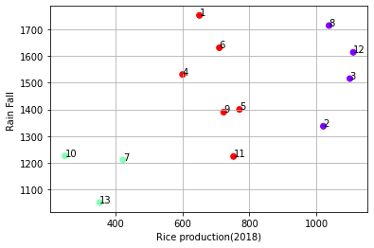 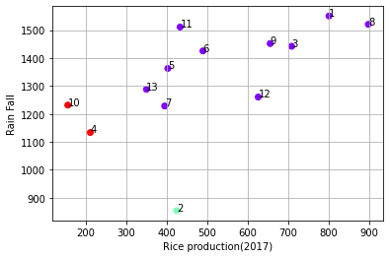

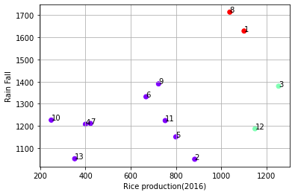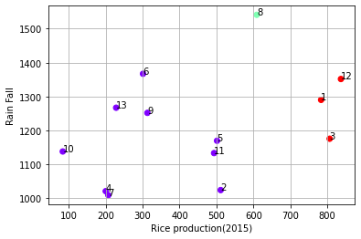

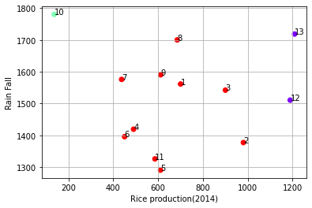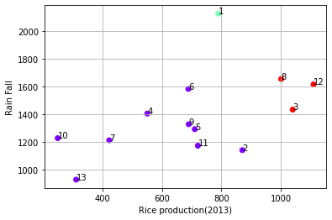

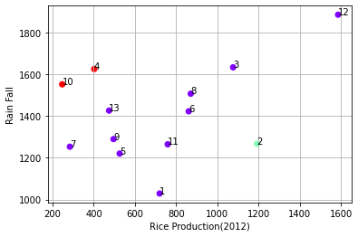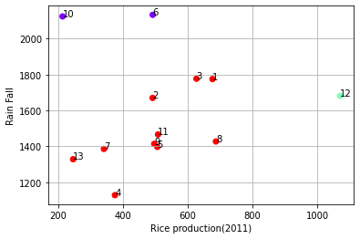

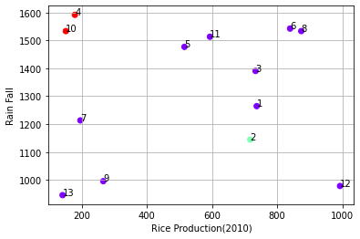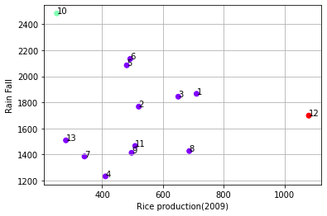

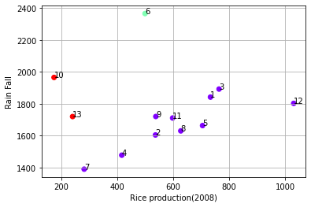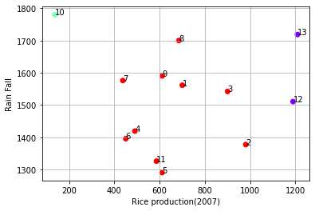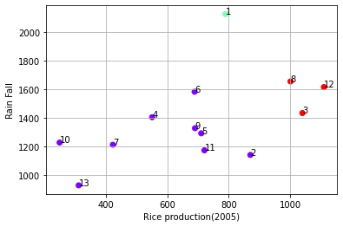 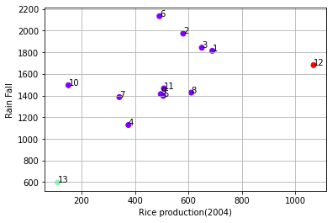

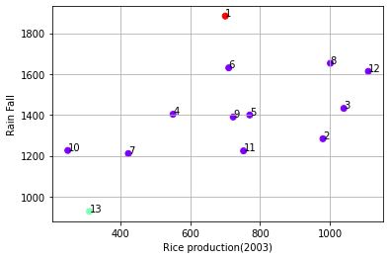 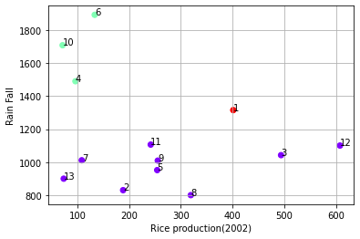

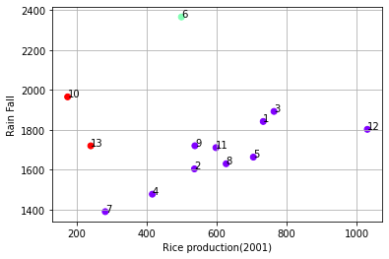 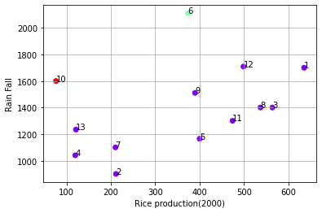

**Input:**

import pandas as pd

import numpy as np

import matplotlib.pyplot as plt

import scipy

from scipy.cluster.hierarchy import fcluster

from scipy.cluster.hierarchy import cophenet

from scipy.spatial.distance import pdist

from google.colab import files

uploaded = files.upload()

import pandas as pd

import io

df = pd.read_csv(io.BytesIO(uploaded['head.csv']))

print(df)

import sklearn

from sklearn.cluster import AgglomerativeClustering

k=3

Hclustering=AgglomerativeClustering(n_clusters=k,affinity='euclidean',linkage='single')

Hclustering.fit(df)

Hclustering.fit_predict(df)

print(Hclustering.labels_)

x=df['Rice production']

y=df['Humidity']

n=range(1,14)

fig,ax=plt.subplots()

ax.scatter(x,y,marker='o',c=Hclustering.labels_,cmap='rainbow')

plt.grid()

plt.xlabel("Rice production")

plt.ylabel("Humidity")

for i, txt in enumerate(n):

ax.annotate(txt,(x[i],y[i]))

plt.show()

**Output :**

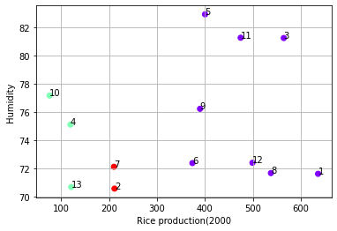 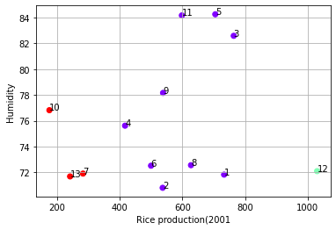

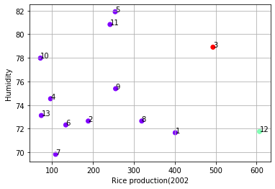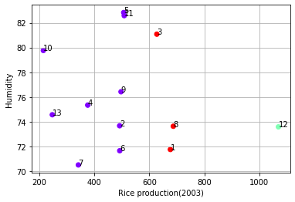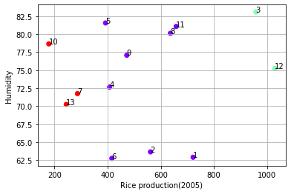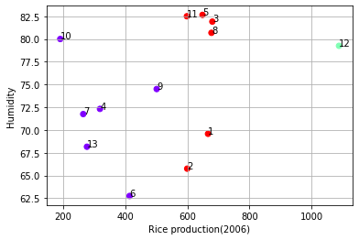

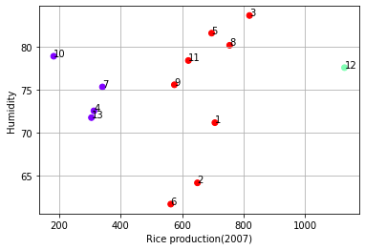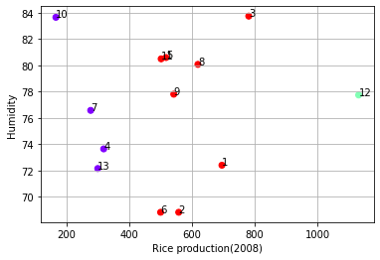

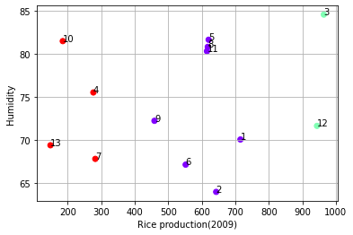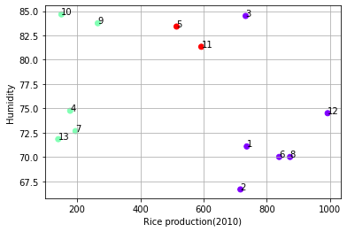

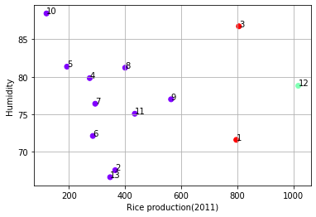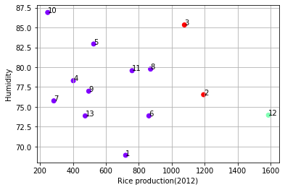

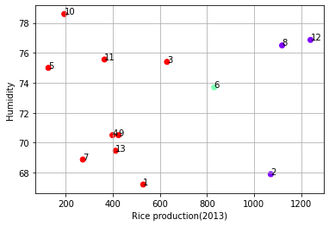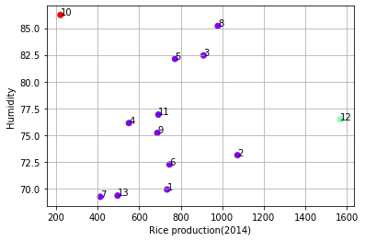

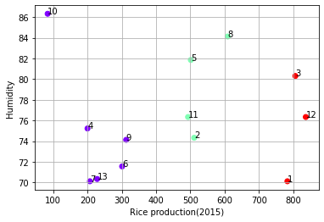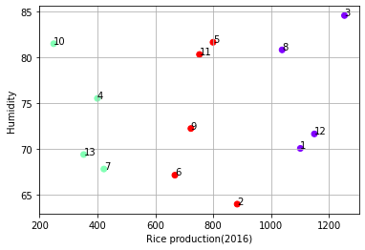

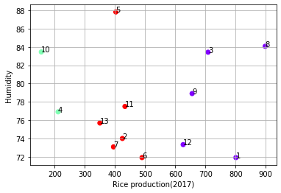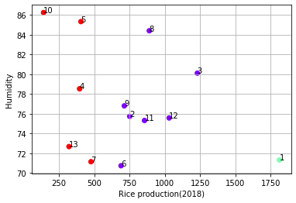

**Input:**

import pandas as pd

import numpy as np

import matplotlib.pyplot as plt

import scipy

from scipy.cluster.hierarchy import fcluster

from scipy.cluster.hierarchy import cophenet

from scipy.spatial.distance import pdist

from google.colab import files

uploaded = files.upload()

import pandas as pd

import io

df = pd.read_csv(io.BytesIO(uploaded['head.csv']))

print(df)

import sklearn

from sklearn.cluster import AgglomerativeClustering

k=3

Hclustering=AgglomerativeClustering(n_clusters=k,affinity='euclidean',linkage='single')

Hclustering.fit(df)

Hclustering.fit_predict(df)

print(Hclustering.labels_)

x=df['Rice production']

y=df['Humidity']

n=range(1,14)

fig,ax=plt.subplots()

ax.scatter(x,y,marker='o',c=Hclustering.labels_,cmap='rainbow')

plt.grid()

plt.xlabel("Rice production")

plt.ylabel("Avg Temp")

for i, txt in enumerate(n):

ax.annotate(txt,(x[i],y[i]))

plt.show()

**Output:**

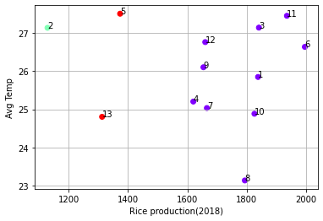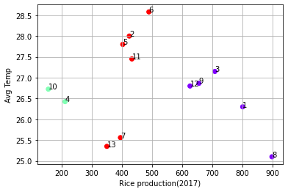

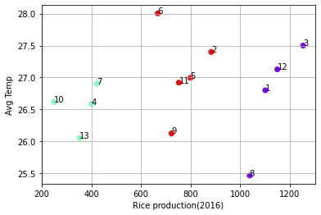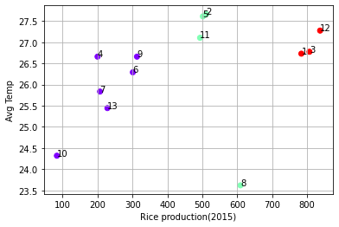

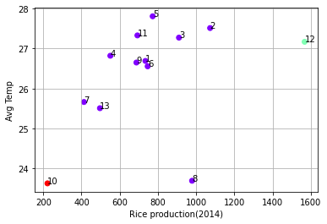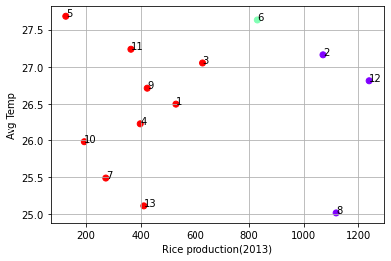

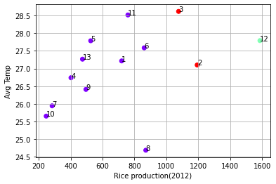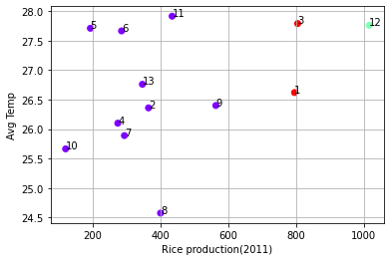

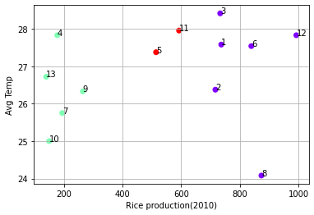 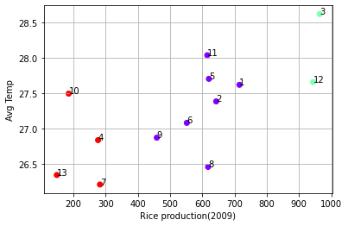

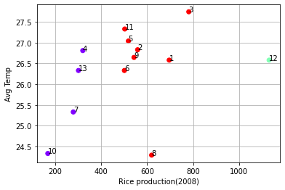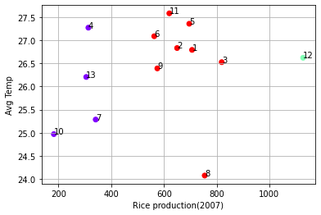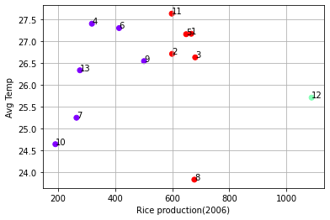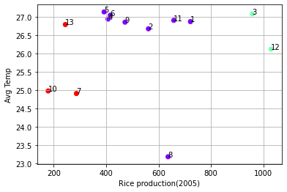 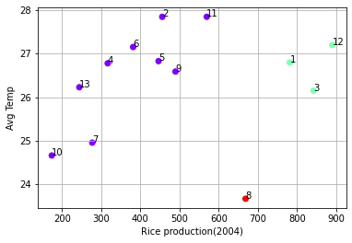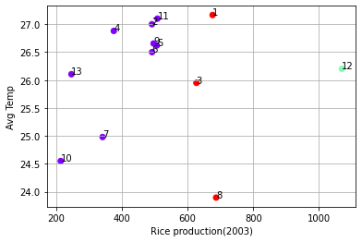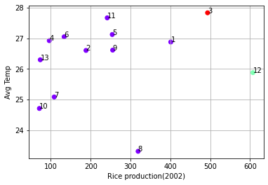 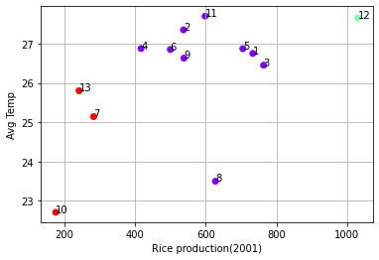

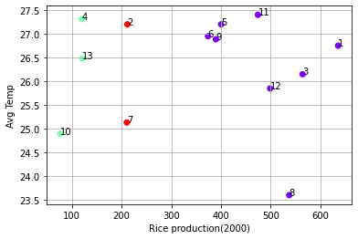

CHAPTER IV

DISSCUSSION AND CONCLUSION

**Chapter IV**

**DISSCUSSION AND CONCLUSION**

By the use of K-mean clustering we got the following table which is given below:

**Table 1**

|  |  |  |  |
| --- | --- | --- | --- |
|  | **Repetition** | | |
| **District** | **Cluster I (Blue)** | **Cluster II (Red)** | **Cluster III (Green)** |
| Balasore | 10 | 7 | 2 |
| Bolangir | 9 | 7 | 3 |
| Cuttack | 9 | 9 | 1 |
| Dhenkanal | 12 | 3 | 4 |
| Ganjam | 10 | 7 | 2 |
| Kalahandi | 12 | 5 | 2 |
| Keonjhar | 10 | 7 | 2 |
| Koraput | 12 | 5 | 2 |
| Mayurbhanja | 14 | 4 | 1 |
| Kandhamal | 10 | 6 | 3 |
| Puri | 11 | 6 | 2 |
| Sambalpur | 7 | 1 | 11 |
| Sundargarh | 10 | 6 | 3 |

The above table shows that how many times the particular district comes into that specific cluster and the highest number of repetition of district will be the final overall cluster.

In the following 19 Years dataset of Rice Production Vs Humidity, we can see that there is total 5 Years when the Rice production is high, 5 Years with medium Rice production and finally 9 Years with low amount of Rice production. In the map below we can see that the overall Rice production due to the impact of Humidity, where the code is like cluster color –Number of years - repetition in that cluster. For example Mayurbhanj – Blue – 14 times means it has come 14 times in Blue cluster. Here blue color implies that low Rice production due to low Humidity level so maximum number of districts are coming in the blue cluster. Hence we can conclude that Rice production is low due to impact of Humidity during the given time period.

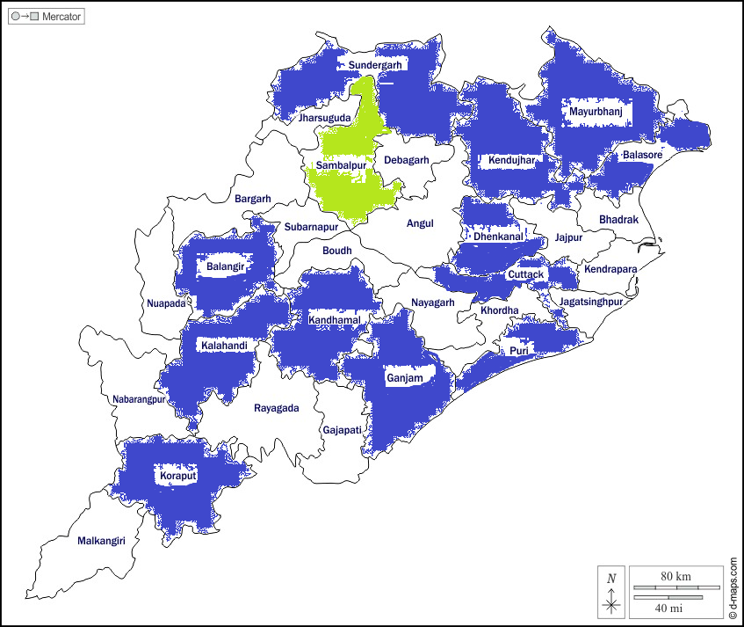

**Plot 1 – Cluster of different districts of Odisha (Rice production Vs Humidity)**

**Rice production vs Average Temperature**

**Table II**

|  |  |  |  |
| --- | --- | --- | --- |
|  | **Repetition** | | |
| **District** | **Cluster I (Blue)** | **Cluster II (Red)** | **Cluster III (Green)** |
| Balasore | 10 | 8 | 1 |
| Bolangir | 11 | 6 | 2 |
| Cuttack | 6 | 10 | 3 |
| Dhenkanal | 15 | 0 | 4 |
| Ganjam | 10 | 8 | 1 |
| Kalahandi | 14 | 4 | 1 |
| Keonjhar | 12 | 5 | 2 |
| Koraput | 13 | 5 | 1 |
| Mayurbhanja | 14 | 1 | 4 |
| Kandhamal | 11 | 7 | 1 |
| Puri | 11 | 8 | 0 |
| Sambalpur | 5 | 2 | 12 |
| Sundargarh | 10 | 6 | 3 |

The above table shows that how many times the particular district comes into that specific cluster and the highest number of repetition of district will be the final overall cluster.

In the following 19 Years dataset of Rice Production Vs Temperature, we can see that there is total 4 Years when the Rice production is high, 3 Years with medium Rice production and finally 12 Years with low amount of Rice production. In the map below we can see that the overall Rice production due to the impact of Temperature, where the code is like cluster color –Number of years - repetition in that cluster. For example Mayurbhanj – Blue – 14 times means it has come 14 times in Blue cluster. Here blue color implies that low Rice production due to low Temperature so maximum number of districts are coming in the blue cluster. Hence we can conclude that Rice production is low due to impact of Temperature during the given time period.

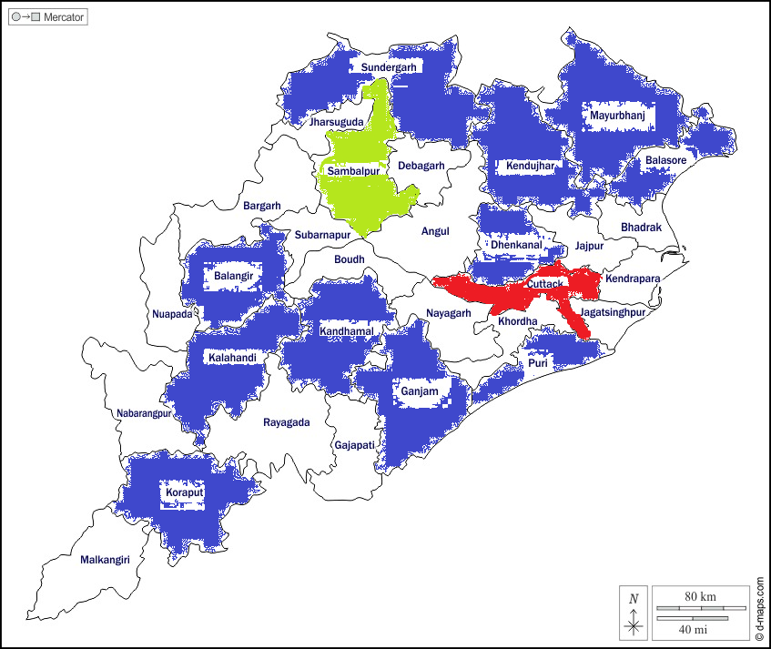

**Plot 1 – Cluster of different districts of Odisha (Rice production Vs Temperature)**

**References**

**1.** Directorate of Economics and Statistics. Department of Agriculture, Cooperation and Farmers Welfare. Ministry of Agriculture and Farmers Welfare, Govt. of India. Available from: <http://desagri.gov.in/en/>.

**2.** Department of Agriculture & Farmers’ Empowerment, Government of Odisha. Available from: <https://agri.odisha.gov.in/>.

**3.** indiastat focused on facts. Available from: <https://www.indiastat.com/>.

**4.** Statista. Available from: <https://www.statista.com/statistics/255945/top-countries-of-destination-for-us-rice-exports-2011/>.

**5.** Global Climate Change, NASA. Available from: <https://climate.nasa.gov/>.

**6.** UNFCCC, <https://unfccc.int/>.

**7.** National Oceanic and Atmospheric Administration, <https://www.climate.gov/news-features/understanding-climate/climate-change-global-temperature#:~:text=According%20to%20NOAA's%202020%20Annual,more%20than%20twice%20that%20rate>.

**8**. Department of Science & Technology, Climate Change Program, <https://dst.gov.in/climate-change-programme>.

**9.** Ministry of Environment, Forest and Climate Change, <https://moef.gov.in/en/>.

**10.** NAPCC 8 India’s National Action Plan on Climate Change, <https://www.ncbi.nlm.nih.gov/pmc/articles/PMC2822162/>.

**11**.NAPCC 8 <https://www.indiatoday.in/education-today/gk-current-affairs/story/8-missions-govt-napcc-1375346-2018-10-25>.

**12**.https://www.mea.gov.in/articles-in-indian media.htm?dtl/32018/Indias_Climate_Change_Policy_Towards_a_Better_Future.

**13.** WorldData.info, The climate in India, <https://www.worlddata.info/asia/india/climate.php>.

**14**.www.weather-atlas.com,<https://www.weather-atlas.com/en/india/bhubaneswar-climate#humidity_relative>.

**15.** Current Results, Weather and Science facts, Available from: <https://www.currentresults.com/Weather/India/average-yearly-precipitation.php>.

**16.** Indian Climate, <https://www.indianclimate.com/show-data.php>.

**17.** Indiastat odisha, Available from: <http://www.indiastatodisha.com/>.

**18.** Climate Data Service Portal, <https://climate.copernicus.eu/precipitation-relative-humidity-and-soil-moisture-february-2022>.

**19**. Climate Data Service Portal, <https://climate.copernicus.eu/precipitation-relative-humidity-and-soil-moisture-february-2022>.

# 20. Introduction to the Basic Drivers of Climate By: Alison N. P. Stevens (*Mount Ida College*) 2010 Nature EducationCitation: Stevens, A. (2010) Introduction to the Basic Drivers of Climate *Nature Education Knowledge* 3(10):10. <file:///C:/Users/user/Downloads/Introduction%20to%20the%20Basic%20Drivers%20of%20Climate%20_%20Learn%20Science%20at%20Scitable.html>.

**21**. Regional Climate Impacts of Future Changes in the Mid–Latitude Atmospheric Circulation: a Storyline View, <file:///C:/Users/user/Downloads/Introduction%20to%20the%20Basic%20Drivers%20of%20Climate%20_%20Learn%20Science%20at%20Scitable.html>.

**22.** Improved K-mean Clustering Algorithm for Prediction Analysis using Classification Technique in Data Mining, International Journal of Computer Applications (0975 – 8887) Volume 157 – No 6, January 2017, <https://www.ijcaonline.org/archives/volume157/number6/bansal-2017-ijca-912719.pdf>.

**23**. K-means Clustering via Principal Component Analysis Chris Ding chqding@lbl.gov Xiaofeng He xhe@lbl.gov Computational Research Division, Lawrence Berkeley National Laboratory, Berkeley, CA 94720, <https://ranger.uta.edu/~chqding/papers/KmeansPCA1.pdf>.

**24.** Climate Data Analysis Using Clustering Data Mining Techniques [N. Hadzimejlic](https://www.semanticscholar.org/author/N.-Hadzimejlic/3475577), [D. Donko](https://www.semanticscholar.org/author/D.-Donko/3227545), [Kampus Univerziteta](https://www.semanticscholar.org/author/Kampus-Univerziteta/90479276) Published 2012 ,Environmental Science, <https://www.semanticscholar.org/paper/Climate-Data-Analysis-Using-Clustering-Data-Mining-Hadzimejlic-Donko/8855e8d1719169ea1f982ddc24b19e40e77b8d0f>.

**25.** Corpus ID: 2124923 Weather Prediction Using J48, EM And K-Means Clustering Algorithms [P. Kalaiselvi](https://www.semanticscholar.org/author/P.-Kalaiselvi/48501692) Published 2016 Environmental Science, Computer Science, <https://www.semanticscholar.org/paper/Weather-Prediction-Using-J48%2C-EM-And-K-Means-Kalaiselvi/c4710eb39f012cb371a363055ae80fcbfb25516d>.