

|  |  |
| --- | --- |
|  |  |
|  |  |

**CRM Laptop-Rental-Management System Submitted By-Shubham Kumar**

**Email:**[**shubham1.kumar.21@aot.edu.in**](mailto:rahul.ranjankumar.21@gmail.com)

|  |  |
| --- | --- |
|  |  |
|  |  |

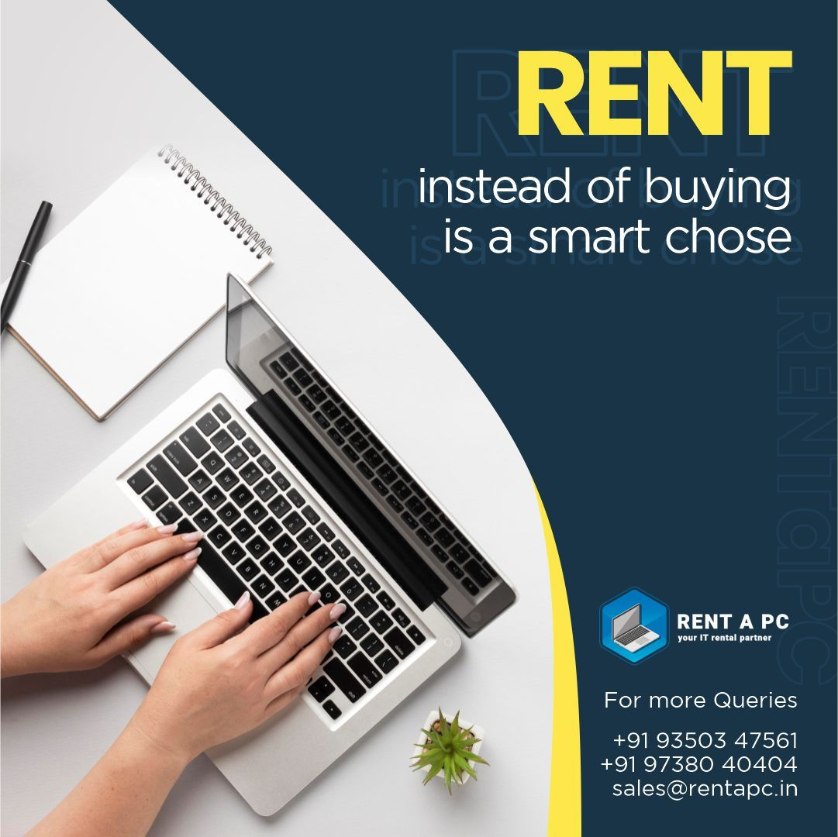

# A CRM Application of Laptop Rentals

**Project Overview**

To develop a robust **Customer Relationship Management (CRM)** applicationspeciﬁcally designed for businesses offering laptop rental services. The applicationwill streamline operations, improve customer service, and enhance the managementof rental processes.

## Purpose of the CRM Application for Laptop Rentals

The primary purpose of developing a CRM application for laptop rentals is to streamline and optimise the rental process while enhancing the customer experience. This application is tailored to address the speciﬁc needsof laptop rental businesses by providing centralised tools for customermanagement, inventorytracking, and operational eﬃciency.Some of the key purposesof this application are provided below:

**Eﬃcient Rental Management:**Automates the rental process by streamlining booking, invoicing, and tracking, reducing manual errors and saving time on routinetasks.

**Enhanced CustomerExperience:** Provides personalised support and easy accessto laptop availability, speciﬁcations, and reservations, ensuring a smoothand

user-friendly experience.

**Data-Driven Decision Making:** Generates reports and analyses trends to optimiserentals,improve inventory management, and tailor services tocustomer preferences. **Operational Transparency:**Ensures clear access controls, maintains detailed transaction records, and promotesaccountability acrossall operations.

**Increased RevenuePotential:** Enhances revenue throughdynamic pricing, upselling,promotions, and customer retention strategies like loyalty programs.

# Key Features

### Customer Management:

This feature enables the storage and management of detailed customerinformation,including contact details, rental history, and preferences. It ensuresbusinesses canoffer personalised services and maintainbetter relationships with customers.

### Laptop Inventory Management:

This feature tracksthe status, availability, and conditionof each laptop in the

inventory. It includes speciﬁcations, rental rates, and maintenance history,helping businesses manage their stock eﬃcientlyand prevent overbooking.

### Order and Rental Management:

Simpliﬁes the entirerental process,from booking a laptop to generating rental agreements and invoices. The system automatically updates the inventory andsends remindersfor overdue rentals,ensuring smooth operations.

### 4 .Reporting and Analytics:

Provides the ability to generate reports and analyse rental trends, revenue, andinventory usage. This featurehelps businesses identify patterns,make informeddecisions, and optimise operations to boost proﬁtability.

### Communication Tools:

Automates communication with customers through email and SMS notiﬁcations forbooking conﬁrmations, rental reminders, and promotional offers. This feature enhancescustomer engagement and ensures timelyupdates.

# Objectives

The objective of this project is to create a comprehensive CRM application speciﬁcally designedfor businesses that offer laptoprental services.The goal is to streamline and automate the rental process,improve customer relationship management and increase the eﬃciency for the organisation.

**Automating Rental Processes:** Simplifying and automatingbooking, invoicing,inventory management, and rental trackingto reduce manualwork and errors.

**Enhancing Customer Experience:** Providing personalised servicesand easyaccessto rental information, improving customer satisfaction and retention.

**Improving Revenue and Business Insights:** Leveraging reporting tools and analytics to optimise pricing,identify trends, and make data-driven decisions that increase proﬁtability.

**Effective Communication:** Integrate automated communication tools to send timelyemail and SMS notiﬁcations for booking conﬁrmations, rental reminders, and promotions, ensuring continuous customer engagement and enhancing communication betweenthe business and its customers.

# Beneﬁts of this Application

### Time and Cost Savings:

|  |  |
| --- | --- |
|  |  |
|  |  |

Automating repetitive tasks such as order management, inventory updates, and payment processing helps businesses save time and reduce operational costs. Thisleads to betterresource allocation and optimised workﬂows.

### Seamless Customer Management:

|  |  |
| --- | --- |
|  |  |
|  |  |

The CRMsystem centralised customer data, allowing businesses to

track rental history,preferences, and interactions. This enables more targetedmarketing, better customersupport, and personalised offersthat enhance customerloyalty.

### Enhanced Reporting and Analytics:

|  |  |
| --- | --- |
|  |  |
|  |  |

The ability to generate detailed reports on rental usage, customer trends, and ﬁnancial performance helps businesses identify areas for improvement, optimisepricingstrategies, and make more informeddecisions about inventory and promotions.

### Reduced Risk of Errors:

|  |  |
| --- | --- |
|  |  |
|  |  |

By minimising manual input, the system reducesthechances of human errorin taskslikeinvoicing, payment processing, and inventory tracking,which ensures greateraccuracy in ﬁnancialand operational data.

# Example Workﬂow

### Customer Registration & Booking:

|  |  |
| --- | --- |
|  |  |
|  |  |

Customers create an account,browseavailable laptops, selectamodel, and booktherental online.

### Payment & Order Conﬁrmation:

|  |  |
| --- | --- |
|  |  |
|  |  |

The customer conﬁrmsthe rental, makesa secure payment,and receivesan orderconﬁrmation and invoice.

### InventoryManagement & Assignment:

|  |  |
| --- | --- |
|  |  |
|  |  |

The system updateslaptop availability, and staff assigns the rented laptopfordelivery or pickup.

### Rental Monitoring & Notiﬁcations:

|  |  |
| --- | --- |
|  |  |
|  |  |

Automated reminders are sent for rental periodend, with optionsfor extensionor return.

### Laptop Return& Feedback:

|  |  |
| --- | --- |
|  |  |
|  |  |

The customer returnsthelaptop, inventory is updated, and feedback is collected forimproved service.

# Summary



|  |  |
| --- | --- |
|  |  |
|  |  |

The CRMapplication for laptop rentals streamlines the rental processby enabling customers to easilybrowse, book, and pay for laptops online.It automates inventory management, updates availability, and notiﬁes customers aboutrental periods. After the rental,the system handleslaptop returns, updates inventory, and collects customerfeedback to enhanceservice

## Salesforce Key Featuresand ConceptsUtilised

* 1. **Customer Relationship Management(CRM):** Centralised customer data, including contact information, purchasehistory, andinteractions, to enhanceservice and buildstronger relationships.

### Sales Cloud:

Automates sales processes such as lead generation, opportunity management, and pipeline tracking, improving eﬃciency and conversion rates.

### Service Cloud:

Providestools for managing customer support, including case tracking,knowledge bases,and omnichannel communication.

### Marketing Cloud:

Enablespersonalised marketing campaignsthrough email, socialmedia, andanalytics, ensuring targeted customerengagement.

### Einstein Analytics:

Leverages AI-powered insightsfor predictive analytics, helping businesses make data-driven decisions and optimiseperformance.

### Custom Object and App Development:

Supportsthe creation of custom objects and workﬂows tailoredto uniquebusiness needs,ensuring ﬂexibility and scalability.

### Process Automation:

Automates repetitive tasks with tools like Process Builder, Flow, and Apextriggers, enhancingproductivity and reducingerrors.

### Reports and Dashboards:

Provides real-time visualisations of data to monitor performance, track KPIs,andidentify trends.

### Collaboration Tools(Chatter):

Enhancesteam collaboration by allowing users to communicate, share ﬁles,and update projectstatuses within the platform.

### Integration Capabilities:

Integrates seamlessly with third-party apps and systems,including ERP, payment gateways, and email services, ensuring a uniﬁedworkﬂow.

### Role-Based Access Control:

Manages user permissions and data visibility based on roles,ensuringsecurity and compliance.

## Detailed Stepsto Solution DesigninSalesforce

### Requirements Gatheringand Analysis

**Objective:** Understand the business needs and challenges.Identifykey use cases,workﬂows, and pain points.

Document functional and non-functional requirements. Prioritise requirements based on business impact and feasibility.

### Design Data Model

**Objective:** Deﬁne how data will be stored, organized,and related.

**Steps:**

* 1. Identify standard Salesforce objects to use (e.g., Total Laptops, consumer,LaptopBookings, BillingProcess).
  2. Create custom objects for speciﬁc businessneeds.
  3. Establish relationships betweenobjects (e.g.,master-detail, lookup).
  4. Deﬁne ﬁeld-level detailssuch as ﬁeld types, picklists, and validation rules.

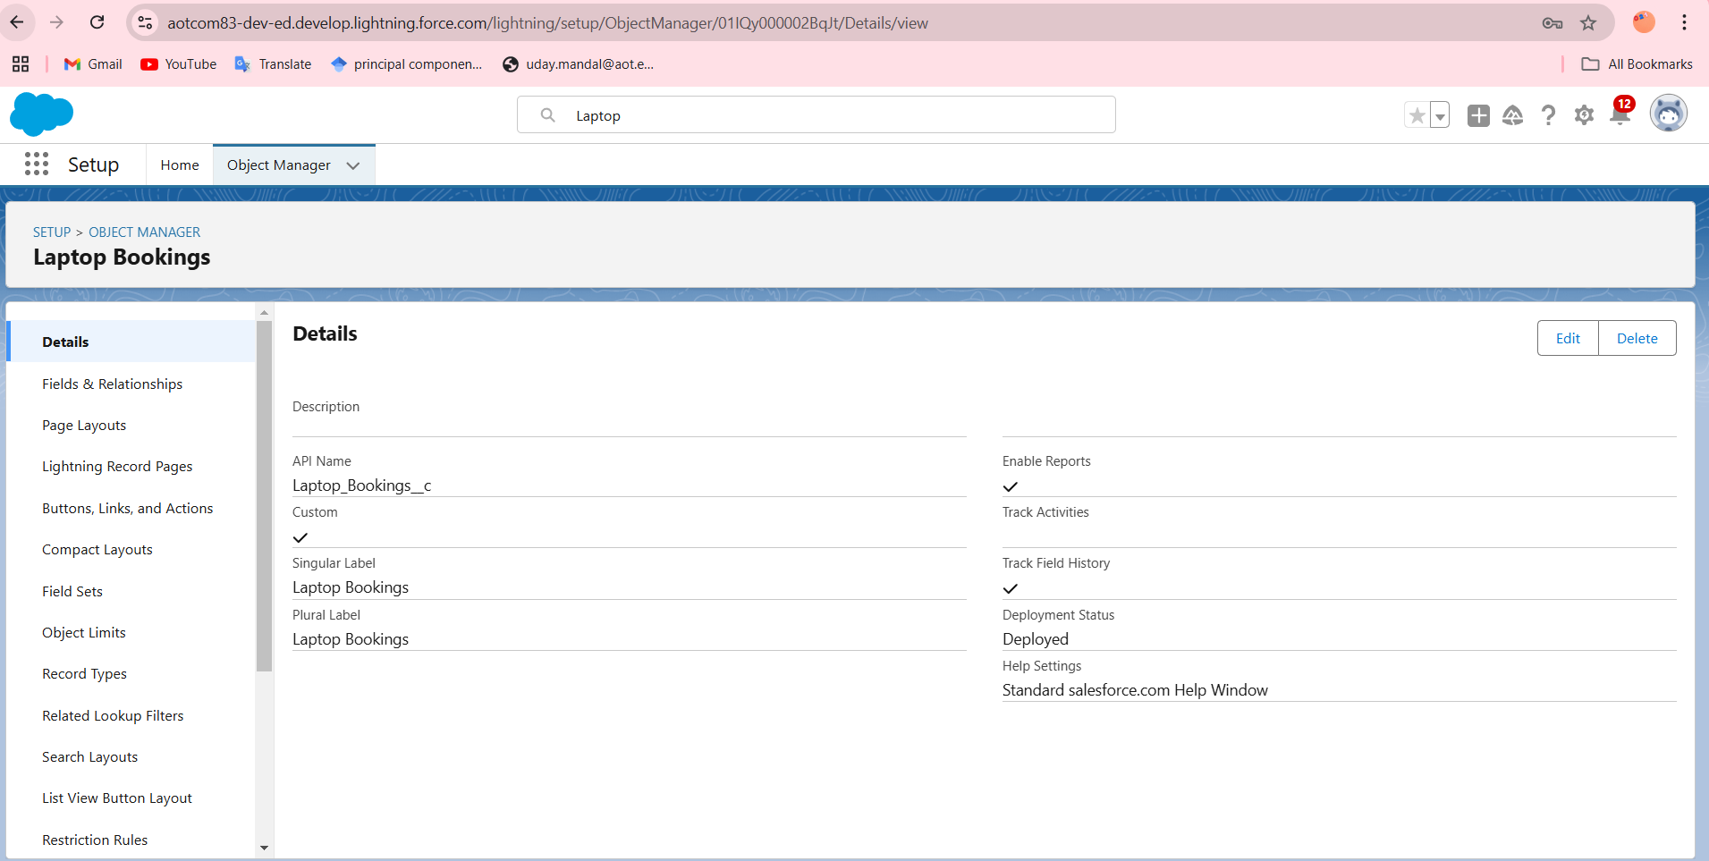

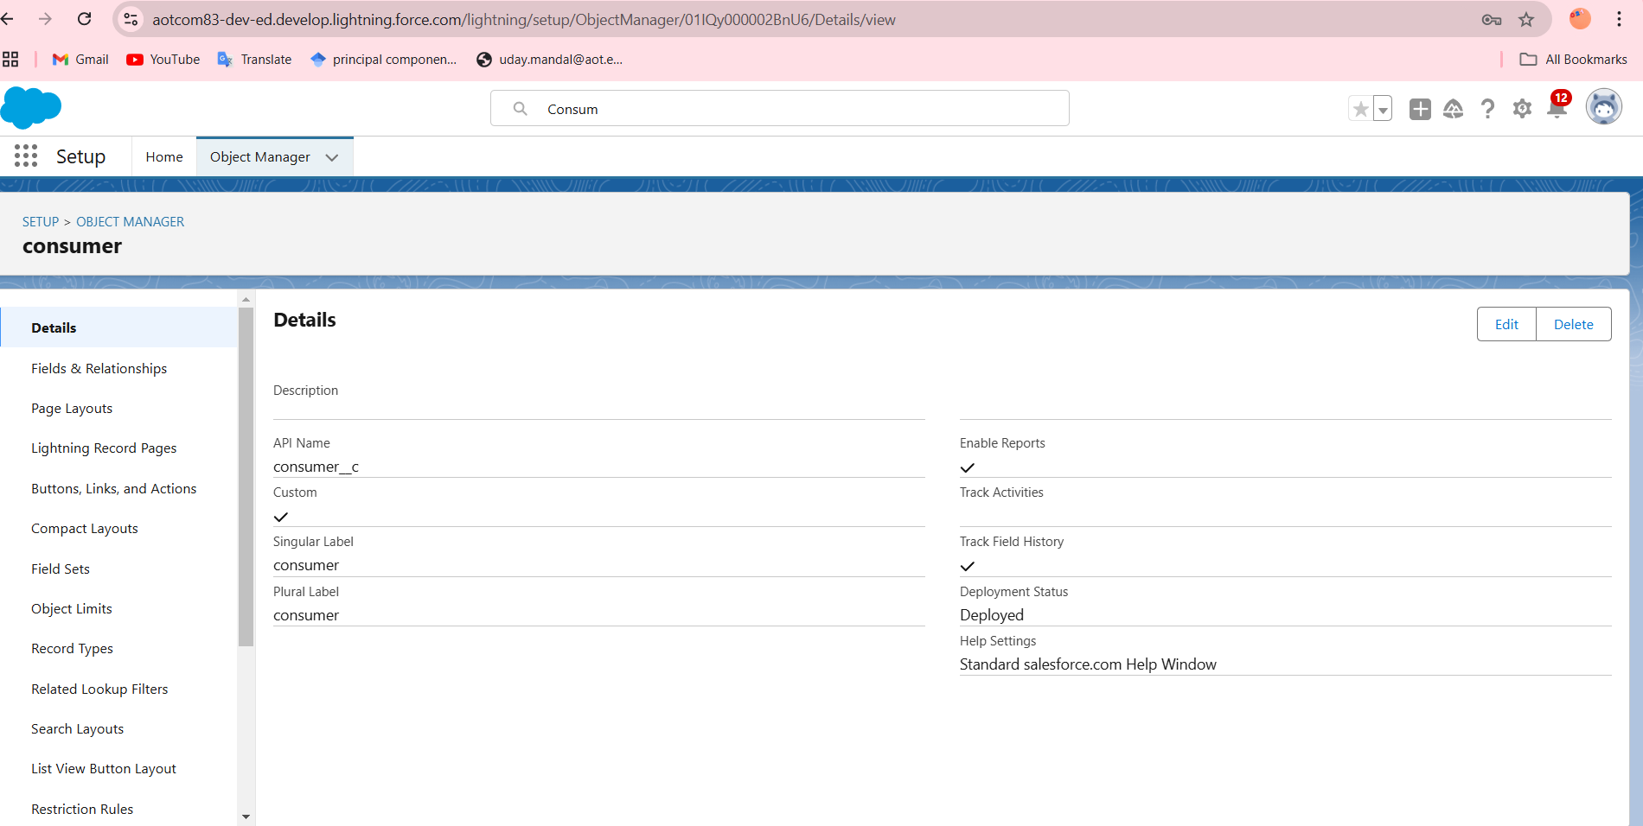

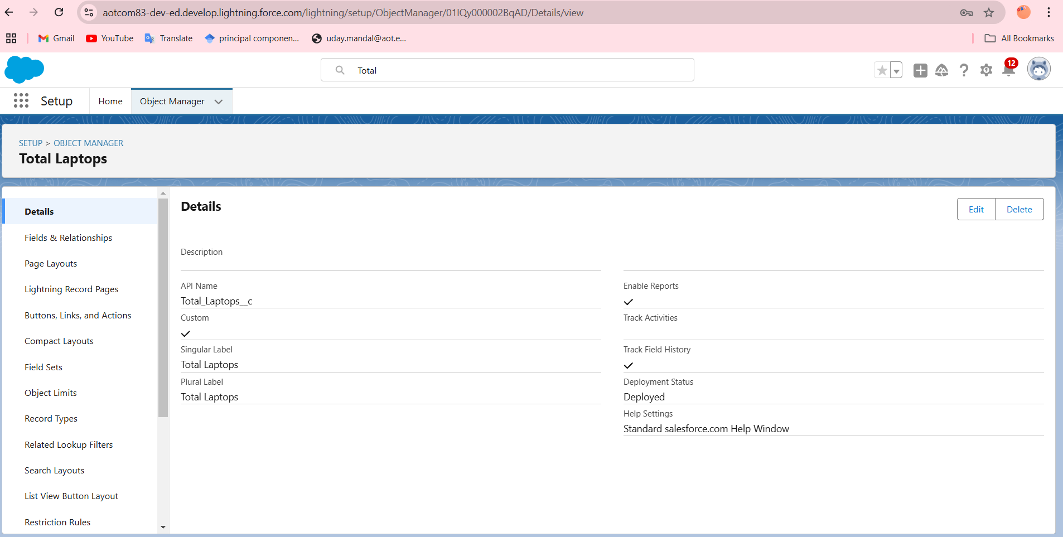

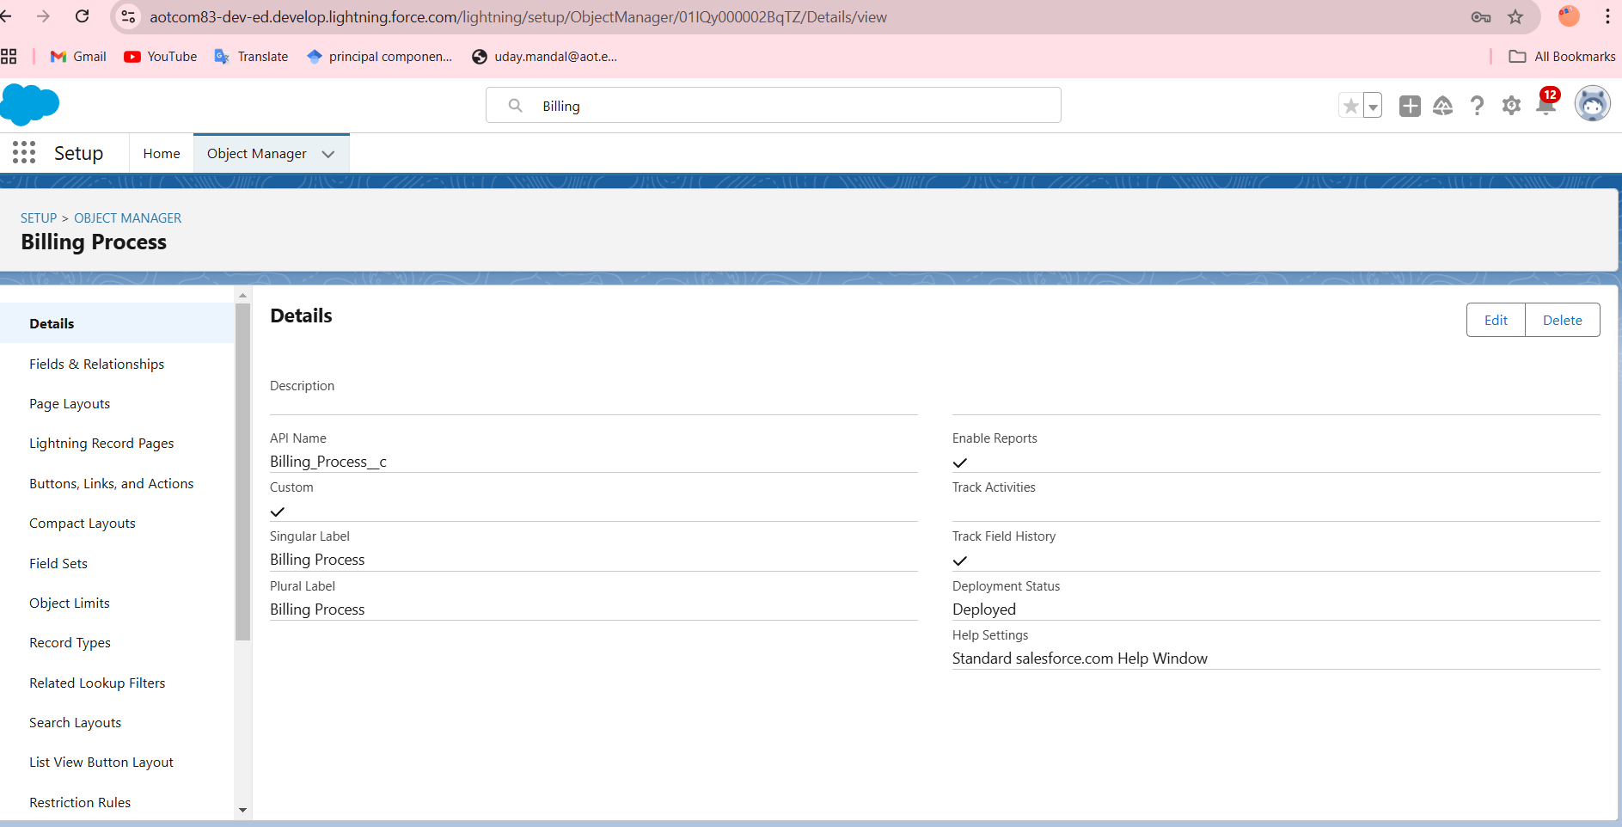

|  |  |
| --- | --- |
|  |  |
|  |  |

### User Interface Design

Using tabs in a User Interface(UI) is a common design approachto organize and displayinformation eﬃciently.Tabs allow users to navigatebetween different sections or functionalities without leaving the current page, ensuring a clean and user-friendly experience.

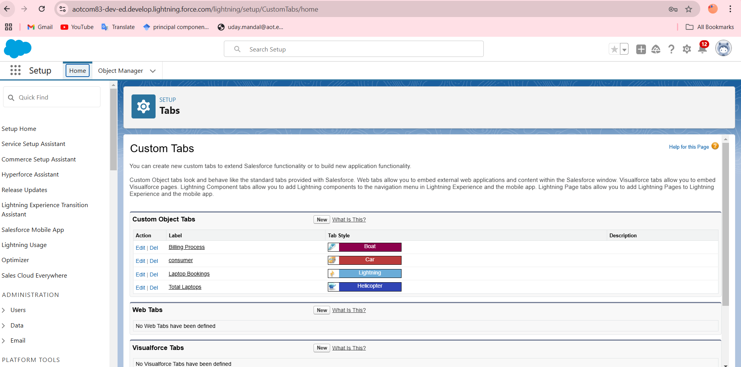

### Flow Design

When designing a Flow in Salesforce, it’s important to ensure itis eﬃcient,scalable,and user-friendly.

## Flow BuilderLayout

1. **Start Element:**

Deﬁne the Flow trigger(e.g., button click,record change, or schedule).

### Decisions:

Add conditional logic to branch the Flow based on criteria(e.g., laptop availability).

### Assignments:

Set or updatevariables to store or calculatedata dynamically.

### Loops:

Iterate over collections of data

### Actions:

Invoke externalsystems, send emails,or run custom Apex actions.

### Record Elements:

Performdatabase operations like creating, reading,updating, or deletingrecords.

This structured approachensures a logicaland user-friendly Flow design.

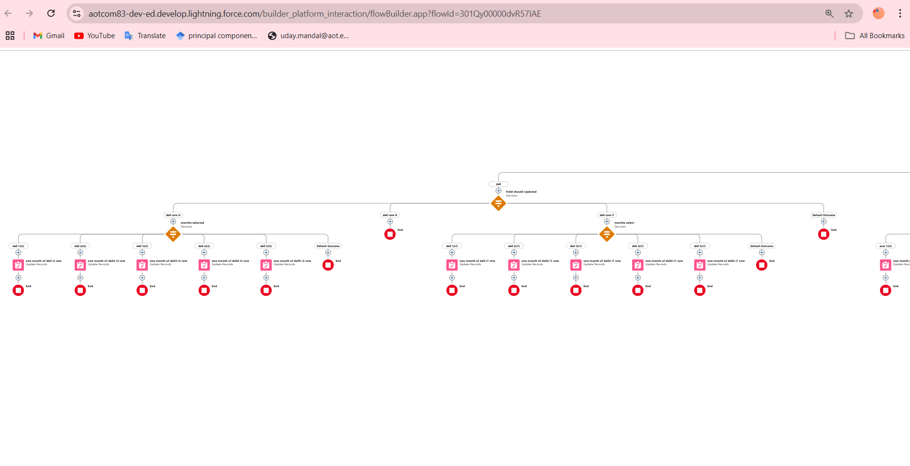

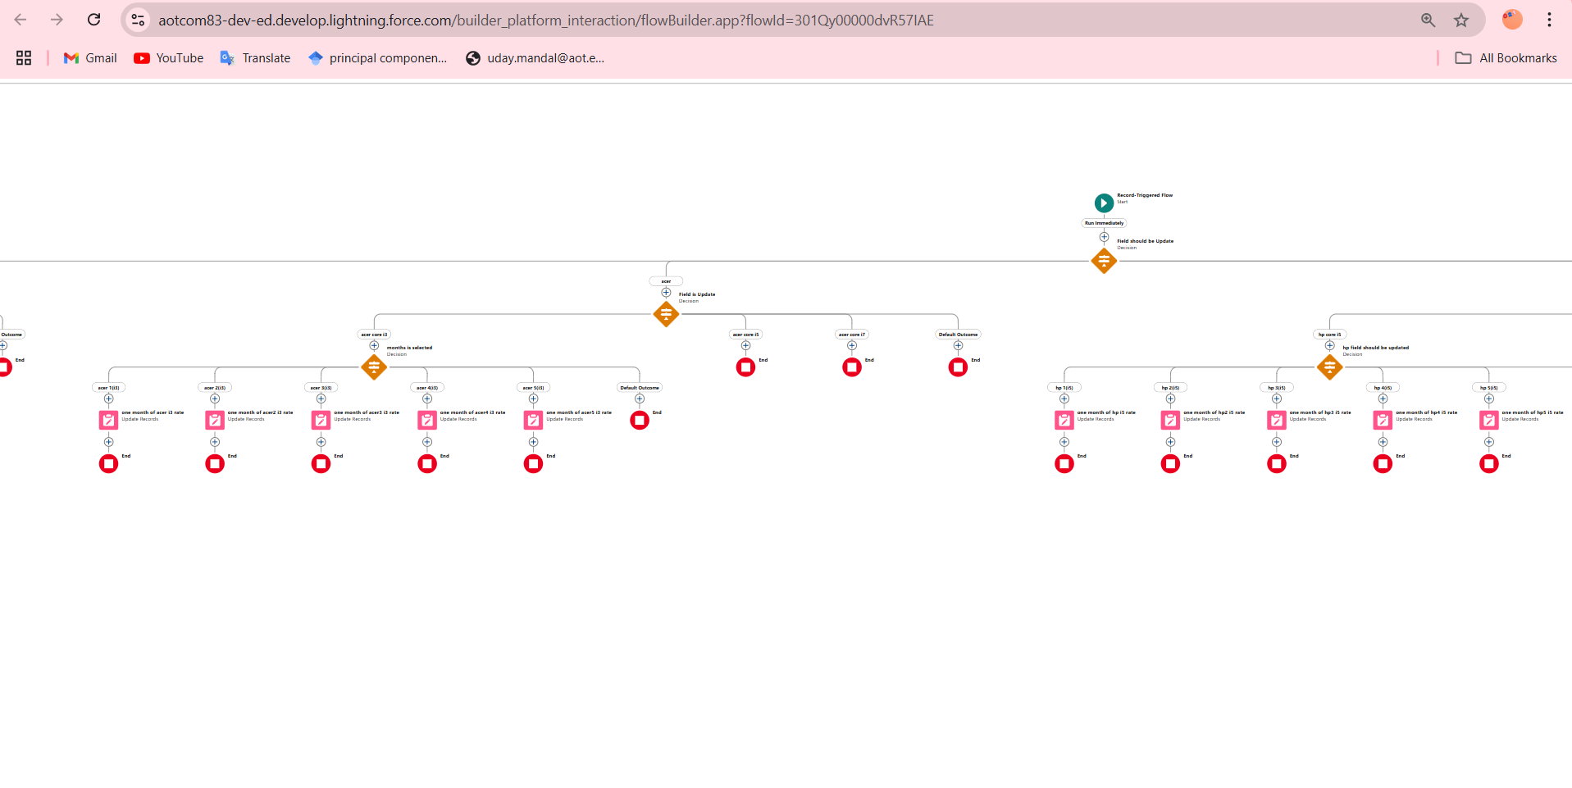

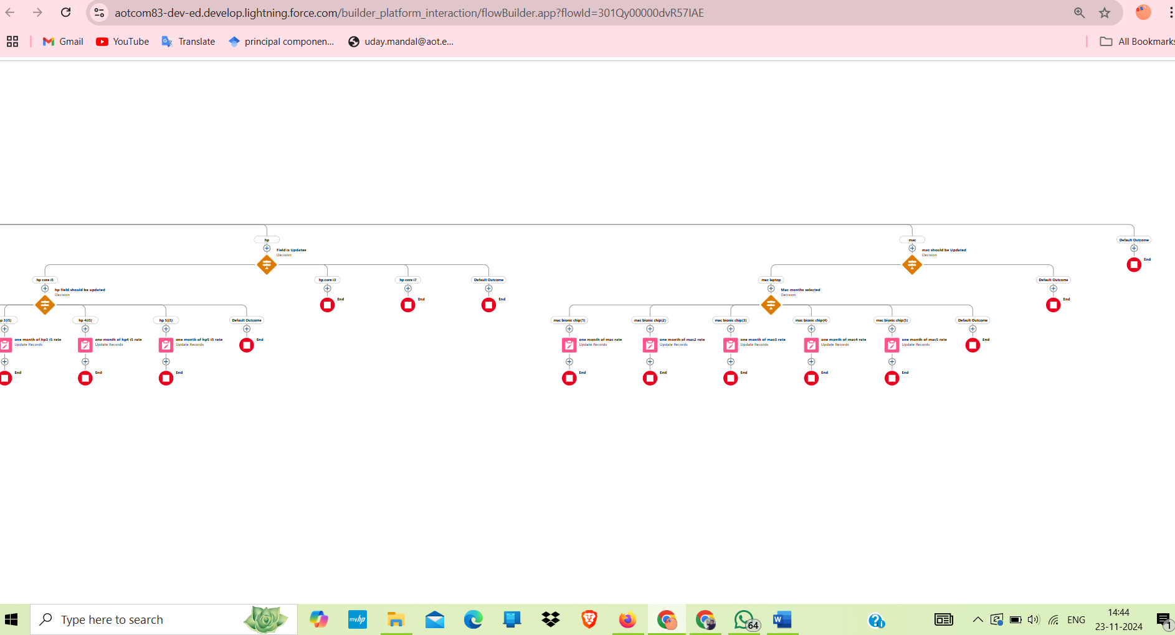

|  |  |
| --- | --- |
|  |  |
|  |  |

### Validation Rule For Phone Number Field in CustomerObject

The validation rule checks if the phone number enteredinthe Consumer object follows the required format using regularexpressions. It ensures that only valid phone numbersare stored, improvingdata consistency and user experience.

## Reports and Dashboards

In Salesforce, **Reports** and **Dashboards** are essential tools for data analysis and visualisation. **Reports** allowusers to displayand organise data from Salesforce, with types including **Tabular**, **Summary**, **Matrix**, and **Joined Reports**. These reports can be customised using ﬁlters, grouping, summaries, and charts to provide meaningfulinsights. They help users track key businessdata such as customer activity, sales, and inventory, facilitating better decision-making.

On the other hand, **Dashboards** provide a visual representation of the data from reports, offering a high-level view of key metricsthrough components like charts, tables, gauges, and metrics. Dashboards can be customised with ﬁlters to show real-time insights and help monitor business performance. They allow users to quickly understand trends, track progress toward goals, and make informed

decisions. Together, reports and dashboards are powerfultools for managingandvisualising data, improving operational eﬃciency, and fostering data-driven collaboration within teams.

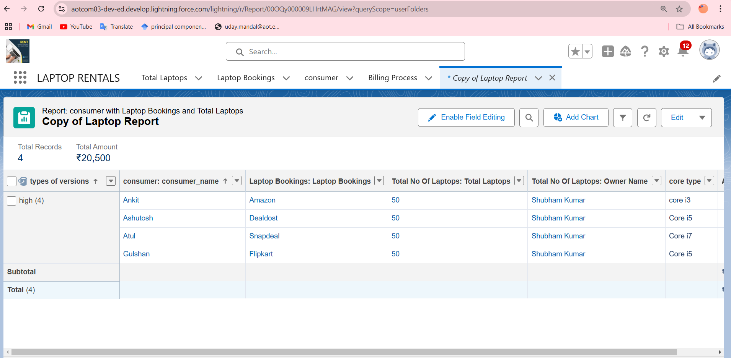

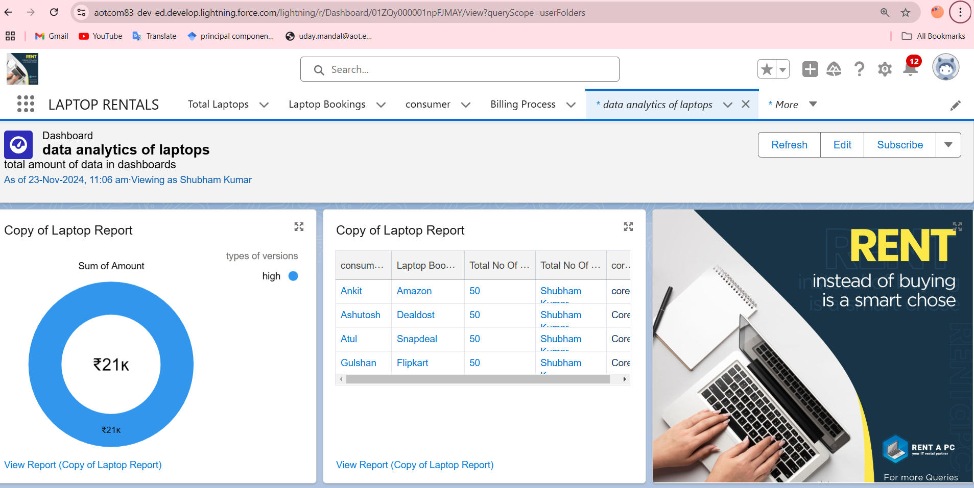

|  |  |
| --- | --- |
|  |  |
|  |  |

# Conclusion

The **Laptop Rental CRM Application** is a centralised platform designed to streamline the laptoprental processfor both customers and administrators. Built with Salesforce, it leverages core CRM featuresand automation tools tomanage

inventory, track rentals, enhance customer communication, and optimise operations. The system enables users to performkey functions such as bookinglaptops, tracking rental durations, and generating reports.

Administrators can eﬃciently handle inventory updates, approve requests,and send notiﬁcations. Customers beneﬁt from a seamlessbooking experience, guided workﬂows, and timely reminders.

This project integratesuser-friendly UI componentslike tab navigation and

interactive forms, coupled with powerful backend automation using Flows, ensuringa smooth, error-freeprocess. Additionally, it fosters effectivecommunicationthroughintegrated email and notiﬁcation tools.

The application ultimately aims to enhance customer satisfaction, improve operational eﬃciency, and provide real-timeinsights for better decision-making in laptop rentalmanagement.