I have used mean shift segmentation for automating the process of finding the foreground/background masks.

* For the flower image, I have used high bandwidth parameter for the colour feature to get greater colour mixing in regions with highly varying colours as this provides a good blurring effect. In the gradient implementation of the PDF, I have only updated the colour channels but not updated the spatial channels in each iteration as this gave smoother boundaries and results. After getting this smooth image, I converted it to grayscale and thresholded it above 110 intensity value to get the foreground mask. The negative of this will give the background mask.

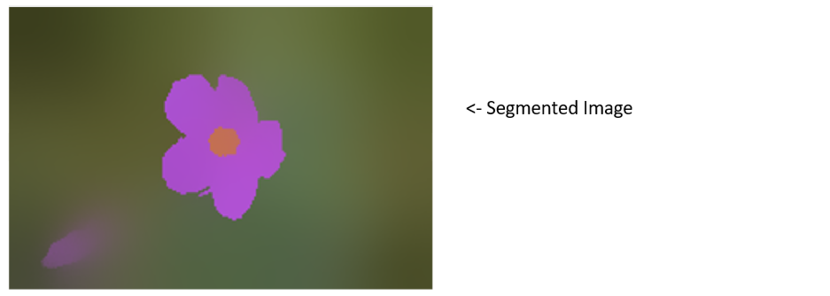

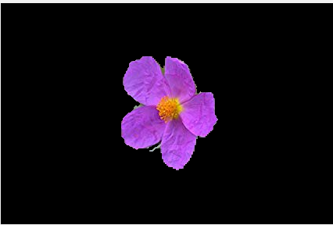

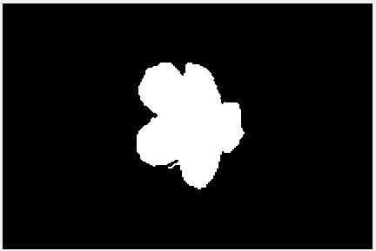

  Foreground mask Foreground Image

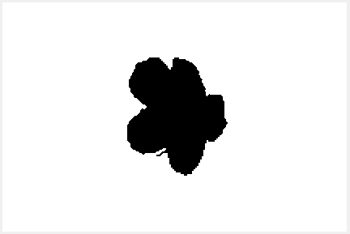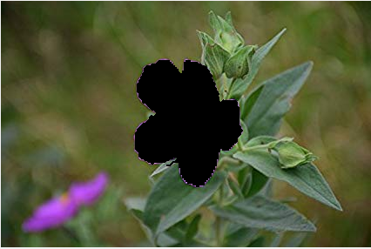

  Background mask Background Image

* For the bird image, similar to the flower image I generated a segmented image and applied threshold of 100 on it. The bird image had some anomalies (some white spots in the mask other than the body of the bird). We got rid of these spots by manually setting their intensities to zero as follows:

**mask(1:180, 550:end) = 0;**

**mask(180:360,end-100:end) =0;**

**mask(end-150:end-50,end-315:end-275) = 0;**

**mask(210:450,110:285) = 0;**

**mask(430:500,340:450) = 0;**

**mask(310:350,280:382) = 0;**

**mask(1:25,300:420) = 0;**

Here we can see the exact regions where we manually assigned the intensities to be zero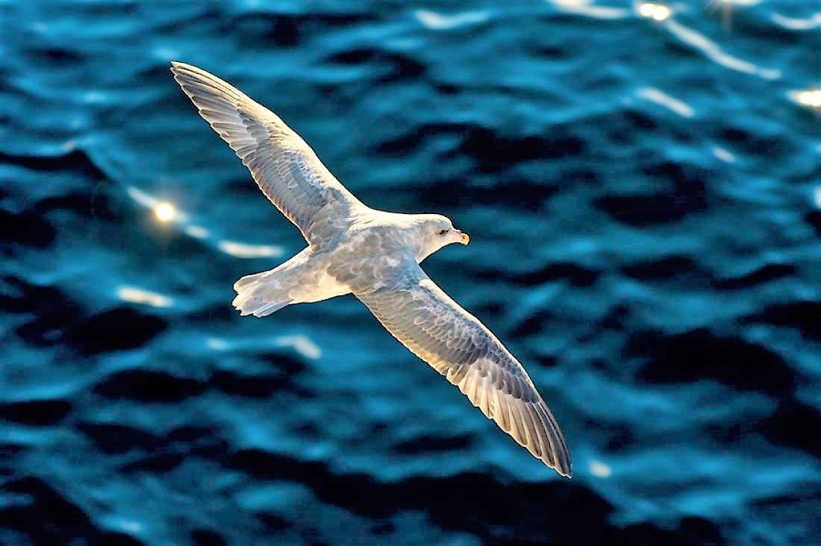

< - Original Image

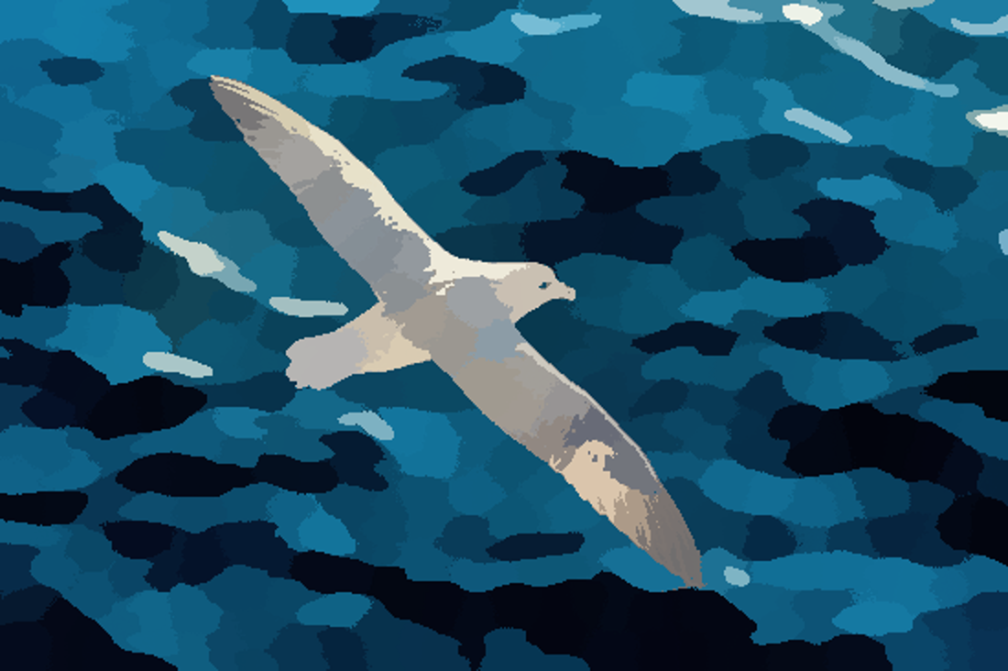

< - Segmented Image

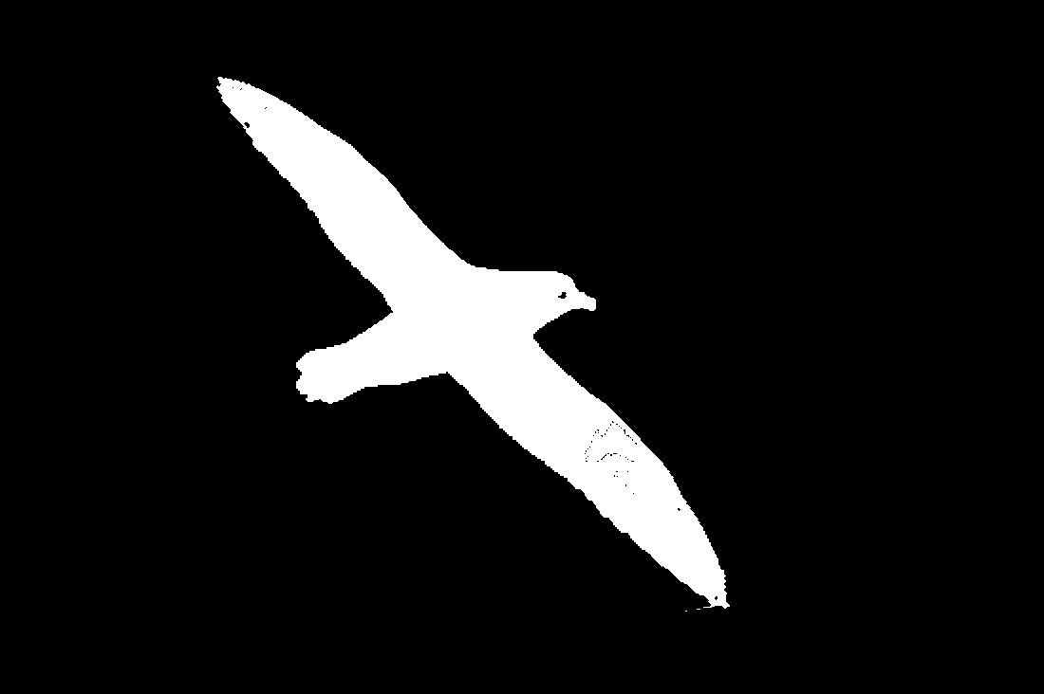

< - Mask

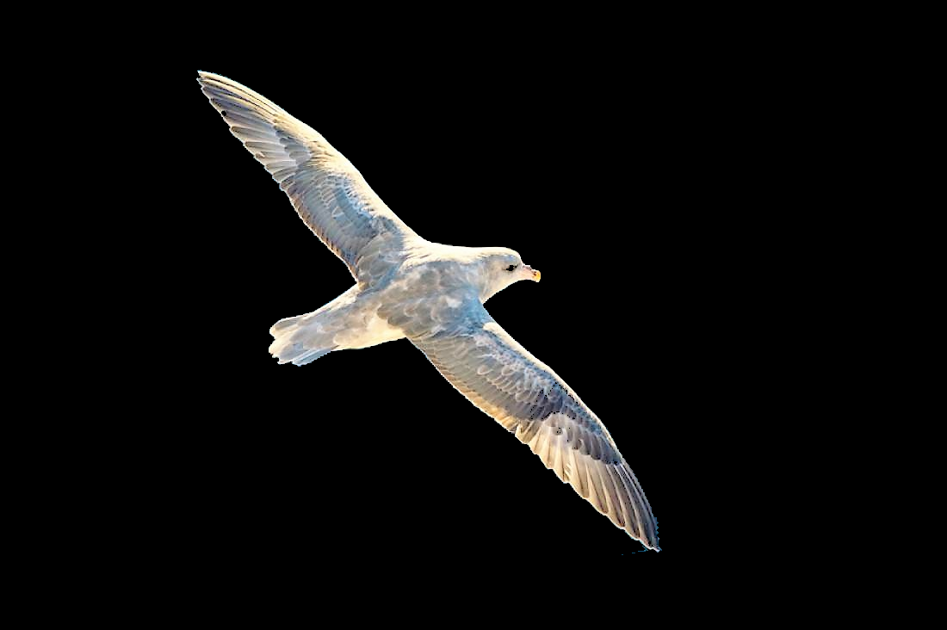

< - Foreground Image

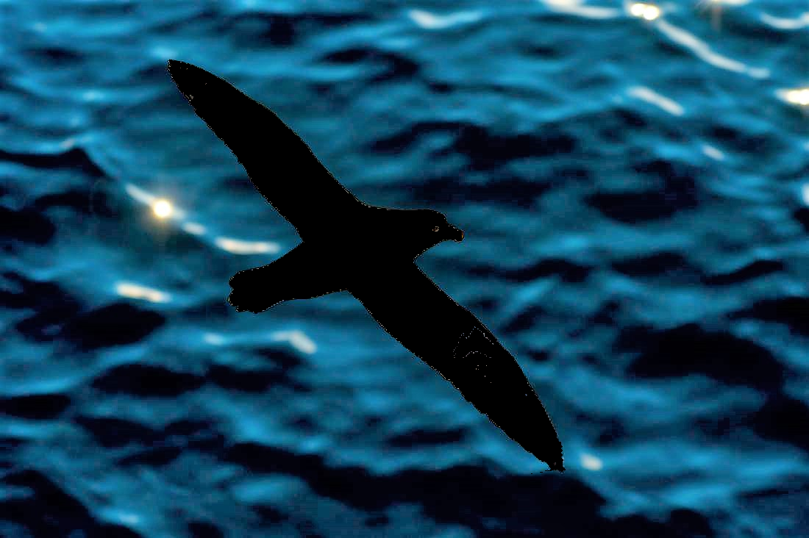

< - Background Image