Two ESP-32 With WIFI/BLUETOOTH/RF CONNECTIVITY

- Turning will be done, by simple servo motor changing direction in front, could possibly do pulse width modulation I do not know exactly how the angles on them work to make micro ajudsments, I would use differential but not required for this simple of design.
- Making an h-bridge PCB to use a more powerful battery to a good motor, also use pulse width modulation to allow the motor to have a variety of speeds
- If i use a bigger battery, im gonna have to make power supply PCB to the esp32
- ESP-32 going to use a communication protocol, thru wifi/bluetooth, from controller to car
- The rc can have the joystick, a button for honk, a screen for speed, a screen for battery percentage.
I wanna eventually make it so I can connect a camera to it, i can sit in my room then use a model to move it based on something the models detects me do, like put specific hand geistures or something. This would require me to do a WEB server, and me locally running a python script for the model

- Im gonna have to CAD the the controller and car, preferably make it like an M8.

Notes:
- For the joystick keep pins to left, so bottom right will have 4095.
- Servo motor right 0deg, and left 180 deg
- When implementing the servo motor i ran into a hardware limitation with the esp32 cpu being to slow for doing all the calculations for each loop cycle meaning the led, the throttle control, goes super slow. To solve this im trying to make it so you do not do those calculations every loop, not 100 times a second maybe lik 25 times a second, and also tried reducing floating point number calculations
- I tried to do bluetooth, but its buggin havent fixed it yet, like the pwm signal doesnt work bec of a backlog forming of signals from the rc that causes the car to be in an infinite loop. I am going to try a handshake approach tomorrow, where i send a signal back when a message is received and only then i send another one. I am going to have to account for error messages as well, parallel processing didnt work, but chat saying this solution i thought of could work
- Shrey told me to try using RF technology to do the signal transfer between the controller and the car, try that
- Also im really thinking that i should still stick this stage more, because im thinking of adding autonomous driving, done by connecting the car thru wifi to my computer by like a switch on the remote controller to make it in autonomous mode
- ebyte lora, long range mad slow, or nRF24, short range mad fast.
- nRF240I over the the other one is communicated using spi from the esp32
- RF over bluetooth, PWM being super buggy, and i had to fix by making it occur every certain time frame instead of each loop
- Changed from cubic to quadratic rate for the motor
- Debounce required for the button to show westwood animation.
- Im adding a third mode with another button thats gonna do ai hand signal moving using wifi, no more hardware needed other than extra button, can implement after car is made physically.
- Add LEDS ontop of the button to indicate current mode.

Timeline

Throttle:
- Using PWM to control speed, ESP32 has built in function
- Gonna make the control exponential
- Add tiny deadzone for the joystick
- Have to add a function for ramping or slew rate limiting.
- Figure out reverse direction with one PWM pin, and one direction pin, the driver board would have a way where i can switch voltage, kind of like switch 2 from 2ei4 project 2, to let current flow thru the motor opposite direction
- LED indicators

How to test:
- Two LEDS, when going forward one will do the thing with voltage = 0 at center, and then the other will do in opposite direction. ✅
- Add tiny deadzone ✅
- Make an exponential ✅
- Make a function for ramping or slew rate limiting✅

- Change the code for the motor and test that now. I TRIED TESTING THE MOTOR, WITH A SIMPLE CIRCUIT I TRIED WITH THE BJT AND THE A MOSFET FROM THE 2EI4 KIT WITH VCC= 5V AND BASE OR GATE BEING THE PWM SIGNAL, BUT IT WOULDN’T WORK AS IT COULDN’T DRAW ENOUGH CURRENT.
- The way I made it now is one LED acts, as the PWM signal, and the other the direction, as thats all the esp32 is providing to the eventual motor driver, further testing to be done with the motor driver and what i have should work.

Quick Changes For Motor:
- (Currently Have two PWM PINS AS IM WORKING WITH LEDS RN, BUT THIS IS QUICK FIX, IN THE IF STATEMENTS FOR FORWARD AND REVERSE CHANGE THE DIRECTION PIN AND HAVE PWM FOR ONE PIN ONLY)
- May have to account for Minimum motor start duty Many motors won’t move until ~20–30% PWM.

Steering:
- Positional servo motor starting at center moves left and right based on joystick x direc movements.
- Add tiny deadzone, grab function from throttle
- Make an exponential, grab function from throttle
- Make a function for ramping or slew rate limiting, grab function from throttle, but make it so the step is much much bigger and only one value not two as there isn't the same mechanical issues for moving left right that the throttle has.
- Im doing like a ackerman style mechanism, just printed something basic testing thing off top my head to see how it would look conceptually
- I know there is math I am going to have to do to determine the ackerman proportions and what not, and aslo need to properly understand why I need it, to a degree I do as both wheels do not turn at same angle, but you know what I mean

Remote Control:
- Use uart for sending the numbers over,
- Make it so i can display throttle speed, the normalized value as a percentage
- A XXX X XX B. HAVE THE RC LOOP RUN WITH A DELAY OF 50 MS FOR TESTING, MAIN ISSUE IS THE BACKLOG OF INFORMATION
- Im going to try using RF signals
- Have a switch that lets it enter autonomous mode, which can look at the road on the ground for example i can have the lanes lines, the controller can have right and left signaling things that let the car turn automatically, go straight, and auto stop if something comes infront of it
- Im using the RF module now, it is used with the breakout adapter, an you need to use more than 3.3V, the thing will regulate, it needs current
- I have a screen that has a display, an animation and what not

- Added three mode buttons using internal pull-ups: SW1 on GPIO19 for RC mode, SW2 on GPIO21 for semi-auto mode, and SW3 on GPIO22 for AI mode.
- Added three mode LEDs from the schematic: GPIO15 for RC mode, GPIO33 for semi-auto mode, and GPIO12 for AI mode. Only the LED for the current mode turns on.
- Remote now starts in default RC mode. Normal joystick driving only works while RC mode is selected.
- Semi-auto mode and AI mode are placeholders for now. Pressing their buttons switches modes and lights the correct LED, but they do not run driving logic yet.
- Added debounce logic for the three mode buttons so one press only registers once.
- Added safety stop on mode change. Before switching modes, the remote sends neutral motor and steering packets to stop the car and reset steering to center.

- Added sensor telemetry receiving through nRF24 ACK payloads so the remote can receive data back from the car.

- Added mode 2 sensor display screen showing left IR value, right IR value, and VL53L0X distance.

- Mode 2 now keeps the car stopped and sends neutral packets while requesting sensor telemetry.

- During startup/replay animation, all mode LEDs turn off. After animation finishes, the current mode LED turns back on.

- Existing remote joystick, RF, display, mode button, and mode LED pins stayed the same.

Semi-Auto Driving:
- I want to add semi auto driving, use a tof sensor in the front of the car to slow the car down or obstacle to stop, and IR/ LineTracker sensor to stay in the middle of the road. I will put down Black Tape on the ground left and right like the road to demo.
- I will add the sensors to the car esp32, and button to toggle normal drive and semi auto drive on the Remote control, add logic later after assembly.
- Just add the sensors to the esp32 and make the functionality of the toggle button make it so the car just sends the readings to the remote and simple display, to see if the sensors work correctly, as proper logic can be written after assembly, and to check if the nrf24l01 can act as transceiver
- The tof sensor can just have some type of logic to calculate speed to keep distance in front, and if the distance keeps getting less and less instead of staying a number that I pick, like a threshold, then the car keeps slowing down and down until full stop.
- The car gets steering based on the IR/ LineTracker sensor that faces on the ground to check whether close to the road or not if the steering correction, and also if both sides see road borders, the black tape, then the car stops.
- I want to make it so when i click the button, i can use the joystick to determine speed, and than i could click the joystick button at that state to initiate it

- HAVENT GOTTEN HERE, BUT MAKE SURE THE ESP32 DOES A PID CONTROLLER ALGORITHIM FOR THE STEERING CONTROL

- Added two TCRT5000 IR sensor readings for future line/object detection.

- Added VL53L0X ToF distance reading for future obstacle distance measurement.

- Semi-auto mode does not drive yet. It only displays sensor readings and keeps motor/steering neutral.

- Car sends sensor readings back to the remote using nRF24 ACK payloads.

- Bro the tof sensor being so weird, its not reading data for some reason ideky.
- The speed of the ack send, the sensor readings I can change to make faster later when working on the code for that one.
- Bro the difference was VL53L1X is the part I had and I was trying to use VL53L0X library

AI Signal Mode:
- Using an ai model i can use hand gestures to move the car, super simple, doesn't need any other hardware other than an extra button
- Can do logic after car itself is built like the semi auto driving mode
V

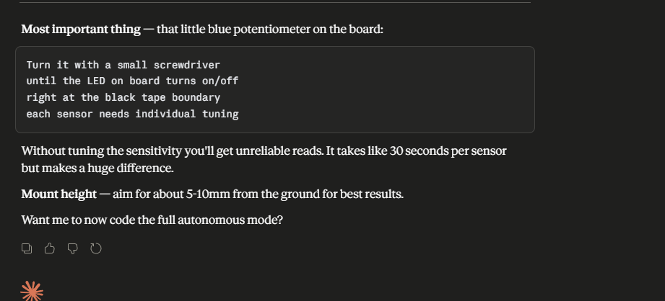

3D PRINTING TIRE RIMS:
- I need to custom 3d print the tire rims o the motor could connect to the tires, V0.
- First thing i printed online copy https://www.thingiverse.com/thing:3284612, and printed to check if it fit than will make my own and measure the tires and such.
- Measurements were taken using the Caliper I 3D printed
- I printed one using chatgpt recommendations, the whole for d shaft was perfect, the width side length perfect for the inner and outer parts of the rim, however the overall diameter felt a couple mm too small, going to reprint with slightly bigger one and than try again. I used simpler print that doesnt take too long, like the infill, when printing the real wheels going to make infill like 70% but for this purpose its fine, and some other factors better maybe.
- V2 worked, its perfect, all its missing is a design, which I can get to, after adding all the sensors to esp32.
- After sensors, plan is to make Sketch of what the car will look like, and any branding I want to add, so I can add touches to the wheel design as well
- Print V3, the one with the designs and what not, before a final print
- REMEMBER I DID THE SKETCHES ON MY IPAD

REMOTE CONTROL CAD:
- Trying to figure out how I should go about coding the parts to fit the joystick and screen onto
- They both have holes on the corners that maybe like a stick could go into to keep them in place, perhaps with glue ontop of that.
- I was gonna look at how the xbox and ps4 controllers keep the joystick free to move with it being inside completely

Design Choices For CAD:

PCB:
- Was originally gonna print driver board, have the rough sketch design but used prebuilt for each of use.
- Working on the rc schematic right now, everything is female headers.
- The three buttons are gonna be illuminated themselves instead of 3 buttons 3 leds, so the button pressed its mode is active, the led will be on.
- I have to use B3W-9002-Y1N, which is yellow as the footprint model and what not for the other colours I want potentially like green, white or red do not exist, so it will have to do until I order parts where I just swap out which colour I want.
- I only have hand iron, so I had to restart alot of the parts, like the buck converter, as they require flux paste or other ways like the hot blowing gun to get soldered, which im not gonna put more money into right now. This means I got parts that would let me do the hand soldering.
- When doing the PCB layout for the esp32 header pins, i needed to measure the inside part of the esp32 find that distance, and thats the distance between the two headers, 22.92mm gotten from subtracting the male header pins width times two from the total width
- Had to make changes in the schematic after the pcb layout was done, leaving 3-5mm space on the edge, the gnd 3.3V pin was wrong place around in the joystick header, the tft display is also wrong, the buttons resistor I changed from 68 to 47 ohms, the cathode of the LED was 3.3V which i changed to gnd
- After doing that and updating the schematic I went to routing, Im just learning as am going, and making sure I soke up as much knowledge as I can. The routing for example I keep asking Claude which I think is good, Many imagine all these notes on obsidian, I need to get on it super soon brodigy.
- Its saying for signals 0.2mm, power(5V, 3V3) 0.5mm, and VBat 0.8mm.
- Multiple layers, for traces separated by the fiberglass insulator in the middle. Assuming more complex boards will have way more layers.
- PCBs were pretty simple, in the process of shrey and hamza looking at them, memorable things were just making sure certain traces and layout parts were away from one another to ensure there wasn’t noise, like the motor from the nrf module.
- Traces were different sizes based on power, battery, and signals. Like 0.5mm, 0.8mm, 0.2mm.

- So the pcb came and the stupid esp32 doesnt fit perfectly, we gonna see whats gonna happen if the part comes and I solder it, but I might just use wires bec the wait time is so long, for now,
- I did the switch and power supply, excluding light up led, part and i accidentally short circuit the gnd and 5v output, oops, the thing was so hot and gave me a horrendous reading, luckly I fixed it, the solder of the pins were touching, thank goodness. Im getting 4.95V output, hopefully enough for the esp32
- Also i used my second pcb for the car, the voltage converter was impossible to stick using the solder so i just took a fresh one and it worked
- The leds both got cooked while soldering, to see if solder is going thru for the remote the button led and display should indicate it, for the car ill put the normal led and if anyhting i could use the multimeter
- I think this is some up the most frustration ive ever felt doing anything, not even the pokemon ascii project got me like this, all my fingers screwed, and now i screwed my thumb, i cant use it for some time now, thank god i had extra wires, i only need to desolder the motor driver, and the two ir sensors for the car, and just the power pins for the remote
- I forgot about the 5v input for the motor driver, i remembered if i add the jumper back then potentially it can internally handle the 5V step down, last case scenario i just solder that wire to a 5V pin from the esp32
- I need to solder 3 wires remote rf module, 6wires total for both ir sensors combined, and 4 for tof sensor
- Bro i got the male headers for everything off, but i did too good of a job with the tof sensor, the hole via came out and i fried the board :`), im gonna grab it from, aathi, naiyar, or mahi and watch a video on easy way to remove them
- So i tried using the esp with just wires, so doesnt work at all, im gonna solder the esp straight onto the board,
- The leds do not work anymore, so i am getting rid of their functionality, say the third button is future implementation for another mode, like imagine a full automatic with camera and everything mode type of thing and to save time im not doing it anymore.

- Im using the 20 pins connecters now and got the esp32s onto the pcb, the way im doing is using the cable front he computer, ill implement one feature at a time nd see if they work consistently then move on, starting with the remote buttons

- So im back to testing using the arduino ide, the things that dont work are the tof, the two irs, and the one nrf, my best guess is taking the solder pins out screw them, so i have one nrf still ill change it out and see if works, hopefuly it does, the tof ill grab from naiyar, and the two ir modules probably go back to sayal electronics tomorrow and buy the pins as well, but atleast everything other than that works, thank god. Hopefully after that i can put the 5V thing onto the pcb from the other one, and all the pcb stuff works by tomorrow.
- So i switched out the stupid nrf and it still doesnt work. What im doing right now is i took the esps off the pcb, and individually testing with new pins going to the old pins, the assignments for the nrf module, and seeing which pin is causing the issue, since im not using leds anymore i could possible use one of those for the nrf for the remote and the car just pray it works.
- Esp 32 with longer stick soldered on has pin 13 that doesnt work, and thats the only pin that doesnt work, once i come back from picking up the ir module and some header pins i will see if i can use that specific esp for the remote, checking if the pins thats needed in the car and remote are fine and vice versa, then seeing if i could use the button led pin.
- Im switching pin 13 for 33 on the remote pcb, and button 1 19 ill try soldering on it, but if i cant its gonna be pin 15
- My tof sensor on the pcb is vcc is 5v but my vcc is 3.3, im gonna use the via to test 3.3 volts, all the senors work tho, so what i need to do, is change the pins for the button1 and pin 13, also for 3.3V into the tof sensor, those fixes should make it so those three things work.
- Solder pin into 33, 15 on remote, and pin into 3.3V via, change the code so instead of pin 13 is 33, and instead of 19 its 15. Im hoping all the other pins work so that when i connect it up the esps work bec i think originally i had the esps on opposite boards.
- Bro right before soldering pin 18 fell out for the remote which is used for the display other wise, if that display doesnt work im gonna use the last remote led button for it, hopefully it still works i just soldered it back on, the stupid solder hole for the ir sensor with piin 16 is gone on the pcb so i soldered directly onto the pin sticking on the underside of the pcb, i think i should be good to test it now, but ill take a break first.
- Bro screw this im buying two new esps, the broken one is acting up right now, im gonna just use the new ones, this is good tho im learning so much tho on what not to doo next time, im just gonna wait for the new esps and then not even change the pin assignment, hopefully everything works, bec im not going thru the hassle right now to see which pins work or not
- Finally good news bro, with the new esp32 everything works, the nrf module at the start once i first started it was fine, but then started bugging and stopped, prob some wiring issue but everything else works. Im pretty sure with wires i the car pcb, so i could prob put male headers and get it fixed. Finally brother its been a month, ill finish this tommorow, then weekend the remote, and then next monday and tuesday car hopefully, then new week work time get git hub and everything done. If i actually lock in, I can finish all this fast and get the verliog stuff learnt, and risc 5 completed, with the chip and assic board printed from tiny tapeout i need to be done everything by july 24 today is july 16 you got this brother.
- I forgot i need to solder the 5v converter stuff onto the board, ill do that after i fix the nrf module, and then i can do the remote after that.
- So all the technical stuff works, but the nrf module just buggy some times so just reset the car esp each time that happens, i need to solder the 5v stuff on, which i will do after i come back from walmart
- So i did the soldering for the power supply and everything works, but one of the inductors were broken so I had to buy a new one, but the connection worked perfectly
- I spent way more to buy the extra esp32, the extra sensors, and new Inductor, but it was learning experience, i think im done with this part like i just need to solder the new inductor when it comes in, but I will get started on the car CAD, as that will be annoying

Car CAD:
- I'm gonna start with the steering system, then work my way backwards, as the tires are already made, and the rest should be pretty easy you know?
- https://www.youtube.com/watch?v=vlSZeEDv-VY, this the video im gonna do similar to, theres a couple things I need to figure out tho, like the dimensions how big, also what do i want the wheels rotating on, a metal pin or the 3d printed material you know?
- So following the video im making the steering, ive printed the chassis twice and have hopefully fixed everything
- The steering ive printed twice, the metal rod im using the paperclip and we will see if this works
- So the steering works, i just need to make some adjustments as well as the way i would connect to the remaining car and add the way to put the wheels on, i also need a way to hold the sensor, ill try it again’
- So i havent been uopdating this, but ive been doing alot, right now im buying a motor replamcents bec i messed up, but i think it will help with the smaller pwm actually having the car moving instead of the 500 rpm ones im using now, im gonna use 200rpm.
- Holy bro i just fried my esp32, by connecting 5v and the power thing do not do that again but another 35 down the drain holy man, but rrealistically i have to test the speed thing now bec the steering part of auto drive works, after speed thing i check, then the front on driving, meaning the tof sensor part of it, like making it slow down and what not and im done. Today the filament is coming so ill get that printed and get like maybe the joystick super glued on, buttons, and switch, ill ait for the buttons and the rest of the stuff tho just in case
- This life we live in is one stupid life, the rf module was also fried, thank god i had an extra one, i just used that, like cmon bro thats so stupid.
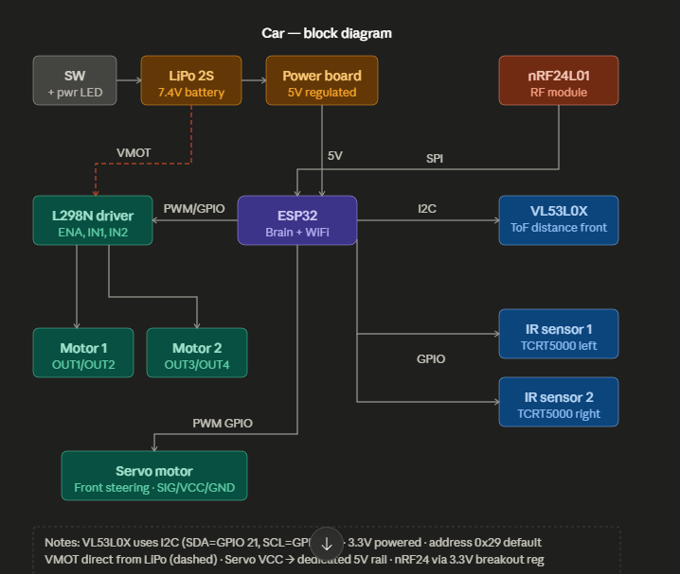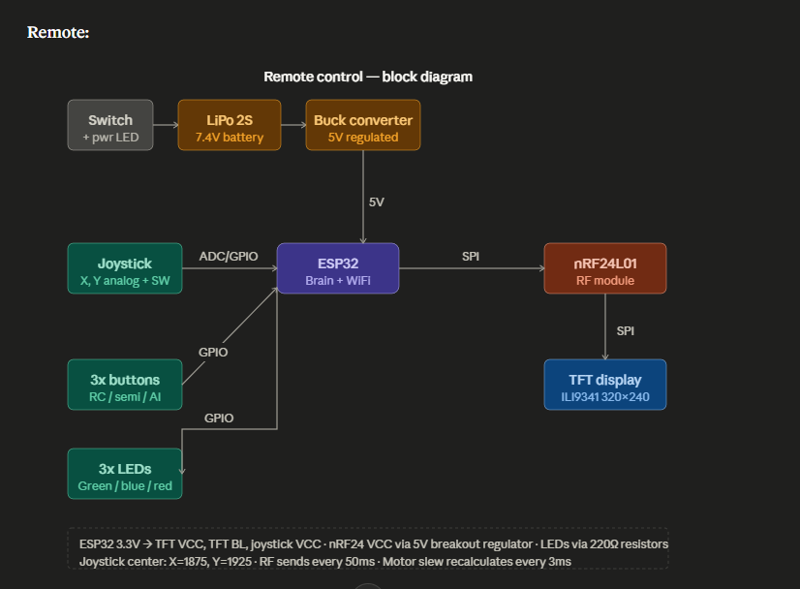

Hello, so I finished breaboarding my project, but I wanted to make a pcb with some more parts, if you have some time can you look at these block diagrams I got claude to make them for me, and give any advice wht to add, change, how I should go about making the pcb on altium like I think the routeing for the motor will have to be thicker stuff like that, anything for soldering if i should use mostly thru hole, I was thinking using connecters.

Description:
It's a custom RC car built around two ESP32s talking over nRF24L01 RF. The controller has a joystick, a TFT screen showing speed and direction, and three mode buttons. The car has a brushed DC motor through an L298N, a servo for steering, a microwave radar in the front, and two IR sensors on the bottom. There are three modes: regular RC, semi-auto where the radar slows the car for obstacles and the IR sensors keep it between lane markers on the ground, and an AI mode where it connects to my PC over WiFi and I can drive it with hand gestures.

Claude Said This PCB Advice:

For the car power board, stuff that'll save you pain:

Decoupling caps (100nF ceramic) right at the ESP32 power pins and the L298N logic supply — without these you'll get random resets when the motor switches.
A fuse or polyfuse between the LiPo and VMOT. Motors can pull a lot of current on stall and you don't want to cook your traces.
Reverse polarity protection on the LiPo input — a P-channel MOSFET or even just a diode. One wrong connection kills everything.
A dedicated LDO or switching reg for the servo (like an AMS1117-5.0 from the battery rail) with a big capacitor on the output, rather than sharing the main 5V rail. Servo spikes are brutal.
Indicator LEDs on the 5V and 3.3V rails so you know at a glance what's powered up.
Test points on VMOT, 5V, 3.3V, and the SPI lines. You'll thank yourself when debugging.

For the remote, same decoupling caps, and make sure the nRF24 has its own 100µF electrolytic + 100nF ceramic close to its VCC pin — that module is notorious for brownout resets without good bypassing.

Things to Keep in Mind
- Document what assumptions you are making for when you implement motor driver.
- You might want to log PWM duty to Serial for testing later with motor, so you know the code is producing the correct signals.
- If you simulate, consider virtual “motor current” in code, so you can test braking or direction changes.
- Do NOT power the servo from the ESP32 5V pin. Straight from battery

Pick Motor and Battery ~ Look into possible problems they might have with rest of the design

Design Block Diagram For H-Bridge and get advice from MED-T Lead
Make PCB and ask MED-T Lead for help

PRINT PCB AND TEST WITH MOTOR AND BATTERY

- Power supply for all parts because of current, including RF module, Servo Motor, Motor, I think the joystick should be fine, but might as well

